Term Project Proposal for CPD-4414

**Name of Project**

SellEasyERP

**Project Author**

Bino Oommen Samuel (c0647015)

**Description**

I intend to make a web based Enterprise Relationship Management (ERP) application in Java which would handle important sections like sales, purchase and inventory management of products.

In this ERP we will be able to store records and manage it using CRUD operations. In some cases we cannot let the record to be deleted or edited for example: - if a product has been purchased or sold then, we cannot delete it because may cause problems in the system in different sections, it’s all based on the business rules.

Basically this ERP will have an admin side login (Later on if possible can add different levels of admin side users like sales manager/sales user etc.) and record for products, customers and seller (can be both), sales order, sales order lines, purchase order, purchase order lines, warehouse.

**Critical Path Analysis Flow Diagram**

Product and quantity handled

Update product quantity to inventory

Update product quantity to inventory

Add customer to sale order

Add product to sale order

Add supplier to purchase order

Add products to purchase order

Inventory

Purchase Order

Sale Order

**User Interface Mock-ups**

Have added 3 mock-ups related to the products, the other models will also have a similar concept of CRUD.

1, Product List View

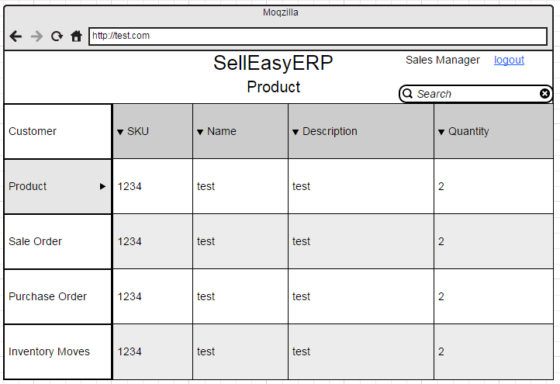

2, Product Edit View

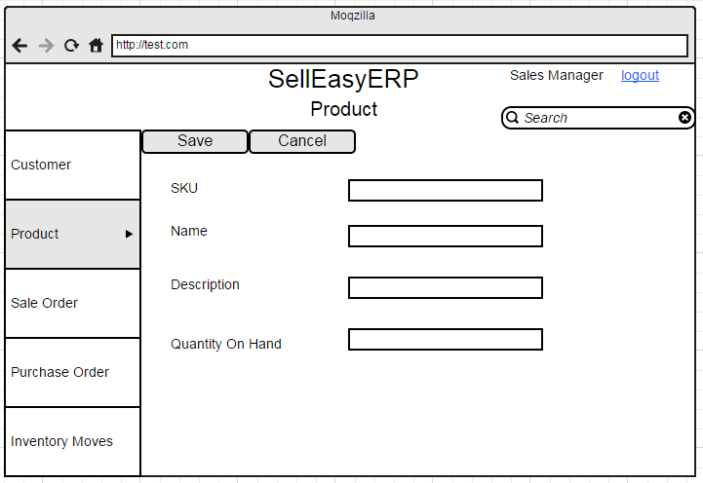

3, Product View After data is saved

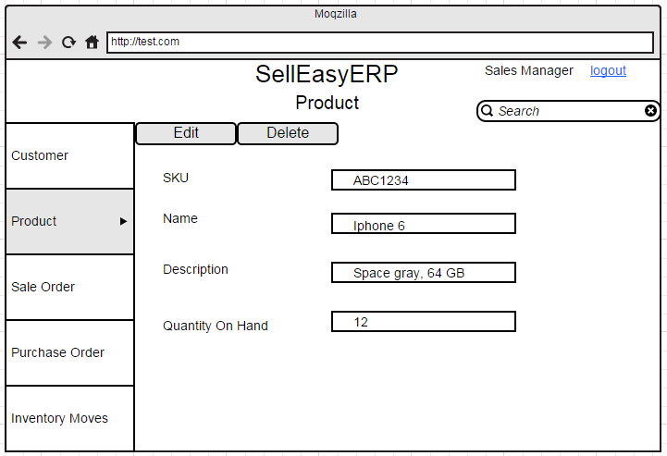

**End-User Frequently Asked Questions (FAQs)**

1. Who is the end user?

Answer: - The end user is not the customer, it is the system user/admin/manager.

2. What is an ERP?

Answer: - [Form Wikipedia] Enterprise resource planning (**ERP**) is business process management software that allows an organization to use a system of integrated applications to manage the business and automate many back office functions related to technology, services and human resources.

3. Do I need an ERP system?

Answer: - If your organisation handles lots of records and want to manage them easily using a web based system, with different managing levels and at the end create reports with the data ERP is a very good option.

4. Benefits of ERP?

Answer: -

a. Easily accessible all over the world in any supported device.

b. Different user/managing levels.

c. Business Reports.

d. Easily expandable with new modules.

e. Makes business easier.

f. Helps in exporting and importing data.

5. How long does an ERP implementation take?

Answer: - ERP implementation depend on the data to be migrated usually it is done now a days by exporting data from the old system and importing it to the new ERP system in a csv format. In some cases we might have to add few extra fields of to the new system.