Assessment 02
Student: Rosmin Roy | Subject: Web Development | Date: 3 April 2026
Contents
Assessment 02 1
1. Cover Page 2
2. General Requirements 2
3. HTML Requirements (per file) 2
4. CSS Requirements (portfolio.css) 4
5. Concept Map 5
6. Story Board 5
7. Validation 7
8. Web Pages 8
index.html 8
rroy_A2_about.html 11
rroy_A2_resume.html 14
rroy_A2_web_skills.html 17
portfolio.css 21
9. Test 24
10. References 24

1. Cover Page

This is my Assessment 02 for Web Development. I’ve developed a Portfolio website using 4 HTML files and a CSS file to showcase different HTML and CSS requirements. I have followed a consistent theme and style across all the web pages, making it look like a professional and aesthetic Portfolio website.

The assessment asked to theme the whole site consistently in a way that matches a fictious company. I have chosen a fictious restaurant in the Food Industry and named it “Spice Blend”, which will be an Indian restaurant serving Kerala cuisine, which is why I have themed the whole web site based on an olive-green colour theme.

There were a lot of HTML and CSS elements in the assessment, and I enjoyed learning and understanding how we can use all this knowledge and technology to develop a user-friendly website.

I used Copilot AI to generate some of the images for this assessment: certificate.png and profile.png.

2. General Requirements
No | Requirement | Met? | Notes
1 | Main folder with various subfolders and files has been stored within the appropriate folder structure. | Yes
2 | Concept map | Yes
3 | 4 HTML files created with correct naming convention | Yes
4 | Storyboard for each HTML file | Yes
5 | External CSS file (portfolio.css) stored inside a css folder | Yes
6 | Cover page included in report | Yes
7 | Validation results included in report | Yes

3. HTML Requirements (per file)
No | Requirement | index.html | rroy_A2  _about.html | rroy_A2  _resume.html | rroy_A2  _web_skills.html
1 | HTML5 DOCTYPE declaration | Yes | Yes | Yes | Yes
2 | Comment to the document head describing the document’s content and containing your name and the date | Yes | Yes | Yes | Yes
3 | Appropriate page title in document head | Yes | Yes | Yes | Yes
4 | Character set to UTF-8 | Yes | Yes | Yes | Yes
5 | Sufficient comments alongside code | Yes | Yes | Yes | Yes
6 | Inline style | Yes | Yes | Yes | Yes
7 | Internal style sheet | Yes | Yes | Yes | Yes
8 | External style sheet | Yes | Yes | Yes | Yes
9 | Horizontal navigation bar | Yes | Yes | Yes | Yes
10 | Paragraphs (<p>) | Yes | Yes | Yes | Yes
11 | Ordered list (<ol>) | Yes | Yes | Yes | Yes
12 | Unordered list (<ul>) | Yes | Yes | Yes | Yes
13 | Headings (<h1>–<h6>) | Yes | Yes | Yes | Yes
14 | Images (<img>) | Yes | Yes | Yes | Yes
15 | Internal links (linking to sections/pages within the site) | Yes | Yes | Yes | Yes
16 | External links (linking to outside websites) | Yes | Yes | Yes | Yes
17 | Email link (mailto:) | Yes | Yes | Yes | Yes
18 | Phone link (tel:) | Yes | Yes | Yes | Yes
19 | Character reference | Yes | Yes | Yes | Yes
20 | Validation | Yes | Yes | Yes | Yes

4. CSS Requirements (portfolio.css)
No | Requirement | Met?
1 | At least two different text colours | Yes
2 | At least two different background colours (one applied to entire webpage) | Yes
3 | At least two different font-weights | Yes
4 | At least two different font-styles | Yes
5 | At least two different font-sizes | Yes
6 | At least one font-family with four typefaces | Yes
7 | Three differently aligned paragraphs | Yes
8 | At least two different text-decorations | Yes
9 | At least one class selector | Yes
10 | At least one ID selector | Yes
11 | Unordered list bullet changed to squares | Yes
12 | Ordered list numbers changed to Roman numerals | Yes
13 | At least one <div> used in HTML | Yes
14 | At least one <span> used in HTML | Yes
15 | Sufficient comments alongside CSS code | Yes
16 | Validation | Yes

5. Concept Map

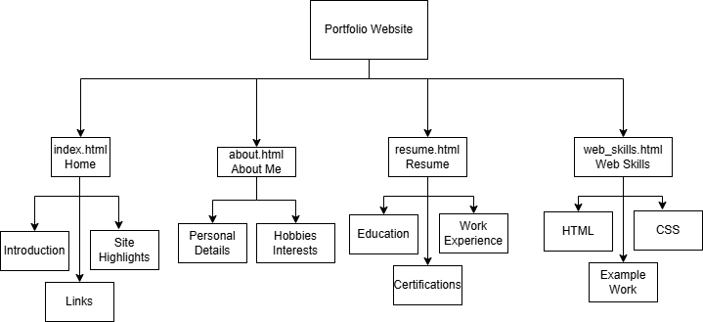

Folder Structure:

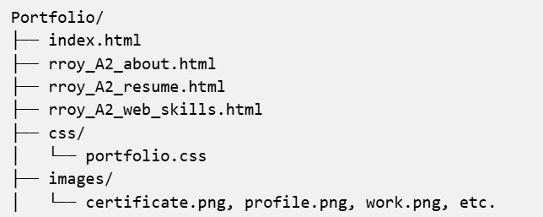

6. Story Board

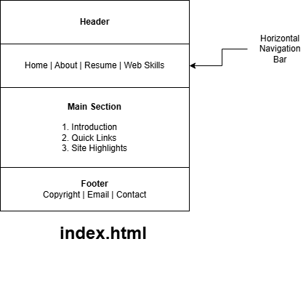

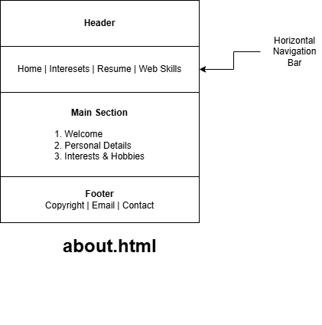

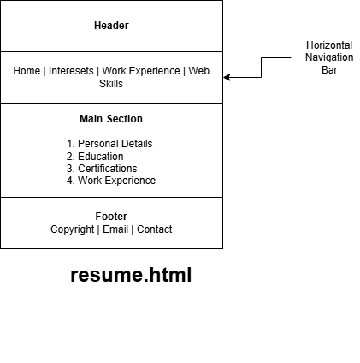

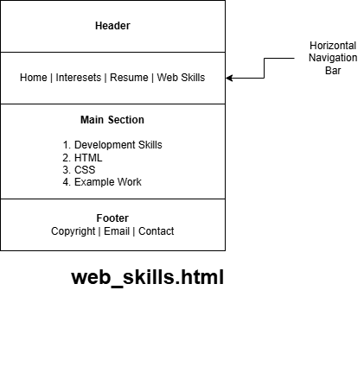

7. Validation

I validated each of the HTML files using the W3C Nu Html Checker (validator.w3.org). I submitted the files using the "Validate by File Upload" method, uploaded the file into the tool and clicked ‘Check’. The screenshots are attached below for each HTML file.

I validated the external stylesheet portfolio.css using the W3C CSS Validation Service (jigsaw.w3.org/css-validator). I submitted the file using the "Validate by File Upload" method, uploaded the file into the tool and clicked “Check”. The screenshot is attached below for the CSS file.

8. Web Pages

index.html

Source Code: Attached

<!DOCTYPE html>
<html lang="en">

<head>
<!-- Index page for portfolio -->
<!-- Author: Rosmin Roy -->
<!-- Date: 21 March 2026 -->
<meta charset="UTF-8">
<meta name="viewport" content="width=device-width, initial-scale=1.0">

<!-- Page Title -->
<title>Rosmin's Portfolio</title>

<!-- External style sheet -->
<link rel="stylesheet" href="css/portfolio.css">

<!-- Internal stylesheet -->
<style>
/* Internal style */
.welcome-box {
background-color: cornsilk;
border: 1px solid orange;
padding: 10px;
margin-bottom: 10px;
}
</style>

</head>

<body>

<!-- Page Header -->
<div id="page-header">
<!-- Inline style -->
<!-- character reference -->
<h1 style="letter-spacing: 2px;">Rosmin Roy &mdash; Portfolio</h1>
<p>Web Developer</p>
</div>

<!-- Horizontal Navigation -->
<!-- Internal links -->
<nav>
<ul>
<!-- Internal links -->
<li><a href="#top">Home</a></li>
<li><a href="rroy_A2_about.html">About</a></li>
<li><a href="rroy_A2_resume.html">Resume</a></li>
<li><a href="rroy_A2_web_skills.html">Web Skills</a></li>
</ul>
</nav>

<!-- main-content section -->
<div id="top" class="main-content">

<!-- Welcome box -->
<div class="welcome-box">
<h1>Welcome to My Portfolio</h1>
<p>
Hello! I'm Rosmin Roy, I am doing Bachelors in Educational Studies.
This portfolio showcases my skills, experience, and projects in web development.
</p>

<!-- Images -->
<img src="images/profile.png" alt="Profile Picture" width="100" height="100">

<p>
You can explore the different sections to learn more about me and my work.
</p>
</div>

<!-- Headings -->
<h2>Quick Links</h2>

<!-- Unordered list -->
<ul>
<!-- character references -->
<li><a href="rroy_A2_about.html">About Me</a> &ndash; More about who I am</li>
<li><a href="rroy_A2_resume.html">Resume</a> &ndash; Education and experience</li>
<li><a href="rroy_A2_web_skills.html">Web Skills</a> &ndash; HTML, CSS and more</li>
</ul>

<h2>Site Highlights</h2>

<!-- Ordered list -->
<ol>
<li>Clean and simple layout</li>
<li>Fully validated HTML5 and CSS</li>
<li>User-friendly interface and easy navigation</li>
<li>Consistent colour scheme throughout</li>
<li>Succinct and lucid content</li>
</ol>

<!-- External link -->
<p>
Visit the university website:
<a href="https://www.csu.edu.au" target="_blank">
<!-- span -->
<span style="color: olive; font-weight: bold;">Charles Sturt University</span>
</a>
</p>

</div>
<!-- End main-content div -->

<!-- Page Footer -->
<div id="page-footer">
<p>
&copy; 2026 Rosmin Roy |
<!-- Email and phone links -->
<a href="mailto:rosmin.roy@sample.com">rosmin.roy@sample.com</a> |
<a href="tel:+61400000000">+61 400 000 000</a>
</p>
</div>

</body>

</html>

Tests/Validations

Validated using https://validator.w3.org/
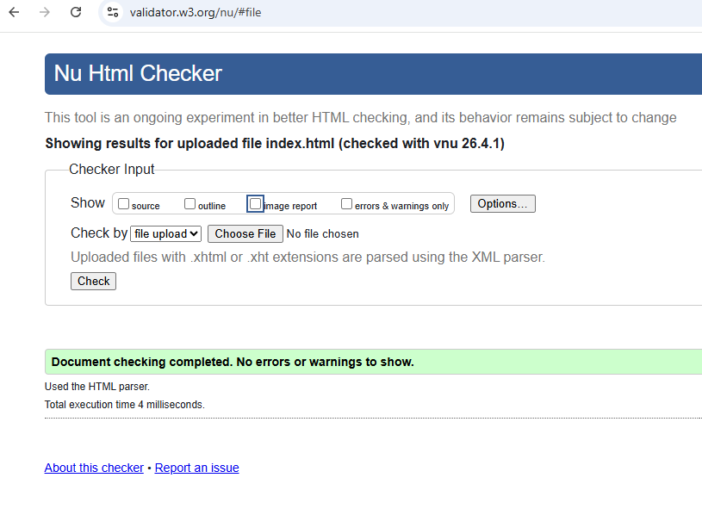

Personal Reflections

This was the first page I attempted and since I learnt HTML from the course and I had a prior learning experience, I had a basic idea of what to include as part of the HTML file.

I initially jumped to write the HTML elements required as part of the assignment, and it was a mess with all the elements all over the place. Then I understood the importance of a Story Board and Concept map, so I can design up-front what each web page should contain and how an end-user can navigate across al the pages in a smooth and consistent manner. I split all the webpages into three sections – a header, a main-content and a footer. And applied this template across all the other HTML pages too.

Then I added the headings, paragraphs and ordered and unordered lists. Initially the page looked very plain with just black and white colours. I added an Internal stylesheet for the welcome box and a few inline colours. Then, I added a few character references.

I had to often reference https://www.w3schools.com/ for the correct usage of HTML and CSS elements.

rroy_A2_about.html

Source Code: Attached

<!DOCTYPE html>
<html lang="en">

<head>
<!-- About page for Portfolio -->
<!-- Author: Rosmin Roy -->
<!-- Date: 25 March 2026 -->
<meta charset="UTF-8">
<meta name="viewport" content="width=device-width, initial-scale=1.0">

<!-- Page title -->
<title>About Me - Rosmin's Portfolio</title>

<!-- External Style sheet -->
<link rel="stylesheet" href="css/portfolio.css">

<!-- Internal Style -->
<style>
.hobbies-list {
background-color: cornsilk;
padding: 10px 10px 10px 30px;
border-left: 3px solid orange;
}
</style>
</head>

<body>

<!-- Page header -->
<div id="page-header">
<!-- h1 heading and Inline style -->
<h1 style="font-size: 26px;">About Me</h1>
<!-- character reference -->
<p>Rosmin Roy &mdash; Personal Portfolio</p>
</div>

<!-- Horizontal navigation -->
<nav>
<ul>
<!-- Internal links -->
<li><a href="index.html">Home</a></li>
<li><a href="#interests">Interests</a></li>
<li><a href="rroy_A2_resume.html">Resume</a></li>
<li><a href="rroy_A2_web_skills.html">Web Skills</a></li>
</ul>
</nav>

<!-- Main-content section -->
<div class="main-content">

<!-- Headings -->
<h2>Welcome to My Portfolio</h2>

<!-- Paragraphs -->
<p>Welcome to my portfolio home page.</p>
<p>Here you will find information about my background, skills, and projects.</p>

<!-- Images -->
<img src="images/profile.png" alt="Profile Picture" width="100" height="100">

<h2>Personal Details</h2>

<!-- Unorderd list -->
<ul>
<li>Name: Rosmin Roy</li>
<li>Location: Sydney, NSW, Australia</li>
<li>Degree: Bachelor of Educational Studies</li>
<li>University: Charles Sturt University</li>

</ul>
<p>
Connect with me on
<a href="https://www.linkedin.com" target="_blank">LinkedIn</a>.
</p>

<!-- Interests and Hobbies -->
<h2 id="interests">Interests &amp; Hobbies</h2>

<p>
Below is a list of my main hobbies and interests:
</p>

<!-- Ordred list -->
<ol class="hobbies-list">
<li>Web Development</li>
<li>Cooking &amp; Exploring Cuisines</li>
<li>Catching up with friends</li>
</ol>

<!-- span element -->
<p>
My student ID is <span style="font-weight: bold; color: olive;">12345678</span>.
</p>

</div>
<!-- End main-content div -->

<!-- Page Footer -->
<div id="page-footer">
<p>
<!-- &copy; is a Character reference -->
&copy; 2026 Rosmin Roy |
<!-- Email and phone links -->
<a href="mailto:rosmin.roy@sample.com">rosmin.roy@sample.com</a> |
<a href="tel:+61400000000">+61 400 000 000</a>
</p>
</div>

</body>

</html>

Tests/Validations

Validated using https://validator.w3.org/

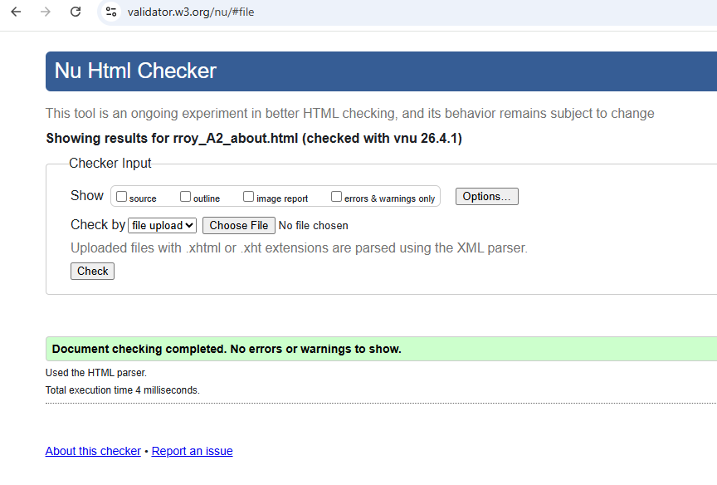

Personal Reflections

The about page is very similar to the index page. I added an internal style for my hobbies and learnt the difference between class based and id-based selectors. I generated an image for my profile using Co-Pilot AI and specified the width and height for a proper alignment.

rroy_A2_resume.html

Source Code: Attached

<!DOCTYPE html>
<html lang="en">

<head>
<!-- Resume page for Portfolio -->
<!-- Author: Rosmin Roy -->
<!-- Date: 28 March 2026 -->
<meta charset="UTF-8">
<meta name="viewport" content="width=device-width, initial-scale=1.0">

<!-- Page title -->
<title>Resume - Rosmin's Portfolio</title>

<!-- External style sheet -->
<link rel="stylesheet" href="css/portfolio.css">

<!-- Internal style -->
<style>
.resume-section {
margin-bottom: 24px;
}

.job-title {
font-weight: bold;
font-style: italic;
}
</style>
</head>

<body>

<!-- Page Header -->
<div id="page-header">
<!-- Inline style -->
<h1 style="font-size: 26px;">My Resume</h1>
<p>Rosmin Roy &mdash; Web Developer</p>
<!-- character reference -->
</div>

<!-- Horizontal Navigation -->
<nav>
<ul>
<!-- Internal links -->
<li><a href="index.html">Home</a></li>
<li><a href="rroy_A2_about.html">About Me</a></li>
<li><a href="#work-experience">Work Experience</a></li>
<li><a href="rroy_A2_web_skills.html">Web Skills</a></li>
</ul>
</nav>

<!-- main-content section -->
<div class="main-content">

<!-- Personal -->
<h2>Personal Details</h2>

<!-- Paragraph -->
<p>
Full Name: Rosmin Roy<br>
Location: Sydney, NSW, Australia<br>
<!-- Email link -->
Email: <a href="mailto:rosmin.roy@sample.com">rosmin.roy@sample.com</a><br>
<!-- Phone link -->
Phone: <a href="tel:+61400000000">+61 400 000 000</a>
</p>

<!-- Education -->
<h2>Education</h2>

<div class="resume-section">
<h3>Bachelor of Educational Studies</h3>
<p>
Charles Sturt University, 2026 &ndash; Present
</p>

<!-- External link -->
<p>
View my academic transcript on the
<a href="https://www.csu.edu.au" target="_blank">CSU Student Portal</a>.
</p>

<!-- Unordered list -->
<ul>
<li>Web Development</li>
<li>Database Systems</li>
<li>Python Programming</li>
<li>AI</li>
</ul>

<!-- Image -->
<h2>Certifications</h2>
<img src="images/certificate.png" alt="Web development certificate" width="300">

</div>

<!-- Work Experience -->
<h2 id="work-experience">Work Experience</h2>

<div class="resume-section">
<p class="job-title">Junior Web Developer &ndash; Spice Blend Restaurant (2024)</p>
<!-- Ordered list -->
<ol>
<li>Maintained the restaurant website and updated menu content</li>
<li>Collaborated with marketing team</li>
</ol>
</div>

<!-- span elemnt -->
<p>
References available upon request.
<span style="color: olive;">(Email or call to request.)</span>
</p>

<!-- Center-aligned paragrph -->
<p class="align-center">
-- End of Resume --
</p>

</div>
<!-- End main-content div -->

<!-- Page Footer -->
<div id="page-footer">
<p>
&copy; 2026 Rosmin Roy |
<!-- Email and phone links -->
<a href="mailto:rosmin.roy@sample.com">rosmin.roy@sample.com</a> |
<a href="tel:+61400000000">+61 400 000 000</a>
</p>
</div>

</body>

</html>

Tests/Validations

Validated using https://validator.w3.org/
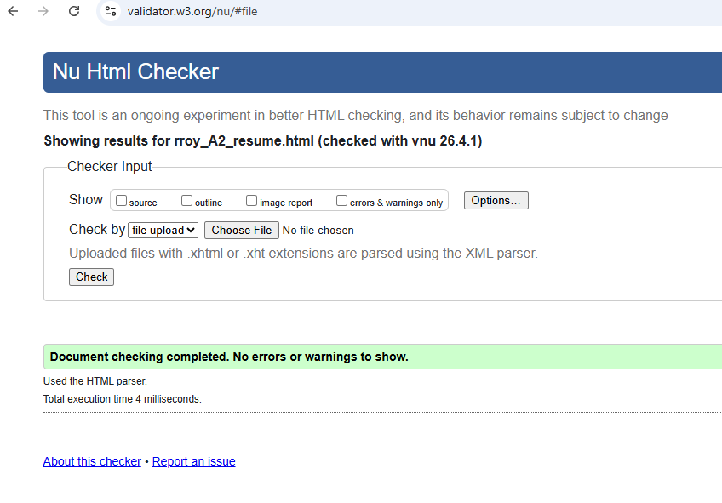

Personal Reflections

I found the resume.html somewhat like the about webpage. I generated an image for a sample certificate using Co-Pilot AI and specified the width for a proper alignment.

rroy_A2_web_skills.html

Source Code: Attached

<!DOCTYPE html>
<html lang="en">

<head>
<!-- Web skills page for portfolio -->
<!-- Author: Rosmin Roy -->
<!-- Date: 31 March 2026 -->
<meta charset="UTF-8">
<meta name="viewport" content="width=device-width, initial-scale=1.0">

<!-- Page Title -->
<title>Web Skills - Rosmin's Portfolio</title>

<!-- External style sheet -->
<link rel="stylesheet" href="css/portfolio.css">

<!-- Internal style sheet -->
<style>
/* Internal style */
.skill-label {
font-style: italic;
color: black;
}
</style>
</head>

<body>

<!-- Page Header -->
<div id="page-header">
<!-- h1 heading and Inline style -->
<h1 style="font-style: normal;">Web Skills</h1>
<!-- &mdash; is a character reference -->
<p>Rosmin Roy &mdash; Personal Portfolio</p>
</div>

<!-- Horizontal Navigaton -->
<nav>
<ul>
<!-- Internal links -->
<li><a href="index.html">Home</a></li>
<li><a href="rroy_A2_about.html">About</a></li>
<li><a href="rroy_A2_resume.html">Resume</a></li>
<li><a href="#sample-work">Sample Work</a></li>
</ul>
</nav>

<!-- main-content section -->
<div class="main-content">

<!-- Headings -->
<h2>My Web Development Skills</h2>

<p>This page outlines the web development skills I have developed during my studies.
I have been learning HTML, CSS, and the fundamentals of web design.
</p>

<h2>HTML</h2>

<!-- Unordered list -->
<h3>HTML Skills</h3>
<ul>
<li>Document structure &amp; doctype</li>
<li>Headings, paragraphs, and text formatting</li>
<li>Links &mdash; internal, external, email and phone</li>
<!-- &mdash; is a character reference -->
<li>Images and multimedia</li>
<li>Tables and lists</li>
</ul>

<!-- CSS Skills -->
<h2>CSS</h2>

<!-- Ordered list -->
<h3>CSS Skills</h3>
<ol>
<li>Selectors &mdash; class, ID, element</li>
<li>Colours and backgrounds</li>
<li>Fonts and text styling</li>
<li>Lists and navigation styling</li>
</ol>

<div class="skill-label">

<h2 id="sample-work">Example Work</h2>
<p>Here is an example of a simple web page I created as part of my coursework:
<!-- External link and image -->
<a href="https://www.keralakitchen.com.au/" target="_blank">
Spice Blend<img src="images/work.png" alt="Website Example" width="300">
</a>
</p>

<p>
My current skill level is
<span style="color: #8b1a1e; font-weight: bold;">Beginner to Intermediate</span>.
</p>

</div>

<!-- Right-aligned paragrph -->
<p class="align-right">
Last updated: March 2026
</p>

</div>
<!-- End main-content div -->

<!-- Page footer -->
<div id="page-footer">
<p>
<!-- Character refernce -->
&copy; 2026 Rosmin Roy |
<!-- Email and phone links -->
<a href="mailto:rosmin.roy@sample.com">rosmin.roy@sample.com</a> |
<a href="tel:+61400000000">+61 400 000 000</a>
</p>
</div>

</body>

</html>

Tests/Validations

Validated using https://validator.w3.org/

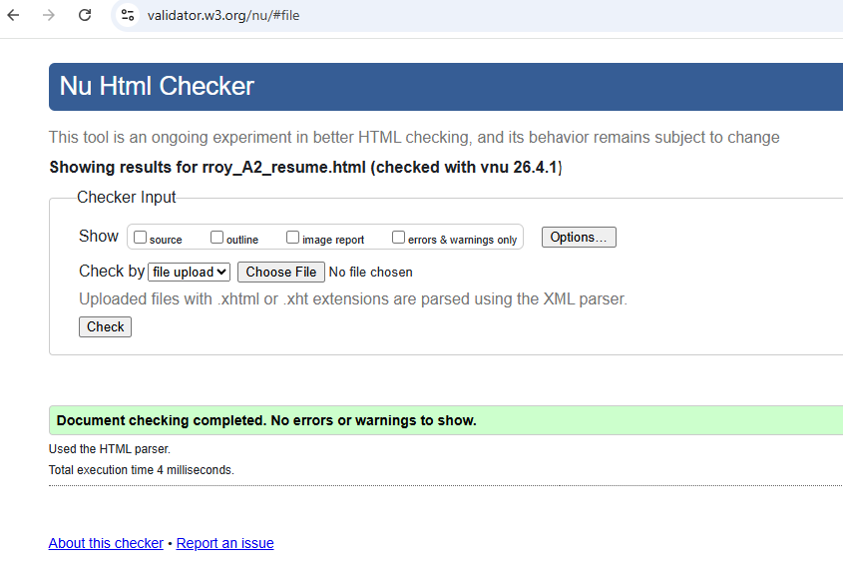

Personal Reflections

In the web skills page, I added a fictious company Spice Blend’s screenshot and an external link. The rest of the sections are similar to the previous HTML pages.

portfolio.css

Source Code: Attached

/*
portfolio.css
Author: Rosmin Roy
Date: 31 March 2026
*/

/* Background colour for entire web page */
body {
background-color: ivory;
font-family: Arial, Helvetica, Geneva, sans-serif;
font-size: 16px;
color: black;
margin: 0;
padding: 0;
}

/* Horizontal navigation Containr */
nav {
background-color: olivedrab;
padding: 10px 0;
}

nav ul {
list-style-type: none;
margin: 0;
padding: 0;
text-align: center;
}

nav ul li {
display: inline;
margin: 0 15px;
}

nav ul li a {
color: white;
text-decoration: none;
font-weight: bold;
font-size: 18px;
}

nav ul li a:hover {
text-decoration: underline;
}

/* Page header */
#page-header {
background-color: olivedrab;
color: white;
padding: 20px;
text-align: center; /* text alignment 2: centre */
}

#page-header h1 {
margin: 0;
font-size: 28px;
font-style: italic; /* Font-style 1: italic */
}

/* Class selector */
.main-content {
padding: 20px 40px;
text-align: left; /* Text alignment 1: left */
}

/* Headings */
h2 {
color: olivedrab;
font-size: 22px; /* Font-size 2 */
font-weight: bold;
}

h3 {
color: black;
font-weight: normal;
font-style: italic; /* font-style 2: italic */
font-size: 18px;
}

/* Paragrphs */
p {
line-height: 1.5;
margin-bottom: 10px;
}

/* Center-alignd Paragraph class */
.align-center {
text-align: center;
}

/* Right-aligned paragrph class */
.align-right {
text-align: right;
}

/* Unordered list Square bulets */
ul {
list-style-type: square;
padding-left: 24px;
}

/* Ordered list Roman Numerls */
ol {
list-style-type: upper-roman;
padding-left: 24px;
}

/* ID selector used for the footer section */
#page-footer {
background-color: olivedrab;
color: beige;
text-align: center;
padding: 10px;
font-size: 12px;
margin-top: 20px;
}

#page-footer a {
color: beige;
}

/* Images */
img {
max-width: 100%;
height: auto;
display: block;
margin: 10px 0;
}

Tests/Validations

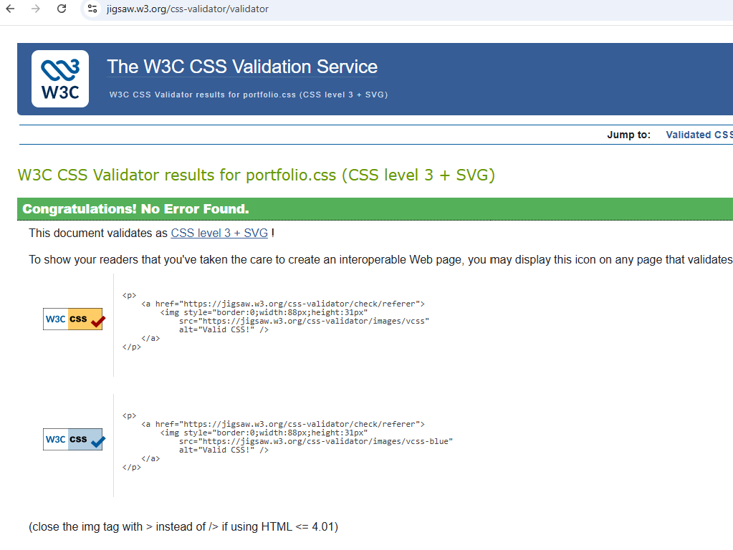

Personal Reflections

All the webpages came to a beautiful theme and working on the CSS file. At first, I added an ivory colour to the entire body and then added olive colours to the header, main-content and footer sections. These colours look similar to a green Kerala themed restaurant website I’ve used as an inspiration - https://www.keralakitchen.com.au/.

There were a lot of requirements for the CSS file, and I had to be very careful in adding each of them. I had to refer https://www.w3schools.com/ and the course textbook Web Programming with HTML, CSS and JavaScript. I understood the differences between type/element, class based and id-based selectors.

I added three different alignments for paragraphs: left, right and centre. I added different styles for the ordered and unordered lists; and added different font-sizes as well.

9. Test

I opened all the 4 HTML pages in Google Chrome and tested all the webpages and links. All the sections in all the webpages were visible and clear.

All the HTML pages have the header, main and footer sections. The inline, internal and external stylesheets work as expected. The images are rendered correctly and in appropriate proportions.

The headers, paragraphs, div, spans, ordered and unordered lists had the correct alignment and styles.

10. References

World Wide Web Consortium. (2014). HTML5: A vocabulary and associated APIs for HTML and XHTML. https://www.w3.org/TR/html5/

W3Schools. (2025). W3Schools online web tutorials; W3schools.com.
W3Schools. https://www.w3schools.com/
World Wide Web Consortium. (2024a). Nu Html Checker. https://validator.w3.org/nu/

World Wide Web Consortium. (2024b). W3C CSS validation service. https://jigsaw.w3.org/css-validator/

DeGuzman, K. (2022, April 24). How to Pre-Visualize a Website Using Storyboards. StudioBinder. https://www.studiobinder.com/blog/storyboard-website-design/
‌

‌

