Download the MongoDB from below link

<https://www.mongodb.com/download-center?jmp=nav>

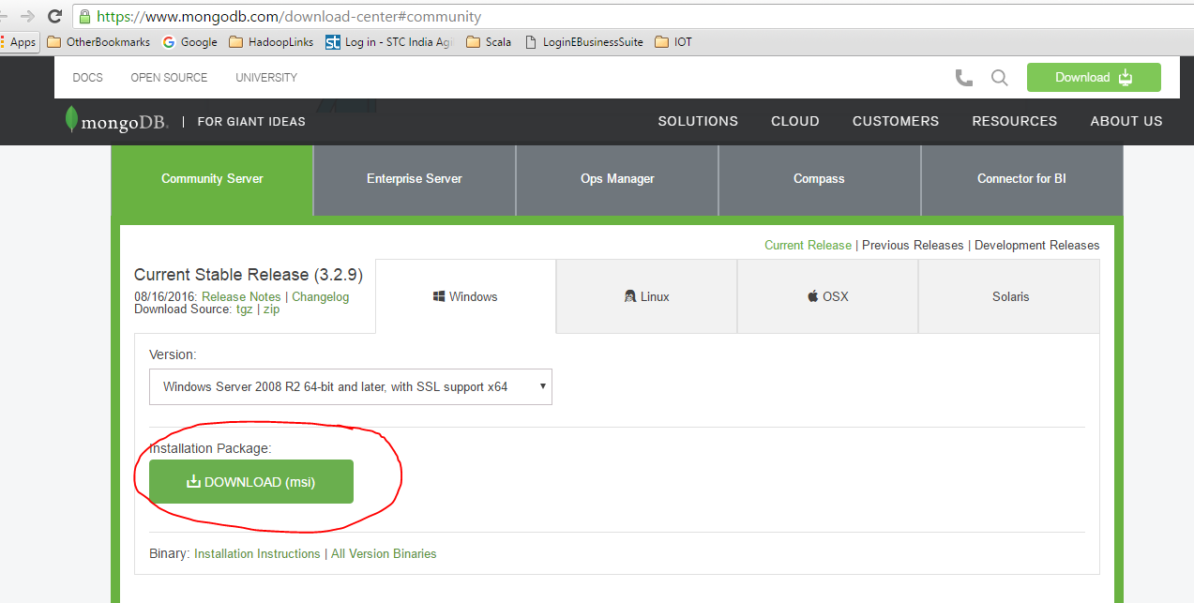

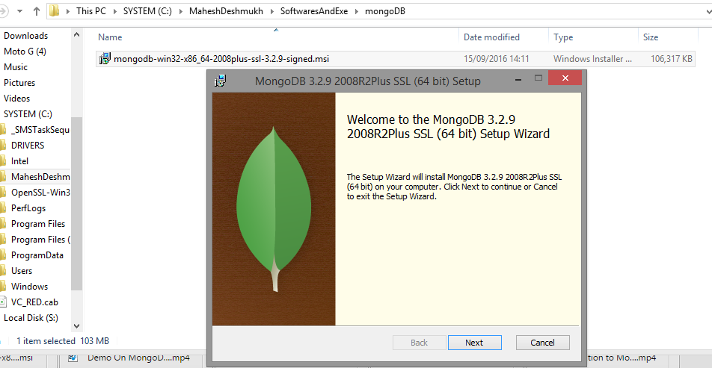

Choose installation type as complete

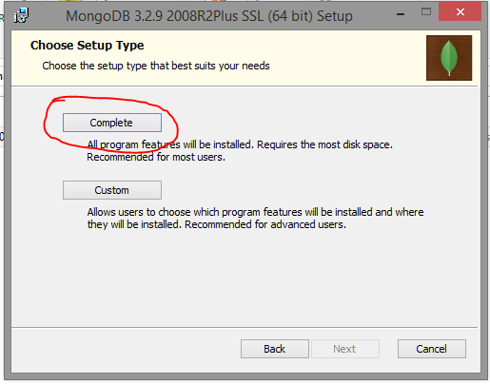

After installation check the directory

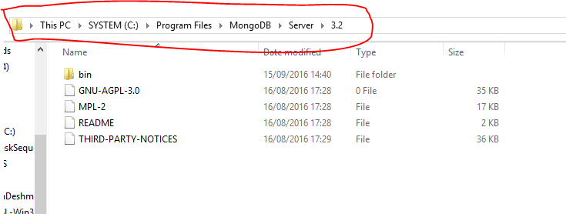

Create configuration file mongo.config

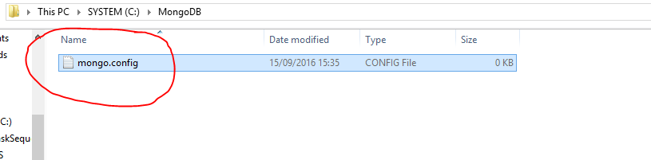

Contents for config file are

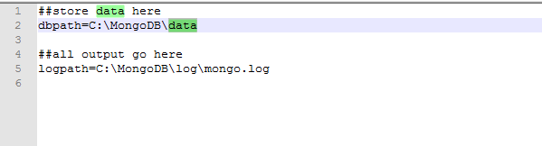

MongoDB need a folder (data directory) to store its data. By default, it will store in “**C:\data\db**“, create this folder manually. MongoDB won’t create it for you. You can also specify an alternate data directory with --**dbpath** option.

**Run MongoDB server**

Use cmd **mongod.exe --config C:\MongoDB\mongo.config** to start MongoDB server.

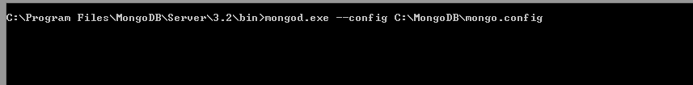

**MongoDB as Windows Service**

Add MongoDB as Windows Service, so that MongoDB will start automatically following each system restart.

Install as Windows Service with **--install**.

Install MongoDB as Windows service on Windows 8, but hit “Access is denied.” error message,

To fix it, run the Command Prompt with Administrative Privileges – right click on the command prompt icon, **select run as administrator**

**mongod --config C:\MongoDB\mongo.config --install**



A Windows service named “**MongoDB**” is created. Right click on it and start the service.

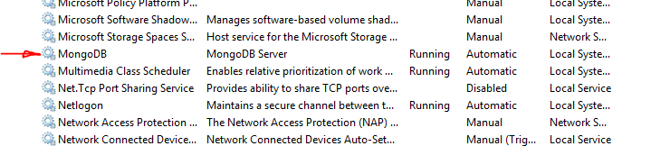

**Connect to MongoDB**

Uses mongo.exe to connect to the started MongoDB server.

Use cmd **mongo**

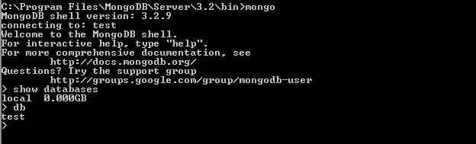

> show tables;

> use vehicles ---------- For creating new database Vehicles

switched to db vehicles

> show tables

> db.createUser({user:"vehicle",pwd:"vehicle",roles:["readWrite","dbAdmin"]}) --- For creating Credantial

Successfully added user: { "user" : "vehicle", "roles" : [ "readWrite", "dbAdmin" ] }

> show databases;

admin 0.000GB

local 0.000GB

vehicles 0.027GB

> use vehicles

switched to db vehicles

> db.vehicles.find();

> show collections

vehiclesData

> db.vehiclesData.find()

{ "_id" : ObjectId("5685ca160cf2fa41c86cbf2d"), "loc" : { "type" : "Point", "coordinates"

psStatus" : "1", "gpsSpeed" : 0, "gpsHeading" : 0, "gpsAltitude" : 14, "gpsSatCount" : 8,

") }

C:\Program Files\MongoDB\Server\3.2\bin>mongoimport --db vehicles --collection vehiclesData --drop --file eventDetailsDump.json

The jason file should be available in "C:\Program Files\MongoDB\Server\3.2\bin>"

TO save Images in fs collection of DB “test” from cmd prompt.

1. Put the images in bin directory of mongo

C:\Program Files\MongoDB\Server\3.6\bin\tm-img-05.jpg

1. mongofiles.exe -d test put -l .\ <Image Name>.<jpg/png> <Image Name> -t image/jpeg

mongofiles.exe -d test put -l .\tm-img-05.jpg tm-img-05 -t image/jpeg



1. to See the file in Db “test”

