As the first step, I selected

* IntelliJ IDEA / JAVA
* Selenium
* TestNG
* Cucumber

to implement the scenarios given due to the following factors.

Widely available tools

JAVA language is ideally most of the developers can grasp quick even who don’t know the language

Selenium is a popular yet open source software which can be used to do the automation. Also the documentation is huge, clear when it comes to an issue or a in the coding.

Cucumber can be used to automate the test script in a way that almost technical and non-technical guys can understand the testing functionality/case.

As a point to start and also maintain the quality of the code and to ease up the future changes in the code, TestNG can be used as a dependency management tool.

My testsuite has 3 basic files for the testing purpose.

Runner file

Feature file and the Step definition file.

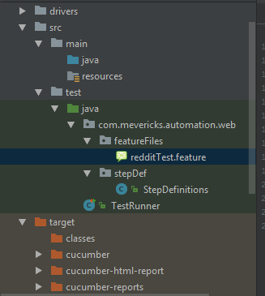

In order to view the test results as a report I have implement the runner file and it will generate set of reports to the /target folder.

Test runner file will execute the test cases or the .feature file can be used to do the automation execution.

