Updates of Linear charger in Dec 2018

Updates of Buck in Dec 2018
- Criteria
- Catalog
Power management >> Stepdown(Buck) >> Integrated switch(IC)
- Vin
Vin_min ≤ 9
Vin_max ≥ 20V
- Vout
Vout_min ≤ 9
Vout_max ≥ 9.5V
- Iout
200mA ≤ Iout ≤ 3A
- Channels
1
- Mode
- Efficiency
η ≥ 90% @ 200mA
η ≥ 80% @ 10mA
η ≥ 50% @ 1mA
- Iq
Iq ≤ 0.1mA
- Features
Enable
Light load efficiency
Synchronous Rectification
Current limiter: 200mA-500mA
- Package
- Price
Price ≤ $1 @1000 pieces
- Comparison

Part No. | Vin | Vout | Iout | η | Iq | I lim | Feature | Pkg | Price
TPS54061 | √ | √ | √ | √ | √ | √ | √
TPS560430 | √ | √ | √ | × | √ | × | √
TPS54202 | √ | √ | √ | √ | √ | × | √
TPS54202H | √ | √ | √ | √ | √ | × | √
TPS56339 | √ | √ | √ | √ | √ | × | √
TPS54335-1A | √ | √ | √ | × | × | × | √
TPS54334 | √ | √ | √ | × | × | × | √
TPS54336A | √ | √ | √ | × | × | × | √
TPS54335A | √ | √ | √ | × | × | × | √
TPS54335-2A | √ | √ | √ | × | × | × | √
TPS54302 | √ | √ | √ | √√ | √ | × | √

Schematics of control circuitry

- PlanI
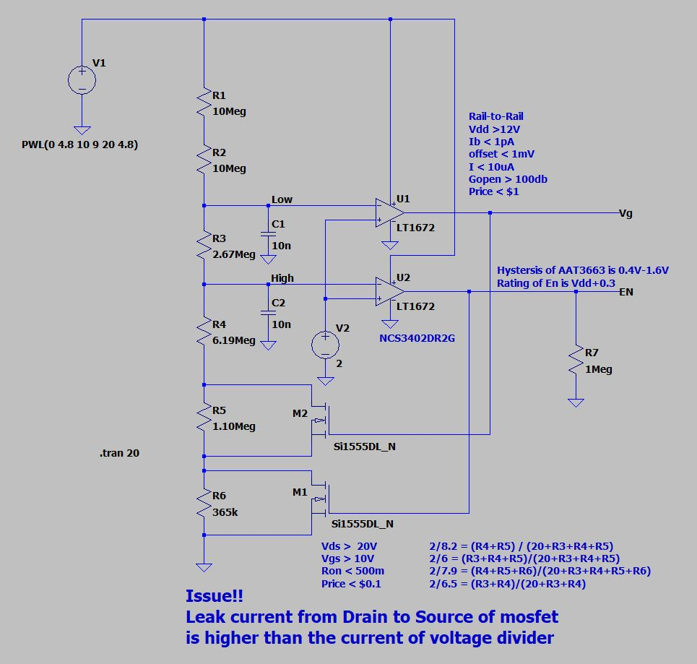
- PlanII
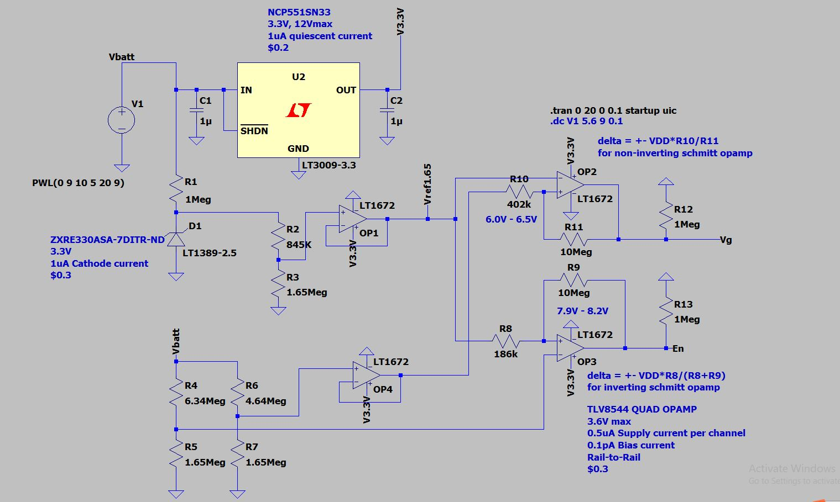

Simulation of control circuitry
- MarcPlan.asc
- MyPlan.asc

Parameter calculation
- PlanI
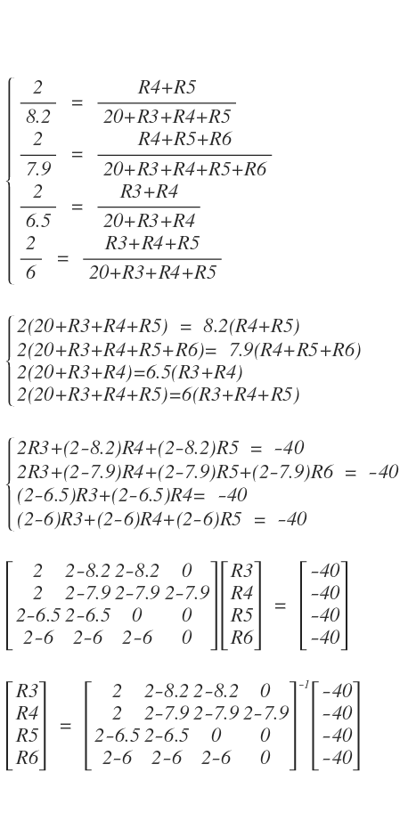

Reference: ResistanceCal.m

- PlanII
- For 7.9-8.2 Schmitt
∆= ± Vbatt * R8 / (R8 + R9)
= ± 8.05V * 186k / (10Meg + 186k)
≈ ± 0.15V
∆= ± Vbatt * R10 / R11
= ± 6.25V *402k / 10Meg
≈ ±0.25V
- For Voltage divider
Vref_u = R5 / (R4+R5) * Vbatt
= 1.65Meg / (1.65Meg + 6.34Meg) * 8.05V
≈ 1.65V
Vref_l = R7 / (R6+R7) * Vbatt
= 1.65Meg / (1.65Meg + 4.64Meg) * 6.25V
≈ 1.65V
- Buck
TPS54061_Cal.ods
- Linear Charger

Test result
- Functional test
Situation: 20mA regular load, switch on/off @ ground line by N-FET,
Schmitt @ 7.9V-8.2V
Schmitt @ 6.0V-6.5V
Alkaline charging:
Solar Panel charging:
- Control Circuitry
- PlanI
Issue: Leakage current from drain to source of N-MOSFET is 1uA typically. It is even higher than the current of voltage divider.
- PlanII
- Schmitt trigger 7.9-8.2
- Schmitt trigger 6.0-6.5
- Current
- Buck
- Functional
200mA shut down:
enable:
UVLO:
f_sw:
duty:
- Vin & Vout
Vin RMS:
Vin ripple:
- Ripple
Vout_ripple @ 100mA:
Vout_ripple @ 10mA:
Vout_ripple @ 1mA:
Iout_ripple @ 100mA:
Iout_ripple @ 10mA
Iout_ripple @ 1mA:
- Efficiency
η @ 100mA:
η @ 10mA:
η @ 1mA:
- Transient load

- f-domain close loop response
- short

- Linear Charger
- functional
- Vin & Vout
- Ripple
- Efficiency
- short

