With high speed PCI V2.1 bus controller and legacy audio SB16® DSPemulator,CMI8738 is designed for PC add-in cards and all-in-one motherboards. No external CODEC is needed in CMI8738: CMI-8738 supports the legacy audio – SB16™, FM emulator/DLS wavetable music synthesis, and HRTF 3D positional audio functions. Above all CMI8738 supports PCtel® HSP56 (1789) interface.
Being compatible with A3D™ and DirectSound™ 3D, CMI8738 meets PC98® requirements, and supports professional digital audio interface such as 24-bit SPDIF IN (0.5V ~ 5V)and OUT(44.1K and 48K format).
CMI8738 uses HRTF 3D extension technology to enhance traditional HRTF 3D positional audio by substituting two-speaker system by four- speaker one(it supports additional 2CH 16-bit DAC to provide rear side audio). It greatly improves HRTF 3D positional audio quality and successfully removes the sweet spot limitations: users can enjoy genuine 3D audio gaming effects, and don't have to worry about the environmental confinement any more.
Being outstanding for its full audio functions, competitive price, and power management, CMI-8738 is the best choice for people seeking for optimum use of the PC applications.
C-Media licensed HRTF 3D library from Central Research Lab (CRL®), U.K, who provides one of the world's best HRTF libraries (CRL® also licensed its audio technology to YAMAHA®, ESS®, and other well-known sound chip makers).

Features
- HRTF-based 3D positional audio, supporting DirectSound™ 3D and A3D™ interface
- Supports rear side speakers, C3DX positional audio in 4 CH speaker mode
- Legacy audio SB16™ compatible
- DLS-based wavetable music synthesizer, supports DirectMusic™
- Professional digital audio interface supporting 24-bit SPDIF IN and OUT (44.1K and 48K format)
- Built-in 32ohm Earphone buffer
- Built-in PCtel® HSP56 Modem™ interface
- Drivers support AC3® 5.1CH interface.
- MPU-401 port
- Dual game port
- 16-bit full duplex CODEC
- 4 CH 16-bit DAC
- 32-bit PCI bus master
- External E²PROM interface
- Single chip design, +5V, 128 pins QFP
Preliminary Ver 0.6
CMI-8738/PCI C3DX
PCI-Based HRTF 3D Extension Positional Audio Chip
PCI interface
PCI interface

DMA engine
IRQ control
emulatorll duplex CODECo,nter.0..
SPDIF IN and OUT
MPU 401 and
GAME port

Music Synthesizer HRTF DSP engine

Earphone buffer
Rear L/R
HSP56 Modem interface
CMI-8738/PCI Block Diagram

PCI BUS

Legacy audio
SB16™emulator
16-bit CODEC
Analog Mixer
PLL and timing circuit

14.318Mhz

3D Surround
LINE OUT

MIC AMP

LINE / CD / AUX / PCPSK IN

MIC IN

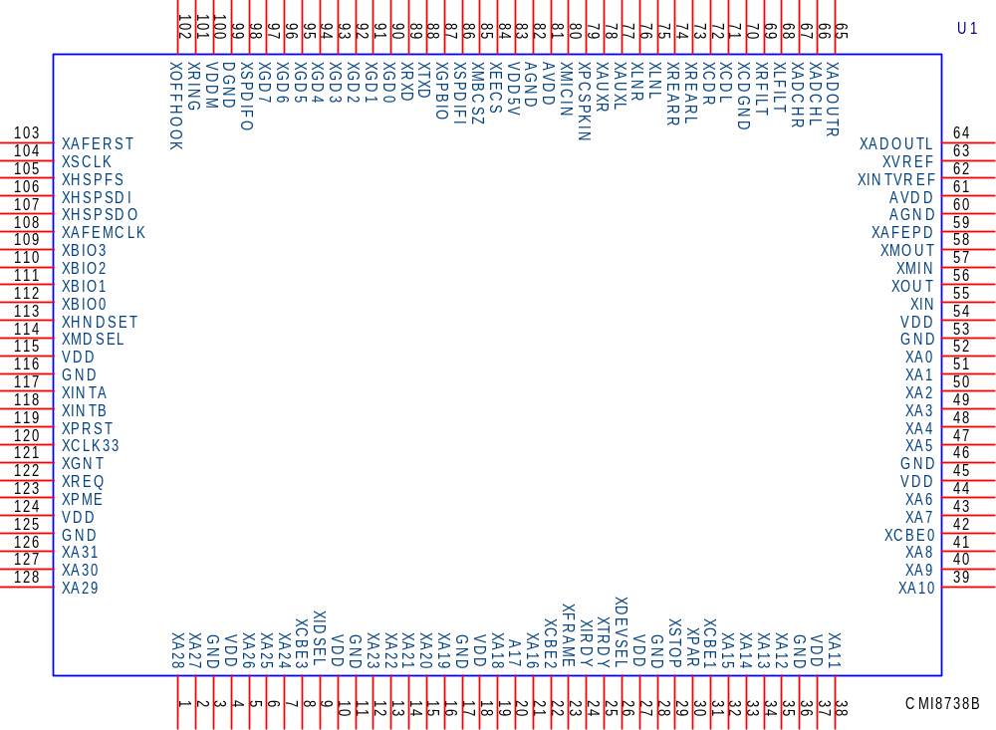

PINOUT
PINOUT
CMI-8738/PCI AUDIO Specification
PINOUT

CMI8738/PCI C3DX AUDIO CHIP
QFP 128 PINS

DIGITAL PIN DESCRIPTION
PIN DESCRIPTION

Name | Number | PIN Type | Definition
XA31-XA0 | 126-128,1-2,5-7,12-16,19-21,32-35,38-41,43-44,47-52 | I/O | PCI bus address and data lines
XINTA | 117 | O | Interrupt request , active-low.
XINTB | 118 | O | Modem Interrupt request,active-low
XPRST | 119 | I | Reset
XCLK33 | 120 | I | PCI bus clock.
XGNT | 121 | I | Bus master grant, active-low.
XREQ | 122 | O | Bus master request, tri-state output, active-low.
XIDSEL | 9 | I | ID select, active-high.
XFRAME | 23 | I/O | Cycle frame, active-low.
XIRDY | 24 | I/O | Initiator ready, active-low. The bus master device is ready to transmit or receive data
XTRDY | 25 | I/O | Target ready, active-low. The target device is ready to transmit or receive data
XDEVSEL | 26 | I/O | Device select, active-low. The target device has decoded the address of the current transaction as its own chip select range.
XSTOP | 29 | I/O | Stop transaction, active-low. The target device request to the master to stop the current transaction.
XPAR | 30 | I/O | Parity. The pin indicates even parity across XA31-XA9 and XCBE3-0 for both address and data phases.
XCBE3,2,1,0 | 8,22,31,42 | I/O | Multiplexed command/byte enable. These pins indicate cycle type during the address phase of a transaction.
VDD | 4,10,18,27,37,45,54,115,124 | +5V | Digital and PCI I/O power pin
GND | 3,11,17,28,36,46,53,116,125 | GND | Digital and PCI I/O ground
XIN | 55 | I | 14.318Mhz crystal, or external clock input
XOUT | 56 | O | 14.318Mhz crystal
XGD7-XGD4 | 97-94 | I | Game port switch input pin.  Switch D to switch A
XGD3-XGD0 | 93-90 | I/O | Game port resistor input pin.  RC3 to RC0
XTXD | 88 | O | MIDI transmit data
XRXD | 89 | I | MIDI receive data
XSPDIFO | 98 | O | 44.1kHZ SPDIF output
XSPDIFI | 86 | I* | 44.1kHZ SPDIF input
XSCL | 104 | O | General purpose output
XBIO3-XBIO0 | 109-112 | I/O | General purpose I/O
VDD5V | 83 | +5V | Digital and PCI I/O power pin
VDDM | 100 | +5V | Digital and PCI I/O power pin
DGND | 99 | GND | Digital and PCI I/O ground
XEECS | 84 | O | EEPROM chip select

PIN DESCRIPTION
ANALOG PIN DESCRIPTION

AVDD | 61,81 | +5V | Analog power
AGND | 60,82 | GND | Analog ground
XADOUTL-R | 64,65 | AO1 | Line out
XADCHL-R | 66,67 | AI/O | ADC filter
XLFILT | 68 | AI/O | Left channel DAC filter
XRFILT | 69 | AI/O | Right channel DAC filter
XVREF | 63 | AI | Reference Voltage
XCDL-R  XCDGND | 71,72,70 | AI | CD audio differential input
XLNL-R | 75,76 | AI | Line in or Rear speaker out
XAUXL-R | 77,78 | AI | Aux. Line in
XPCSPKIN | 79 | AI | PC beep signal
XMICIN | 80 | AI | Microphone in
XREARL-R | 73,74 | AI/O | Rear speaker out
XMDSEL | 114 | I | Modem chip select (high:enable)
XGPBIO | 87 | O | General purpose I/O pin (0=disabled, 1=enabled)
XRING | 101 | I | Ring detection input
XOFFHOOK | 102 | O | Off-hook control output
XAFERST | 103 | O | Reset signal for MODEM DAA
XHSPFS | 105 | O | DAA frame SYNC
XHSPSDI | 106 | I | DAA data input
XHSPSDO | 107 | O | DAA data output
XAFEMCLK | 108 | O | DAA master clock
XHNDSET | 113 | O | Reserved
XAFEPD | 59 | O | Reserved
XMOUT | 58 | O | MODEM crystal output (18.432MHz)
XMIN | 57 | I | MODEM crystal input
XMBCSZ | 85 | I | Audio chip select (low:enable)

POWER ON CONFIGURATION PIN

Name | Number | Definition
XTXD | 88 | When pull-down select add-on mode,  default pull-high motherboard.
XAFEPD | 59 | When pull-down enable #INTB share with #INTA,  default high disabled.
XHNDSET | 113 | When pull-down enable external 18.432Mhz x'tal to HSP module, default pull-high enable internal 24.576Mhz to HSP module.
XBIO0 | 112 | When pull-down select CLKGEN ref. clock to external 24.576Mhz x'tal. default pull-high select 14.318Mhz

ELECTRICAL CHARACTERISTICS

Absolute Maximum Ratings
Ratings | Symbol | Value | Units
Digital power voltage | VDD | VDD±5% | V
Analog power voltage | AVDD | AVDD±5% | V
Operating temperature range | TO | 0 to 70 | °C
Storage temperature range | TST | -40 to 125 | °C
Maximum power dissipation | PDMAX | 300 | MW

Digital Characteristics
PARAMETER | Symbol | Min | Typ | Max | Unit
Input high voltage(PCI I/O) | VIH | 2. |  | VDD+0.5 | V
Input low voltage (PCI I/O) | VIL | -0.5 |  | 0.8 | V
Output high voltage | VOH | 2.4 |  | VDD | V
Output low voltage | VOL | 0.0 | 0.2 | 0.4 | V
SPDIF IN input high voltage | VIH1 |  | 2.6 |  | V
SPDIF IN input low voltage | VIL1 |  | 2.4 |  | V
SPDIF output high voltage | VOH1 |  | VDD |  | V
SPDIF output low voltage | VOL1 |  | VSS |  | V
Output buffer current |  |  | 5 |  | mA

Audio Characteristics
PARAMETER | Symbol | Min | Typ | Max | Unit
Analog input voltage | Avin |  | 1.1 |  | VRms
Analog output voltage | Avout |  | 1.1 |  | VRms
A-A S/N ratio |  |  | 85 |  | db
A-A THD |  |  | 0.09
ADC S/N ratio |  |  | 80 |  | db
ADC THD |  |  | 0.1 | 0.2 | %
DAC S/N ratio |  |  | 80 |  | db
DAC THD |  |  | 0.1 | 0.2 | %
SPDIF IN/OUT S/N ratio |  |  | 120 |  | db
SPDIF IN/OUT THD |  |  | 0 |  | %
Microphone input level |  | 20 |  | 200 | mv
Microphone booster |  |  |  | 20 | db

Application circuit: (for mainboard purpose)
Schematic Circuit
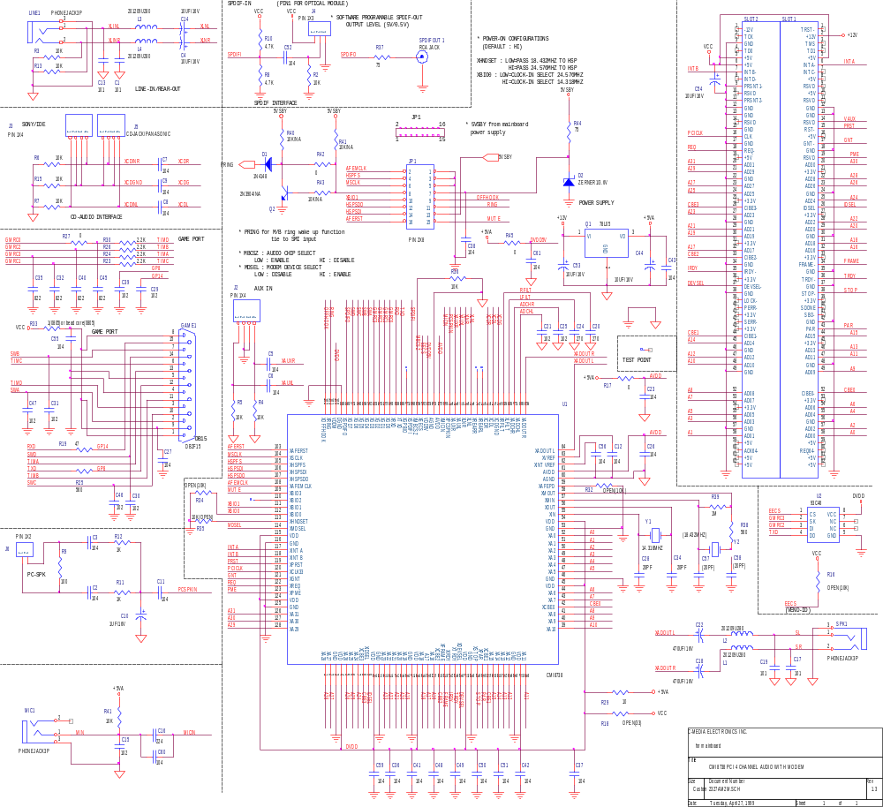

BOM: (for mainboard)
Schematic Circuit
No. | Quantity | Reference | Part
1 | 4 | C1,C13,C17,C19 | 101
2 | 28 | C2,C3,C5,C6,C7,C8,C9,C11, | 104
 |  | C12,C23,C26,C27,C36,C37,
 |  | C38,C41,C42,C43,C48,C49,
 |  | C50,C51,C52,C55,C56,C59,
 |  | C60,C61
3 | 5 | C4,C14,C44,C53,C54 | 10UF/16V
4 | 1 | C10 | 1UF/16V
5 | 9 | C15,C21,C25,C29,C30,C31, | 102
 |  | C39,C46,C47
6 | 1 | C16 | 224
7 | 2 | C18,C22 | 470UF/16V
8 | 2 | C20,C24 | 270
9 | 2 | C28,C34 | 20PF
10 | 4 | C32,C35,C40,C45 | 822
11 | 2 | C57,C58 | (20PF)
12 | 1 | D1 | 1N4148
13 | 1 | D2 | ZERNER1/3.6V
14 | 1 | GAME1 | DB2F15
15 | 2 | J2,J3 | PIN 1X4
16 | 1 | J4 | PIN 1X3
17 | 1 | J5 | CD-JACK/PANASONIC
18 | 1 | J6 | PIN 1X2
19 | 1 | JP1 | PIN 2X8
20 | 4 | L1,L2,L3,L4 | 201209U280
21 | 3 | LINE1,MIC1,SPK1 | PHONEJACK3P
22 | 1 | Q1 | 78L05
23 | 1 | Q2 | 2N3904/NA
24 | 10 | R2,R3,R4,R5,R6,R7,R13, | 10K
 |  | R15,R36,R41
25 | 2 | R8,R10 | 4.7K
26 | 1 | R9 | 100
27 | 2 | R11,R12 | 1K
28 | 2 | R16,R34 | OPEN(10K)
29 | 4 | R17,R27,R42,R45 | 0

No. | Quantity | Reference | Part
30 | 1 | R18 | OPEN(33)
31 | 1 | R19 | 47
32 | 4 | R23,R24,R26,R30 | 2.2K
33 | 2 | R25,R38 | 560
34 | 1 | R29 | 10
35 | 1 | R32 | OPEN(1OK)
36 | 1 | R33 | 1(0805)or bead core(0805)
37 | 1 | R35 | 10K(OPEN)
38 | 2 | R37,R44 | 75
39 | 1 | R39 | 1M
40 | 3 | R40,R41,R43 | 10K/NA
41 | 2 | SLOT1,SLOT2 | ---
42 | 1 | SPDIFOUT1 | RCA JACK
43 | 5 | TP1,TP4,TP5,TP6,TP9 | TEST PIN
44 | 1 | U1 | CMI8738
45 | 1 | U2 | 93C46
46 | 1 | Y1 | 14.318MHZ
47 | 1 | Y2 | (18.432MHZ)

Application circuit: (for add-on card purpose)
Schematic Circuit
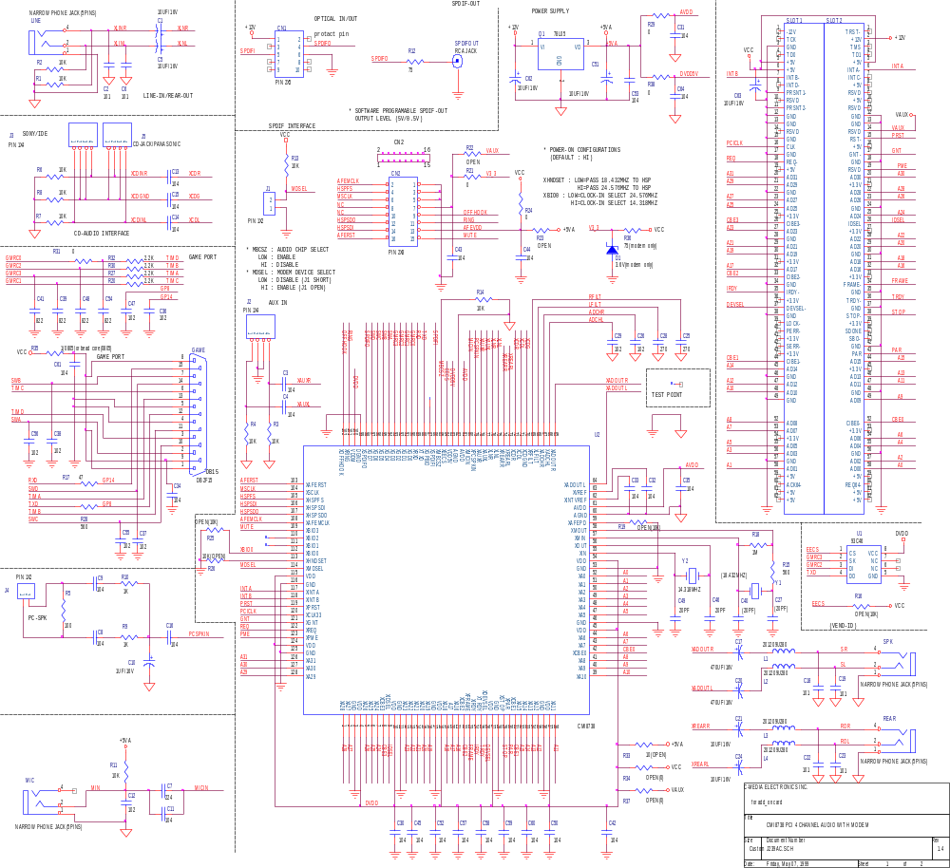

BOM: (for add-on card)
Schematic Circuit
No. | Quantity | Reference | Part
1 | 7 | C1,C5,C21,C24,C51,C62, | 10UF/16V
 |  | C63
2 | 6 | C2,C6,C18,C19,C22,C23 | 101
3 | 28 | C3,C4,C8,C9,C11,C13,C14, | 104
 |  | C15,C16,C30,C31,C32,C33,
 |  | C34,C35,C42,C43,C44,C45,
 |  | C50,C52,C53,C57,C58,C59,
 |  | C60,C61,C64
4 | 1 | C7 | 224
5 | 1 | C10 | 1UF/16V
6 | 9 | C12,C26,C29,C36,C37,C38, | 102
 |  | C47,C55,C56
7 | 2 | C17,C20 | 470UF/16V
8 | 2 | C25,C28 | 270
9 | 2 | C27,C40 | (20PF)
10 | 4 | C39,C41,C48,C54 | 822
11 | 2 | C46,C49 | 20PF
12 | 1 | CN1 | PIN 2X5
13 | 1 | CN2 | PIN 2X8
14 | 1 | D1 | 3.6V(modem only)
15 | 1 | GAME | DB2F15
16 | 2 | J1,J4 | PIN 1X2
17 | 2 | J2,J3 | PIN 1X4
18 | 1 | J5 | CD-JACK/PANASONIC
19 | 4 | L1,L2,L3,L4 | 201209U280
20 | 4 | LINE,MIC,REAR,SPK | 3.5 PHONE JACK
21 | 1 | Q1 | 78L05
22 | 10 | R1,R2,R3,R4,R6,R7,R8,R11 | 10K
 |  | R13,R14
23 | 1 | R5 | 100
24 | 2 | R9,R10 | 1K
25 | 1 | R12 | 75

No. | Quantity | Reference | Part
26 | 2 | R15,R28 | 560
27 | 3 | R16,R19,R25 | OPEN(10K)
28 | 1 | R17 | 47
29 | 1 | R18 | 1M
30 | 4 | R20,R27,R30,R32 | 2.2K
31 | 5 | R21,R24,R29,R31,R38 | 0
32 | 2 | R22,R23 | OPEN
33 | 1 | R26 | 10K(OPEN)
34 | 1 | R33 | 10(OPEN)
35 | 2 | R34,R37 | OPEN(0)
36 | 1 | R35 | 1(0805)or bead core(0805)
37 | 1 | R36 | 75(modem only)
38 | 1 | SLOT1 | PCIC2
39 | 1 | SLOT2 | PCIS2
40 | 1 | SPDIFOUT | RCA JACK
41 | 4 | TP1,TP2,TP3,TP9 | TEST PIN
42 | 1 | U1 | 93C46
43 | 1 | U2 | CMI8738
44 | 1 | Y1 | (18.432MHZ)
45 | 1 | Y2 | 14.318MHZ

Application circuit: (SPDIF optical module)
Schematic Circuit
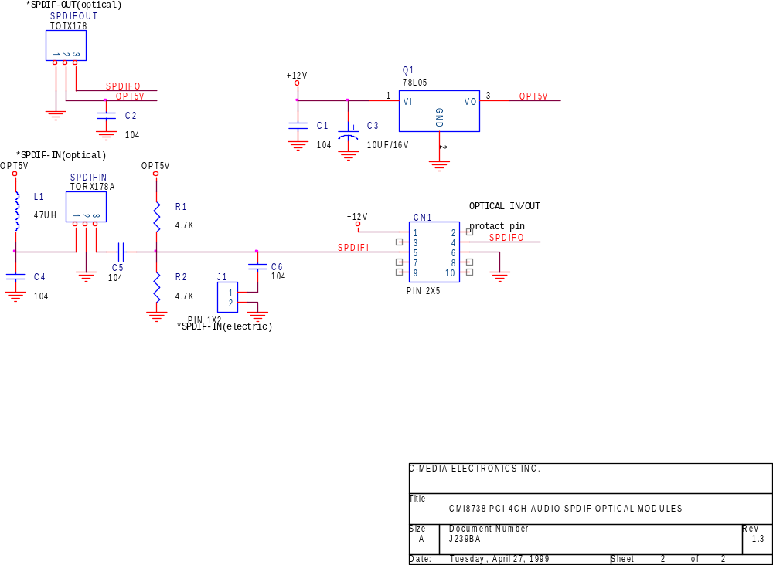

BOM: (for SPDIF optical module)
Schematic Circuit
No. | Quantity | Reference | Part
1 | 5 | C1,C2,C4,C5,C6 | 104
2 | 1 | C3 | 10UF/16V
3 | 1 | CN1 | PIN 2X5
4 | 1 | J1 | PIN 1X2
5 | 1 | L1 | 47UH
6 | 1 | Q1 | 78L05
7 | 2 | R1,R2 | 4.7K
8 | 1 | SPDIFIN | TORX178A
9 | 1 | SPDIFOUT | TOTX178

CMI8738 PCI Configuration Spaces(Audio)
Configuration

00h 13F6 : (Vender ID) read only
02h 0111 : (Device ID) read only
04h 0006 : Command (State after #RST all is “0”)
0 (bit 9) Fast back-to-back enable
0 (bit 8) #SERR enable (R/W)
0 (bit 7) Wait cycle control
0 (bit 6) Parity error response
0 (bit 5) VGA palette snoop
0 (bit 4) Memory write and invalidate enable
0 (bit 3) Special cycles
1 (bit 2) Bus master (R/W)
0 (bit 1) Memory space
1 (bit 0) I/O space (R/W)
06h 0280 : Status
0 (bit 15) Detected Parity Error
0 (bit 14) Signaled System Error
0 (bit 13) Received Master Abort
0 (bit 12) Received Target Abort
0 (bit 11) Signaled Target Abort
01 (bits 10-9) DEVSEL timing 00-fast, 01-medium, 10-slow
0 (bit 8) Data Parity Error Detected
1 (bit 7) Fast Back-to-Back Capable
0 (bit 6) UDF Supported
0 (bit 5) 0-33MHz ,1-66MHZ Capable
00000 (bits 4-0) Reserved
08h 10 : Revision ID
09h 040100 : Audio device
0Ch 00 : Cache Line Size
0Dh 20 : Latency Timer
0Eh 80 : Header Type
0Fh 00 : BIST

10h 0000d401 : I/O of length : -65280(ffff0100h) : First Base Address register
14h 00000000 : Uninitialized : Second Base Address register
18h 00000000 : Uninitialized : Third Base Address register
Configuration
1Ch 00000000 : Uninitialized : Fourth Base Address register
20h 00000000 : Uninitialized : Fifth Base Address register
24h 00000000 : Uninitialized : Sixth Base Address register
28h 00000000 : Cardbus CIS Pointer
2Ch 13f6 : (SubSystem Vender ID) (R/W)
2Eh ffff : SubSystem ID (R/W)
30h 00000000 : Expansion ROM Base Address
34h 00000000 : Reserved
38h 00000000 : Reserved
3Ch 05 : Interrupt Line
3Dh 01 : Interrupt Pin
3Eh 02 : Min Grant
3Fh 18 : Max Latency

CMI8738 Configuration Spaces(Modem)
00h 13F6: (Vender ID) read only
02h 0211: (Device ID) read only
04h Command (State after #RST all is "0")
0 (bit 9) Fast back-to-back enable (read only)
0 (bit 8) #SERR enable (Read only)
0 (bit 7) Wait cycle control (read only)
0 (bit 6) Parity error response (read only)
0 (bit 5) VGA palette snoop (read only)
0 (bit 4) Memory write and invalidate enable (read only)
0 (bit 3) Special cycles (read only)
0 (bit 2) Bus master (read only)
1 (bit 1) Memory space (R/W)
0 (bit 0) I/O space (read only)
06h Status
B0 (bit 15) Detected Parity Error
B0 (bit 14) Signaled System Error

B0 (bit 13) Received Master Abort
B0 (bit 12) Received Target Abort
B0 (bit 11) Signaled Target Abort
B01 (bits 10-9) DEVSEL timing 00-fast, 01-medium, 10-slow
B0 (bit 8) Data parity Error Detected
B0 (bit 7) Fast Back-to-Back Capable
B0 (bit 6) UDF Supported
B0 (bit 5) 0-33MHz, 1-66MHz Capable
B00000 (bits 4-0) Reserved
08h X10: Revision ID
09h X078000: Communication device (Modem)
0Ch X00: Cache Line Size
0Dh X00: latency Timer
oEh X80: Header Type (Multifunction device)
oFh X00: BIST
10h Xbbbbb000: Allocate 4K memory space.
14h X00000000: not used - Second Base Address register
18h X00000000: not used - Third Base Address register
1Ch X00000000: not used- Four Base Address register
20h X00000000: not used- Fifth Base Address register
24h X00000000: not used- Sixth Base Address register
28h X00000000: Card bus CIS Pointer
2Ch X13f6: Sub-System Vender ID (Value can be replaced after reset.) (R/W)
2Eh X0211: Sub-System ID (Value can be replaced after reset) (R/W)
*Refer to the Audio PCI registers bit-13 of address (18-1B) for how to replace.30h X00000000: Expansion ROM Base Address
34h X00000040: pointer to the power-saving registers. (Read only)
38h X00000000: Reserved
3Ch X00: Interrupt Line (R/W)
3Dh Interrupt Pin(X01 share interrupt/X02 not share interrupt with Audio)
*Select from the power on pin configuration
3Eh X00: Min Grant(not used)
3Fh X00: max Latency(not used)
40h XEC4A0001(read only)

44h-47h
B0-B1: PMST (R/W) (11)
B7-B2: all 0 (read only)
B8: PMEEN (R/W) (Sticky bit)
B12-B9: DSEL (R/W) 0000
B14-B13: all 0 (read only)
B15: PMESTS (Sticky bit)

DMA Slave Configuration Register(R/W) PCI Configuration address 40H
Configuration
Bit(s) Function
31:16 Reserved
15:4 Slave Base Address 15-4. INTEL VX chipset seleted if Base Address 15:4=000h
3 Non legacy Extended Addressing
- = disabled
- = enabled
2:1 Transfer Size
00 = 8 bit transfer
- = 16 bit transfer
- = 32 bit transfer, non legacy
- = Reserved
- Channel Enable
- = disabled
- = enabled

Internal Register Mapping

Function Control Register 0
Address 00H
Bit(s) R/W Name Description

31:20 Reserved.
19 RST_CH1 Channel1, 1->Reset (Default 0)
18 RST_CH0 Channel0, 1->Reset (Default 0)
17 CHEN1 Channel1, 1->Enabled, 0->Disabled.
16 CHEN0 Channel0, 1->Enabled, 0->Disabled.
15-2 Reserved
3 PAUSE1 Channel1, 1->Pause if channel1 is enabled.
2 PAUSE0 Channel0, 1->Pause if channel0 is enabled.
1 CHADC1 Channel 1 , 1->Recording, 0->Playback
0 CHADC0 Channel 0, 1->Recording, 0->Playback

Function Control Register 1
Address 04H
Bit(s) R/W Name Description
31-16 Reserved
15:13 DSFC[2:0] DAC Sampling Frequency Select,
0 0 0 5.512 K
0 0 1 11.025 K
0 1 0 22.05 K
0 1 1 44.1 K
1 0 0 8 K
1 0 1 16 K
1 1 0 32 K
1 1 1 48 K
12:10 ASFC[2:0] ADC Sampling Frequency Select,
0 0 0 5.512 K
0 0 1 11.025 K
0 1 0 22.05 K
0 1 1 44.1 K
1 0 0 8 K
1 0 1 16 K
1 1 0 32 K
1 1 1 48 K
9 SPDF_1 SPDIF IN/OUT at Channel B at 44.1K double-words/sec.
8 SPDF_0 SPDIF OUT only at Channel A at 44.1K double-words/sec.
7 SPDFLOOP external SPDIF/IN loopback to external SPDIF/OUT .
6 SPDO2DAC SPDIF/OUT can be heard from internal DAC.
5 INTRM Interrupt Mask bit for MCB (Master control block) module interrupt.
0 MCB interrupt disabled.
1 MCB interrupt enabled.
4 BREQ If this bit is set low it will prevent the MCB and DAC/ADC block from accessing the memory.
0 Bus Master request disabled(power on state)
1 Bus Master request enabled.
3 VOICE_EN This bit enables Legacy Voice device(SB16,FM).
0 Legacy Voice disabled on channel 0.
1 Legacy Voice enabled on channel 0.
2 UART_EN This bit enables Legacy UART device.
0 UART disabled
1 UART enabled
1 JYSTK_EN This bit enables Legacy Joystick device.
0 Joystick disabled
1 Joystick enabled
0 Reserved

Channel Format Register
Address 08H
Bit(s) R/W Name Description
31:16 Reserved
15-14 AdcBitLen[1:0] Sample resolution
- 16 Bits per sample . (Default)
- 15 Bits per sample.
- 14 Bits per sample.
- 13 Bits per sample.
13-12 AdcDacLen[1:0] Sample resolution
- 600nSec per bit in a sample.
- 660nSec per bit in a sample.
- 1.3uSec per bit in a sample. (Default)
- 2.8uSec per bit in a sample.
11 CH1 Ssmple Rate 176K
10 CH1 Sample Rate 88K
9 CH0 Sample Rate 176K
8 CH0 Sample Rate 88K
7:4 reserved
3:2 CH1FMT[1:0] Data format of channel 1
00 8 bit Mono mode
01 8 bit Stereo mode
10 16 bit Mono mode
11 16 bit Stereo mode
1:0 CH0FMT[1:0] Data format of channel0
00 8 bit Mono mode
01 8 bit Stereo mode
10 16bit Mono mode
11 16 bit Stereo mode

Interrupt Hold/Clear Register
Address 0CH
Bit(s) R/W Name Description
31:19 Reserved
18 TDMA_INT_EN Interrupt hold/clear bits for updating TDMA position
- Interruupt Clear
- Interrupt Hold if exist.
17 CH1_INT_EN Interrupt hold/clear bits for the Channel 1.
- Interrupt Clear
- Interrupt Hold if exist.
16 CH0_INT_EN Interrupt hold/clear bits for the Channel 0.
0 Interrupt Clear
1 Interrupt Hold if exist.
15:0 Reserved

Interrupt Register
Address 10H
Bit(s) R/W Name Description
31 R INTR Interrupt reflected from any sources.
- No interrupt
- Interrupt pending
30:28 Reserved
27 R VCO
26 R MCBint Abort conditions occur during PCI Bus Target/Master Access.
0 No interrupt
- Interrupt pending
25:17 Reserved
16 R UARTint This bit is the UART interrupt bit.
- No UART interrupt
- UART interrupt pending
15: R LTDMAINT Interrupt for updating Low Channel TDMA position.
- No interrupt
1 Interrupt pending
14 R HTDMAINT Interrupt for updation High Channel TDMA position.
- No interrupt.
1 Interrupt pending.
13:8 Reserved
7 R XDO46 Direct programming EEPROM interface , read data register
6 R LHBTOG High/Low status from DMA CTRL register.
5 R LegHDMA Legacy is in High DMA channel.
4 R LegStereo Legacy is in Stereo mode.
3 R Ch1Busy Channel B Busy.
2 R Ch0Busy Channel A Busy.
1 R Chint1 Channel B Interrupt.
- No interrupt
- Interrupt pending
0 R Chint0 Channel A Interrupt.
0 No interrupt
1 Interrupt pending

Legacy Control/Status Register
Address 14H
Bit(s) R/W Name Description
31 Reserved
30:29 VMPU [1:0] Base address for MPU401 access
- Base address : 330h
- Base address : 320h
10 Base address : 310h
11 Base address : 300h

- Reserved
27:26 VSBSEL[1:0] The Base Address Select for SB16 access.
- Base address: 220h
- Base address: 240h
- Base address: 260h
- Base address: 280h
25:24 FMSEL[1:0] The Base Address Select for FM access.
- Base address : 388h
- Base address : 3C8h
- Base address : 3E0h
- Base address : 3E8h
- ENSPDOUT enable XSPDIF/OUT to I/O Interface
- SPDCOPYRHT SPDIF IN/OUT CopyRight status bit
- DAC2SPDO enable Wave+FM+MIDI to SPDIF/OUT interface
20 SetRetry Mode of wait state . 0:legacy I/O wait (default) 1:legacy I/O BUS retry
- C_EEACCESS Direct programming EEPROM interface Registers.
- C_EECS
- C_EEDI46
- C_EECK46
15-0 Reserved

Micellaneous Control Register
Address 18H
Bit(s) R/W Name Description
31 PWD Power Down Mode enabled..
30 RESET Reset Bus Master/DSP Engine.
29:28 SFIL[1:0] Four level of filter control at the front end DAC..
27 TX/VX Which motherboard to work with
- VX chip sets.
- TX chip sets.
26 N4SPK3D
25 SPDO5V
24 W / SPDIF48K ; R / SPATUS48K ;
23 ENDBDAC Default low, High will enable Double DAC structure.
22 XCHGDAC Default low,
0 CH0 > Front SPKR, CH1 > Back SPKR.
1 CH0 > Back SPKR, CH1 > Front SPKR.
21 SPD32SEL when high, support 32bits SPDIF format ,low 16bits
20 SPDFLOOPI internal SPDIF/OUT loopback to internal SPDIF/IN, for loopback testing
19 FM_EN Legacy FM enabled.
18 Reserved
17 Reserved
16 VIDWPDSB Sub ID write protect disabled. (default 0)
15 SPDF_AC97 0: SPDIF/OUT 44.1K 1:SPDIF/OUT 48K(share with AC97 transfer)
14 MASK_EN Activate channel mask on Legacy DMA.
- Disabled
- Enabled
13 VIDWPDSB Write Protect of HSP Configuration Sub ID.
- Protect.
- No protect.
12 SFILENB Let software contrl filter stepping at the front end DAC.
11-9 Mmode[2:0] Modem DAA interface mode selection,default 000
000 Modem in Local DAA interface mode
001 Modem in AC97_LINK mode
010 Modem in parallel CM_LINK mode (external modem bridge supported)
1XX Modem in serial CM_LINK mode (external modem bridge supported)
8 Reserved
7 FLINKON force Link detection on when in CM_LINK mode,default 0
6 FLINKOFF force Link detection off when in CM_LINK mode,default 0
5 Reserved
4 MIDSMP Enable 1/2 interpolation at the Front end DAC..
3:2 UPDDMA[1:0] For every the number of samples to notify updating TDMA position.
- Every 2048 samples
- Every 1024 samples
- Every 512 samples.
- Every 256 samples.
1:0 TWAIT[1:0] For controling the length of legacy BUS cycle.
- 3 PCICLK.
- 18 PCICLK.
- 24 PCICLK
- 32 PCICLK
* Notice REQ_SQ[2:0] States of BusRequest Engine.
MM_DATA Bus Master is using Bus.
MIDLE Bus Master is not using Bus.
REQA/REQB Channel 0/1 BusMaster Request.
GNTA/GNTB Channel 0/1 BusMaster Grant.
ADRQ/BDRQ Channel 0/1 DMA Request.
ADACK/BDACK Channel 0/1 DMA Acknoledge.
AIRQ/BIRQ Channel 0/1 Interrupt.
CX/BX Channel 0/1 Busy.

Mixer Control / Device Configure Register (can be accessed only by BYTE instruction)
Address 20H
Bit(s) R/W Name Description
7:0 W SBVR[7:0] Programmable SB16 version No.
R DEV[7:0] Hardwire device version No.

Address 21H
Bit(s) R/W Name Description
7 Reserved
6 Reserved
5:4 Reserved
3 Reserved
2 X_ADPCM SB16 ADPCM enable,default disabled.
1 PROINV SBPro Left/Right channel switching.
0 X_SB16 Indicate device active as SB16 compatible, default SB16

Address 22H
Bit(s) R/W Name Description
7:0 IDXdata Mapping SB16 mixer INDEX register data port(A2x5h)

Address 23H
Bit(s) R/W Name Description
7:0 IDXaddr Mapping SB16 mixer INDEX register address port(A2x4h)

Address 24H
Bit(s) R/W Name Description
7 Fmmute Mute FM
6 Wsmute Mute Wave stream
5 SPK4 select four speaker mode(emulate Line in to Line out )
4 Rear2front exchange rear and front channels’s speaker out
3 Waveinl Digital Wave recording Left channel
2 Waveinr Digital Wave recording Right channel
1 X3DEN 3D surround enable.
0 Cdplay SPDIF/IN PCM to DAC enable

Address 25H
Bit(s) R/W Name Description
7 RAUXREN Recording source select R-Aux
6 RAUXLEN Recording source select L_Aux
5 VAUXRM R-AUX mute control
4 VAUXLM L-AUX mute control
3:1 VADMIC[2:0] Recording MIC volume control
0 MICGAINZ MIC gain control,default high

Address 26H
Bit(s) R/W Name Description
7:4 VAUXL[3:0] L-AUX volume control
3:0 VAUXR[3:0] R-AUX volume control

Address 27H
Bit(s) R/W Name Description
0 DMAUTO SB16 Low/High DMA Auto detect enabled ,When high.
1 SPDVALID SPDIF/IN valid bit detect enabled, When high.
2 XGPBIO general purpose bi-direction pin, when high output tri-state
3 Reserved
4 Reserved
5 XGPO1 general purpose output pin 1,this pin shared with XSPDIFO pin, and enabled when index reg. F0_bit 0 programmed high.
6:7 Reserved

Mup401 PCI Port
Index address 40-4FH
FM PCI Port
Index address 50-5FH

Legacy SB16 mixer
Index | D7 | D6 | D5 | D4 | D3 | D2 | D1 | D0
0x00 | Reserved
0x04 | Wave volume left channel |  |  |  | Wave volume right channel
0x0A |  |  |  |  |  | Mic volume
0x22 | Master volume left channel |  |  |  | Master volume right channel
0x26 | FM volume left channel |  |  |  | FM volume right channel
0x28 | Analog-CD volume left channel |  |  |  | Analog-CD volume right channel
0x2E | Line-in volume left channel |  |  |  | Line-in volume right channel
0x30 | Reserved
0x31 | Reserved
0x32 | Reserved
0x33 | Reserved
0x34 | Reserved
0x35 | Reserved
0x36 | Reserved
0x37 | Reserved
0x38 | Reserved
0x39 | Reserved
0x3A | Reserved
0x3B | PC spk volume
0x3C |  |  |  | Output muting controls
0x3C |  |  |  | Line L | Line R | CD L | CD R | Mic
0x3D |  | Recording left channel controls
0x3D |  | FM L | FM R | Line L | Line R | CD L | CD R | Mic
0x3E |  | Recording right channel controls
0x3E |  | FM L | FM R | Line L | Line R | CD L | CD R | Mic
0x3F | Reserved
0x40 | Reserved
0x41 | Reserved
0x42 | Reserved
0x43 | Reserved
0x44 | Reserved
0x45 | Reserved
0x46 | Reserved
0x47 | Reserved
0x80 |  |  |  |  | IRQ channel (read only)
0x80 |  |  |  |  | IRQ10 | IRQ7 | IRQ5 | IRQ2(9)
0x81 | 16 bit DMA channel (read only) |  |  |  | 8 bit DMA channel (read only)
0x81 | DMA 7 |  | DMA 5 |  | DMA 3 |  | DMA 1 | DMA 0
0x82 |  |  |  |  |  | Interrupt status (read only)
0x82 |  |  |  |  |  | MPU-401 | 16bit DMA | 8bit DMA
* Please do not write any values into reserved registers

CMI8738 SPDIF IN/OUT Test Report
SPDIF Test Report
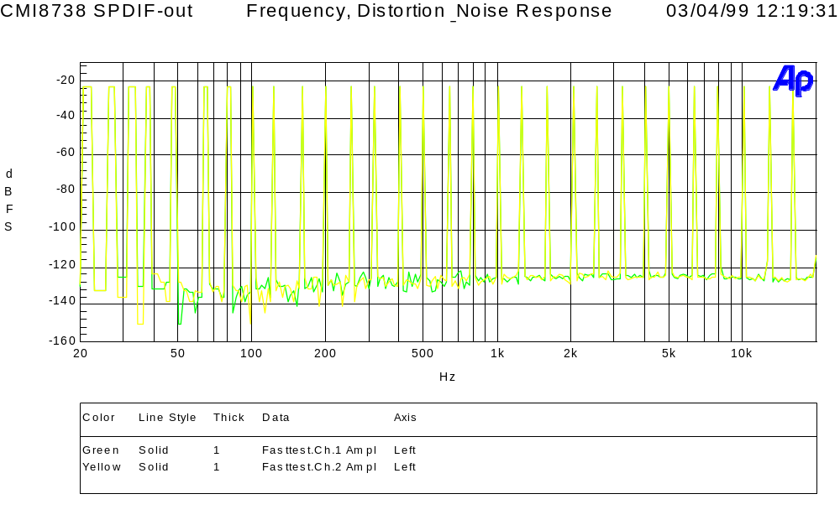

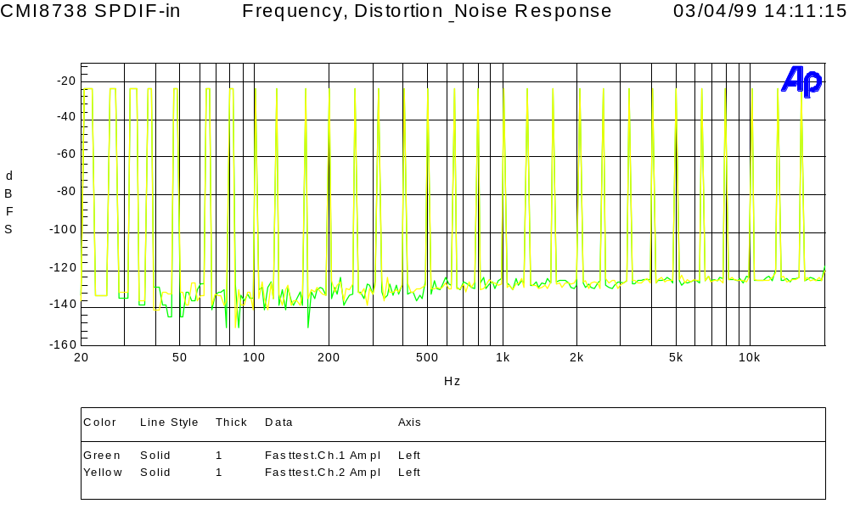

SPDIF Test Report
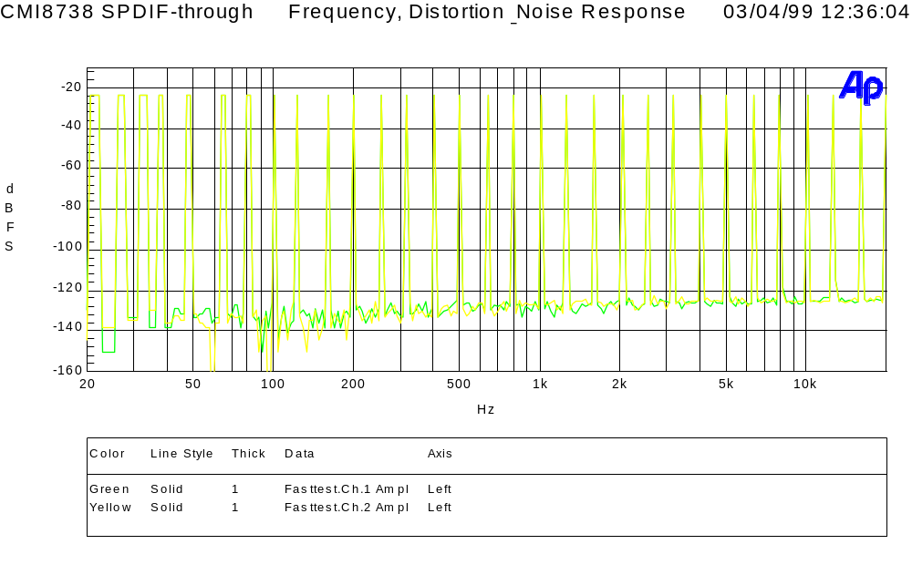

- SPDIF OUT (playback) > 120db
- SPDIF IN (recording ) > 120db
- SPDIF through mode (bypass) > 120db

* This report is generated by Audio Precision® System II using multi-tone mode.
- Stereo
It is only one-dimensional, as sounds come from (left /right) the physical location of speakers.
Audio Processing Technology

- Surround (Stereo Expander )
It filters the existing stereo signal to make the sounds fill in the area around the speakers, and in front of the listener. Sound sources appear to come from outside the physical locations of the speakers.

- Multi-Speaker Surround (Dolby Pro Logic or Digital AC-3)
It uses five speakers instead of two to surround the listener; hence, sound sources come from five directions and create engaging audio experience. This surround sound effect, however, has to be pre-recorded, and it dose not support interactive environment.

- HRTF 3D Positional 3D (C-Media 3D)
Only this sound processing technology can be called real 3D manifestation, as 3D usually refers to the three dimensions of X, Y and Z. This technology allows people to pin-point the location of sound in the real world (up/down, left/right, front/back)using only two speakers or a pair of headphones. This technology also supports interactive 3D applications to get a real-time placement of sounds via API (application programming interface) such as Microsoft DirectSound3DTM. We can also use this technology to simulate Multi-speaker Surround with two physical speakers to deliver five “virtual" speakers in the air, surrounding the listener and creating home theater sound environment. This is the most economical and the easiest solution to people who would like to get high performance surround sound but don’t want to spend money in adding extra speakers.
Audio Processing Technology
A virtual speaker
A physical speaker

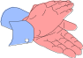







- HRTF 3D Extension Positional (C-Media 3DX)
Audio Processing Technology
3D illusion exists because traditional 3D positional audio system assumes the user's position as the sweet spot to design crosstalk-cancellation circuit; therefore, if the user wants to have 3D positional audio effects, he can’t move his head or position out of sweet spot. Another 3D illusion fails because half the population are compulsive "head-turners" who will never get 3D audio from two speakers . To remedy this, C-Media utilizes HRTF 3D extension technology (C3DX) to enhance traditional HRTF 3D positional audio by substituting two-speaker system by four-speaker one. Therefore, at least one or two speakers should be placed behind the listener's head to complement the rear-side effect, thus creating compelling realistic sound. This technology greatly improves HRTF 3D positional audio quality, and successfully eliminates the sweet spot limitation. Users can enjoy the real 3D audio gaming effects, and don't have to worry about the environmental confinement any more.

A virtual
speaker
A physical speaker

HRTF 3D Positional Audio Technology White-Paper
C3D HRTF Positional Audio Technology

C3D technology uses an audio filter called Head Related Transfer Functions (HRTFs), which is licensed from CRL®(Central Research Lab). The basic concept of C3D is: since we can hear sound three dimensionally in the real world using our two ears, it must be possible to regenerate the same sound effect from two loud speakers.

What is HRTF ?

HRTF (Head Related Transfer Functions) is a set of audio filters which can vary locations of sound effects (spatial hearing cues) in three-dimension measured from the listener's eardrum.
People can use this technology and special digital signal processing to re-create spatial hearing cues, so as to makes the ears hear a realistic and three-dimensional sounds coming from a pairs of loud speakers or headphones.

There are several listening cues which allow people to hear sounds three-dimensionally :

(I). Spatial Hearing : Primary 3D-cues

1. IAD
The head shadowing effect creates differences in the amplitudes of the sound signals arriving at each ear from the source. The effects of diffraction are most noticeable in the range between about 700 Hz to 8 KHz, where the A and S functions periodically converge and diverge gently. This Inter-aural Amplitude difference (IAD) is one of the primary 3D sound cues.

HRTF 3D Positional Audio Technology White-Paper

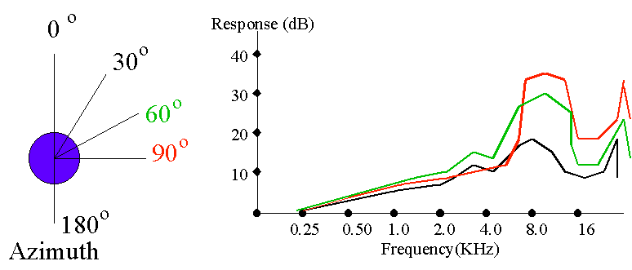

2. ITD
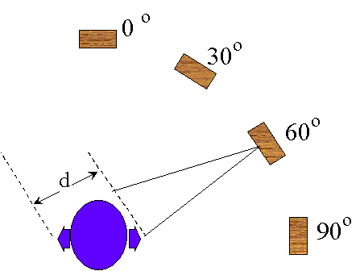
In addition to IAD, there is also a time-of-arrival difference between the left and right ears(unless the sound source is in one of the pole positions, such as directly in front, behind, above and below): this is known as the Inter-aural Time Delay (ITD).

3. Pinna Effects
HRTF 3D Positional Audio Technology White-Paper
It has been presumed by several researchers that the convolutions of the pinna create the spectral features which constitute the 'height' cues. In practical experiments by Gardner, in which different parts of the pinna were occluded, and then the ability of a number of subjects to identify sound source positions at different heights was tested, it was shown that the different features all contributed by different amounts. For example, if the fossa is excluded, then height localization capability is impaired, but not totally extinguished. It would be reasonable to conclude that it is the combined effect of the pinna convolutions which create the various localization cues, and it is not valid - or logical - to attempt to assign particular spatial capabilities with individual physical features.
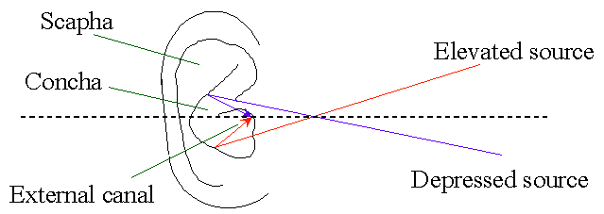

(II). Spatial Hearing : Secondary 3D-cues (shoulder & local reflections)

In addition to the 'primary' 3D sound cues (IAD, ITD and pinna effects), there are several additional cues which do contribute to the localization capability; these will be referred to here as 'secondary' cues, and include shoulder/torso reflections, local room reflections, and psychological cues.

1. Shoulder / Torso reflections
The presence of a torso attached to an artificial head has the effect of increasing the pressure in the vicinity of the ear up to frequencies of around 2 kHz. The effect is greater for frontal sources than lateral ones. In experience, the presence of the torso does not appear to contribute much to spatial accuracy. However, shoulders are located very close to the ears, and their effect is greater, this time, in respect of
HRTF 3D Positional Audio Technology White-Paper
lateral sounds. If one listens to an artificial head first without - and then with - shoulder fitments, then it is clear that the shoulders do contribute to spatial effects in certain positions. The shoulders provide a strong reflection from lateral sources, with a short path-length of around 10 cm between direct sound and reflection. The effects are most important for side-positioned sources, especially for "height" effects, where the shoulders tend to mask sources which move below about 30 degree depression.

- Local, Room Reflections

In simulations, it is clear that the incorporation of first-order simulated room reflections can help in the creation of sound images which have a "solid" nature. However, the effects - if accurately simulated - are relatively slight. Experience has shown that it is primarily the quality of the HRTFs themselves which determine the quality and solidity of the sound image. The further addition of second-order reflections does not help significantly, because in reality, there is a great number of reflections in the average room. A method which does help to recreate the acoustic experience of a room, however, is to use approximate simulations of lateral reverb, using either 2 or 4 laterally placed "virtual" sources at, say, +-70 degrees and 80 degrees azimuth.
- The quality of the sound image relates to the HRTFs used.
- The quality of the room image relates to addition of reflections and reverb.

3. Psychological Cues

There are clearly psychological cues present in everyday life which work together with the audio cues to tell us about the world around us. For example, if you hear the sound of a helicopter flying, you expect it to be up in the air, and not downwards. If a dog is barking nearby, you would expect it to be downwards.

How to listen to C3D sound correctly and properly?
HRTF 3D Positional Audio Technology White-Paper

1. Use Headphones to Have Much Better Effect

When you use headphones in listening, there will be less interference such as outside voices or room reflections comparing to using speakers.

2. Choose Correct Output Devices

Choose the correct output devices in the options of demo program in accordance with what listening devices you want to listen to. Listening through speakers must be proceeded by crosstalk-cancellation, so if you choose the wrong output devices, there won’t be any 3D positional audio effect.
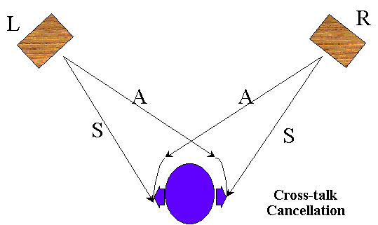

3. Position of Speakers
HRTF 3D Positional Audio Technology White-Paper

If you listen from speakers, please do not reverse the left and right speakers, which should be put in equal distance from the listener. That is, the listener, the left, and the right speaker must be in the topmost of a right triangle. The position of the listener is called the “sweet spot”. In addition, the height of the listener’s ears must be equal to that of the speakers.
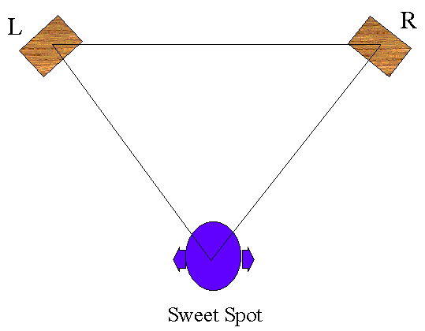

4. Turn Surround Sound Functions off

When the surround sound effect is enabled, it will cause confusion with C3D sound, and make positional sound effect invalid.

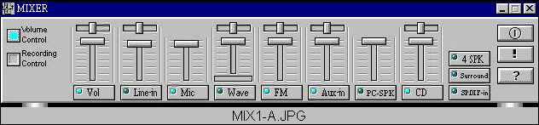
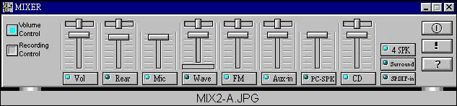
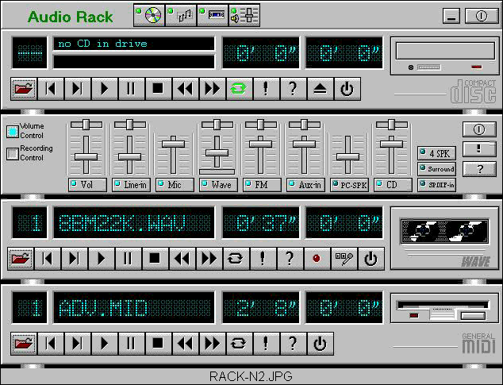
Audio Rack Panel
Two Speakers System :
Four Speakers System :
4 Speakers system Enable
Line-In becomes
Rear Speakers Output
Audio Rack Panel

CMI8738 PCI Audio Adapter Layout Notes

- The wires of analog circuits(chip pin64-80) must be wider than 12mil.
- Placing digital signals such as SPDIF IN/OUT(pin86, 98) and TXD/RXD(pin88,89) near the analog signals should be avoided. However, if these signals have to be adjacent, please place ground between these digital and analog signal wires to isolate noises.
- The whole PCB grounding should be well-organized(The ground must be placed as much as possible. Also, the ground of both the component and the solder sides should be drilled as much as possible.).
- The grounding under CMI8738 should be well-organized as mentioned above.
- The regulator(78L05) must be placed near the chip as much as possible.
- The chip and the circuits need independent power supply regulators to prevent insufficient currents.

