# Abstract

Increasing rate of people who needs transfusion and donation of blood, could possibly be aided by the technology is about to happen. Perhaps, every day, community is facing abundant amount of people who are searching for a donor of a blood that will certainly matches with the type of their lifeblood. Since it deals with the essential data and information of the person, old methods and process should be modernized and improved for it to be efficient and effective. With the use of technological implementation of an android application for blood donor finder, using the new technologies. A collection of data and extraction of information from the end-users will be introduced. The goal is to increase and improve the methods and processes through the help of the crowd sharing information. The study has anticipated and offered the aid, speed and efficiency of the current method and slow process in finding and searching for a donor of a blood. By implementing this method, RedFlow: a Blood Donor Matching and Screening application could possibly help those people who are in need and in searching for this kind of system. It is expected that the proposed system will improve the current process and old methods in searching for a matched blood donor.

**Table of Contents**

**Abstract i**

**List of Figures iv**

**List of Tables v**

**CHAPTER 1 1**

**INTRODUCTION 1**

**1.1 Rationale of the Study 1**

**1.2 Statement of the problem 2**

**1.2.1 General Objective 2**

**1.2.2 Specific Objectives 2**

**1.3 Significance of the Study 3**

**1.4 Scope and Limitation 4**

**Chapter 2 5**

**RELATED SYSTEMS 5**

**Chapter 3 12**

**Technical Background 12**

**CHAPTER 4 16**

**Design and Methodology 16**

**4.1 Conceptual Framework 16**

**4.2 Analysis and Design 18**

**4.2.1 Flow Chart 18**

**4.2.2 Use Case Tools 19**

**4.2.3 Data Flow Diagram 22**

**4.3 Development Model 23**

**4.3.1 Initial Planning 23**

**4.3.2 Define Requirements 23**

**4.3.3 Analysis and Design 24**

**4.3.4 Implementation 24**

**4.3.5 Test and Evaluation 24**

**4.3.6 Deployment 25**

**4.4 Development Approach 26**

**4.5 Software Development Tools 27**

**4.7 Responsibility 29**

**4.8 Budget and Management Cost 31**

**4.9 Verification, Validation and Testing 32**

**References 33**

**Curriculum Vitae 46**

# List of Figures

**Figure 4.1 Conceptual Framework 17**

**Figure 4.2 Sequence Diagram 18**

**Figure 4.3 Use Case Tools 21**

**Figure 4.4 Data Flow Diagram 22**

**Figure 4.5 Incremental and Iterative Model 25**

**Figure 4.6 Top down Approach 26**

**Figure 4.7 Schedule and Timeline 28**

**Figure 4.8 Alpha Beta Test 32**

# List of Tables

**Table 4-1 Use case tools 20**

**Table 4-2 Software Development Tools 27**

**Table 4-3 Table of Responsibility 29**

**Table 4-4 Table Budget for Project Proposal Documentation Making 31**

**Table 4 5 Table Computed cost for the system based on technical requirements. 31**

**Table 4-6 Table Computed cost for the utility costs. 31**

# CHAPTER 1

# INTRODUCTION

## **1.1 Rationale of the Study**

Blood is a vital but often scarce resource in some developing countries. Searching for a blood donor for your love ones inflict huge emotional, physical and financial impact on family and community members (Osuntogun et al, 2009). Finding a blood donor involves inquiring in blood banks, radio announcement and television announcement. Those methods are very costly and energy consuming. But it does not mean it is not effective or it must be stop. Nowadays, social networking sites are also used in finding for a blood donors. However there are many irrelevant information that are present in a social networking site making the users distracted and reducing the credibility of the informations.

The “wisdom of crowds” can help address broad accessibility problems (Sato et al., 2010). And one of every four people use the internet and the number of user is increasing rapidly. RedFlow: an android application for Blood Donor Matching & Screening exploits the techniques of a social networking site. It is an application or system where all the posts are about blood donors who wants to donate, and a post that finds a blood donor. The wall will display all the post depends on the filter you choose like, show all post, show only the compatible blood, and location based filter.

With the advancement of technology, it will efficiently improve the creation of application to ease and hasten the dissemination of information for finding a blood donor that is compatible with the finder. The goal of the study is to develop a system that could easily disseminate the information about the blood donation scenery, accessible through mobile application.

## **1.2 Statement of the problem**

### **1.2.1 General Objective**

The main objective of the study is to develop a Blood Donor Matching & Screening Application for searching a blood donor with the collaboration of blood service facilities.

### **1.2.2 Specific Objectives**

At the end of the study the proponents specifically aim to:

1. Design an algorithm for matching and preliminary screening for blood donors.
2. Design and develop a blood donor matching and screening application.
3. Test and evaluate the application.

## **1.3 Significance of the Study**

This study will provide improvements on the process flow and methods. Therefore, the research on a system for finding a blood donor will benefit the following:

**Blood Donor**

The application will increase the happiness of the donor by helping save lives of others and will fulfill their desire to donate a blood and help a finder to save time and effort.

**Medical patients**

The application will help the medical patients by receiving a blood that is forfeited by the finders, or a blood bags that are not claimed by the finders will automatically go to a certain matched medical patients.

**Medical Institutions**

The application will help lose the loads of staffs. Because the application automates some processes, like taking of preliminary test in the application which tends to give a result for a certain user if he or she is a qualified donor. And it also widens their scope of searching if ever there is a patient that needs a blood bag with a certain blood type. Also they can earn money from the blood bags that are not claimed by the users of this app.

**Philippine Red Cross**

The application will help Philippine Red cross to add a scope to the current process on how people donate blood to this facility. By also improving the speed of the process because this app will conduct a preliminary test to a certain donor before they can donate. Which tends to help the donor to save time.

**Blood Centers**

The application will help the blood centers by helping this facilities to improve their profiling, and will also give another option for the people who goes to blood centers and inquire for a blood bag or blood donor.

## **1.4 Scope and Limitation**

This research will develop: an Android application that will help people find a blood donor with the right blood type. An android application that dramatically improves searching of donors by efficiently disseminating information to the users. The scope of the study is for those who are in search of blood donors. The study covers on providing details of the blood donor finder and those who wants to donate a blood. The system is also partnered to a blood service facility, which tends to help the system to filter users if the user is healthy enough to donate a blood.

Also it has a web service which is a web based application where the admin can monitor some data statistics like what Blood type that are frequently searched in a certain location, monthly transaction statistics, age and gender that are frequently donating blood, age and gender that frequently needs a blood donation. Also the system can track the donated blood if it is already given to the person who needs it, it will notify the donor via SMS notification.

The system only runs on android and needs internet connection to work. It only disseminates information therefore the developers are not held liable for any risk the user will encounter (e.g. frame-up, scam, and prank). The system also not held liable for a blood donor finder to pay the donor.

# Chapter 2

# RELATED SYSTEMS

This chapter provides discussion on studies and references related to Blood donor finder application. It is the intention of this research to develop an online system of the said application.

**Data Analytics**

According to Shiming Zhang et. at(2014); The capability to gain useful knowledge from such big data is thus crucial to the success of today’s organizations. The goal of this system to do online, real-time analytics over large temporal data, such as call logs from mobile network operator. The OceanRT(pronounced "ocean art") uses a high end computing architecture and a new storage scheme for implementing analytics in real-time over temporal data. On the computing architecture side, OceanRT dwells in multiple interconnected commodity servers from which they use Zookeeper. On the storage scheme side, OceanRT can process data from a relational DBMS,HDFS, andHBase. This system focuses on big data and trying to improve its performance thru complex computing methods.

Xuan Liu, Meiyu Lu, Beng Chin Ooi, Yanyan Shen, Sai Wu and Meihui Zhang (August, 2012) showed collective intelligence helps solve many computationally difficult tasks, thereby improving the quality of output and users’ experience. Their study introduced the quality-sensitive answering model and is divided into two different sub-models, the prediction model and the verification model. The process is like Yahoo! Answers, where you ask a question then the public will answer it and the most voted one is possibly the right answer. Their study however uses a crowdsourcing engine that will accumulate all the answers and the correct one will be determined based on the probability estimation. The system they are proposing depends on the crowd who respond to the question which can hassle people.

**Design of a blood flow system**

Osuntogun et al, (2009) blood is a vital but often scarce resource in some developing countries. He also stated in the article, it is vital that a safe blood is made accessible for the transfusions in hospitals and clinic to avoid the spread of transfusion-transmitted infections such as HIV, Hepatitis and Syphilis. And they also tried to predict the collection and usage for upcoming time period and find an allocated assignment for blood distribution that is fair and efficient.

The researchers believe that the said application can help save lives, and the approach could also be used and adopted to other kinds and forms of situations and other events that involves the searching for a donor that matched with the specified blood type that is needed by the finder.

And according to Bekhor et al. (2015) Smartphones are highly dominant, even in 3rd world countries, and are also likely to become even more common in the future. They can often endure to function even throughout a power outage. People usually carry their smartphones, or keep them close, also they are available in times of emergency. The author has opened the eyes of the researchers that the planned proposed system best fits as an application for mobile due to its their mobility and utility.

**Social Accessibility through collaboration**

According to Sato et al, (2010) one out of every four people use the internet and the number of users is increasingly rapidly. People nowadays tends to connect and augment their lives on the applications and web services available in today’s generation. And also The Wisdom of crowds can help address comprehensive availability problems. Which opened the eyes of the researchers that data and information that could be possibly extracted from the public is very important and essential to the process of the said proposed system by the researchers.

According to Shahla F. Ali (2016). The mounting use of crowd source technology such as crowd charting and resource tracking being generally accessible, collaboratively design, and subject to continuing progress and responsive to on-the-ground needs redirects in many respects to the emerging needs of people in this generation. The researchers also tried to look at the possible probabilities that will arise in the future with the collaborative of social accessibility thing.

**JWS: A flexible web service**

And the researchers also considered the concept and use of web service, According to Cho et al, (2008) web services have been proposed as means to provide more convenient access to computation services. The researchers also realized that when deciding to deploy a new web service it necessitates expertise in related technologies as well as access to a web services server.

And according to the information gathered by the researchers web service is any piece and a fragment of a software that tends to make itself accessible all over the web and uses a consistent XML messaging system. Also XML translates all the communications to a web services.

**Social and mobile interaction design to increase the loyalty rates of young blood donors**

Foth et al,(2013) young adults represent the largest group of first time donors to the Australian red cross blood service. now a days a lot of young people use the internet and various forms of social media everyday. Web or mobile based technology, this changesa the way that young people interact with one another. The researchers realized that the study seeks the identification of best practices of employing mobile application.

Pearson, et al. (2012); The US National Library of Medicine has developed a web-based system called, People Locator. It allows family members to search for missing individual. It is a web site which photos and personal information for missing or found people can be posted by any person who can access the site. People who lost someone can visit the site and search for their loved ones.

Parsons, et al. (2015); During natural disasters, social networks such as twitter are often used for disseminating and gathering information. It has been widely used since the domination of smartphones. However, as the social networks grow so are the number of information posted on them. Variety of information are posted every single day. Over time, people learned to negate information that are not of their interests. It eroded the potential of social networks as a tool for disaster management. According to the authors, disaster management involves handling, organizing and controlling the events and activities in preparation and response to disasters. A disaster can be defined as a singular, large scale, high impact extreme event. Microblogging and social networking sites are usually used in an event of a natural disaster to share and gather information in real-time.

Sizov, Sergej (2012); For many Web 2.0 applications and platforms, multimodal understanding of shared content is an important success factor. By combining text features (such as tags and any other text labels) with spatial knowledge (such as geotags, coordinates of images, and videos), improves characterization of social media. To construct better algorithms for content management, retrieval, and event detection, the author developed a model-based framework called GeoFolk. It combines text features management systems in disaster relief tasks such as disaster data collection and analysis

**Related Systems**

**Blood Donor Application**

This application is made by the American Red Cross. The smartphone application can find nearby Red Cross blood drives, schedule appointments, earn rewards from the premier retailers, etc. It also gets geo-targeted blood shortage alert that lets you know if your blood type is needed in your area. It lets you earn unique badges to proudly share your achievements via social media, text, or email whether you’re a first-timer or a gallon donor.

**BloodDonor.me**

The Blooddonor.me mobile App made by Global Shapers Chandigarh aims to connect a blood donor and receiver and facilitate the process of blood donation to save precious lives in crisis situations. Blood is in perennial short supply. 60% of the population can donate blood but only 4% do so and there is a perpetual shortfall of blood donors. By using this Blood Donor Mobile App, you can register a blood donation request and get suitable blood donors. This Blood Donor app aims to bridge the gap between blood donors and recipients and help them in saving previous lives using this App.

**Indian Blood Donors**

Once they give you a Donors Name and Number we do not give the same Donors Name and Number to anyone else for the next 90 days. So do not do a search unless you need a donor. If you do test search the donor will be wasted and the patient who really need the blood might not get one. Your number will is sent to the donor once you do a search. The donor will call you if you are not able to reach him. The will be displaying the blood donors name and contact number when you do a search. Once you talk to the donor, select the correct feedback given by the donors through the drop down menu. This will not only help us serve you and other patients in a better way but will save this information for your reference in the donors you contacted section.

**Robi Blood Finder**

Robi Blood Finder app is made in such a way, that wherever you are - in town or at a village, it will help you to donate blood at your nearest places. You call people and search for blood donors. Its quite a time consuming process. Its a blood bank which is providing you the list of people willing to donate blood. A solution in your of time of need. Go to Google Play Store, download this app and register yourself to avail the facility. It is a great spirit, a desire to be accountable to our community, by helping others with some taps on your mobile screen.

**Comparative Analysis**

Table 2 1 Comparative Analysis

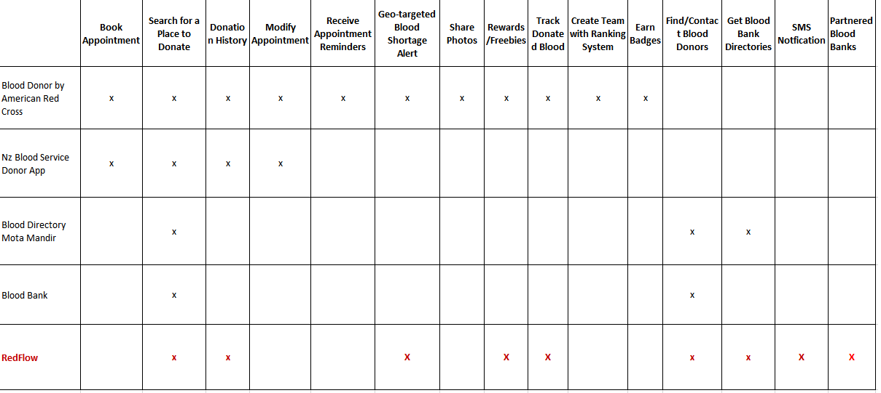

# Chapter 3

# Technical Background

**Mobile Computing System**

According to Jing et al, (1999) the mobile industry continues to scale rapidly, with a total of 3.6 billion unique mobile subscribers at the end of 2014. Half of the world’s population now has a mobile subscription—up from just one in five 10 years ago. An additional one billion subscribers are predicted by 2020, taking the global penetration rate to approximately 60%. There were 7.1 billion global SIM connections at the end of 2014, and a further 243 million machine-to-machine (M2M) connections (GSMA, 2015). A mobile computing system allow users who convey portable devices to have access to information services through common infrastructure, regardless of their physical location. Basing on those statements above the researchers decided to implement and develop their system into this platform.

**Health**

Health, it is not just about a healthy body but also a sound mental health. According to Bidisha Mukherjee (2016) you should take good care of your health. This will make you feel more energetic and will help you carry out both simple as well as strenuous task without pushing yourself too hard. Since the proposed system involves blood which is the source of life health is very important aspect in the part of research to formulate this sytem

**Android Operating System**

According to Nguyen Huu Hoang (2016) Android, The modern operating system for mobiles, with the availability and millions of its apps, tends to become an important party of Human lives. It is the most used mobile operating system in this generation. Android is a mobile operating system developed by Google designed primarily for touchscreen mobile devices such as smartphones and tablets. The Android OS for mobile offers developers the opportunity to create innovative experiences via features such as multitasking, mobile mash-up, and access to hardware and system-level functions.

**Blood donation**

Since the system involves with this very important life source called Blood, the researchers aims to research more about this, according to Torpy et al, (2008) someone needs blood on an average of every 2 seconds, every year, more than 4.5 million patients needs blood transfusion in the United States and Canada. Blood donation is very important and essential in our community now adays.

**Android Software Development Kit (SDK)**

The Android SDK allows mobile software developers the chance to tamper with the platform and generate new and stimulating work. The kit covers all you need to start structured apps. The Android SDK also comes with an emulated virtual device that is fully functional to let you test out your work (Zapata, 2013). The Android SDK is a pre-requisite to acquire Android Studio.

**Android Device**

Android device a phone or table is a mobile computer with a touchscreen display, circuitry, has a smart features, equipped with sensors, including cameras, a microphone, and an accelerometer, and the touchscreen display uses the recognition of finger or stylus gestures replacing the usage of the mouse and keyboard. Android devices are highly customizable and can be changed to outfit your needs; with wallpapers, and customizable launchers which completely change the look of your device's interface (Todd & Barraclough, 2016). Together with the Android Studio, these would be the essential requirements in order to do testing.

**Web Service**

Web service uses an XML to encode all communications to a web service. And a user must invoke the web service by sending an XML message then wait for a corresponding XML response. According to Ma et al, (2007) that web service discovery is one of challenging issues in service oriented computing.

**Client-Server Architecture**

Since other users will access the content from remote places, there is a need for an architecture to provide resource or service to these machines. A client-server architecture is an answer to this problem which is a distributed application structure that partitions task to workloads between the providers of a resource or service, called servers, and users that will access or use this resource called clients. In other words, client is the one who request for a food and the server is the cook. Hemmendinger et al. (1998); “A client application is a process or program that sends messages to a server via the network. The server process or program listens for client requests that are transmitted via web browser over a network developed”

**Firebase**

The firebase realtime database is a cloud-hosted database. It allows data to be stored and synchronized in realtime to every connected client. According to Ben Drucker (2015) firebase is a great tool for speeding up the time it takes to build realtime application. Also firebase allows all the client to share one realtime database instance and will also automatically receive updates with the newest data that is stored in the firebase.

# CHAPTER 4

# Design and Methodology

## **4.1 Conceptual Framework**

By implementing a mobile system for blood donor finder, the operations will significantly reduce the inconvenience brought by the old system. The illustration below shows an insight in an actual circumstance and process flow upon interacting with this mobile app system. The user starts his request by inputting required blood type, province and number of needed blood bags. The server stores the request and sends a list of users with matching blood type and province. The system notifies the donor through in-app and SMS. The donor will then take the preliminary screening in the app. The system interprets the result after the donor is done answering. If the donor got a 50 percent and above rate, the system prompts him if he wants to continue donating. Donor proceeds to partnered blood service facility in order to donate blood. Partnered blood service facility checks the condition of the donor. If donor successfully donates blood, the blood service facility ask the donor’s name and input to the system together with the quantity of blood donated by the donor. The blood service facility administrator submits the record to the server. The server will then notify the finder that there are now blood supply. The finder claims the donated blood from the facility. Donor receives notification that the blood he donated was used.

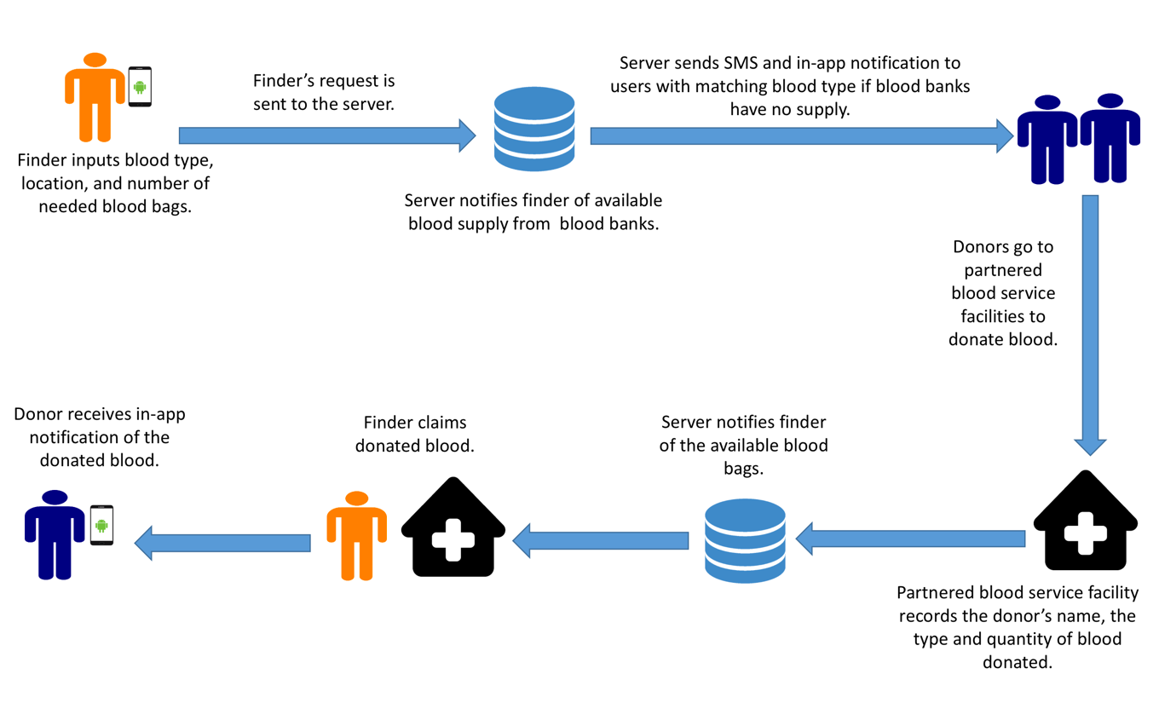

**Figure 4.1 Conceptual Framework**

The current method of finding a blood donor is by going to a blood bank and pay for a bag of a blood and sometimes the specified blood type is not available in the blood bank, which burdens the finder. And another way is asking help to the people by stating that they need a blood with this kind of type. And also by posting in social media hoping for a kind hearted people to help. And after successfully finding a blood, will then transfuse the blood to the person who needs it. Basically it is all about collecting data from public.

## **4.2 Analysis and Design**

### **4.2.1 Flow Chart**

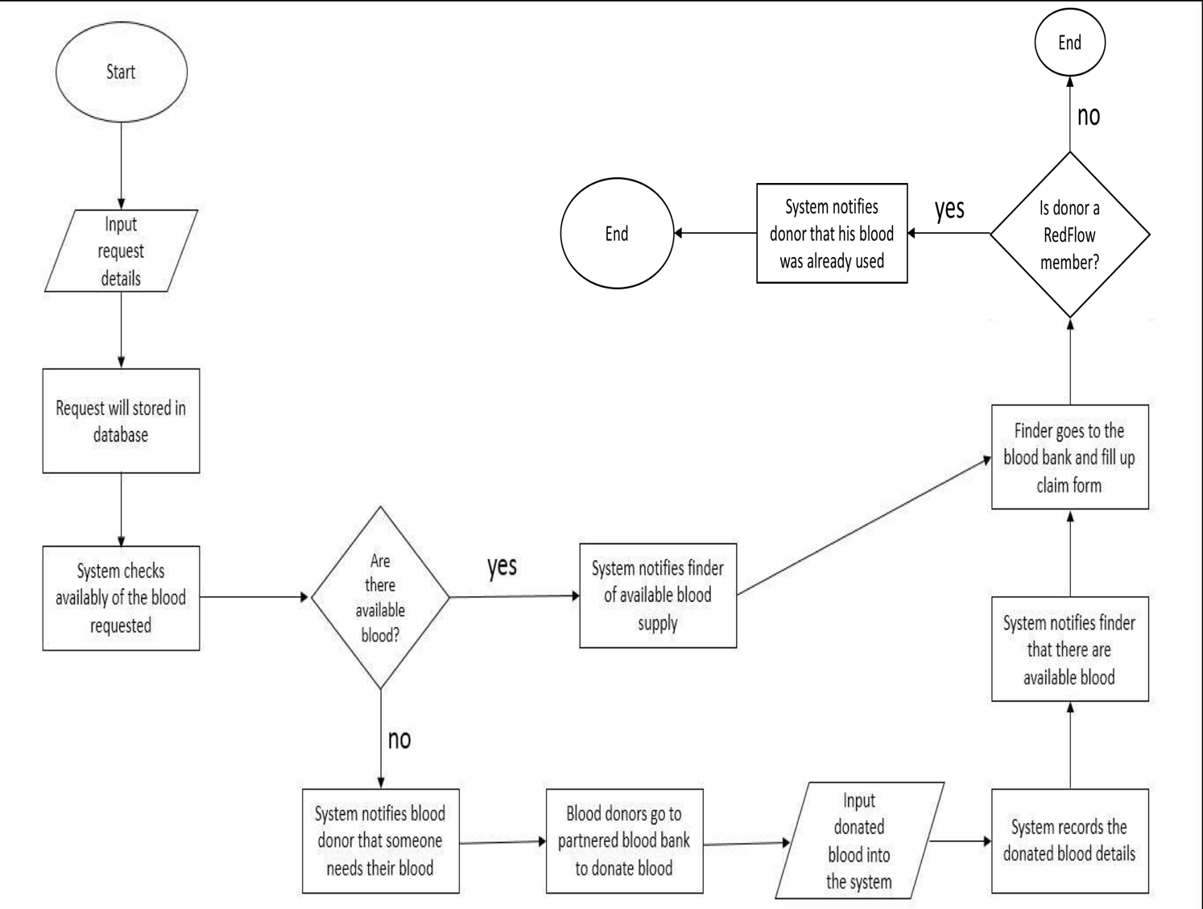

### 

**Figure 4.2 Flow Chart**

### **4.2.2 Use Case Tools**

In order to create a relevant use case for the system, the following actors have been identified:

**Administrator –** A type of user whose job involves helping to organize and supervise the application. Also this user type has the complete access of the system.

**End-user –** A type of user who can write or create a post, this type of user can also view the posts of other users.

1. **Donor –** A type of end-user that can utilize most of the functionalities.
2. **Standard –** A type of end-user that cannot donate.

**Blood Service Admin –** A type of user who is from a blood service client that will manage the transaction between the parties, blood donor and finder.

|  |  |  |
| --- | --- | --- |
| **Actor** | **User Case** | **Description** |
| Admin | Maintenance | The admin has the ability in maintaining the system. |
| Admin/Blood service facility admin | Data Analytics | The admin will be able to view some statistical result of data. |
| Member | Deactivate Account | The members will be able to deactivate his/her account. |
| Member | Post blood donation request | The members will be able to edit or post details of the blood donation request. |
| Member | Choose Blood Donor | Member has the ability to choose a blood donor and ask blood to a certain donor. |
| Blood service facility admin | Manage Transaction | This user has ability to manage the blood donation process both parties |
| Admin/Member | Edit profile | Member has the ability to edit or update their profile. |

Table 4-1 Use case tools

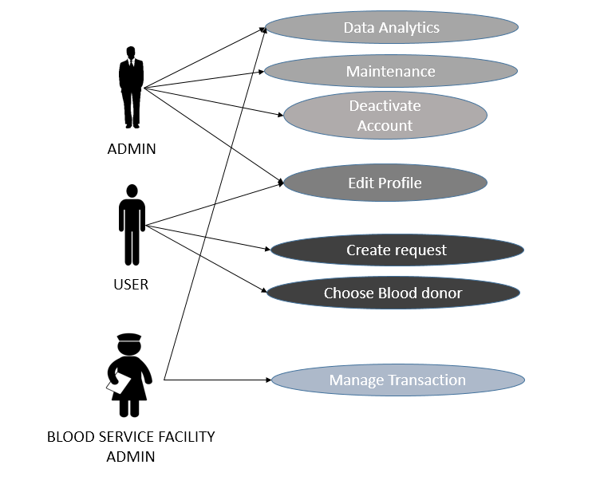

**Figure 4.3 Use Case Tools**

### **4.2.3 Data Flow Diagram**

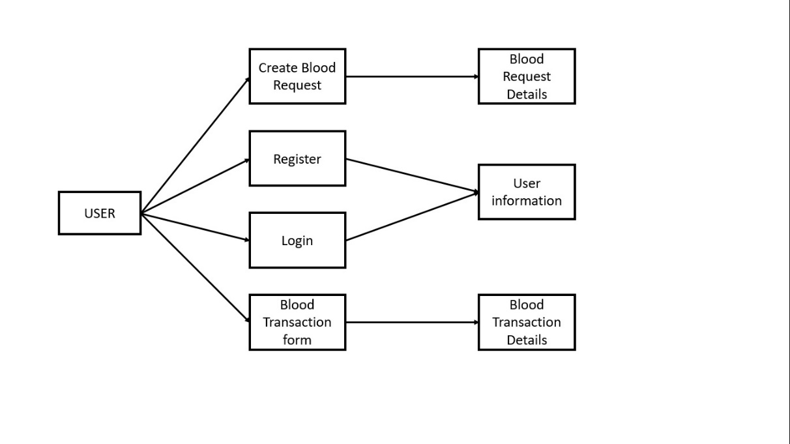

**Figure 4.4 Data Flow Diagram**

## **4.3 Development Model**

In this project, the developers chose the iterative and incremental development to show how the system was developed according to the end-user’s specifications.

And application development process is most commonly built around iterative and incremental approach. Iterative and incremental development process is a discipline for developing system based on producing deliverables.

It is also the best suit for the developers’ development process of the project because a new technology is being use. And it also generates working software quickly and early during the software life cycle. And it also helps the developers to build and improve the application step by step. Hence they can also tract the defects at early stages. And to also avoid the downward flow of the defects.

### **4.3.1 Initial Planning**

In this stage, the researchers found a need to exploit the techniques of society realizing that current method lacks the algorithm in the process of finding a blood donor. After identifying the process, the researchers determined the requirements and identify the problems encountered using the manual or old process.

### **4.3.2 Define Requirements**

In this stage, the researchers analyzed all the information gathered and came up with the solution to the problem. The researchers established the kind of system that should be developed for the community after studying the old process of finding a blood donor.

### **4.3.3 Analysis and Design**

In this stage, the researchers created the lay-out, design, module and prototype that will be needed for the efficiency of finding Blood donor. The developers created Flow Chart.

### **4.3.4 Implementation**

In this stage, the researchers analyzed the requirements for the improvement of the system. If the researchers finds out that there are problems in the process of the system, functions were added to meet the requirements of the system.

### **4.3.5 Test and Evaluation**

In this stage, the developers were ready for testing the system. The researchers gathered all the testing results to identify from the different users of the system and were able to identify if there are any problems found in the system. Evaluation from the users was made after testing the system in line with the system requirements.

### **4.3.6 Deployment**

In this stage, the researchers will deploy the system if there are no problems encountered base from the test and evaluation results. After

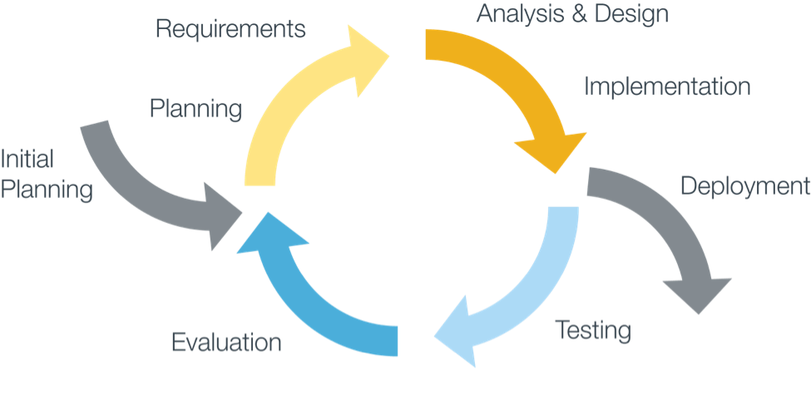

**Figure 4.5 Incremental and Iterative Model**

## **4.4 Development Approach**

The developers uses the top – down bottom approach to develop the application. The researches focuses first on creating the UI or the main functionalities of the application so that quality will not be sacrificed, and then adding the functionalities to the application. The main modules of the system are Login, Post, Donation, and Data Analytics.

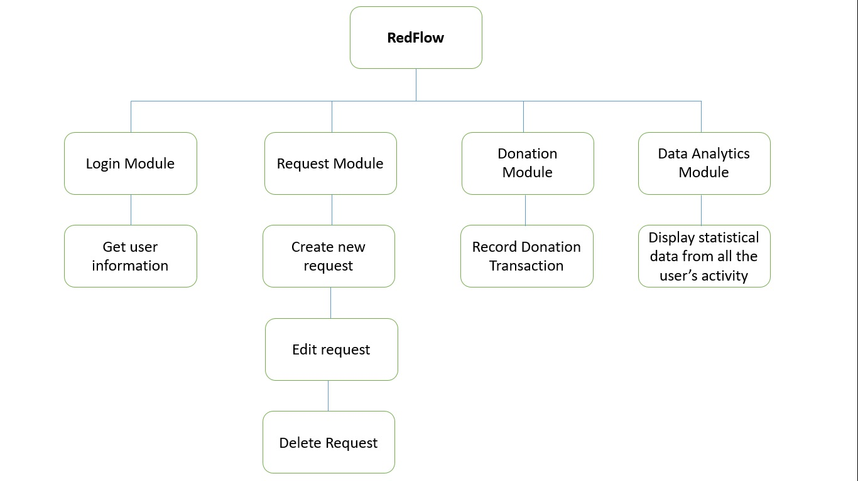

**Figure 4.6 Top down Approach**

## **4.5 Software Development Tools**

All the necessary installations and procedures will be made by the developers on the assigned computers on which the system will be deployed. The following below would be the software needed for the system.

|  |  |
| --- | --- |
| **Tools** | **Description** |
| Android Studio | integrated development environment (**IDE**) for Android platform development. |
| Firebase | a cloud-hosted database. It allows data to be stored and synchronized in realtime to every connected client. |
| Android | the official Operating System (**OS**) of the android phones, which is owned by Google. We use this to test our application on a real android phone. |
| Sublime | a [proprietary](https://en.wikipedia.org/wiki/Proprietary_software) [cross-platform](https://en.wikipedia.org/wiki/Cross-platform) [source code editor](https://en.wikipedia.org/wiki/Source_code_editor) with a [Python](https://en.wikipedia.org/wiki/Python_(programming_language)) [application programming interface](https://en.wikipedia.org/wiki/Application_programming_interface) (**API**). We chose this as our source code editor because of its reliability less crash, and because of its simple User Interface(**UI**). |

Table 4-2 Software Development Tools

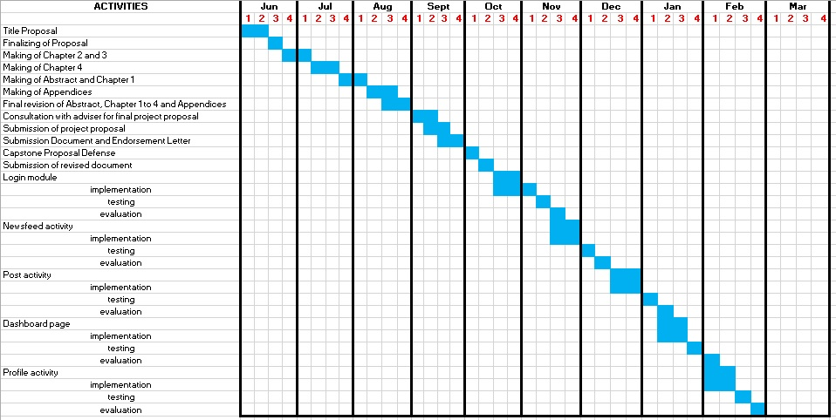

**Figure 4.7 Schedule and Timeline**

### **4.7 Responsibility**

Each of the researcher’s roles and obligations in the construction of the paper.

Table 4-3 Table of Responsibility

|  |  |
| --- | --- |
| **Member** | **Responsibilities** |
| Pacarat | Chapter 1: Abstract, Rationale of the Study |
| Chapter 2: Gathering of Data |
| Chapter 3: Technical Background |
| Chapter 4:, Sequence diagram, Initial planning, Define requirements, Software development tools, timeline, responsibilities, Budget cost management, verification and validation testing |
| Appendices: Software Requirements  Data Analytics Module  Admin Dashboard Page |
| Pastillo | Chapter 1: Scope and Limitations |
| Chapter 2: Gathering of Data |
| Chapter 4: Flowchart, Use case, ERD, sequence diagram, Initial planning Define requirements, Development approach, responsibilities, budget cost management, verification and validation testing |
| Appendices: Summary  Login Module  Newsfeed Activity |
| Tantay | Chapter 1: Significance of the Study |
| Chapter 2: Gathering of Data |
| Chapter 4: Conceptual framework, Use Case, Sequence Diagram, Development model, Initial planning, Define requirements, Development approach, responsibilities, budget cost management, verification and validation testing |
| Appendices: Transmittal Letter |
|  | Chapter 1: Statement of the Problem |
| Chapter 2: Gathering of Data |
| Chapter 4: Project Management, Verification, Validation and Testing |
| Appendices: Acknowledgement  Post Activity  Profile Activity |

## **4.8 Budget and Management Cost**

Table 4-4 Table Budget for Project Proposal Documentation Making

|  |  |
| --- | --- |
| **Item** | **Cost** |
| Printer Ink | P 800.00 |
| Bondpaper | P 320.00 |
| Materials (envelope, folders, etc.) | P 35.00 |
| Total: | P 1055.00 |

Table 4 5 Table Computed cost for the system based on technical requirements.

|  |  |
| --- | --- |
| **Item** | **Cost** |
| 2 Android Device | P 15,000.00 |
| Internet Service Provider | P 1,299.00 |
| Total: | P 16,299.00 |

Table 4-6 Table Computed cost for the utility costs.

|  |  |
| --- | --- |
| **Item** | **Cost** |
| Transportation | P 500.00 |
| Snacks | P 1,500.00 |
| Total: | P 2,000.00 |

## **4.9 Verification, Validation and Testing**

**Alpha Test**

Login

Create Request

Edit Request

Delete Request

View Request Details

Registration

**Beta Test**

View statistics

Edit Profile Details

transaction

match user module

Start Developing

Final Release

**Figure 4.8 Alpha Beta Test**

The researcher Decided to use the Alpha and Beta Testing for the verification and validation of the application.

On the start of the development phase, the researchers will focus on the login activity, creating post, editing a post, deleting a post, viewing a post, and registration activity. After developing those modules, the researcher’s start the alpha test by releasing the application. The researchers will then let the application be tested by the people with a composition of 15. If ever the result and feedback is negative, the researchers will analyze and plan on which part of the application needs a change. If ever the feedbacks and result is good then the researchers will proceed in developing the additional modules which is comment on post, transaction, edit profile details, and matched user module.

In short, in this phase, the developers are ready for testing the system. The developers will gather all the testing results to identify from the different users of the system and will be able to identify if there are any problems found in the system. Evaluation from the users is made after testing the system in line with the system requirements

# References

**Journal**

Ali, S. F. (2016, june). *Cambridge*. Retrieved from www.Cambridge.org: https://www.cambridge.org/core/books/governing-disasters/publicprivate-partnerships-through-crowd-sourced-governance/CBA4B74CCCDD6BDB7853FC9C2A3F05BD#

Andre, Cho; Deva, Tempero. (2008). JWS: a flexible web service. *ACM digital library*, 1,2.

Daisuke, S., Masatomo, K. H., & Chieko, A. (2010). Social Accessibility: the challenge of improving web accessibility through collaboration. *ACM Digital library*, 1.

Drucker, B. (2015). *firebase-building-realtime-app*. Retrieved from www.airpair.com: https://www.airpair.com/firebase/posts/firebase-building-realtime-app

Hemmendinger, H. R. (1998). *Client/server Term Definition*. Retrieved from www.maffeis.com: http://www.maffeis.com/articles/research

Hoang, N. H. (2016). Poster: Android Whole-System Control Flow Analysis for Accurate Application Behavior Modeling. *ACM Digital Library*, 30.

Zhang, S., Yang, Y., Fan, W., Lan, L., Yuan, M. (2014). *OceanRT: Real- Time Analytics over Large Temporal Data, ACM 978-1-4503-*

*23765/14/06,* 1099-1102. doi: 10.1145/2588555.2594513

Watzdorf, S., Michahelles, F. (2010). *Accuracy of Positioning Data on Smartphones, ACM 978-1-4503-0412-2/10/11,* doi:

10.1145/1899662.1899664

Damian, M. L, Bertino, E., Silvestri, C. (2009). *Protecting location privacy*

*against spatial inferences: the PROBE approach, ACM ISBN 978-*

*1-60558-853-7/09/11,* 32-41. doi: 10.1145/1667502.1667511

Allen, D., Daescu O. (2013). *A Comprehensive System for Locating*

*Medical Services, ACM 978-1-4503-1973-7/13/05,* doi:

10.1145/2504335.2504368

Lorenzi, D., Vaidya, J., Chun, S., Shafiq B., Naik, V., Atluri, V., & Adam, N.

(2013). *Community Based Emergency Response. ACM ISBN: 978-*

*1-4503-2057-3 , 82*. doi:10.1145/2479724.2479739

Hyojeong, S., Taiwoo, Seungwoo, Bupjae, Junehwa, Yohan, & Hojung. (2014). *Cosmic: designing a mobile crowd-sourced collaborative application to find a missing child in situ.* New York: MobileHCI.

Jin, Jing; Helal; Elmagarmid. (1999). Client-server computing in mobile environments. *ACM digital library*, 117-157 .

Shlomo Bekhor; Sara, Yerach, Yaron, Yehoshua. (2015). A personalized GeoSocial app for surviving earthquake. *ACM digital library*, 1.

Todd, A., & Barraclough, C. (2016). *Recombu*. Retrieved from What is Android and what is an Android phone?: https://recombu.com/mobile/article/what-is-android-and-what-is-an-android-phone_M12615.html

**Books**

Zapata, B. C. (2013). *Android Studio Application Development.* Packt Publishing Ltd.

**Website**

Hemmendinger, H. R. (1998). *Client/server Term Definition*. Retrieved from www.maffeis.com: http://www.maffeis.com/articles/research

Drucker, B. (2015). *firebase-building-realtime-app*. Retrieved from www.airpair.com: https://www.airpair.com/firebase/posts/firebase-building-realtime-app

**APPENDIX A INTERVIEW**

**INTERVIEW QUESTIONS:**

**1. What is the general process in donating blood?**

**2. What are the general questions asked to a donor before donating blood?**

**3. How many blood bags can a donor donate?**

**4. What do you do to donors after they donate blood?**

**5. Is the supply of donated blood greater than the demand?**

**APPENDIX B BLOOD DONATION PROCESS BOOKLET FROM DEPARTMENT OF HEALTH**

**WHO IS QUALIFIED TO DONATE?**

**AGE:** 16-65 years old (ages 16 and 17 needs a consent from their parents or guardian)

**WEIGHT:** not less than 50 kilos (110lbs.)

**PULSE:** 60-100 beats/minuet

**BLOOD PRESSURE:** 90/60 to 160/100 mmHg

**HEMOGLOBIN:** Not more than 125g/L (Hct 38% 0 >)

**WAYS OF DONATING BLOOD:**

**BEFORE DONATION**

* You will be given “Donor-form” when you arrive.
* You will be asked by the staff of the blood center about your health.
* You will undergo weight, blood pressure and heart test.
* You will be examined by the doctor.
* They will get a blood sample from you to examine your hemoglobin.

The process of choosing blood donor may consume 10-15 minutes. You are expected to answer the questions honestly for the sake of the patient who will receive the blood donated by the donor, all the information obtained is confidential.

**DURING THE DONATION OF BLOOD**

* You will be asked to lay down to start the blood donation that is done by the “Phlebotomist”.
* This will take 10-15 minutes.

**AFTER THE BLOOD DONATION**

* 10 minutes rest.
* You will be given food and drinks.
* You will be given instructions and information to take care of yourself
* You will be asked to drinks lots of fluid specifically water.
* The blood count of your body will increase back to normal after 24 hours while continuing the consumption of fluids except alcoholic drinks.

**REASONS WHY YOU CANNOT DONATE BLOOD**

There are conditions that will hinder an individual to donate a blood for a certain period of time.

**Temporary conditions that will hinder a person to donate a blood**

* Pregnancy
* Ordinary Sickness
* Drinking of alcoholic drinks
* Earrings or tattoo
* Operation

**Permanent conditions that will hinder a person to donate a blood**

* Cancer
* Heart Disease
* Lung disease
* Hepatitis B and C
* HIV or STD
* Long and risky work
* Decrease of weight more than 5 kg without any reasons
* Drunkenness
* And other disease that are listed in “GUID MEDICAL ASSESSMENT OF BLOOD DONORS”.

**WHO ARE QUALIFIED TO RECEIVE A BLOOD**

**PATIENCE THAT COULD POSSIBLE RECEIVE FROM YOUR DONATION ARE THE FOLLOWING:**

* BLEEDING
* LEUKEMIA
* HEMOPHILIA
* PREGNANCY WITH COMPLICATION
* ACCIDENTS
* TRANSPLANT
* OPERATION, AND MORE

**HOW FREQUENT CAN WE DONATE BLOOD?**

We are able to donate blood every 12 weeks (3 months) this is the right time for a donor to obtain the normal count of “IRON” in the body.

**WHERE DO I GO TO DONATE A BLOOD?**

**THIS ARE THE FACILITIES WHO ARE POSSIBLE TO COLLECT A BLOOD:**

* DOH region VII blood center
* Philippine Red Cross
* DOH hospitals, LGUs/NGOs Blood service facilities

**AT TIMES WHEN THERE ARE “MOBILE BLOOD DONATIONS” IN:**

* Barangay
* Government agencies
* Private agencies
* Schools and colleges

**WHAT ARE THE THINGS THAT ARE NEEDED TO BE READY FOR DONATING A BLOOD?**

* Sleep of more than 6 hours
* Do not drink alcoholic drinks within 24 hours before donating
* Avoid eating oily and fatty foods
* Drink a lot of water
* Eat what is enough for you, before 2 hours of donation

**A SAFETY BLOOD CAN ONLY BE OBTAINED TO THE PERSON LIKE YOU WHO CAN GIVE TIME TO SACRIFICE YOUR BLOOD AND TIME FOR OTHERS.**

**THEREFORE, GIVE LOVE….**

**GIVE BLOOD TO THE….**

**DEPARTMENT OF HEALTH**

National Voluntary Blood Services Program **Lung Center Compound, Quezon Avenue,**

**Quezon City**

**Tel. No: (02) 995**-3846

Website: home.nbbnets.net

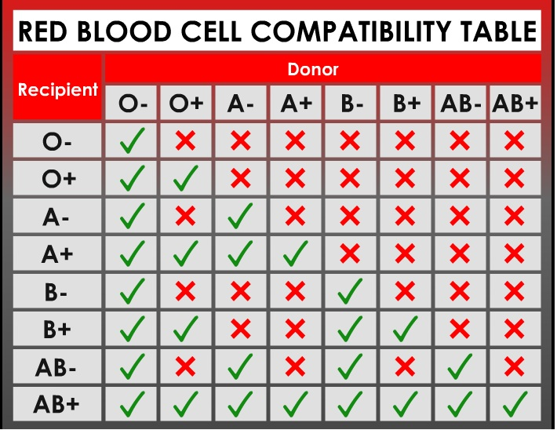

Shelia Fatima C. Fernandez, RN

Lic. No. 0313069

**APPENDIX C REGISTRATION AND REQUEST FIELDS**

**Registration:**

**-Full Name**

**-Age**

**-Address**

**-Contact Number(Mobile)**

**Request:**

**-Blood type**

**-Quantity**

**-Nature of the request**

**-Date range**

**-Location**

# Curriculum Vitae