BINTANG NAUFAL FAYYAZI

XII RPL 3

11-10-2023

C.latihan

Kontrol text

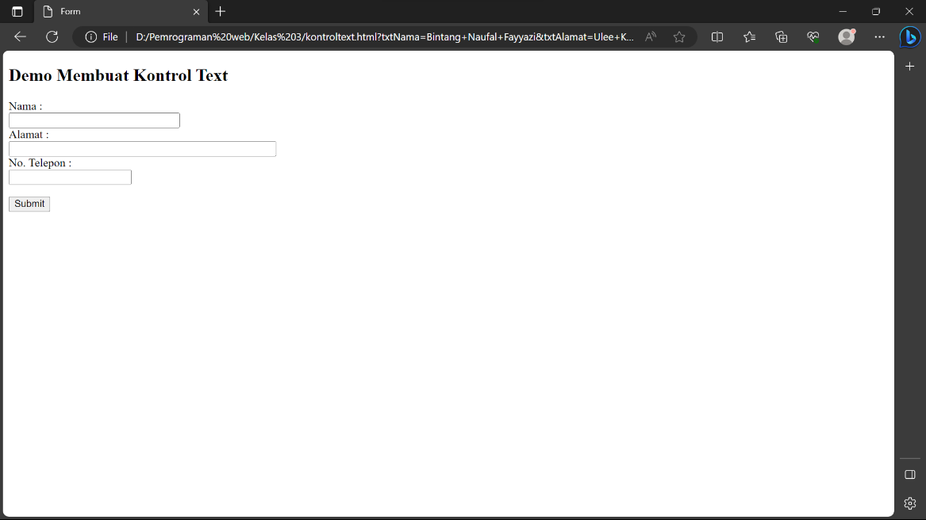

Kontrol TextArea

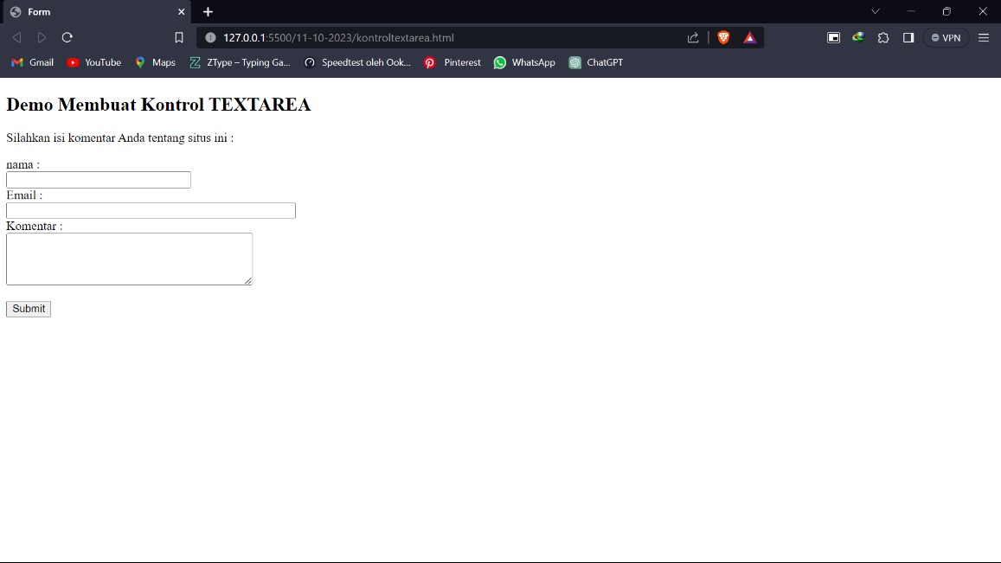

Radio Buttton

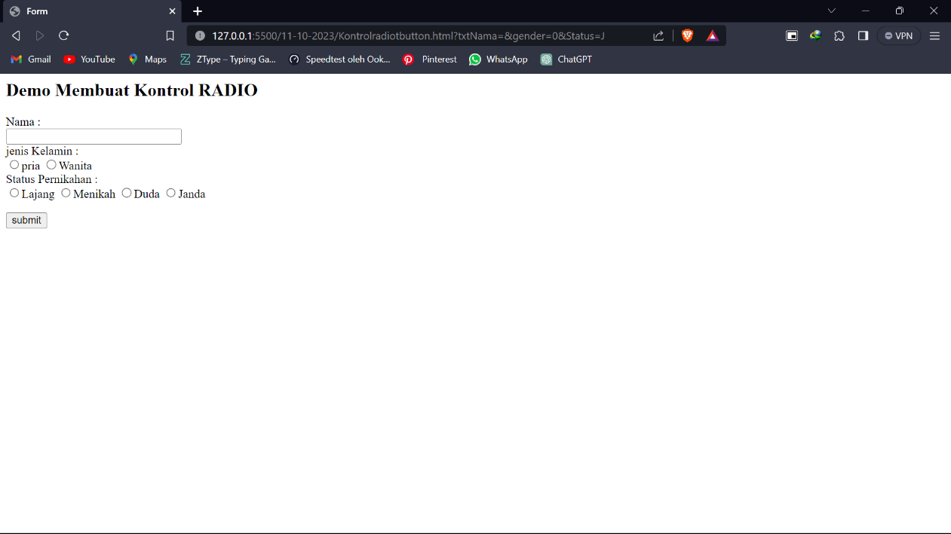

Checkbox & Listbox

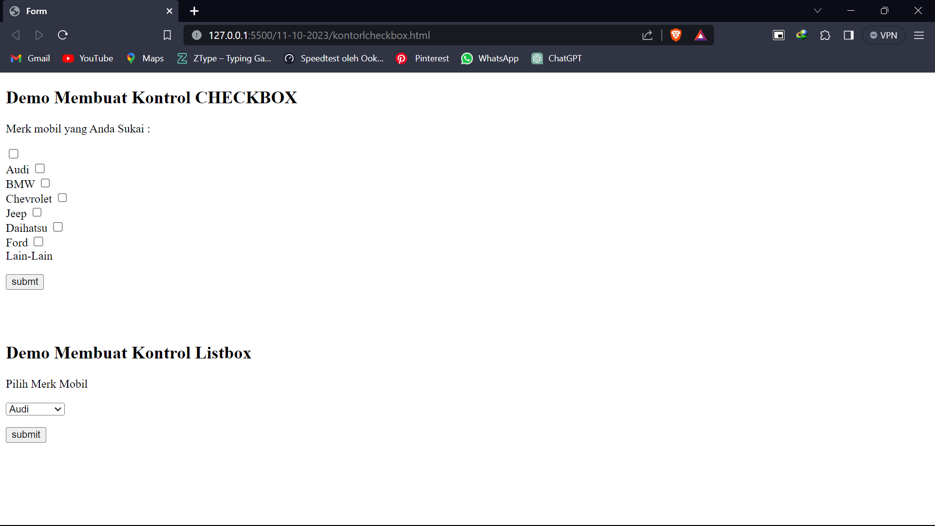

Kontrol password

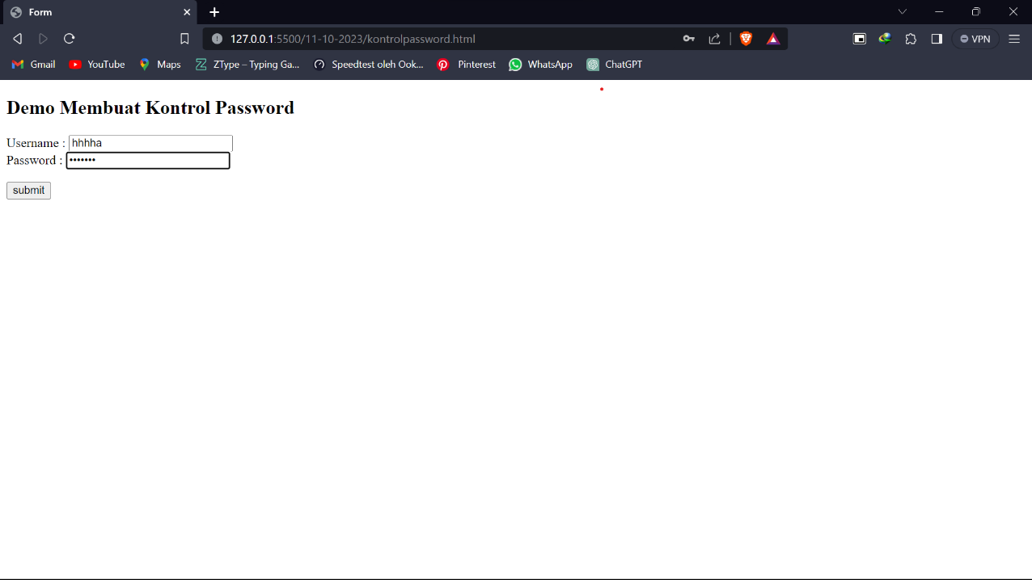

Kontrol Reset

