College WTF
Technical Progress Report
An Anonymous Campus Story-Sharing Web Application
Websites link:

Team Members, Group 8
Sara Al-Hachami (hi0172) Gloria Llakmani (h02308)
Harshil Kunjadiya (hu4637) Collin Maxey (hp4780)
Course: CSC 5750, Principles of Web Technology
Instructor: Hadi Nasser | Winter 2026

1. Technology Stack
College WTF is a full-stack web application built using standard web technologies. The frontend uses plain HTML5, CSS3, and vanilla JavaScript, with no frameworks or build tools. The backend is implemented using Node.js with the Express framework. Data is stored in a PostgreSQL relational database, accessed through the node-postgres (pg) library using a connection pool.
For deployment, the frontend is hosted on Netlify, allowing the application to be publicly accessible as a static site. During development and demonstration, the application can run in two modes: a fully connected mode using the Express backend and PostgreSQL database, or a standalone mode using browser localStorage to simulate backend functionality.
Initial plans included deploying the backend and database using Amazon Web Services (AWS), but this was not required for the current implementation.

Layer | Technology | Purpose
Frontend | HTML5, CSS3, Vanilla JavaScript | UI rendering, DOM manipulation, user interaction, async fetch calls
Backend | Node.js + Express | REST API server, route handling, request validation, business logic
Database | PostgreSQL (via pg Pool) | Relational data storage, stories, reactions, admin users, moderation log
Auth | bcryptjs + jsonwebtoken (JWT) | Admin password hashing and session token generation/verification
Deploy | Netlify (Frontend), Local / Optional Node.js Backend | Static site hosting for frontend, optional backend for full-stack functionality

The decision to avoid a frontend framework was deliberate. The course covers core web technologies, HTML, CSS, and JavaScript, so the project was built to demonstrate a solid understanding of those fundamentals rather than relying on abstractions like React or Vue. All DOM manipulation, event handling, and asynchronous data fetching are done natively in JavaScript, which makes the code portable and easy to run by simply opening the HTML file in a browser during development.

2. System Architecture
The application follows a three-tier architecture: a frontend client tier, a backend API tier, and a database tier. Each tier has a well-defined responsibility and communicates with the others through standard interfaces, HTTP and SQL respectively.

2.5 System Architecture Diagram
Figure 1 shows the three-tier structure of College WTF, including the communication protocols between each layer.

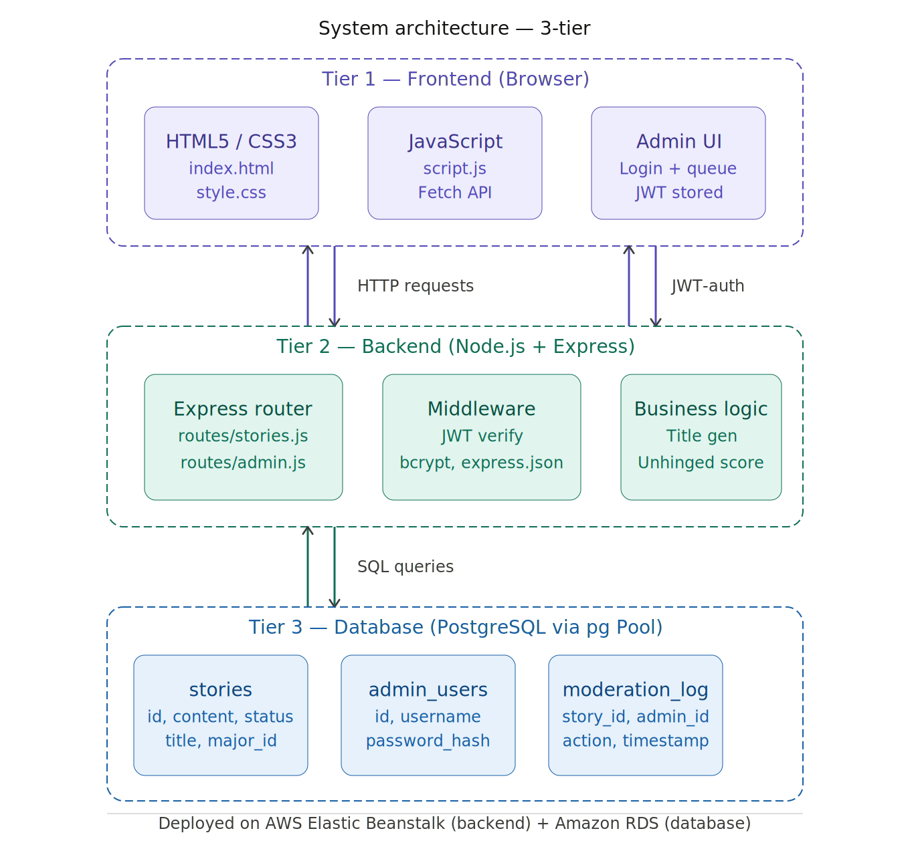
Figure 1 — System Architecture Diagram

2.1 Frontend (HTML, CSS, JavaScript)
The frontend is a single HTML file (index.html) supported by a stylesheet (style.css) and a JavaScript file (script.js). There is no build step, the browser loads and runs these files directly. All page navigation is handled by showing and hiding <div> elements using JavaScript, so the app behaves like a single-page application without being one in the framework sense.
JavaScript handles all interactivity: building filter chips, rendering story cards, opening and submitting the submission modal, managing the admin moderation queue, and updating the DOM in place after user actions like reacting to a story. Data is fetched from the backend using the native Fetch API with async/await. During local development (when no backend is connected), all data is stored in and retrieved from the browser’s localStorage under the key wtf_stories_v2 so the app is still fully functional. The v2 key is intentionally different from the original wtf_stories key used in v1 to avoid conflicts. A built-in migration function runs automatically on first load, if it finds existing stories that are missing the reactions, reactedBy, or title fields (left over from v1), it adds those fields with default values and re-saves the data before rendering.

2.2 Backend (Node.js + Express)
The backend is a Node.js application using the Express framework. It exposes a REST API that the frontend consumes. All API routes are prefixed with /api/. The server handles four main concerns: story retrieval (GET with filter parameters), story submission (POST with validation), reaction tracking (POST with fingerprint-based deduplication), and admin moderation (authenticated GET and PATCH routes protected by JWT middleware).
The Express app is structured into separate route files, routes/stories.js and routes/admin.js, each imported and mounted in the main index.js entry point. The v2 upgrade replaces routes/stories.js with the updated routes_stories_v2.js file, which adds the /react endpoint, the /sotd endpoint, and the title and unhinged score generation logic. The admin routes (login, pending queue, approve/reject/flag, stats, and moderation log) remain in a separate routes/admin.js file that was not changed as part of the v2 upgrade. A shared middleware file (middleware/auth.js) handles JWT verification for all admin-only endpoints. Request bodies are parsed as JSON using Express’s built-in express.json() middleware.

2.3 Database (PostgreSQL)
The database is PostgreSQL, accessed from Node.js using the pg library’s Pool class. A connection pool is initialized once when the server starts and shared across all route handlers. All SQL queries are parameterized to prevent SQL injection. One exception worth noting is the reaction update query in routes/stories.js, which dynamically constructs the column name using a template literal (e.g., react_${reaction}). This is safe because the reaction value is validated against a strict allowlist of four permitted values before it is used, the query is never constructed with raw user input. For operations that touch multiple tables (such as approving a story and writing to the moderation log simultaneously), the backend uses transactions with BEGIN, COMMIT, and ROLLBACK to ensure data consistency.

2.4 How the Tiers Connect
When a user interacts with the frontend, for example, submitting a story, JavaScript collects the form data, validates it client-side, and sends a POST request to /api/stories using the Fetch API. The Express backend receives the request, validates the body again server-side, generates a title and computes an unhinged score, then executes a parameterized INSERT query against the PostgreSQL database. The database returns the new story's ID, which the backend sends back to the frontend as a JSON response. The frontend then shows a success message. The data flow is always: User Action → JavaScript → Fetch Request → Express Route Handler → PostgreSQL Query → JSON Response → DOM Update.

3. Detailed Design and Implementation

3.1 Frontend Communication with the Backend
All communication between the frontend and backend goes through HTTP requests using the browser's native Fetch API. The frontend JavaScript file (script.js) contains a lightweight api.js-style pattern where all fetch calls are centralized. During development, API requests are routed directly to the Express server running locally. The following table lists the primary API endpoints the frontend consumes:

Method | Endpoint | Auth | Frontend Use
GET | /api/stories/meta | No | Fetches all majors and categories to populate filter chips and modal dropdowns
GET | /api/stories | No | Fetches approved stories; supports ?major=, ?category=, ?sort= query params
GET | /api/stories/sotd | No | Fetches the most-reacted story from the last 24 hours for the Story of the Day card
POST | /api/stories | No | Submits a new anonymous story; backend auto-generates title and unhinged score
POST | /api/stories/:id/react | No | Records a reaction (💀🤡🫡📉); supports toggle and swap
POST | /api/admin/login | No | Authenticates admin credentials and returns a signed JWT
GET | /api/admin/stories/pending | JWT | Returns all pending/flagged stories for the moderation queue
PATCH | /api/admin/stories/:id | JWT | Approves, rejects, or flags a story; writes to moderation log
GET | /api/admin/stats | JWT | Returns story counts and breakdowns by major and category

A typical frontend fetch call looks like this:

async function fetchStories(major, category, sort) {
const params = new URLSearchParams();
if (major) params.set('major', major);
if (category) params.set('category', category);
if (sort) params.set('sort', sort);
const res = await fetch('/api/stories?' + params.toString());
const data = await res.json();
return data; // array of story objects
}

For authenticated admin requests, the JWT token is retrieved from localStorage and included in the Authorization header as a Bearer token. If the server returns a 401, the frontend redirects the user back to the login page. Note: the endpoint table above reflects the full backend API. In the standalone frontend version (no backend connected), all of these interactions are simulated using the browser’s localStorage under the key wtf_stories_v2, the same function names and data shapes are used in both modes, so switching between them requires no changes to the UI code.

3.2 Data Flow: Story Submission to Feed Display
The full lifecycle of a story, from the moment a student types it to the moment it appears on the feed, passes through several distinct stages. Understanding this flow makes it clear how all three tiers work together.
Stage 1, User Fills the Submission Form
The student opens the submission modal by clicking the 'Share Your Story' button on the hero section. The modal is a standard HTML form built inside a hidden <div> that becomes visible. JavaScript listens for input events on the text area and change events on the two dropdowns (major and category). The Submit button stays disabled until the story is at least 20 characters long and both dropdowns have a selection. A character counter updates live as the user types, turning red when they approach the 500-character limit.

Stage 2, Client-Side Submission
When the user clicks Submit, JavaScript reads the text area content, the selected major ID, and the selected category ID. It trims whitespace and does a final length check before sending a POST request to /api/stories with a JSON body containing those three values. The modal immediately shows a loading state to prevent double-submission.

Stage 3, Backend Validation and Processing
The Express route handler in routes/stories.js receives the POST request. It validates the content length again (20–500 characters), confirms that the provided major_id and category_id actually exist in the database by running quick SELECT queries, then generates a title from the story text using a rule-based function that extracts and capitalizes the first meaningful sentence. It also computes an unhinged score based on story length, keyword presence (fail, cried, dropped, etc.), and punctuation. Both the title and score are generated server-side so they are consistent regardless of what the client sends.

Stage 4, Database Insert
The backend runs a parameterized INSERT statement against the stories table. The new story is stored with a status of 'pending', meaning it will not appear in the public feed yet. The database returns the new story_id and submitted_at timestamp, which the backend sends back to the frontend as a 201 Created response.

Stage 5, Admin Moderation
An admin logs into the moderation dashboard using their username and password. The backend verifies the password against the bcrypt hash stored in the admin_users table and returns a signed JWT. The admin's browser stores this token in localStorage. The admin dashboard then fetches all pending stories from GET /api/admin/stories/pending and displays them in a queue. For each story, the admin can Approve, Reject, or Flag it. When the admin clicks Approve, the frontend sends a PATCH request to /api/admin/stories/:id with the body { action: 'approved' }. The backend runs a database transaction that sets the story's status to 'approved', fills in published_at with the current timestamp, and inserts a record into the moderation_log table recording which admin took which action and when.

Stage 6, Feed Display
Once approved, the story appears in the public feed. When any user loads the feed page (or triggers a filter/sort change), the frontend calls GET /api/stories with the current filter parameters. The backend runs a JOIN query across stories, majors, and categories tables to return a complete story object including the major name, category name, title, unhinged score, and all four reaction counts. JavaScript maps over this array and builds HTML for each story card, injecting the title, content, tags, unhinged badge, and reaction buttons into the DOM. Reaction counts update in place without a full page reload when a user reacts.

3.3 Sequence Diagram
Figure 3 shows the full message flow across all participants for the story lifecycle: from submission through admin approval to public display.
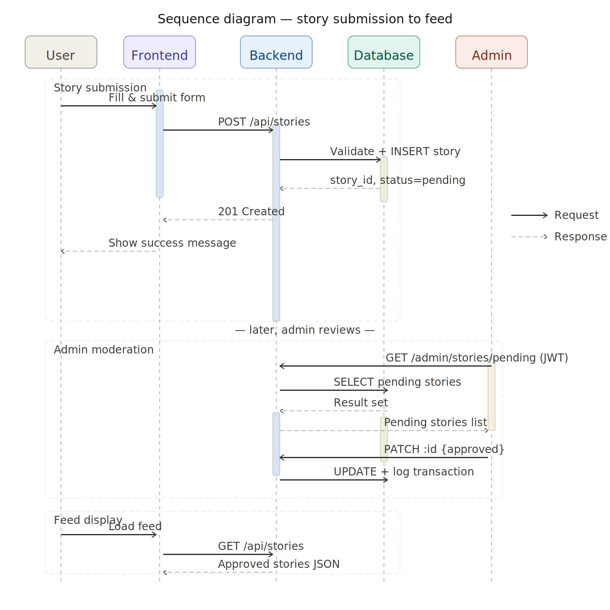
Figure 3 — Sequence Diagram: Story Submission to Feed Display

3.4 Activity Diagram
Figure 4 shows the story lifecycle with decision points at validation and admin moderation, including the approved and rejected branches.
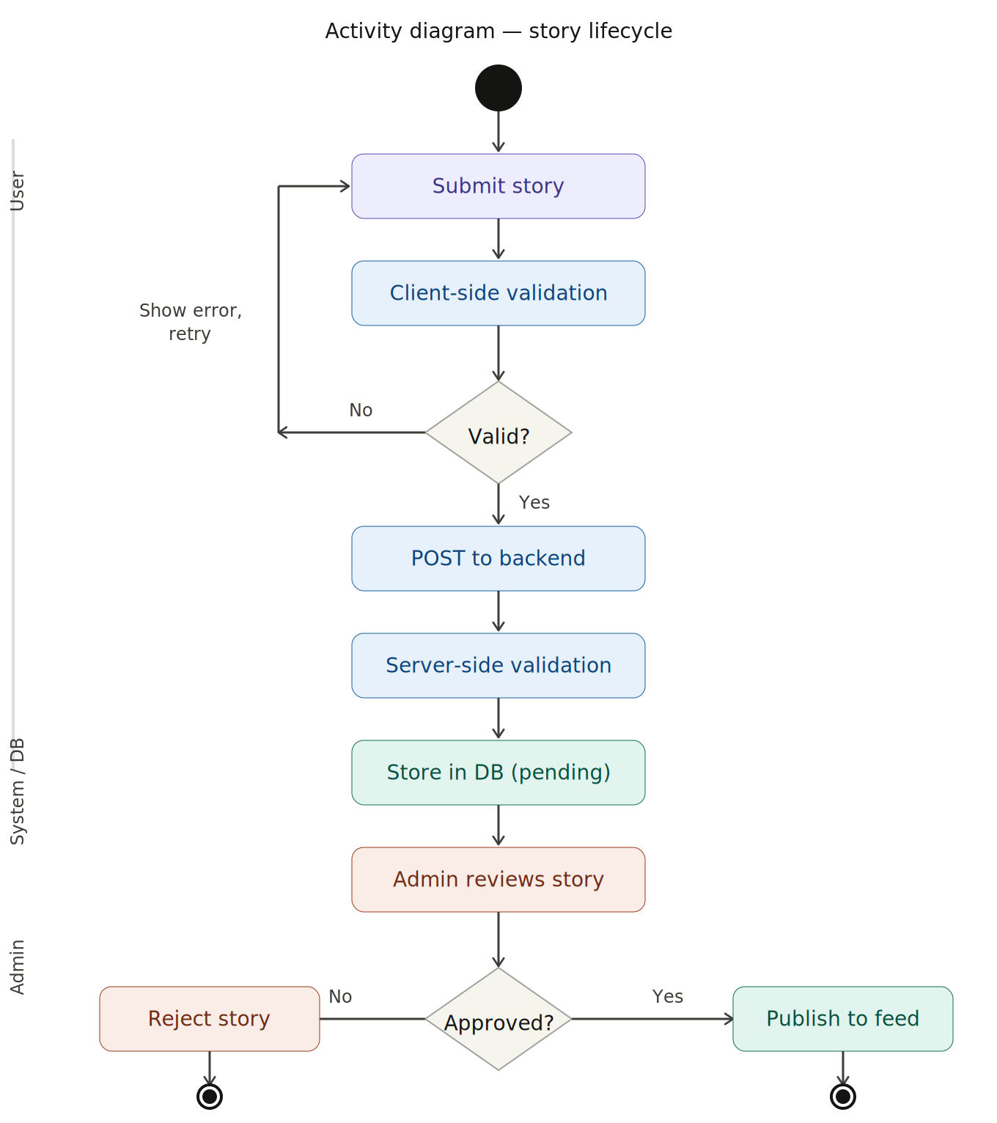
Figure 4 — Activity Diagram: Story Lifecycle

4. Usage Scenarios and Use Case Diagram

4.1 User Roles
College WTF supports two distinct user roles. The anonymous student user is any person who visits the public-facing site. They can browse the story feed, apply filters, react to stories they find funny or relatable, and submit their own stories. No account creation or login is required for any of these actions. The app is designed to make participation as frictionless as possible. The admin moderator is a trusted team member who accesses a protected dashboard by logging in with a username and password. Their job is to review submitted stories and decide whether to approve them for the public feed, reject them, or flag them for a second look. Admins can also view moderation history and basic usage statistics.

4.2 Use Cases
- Submit Story: The anonymous user opens the submission modal, types their story (20–500 characters), selects their academic major and story category from dropdowns, and clicks Submit. The story enters a moderation queue. No account is needed.
- Browse Feed: The anonymous user lands on the main feed and sees a list of approved stories sorted by newest first. They can scroll through them, read the titles and content, and see how other students have reacted.
- Filter Feed: The anonymous user selects one or more filter chips (by major or category) to narrow the feed to stories relevant to their own experience. They can also sort by most-reacted instead of newest.
- React to Story: The anonymous user clicks one of four reaction buttons on any story card, 💀 insane, 🤡 nah what, 🫡 respect, or 📉 downfall. The count updates instantly. Clicking the same reaction again undoes it. Clicking a different one swaps the reaction. One reaction per story per browser session.
- View Story of the Day: If at least one story was approved in the last 24 hours, the most-reacted story from that window is featured in a highlighted card at the top of the feed above the regular list.
- Admin Login: The admin navigates to the login page, enters their credentials, and receives a JWT token that grants access to the moderation dashboard.
- Admin Reviews Queue: The admin sees all pending and flagged stories in chronological order. Each card shows the story title, content, major tag, category tag, and unhinged meter rating.
- Admin Approves Story: The admin clicks Approve on a pending story. It is immediately published to the public feed. The action is recorded in the moderation log with a timestamp.
- Admin Rejects Story: The admin clicks Reject, optionally types a short reason, and the story is removed from the queue. The action is logged.
- Admin Views Statistics: The admin switches to the Breakdown tab to see counts of approved stories by major and by category.

4.3 Use Case Diagram (Text Representation)
The following text diagram represents the use cases for each actor. In a formal diagram this would be drawn as an oval-based UML use case diagram with actor figures and association lines.

-COLLEGE WTF, USE CASE DIAGRAM -
ACTORS
[Anonymous User] Any visitor to the site, no login required
[Admin Moderator] Authenticated team member with dashboard access
ANONYMOUS USER
Anonymous User ─── Submit Story
Anonymous User ─── Browse Feed
Anonymous User ─── Filter by Major / Category
Anonymous User ─── Sort by Newest / Most Reacted
Anonymous User ─── React to Story (Series of emojis within the web application)
Anonymous User ─── View Story of the Day
ADMIN MODERATOR
Admin Moderator ─── Log In to Dashboard
Admin Moderator ─── View Pending Queue
Admin Moderator ─── Approve Story ──(includes)── Publish to Feed
Admin Moderator ─── Reject Story ──(includes)──Log Decision
Admin Moderator ─── Flag Story ──(includes)──Log Decision
Admin Moderator ─── View Moderation Log
Admin Moderator ─── View Breakdown Statistics
SYSTEM BOUNDARY: College WTF Platform
All use cases above occur within this boundary.
Submit Story ──(includes)──Enter Moderation Queue
React to Story ──(extends)── Undo Reaction (if same reaction clicked)

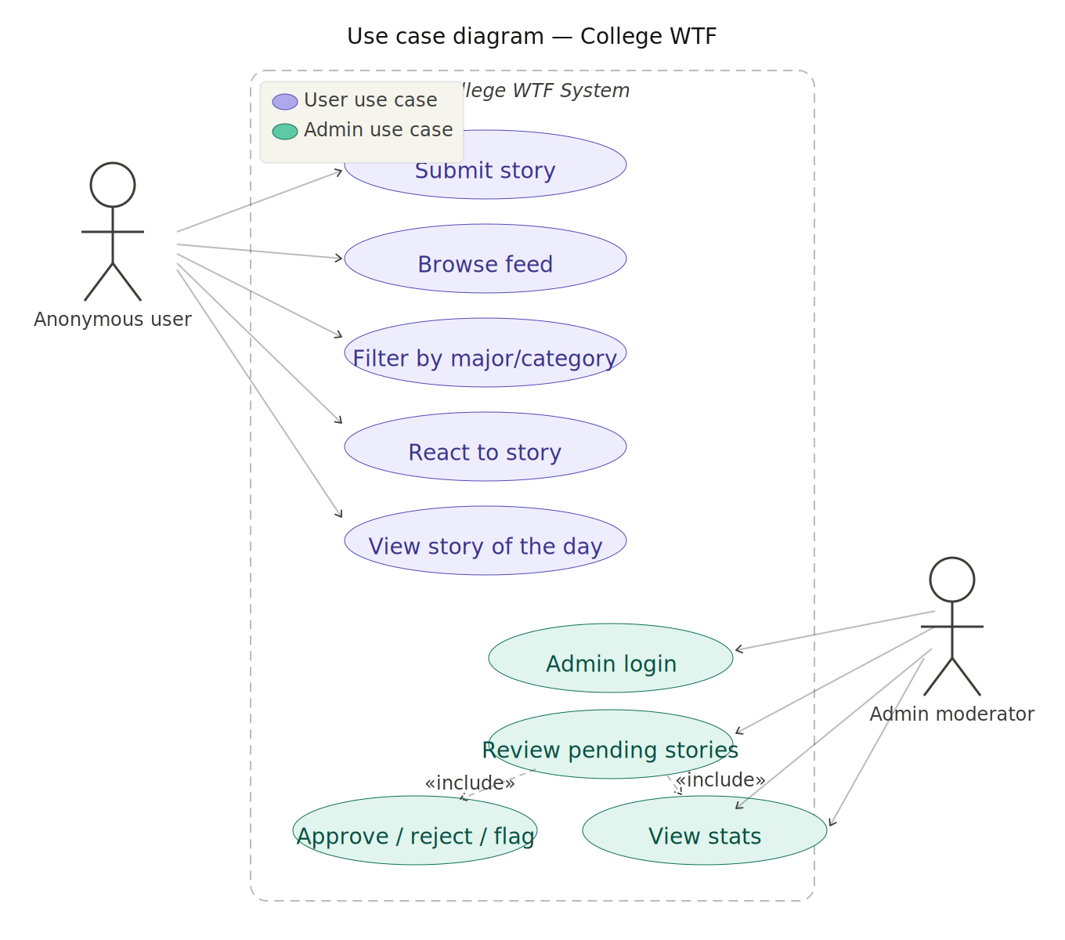
Figure 2 — Use Case Diagram: Anonymous User and Admin Moderator

5. Data Model
The PostgreSQL database is organized into six tables. Each table has a clear, focused responsibility. The stories table is the central table, most other tables either reference it or support it. All tables use SERIAL primary keys (PostgreSQL's auto-incrementing integer type) and snake_case column naming.

5.1 Table: stories
This is the most important table in the schema. Every submission, whether pending, approved, or rejected, is stored here. The status column controls whether a story is visible on the public feed. The four react_* columns cache reaction counts so the feed can be sorted by total reactions without an expensive aggregation join on every request. The title and unhinged_score columns are auto-generated by the backend on submission.

Column | Type | Constraint | Description
story_id | SERIAL | PRIMARY KEY | Auto-incremented unique identifier
content | TEXT | NOT NULL, CHECK (length 20–500) | The full story text submitted by the user
title | VARCHAR(200) | NULLABLE | Auto-generated one-line title from the story content
major_id | INTEGER | FK → majors(major_id) | Which academic major the story belongs to
category_id | INTEGER | FK → categories(category_id) | Which story category was selected
status | VARCHAR(20) | DEFAULT 'pending' | One of: pending, approved, rejected, flagged
react_insane | INTEGER | DEFAULT 0 | Cached count of 💀 reactions
react_nah | INTEGER | DEFAULT 0 | Cached count of 🤡 reactions
react_respect | INTEGER | DEFAULT 0 | Cached count of 🫡 reactions
react_downfall | INTEGER | DEFAULT 0 | Cached count of 📉 reactions
unhinged_score | INTEGER | DEFAULT 0 | Computed chaos score used to determine the Unhinged Meter label
submitted_at | TIMESTAMP | DEFAULT NOW() | When the story was submitted
published_at | TIMESTAMP | NULLABLE | Set when an admin approves; NULL until then

5.2 Table: categories
A reference table holding the predefined story categories. Categories are managed by the admin team and are not user-created. The slug column provides a URL-safe version of the name used as a query parameter in filter requests (e.g., GET /api/stories?category=exam-mishaps).

Column | Type | Constraint | Description
category_id | SERIAL | PRIMARY KEY | Auto-incremented unique identifier
name | VARCHAR(100) | NOT NULL, UNIQUE | Display name shown in UI (e.g., Exam Mishaps)
slug | VARCHAR(100) | NOT NULL, UNIQUE | URL-safe name used in API filter queries
description | TEXT | NULLABLE | Short description shown as a tooltip
created_at | TIMESTAMP | DEFAULT NOW() | When this category was added

5.3 Table: majors
A reference table for academic majors. Like categories, majors are predefined and presented as a fixed dropdown to users during submission. The department column optionally groups majors by college (e.g., STEM, Health Sciences) for aggregate reporting.

Column | Type | Constraint | Description
major_id | SERIAL | PRIMARY KEY | Auto-incremented unique identifier
name | VARCHAR(150) | NOT NULL, UNIQUE | Full major name (e.g., Computer Science)
slug | VARCHAR(150) | NOT NULL, UNIQUE | URL-safe name used in API filter queries
department | VARCHAR(100) | NULLABLE | Optional grouping field (e.g., STEM, Business)
created_at | TIMESTAMP | DEFAULT NOW() | When this major was added

5.4 Table: reactions
Tracks individual reaction events. Because the platform does not require user accounts, a browser fingerprint hash (SHA-256 of IP address and user-agent) is used as a proxy for identity. The UNIQUE constraint on (story_id, fingerprint_hash) ensures each browser can only have one active reaction per story at any time. When a user swaps reactions, the existing row is updated rather than a new one being inserted.

Column | Type | Constraint | Description
reaction_id | SERIAL | PRIMARY KEY | Auto-incremented unique identifier
story_id | INTEGER | FK → stories(story_id) ON DELETE CASCADE | References the story being reacted to
fingerprint_hash | VARCHAR(64) | NOT NULL | SHA-256 hash of IP + user-agent string
reaction_key | VARCHAR(20) | NOT NULL, CHECK IN (insane,nah,respect,downfall) | Which reaction was chosen
reacted_at | TIMESTAMP | DEFAULT NOW() | When the reaction was recorded
 | UNIQUE | (story_id, fingerprint_hash) | Prevents more than one active reaction per browser per story

5.5 Table: admin_users
Stores credentials for admin moderators. Passwords are never stored in plaintext, only bcrypt hashes with a cost factor of 10 are stored. The table is intentionally minimal; the application does not require a complex role-based permission system.

Column | Type | Constraint | Description
admin_id | SERIAL | PRIMARY KEY | Auto-incremented unique identifier
username | VARCHAR(100) | NOT NULL, UNIQUE | Admin login name
password_hash | VARCHAR(255) | NOT NULL | bcrypt hash of the admin's password
created_at | TIMESTAMP | DEFAULT NOW() | When the account was created
last_login | TIMESTAMP | NULLABLE | Timestamp of the most recent successful login

5.6 Table: moderation_log
An audit trail of every moderation decision. Every time an admin approves, rejects, or flags a story, a record is written here with the story ID, the admin ID, the action taken, optional notes, and a timestamp. This table supports accountability and makes it easy to review past decisions or reverse them if needed.

Column | Type | Constraint | Description
log_id | SERIAL | PRIMARY KEY | Auto-incremented unique identifier
story_id | INTEGER | FK → stories(story_id) | Which story was acted on
admin_id | INTEGER | FK → admin_users(admin_id) | Which admin performed the action
action | VARCHAR(20) | NOT NULL | The decision: approved, rejected, or flagged
notes | TEXT | NULLABLE | Optional reason for rejection recorded by the admin
acted_at | TIMESTAMP | DEFAULT NOW() | When the decision was made

5.7 Entity Relationships
The stories table is the hub of the data model. It has a many-to-one relationship with both majors and categories, meaning many stories can belong to a single major or category but each story has exactly one of each. The reactions table has a many-to-one relationship with stories, one story can have many reaction records, each from a different browser fingerprint. The moderation_log table has many-to-one relationships with both stories and admin_users, recording which admin acted on which story. The reference tables (majors, categories) are stable and rarely change; the transactional tables (stories, reactions, moderation_log) grow as users interact with the platform.

6. User Interface Design Decisions
The UI for College WTF was designed around a few core principles: keep the barrier to participation as low as possible, make content easy to browse and find, and make sure the platform stays appropriate and focused. Each major design decision reflects one of these goals.

6.1 Anonymous Submission
The submission flow requires no account creation, no email, and no name. Users see a single button, a text box, and two dropdowns. This was a deliberate choice. Research on anonymous platforms consistently shows that participation rates drop significantly when users must sign up. For a humor-driven platform where people share slightly embarrassing stories about themselves, anonymity is especially important. Removing the account barrier means more stories get submitted, and the content stays candid rather than polished for an audience.

6.2 Filtering by Major and Category
The dual-filter system, filtering by both academic major and story category, is what separates College WTF from a generic anonymous posting board. A nursing student browsing 'Nursing, Awkward Professor' stories will see content that is immediately, specifically relatable to their own experience. This level of organization makes the platform more valuable than a chronological feed of unrelated content. Filter chips were chosen over a dropdown because they are faster to interact with, users can see all their options at once and toggle between them without opening a menu.

6.3 Moderation System
All submissions pass through an admin moderation queue before appearing publicly. This was a non-negotiable design requirement. Anonymous platforms without moderation tend to drift toward negativity, harassment, or content that names and targets specific individuals. The moderation step keeps the content focused on humor and shared experience rather than personal attacks. The admin dashboard was designed to make this process fast; an admin should be able to review and action 20 stories in under 10 minutes. Each pending card shows the full story text, the auto-generated title, the major and category tags, and the Unhinged Meter score so the admin can make a quick, informed decision.

6.4 Reactions Instead of a Single Upvote
The original design used a simple upvote button. This was replaced in the frontend with four emoji reactions: 💀 insane, 🤡 nah what, 🫡 respect, and 📉 downfall. In the database, the original upvote_count column was kept and the four react_* columns were added alongside it, existing upvote counts were backfilled into react_insane for continuity. The reason for the change is that different stories deserve different responses, and a single upvote treats all positive reactions as equivalent. Someone being impressed by a student’s unhinged behavior is different from someone finding it relatable or calling it out as a bad idea. The four reactions let the community express more nuance while keeping the UI simple. Each reaction also serves as a signal for the Story of the Day algorithm, the story with the highest total reaction count in the last 24 hours gets featured.

6.5 Clean, Minimal Layout
The visual design prioritizes readability over decoration. White cards on a light gray background, a single blue accent color, tight borders, and generous white space between cards. The layout is intentionally similar to platforms students already use (Reddit, Twitter), which reduces cognitive load, the interface feels familiar without being derivative. The navbar is minimal with just two buttons (Feed and Admin), and the hero section is short and to the point. No sidebars, no ads, no suggested content. The story is the whole product.

6.6 Unhinged Meter
The Unhinged Meter badge (😐 Normal, 😬 Questionable, 💀 Unhinged) was added to give each story a personality signal briefly. The score is computed from a combination of story length, the presence of certain high-drama keywords (fail, cried, expelled, etc.), and punctuation patterns. Longer stories with more crisis language score higher. This is not meant to be a precise measure; it is a lightweight fun feature that helps users quickly identify which stories are mild and which ones are likely to make them spit out their coffee. It also provides useful context for admins reviewing the moderation queue.

7. Implementation Progress and Outstanding Issues

7.1 Completed Features
The following components are fully implemented and working as of this report:

Auto-Generated Titles

Rule-based title generation from story content (first sentence extraction, capitalization, 68-character cap).

Generated server-side on submission and stored in the title column.

Displayed prominently above the story text on every card.

Core Story Flow
- Anonymous story submission form with client-side validation, character counter, and major/category dropdowns.
- Backend POST /api/stories route with server-side validation, auto-generated title, and unhinged score computation.
- PostgreSQL INSERT with proper parameterized queries.
- Story feed rendering: all approved stories fetched from the database and rendered as HTML cards.

Filtering and Sorting
- Filter chips for major and category, both can be combined simultaneously.
- URL parameter-based filtering passed to the backend query.
- Sort by newest (ORDER BY published_at DESC) and most reacted (ORDER BY total reaction count DESC).

Reaction System
- Four-reaction system added alongside the original upvote_count column (which is retained in the database and backfilled into react_insane for existing stories).
- Fingerprint-based deduplication in the backend, one reaction per browser per story.
- Toggle behavior: clicking the same reaction again removes it; clicking a different one swaps it.
- In-place DOM update with pop animation on click, no full page reloads.
- Cached reaction counts in the stories table for efficient sorting.

Unhinged Meter
- Score computed from story length, keyword hits (30+ crisis words), and exclamation marks.
- Three tiers: 😐 Normal, 😬 Questionable, 💀 Unhinged.
- Badge displayed on every story card and on pending cards in the admin queue.

Admin Dashboard
- Login system with bcrypt password verification and JWT token issuance.
- Pending moderation queue showing all pending and flagged stories.
- Approve / Reject / Flag actions with optional notes, all write to moderation_log.
- Moderation log tab showing the last 50 decisions with timestamps.
- Breakdown tab showing story counts by major and category.

Story of the Day
- Backend endpoint GET /api/stories/sotd returns the most-reacted story from the last 24 hours.
- Frontend renders a highlighted featured card above the feed when data is available.
- Section hides automatically if no stories were approved in the last 24 hours.

7.2 In Progress
- Deployment refinement: The frontend is currently deployed on Netlify as a static site. Backend integration with the Express API and PostgreSQL database is functional in development but not deployed in production. Future work may include full-stack cloud deployment if required.
- Mobile responsiveness: The filter bar and submission modal require additional CSS adjustments for smaller screen sizes. The desktop layout is complete, and mobile optimization is in progress.
- Admin statistics panel: The per-major and per-category breakdowns are currently displayed as static counts. A visual representation using charts (e.g., bar graphs) is planned but not yet implemented.

7.3 Current Issues and Challenges
Database Integration Limitations
During development, the PostgreSQL database connection was tested locally using a connection pool. Since the backend is not deployed in production, database interactions are not active in the deployed Netlify version. This is an intentional design choice for the current implementation, allowing the frontend to function independently using localStorage.
Authentication Edge Cases
The JWT middleware correctly rejects expired and malformed tokens, but there is a known edge case where an admin who is logged in during a server restart will receive a 401 on their next action because the JWT_SECRET environment variable defaults to a different value in development versus production. The solution is to ensure JWT_SECRET is consistently set via the .env file (development) and Elastic Beanstalk environment properties (production), which is part of the deployment work still in progress.

Fingerprint-Based Deduplication Limitations
The reaction deduplication system uses a SHA-256 hash of the user's IP address and user-agent string as a proxy for identity. This works well for typical use but has known limitations: a user who clears their browser data, switches browsers, or uses a VPN will be treated as a new user and can react again. This is an acceptable tradeoff for a platform that deliberately avoids accounts. Implementing stricter deduplication would require some form of persistent client-side identifier (a cookie or localStorage key), which adds complexity without significantly changing the platform's casual nature. This is a documented known limitation rather than an unresolved bug.

Moderation at Scale
The current moderation workflow is manual, every story must be individually reviewed by an admin. For the scale of a class project this is perfectly manageable. However, if the platform were ever deployed publicly, the volume of submissions would quickly make manual review unsustainable. A future improvement would be to add an automated pre-screening step that uses keyword matching to automatically flag or reject obvious violations before they reach the human moderation queue, reducing the number of stories an admin needs to read.

7.4 Next Steps
- Improve deployment setup: Continue using Netlify for frontend hosting and explore optional deployment of the Express backend and PostgreSQL database for a fully integrated production version if required.
- Conduct final testing: Verify all core features including story submission, feed filtering, reactions, and admin moderation in both local (backend-connected) and standalone (localStorage) modes.
- Enhance mobile responsiveness: Refine CSS for the filter bar overflow and submission modal layout on screens narrower than 600px to ensure a smooth mobile experience.
- Expand documentation: Add a concise API reference section summarizing all endpoints, request formats, and expected responses to improve clarity and usability.
- Handle edge cases: Ensure the Story of the Day feature correctly handles tie scenarios (e.g., multiple stories with equal reaction counts within the 24-hour window).

8. Team Contributions
The following describes each team member’s area of responsibility and the specific components they implemented in this project.

8.1 Sara Al-Hachami (hi0172) (Front-End Development and System Integration)
Sara was responsible for the complete frontend of the application and for coordinating integration between the frontend and backend layers. Her work covers the single-file HTML/CSS/JavaScript architecture (index.html, style.css, script.js), all SPA-style page navigation via show/hide div logic, the story submission modal with live character counter and client-side validation, and the filter chip UI for browsing by major and category. She also implemented the story card rendering pipeline, the in-place reaction DOM updates with pop animation, and the dual-mode design that allows the frontend to run fully in standalone localStorage mode when no backend is connected. The v1-to-v2 data migration function that runs automatically on first load is also part of her work. On the integration side, Sara coordinated the fetch call contracts between the frontend and the Express API, ensuring consistent data shapes across both connected and standalone modes.

8.2 Gloria Llakmani (h02308) (Back-End API Development)
Gloria was responsible for the Node.js and Express backend API. Her work includes implementing all REST routes under /api/, including story retrieval with filter and sort parameters, story submission with server-side validation, auto-generated title logic, and unhinged score computation. She built the reaction endpoint (POST /api/stories/:id/react) with fingerprint-based deduplication and toggle/swap behavior, and the Story of the Day endpoint (GET /api/stories/sotd). Gloria also implemented the admin routes for login, the pending moderation queue, approve/reject/flag actions, moderation log retrieval, and the breakdown statistics endpoint. JWT middleware for protecting admin-only routes and the bcrypt-based login flow are also part of her contribution. The v2 backend upgrade, which introduced routes_stories_v2.js alongside the unchanged admin routes, was her responsibility.

8.3 Harshil Kunjadiya (hu4637) (Database Design and Implementation)
Harshil was responsible for the PostgreSQL database layer. His work covers the full six-table schema: stories, categories, majors, reactions, admin_users, and moderation_log. He designed the relational model including foreign key relationships, SERIAL primary keys, UNIQUE constraints, and CHECK constraints such as the allowlist on reaction_key. All parameterized queries across route handlers were written to his specification to prevent SQL injection. He implemented transaction-based operations for multi-table writes (e.g., approving a story and writing to the moderation log atomically using BEGIN/COMMIT/ROLLBACK). The cached reaction count columns on the stories table, which enable efficient sort-by-reactions queries without aggregation joins, are a deliberate query optimization decision in his design. He also configured the pg Pool connection shared across all route handlers.

8.4 Collin Maxey (hp4780) (Deployment, Testing, and Admin Dashboard)
Collin was responsible for deployment, testing, and the implementation of the administrative and moderation dashboard. On the deployment side, he set up and maintains the Netlify static site hosting for the frontend and is leading the ongoing work to integrate the Express backend and PostgreSQL database into a production environment. He identified and documented the JWT_SECRET environment variable edge case affecting admins after a server restart. On the admin dashboard side, Collin implemented the login page, the pending story queue UI, the approve/reject/flag action flows with optional notes, the moderation log tab displaying the last 50 decisions, and the breakdown statistics tab showing story counts by major and category. He also conducted end-to-end testing of core features in both backend connected and localStorage standalone modes and documented the known limitations around fingerprint based deduplication and moderation scalability.

9. Milestone Status
The project defined two major intermediate milestones to track progress throughout the semester. The status of each is reported below.

Milestone 1: Core Backend and Database Structure (Complete)
Milestone 1 targeted the completion of the core backend and database structure, including story submission, storage, and moderation workflows. This milestone is fully complete. The PostgreSQL schema covering all six tables is implemented and tested. The Express API handles story submission with server-side validation, parameterized database inserts, and auto-generated titles and unhinged scores. The moderation workflow is end-to-end functional: stories are stored with a pending status; admins can log in via JWT-authenticated credentials and approve/reject/flag decisions are written transactionally to both the stories table and the moderation_log. The reaction system, including fingerprint-based deduplication and cached reaction counts, is also in place. All components targeted by Milestone 1 are working in the local development environment.

Milestone 2: Front-End Integration, Filtering, and Deployment (Complete)
Milestone 2 targeted front-end integration with backend services, implementation of filtering by major and category, and deployment of the application to a cloud platform. This milestone is complete. Frontend integration is fully functional: all fetch calls map to the correct API endpoints, filter and sort parameters are passed via URL query strings to the backend, and the frontend gracefully falls back to localStorage when no backend is connected. Major and category filtering using filter chips is fully implemented, including combined multi-filter support and sorting by most reacted.

The frontend is deployed on Netlify as a publicly accessible static site, allowing users to interact with the application without requiring a backend connection. While the backend and database are not deployed in a production cloud environment, they are fully implemented and operational in the local development environment.
Overall, all objectives of this milestone have been met, and the system demonstrates complete frontend integration, filtering functionality, and deployment within the defined project scope.

College WTF, Technical Progress Report, Group 8, CSC 5750

