Screenshots – Day 13 (Exploratory Testing, automationexercise.com)
1. Home Page — Mixed Product Categories
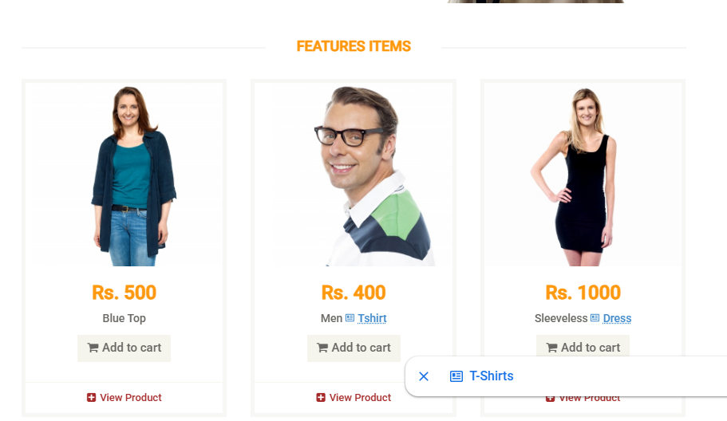
Products from different categories (men, women, children) appear mixed together on the Home Page.
2. Category Sidebar & Layout
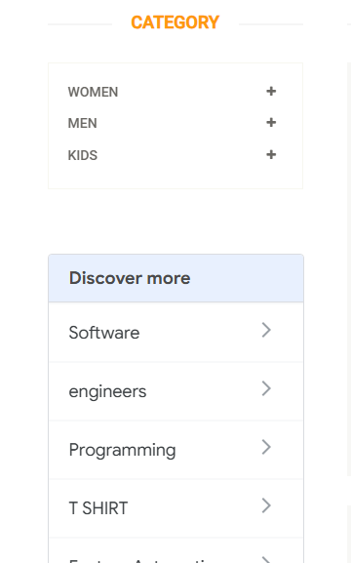
Category block and "Discover More" section are not logically aligned; no proper filter option available.
3. All Products Page
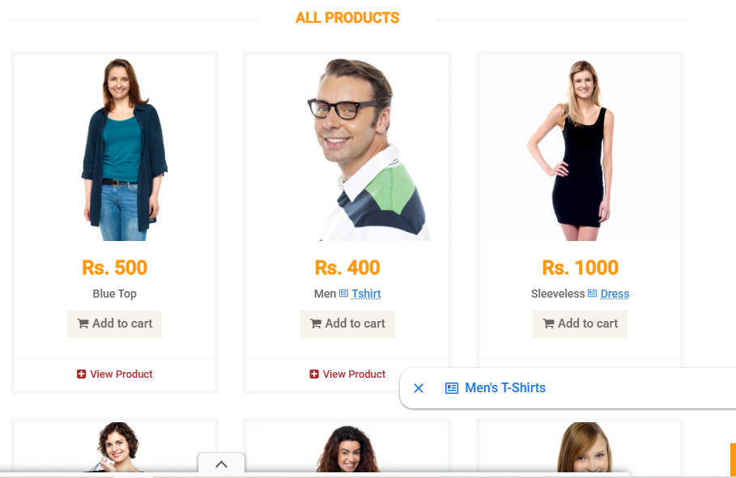
Same category-mixing issue as the Home Page.
4. Search Bar Visibility
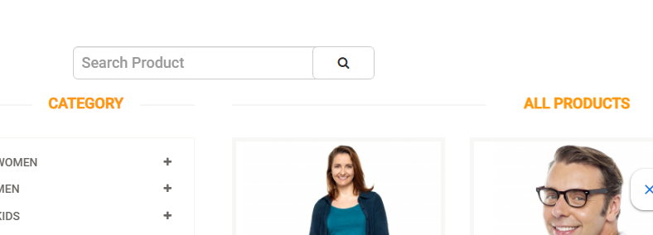
Low-contrast color scheme makes the search bar difficult to spot.
5. "Big Sale" Banner

Banner image is not clickable and does not lead to any products.
6. Product Hover / Add to Cart
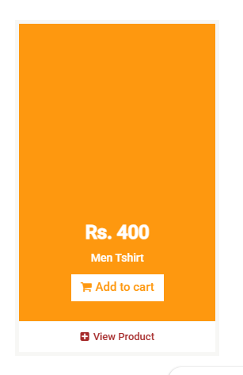
Hovering shows "Add to Cart," but only the small "View Product" icon opens product details.
7. Product Detail Page
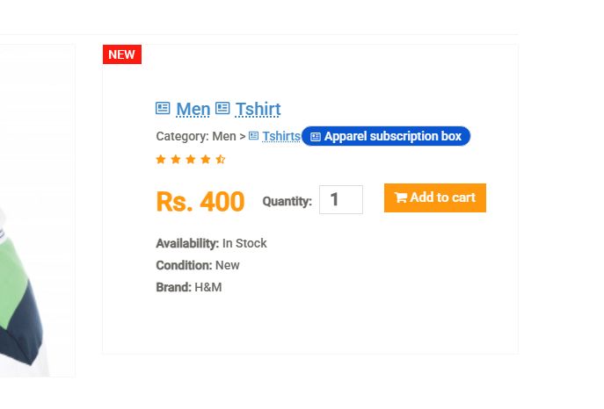
Missing fabric and size information; "Add a Review" section feels unnecessary.
8. Cart — No Remove Option
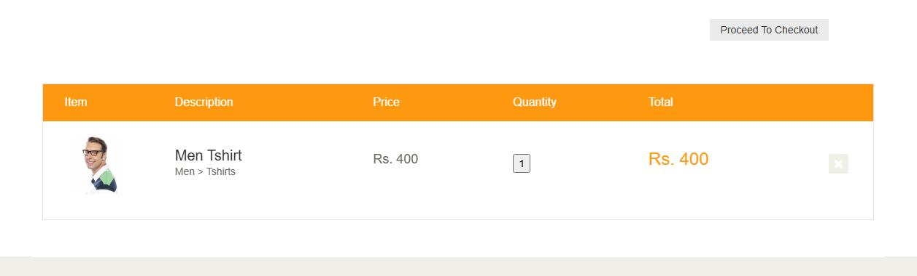
"Add to Cart" is available, but there is no way to remove the product from this view.
9. Cart Icon / Item Count
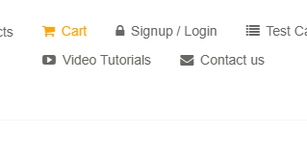
No visible cart icon and no item count shown after adding products.
10. Subscription Box on Every Page
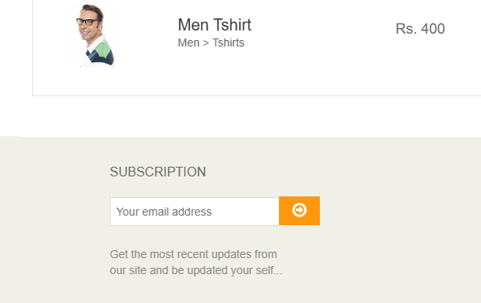
Subscription box appears even on pages like Login, where it isn't needed.
11. Top Navigation Menu Bar

Menu bar styling looks inconsistent/misaligned with the rest of the page.
12. Registration Page Layout
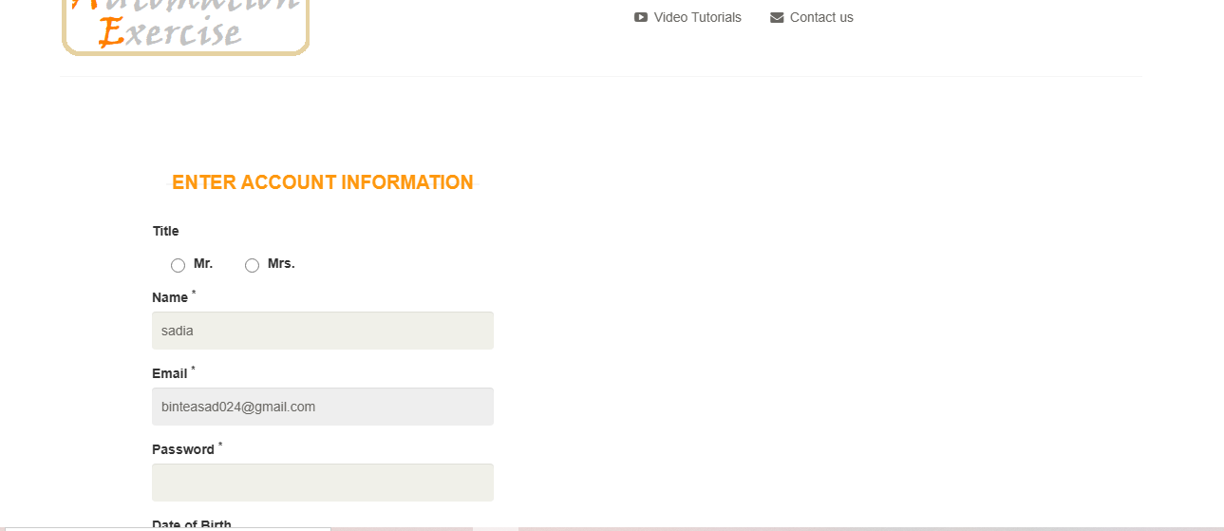
Form is aligned to the left, leaving the right side of the page empty.

