Day 6 – SQL Screenshots

Screenshot 1 – Students Table
Query Executed:
SELECT * FROM Students;
Explanation:
This query displays all records and all columns from the Students table. It is used to verify that the student data has been inserted correctly into the database.
Screenshot:
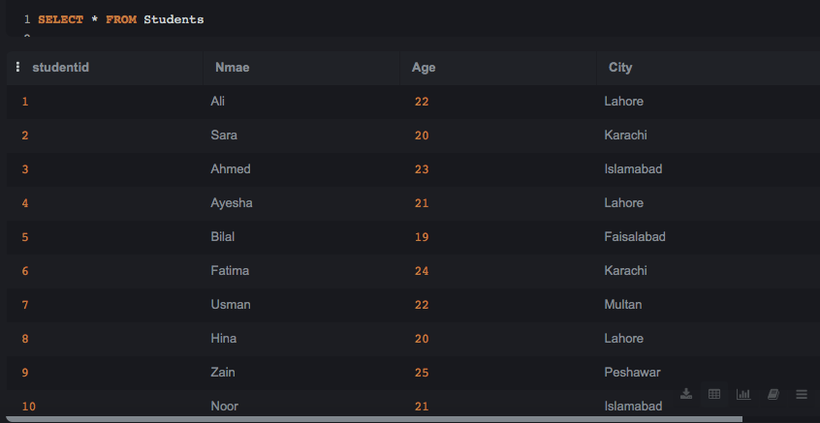

Screenshot 2 – Courses Table
Query Executed:
SELECT * FROM Courses;
Explanation:
This query displays all records from the Courses table. It verifies that the course information and StudentID values have been stored successfully.
Screenshot:
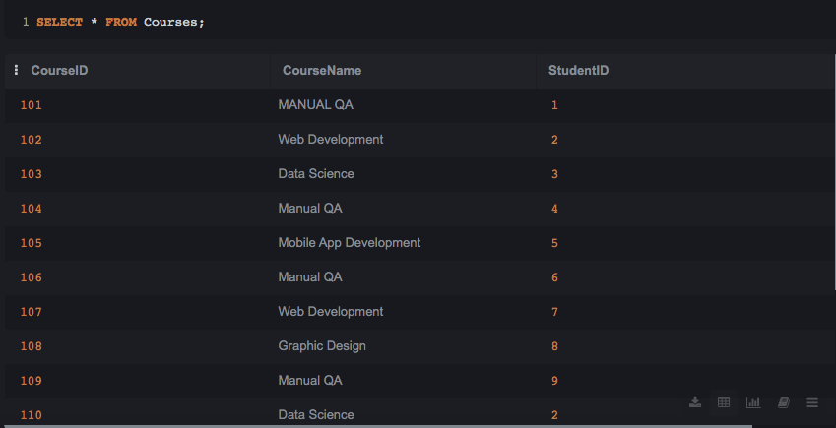

Screenshot 3 – INNER JOIN Result
Query Executed:
SELECT Students.Name, Courses.CourseName FROM Students INNER JOIN Courses ON Students.StudentID = Courses.StudentID;
Explanation:
This query joins the Students and Courses tables using StudentID. It returns only the students who have matching course records.
Screenshot:
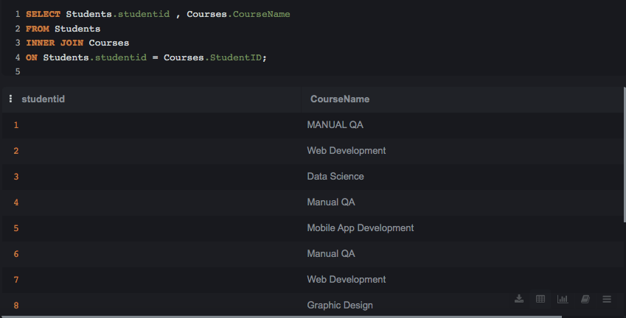

Screenshot 4 – LEFT JOIN Result
Query Executed:
SELECT Students.Name, Courses.CourseName FROM Students LEFT JOIN Courses ON Students.StudentID = Courses.StudentID;
Explanation:
This query displays all students from the Students table. If a student is not enrolled in any course, the CourseName column shows NULL.
Screenshot:
(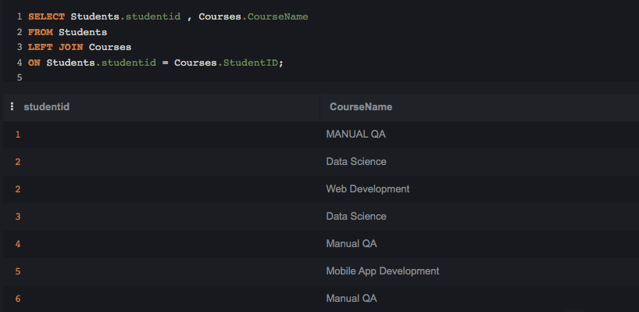
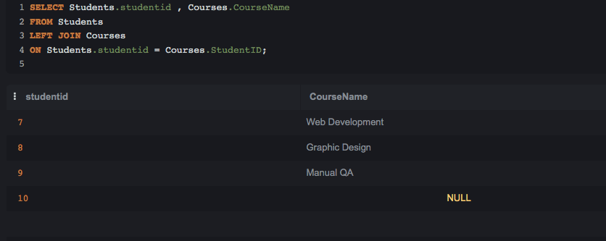

Screenshot 5 – Count Students in Each Course
Query Executed:
SELECT CourseName, COUNT(StudentID) AS TotalStudents FROM Courses GROUP BY CourseName;
Explanation:
This query groups the data by CourseName and counts how many students are enrolled in each course.
Screenshot:
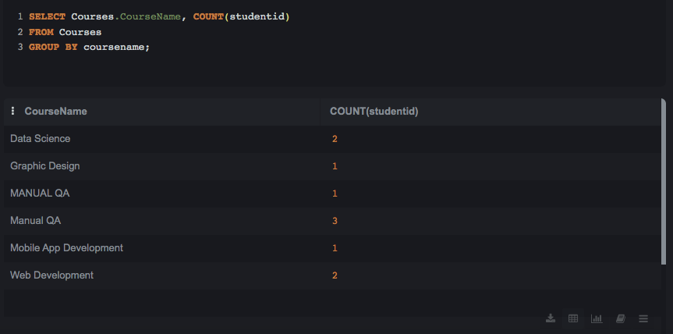

Screenshot 6 – Students Ordered by Name
Query Executed:
SELECT * FROM Students ORDER BY Name;
Explanation:
This query displays all student records and sorts them alphabetically by Name in ascending order.
Screenshot:
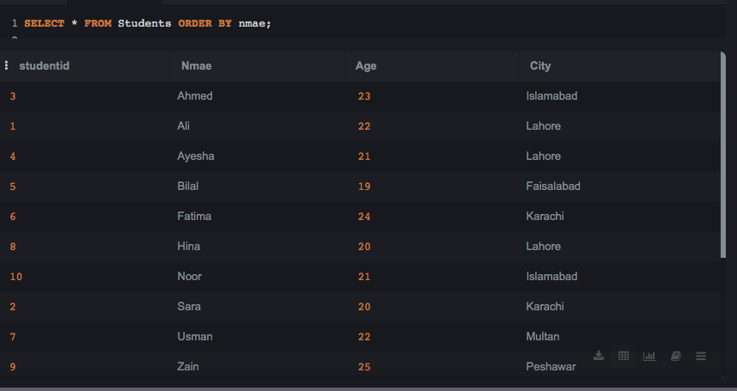

Screenshot 7 – Students Older Than 20
Query Executed:
SELECT * FROM Students WHERE Age > 20;
Explanation:
This query filters the student records and displays only those students whose age is greater than 20 years.
Screenshot:
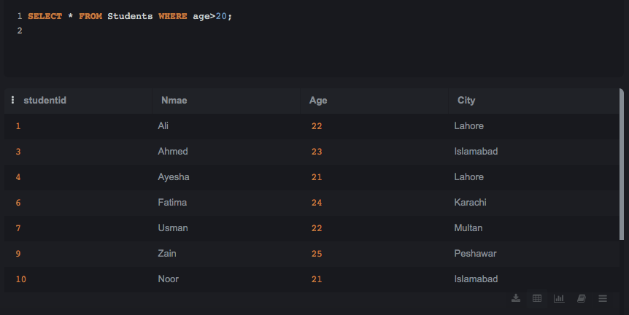

Screenshot 8 – Students Grouped by City
Query Executed:
SELECT City, COUNT(*) AS TotalStudents FROM Students GROUP BY City;
Explanation:
This query groups students according to their city and counts the total number of students in each city.
Screenshot:
