Day 6 – Data Validation

Objective
The objective of this exercise is to verify that the data displayed on the website matches the data stored in the database.

Scenario
The website displays the following information:
- Student Name: Ali
- Course: Manual QA
As a QA Engineer, I need to verify whether this information exists in the database.

SQL Query Used
SELECT Students.Name, Courses.CourseName FROM Students INNER JOIN Courses ON Students.StudentID = Courses.StudentID WHERE Students.Name = 'Ali' AND Courses.CourseName = 'Manual QA';

Result
The query returned one matching record:
Name | CourseName
Ali | Manual QA
This confirms that the information displayed on the website matches the data stored in the database.
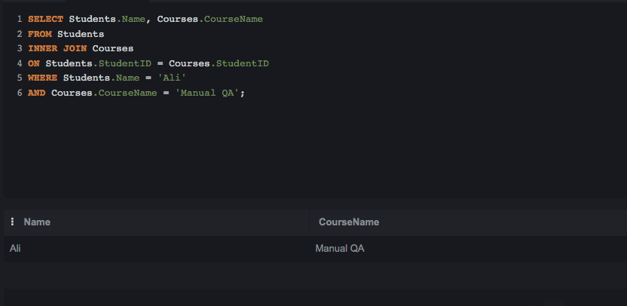

Why is SQL Useful for a QA Engineer?
SQL helps QA Engineers verify that the data displayed in an application is accurate and consistent with the database. It is used to validate records, investigate defects, check data integrity, and ensure that information is stored and retrieved correctly. SQL also helps testers verify that application features are working as expected.

Conclusion
This data validation exercise confirmed that the student Ali is enrolled in the Manual QA course. The data shown on the website matched the database record, indicating that the application retrieved and displayed the correct information.

