Query 1: Show all students
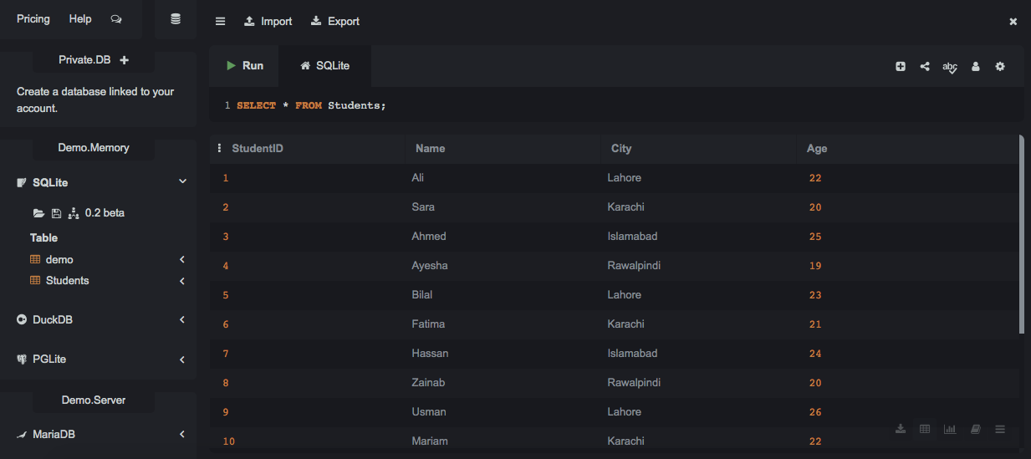This query displays all 10 records from the Students table.
Query 2: Show students from a specific city
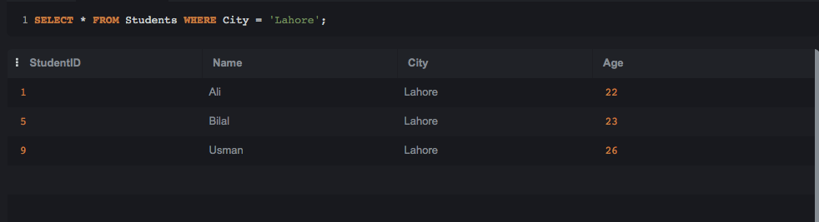
This query filters and displays only students from Lahore.
Query 3: Show students older than 20
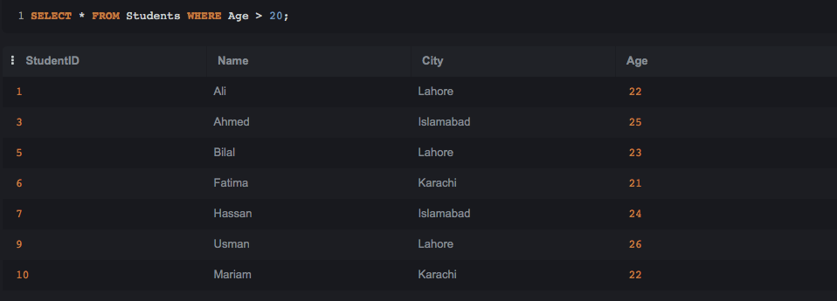
This query displays students whose age is greater than 20.
Query 4: Sort students by Name
This query displays all students sorted alphabetically by name.
Query 5: Sort students by Age
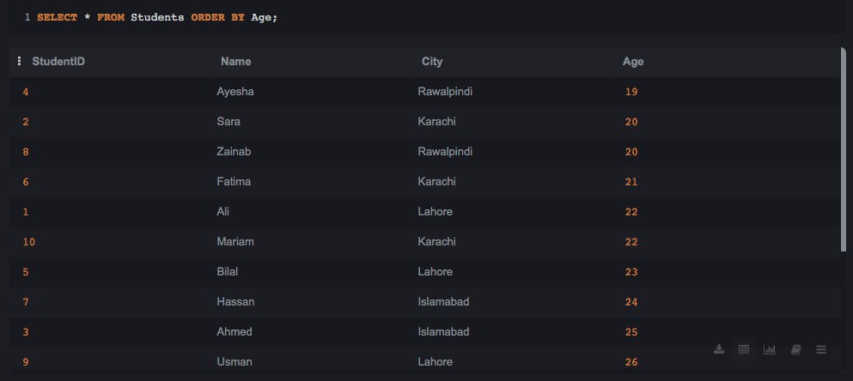
This query displays all students sorted by age in ascending order.
Query 6: Count total students
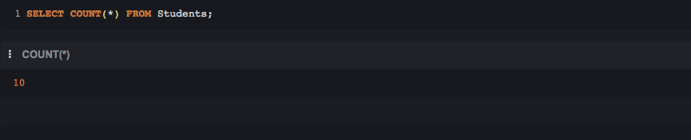
This query returns the total number of records in the Students table.
Query 7: Find maximum age
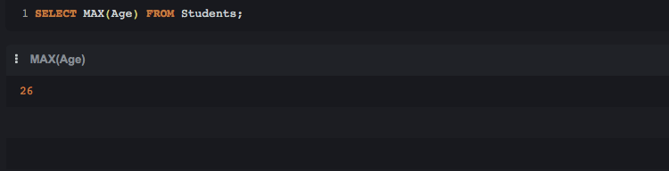
This query returns the highest age value among all students.
Query 8: Find minimum age
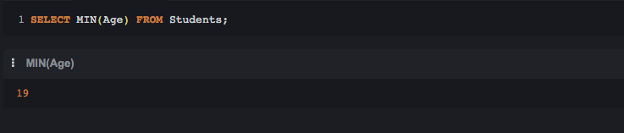
This query returns the lowest age value among all students.
Query 9: Update a student's city
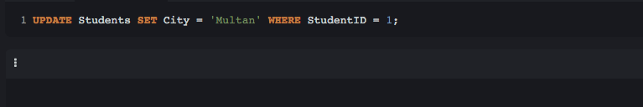
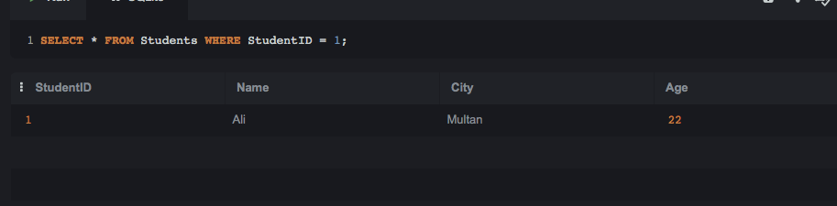
This query updates StudentID 1's city to "Multan," and the confirmation query shows the updated record.
Query 10: Delete a record

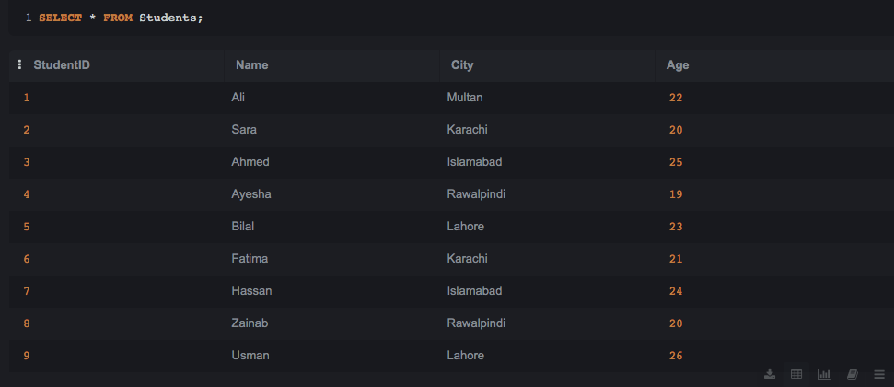
This query deletes the record with StudentID 10, and the confirmation query shows only 9 remaining records.

