JIRA Practice – Day 4

Screenshot 1: JIRA Dashboard ("For You" page)
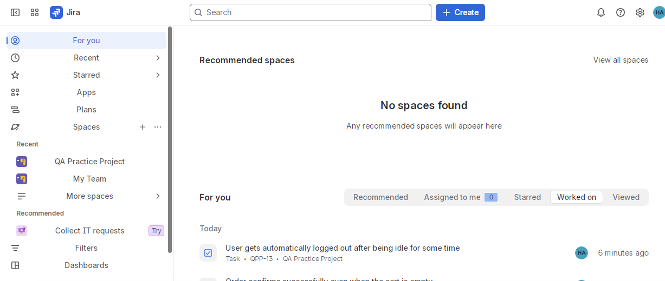
This is the JIRA home dashboard, showing recent activity across my project, including the most recently created task.

Screenshot 2: QA Practice Project – Board View
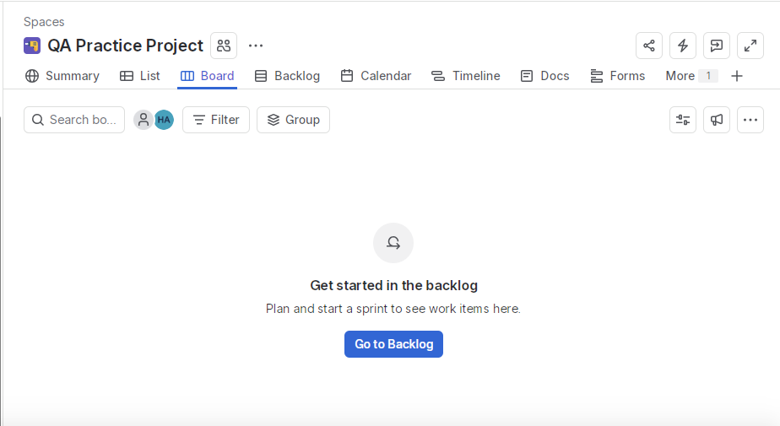
This is the Board view of my "QA Practice Project." Since no sprint has been started yet, it shows a prompt to begin from the Backlog.

Screenshot 3: Backlog Overview
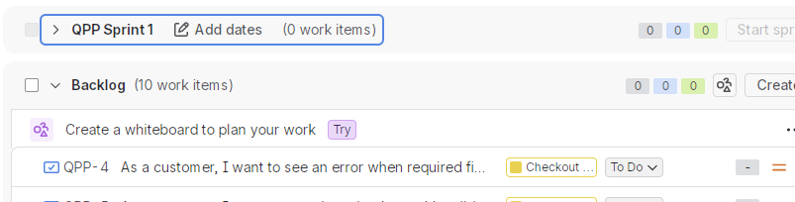
This is the Backlog view of the project, showing Sprint 1 and a total of 10 work items created for this project.

Screenshot 4: User Stories (Items)
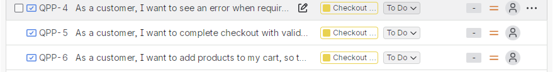
These are the 3 User Stories created under the "Checkout System Testing" Epic, written from the customer's perspective (e.g., "As a customer, I want to...").

Screenshot 5: Tasks
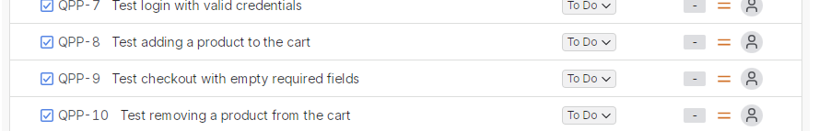
These are 4 of the 5 Tasks created for testing specific checkout-related functionality, such as login, adding to cart, and checkout validation.

Screenshot 6: Bugs (logged as Tasks)
These are the 2 real bugs found during testing (empty cart allowing order confirmation, and the idle-logout issue), logged as Tasks since this JIRA template did not include a separate "Bug" issue type.

