Postman Screenshots – Day 8
Screenshot 1 — Postman Setup
Endpoint: N/A
This shows the initial Postman workspace with an empty request tab, along with the "Get data" and "Post data" requests from an earlier collection.
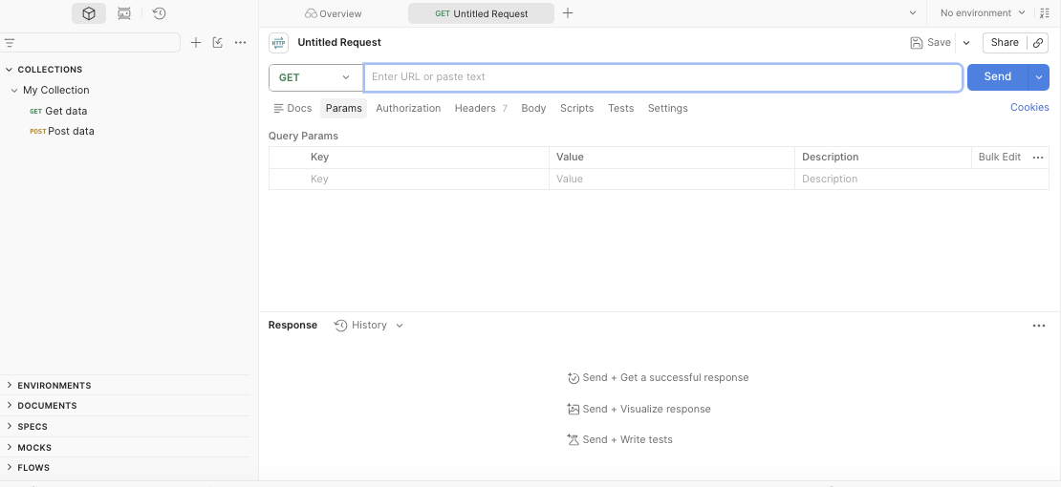

Screenshot 2 — GET All Users (with Headers)
Method: GET
Endpoint: https://jsonplaceholder.typicode.com/users
What I tested: I sent a request to fetch all users and inspected the Headers tab to observe what information is automatically sent with a request.
Headers Observed: Cache-Control, Postman-Token, Host, User-Agent, Accept, Accept-Encoding, Connection
Expected Result: The API should return all users with a 200 OK response, and headers should be visible.
Actual Result: 200 OK received, users returned in JSON format, headers displayed correctly.
Result: ✅ PASS
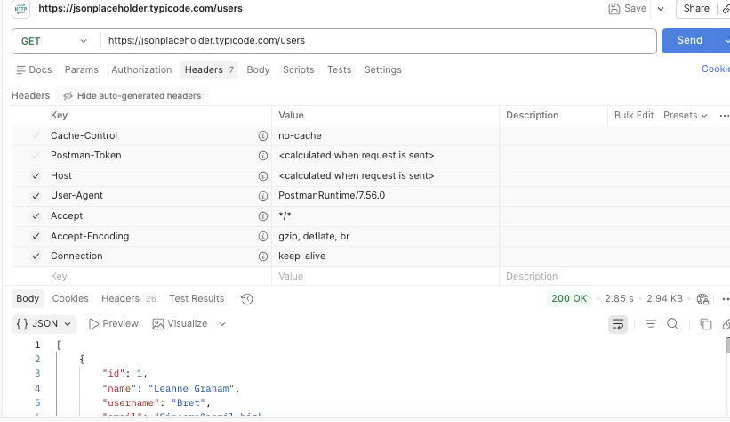

Screenshot 3 — Query Parameter
Method: GET | Endpoint: https://jsonplaceholder.typicode.com/posts?userId=1
Query Parameter: userId = 1
What I tested: Whether the API could filter posts by a specific user ID using a query parameter.
Expected Result: Only posts belonging to userId 1 should be returned.
Actual Result: Posts belonging to userId 1 were returned successfully with 200 OK.
Result: ✅ PASS
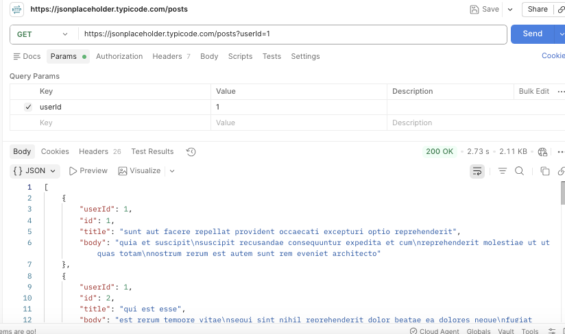

Screenshot 4 — Path Parameter
Method: GET | Endpoint: https://jsonplaceholder.typicode.com/posts/5
Path Parameter: 5
What I tested: Whether the API could retrieve the specific post with ID 5.
Expected Result: The API should return only Post ID 5.
Actual Result: Post ID 5 was returned successfully with 200 OK.
Result: ✅ PASS
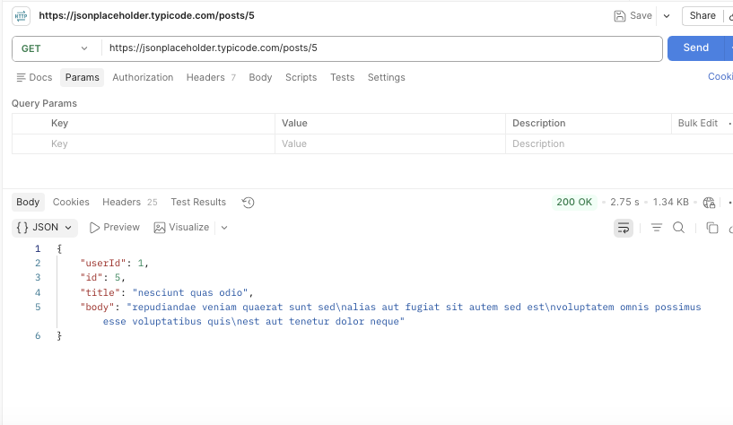

Screenshot 5 — Creating an Environment Variable
This shows the creation of a new Postman Environment ("New Environment") to store reusable values like the base URL.
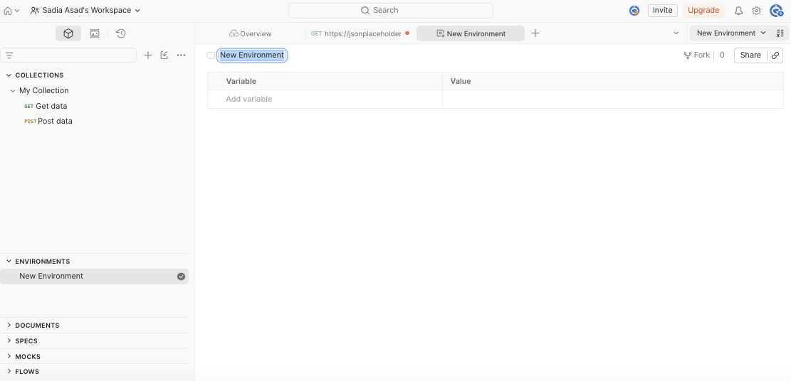

Screenshot 6 — Using the Environment Variable
Method: GET | Endpoint: {{base_url}}/posts
Environment: QA API Environment | Variable: base_url = https://jsonplaceholder.typicode.com
What I tested: Whether Postman could correctly replace {{base_url}} with the stored URL and send the request successfully.
Expected Result: The request should resolve {{base_url}} and return a successful response.
Actual Result: The request was sent successfully using {{base_url}} and returned 200 OK.
Result: ✅ PASS
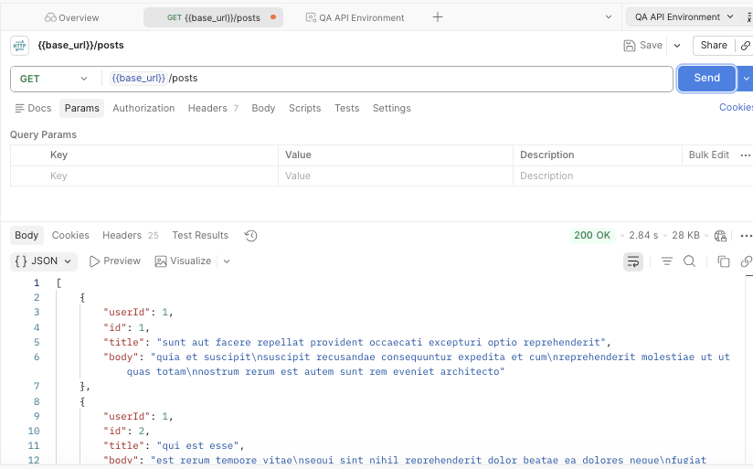

Screenshot 7 — Creating the QA API Practice Collection
This shows the newly created, empty "QA API Practice" collection used to organize all of today's requests.
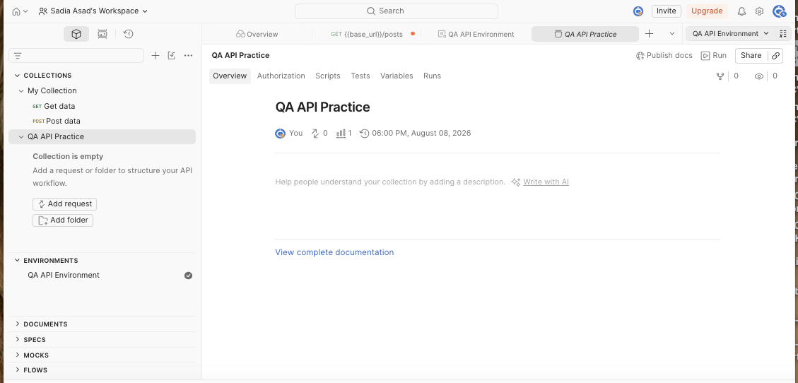

Screenshot 8 — GET All Users (Saved in Collection)
Method: GET | Endpoint: {{base_url}}/users
Collection: QA API Practice
What I tested: I organized and re-ran the GET All Users request inside the collection.
Expected Result: The request should execute successfully from within the collection.
Actual Result: 200 OK received, users returned in JSON format.
Result: ✅ PASS
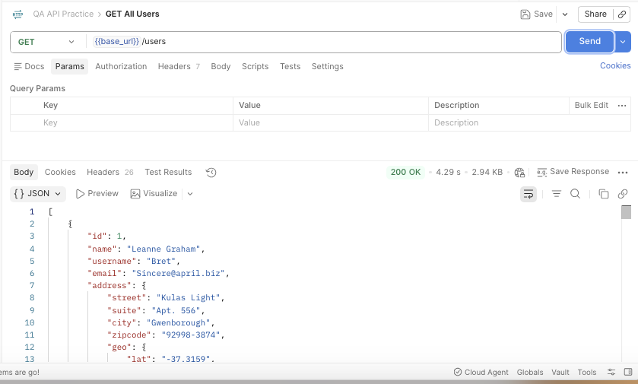

Screenshot 9 — GET Single User
Method: GET | Endpoint: {{base_url}}/users/1
Path Parameter: 1
What I tested: Whether the API could retrieve User ID 1 specifically.
Expected Result: User ID 1 should be returned with 200 OK.
Actual Result: User ID 1 was returned successfully in JSON format.
Result: ✅ PASS
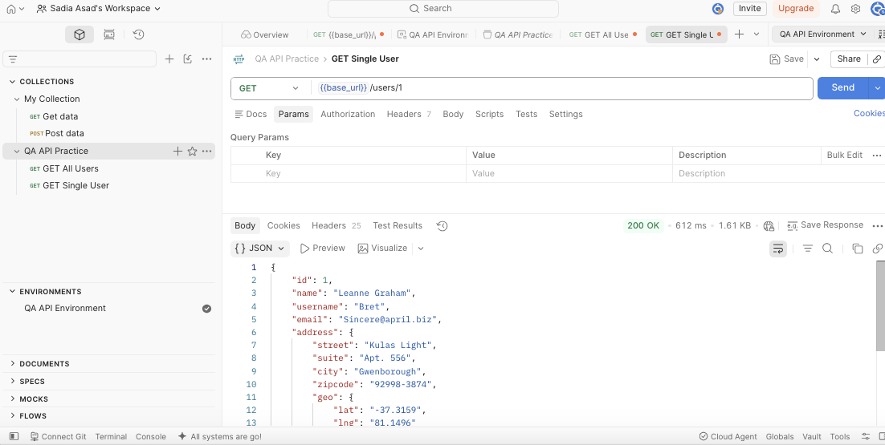

Screenshot 10 — GET Comments
Method: GET | Endpoint: {{base_url}}/comments
What I tested: Whether the API could successfully retrieve the comments list.
Expected Result: A list of comments should be returned successfully.
Actual Result: Comments were returned successfully with 200 OK.
Result: ✅ PASS
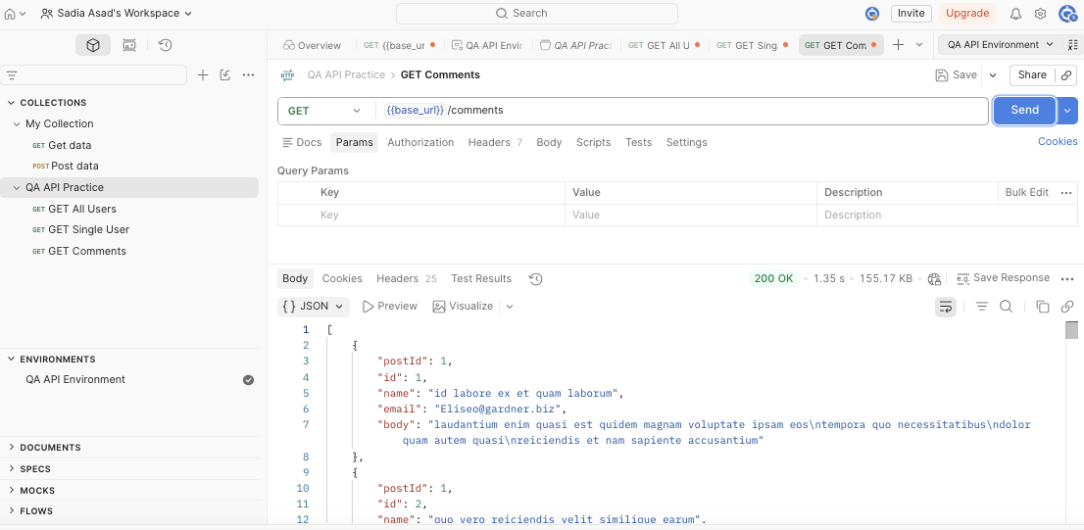

Screenshot 11 — GET Posts by User (Query Parameter, in Collection)
Method: GET | Endpoint: {{base_url}}/posts?userId=1
What I tested: API filtering using the userId query parameter, saved within the collection.
Expected Result: Posts belonging to User ID 1 should be returned.
Actual Result: Posts belonging to User ID 1 were returned successfully with 200 OK.
Result: ✅ PASS
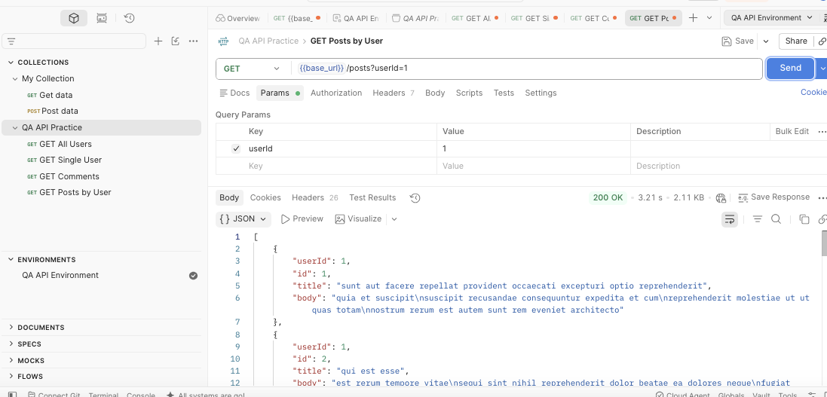

Screenshot 12 — POST Create New Post
Method: POST | Endpoint: {{base_url}}/posts
Request Body:
json
{ "title": "QA Day 8 Practice", "body": "I am learning API testing with Postman.", "userId": 1 }
What I tested: Whether the API could create a new post using the submitted JSON data.
Expected Result: A new post should be created and the API should return 201 Created.
Actual Result: 201 Created received with the new post's information.
Result: ✅ PASS
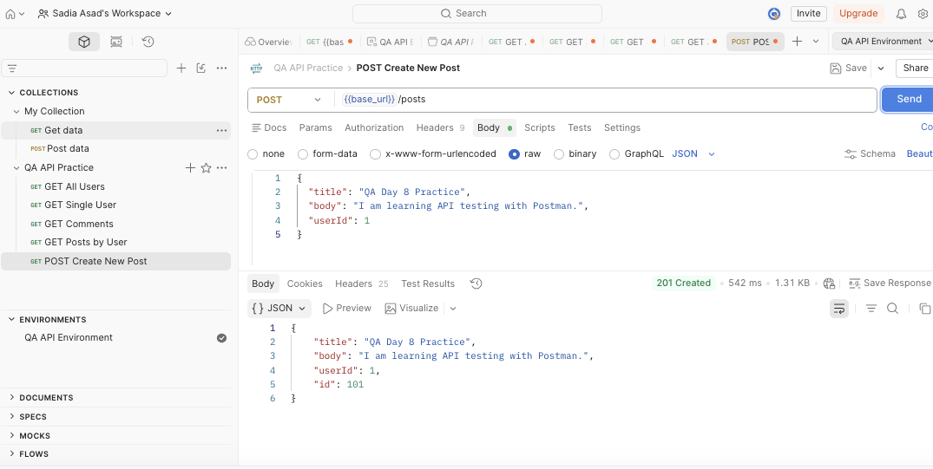

Screenshot 13 — PUT Update Post
Method: PUT | Endpoint: {{base_url}}/posts/1
Request Body:
json
{ "id": 1, "title": "Updated QA Post", "body": "I updated this post using PUT request.", "userId": 1 }
What I tested: Whether the existing post could be updated using PUT.
Expected Result: The post should be updated and return 200 OK.
Actual Result: 200 OK received with updated post information.
Important QA Point: PUT updates an existing resource, so 200 OK is the correct successful response (not 201, which is for creating new resources).
Result: ✅ PASS
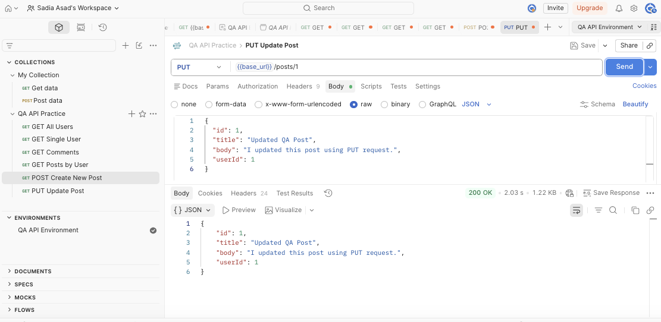

Screenshot 14 — DELETE Post
Method: DELETE | Endpoint: {{base_url}}/posts/1
What I tested: Whether the API could successfully process a delete request for Post ID 1.
Expected Result: The API should successfully process the DELETE request.
Actual Result: 200 OK received, request processed successfully.
Result: ✅ PASS
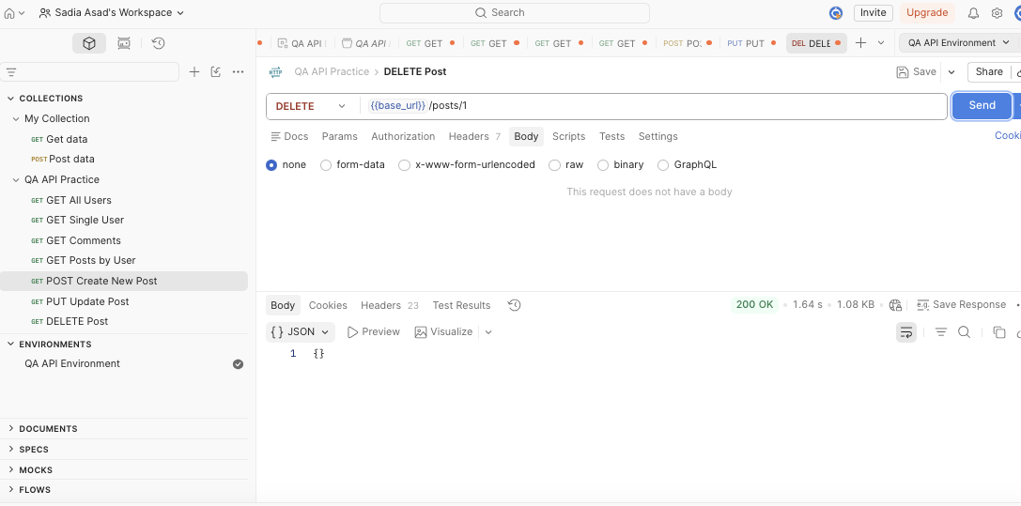

🎯 Final Conclusion
During Day 8, I practiced API testing using Postman and learned how to:
- Inspect API Headers
- Use Query Parameters
- Use Path Parameters
- Use Request and Response Bodies
- Create and use Environment Variables
- Create and organize a Postman Collection
- Validate API responses
- Test GET, POST, PUT, and DELETE requests
All practical API requests were successfully executed and validated.
Overall Result: PASS ✅

