Screenshots – Day 9 (DevTools Practice)
1. Elements Tab — Login Button
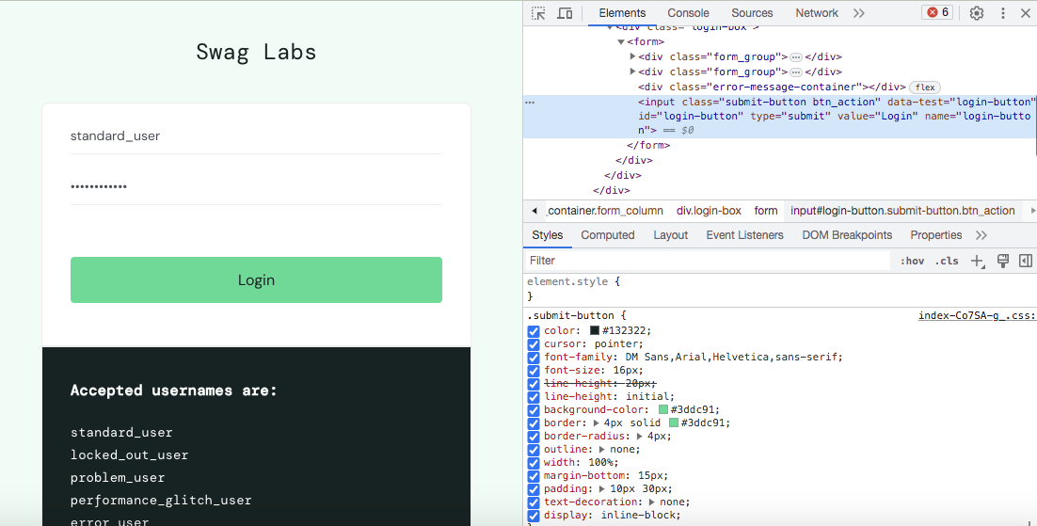
Inspected the Login button's HTML structure.
2. Elements Tab — Username Field
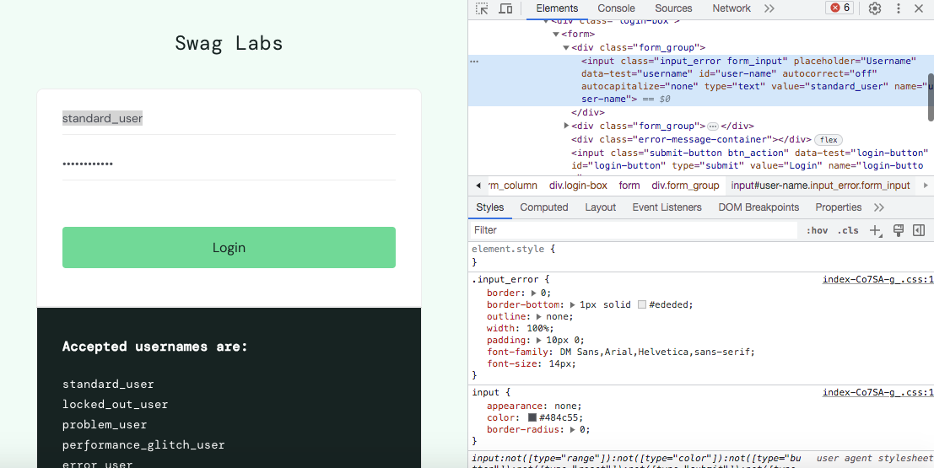
Inspected the Username input field's HTML.
3. Elements Tab — Password Field
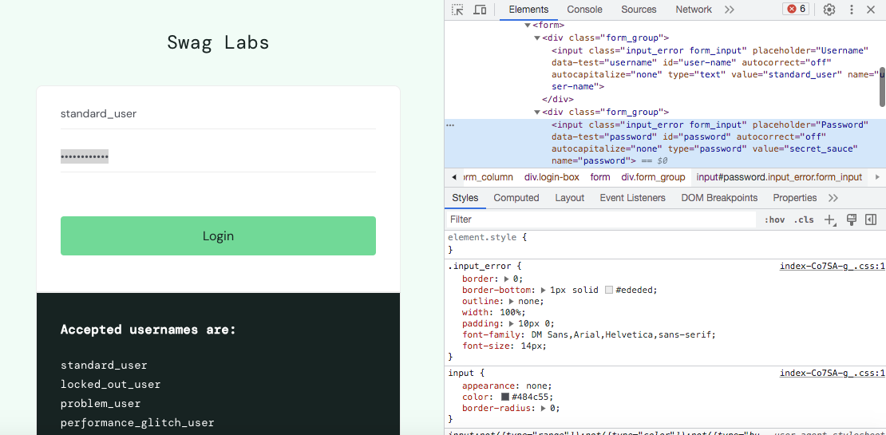
Inspected the Password input field's HTML.
4. Elements Tab — Product Card
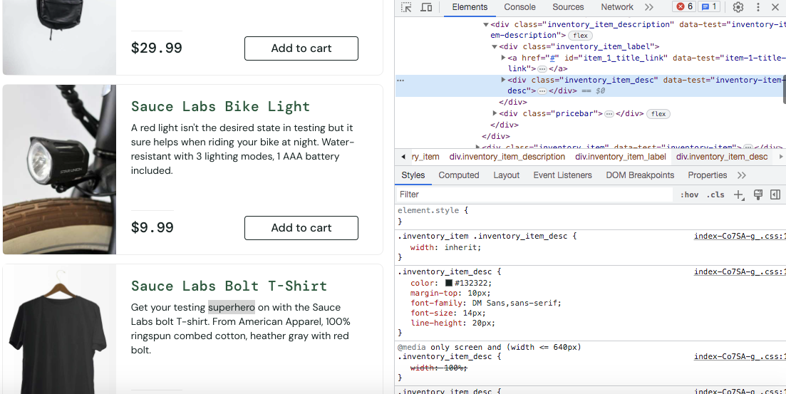
Inspected the HTML structure of a product card.
5. Network Tab — All Requests
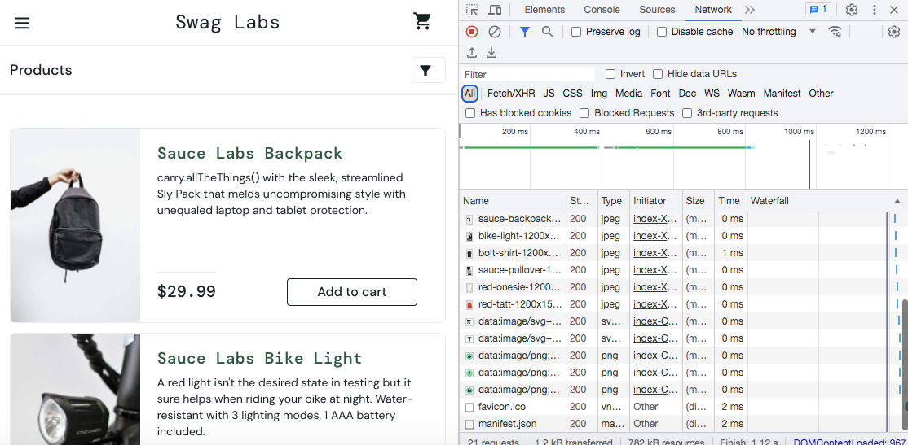
Observed all requests sent when the page was refreshed, including status codes and response times.
6. Network Tab — Fetch/XHR Filtered
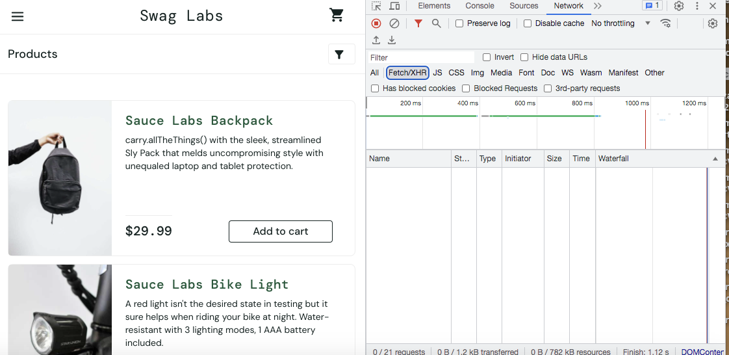
Filtered requests to show only Fetch/XHR (actual data) calls.
7. Console Tab
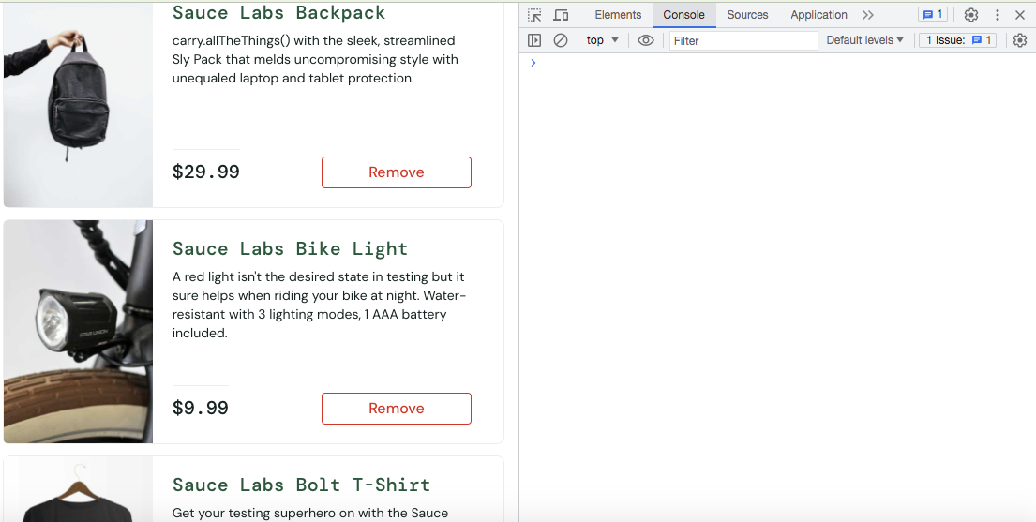
No errors or warnings were found in the Console.
8. Application Tab — Cookies
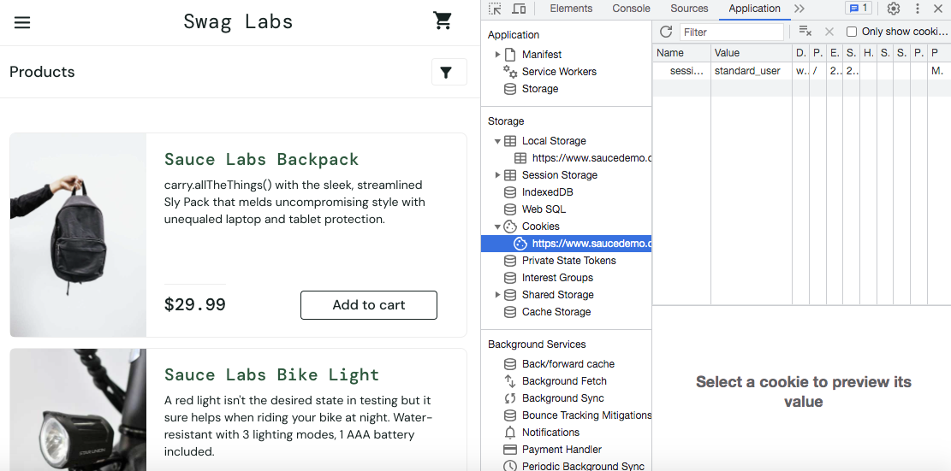
Cookie storing the logged-in session (standard_user).
9. Application Tab — Local Storage
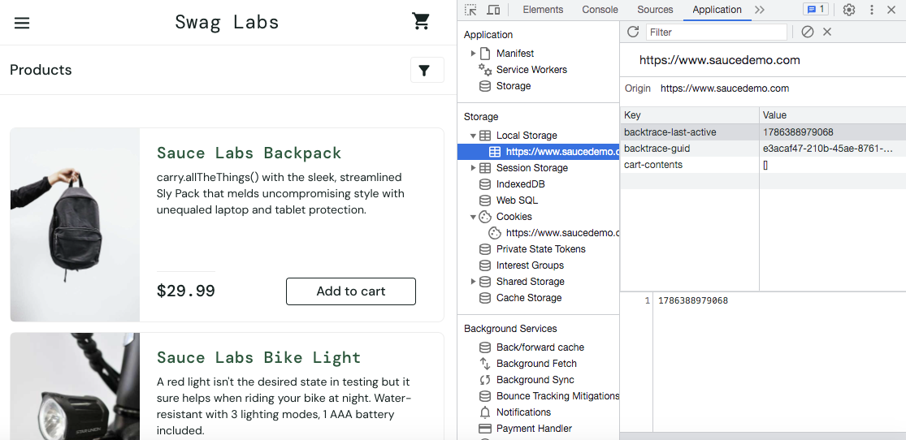
Local Storage showing key-value pairs, including cart contents.
10. Application Tab — Session Storage
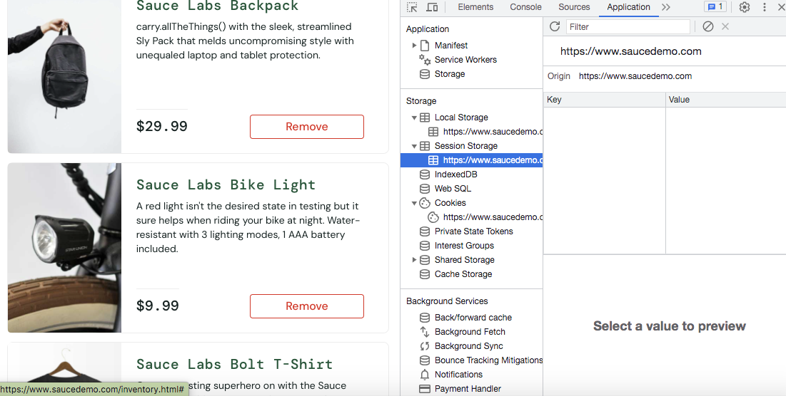
Session Storage was empty for this application.

