Day 7 – Postman API Testing Screenshots
Tool: Postman Web
API: JSONPlaceholder

Purpose
This document contains screenshots of API requests performed using Postman as part of Day 7 Manual QA API Testing training.

Screenshot 1 – GET All Posts

Request
Method: GET
Endpoint:
https://jsonplaceholder.typicode.com/posts

What was tested?
The GET request was used to retrieve all posts from the API.

Expected Result
The API should return a list of posts with a successful HTTP status code.

Actual Result
The API returned the posts successfully with 200 OK.

Test Result
PASS ✅
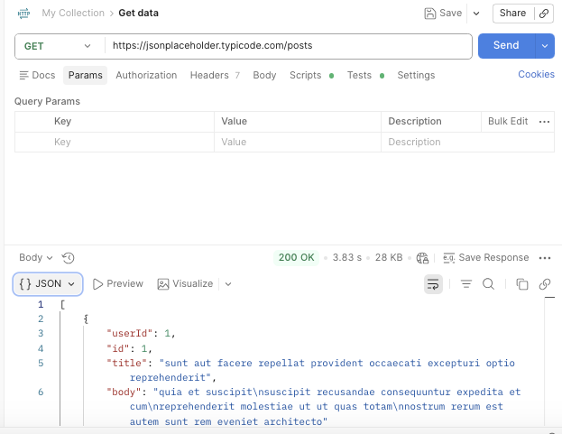

Screenshot 2 – GET Post #1

Request
Method: GET
Endpoint:
https://jsonplaceholder.typicode.com/posts/1

What was tested?
The request was used to retrieve a specific post with ID 1.

Expected Result
Post ID 1 should be returned successfully.

Actual Result
Post ID 1 was returned with 200 OK.

Test Result
PASS ✅

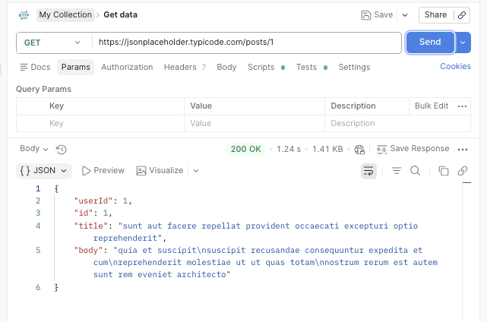

Screenshot 3 – GET All Users

Request
Method: GET
Endpoint:
https://jsonplaceholder.typicode.com/users

What was tested?
The request was used to retrieve all users from the API.

Expected Result
The API should return a list of users in JSON format.

Actual Result
Users were returned successfully with 200 OK.

Test Result
PASS ✅

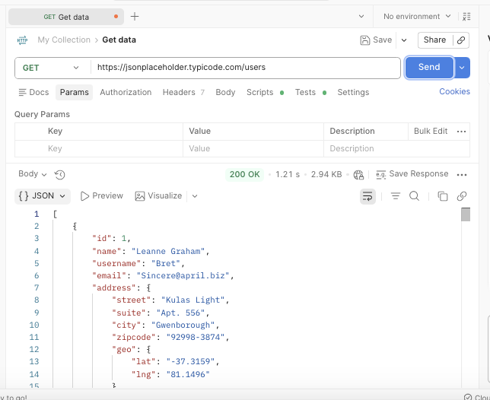

Screenshot 4 – POST Create New Post

Request
Method: POST
Endpoint:
https://jsonplaceholder.typicode.com/posts

What was tested?
A POST request was used to send JSON data and create a new post.

Request Body
{ "title": "QA Training Test", "body": "This is my first POST request in Postman.", "userId": 1 }

Expected Result
A new post should be created successfully.

Actual Result
The API returned 201 Created with the submitted post data.

Test Result
PASS ✅

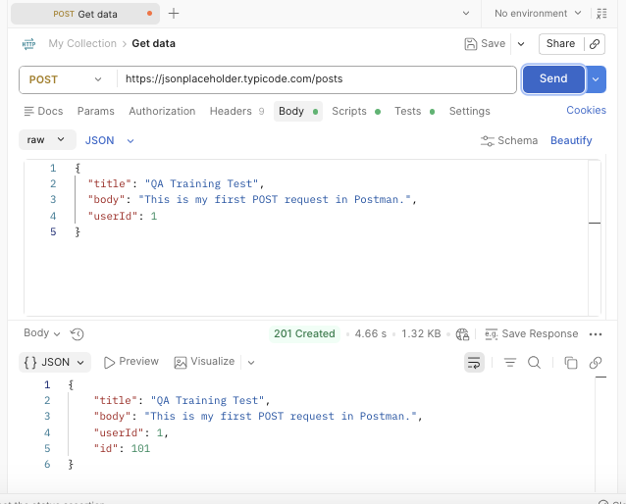

Screenshot 5 – PUT Update Post #1

Request
Method: PUT
Endpoint:
https://jsonplaceholder.typicode.com/posts/1

What was tested?
A PUT request was used to update an existing post.

Request Body
{ "id": 1, "title": "Updated QA Training Post", "body": "I have updated this post using PUT in Postman.", "userId": 1 }

Expected Result
Post #1 should be updated successfully.

Actual Result
The updated post was returned with 200 OK.

Test Result
PASS ✅

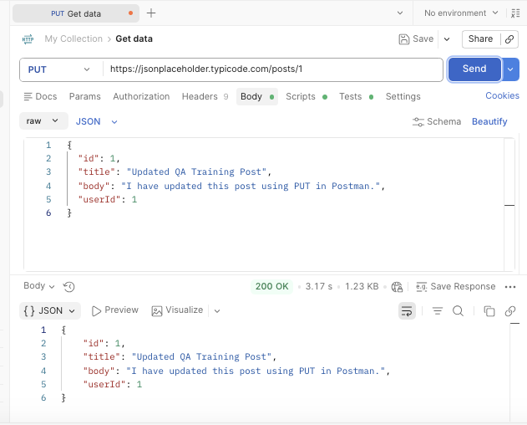

Screenshot 6 – DELETE Post #1

Request
Method: DELETE
Endpoint:
https://jsonplaceholder.typicode.com/posts/1

What was tested?
A DELETE request was sent to remove post #1.

Expected Result
The API should process the delete request successfully.

Actual Result
The API returned 200 OK, indicating that the request was processed successfully.

Test Result
PASS ✅

