DAY 12 – BUG REPORT

BUG REPORT 01
Bug ID: BUG-001
Test Case ID: TC_09
Bug Title: Search with invalid/non-existing product does not display a "No Results" message
Module: Search
Severity: Moderate
Priority: Low
Environment:
Browser: Chrome
OS: Windows 10
Reported By: Sadia
Date Reported: 19/08/2026

Preconditions
User is on the Products/Search page.

Steps to Reproduce
- Open the Products page.
- Enter an invalid/non-existing search term.
- Click the Search button.

Test Data
Search Term: bnhgh

Expected Result
System should display an appropriate "No Results" or "No products found" message when no matching product is available.

Actual Result
Search page opened, but no "No Results" message was displayed.

Bug Description
When a user searches for a product that does not exist, the system does not provide a clear message indicating that no matching products were found.

Attachment / Screenshot

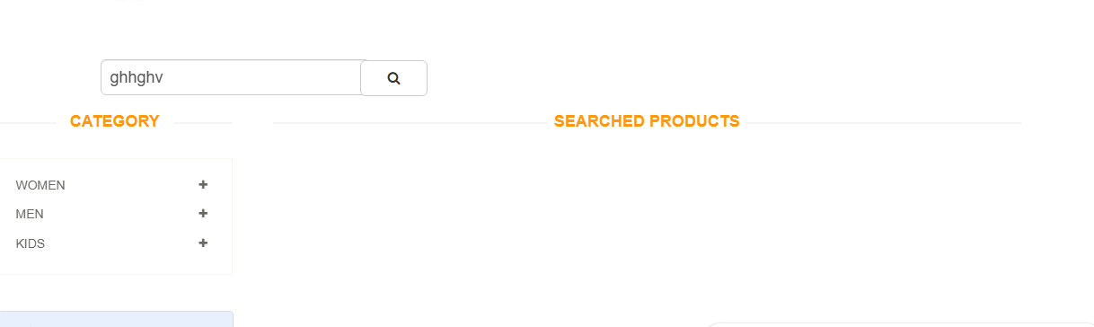

Status
Open

BUG REPORT 02
Bug ID: BUG-002
Test Case ID: TC_10
Bug Title: Cart icon does not display the updated item count after adding a product
Module: Cart
Severity: High
Priority: High
Environment:
Browser: Chrome
OS: Windows 10
Reported By: Sadia
Date Reported: 19/08/2026

Preconditions
User is on the Products page.

Steps to Reproduce
- Open the Products page.
- Select a product.
- Click "Add to Cart".
- Observe the cart icon.

Test Data

Expected Result
Product should be added to the cart, and the cart icon should display the updated number of items.

Actual Result
Product was added to the cart, but no item count number appeared on the cart icon.

Bug Description
After adding a product to the cart, the cart icon does not display the number of products currently added.

Attachment / Screenshot

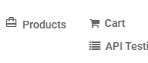

Status
Open

BUG REPORT 03
Bug ID: BUG-003
Test Case ID: TC_11
Bug Title: Cart icon does not display the number of added products
Module: Cart
Severity: High
Priority: Medium
Environment:
Browser: Chrome
OS: Windows 10
Reported By: Sadia
Date Reported: 19/08/2026

Preconditions
Products have already been added to the cart.

Steps to Reproduce
- Add one or more products to the cart.
- Observe the cart icon.

Test Data

Expected Result
The cart icon should display the correct number of products added to the cart.

Actual Result
No number was displayed on the cart icon.

Bug Description
The cart icon does not show the current number of products added to the cart.

Attachment / Screenshot

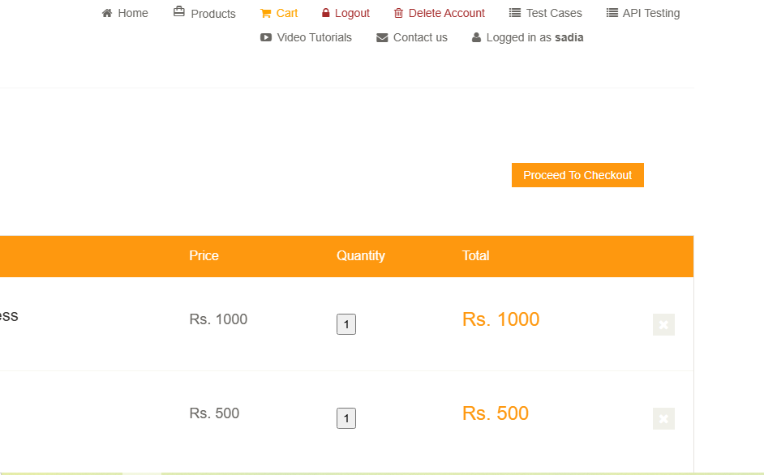

Status
Open

BUG REPORT 04
Bug ID: BUG-004
Test Case ID: TC_12
Bug Title: No option is available to remove a product from the cart
Module: Cart
Severity: High
Priority: High
Environment:
Browser: Chrome
OS: Windows 10
Reported By: Sadia
Date Reported: 19/08/2026

Preconditions
Products have already been added to the cart.

Steps to Reproduce
- Add a product to the cart.
- Open the Cart.
- Attempt to remove the product.

Test Data

Expected Result
User should have an option to remove the selected product from the cart.

Actual Result
No option was available to remove the product from the cart.

Bug Description
The cart does not provide an available option for the user to remove an added product.

Attachment / Screenshot

Status
Open

BUG REPORT 05
Bug ID: BUG-005
Test Case ID: TC_15
Bug Title: Order can be completed using an expired card date
Module: Checkout / Payment
Severity: High
Priority: High
Environment:
Browser: Chrome
OS: Windows 10
Reported By: Sadia
Date Reported: 19/08/2026

Preconditions
User is placing an order and is on the payment section.

Steps to Reproduce
- Add a product to the cart.
- Proceed to checkout.
- Enter card details.
- Enter an expired card expiry date.
- Submit/place the order.

Test Data
Expiry Date: 04/1993

Expected Result
System should identify the expired card date and prevent the order from being completed.

Actual Result
Order was completed despite the expired card date.

Bug Description
The checkout/payment process allows an order to be completed even when an expired card expiry date is entered.

Attachment / Screenshot

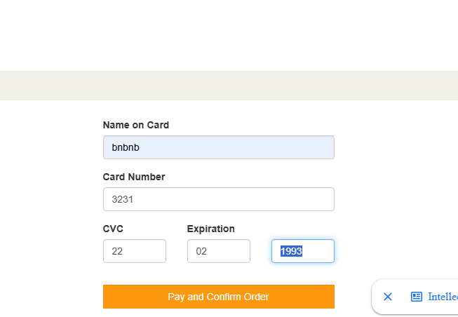

Status
Open

BUG REPORT 06
Bug ID: BUG-006
Test Case ID: TC_19
Bug Title: Delete Account permanently deletes the account without a confirmation prompt
Module: Account Management
Severity: Moderate
Priority: Medium
Environment:
Browser: Chrome
OS: Windows 10
Reported By: Sadia
Date Reported: 19/08/2026

Preconditions
User is logged in.

Steps to Reproduce
- Log in to the website.
- Click "Delete Account".
- Observe the system response.

Test Data

Expected Result
System should display a confirmation prompt before permanently deleting the account.

Actual Result
Account was permanently deleted immediately without displaying a confirmation prompt.

Bug Description
The Delete Account function does not provide a confirmation step before permanently deleting the user's account.

Attachment / Screenshot

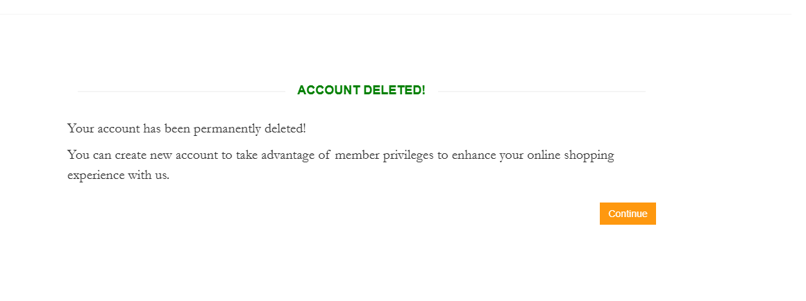

Status
Open

