STUDENT RESULTS SYSTEM ASSIGNMENT 1 DOCUMENTATION

Table of contents
1 Problem and proposed solution 2

2 Project objectives 2

3 Assignment requirements 2

4 Class design and inheritance 3

5 Objects and object interaction 3

6 Instance class and static methods 4

7 Data structure and record functions 4

8 Digital Public Goods principles 5

9 Program execution and testing 6

10 Conclusion 7

11 References 8

1 Problem and proposed solution
A small classroom results exercise needs a clear way to keep each student’s details with a course score. Separate variables can become difficult to follow when more than one learner is involved. The solution groups the details into objects and stores the added objects in one list.
The education domain matches an example in the assignment brief. The program demonstrates record creation, updates, display and result calculation. Its pass threshold is 50 for demonstration purposes; it does not claim to reproduce the university’s grading rules. The fictional records are Alieu Kamara and Hawa Conteh.

2 Project objectives
- Create a parent Person class and a child Student class with relevant attributes and methods.
- Store multiple Student objects in one list, with functions to add and display them.
- Demonstrate instance, class and static methods and interaction between two objects.
- Validate basic input values and explain the project’s DPG design choices.

3 Assignment requirements
Brief requirement | Implementation or submission item
At least two classes | Person and Student, linked through inheritance.
Attributes and methods | Name, student ID, age, course and score; update and display methods.
Object creation and interaction | Two Student objects; student1.compare_score(student2).
One list or dictionary | The students list stores added Student objects.
Add and display functions | add_student() and display_students().
Instance class and static methods | update_score(), get_total_students() and is_valid_score().
DPG explanation and source publication | README.md and MIT LICENSE supplied; GitHub upload remains a submission step.
Execution evidence and hardcopy | Captured output image and test results supplied; take a terminal screenshot of your own run.
The optional tuple extension is not used. Keeping one list makes the required data structure easy to identify. The source file contains no imports, database, persistent storage or __name__ guard.

4 Class design and inheritance

Person parent class
Person stores the details shared by student records: name, student_id and age. Its constructor checks that the name and ID contain text and that age is a non-negative integer. It removes outer spaces from the text. update_name() validates a replacement name, while display_info() prints the common attributes.

Student child class
Student inherits from Person using class Student(Person). Its constructor checks the course and score, calls super().__init__() for the shared fields, and then stores course and score. Reusing the parent constructor avoids duplicating its validation and assignments.
Attribute | Where it is defined | Meaning
name | Person | The fictional learner’s name.
student_id | Person | The ID checked for duplicates when adding to the list.
age | Person | A non-negative whole number.
course | Student | The course associated with the score.
score | Student | A numeric value from 0 to 100.
total_students | Student class | Count of successfully constructed Student objects.
Student overrides display_info(). It first calls the parent implementation, then prints the course, score and result. The attributes are public, so this example does not claim to enforce private encapsulation. Updates should use the supplied methods to preserve their checks.

5 Objects and object interaction
student1 = Student("Alieu Kamara", "S001", 21, "Python OOP", 45)
student2 = Student("Hawa Conteh", "S002", 20, "Networking", 82)
The constructor arguments give each object its own identity and result details. After creation, student1.update_name() changes Alieu’s name and student1.update_score(68) changes his score. Hawa’s attributes remain separate because each object holds its own data.
student1.compare_score(student2)
This instance method receives another Student object. It reads the other object’s score and returns a sentence identifying the higher score, or a message for equal scores. It rejects a non-Student comparison target. The comparison demonstrates object interaction; scores from different courses are not treated as a meaningful academic ranking.

6 Instance class and static methods
Method | Method type | Purpose
update_name(new_name) | Instance | Validate and replace the name inherited from Person.
update_score(new_score) | Instance | Change one student’s score after validation.
get_result() | Instance | Return Pass at 50 or above, otherwise Needs improvement.
compare_score(...) | Instance | Compare scores held by two Student objects.
display_info() | Instance | Print common and student-specific details.
get_total_students() | Class | Return total_students through cls.
is_valid_score(score) | Static | Check a value without depending on an individual object.

Instance methods
An instance method uses self to access one object. For example, update_score() changes self.score. A rejected update raises ValueError before assignment, so the existing score remains unchanged. display_info() also uses self to display the particular object’s details.

Class method
The @classmethod decorator supplies cls. get_total_students() reads the shared class counter. The counter increases only after a Student constructor completes successfully. It counts created objects, not the number of records accepted into the list.

Static method
The @staticmethod decorator defines a function associated with Student that needs neither self nor cls. is_valid_score() accepts only int or float values in the inclusive range 0 to 100. The exact type check excludes booleans. Values outside the range, NaN and infinity do not pass the check.

7 Data structure and record functions
students = []
add_student(student1)
add_student(student2)
display_students()
The single students list stores the added objects. add_student() first rejects a non-Student object, then loops through existing records to check the ID. A matching ID is rejected. Otherwise, append() adds the object. display_students() prints a message for an empty list or loops through the objects and calls each display method.

8 Digital Public Goods principles

Open source
The source is accompanied by an MIT license and a README explaining use, design and example output. The license permits reuse under its stated terms. Publishing these files in a public GitHub repository will complete the brief’s publication step. No repository upload has been performed as part of this package (Open Source Initiative, n.d.).

Inclusive and accessible design
The program uses clear text labels and messages instead of requiring colour recognition. It needs only Python 3 and no package installation or network connection. Its comments and small classes help beginners follow the code. These are practical accessibility choices for a classroom console example; the project has not undergone a formal accessibility audit.

Privacy respecting demonstration data
All example records are fictional. The program does not ask for real student information, write files, contact a server or use a database. Record values exist during execution and are printed locally. Names, IDs, ages and scores would become personal information if real records were substituted, so public submission material must continue to use fictional data.

Modular and reusable design
Person handles shared identity fields, while Student adds course and result behaviour. The two record functions handle list operations. A future example can reuse the parent class without copying its constructor. The score validator can be called independently through Student.is_valid_score().

Scope of the alignment claim
The implementation addresses the DPG principles named in the course brief. The full Digital Public Goods Standard contains broader requirements and a review process for recognition. This student project does not claim registry recognition or full certification (Digital Public Goods Alliance, n.d.).

Practical limitations
The solution is a demonstration rather than a production student information system. It has no login, encrypted storage, search, deletion, persistent records or interactive input menu. Running it again creates the fixed examples again. Invalid constructor and update values raise errors; the demonstration does not catch those exceptions.

9 Program execution and testing
The supplied program was executed successfully. Alieu’s updated score is 68, Hawa’s score is 82, both results are Pass, the object count is 2 and the validity check for 105 returns False. The image below renders the actual captured stdout; it is not a terminal application screenshot.
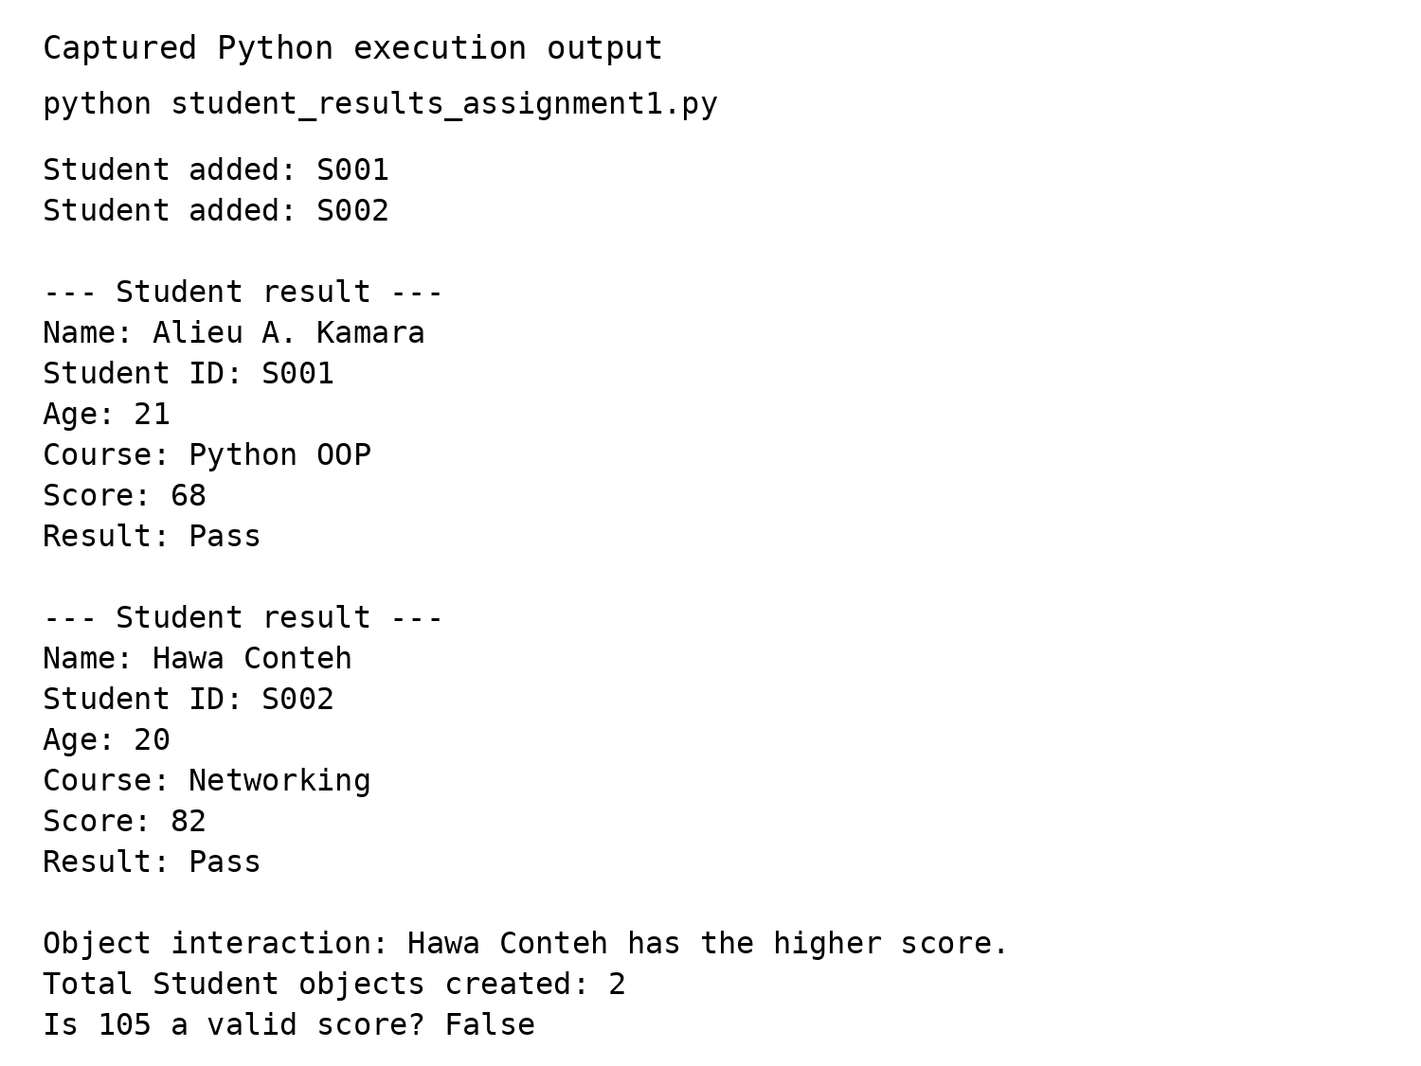
Figure 1 Captured output from running the supplied Python file
Verification passed 34 functional checks. They covered score boundaries at 0, 49.9, 50 and 100; rejection of invalid scores and ages; retained values after rejected updates; duplicate IDs; empty-list display; comparisons; and the difference between object count and stored record count. The full results are in verification_results.txt.
Before final hardcopy submission, run the program on your computer and capture a terminal screenshot showing the command and output. This supplies the personal execution screenshot requested in the brief.

11 Conclusion
The Student Results System meets the core programming requirements through two classes, one list and separate add and display functions. Person provides shared attributes, while Student inherits those details and adds a course, score and result behaviour. Constructor calls create two fictional records, and instance methods demonstrate updates.
The implementation also demonstrates the three method types. Instance methods work with individual students, a class method reports the number of constructed Student objects and a static method validates scores. compare_score() shows one object receiving and reading another object.
The program ran successfully and passed 34 functional checks. Its output matches the documented example. The README, license and fictional data support the brief’s DPG principles while keeping the work understandable for a beginner. GitHub publication, the lecturer collaborator invitation and the student’s own terminal screenshot must be completed before final submission.

12 References
Limkokwing University of Creative Technology Sierra Leone (2026). PROG211 Object Oriented Programming 1 Individual Assignment Real World Solutions under DPG Standards. Three page assignment brief supplied as OOP1 ASSIGNMENT (2)(1).pdf.
Digital Public Goods Alliance (n.d.). Digital Public Goods Standard. Available at https://www.digitalpublicgoods.net/standard (Accessed 30 October 2026).
Open Source Initiative (n.d.). The MIT License. Available at https://opensource.org/license/mit (Accessed 30 October 2026).
GitHub (n.d.). Inviting collaborators to a personal repository. Available at https://docs.github.com/en/repositories/managing-your-repositorys-settings-and-features/repository-access-and-collaboration/inviting-collaborators-to-a-personal-repository (Accessed 30 October 2026).
Student Results System (2026). Python source, captured execution output and functional verification results included in this assignment package.

