1. List three data sources Power BI can connect to.

Sql server, Excel, MySQL

1. What is the first step to import data into Power BI Desktop?

The first step to import data into PowerBI Desktop is to connect to a data source. Selecting the ‘Get data’ and connect to a specific file or data source

1. How do you refresh imported data in Power BI?

We can use the "Refresh" button in the Desktop application or the "Refresh now" option in the Power BI service

1. What file formats can Power BI import directly? (Name two.)

xlsx, csv, json, pdf

1. What does the "Navigator" window show after selecting a data source?

After selecting data source in Power BI, the ‘Navigator’ window shows:

* + The list of available tables, views and sheets from a selected data source
  + When we click on it, we can inspect the content before loading
  + There are checkboxes to select tables to select we want to load or transform
  + There are options that we can immediately load the data or we can use Power Query Editor by clicking ‘Transform data’

1. Import Sales_Data.csv and load only the "Product" and "Price" columns.

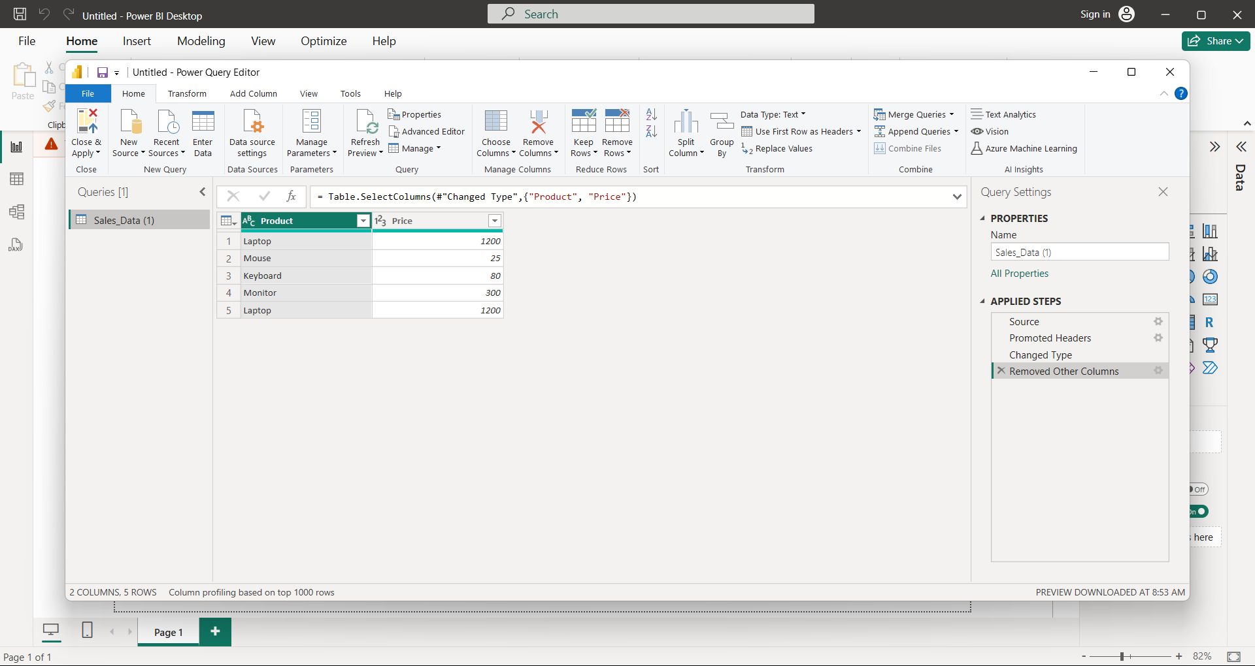

1. How would you change OrderDate to a date format during import?

1. What is the difference between "Load" and "Transform Data" in the import dialog?

If we want to make changes before importing the data we can use transform data for making hanges. Load just imports without any change.

1. Why might you see an error when connecting to a SQL database? (Name one reason.)

You might see an error when the data you're sending doesn't match the column's data type in the SQL table.

1. How do you replace a data source after importing it?

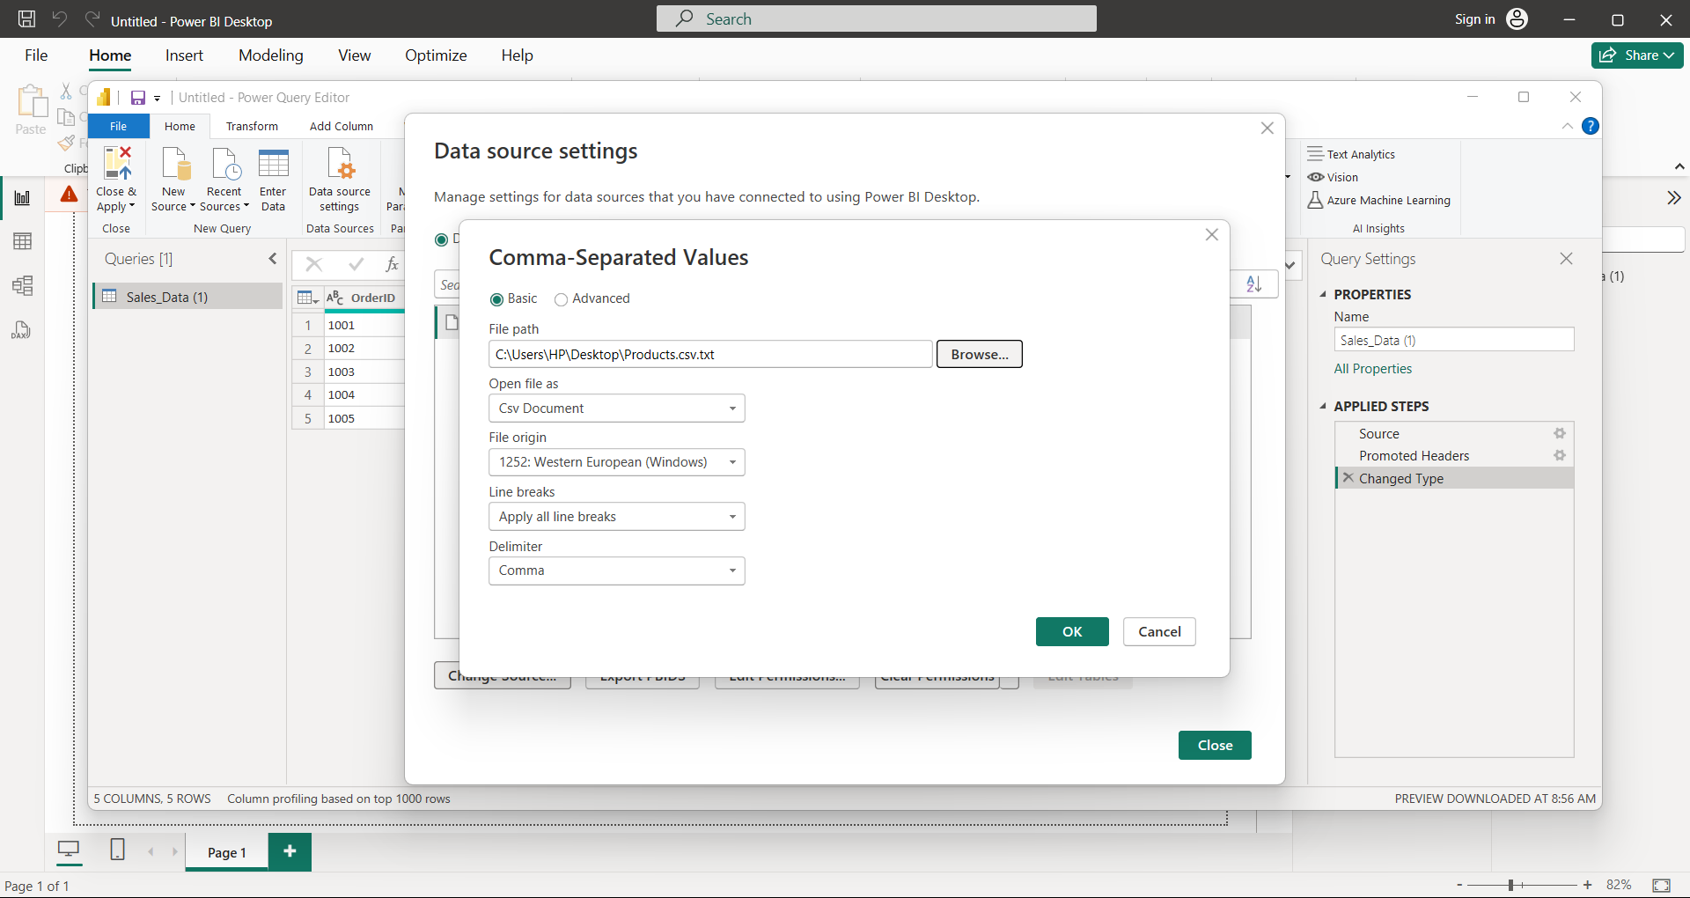

1. Write the M-code to import only rows where Quantity > 1.

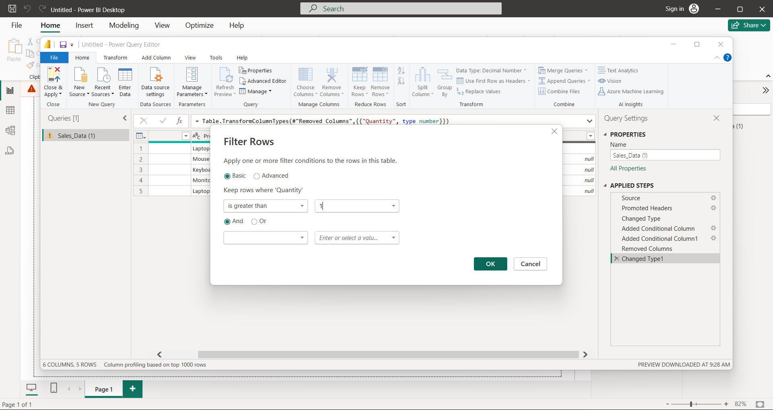

1. How would you change the data source if Sales_Data.csv changed?

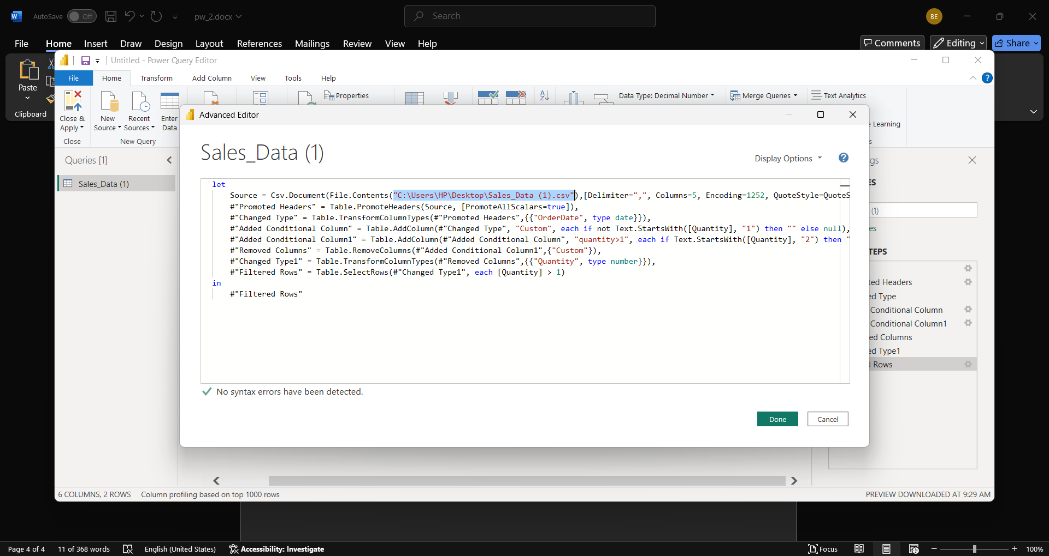

1. Troubleshoot: Your CSV import fails due to a "mixed data type" error—how do you fix it?

You can replace or remove error values using “Remove Errors” or “Replace Errors” in Power Query or choose the correct type based on the most flexible or appropriate format.

1. Connect to a live SQL database with parameters (e.g., filter by year).

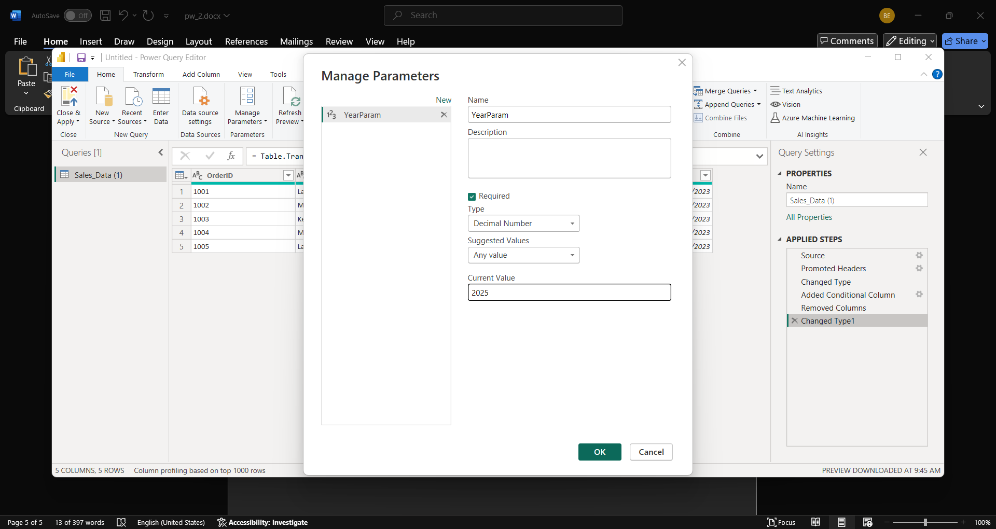

1. How would you automate data imports using Power BI and Power Automate?

To automate data imports, you can use Power BI Service to publish your report and then use Power Automate to create a flow that triggers a dataset refresh