删除的表：

1、lms_content_participations 空表

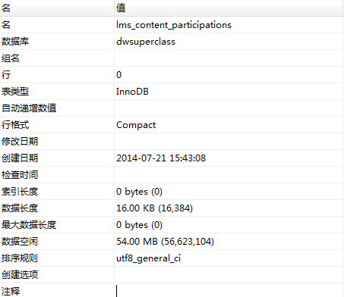

CREATE TABLE `lms_content_participations` (

`id` bigint(20) NOT NULL DEFAULT '0',

`content_type` varchar(259) DEFAULT NULL,

`content_id` bigint(20) DEFAULT NULL,

`user_id` bigint(20) DEFAULT NULL,

`workflow_state` varchar(259) DEFAULT NULL,

PRIMARY KEY (`id`)

) ENGINE=InnoDB DEFAULT CHARSET=utf8;

2、