RMIT International University Vietnam
Assignment Cover Page
Subject Code: | TCHE2695
Subject Name: | Scholarly Investigations into Learning and Teaching at RMIT
Location & Campus: | SGC
Title of Assignment: | Assignment 3
Student name: | Bin Youn
Student Number: | s4198749
Teacher's Name: | Dr Ebony Coletu
Assignment due date: | 18 Sep
Date of Submission: | 21 Sep
Word Count: | Body 4,889
AI use statement: | I declare that I have used AI (Claude) for the following limited purposes:  1. Grammar checking and proofreading, to improve clarity and correct errors.  2. Reference formatting, to ensure consistent Harvard-style formatting.  3. Structural organisation, to help arrange my paper with references.  I confirm that all content, experiences, insights, and critical analysis are entirely my own, consistent with how I have written throughout the Graduate Certificate. AI was used solely as a proofreading, formatting, and structuring aid.

A System for Making Collaborative Learning Visible Across a Design Degree
PACE: Practice for Adaptive, Connected and Critically Engaged

Abstract
Industry keeps naming the same gap in design graduates: not technical skill, but the human capabilities of collaboration, adaptability, and handling critique. Artificial intelligence raises the stakes, since it commoditises the technical and leaves these human capabilities as a graduate’s durable value. Yet these capabilities form through informal interaction across a whole degree, and current assessment, which reads the final artefact, never sees them. This capstone treats that invisibility as a design problem: how can collaborative learning be connected across a degree and made visible, without changing course learning outcomes? Situated in the Digital Media program at RMIT University Vietnam and conducted as design-based research, it draws on collaborative learning theory, programmatic assessment, and self-determination theory, analysing existing student and industry data and testing the design with three educators and industry partners. The output is PACE (Practice for Adaptive, Connected and Critically Engaged), a system that spans the degree rather than redesigning it. From the first year, short workshops guide students to take part in collaborative and public work and to reflect on it; what accumulates is not a set of separate credentials but a growing record of traces of learning, which becomes assessable only in the final-stage course. A working prototype demonstrates it, and testing honestly reshaped the design, moving it from a points system toward traces of learning. For students whose real growth goes unrecorded, and for the program and partners who prepare them, PACE makes visible what has always mattered but rarely counted.
Keywords: collaborative learning; traces of learning; programmatic assessment; career development learning; design education; design-based research
1. Introduction
When I began teaching in the Digital Media program at RMIT University Vietnam, I assumed that my task was to help students make better work. Over five semesters of leading exhibitions and workshops, and mentoring projects, I came to see that the students who struggled most were rarely those who lacked technical skill. They were those who could not yet work across difference, adapt when a brief changed, or absorb hard feedback without taking it personally. The most capable makers were not always the most employable graduates, and the difference lay in capabilities our assessment never named.
This paper asks how a design program can make such collaboratively formed and adaptive capability visible and assessable across a degree, without adding new courses or rewriting course learning outcomes. The question matters now for two reasons: as artificial intelligence commoditises technical skills, a graduate’s durable value shifts toward the human capabilities hardest to automate, and the Digital Media program is being rebuilt as Digital Design, a change decided at curriculum-architecture level and pending approval in Vietnam. A program under redesign is precisely when a new capability structure can be built in rather than retrofitted.
My response is PACE: Practice for Adaptive, Connected and Critically Engaged, a system that spans the degree rather than redesigning it. A student leaves a trace through genuine participation in collaborative and public work, and deepens it through reflection; the record feeds Career Development Learning and can count toward assessment through existing mechanisms. I developed and tested PACE as design-based research, testing it against institutional data and interviews with three educators and industry partners. Its central finding is that PACE is strongest as a developmental, visibility-focused record, sharpened, not simply confirmed, by the evidence.
2. The problem
A gap that students do not see
The graduate capability gap in creative disciplines is well documented, but in my own program it takes a revealing shape: students misperceive where their gap lies. In a Future Readiness survey of seventeen Digital Media students (Semester 1, 2026), when asked where the biggest gap sat between their abilities and industry expectations, nine named technical or hard skills. Only one named communication. On the students' own account, the work to be done before employment is technical.
The industry view inverts this. In supervisor feedback on Digital Media interns (COMM2584, Semester 3 2025), the leading area for improvement was communication, at twenty per cent, followed by time management and technical skill, the exact capability the survey above shows students rating lowest as their own gap. Students systematically under-weight this capability relative to what industry rewards.
A capability that can be produced, but is not seen
If the gap forms between people, the question is whether collaborative learning can be produced inside a program and, if so, why it remains invisible. The M-NODE cross-cultural workshop offers evidence that it can: twelve RMIT Digital Media students paired with six DIMA (Korea) peers for a hackathon and field-research trip in January 2026, rating the experience 9.0 out of 10, with prototyping confidence rising twenty-five per cent. The learning they described, communicating across cultures, dividing work across an unfamiliar team, was collaborative, yet none of it appears on a transcript. It was produced, it was felt, and it left no formal trace, the specific problem PACE addresses.
Why the CV, and the internship, do not close the gap
The usual instrument for signalling capability to employers, the curriculum vitae, is itself losing credibility, because it is self-asserted. An industry partner who both teaches and hires our students was blunt in interview: asked whether he trusts what graduates put on their CV, he said, “Do I trust that? I don’t,” because “they lie so much on a CV.” The internship, the program’s established route, cannot close the gap either: it is high-barrier and access-limited. In the new structure the final-stage Exhibits course is positioned as the in-school alternative, the natural site for a mechanism that evidences this capability for every student.
3. Literature and conceptual grounding
Collaborative learning
PACE is built on the premise that the capability it targets is produced through collaboration, not developed alone. Five sources ground this: Dillenbourg (1999) on what collaborative learning is, Vygotsky (1978) on how it becomes capability, De Jaegher and Di Paolo (2007) on what happens inside a collaborative exchange, Quinlan (2016, extended 2022) on where these relationships sit within a degree, and self-determination theory (Ryan & Deci 2000, discussed below) on why a student engages authentically rather than performing it. The capability PACE targets forms in interaction, which is exactly why a transcript reading a finished artefact cannot see it.
In the sense used throughout, the capability PACE targets is relational: it exists between people rather than inside one person alone, the long-standing claim of distributed accounts of cognition, which locate thinking across people, tools and settings rather than within a single mind (Salomon 1993; Pea 1993), and the same premise Roy, Harris and Haslem (2025) develop from RMIT’s own School of Design and School of Education under the heading of relational education design, and which Quinlan’s (2016; 2022) five relationships give a concrete, mappable structure, set out in Figure 1. Relational names the phenomenon without explaining it; collaborative learning is the well-theorised mechanism this paper builds on as the load-bearing theory.
These five sources answer different questions rather than sitting alongside one another. Dillenbourg (1999) answers what collaboration is: joint construction of understanding, not parallel effort , and cautions that collaboration is only a potential environment for learning, since placing students in a shared task does not guarantee the cognitive engagement that produces it, which is why PACE builds a structured mechanic rather than relying on group work alone. Vygotsky (1978) answers how that activity becomes individual capability over time, exactly the direction PACE’s nine-semester accumulation assumes. De Jaegher and Di Paolo’s (2007) participatory sense-making answers what is happening inside a single collaborative episode. Quinlan (2016; 2022) answers where: the specific relationships a degree can be designed around. Self-determination theory (Ryan & Deci 2000) answers why a student engages authentically, since relatedness, competence, and autonomy explain why the interaction matters to the person inside it.
Read together, these sources move from definition, to developmental mechanism, to moment-to-moment process, to institutional site, to motivation. PACE’s design follows the same order: a workshop situates the collaboration; it repeats across nine semesters so the capability is internalised, not just demonstrated once; it is built around live spoken exchange, because that is where participatory sense-making actually happens; it is organised around the relationships Quinlan identifies (Figure 1); and it protects the motivation collaboration depends on, rather than manufacture compliance with a rubric.
Programmatic assessment
PACE draws first on programmatic assessment, which reconceives assessment as many low-stakes data-points gathered over time and triangulated toward capability judgements, rather than isolated high-stakes tasks (Heeneman et al. 2021), since complex capabilities cannot be captured in a single moment and must be sampled longitudinally (van der Vleuten, Lindemann & Schmidt 2018). I hold this borrowing carefully, since the literature originates largely in health-sciences education and its transfer to creative disciplines is argued here rather than empirically established; Jones’s (2024) programmatic approach in a creative-arts context at UNSW offers a precedent. The specific difficulty of assessing collaboration fairly, disentangling individual contribution and ensuring every student can genuinely participate, is itself the subject of a substantial literature (Tumpa et al. 2022).
Career Development Learning
If programmatic assessment supplies the logic, Career Development Learning supplies the vehicle. Bridgstock (2009) argues that graduate employability requires career management skills, including the capacity to self-evaluate and articulate one’s own developing identity, and later work shows Career Development Learning can live both inside a course and beyond it (Bridgstock, Grant-Iramu & McAlpine 2019). Framing the capability record as Career Development Learning rather than a change to course learning outcomes lets PACE sit on top of existing courses, avoiding the heavy approval that altering outcomes would require.
The micro-credential surge and its blind spot
The dominant global response to the graduate-skills question has been the micro-credential, and it would be dishonest to dismiss it: Coursera’s (2025, 2026) impact reports show micro-credentials benefit every stakeholder. My earlier reasoning rejected them as commercial; the evidence does not support that. The genuine limitation is specific: both reports name soft skills as the leading gap, yet every credential they assess is technical, poorly suited to a capability enacted between people that accrues over time (Wheelahan & Moodie 2021). PACE responds to a specific, evidenced blind spot in a successful model.
Traces of learning, and how students develop
The concept at the centre of PACE is the trace of learning: an informal, not-yet-formalised indicator that appears in interaction, distinct from formal assessment. This project uses “traces of learning” as a working term for the visible signs through which learning becomes discernible across formal, informal, and practice-based contexts, consistent with scholarship treating formal and informal learning as overlapping rather than discrete categories (Colley, Hodkinson & Malcolm 2003).
Two further bodies of work explain why this capability is both hard to build and hard to see. Critique in design education exposes not only ideas but identities, which makes feedback emotionally charged and helps explain why students defend rather than absorb it (Schön 1983). Professional identity develops gradually through disciplinary learning, reflection, mentoring, and practice-based experience, though higher-education research has not always made the pedagogy-identity connection explicit (Trede, Macklin & Bridges 2012). Both ground PACE’s design: its reflection step, its identity prompt, and its emphasis on real participation.
Self-determination theory, and why the language matters
Finally, PACE rests on self-determination theory, which holds durable motivation depends on autonomy, competence, and relatedness (Ryan & Deci 2000). My three capabilities map onto these: Connected to relatedness, Adaptive to competence under changing conditions, Critically Engaged to the autonomy of judgement. I avoid the vocabulary of points and rewards, since extrinsic markers can undermine intrinsic motivation (Hanus & Fox 2015). I speak of a trace rather than a point: evidence left by genuine practice, which cannot be performed for the way a reward can.
4. The design: PACE
Three capabilities
PACE records three capabilities the university already names: Connected, Adaptive, and Critically Engaged. I treat these as interdependent rather than separate. My analysis of the interview data suggested that adaptability often leads: a student who can adapt to feedback is then able to stay connected to a team and engage critically rather than defend. The three map onto self-determination theory’s relatedness, competence, and autonomy.
Collaborative learning also explains, mechanism by mechanism, why the three capabilities cluster the way the interview data suggests. Connected is most direct: sustained contact with the same peer group is what Vygotsky’s (1978) social account and self-determination theory’s relatedness both predict should build belonging. Adaptive follows from collaboration’s structure itself: Dillenbourg (1999) treats it as negotiating shared understanding, requiring a student to adjust their thinking rather than defend a fixed position. Critically Engaged follows from the same mechanism turned outward: practising defending a position to peers is the same move critical engagement asks for in front of an external critic.
The mechanic: leave a trace, deepen by reflection
The core mechanic has two steps. A student leaves a trace by participating in real collaborative and public work; participation alone only records attendance. A trace becomes evidence only when deepened through reflection, including a prompt asking what the experience revealed about the practitioner they are becoming. Only deepened traces count, responding to a real risk that a student might perform for a record rather than genuinely engage. Reflection is where self-determination and metacognition develop, but the first step still matters: this kind of tracking is not a habit students already have, so learning what is worth keeping is a small, necessary skill on the way to deeper reflection.
The workshop: a persistent peer circle across nine semesters
The mechanic above is delivered through a short, spoken workshop, not a written task. A group of three to four students is placed into a peer circle in their first semester; the same circle continues for all nine semesters, deliberately re-formed once at the start of Year 2 so no student is left in a poor-fit group. Each workshop is 30 to 40 minutes, built around talking: a student shares a trace out loud, receives two peer reactions, and leaves with one thing to try next. In the first year, an educator actively facilitates the workshop, teaching students how to work in a group, how to give and receive peer feedback, and how to use the tracking tools, an ungraded scaffolding layer that surrounds the circle without entering the peer exchange itself, and thins as the habit takes hold. Figure 1 sets out the sequence and where the circle forms, holds, or re-forms.

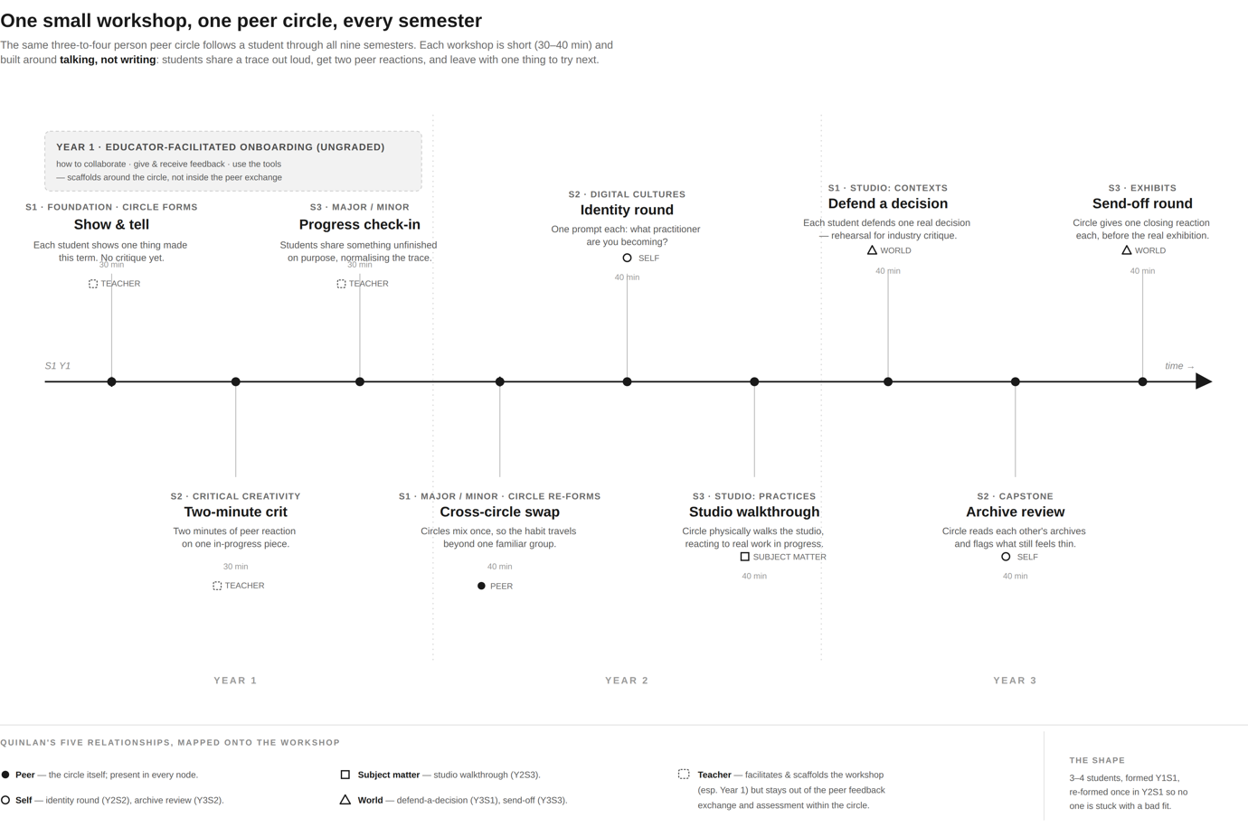
Figure 1. The nine-semester workshop sequence and its persistent peer circle.
This design can be read directly against Quinlan’s (2016) key relationships, extended to five in her 2022 presentation, set out in Figure 1. The peer relationship is structural, the constant across all nine semesters, with a cross-circle swap in Year 2 Semester 1 so a student practises with an unfamiliar group. Self is addressed in the Year 2 Semester 2 identity round, prompting what practitioner are you becoming. Subject matter is present through the studio walkthrough (Year 2 Semester 3), requiring actual work brought into the circle. The world, Quinlan’s 2022 addition, is present through defend-a-decision (Year 3 Semester 1), rehearsing industry critique, and through the shareable archive. Educators facilitate and scaffold the workshop, especially in the first year, but stay out of the peer feedback exchange itself and out of any assessment within the circle, keeping it a space free of assessment anxiety; the assessing-teacher relationship runs instead through existing studio supervision. Whether that separation is right is a genuine open question returned to as a limitation below.
Pathway, threshold, and equity
PACE accumulates across the degree. From the first year, short workshops guide participation and reflection, and a threshold of deepened traces across the three capabilities becomes the condition for the capability-based assessment in the final Exhibits course. The threshold can be met entirely through in-school participation, which every enrolled student can access; participation beyond the school enriches a student’s record but is never required. This is the equity principle: the internship PACE complements is access-limited, and PACE must not reproduce the same barrier.
The prototype, and the platform it points to
I built a working prototype to demonstrate the system. It embodies the two-step mechanic, shows the identity prompt, tracks progress toward the threshold, and produces a shareable archive. An AI assistant offers a question and never issues a score, so judgement stays with the student, addressing evidence that offloading judgement can produce metacognitive laziness (Fan et al. 2025). At full scale, PACE would be a shared, school-wide archive; I present this as future work, its central challenge, ownership and governance, raised by my sponsor.
How PACE differs from what already exists
RMIT already offers Personal Edge, a co-curricular program that develops employability skills. PACE is not a duplicate. My sponsor confirmed Personal Edge does not integrate with any Digital Media course, carries no credit, and being voluntary tends not to reach the students who need it most. PACE differs on exactly these axes: embedded in the discipline’s courses, credit-bearing, drawing on real studio practice. It uses a workshop format familiar from micro-credentials, but what accumulates is a record of traces, not a stack of credentials, because this capability is continuous and collective, not a discrete verifiable unit.
5. Method
Design-based research
I approached this project as design-based research, in which the researcher designs an artefact to address a real problem, tests it, and refines it through evidence. This suits a practitioner capstone: the aim is not to prove a hypothesis but to produce a defensible, theory-grounded design and learn from testing it. It also suits my constraints of time and ethics, allowing the concept to be validated through expert testing and existing data, with empirical user-testing named as a later phase.
Two streams of evidence, and their limits
I drew on two streams. The first was secondary analysis of data already held by the program: the Future Readiness survey (Semester 1, 2026, n=17), internship supervisor feedback from COMM2584 (Semester 3, 2025), and the M-NODE cross-cultural workshop data (January 2026), all carrying no additional research-ethics burden. The second was three interviews with educators and industry partners chosen for their vantage points, each consenting to the use of their responses; I coded each passage to the three capabilities and the design elements it spoke to. I want to be honest about what this method can and cannot claim. The interviews were more design-shaping than a deep account of student behaviour: each was structured around testing PACE with an expert, not drawing an independent picture of how students experience the gap. They were also not fully mutual conversations; I came to each with a design already in motion and used the interview to pressure-test it, a legitimate design-based research move, but a different kind of evidence from a study built to characterise student experience from the ground up.
Scope and ethics
I deliberately did not collect data from students. As someone who mentors and assesses the students in this program, I hold a position of power over them that would compromise both the ethics and the validity of interviewing them about a system I am proposing. Their perspective is important, and I name student user-testing, under appropriate ethical approval, as essential future work. This is a genuine limitation of the study, and I state it as such.
6. Findings
The analysis produced five findings. First, the problem is real and triangulated: the survey shows students under-weight communication while industry flags it, confirmed independently by all three interviewees. Second, students misperceive their own gap, and the cohort is uneven rather than uniformly weak. Third, the micro-credential model succeeds, but not for soft skills, a correction to my own earlier reasoning. Fourth, the design is workable: industry trusts verifiable, showable work over self-report, in one partner’s coded words, “skills are now a commodity”; assessment works through Program Learning Outcomes rather than points on a rubric, echoing my sponsor’s observation that it is industry, not the university, that most values a strong portfolio; and adaptability may lead the other two capabilities. Fifth, the naming had to change, from points to traces, from pathway to practice, and to naming the final course consistently as Exhibits.
7. Discussion
The central move of this project is honest: PACE was designed as an embedded assessment mechanism, and the evidence pointed toward something more precise, a system for connecting and making visible the collaborative learning that already happens across courses. The trust problem an industry partner raised is real but secondary to PACE’s actual purpose, since it does not rest on self-report; it records evidence of genuine participation. This is why the CV’s declining credibility matters: a CV is a claim a student makes about themselves, which employers have learned to discount, whereas a trace is evidence that real practice occurred.
A multilevel reading: purpose, mechanics, and tension
The following section reads PACE through a framework from this program: from the penthouse, why do this; in the kitchen, how does it run; in the basement, what tensions complicate the practice. Read against the Mega, Macro, Meso, Micro scale, the same material looks different depending on which floor a reader stands on.
The penthouse: why do this at all. PACE exists because the capability industry keeps naming, collaboration, adaptability, taking critique, forms through interaction across a degree, and current assessment, reading only the finished artefact, cannot see it, a Mega-level claim that a degree should evidence how a graduate became capable, not only what they produced. If the capability really is collaborative, an instrument that isolates a student to assess them is measuring the wrong thing by construction. Showing unfinished work also has value in its own right, the same habit industry seniors say junior staff lack. The purpose is not to grade collaboration; it is to make a habit with real workplace value visible early enough to be practised.
The kitchen: how it actually runs. PACE is a Meso- and Micro-level design: a short, spoken workshop run inside existing courses across all nine semesters, built around a persistent peer circle re-formed once at the start of Year 2 (Figure 1). A student leaves a trace through real collaborative work, then deepens it through reflection. Visibility is tiered: a student controls what becomes public, gated by a completeness status, while everything opens up with clear tagging at the assessment gate, in the Exhibits course. None of this changes a course learning outcome; it accumulates across a threshold every enrolled student can reach in-school.
The basement: the tensions that complicate it. Beneath the purpose and the mechanics sit five tensions that the design surfaces but does not dissolve, set out against the analytic levels in Figure 2. They are ordered here from the deepest, the Mega level of the field, down to the Micro level of the workshop, with a final tension that cuts across every level. Naming them is not a weakness of the design so much as the honest cost of taking the problem seriously: a system that made these tensions disappear would almost certainly be measuring something easier and less real than the capability PACE is after.
First, and deepest, at the Mega level of the field (Figure 2, tension 1): a trace that is safe inside an ungraded peer circle becomes structurally unsafe once it travels outward. The workshop works precisely because it is a low-stakes space where a student can show unfinished, wobbly work to a small circle of peers without being judged. The moment that same trace is shared with a mentor, an employer, or an assessment gate, the conditions that made honesty possible are gone, and the incentive shifts back toward showing only polished, flattering evidence. Visibility tiers, where the student controls what becomes public and a completeness status signals what a viewer is looking at, manage this tension but do not remove it. The underlying problem, that candour and consequence pull against each other, is a property of assessment itself, not something a single design can engineer away.
Second, at the Macro level (Figure 2, tension 2), normative creep: because much of the evidence behind PACE comes from employers and industry mentors, the design risks quietly encoding what employers want students to perform rather than what the capability actually is. If the loudest voice in the data is the voice that hires, the version of collaboration that gets rewarded may drift toward compliance, looking like a good employee, rather than toward genuine collaborative capability. I narrow this risk by anchoring PACE’s three capabilities in RMIT’s own institutional capabilities rather than only in employer language, so the framing is at least institutionally grounded, but I do not claim to close it. The student data I hold is thinner than the industry data, and until that balance is corrected through student user-testing, the risk of encoding employer preference remains live.
Third, also at the Macro level (Figure 2, tension 3), a question of novelty rather than validity: whether PACE is genuinely a new practice or existing reflective practice re-labelled. RMIT is already saturated with reflection, and students are tired of it, so the burden is on PACE to show it is doing something different. My argument is that it is: PACE’s reflection is forward-looking rather than retrospective, each entry ending with what to try next; cumulative across nine semesters rather than a one-off assignment; tied to a developing practitioner identity rather than a single course outcome; and multimodal, admitting video, image, and audio rather than only written prose. But this is a claim about design intention, and design intention is not evidence. Whether students actually experience PACE as different from the reflection they already resent is precisely the kind of question that can only be answered by testing it with them, which returns the whole project to its central limitation.
Fourth, at the Micro level, inside the mechanic (Figure 2, tension 4): the workshop deliberately keeps teaching staff outside the peer circle, on the reasoning that students speak more honestly about unfinished work to peers than to whoever grades them. But this means the relationship that ultimately decides what counts, the teacher who assesses, is absent from the very space where the capability is practised and rehearsed. This is not only a design concern: RMIT Vietnam’s own Group Work Task Force found that students want more, not less, educator guidance around group work: its purpose, group formation, and conflict management, which cuts directly against keeping staff outside the circle (Benson et al. 2025). The teacher relationship continues through existing studio supervision and through the deepened traces staff eventually read, but it is not present in the circle itself. PACE responds to this at the foundation stage: the Year 1 educator-facilitation layer described above is exactly such a lighter, ungraded touchpoint, teaching students how to collaborate and give feedback, and it aligns with the First Year Working Party’s call for educator guidance and support of group work, while the peer feedback exchange itself stays teacher-free. Whether that facilitation is sufficient, or whether a non-assessed teacher touchpoint should reach beyond Year 1, remains an open question I cannot settle from design intention alone.
Fifth, a tension that cuts across every level (Figure 2, tension 5): the distinction between having a capability and being able to show it. A student may already work well across difference, adapt, and absorb critique, yet lack the visible, articulate expression of those capabilities that an assessor or employer can read. If so, PACE is not making an existing capability visible so much as teaching a second, separate skill, the skill of surfacing and narrating one’s own practice. This is not necessarily a flaw, since knowing how to show in-progress work is itself a professional capability that industry seniors say juniors lack. But it does mean PACE’s claim needs care: it may be developing the expression of capability as much as the capability itself, and I name that rather than resolve it.
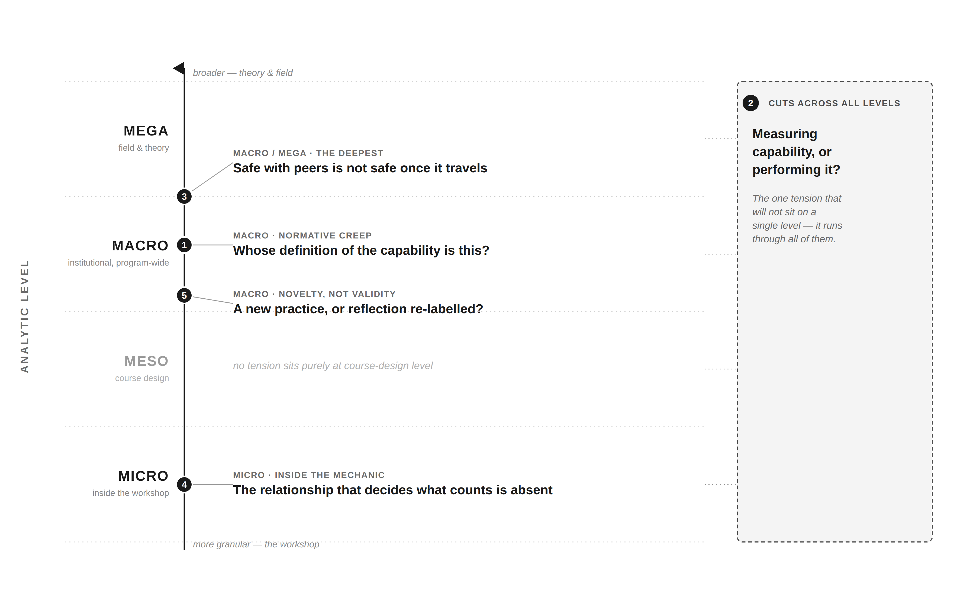
Figure 2. The five tensions mapped across analytic levels, ordered Mega to Micro, with one tension cutting across all levels.
What changes in the design follows from the evidence: weight the record toward verifiable participation rather than self-ratings; integrate assessment through Program Learning Outcomes rather than a points-laden rubric; reflect the ordering of the capabilities; and begin at Foundation, which my sponsor already does. The limitations are real: three experts are a small sample, all educators or employers rather than students; no user-testing has been conducted; the programmatic-assessment literature originates in health sciences; and Digital Design is itself pending approval in Vietnam. The workshop has a further gap: of Quinlan’s five relationships, the sequence builds in peer, self, subject-matter, and world touchpoints but keeps teaching staff outside the circle, a trade-off not yet tested against a lighter, non-assessed teacher touchpoint.
8. Conclusion
This paper asked how a design program could make collaborative learning and adaptive capability visible across a degree, without adding courses or rewriting course learning outcomes. Its answer is PACE: an embedded, visibility-focused record of real creative practice, evidencing three interdependent capabilities, begun early in the degree and counting toward assessment through existing mechanisms. The contribution is a designed, theory-grounded, expert-tested artefact and a working prototype, together with an honest account of how testing refined it. The evidence did not simply confirm PACE; it moved the design from a points idea toward traces of learning, and from grading toward visibility.
The next steps follow from the limitations: student user-testing under ethical approval, a live pilot in the Exhibits course once the program is approved, quantified industry data, and the design of the school-wide platform, whose ownership remains the central institutional challenge. A further extension worth testing is folding the Internship pathway into the same assessment mechanism as Exhibits, so PACE covers every Digital Design student rather than only those on the Exhibits route. PACE is offered not as a finished system but as a defensible proposal, ready to be tested where it matters, in a real course with real students.
I will close on a reflection. In carrying out this project I found myself living the problem I was studying. To propose PACE I had to work across courses I do not own, adapt as the evidence changed my design, and engage critically with challenges to my own idea rather than defend it. The capabilities I am asking the program to make visible in its students are the same ones this capstone demanded of me. What I found hardest was not any single piece of evidence but letting go of an idea I had already invested in. The micro-credential framing was attractive early on precisely because the underlying problem is abstract, and a credential felt concrete, even though it later proved too commercial for what PACE needed to do. The harder struggle was finding a framework that genuinely fit the institution rather than one I simply liked; I was fortunate to join a program-architecture day and talk with my sponsor directly about where my interest actually sat, a conversation that did more to move PACE forward than any reading I had done alone.
References
Referencing style: Harvard.

Benson, K, O’Grady, G, Le, KM & AES 2025, Group work at RMIT Vietnam: the cornerstone of Active, Applied and Authentic Learning, recentering group work as a central vehicle for delivering RMIT’s Signature Pedagogy (AAA), positioning paper, RMIT University Vietnam, Ho Chi Minh City, viewed 15 September 2026.

Bridgstock, R 2009, ‘The graduate attributes we’ve overlooked: enhancing graduate employability through career management skills’, Higher Education Research & Development, vol. 28, no. 1, pp. 31–44.

Bridgstock, R, Grant-Iramu, M & McAlpine, A 2019, ‘Integrating career development learning into the curriculum: collaboration with the careers service for employability’, Journal of Teaching and Learning for Graduate Employability, vol. 10, no. 1, pp. 56–72.

Colley, H, Hodkinson, P & Malcolm, J 2003, Informality and formality in learning: a report for the Learning and Skills Research Centre, Learning and Skills Research Centre, London.

Coursera 2025, Micro-credentials impact report 2025: insights from students and employers, Coursera, viewed 28 August 2026, https://www.coursera.org/.

Coursera 2026, Micro-credentials impact report 2026: insights from students, employers and higher education leaders, Coursera, viewed 1 September 2026, https://www.coursera.org/.

De Jaegher, H & Di Paolo, E 2007, ‘Participatory sense-making’, Phenomenology and the Cognitive Sciences, vol. 6, no. 4, pp. 485–507.

Dillenbourg, P 1999, ‘What do you mean by collaborative learning?’, in P Dillenbourg (ed.), Collaborative learning: cognitive and computational approaches, Elsevier, Oxford, pp. 1–19.

Fan, Y, Tang, L, Le, H, Shen, K, Tan, S, Zhao, Y, Shen, Y, Li, X & Gašević, D 2025, ‘Beware of metacognitive laziness: effects of generative artificial intelligence on learning motivation, processes, and performance’, British Journal of Educational Technology, vol. 56, no. 2, pp. 489–530.

Hanus, MD & Fox, J 2015, ‘Assessing the effects of gamification in the classroom: a longitudinal study on intrinsic motivation, social comparison, satisfaction, effort, and academic performance’, Computers & Education, vol. 80, pp. 152–161.

Heeneman, S, de Jong, L, Dawson, LJ, Wilkinson, TJ, van der Vleuten, CPM & Driessen, EW 2021, ‘Ottawa 2020 consensus statement for programmatic assessment – 1. agreement on the principles’, Medical Teacher, vol. 43, no. 10, pp. 1139–1148.

Jones, MI 2024, AI in creative contexts: mapping a programmatic approach, UNSW Education & Student Experience, viewed 18 September 2026, https://www.unsw.edu.au/.

Pea, RD 1993, ‘Practices of distributed intelligence and designs for education’, in G Salomon (ed.), Distributed cognitions: psychological and educational considerations, Cambridge University Press, Cambridge, pp. 47–87.

Quinlan, KM 2016, ‘How emotion matters in four key relationships in teaching and learning in higher education’, College Teaching, vol. 64, no. 3, pp. 101–111.

Quinlan, KM 2022, ‘Relational learning’, presentation delivered at the University of Auckland Tapestry of Practice Symposium, viewed 10 September 2026, https://teachwell.auckland.ac.nz/teaching/relational-learning/.
Roy, R, Harris, DX & Haslem, N 2025, ‘Relational education design: three case studies and a discussion for aspirational design and education futures’, Qualitative Inquiry, vol. 31, no. 8–9, pp. 791–801.

Ryan, RM & Deci, EL 2000, ‘Self-determination theory and the facilitation of intrinsic motivation, social development, and well-being’, American Psychologist, vol. 55, no. 1, pp. 68–78.

Salomon, G (ed.) 1993, Distributed cognitions: psychological and educational considerations, Cambridge University Press, Cambridge.

Schön, DA 1983, The reflective practitioner: how professionals think in action, Basic Books, New York.

Trede, F, Macklin, R & Bridges, D 2012, ‘Professional identity development: a review of the higher education literature’, Studies in Higher Education, vol. 37, no. 3, pp. 365–384.

Tumpa, RJ, Skaik, S, Ham, M & Chaudhry, G 2022, ‘A holistic overview of studies to improve group-based assessments in higher education: a systematic literature review’, Sustainability, vol. 14, no. 15, article 9638.

van der Vleuten, CPM, Lindemann, I & Schmidt, L 2018, ‘Programmatic assessment: the process, rationale and evidence for modular and longitudinal assessment’, Medical Journal of Australia, vol. 209, no. 9, pp. 386–388.

Vygotsky, LS 1978, Mind in society: the development of higher psychological processes, Harvard University Press, Cambridge, MA.

Wheelahan, L & Moodie, G 2021, ‘Gig qualifications for the gig economy: micro-credentials and the hungry mile’, Higher Education, vol. 83, pp. 1279–1295.

I declare that in submitting all work for this assessment, I have read, understood and agree to the content and expectations of the assessment declaration.

