Monthly Sales Review

Introduction
This review presents product revenue for the selected region and compares regional performance for the reporting period.

Revenue by product
product | revenue
Core | 12450
Plus | 8380

Regional comparison
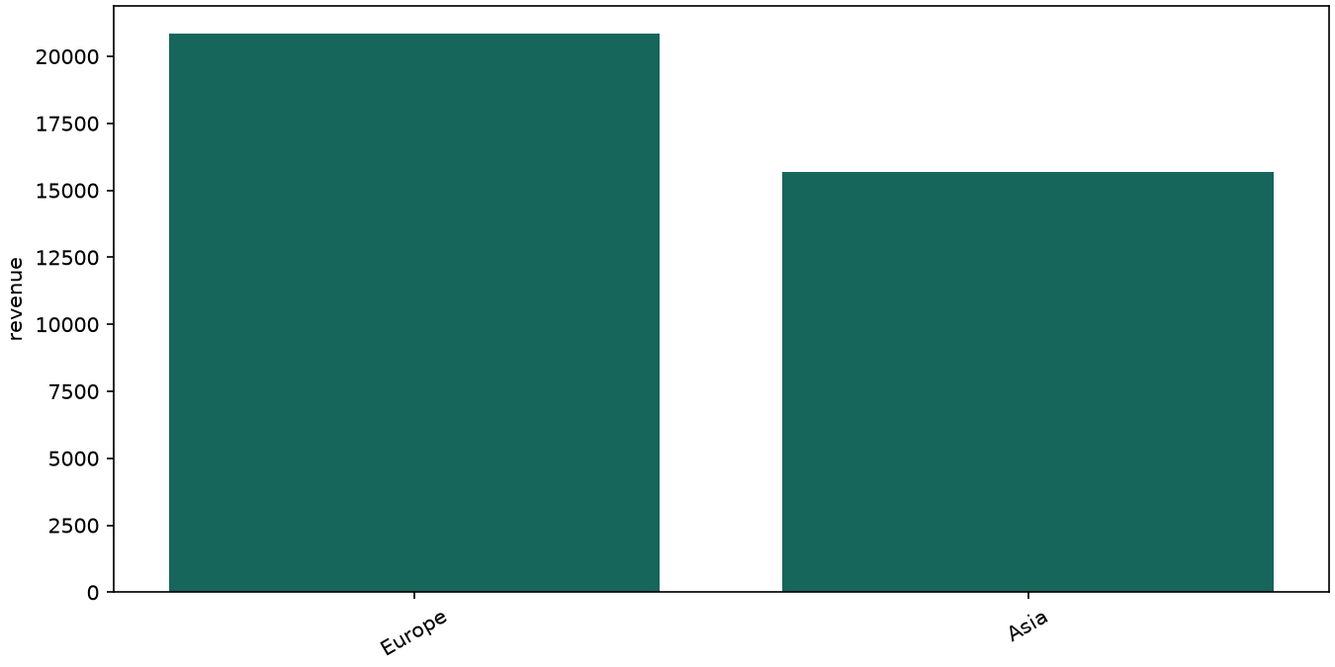

Previous commentary
Last year's results reflected an earlier product mix. Replace this historical commentary during onboarding.

