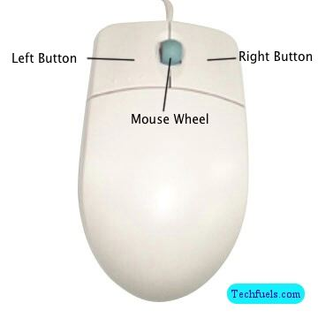A Mouse is an external computer piece of hardware; it allows the user of a computer to move the cursor on the screen. Back in the 1980s it became the most dominant way a user interacted with a computer and up to this day it is still the same. It is the most easiest and most convenient way for a user to interact and do things on a personal computer.

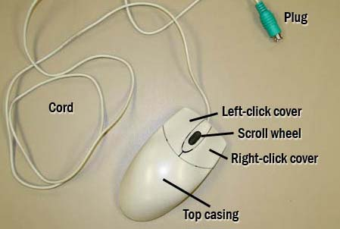

It is a symmetrical device made out of plastic, it is made up of top & bottom casing, left & right click button, scroll wheel, laser/track ball, internal circuit board and a connecting wire (usb/ps2)

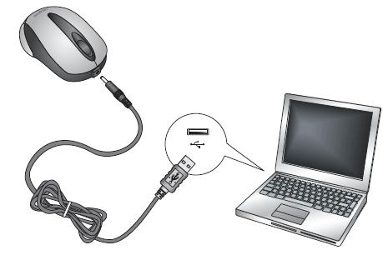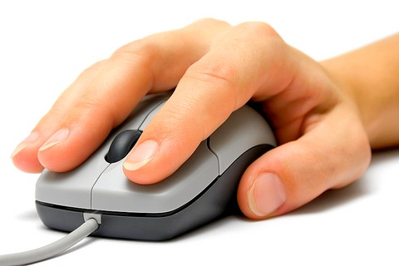The movement of the mouse translates into the movement of the cursor on the screen, it is based on a basic function of using the computer screen as a grid and moves it as the user moves the physical mouse. There are two buttons on the mouse, a right click button and a left click button. Right click button is for basic functions like drag and drop a file, open a file move the cursor on a document, where as the left click button is for accessing menus or settings in the computer or to find properties of a file. To use a mouse, the user rests his hand on the curved top casing, index and middle finger positioned on right and left click buttons. When the user moves the mouse, the laser or the tracking ball beneath the mouse tracks the movement and translates that movement into cursor movement on the screen.

The mouse can be connected to the computer via Bluetooth and or a usb/ps2 cord

In conclusion a mouse is a simple, easy to use yet the most crucial piece of hardware in a computer setup and for a user to interact with it. It transforms the user’s move from the mouse to onscreen cursor movement. It does require a user to get used to the movement and coordination of the mouse to move the cursor on screen.