单细胞免疫谱分析-T细胞和B细胞的V(D)J库整合5'基因表达与抗原特异性

**Chromium Next GEM Single Cell 5' Reagent Kits v2 (Dual Index)**

|  |  |
| --- | --- |
| 5ʹ Gene Expression (GEX) Library Construction | Single Cell V(D)J |
|  |  |

<https://cdn.10xgenomics.com/image/upload/v1666737555/support-documents/CG000331_ChromiumNextGEMSingleCell5-v2_UserGuide_RevE.pdf>

**Algorithm overview**

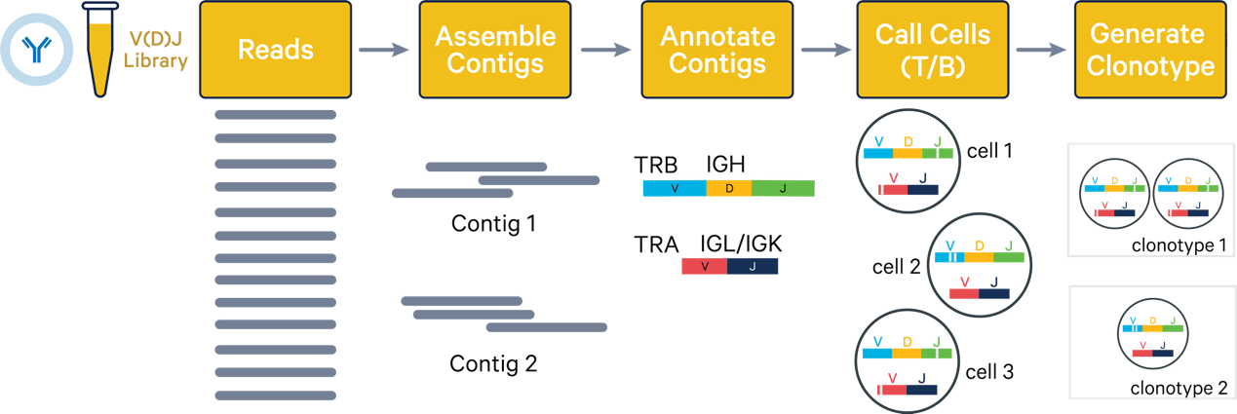

<https://www.10xgenomics.com/support/jp/software/cell-ranger/latest/algorithms-overview/cr-5p-vdj-algorithm>

### 1: Assemble contigs

The assembly process combines reads for a single barcode into assembled contigs, representing the best estimate of the transcript sequences present. [Learn about the assembly algorithm here](https://www.10xgenomics.com/jp/support/software/cell-ranger/latest/resources/cr-5p-vdj-algorithm-assembly)

* Filter out reads with noisy barcodes and UMIs that may arise from PCR errors, sequencing errors, etc.
* Trim adaptors and primer sequences from 5' and 3' ends of the reads.
* Generate full-length transcripts (contigs) from each chain in all observed GEMs/barcodes.

### 2: Annotate contigs

V(D)J contig annotation involves aligning V, D, and J gene segments to contigs, identifying CDR3 sequences, and assessing whether each contig is productive, indicating a likely functional T or B cell receptor. [Learn about the assembly algorithm here](https://www.10xgenomics.com/jp/support/software/cell-ranger/latest/resources/cr-5p-vdj-algorithm-annotations)

* Annotate contigs with V(D)J segment labels and locate CDR3 regions that form the transcript.
* Filter contigs that are full-length and productive.

### 3: Call cells

Identify barcodes/GEMs that contain T or B cells. [Learn about the assembly algorithm here](https://www.10xgenomics.com/jp/support/software/cell-ranger/latest/resources/cr-5p-vdj-algorithm-callcells)

### 4: Generate clonotypes

Group cell-associated barcodes into clonotypes and filter out some cells. [Learn about the assembly algorithm here](https://www.10xgenomics.com/jp/support/software/cell-ranger/latest/resources/cr-5p-vdj-algorithm-clonotyping)

**V(D)J-specific primer**

<https://kb.10xgenomics.com/hc/en-us/articles/360047454291-Which-genes-does-each-V-D-J-specific-primer-map-to>

