1. **Define in your own words: (a) artificial intelligence, (b) agent, and (c) rationality.**
2. Artificial intelligence refers to manmade machines such as computers that can make decisions like humans in solving real world problems.
3. An agent is an entity that can perceive its past and current environment and state and act.
4. Rationality refers relying on logic to measure correctness, or making the best decisions.
5. **To what extent are the following computer systems instances of artificial intelligence:**
6. Bar code scanners are tied into a database with records for each item, it has to be able to recognize that there is a bar code present, scan it, and display the information to the cashier and the customer.
7. Web search engines are connected to all information on the internet, the intelligence needed is not high because it is only doing matching.
8. The voice activated telephone menus are programmed to hear a voice, listen for key words and perform actions based on the words it can understand.
9. **For each of the following activities, give a PEAS description of the task environment and characterize it in terms of the properties (e.g. fully observable, static, continuous, multi agent, etc) listed in lecture slides.**
10. Shopping for used AI books on the Internet:

P: Cost of book, quality/relevance/correct edition

E: Internet’s used book shops

A: key entry, cursor

S: website interfaces, browser.

partially observable, multi-agent, stochastic, sequential, dynamic, continuous

1. Knitting a sweater:

P: Quality of resulting sweater

E: Rocking chair

A: Hands, Needles

S: Eyes.

observable, single agent, stochastic, sequential, dynamic, continuous

1. **Consider a state space where the start state is number 1 and each state k has two successors: numbers 2k and 2k + 1.**
2. 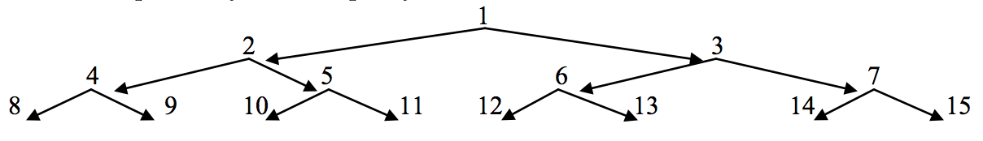
3. breadth first search: 12345 11

depth-limited search (limit = 3): 1245 11

iterative deepening search: 1; 1 2 3; 1 2 4 5 (11)

1. Bidirectional search is very useful, because the only successor of n in the reverse direction is floor(n/2). This helps focus the search. The branching factor is 2 in the forward direction; 1 in the reverse direction
2. 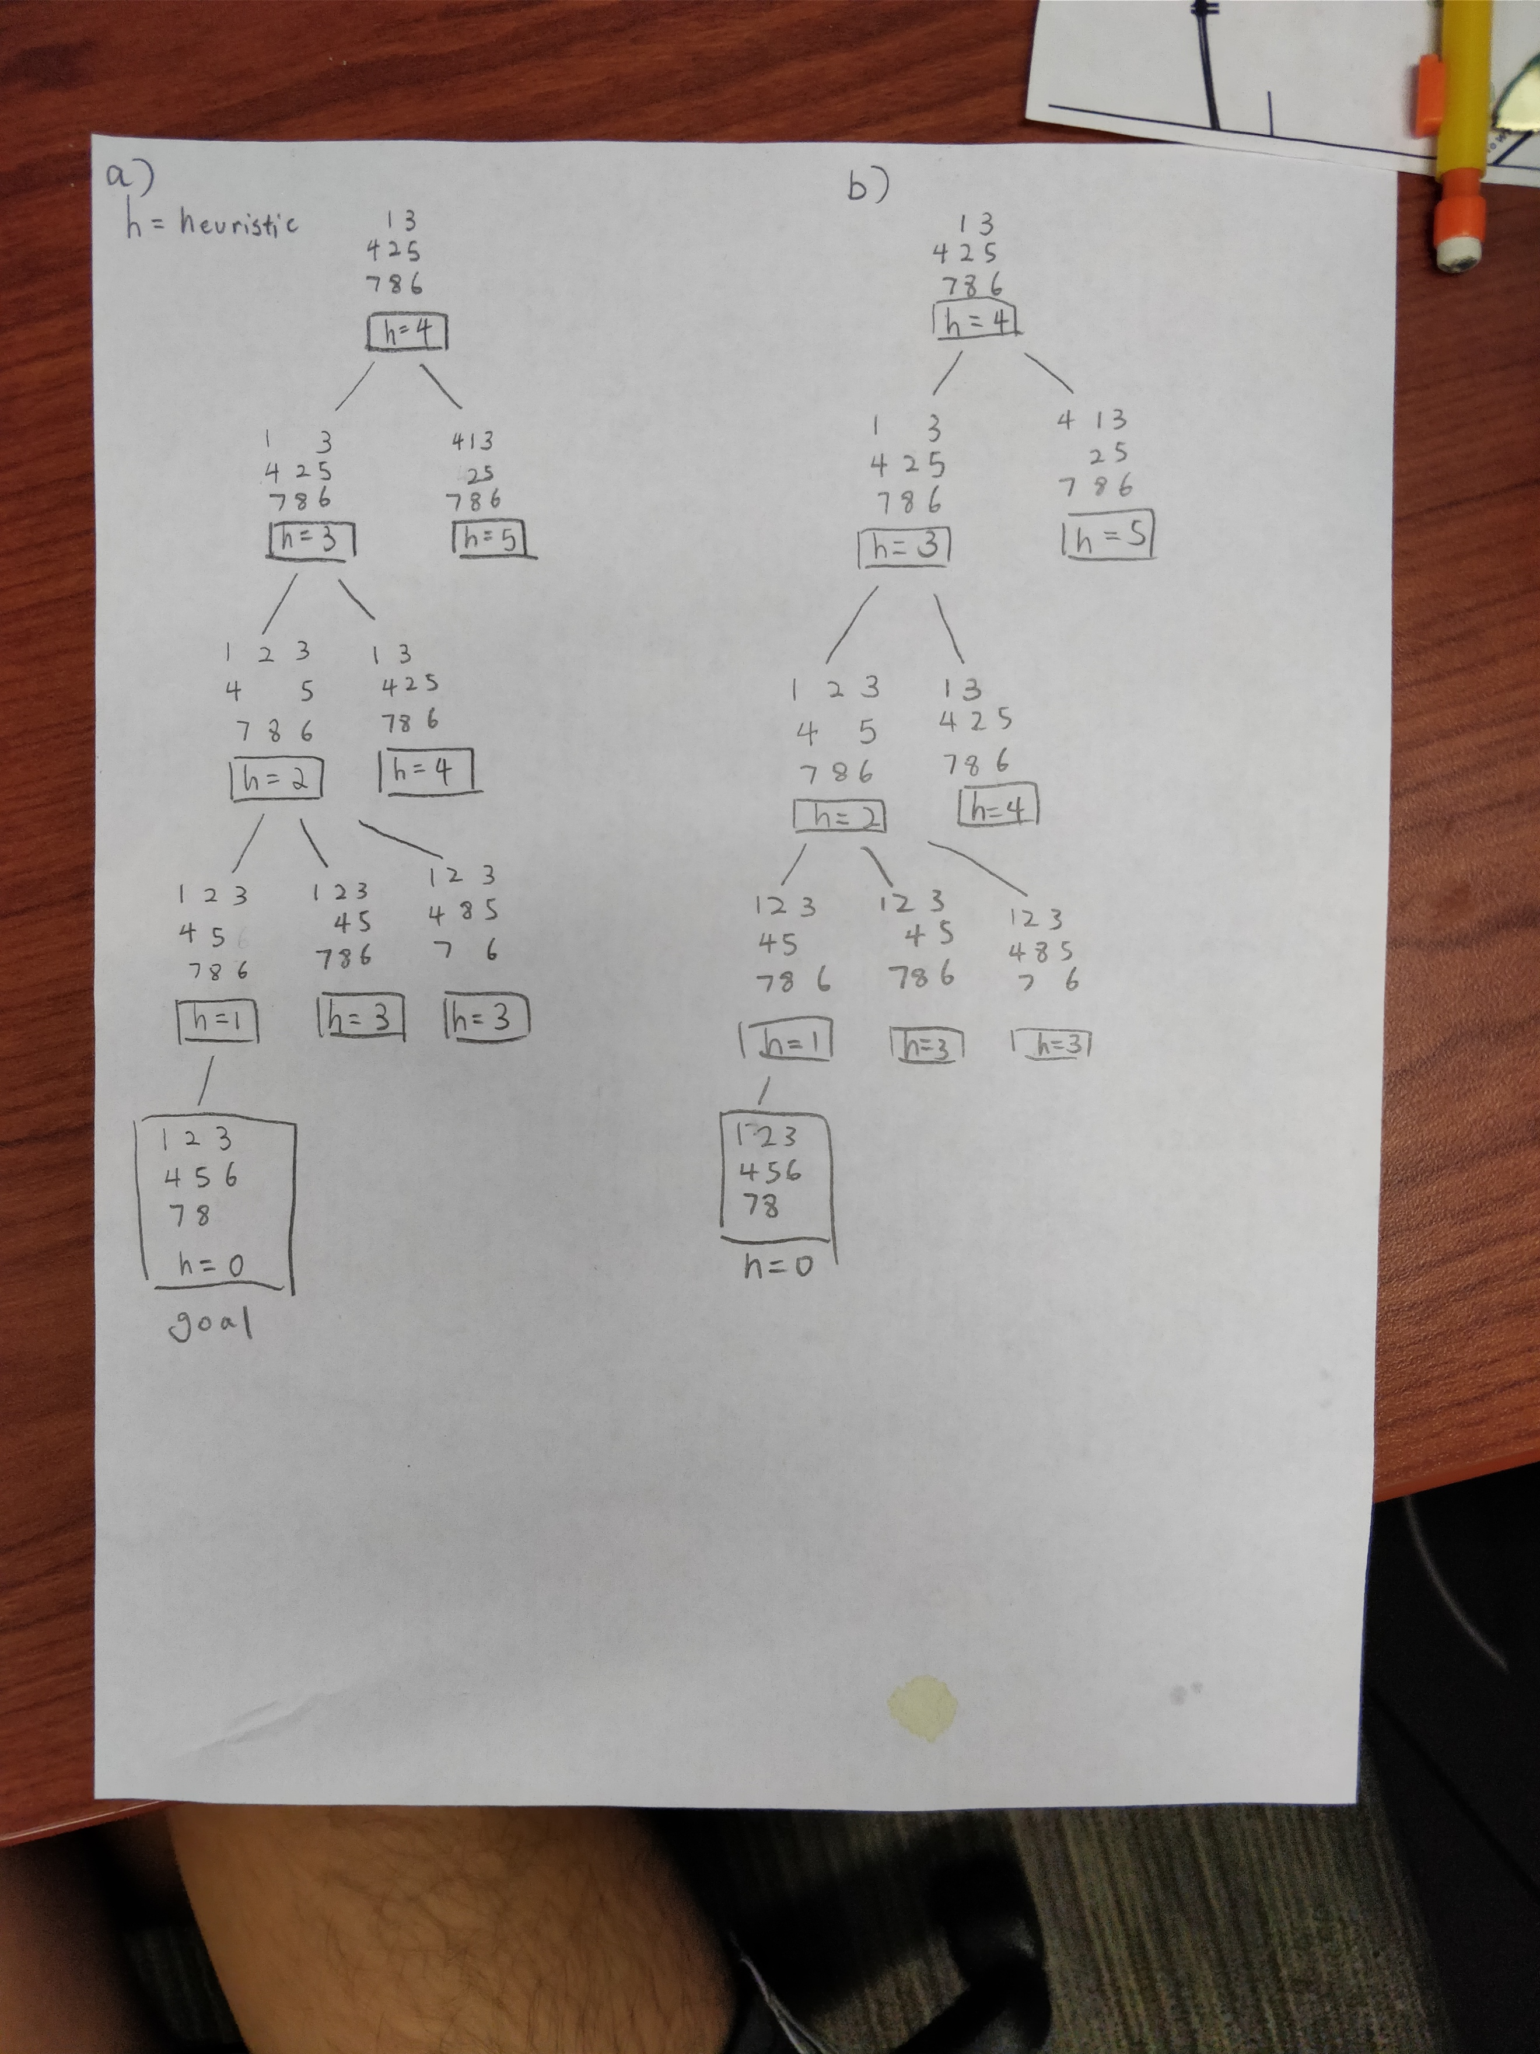

c) Yes, the problem can be solved using breadth first search. 11 un-duplicate states will be generated including the goal state.