**Homework 2 for Intelligent Systems**

Yangqi Su **800957989**

1. Minimax searches the entire tree of actions, even though some of the possible actions can be ignored. Alpha-beta pruning attempts to reduce the search complexity by not evaluating action paths that are known to be worse than the current best path found. This can help save processing time without affecting the final result.

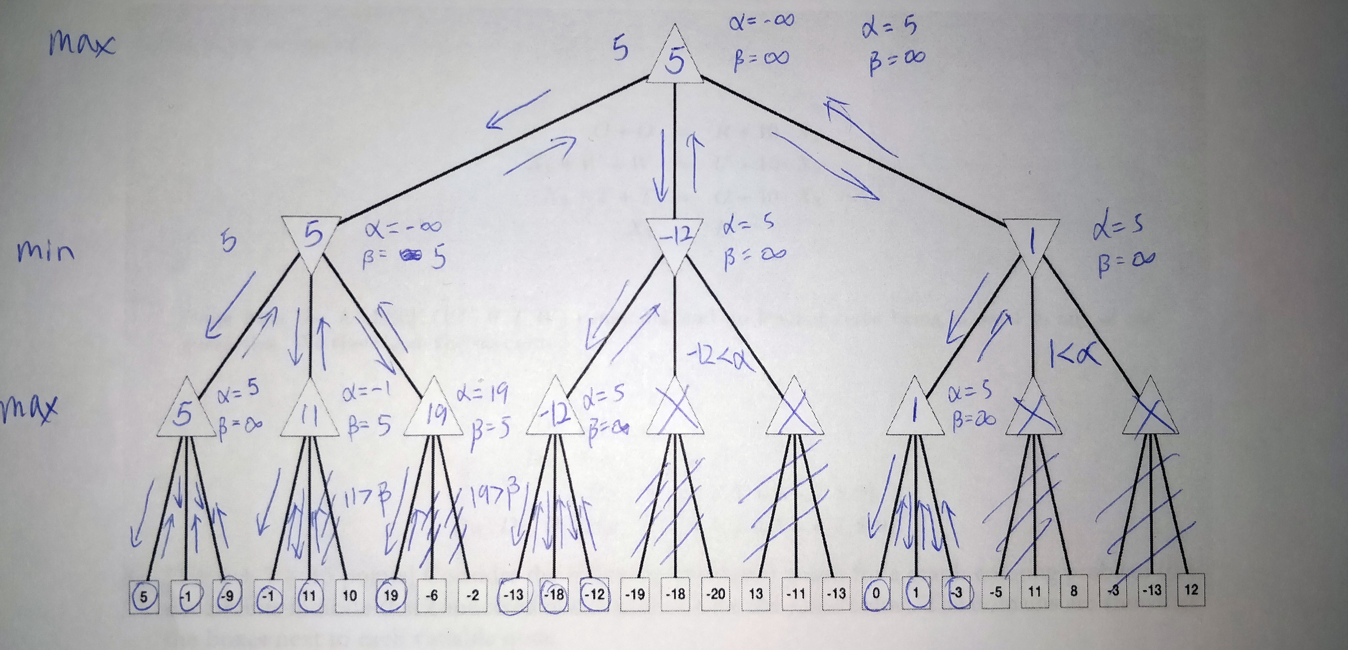**Alpha-beta tracing:**

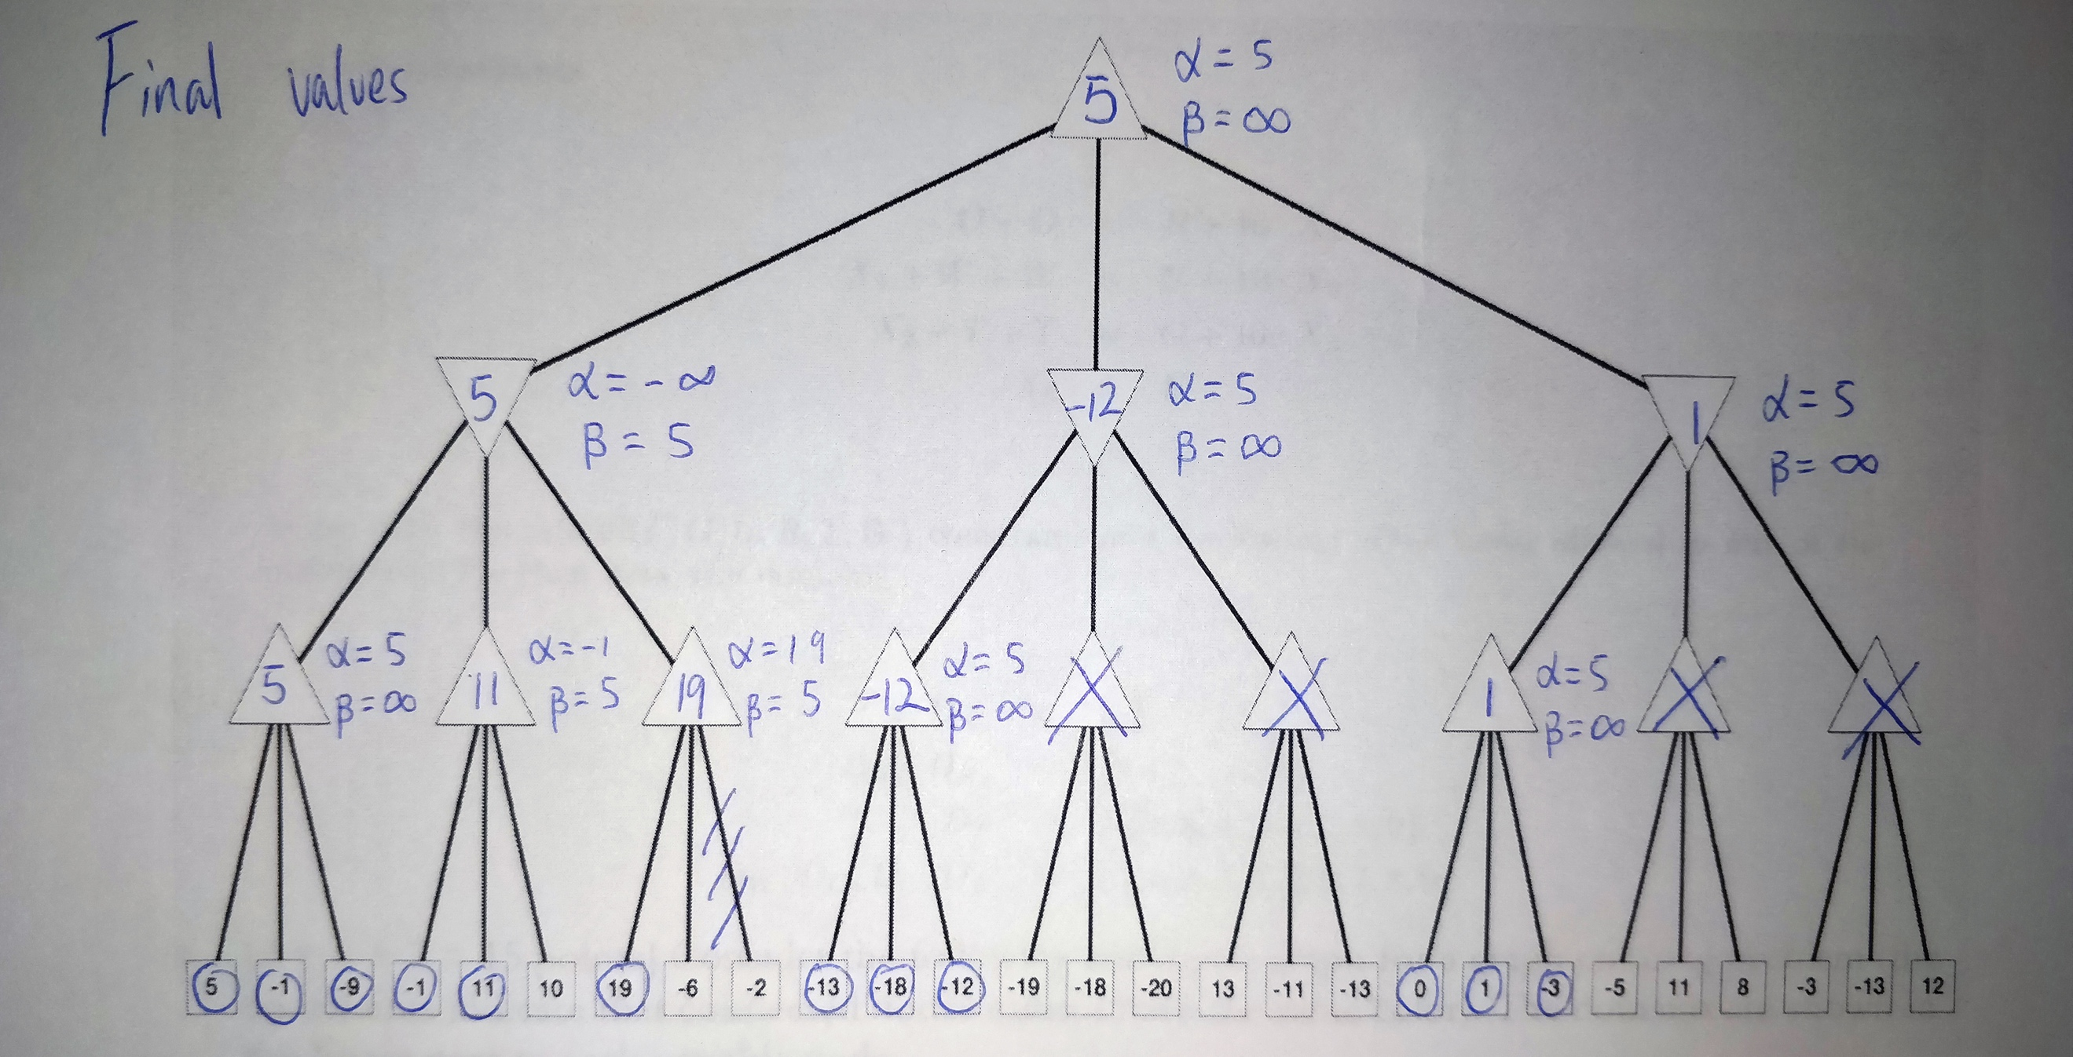**Final Values:**

1. Arc inconsistency check table:

|  |  |  |  |  |  |  |  |
| --- | --- | --- | --- | --- | --- | --- | --- |
| * | **WA** | **NT** | **SA** | **Q** | **NSW** | **V** | **T** |
| initial | G | RGB | RGB | RGB | RGB | R | RGB |
| SA-WA | G | RGB | RB | RGB | RGB | R | RGB |
| WA-NT | G | RB | RB | RGB | RGB | R | RGB |
| V-SA | G | RB | B | RGB | RGB | R | RGB |
| V-NSW | G | RB | B | RGB | GB | R | RGB |
| SA-NT | G | R | B | RGB | GB | R | RGB |
| NT-Q | G | R | B | GB | GB | R | RGB |
| SA-Q | G | R | B | G | GB | R | RGB |
| Q-NSW | G | R | B | G | B | R | RGB |
| SA-NSW | G | R | B | B | \ | R | RGB |

The final arc of SA-NSW produced an inconsistency in which NSW cannot be assigned a color, thus the partial assignment is inconsistent.

1. 1) Given the constraints, it can be seen that the DT is {2,3,4,5,6,7,8,9}, while the domain for U, W, O, R is {0,2,3,4,5,6,7,8,9}. Thus, using MRV, T will be assigned first.

2) Since DF=Dx1 is {1} and X2 +2T = O + 10, T cannot be 2, 3, 4, thus the domain of T becomes {5,6,7,8,9}. Using least constraining value heuristic, assigning T=5 only allows O to only be {0} (since F=1), and assigning T = {6,7,8,9} will allow O to have 2 values, so we first assign T=6.

3) Thus X2 + 12 = O + 10, and DO = {2, 3}. Using MRV, we then assign O. both 2 and 3 don’t affect number of values constrained, thus we first assign O = 2.

4) Given O = 2, X2 = 0. Thus, X1 + 2W = U, R+10X1 = 4. Thus X1 = {0} and R = {4}. Using MRV, R = 4.

5) the constraint thus becomes 2W = U, DU = {0,8} (since O=2, R=4, T=6 and Alldiff), thus DU is smaller than DW, using MRV we assign U first. Least constraining value heuristic is the same for both 0 and 8. We assign U = 0 first.

6) U = 0 implies W = 0, which violates the Alldiff constraint, thus backtrack. U=8 implies W = 4, which also violates Alldiff constraint, thus backtrack back to O, and set O =3.

7) O = 3 and X2 +2T = O + 10 implies X2 = 1. Thus now, X1 + 2W = U + 10, R + 10 X1 = 6. The domain of R becomes {6}, however T = 6, which violates the constraint Alldiff, thus backtrack to T.

8) Now let T = 7.

9) Given T = 7, X2 + 14 = O + 10, thus X2 + 4 = O, DO = {4,5}. MRV tells us to choose value for O, and the LCV is the same for both 4 and 5. Thus O = 4 first.

10) if O = 4, X2 = 0. Now, constraints are: X1 + 2W = U, 8=R+10X1. R can only be 8, while X1 = 0. Thus, MRV tells us to set R first, R=8.

11) Now the constraint is 2W=U. DU = {0,2,6} (R = 8, O=4), Dw = {0,2,3,5,6,9}. Thus, MRV tells us to assign U first. We can see that if U=0, Dw = {}; if U = 2, Dw = {}; thus, using LCV we assign U = 6.

12) Given U = 6, Dw = {3}, thus W= 3. This satisfies all constraints; thus, this is a satisfying assignment.

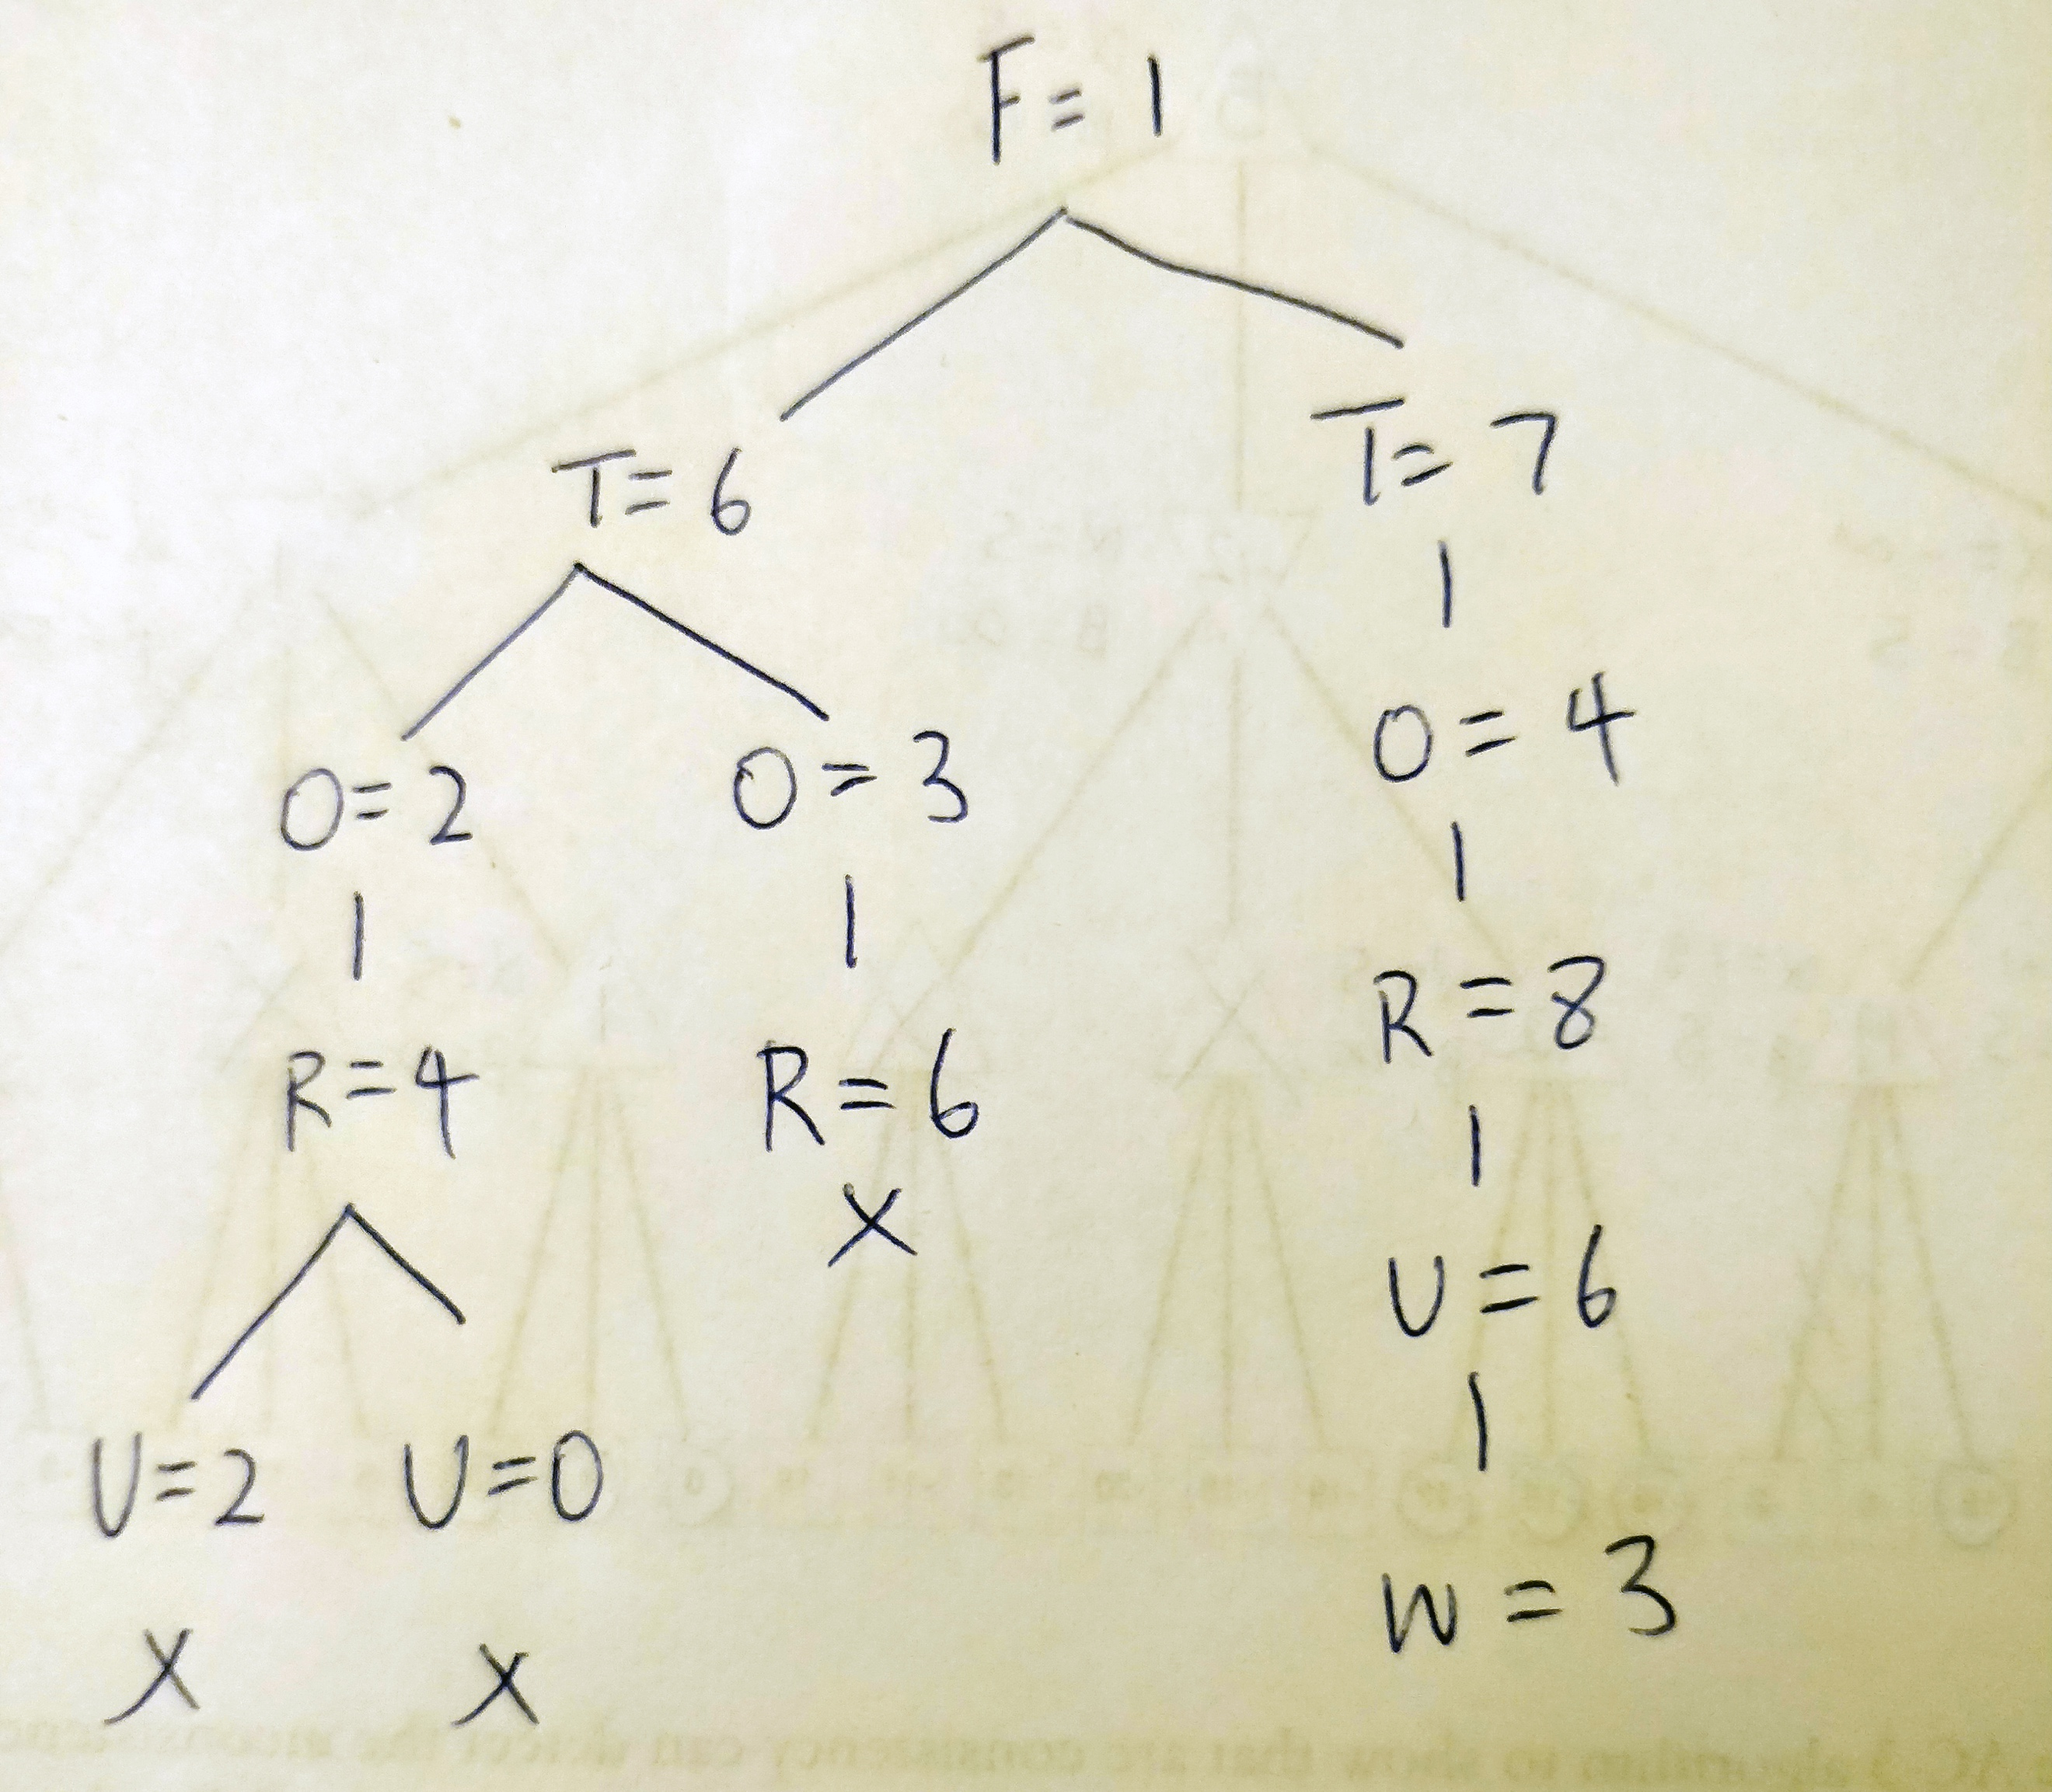**The search tree is given below:**

**Thus F=1, T=7, O=4, R=8, U=6, W=3.**

1. 1) D1 = {R}; D2 = {G, B}; D3 = {G, B}; D4 = {R, G, B}; D5 = {R,B}

2)

|  |  |  |  |
| --- | --- | --- | --- |
| Step # | Var Assigned | Values eliminated from neighbor variables | Backtrack |
| 1 | 1R | None |  |
| 2 | 2R | None |  |
| 3 | 2G | None |  |
| 4 | 3R | None |  |
| 5 | 3G | None |  |
| 6 | 3B | None |  |
| 7 | 4R | None |  |
| 8 | 5R | None |  |
| 9 | 5B | None | yes |
| 10 | 4G | None |  |
| 11 | 4B | None | yes |
| 12 | 2B | None |  |
| 13 | 3R | None |  |
| 14 | 3G | None |  |
| 15 | 4R | None |  |
| 16 | 5R | None |  |

3) **With forward checking:**

|  |  |  |  |
| --- | --- | --- | --- |
| Step # | Var Assigned | Values eliminated from neighbor variables | Backtrack |
| 1 | 1R | 2={G,B}, 3={G,B}; R was eliminated from 2,3 |  |
| 2 | 2G | 3={B}, 4={R,B}; G was eliminated from 3, 4 |  |
| 3 | 3B | 4={R}, 5={R}; B was eliminated from 4,5 |  |
| 4 | 4R | 5={}; R was eliminated from 5 | yes |
| 5 | 2B | 3={G}, 4={R,G}; B was eliminated from 3, 4 |  |
| 6 | 3G | 4={R}; G was eliminated from 4 |  |
| 7 | 4R | 5={B}; R was eliminated from 5 |  |
| 8 | 5B | None |  |