Towards Predictive Ecosystem Syntheses of Vegetation and Microbiome: A Gap of Gaps Framework

Abstract
Theoretical and empirical research have established a view of ecosystems and the entire biosphere as complex adaptive systems since the early 1990s. After over half of a century of modelling ecosystems interacting with the atmosphere, a premise remains of up-scaling biogeochemical processes without capturing self-organization and emergence by appreciating their complexity. As anthropogenic climate change and disturbances speed and intensify, this prevailing and fundamental assumption, however feasible and impactful, is losing its grounds. We argue that the time has come of formulating more integrative ecosystem models that can transcend boundaries of organisms, organizational levels, and spatial-temporal scales to incorporate complex higher-order interactions among plants and microbes. Existing modelling frameworks of forest and microbiome assuming each other implicitly, though insightful, attest to this critical need of integration. Here, we envision a trait-based framework of Pattern, Diversity, and Process for demography-based integrative and scalable modelling of ecosystems integrating vegetation and microbiome across scales. To develop this integrated framework, we identify a series of three motivating questions. while interacting with two data streams of remote sensing and multi-omics. Acknowledging no ‘super plant’, ‘super microbe’, and ‘super model’, as well as no absolute predictivity of ecosystem dynamics, we advocate for this dynamic, cross-scale, and interdisciplinary framework to play a role in understanding, predicting, and managing ecosystems in the face of changing climate and disturbance regimes.

1. Introduction
Anthropogenic environmental changes characterized with climate changes and disturbances are/pose a grand challenge facing ecosystems and the entire biosphere. As an intrinsic component, environmental fluctuations and disturbances promote population persistence, species coexistence, and ecosystem resilience as a source of opportunity and innovation in the face of gradual environmental changes (e.g., Pickett and White 1985; Gunderson and Holling 2002; Turner 2010). However, anthropogenic climate changes and disturbances have been becoming more frequent and intense, as evidenced by such extreme events as heat wave, flash drought, and fire (Seneviratne et al. 2021). Observed critical ecosystem transitions locally and regionally raise serious concerns of even more widespread and profound transitions that would dramatically alter the biosphere-atmosphere interactions (e.g., Smith and Shugart 1993; Cox et al. 2000; Steffen et al. 2018) and deteriorate supplies to humans of ecosystem services (e.g., Daily 1997). Understanding and predicting ecosystem dynamics at different spatial scales are needed to anticipate changes and to inform proactive management (e.g., Barnosky et al. 2012; Bauer et al. 2021; Krishnamurthy et al. 2022; Enquist et al. 2024; REFs). Toward this end, ecosystem models across spatial scales integrating mechanistic understanding have been under active development since the 1970s to meet the grand challenge of understanding and predicting ecosystem responses and feedbacks to climate changes and disturbances (Shugart et al. 2010; Hurtt et al. 1998).
Initial models of an aggregative nature contributed significantly to understanding responses and feedbacks to global environmental changes. [Land surfaces feed back strongly to atmospheric changes]. Models of this nature group and homogenize biological and ecological entities and structures, which we refer to as ‘big models’. Such “big models” are exemplified by the so-called ‘big-leaf’ models that represent large blocks of the land surface as if they function like a large leaf (Sellers et al., 1986), a notion that later extends to “big-root” and “big-microbe” (Wang et al. 2023). As a result, these models are formulated by universal scaling laws (e.g., Marquet et al. 2005; Hatton et al. 2015) and/or biogeographical correlations (Emanuel et al. 1985) with underlying assumptions of equilibrium, optimality, and/or generality. Those scaling relationships are mostly true approached from the perspectives of fundamental scale-invariant physics and statistical learning. These formulations greatly simplify modelling in general and popularize such aggregative ecosystem modelling for scaling across scales that can easily leverage low-resolution, large-extent spatial heterogeneity of land cover and land uses derived from remote sensing and field campaigns (Shugart and Woodward 2011).
However, such aggregative modelling, though impactful, remains deficient. Motivated by catering for Global Climate Models from the earth-system perspective in recognition of land surface influences (Dickens 1984; Sellers et al., 1986; Pitman 2003), these models emerged from a top-down view, without appreciating the complexity and autonomy, of the biosphere (reminiscent of the ‘superorganism’ concept). Therefore, they help scale up short-term responses to much longer terms. As a result, such modelling circumvents organizational levels of population and community. When predicting ecosystem dynamics, they cannot capture widespread spatial-temporal discontinuities (e.g., Holling 1992; Brock 1999; Allen and Holling 2008). For instance, functional biogeography of ecosystems cannot be simply explained by environmental conditions and a few plant functional types (PFTs), but rather by more explicit plant traits and microbial properties to capture historical contingency (Reichstein et al. 2014). Indeed, microbial decomposers control litter decomposition beyond the local scale, and a more explicit consideration of microbial communities in models is warranted (Bradford et al., 2017; Wang and Allison 2022). Addressing such deficiency of aggregative modelling calls for more integrative modelling to capture both dynamics and biogeochemistry.
Accordingly, integrating detailed dynamic models and biogeochemical modelling, Dynamic Global Vegetation Models (DGVMs) were developed for global vegetation dynamics and biogeochemical cycling (Prentice et al. 1989; Woodward and Lomas 2004). [we see huge improvements regarding transient responses and feedbacks to climate changes. However, [elaboration of uncertainty]. Causes abound[refs]. However, structural limits of ecosystem representations predominate for missing fine-scale heterogeneities in ecosystems across scales (Hurtt et al. 1998; Scheiter et al. 2013).
x
The overarching objective of this work is to propose an approach of ecosystem modelling that integrates demography of both vegetation and microbiome in ecosystem dynamics. First of all, we characterize this critical modelling need by demonstrating capabilities of existing demography-based modelling frameworks of forest and microbiome in isolation and discussing the potential importance of representing complex interactions between microbiome and vegetation for ecosystem functioning and dynamics. To achieve this goal of integrating vegetation and microbiome for ecosystem modelling in concert, we propose a hierarchical structure of Gap of Gaps (GoGs), inspired by the forest gap model. Although our eventual goal is the production of a computational modelling framework, we curb our ambition in this very work of intellectual and space limitations and articulate its rationale, components, and approaches. This paper is not meant as a complete description of a new approach; rather, it is intended as motivation and perspective for future model developments. Therefore, we elaborate three exiting questions spanning belowground feedbacks, evolutionary mediation, and emergent simplicity to further motivate the realization, development, and application of this framework. Answering these questions faces a problem of data acquisition and usage. We end with briefly discussing its potential implications for earth system science and ecosystem management in the face of anthropogenic climate changes and disturbances.
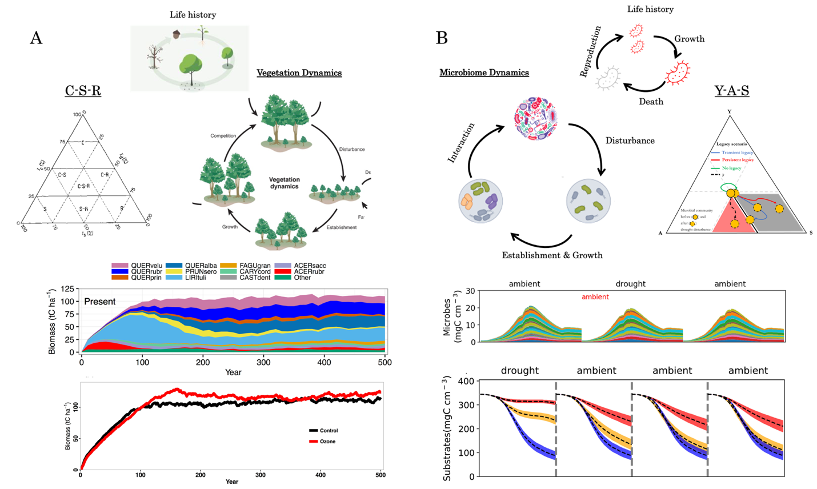
Fig.1 Demography-based modelling of forest and microbiome dynamics and functioning. A) Simulated temperate forest dynamics after a clearcut with respect to composition and undampened biomass from tropospheric ozone pollution in East Tennessee, USA. The biomass (tC ha⁻¹) is means of an ensemble of 200 simulations on a plot size of 500 m² to approximate a shifting-mosaic steady-state landscape using UVAFME-VOC (Wang et al. 2017; GitHub Repository: https://github.com/bioatmosphere/UVAFME-VOC). The triangle shows the C-S-R theory of plant life-history tradeoffs (Grime 1977). B) Simulated dynamics of a grassland litter microbiome system in Southern California, USA with drought disturbance with respect to composition (hypothetical taxa) and functioning (i.e., litter decomposition). The amount of substrates and its uncertainty are based on an ensemble of 40 independent runs of DEMENTpy (Wang and Allison 2021; GitHub Repository: https://github.com/bioatmosphere/DEMENTpy). The triangle shows the Y-A-S theory of microbial life history tradeoffs (Malik et al. 2020).

2. Characterizing a critical need of integrating vegetation-microbiome interactions

It is a short history of accounting for demography in modelling ecosystem functioning. Simulating population dynamics of different organisms has been ongoing at least since the 1940s, most of which, however, were limited to theoretical ecology in the population and community ecology setting, though available for both macro- and micro-organisms (e.g., Levins 1966; Sinko and Streifer 1967; Levins 1969). With an ecosystem perspective, integrating community demography and biogeochemistry appeared notably much earlier in tree communities than in microbial communities. Since the 1970s (Botkin 1972), forest demography models have been under active development (Shugart et al. 2018). Demography-based modelling reflecting this notion in microbiome with a perspective of biogeochemistry did not appear until the 2000s (e.g., Widder et al. 2016). Without exhaustively writing about history and methodology (but see Wu and Loucks (1995) for a general account and van den Berg et al. (2022) for a microbial modelling focus), we detail below the unique insights gained from existing modelling structures to argue for a critical need of explicitly integrating demography of both forest and microbiome (Fig.1).

2.1 Vegetation dynamics and ecosystem functioning
Vegetation dynamics exemplified by forest demography modelling plays a significant role in understanding and predicting implications of forest structures for functioning, dynamics, and resilience (Fig. 1A). Reflecting the view of shifting mosaic of patches/gaps of a forest landscape, the earliest gap models explicitly simulate growth, mortality, and reproduction of different individuals in an array of gaps at different successional stages arising from internal and external disturbances (e.g., Shugart 1984; Shugart et al. 2018). Explicitly modelling sizes and ages of different species using an individual-based approach allows realistic light transfer within forest canopy and individual crown, enabling, for instance, dynamically simulating production and emission of secondary metabolites of Volatile Organic Compounds (VOCs) that are highly variable among species (Wang et al. 2017; 2018). Though conferring unique advantages (e.g., capturing better individual variation), such a strategy of simulating different species occupying a forest landscape can be simplified. By approximating the spatial and vertical structuring of vegetation without an explicit parameterization and simulation of different species, cohort-based models simplify the individual-based forest gap models by utilizing cohorts of like-sized plants without spatially explicitly simulating different patches (e.g., Levin and Paine 1974; Clark 1991; Kohyama 1993; Hurtt et al. 1998). Eventually, this approach was applied to the Ecosystem Demography model (Moorcroft et al. 2001) and the latest Functionally Assembled Terrestrial Ecosystem Simulator (FATES) with more sophisticated algorithms of allometry and carbon-nutrient interactions (Fisher et al. 2018). These models are widely used (Shugart et al. 2018; Buggmann et al. xxxx). One example that exemplifies their unique capability is challenging the long-held contention since the 1950s that tropospheric ozone pollution severely reduces forest carbon sequestration (Fig.1A). These forest demography modelling efforts without explicitly involving demography of the microbiomes offer us insights into forest structural implications for functioning and dynamics.

2.2 Microbial dynamics and decomposition
Similarly, modelling microbiome dynamics independently helps understanding functional emergence from its tremendous complexity (Fig. 1B). This independence serves a purpose in the microbial ecology community of complimenting empirical investigations. However demography-based modelling of dynamics and functioning of microbiome are challenging with their tremendous diversity, micro-scale patterns, and richness of processes (Kreft et al. 1998; Hellweger et al. 2016; Falkowski et al. 2008; Wu et al. 2022). We take for example the state-of-the-art trait-based modelling of litter microbial systems (Allison 2012; Wang and Allison 2021). In essence, it is a lattice-based model of different microbial taxa decomposing leaf litter. The diversity is approached using a trait-based approach to simulate hypothetical individuals. Then, a series of metabolic and demographic processes ranging from turnover to degradation are modelled. Therefore, functioning in terms of litter decomposition and other associated processes is simulated as a self-organization mechanism under the constraint of moisture and temperature, as well as litter inputs. The power of this model can be exemplified by its application to drought disturbance and litter decomposition (Fig.1B). Drought legacies in litter decomposition were revealed to be contingent on intensity and dispersal, leading to different trajectories of microbial system development and decomposition that can be explained by 3-way life-history tradeoffs (Wang and Allison 2021; 2022). These demonstrations show the unique capability and potentials of demography-based microbiome modelling.

2.3 A modelling gap of coupling vegetation and microbiome demography
The above demonstrations reflect an apparent gap of missing a direct linkage between vegetation and microbiome in a coherent, comprehensive ecosystem dynamic modelling framework. Modelling vegetation and microbiome dynamics explicitly in isolation assumes each other implicitly without capturing their complex interactions. The vegetation-focused models usually assumed a first-order microbial control of decomposition, while the explicit microbiome model assumed a constant litter input without feedbacks. However, we now know clearly that vegetation and microbiome are closely coupled, forming a complex adaptive system involving higher-order interactions among members of the plant and microbial communities under fluctuating environments from the above- to the below-ground (e.g., Watt 1947; Perry et al. 1989; Bever et al. 1997; 2003; Mayfield and Stouffer 2017; Fei et al. 2022). Aboveground-belowground interactions or vegetation-microbiome interactions in general are critical for the functioning and resilience of ecosystems across spatial scales (Supporting Fig. 1). of all biomes but vary in structure and magnitude and change over time, or adaptive to disturbances. For instance, in biomes other than the forest, the aboveground competition for light may become subordinate, and complex interactions belowground with the microbiome dominant (e.g., Callaway and Meron 2021; Schenk 2006). As changes in climate and disturbance regimes tighten vegetation-microbiome interactions, neither can be understood while obscuring the other (Perry et al. 1989; Wolfe and Klironomos 2005; Kaisermann et al. 2017; Rudgers et al. 2020; Allsup et al. 2023). For instance, drought altered plant-microbe feedbacks with consequences of plants’ competition by changing bacterial and fungal communities (Kaisermann et al. 2017). Apparently, such complex feedbacks and their ecosystem consequences are what existing models miss the most. For instance, a pair of demography-based vegetation model and a ‘big-microbe’ model, let alone the purely ‘big-model’ paradigm alone (Bever et al. 1997; Kinzig et al. 1998). Indeed, the 1988 summer workshop conceiving and developing the first DGVM acknowledged that dynamics modelling should not be limited to vegetational processes (Prentice et al. 1989)]. This modelling gap needs to be closed in modelling ecosystems across scales.
In essence, the need for explicit integration of vegetation and microbiome is a need to embrace ecosystem complexity to avoid linear thinking.

However, ecosystems as complex adaptive systems make it challenging to close such a modelling gap. Rather, recognizing and exploring the properties of ecosystems whose components are subject to selection prompted a view shift that regards the organization, functioning, and dynamics of different organisms as complex adaptive systems (Levin 1998). That is, memories or legacies in various forms (including evolution) induced by, e.g., environmental changes and/or disturbances, arise in lower organizational levels in vegetation, microbiome, and/or beyond. Higher-level patterns, structures, functions, and dynamics emerge from the self-organization of diverse organismal agents characterized by complex interactions across lower levels under environmental constraints, and feed back to influence the subsequent development of the self-organization (e.g., Odum et al. 1988; Perry 1994; Levin 1998). Self-organization, emergence, and feedback shape hysteresis or, more generally, historical contingency in environmental controls over ecosystem functioning and dynamics across scales (Wolf et al. 2008; Blount et al. 2018). Such a non-linear property of historical contingency acts as the very source of resilience, tipping, and/or alternate states of ecosystems in response to changes in climate and disturbances (e.g., Holling 1973; Levin 1998; Scheffer et al. 2001; Roger et al. 2022). Parsing ecosystems as complex adaptive systems to capture this non-linearity becomes a fundamental challenge in formulating ecosystem models across scales (e.g., Huston et al. 1988). In essence, the need for explicit integration of vegetation and microbiome is a need to embrace ecosystem complexity to avoid linear thinking.

2.4 Towards the grand goal of predictive synthesis
Embracing complexity, though challenging, is in line with the grand goal of ecology. As early as in 1977, Eugene P. Odum (1977) formally advocated for ecology as an integrative discipline to have real applications. O’Neill et al. (1998) also argued that fast and slow and local and distant processes cannot be treated separately. More specifically, Wu & Loucks (1995) proposed a hierarchical patch dynamics paradigm to integrate spatial-temporal scales. The metacommunity concept proposed by Leibold et al. (2004) is another notable endeavor along this line. From advocates to concepts, the concrete models realized, however, fall short of continuing the tradition and fulfilling the goal of integration (e.g., Willis and Bhagwat 2009; Newman et al. 2019). As discussed above, vegetation and microbiome are modelled separately without interaction and coordination, each with its own community of researchers and rich variety of models of different structural assumptions (e.g., Cramer et al. 2001; Sulman et al. 2018; van den Berg et al. 2022). Such a lack of more integrative modelling of both vegetation and microbiome echoes what Edward Wilson (1999) asserted: ‘Predictive syntheses, the ultimate goal of science, are still in an early stage, and especially so in biology.’ To approach toward the grand goal of ecology, we believe major conceptual and logistical hurdles can be crossed for more integrative high-fidelity modelling of ecosystems comprising vegetation and microbiome.
First, arguments against melding microbiomes in an any more explicit manner than xxxx may be just a reasoning fallacy. For instance, litter decomposition studies normally de-emphasize the role of microbial community composition in controlling soil carbon dynamics (e.g., Beugnon et al., 2021). This de-emphasis reflects the influential conceptual framework of a hierarchical control of litter decomposition; that is, litter decomposition is argued to be hierarchically controlled by climate, substrate, and microorganisms, with microbial community composition occupying the least important position (e.g., Lavelle et al., 1993; Aerts, 1997). However, decomposers control litter decomposition beyond the local scale and that a more explicit consideration of microbial communities in models is warranted (Bradford et al., 2017; Wang and Allison 2021; 2022), proving that the framework is a reasoning fallacy.
In addition, a lack of data does not necessarily block us from developing more integrative models. When pursuing more integrative modelling in general, the research community often invokes such limitations as missing data intermingled with scale arbitrariness from empirical investigations (e.g., Zhou et al. 2012; Cavender-Bares et al. 2022). This data challenge, albeit arguably true, does not necessarily block us from developing more integrative models (Purves et al. 2013; Enquist et al. 2024). Indeed, as argued by Cavender-Bares et al. (2022) in the context of biodiversity conservation and remote sensing, data and techniques are not as urgently needed as integrative frameworks. However, developing more integrative frameworks of modelling does not necessarily mean incorporating into models what we empirically find about missing mechanisms. For prediction, models do not necessarily end up with incorporating systems’ components explicitly (Yu and Wang 2024; ML and AI). For understanding, however, we need updated models to reflect more explicit theories and empirical evidence that make possible modelling as a tool to sharpen questions, to formulate hypotheses, and to inform empirical investigations, though relying on purely mechanistic modelling offers limited predictive capability into the future (Yu and Wang 2024).
By crossing these conceptual hurdles, we believe the time has come to develop an ever more integrative framework of ecosystem modelling by capturing diverse responses of not only plants but also microbes and cross-scale interactions for understanding and predicting complex interactions and their long-term ecosystem consequences. In particular, we are equipped with unprecedented software engineering and computational capability for numerical computing [xxxx]. As a first step towards this ambitious goal, we propose an framework based on gaps or patches of both vegetation and microbiome, of which the structure, components, and approaches, as well as the rationale are articulated below.

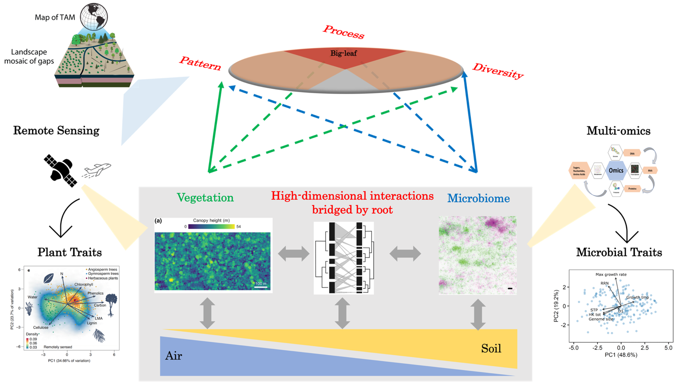
Fig.2 A Gap of Gaps (GoGs) framework of ecosystem dynamics modelling bridging across organizational levels over spatial-temporal scales integrating vegetation and microbiome. The oval atop illustrating the framework is inspired by Meron (2016). Higher-order interactions among plant and microbial community members are mediated by the root system in general and the fine-root system (different orders with mycorrhizal fungi associations) in particular. The PCA of plant traits is from Cavender-Bares et al. (2022), and the microbial traits from Westoby et al. (2021).

3. A Gap of Gaps (GoGs) Framework

‘Species and individuals form different kinds of patches; these patches form a mosaic and together constitute the community. Recognition of the patch is fundamental to an understanding of structure. Patches are dynamically related to each other. But there are departures from this inherent tendency to orderliness. At any given time, therefore, structure is the resultant of causes which make for order, and those that tend to upset it. Both sets of causes must be appreciated.’

3.1 Hierarchical structuring of vegetation and microbial patches
Alex Watt (student of A.G. Tansley) in his seminal work—Pattern and Process in the Plant Communities (Journal of Ecology;1947)—discussed the idea of plant communities spatially organizing into a mosaic of different patches by synthesizing seven examples of plant communities. For instance, forest landscape is a mosaic of patches at different successional stages induced by exogeneous and endogenous disturbances (Pickett and White 1985). This idea of plant community patchiness is the very conceptual root of formulating the now popular forest gap models and their derivatives as discussed above (Fig.1A). which underpins forest demography modelling as discussed above (e.g., Bormann and Likens 1979).
The same notion of patchiness applies to microbial communities, which, however, operates at different spatial-temporal scales. Microbiomes share the pattern formation phenomenon (e.g., biofilm) in both marine and terrestrial environments (e.g., Momeni et al. 2013; Ratzke and Gore 2016; Ebrahimi et al. 2019; Rossy et al. 2019; You et al. 2021), which even provides a unique model system to study pattern formation because of their fast timescales and manageability (e.g., Martinez-Garcia et al. 2022). Indeed, Alex Watt, in ending his discussion, insightfully discussed the equally important micro-organisms (Watt 1947). However, scale differences between vegetational and microbial patches underpin this hierarchical structure. Microbes in general are much smaller in size and faster in turnover than plants[elaboration]. The soil microbial community in a vegetation patch forms different sub-communities or patches arising from self-organizations and environmental heterogeneities (REFs). Soil environment is tremendously heterogeneous because of aggregation (Wang et al. 2019). We argue that one effective way to achieve the desired integration is a contingency on vegetation mosaic of patches, each containing a mosaic of microbial patches. This hierarchical framework of vegetation and microbiome patches is dubbed Gap of Gaps (GoGs) (Fig.2).
Such a GoGs structure contrasts with existing models by allowing pattern formation. Models under the ‘big-model’ modelling paradigm, especially land surface models in earth system models, strongly bias towards biogeochemical processes against biological diversity and their patterning. Using a few functional types of plants/microbes as a simplification strategy, these models prescribe spatial patterning of these PFTs at only regional and larger spatial scales dictated by climatic heterogeneities (Woodward 1987). Even DGVMs, though having pattern accounted for (but in a very limited sense), still face a problem of sacrificing diversity with a few functional types for biogeochemical processes. However, pattern formation plays an essential role in mediating ecosystem functioning, dynamics, and resilience in response to climate change and disturbances (e.g., Meron 2016; Ratzke and Gore 2016; Zobel et al. 2022). In particular, pattern formation has been revealed as an adaptation of ecosystems evading dramatic changes (Rietkerk et al. 2021), acting as a hallmark of ecological resilience in the context of frequent disturbances (Peterson 2002; Cuddington 2011; Martinez-Garcia et al. 2022). GoGs captures spatial (horizontal, vertical, and above- or belowground) structuring of both vegetation and microbiome over time. The capability of such a GoGs framework in its hierarchical nature lies in offering a structure to integrate vegetation-microbiome interactions in an ever more complete (fuller) appreciation of complexity in ecosystem functioning and dynamics.
The beneficial role of pattern formation is conferred by processes including, but certainly not limited to, those that existing models consider. Existing process-oriented modelling with a minimum structural representation without diverse organisms and their patterning is focused on capturing processes of [xxxx]. However, it’s complex to elucidate until recently. For instance, the positive feedback dampens and is subsequently replaced by a negative feedback further away in space, generating scale-dependent feedbacks as a result of spatial processes (Rietkerk et al. 2008). The crucial spatial effects of these processes leading to scale-dependent feedbacks are typically neglected when assuming ecosystem homogeneity. Though system-dependent (Rietkerk et al. 2004; Meron, 2016; Siteu et al. 2023), pattern formation in general is a result of complex, higher-order interactions among diverse individuals across scales mediated by a rich array of processes. Though more intuitively regarded as a result of dictation by external environmental heterogeneities at varying scales, spatial pattern in terms of patches can arise from self-organization without even spatial physio-chemical heterogeneity (Levin 2003; Sheffer et al. 2013). In other words, self-organized pattern formation should be distinguished from those dictated by external environmental heterogeneities that is commonly dealt with in traditional spatial ecology and model formulation (van de Koppell et al. 2008; Sheffer et al. 2013; Meron, 2016). Indeed, a premise of the seminal discussion by Alex Watt is uniformity of external environment (Watt 1947). However, dryland vegetation has become paradigmatic for its regular pattern formation resulting from scale-dependent feedbacks (i.e., Turing Pattern; Rietkerk et al. 2021; Walsh et al. 2023). In fact, self-organized pattern formation, either regular or irregular, appear not only in the aboveground vegetation but also in the complex soil microbiome (e.g., Wu and Loucks 1995; Rietkerk et al. 2004; Tarnita et al. 2017; Siteu et al. 2023; Supporting Fig.1).
Capturing these emerging, non-intuitive mechanistic insights underlying pattern formation faithfully in an ecosystem model structured as GoGs, though at a cost of increasing complexity, is warranted. It is inevitable for such a GoGs structure, by capturing those mechanistic insights, to come with a high complexity, relative to existing models. We do not intend to debunk the low realism of process-focused modelling, but rather to complement those existing structures to reconcile some of the apparent inconsistencies between theoretical ideals and empirical realities. In fact, pattern-oriented modelling has been widely discussed in the literature. In addition, a very similar opinion of valuing pattern is articulated towards new catchment hydrological modeling (Schröder 2006). [high-resolution modelling is also in this direct, though we believe that xxxx]. Therefore, it is warranted to pursue such a GoGs structure of ecosystem modelling with empirical and theoretical supports to serve the need of a predictive ecosystem integration of vegetation and microbiome. Below we elaborate in detail components to be considered in this framework.

3.2 Components

We dismember the shared pattern-process notion into three shared specific components: diversity, pattern, and process. Including these components in this GoGs framework is expected to capture the differences, and their complex interactions, between vegetation and microbiome dynamics.
In formulating demography-based models of ecosystems at different spatial scales, embodying those three components means capturing diverse life-history strategies spatially structured into different patches at different successional stages from the above- to the below-ground. Such an integration is in line with the hierarchy theory of ecosystem organization (Allen and Hoekstra 1990; O’Neill et al. 1998) and the more specific hierarchical patch dynamics theory (Kotliar and Wiens 1990; Wu and Loucks 1995), allowing the expression of disturbances at different scales (Pickett et al. 1989). These spatial structures together with diversity result in both within- (Walker et al. 1999) and cross-scale diversity (Peterson et al. 1998), which enables regeneration and renewal to occur following ecological disruption over a wide range of scales. The resultant models make possible capturing diverse responses (Walker et al. 2023) and cross-scale interactions and feedbacks (e.g., Pascual and Guichard 2005) underlying ecosystem functioning, dynamics, and resilience in response to changing environment and disturbances.

At its core, this modelling framework needs to capture life histories of both plants and microbes. Life history involves growth, reproduction and dispersal, and mortality. The way of systematically controlling these different events is called life history strategy.

of different life history strategies.

Allometric scaling and wood density

Resource acquisition and allocation
Mortality
Reproduction
Dispersal: diffusion term

Atmosphere
Soil physics-chemistry: soil structure, carbon, water, nutrients: Feedbacks to plant and microbial changes.

Capturing such demographic processes in their rich diversity is a mandate. Game theory. Theoretical and empirical efforts dedicated to its implications for functioning are extensive. In particular, plant diversity and its importance have long been appreciated since at least the 1950s (e.g., Chapin et al. 2000), notably in grassland ecosystems with feasible diversity manipulations (e.g., Grace et al. 2016). Though important in a broad sense, redundancy is an argument normally invoked against its explicit account in system-level functioning (i.e., grouped into a few functional types; Smith et al. 1997). This notion of redundancy is especially true for microbiomes (e.g., Allison and Martiny 2008). Microbial diversity, due to cultivation-independent high-throughput sequencing (e.g., Pace 1997; Tringe and Rubin 2005), is revealed to be overwhelmingly high across ecosystems. Although relating microbial diversity to functioning relatively remains at an early stage, its importance is emerging as a big question (e.g., Bardgett and van der Putten 2014; Martiny et al. 2023).

Disturbance

Land use change

It is a nontrivial task to merging components above for both vegetation and microbiome. There have been different ways of making compromises and different approaches of structuring formulations to merge these together (cohort-based and individual-based). For instance, one way of modelling forests is structuring both horizontally by age (i.e., different patches since disturbances) and vertically by size (i.e., different heights in each patch; Kohyama 1993) but by assuming a few plant functional types. Similarly, microbiomes, though not structured specifically by height like trees in each patch, form mosaic of patches consisting of individuals of different cell sizes at different life stages (e.g., Ratzke and Gore 2016). No matter how we make compromises and what specific modelling approaches we use, trait-based modelling can serve as a unified steppingstone towards developing this GoGs framework.

3.3 Trait-based modelling
Trait-based modelling promises synthesis, integration, and generalized prediction. Trait-based approach in general is about assembling traits from morphological to functional for comparative research (Mooney et al. 1972; Shipley et al. 2016), which form high-dimensional spaces for either plants (e.g., Clark 2010) or microbes (Westoby et al. 2021). From these spaces, economic spectra and tradeoffs underlying the emergence of diverse life-history strategies are uncovered and quantified (e.g., Reich et al. 1997; Wright et al. 2004; Lerdau et al. 2023; Fig.2). Trait-based modelling may prescribe these tradeoffs or instead treating these tradeoffs as emergent constraints without traditional taxonomical identity. Benefited from an accumulation of trait measurements, trait-based modelling confers an advantage scaling across large spatial scales (Enquist et al. 2007; Reichstein et al. 2014). More importantly, using traits offers the feasibility of linking mechanisms controlling life history variations (e.g., genetic expression), their interactions, and emergent ecosystem functioning and dynamics over time (Lavorel & Garnier 2002; Enquist et al. 2007; Reichstein et al. 2014; Lerdau et al. 2023). Trait-based modelling has been separately applied firstly to vegetation dynamics (e.g., Lavorel & Garnier 2002; Rüger et al. 2020; Fig.1A) and then to marine microbiome dynamics (e.g., Follows et al. 2007; Fig.1B). Evolution????
However, progress of TBM lags/stumbles. Notably, trait-based modelling not working in predicting dynamics [Elaboration!!!]. [What are the possible reasons?] No pattern formation mechanisms [competition!]. More directly, a Trait-Based Approach to Self-Organized Pattern Formation in Ecology was argued (link). In particular, it is missing explicit interactions between vegetation and microbiome in a way of cross scales as discussed above under Section 2.3. Trait-based modelling needs to be applied under a bigger framework. In other words, trait-based modelling, like traits per se being constrained by not only physio-chemical but also eco-evolutionary processes, needs to be constrained by a more conservative conceptual structure. We believe that this GoGs structure offers such a framework under which trait-based modelling can be applied to keep the promise.

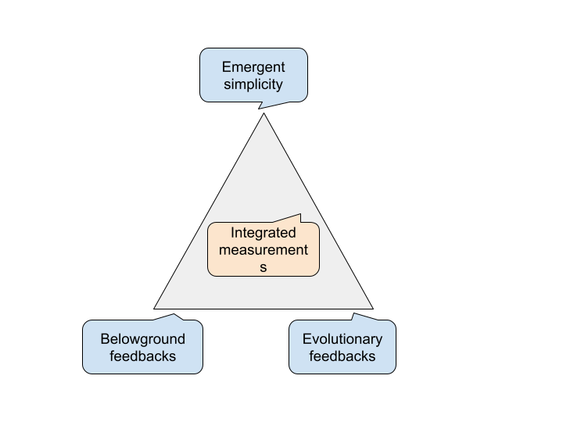

4. Motivating questions for GoGs
Going forward, we pose a series of motivating questions for the realization and development of this structure into a cohesive modelling and computational framework (Fig. 3). Although our goal of realizing and developing this GoGs framework are eventually embodied in the form of algorithms, software, and computing, they should begin with scientific questions. The proposition of this framework is driven in the first place by the overarching challenge of complex interactions between vegetation and microbiome involving both aboveground and belowground patterns and processes. Oriented toward addressing this overarching challenge to characterize those complex interactions, to evaluate their large scale consequences, and to reliably predict ecosystem dynamics in response to climate changes and disturbances across spatial scales, here we pose three motivating questions: First, what are the complex belowground feedbacks to the aboveground changes and consequences for ecosystem functioning and dynamics in response to climate changes and disturbances? Second, what are the evolutionary consequences and feedbacks for ecosystems responding to disturbances? Third, how can we scale from local to regional and global over time by finding emergent simplicity? This non-exhaustive list offers what we believe both foundational and functional to motivate the realization and development of this GoGs framework. These questions by nature are challenging or even impossible for pure empirical inquiry; we need mechanistic modelling of such an ever more integrative nature to complement empirical efforts (Moorcroft 2006; Bowman et al.. 2015; Schlüter et al. 2023). Below we elaborate these three questions with regards rationales, challenges, and implications, highlighting the role of this integrative modeling framework.

4.1 Belowground feedbacks
What are the consequences of self-organized spatial pattern formation in the belowground for ecosystem functioning and dynamics? As discussed above, focus remains on pattern formation of the aboveground vegetation because of easy observations. Mechanisms are explored (REFs), but whether and how the belowground systems, especially the complex soil microbiomes, are involved remain unknown. Answering this question needs the modelling framework proposed here because of its explicit integration as empirical research remains infeasible. Such modelling, however, faces a challenge of handling scale mismatches, which are differences in spatial-temporal scales between vegetation and microbiome (Fig.4). At the spatial scale of a self-organized vegetation pattern, tremendous environmental heterogeneity exists to constrain the self-organization of microbial communities. Take forested ecosystem for example. A mosaic of forest patches on a homogeneous land would have horizontal and vertical physic-chemical heterogeneity for microbes from the aboveground litter to root systems to bulk soils in the complex soil matrix (e.g., Wang et al. 2019; Griffiths et al. 2022). Root systems, especially the fine-root systems comprising different orders and mycorrhizal fungi, play a central role connecting these different parts. Our recent discussion on TAM-based modelling of fine root and fungi associations could be treated as a starting point (Wang et al. 2023) to pursue unified trait-based modelling accommodating both vegetation and microbiome. Through answering this big question, the modelling framework would lay a foundation for better addressing problems related to evolution in a more systemic way.

4.2 Evolutionary consequences and feedbacks
What are the consequences and feedbacks of evolutionary changes for ecosystem functioning? Evolution is the ultimate force of ecosystems as complex adaptive systems to self-organize to stay resilient in the face of frequent and intense disturbances (e.g., Levin 2003; Flack 2017; REFs). Disturbances catalyzes evolution as the likelihood of ecological change generating evolutionary change increases (Wood et al. 2021). Notably, microbial evolution can happen simultaneously with ecological processes (Traverse 1998; Pelletier et al. 2007; Martiny et al. 2023). The assumption of temporal separation between ecology and evolution cannot stand (REFs). It is critically important to elucidate the relative importance of contingency and determinism of ecosystem functioning (Blount et al. 2018; Vahsen et al. 2023). Our demography-based framework offers the backbone structure for incorporating evolution to explore its system-level consequences and feedbacks. Demography is central to understanding evolution (e.g., Metcalf and Pavard 2007; Jones et al. 2014). As paraphrased by James W. Vaupel of Dobzhansky’s classical statement, “nothing in biology makes sense except in light of evolution, nonetheless, nothing in biology makes sense except in light of demography”. Indeed, predicting evolution has been explored extensively (e.g., Lässig et al. 2017; Govaert et al. 2019). However, unlike those previous research mostly confined to the population and community ecology setting, the framework here warrants more integrative explorations of evolutionary implications of both plants and microbes for biogeochemical dynamics (Govaert et al. 2019; REFs). By addressing this question of evolutionary consequences and feedbacks, this modelling framework is expected to offer more integrative and reliable predictions and to set the stage for exploring model simplicity.

4.3 Emergent simplicity for scaling
With a model reaching a stage close to representing ecosystems as complete CASs, we can address another exciting and practical question in ecosystem modelling: can we simplify modelling ecosystems but remain robust and reliable for scaling? Although more complex models do provide a kind of understanding of past events, one consistent concern is that model complexity may trade off with predictability (e.g., Slobodkin and Rapoport 1974). We share this common concern, but do not regard it as an issue that should preclude us from making models more explicit. Nevertheless, acknowledging no absolute predictability of ecosystem dynamics (Levin 2003; REFs), we fully embrace the appealing idea of eventually making models simple (e.g., Edmonds 2000).
However, we believe that seeking such a simplification will not be appropriate until we have a relatively more complex model. The model discussed here is a good candidate: compared to the current models like those under the prevailing paradigm of big-leaf or -microbe models, this modelling framework captured eco-evolutionary processes in a very explicit manner. We emphasize that the simplicity emerged is not the same as data-driven machine learning and artificial intelligence. This simplification works against causally constrained statistical modelling or machine learning. [For instance, ECA]. [Hurtt et al. 1998; Moorcroft et al. 2003]. The rationale is that models are inherently sloppy (Transtrum et al. 2015). We speculate that from the complex models we can find emergent formulae that are simple yet mechanistically correct, which can be used for scaling across large spatial-temporal scales and informing ecosystem management.

5. Challenges of model-data integration
Such an ever more integrative mechanistic modelling framework entails more integrative data usage. The reason we develop computational models in general and propose the structure of this theory-driven modelling framework in particular is to complement pure empirical research of increasing limitedness to tackle such questions as discussed above regarding understanding and predicting complex ecosystems. Empirical research face logistical challenges of experimental manipulation and long-term, high-frequency observations(Schlüter et al. 2023). However, for this complementarity to succeed, one unified question emerges: how to integrate this modelling framework and empirical data from observations and experiments? For purposes from parameterization to verification to calibration and uncertainty quantification, we need to assimilate integrated data that shall span the aboveground and the belowground related to vegetation and microbiome across spatial scales over time. For assimilation of data into such a complex model with inverse problem methodologies, a computational science challenge emerges of high-dimensional unknown parameters. Ill-posedness is a central issue for inverse problems in general; a high-dimensional parameter space make this issue even worse via traditional iterative optimizations and regularizations (REFs). ML and, Generative AI in particular, could play a big role in addressing these challenges, such as through online learning techniques for continuously updating models using streaming data (Aboelyazeed et al. 2023). Though these data-driven machine learning algorithms can help significantly, we still lack empirical data.
Meeting the data needs of this modelling framework is a parallel priority. This lack of integrated data is because of an analytical approach in ecology (see a review by Ohse et al. 2023; Keith et al. 2022). Challenges remain at large in assembling traits for the belowground in general and microbes in particular (e.g., Westoby et al. 2021), let alone efforts of integrating intact plants and microbes under the trait-based modelling approach. Though such data might be relatively complete in certain locations, they are overall missing in most of ecosystems across the globe. Approaches such as active learning and reinforcement learning can help guide the collection of additional data most salient to the digital twin’s objectives. Nevertheless, these data needs can be possibly met by creatively leveraging two representative data streams from the aboveground vegetation to the belowground microbiome. The aboveground plant diversity and pattern can benefit from the remarkable progress of remote sensing in acquiring data of biodiversity at an increasing resolution from sensors to algorithms (Pettorelli et al. 2016; Cavender-Bares et al. 2022). LiDAR (Light Detecting and Ranging; Lefsky et al. 2002), RaDAR (Radio Detecting and Ranging; Hall et al. 2011; Le Toan et al. 2011), and their fusion can distinguish the vertical, horizontal, and 3-D structure of forests (Shugart et al. 2015; Torresani et al. 2023; Yang et al. 2023). Hyperspectral imaging spectroscopy can quantify leaf-and-species-level chemical and functional traits (Asner et al. 2012). A belowground equivalent of remote sensing is multi-omics for soil microbiomes. (including shotgun meta-genomics, single-cell genomics, meta-transcriptomics, meta-proteomics, and targeted and non-targeted metabolomics; e.g., Rondon et al. 2000; Li et al. 2004; Tringe and Rubin 2005; Eberwine et al. 2023). For instance, microbial genome data can be leveraged to infer key functional traits to be integrated into a theory-based hierarchical framework, emergent behavior arising from interactions of individual traits can be predicted (REFs). Together with soil imaging advances (e.g., microfluidic and nanofabrication tools; Hol et al. 2014), these -omics techniques will help reveal microbial pattern, diversity, and process in the soil matrix (e.g., Fierer et al. 2014; REFs). These data, together with accumulation of long-term observations (e.g., Inchausti and Halley 2001; Mechenich et al. 2023), are expected to address the data needs.
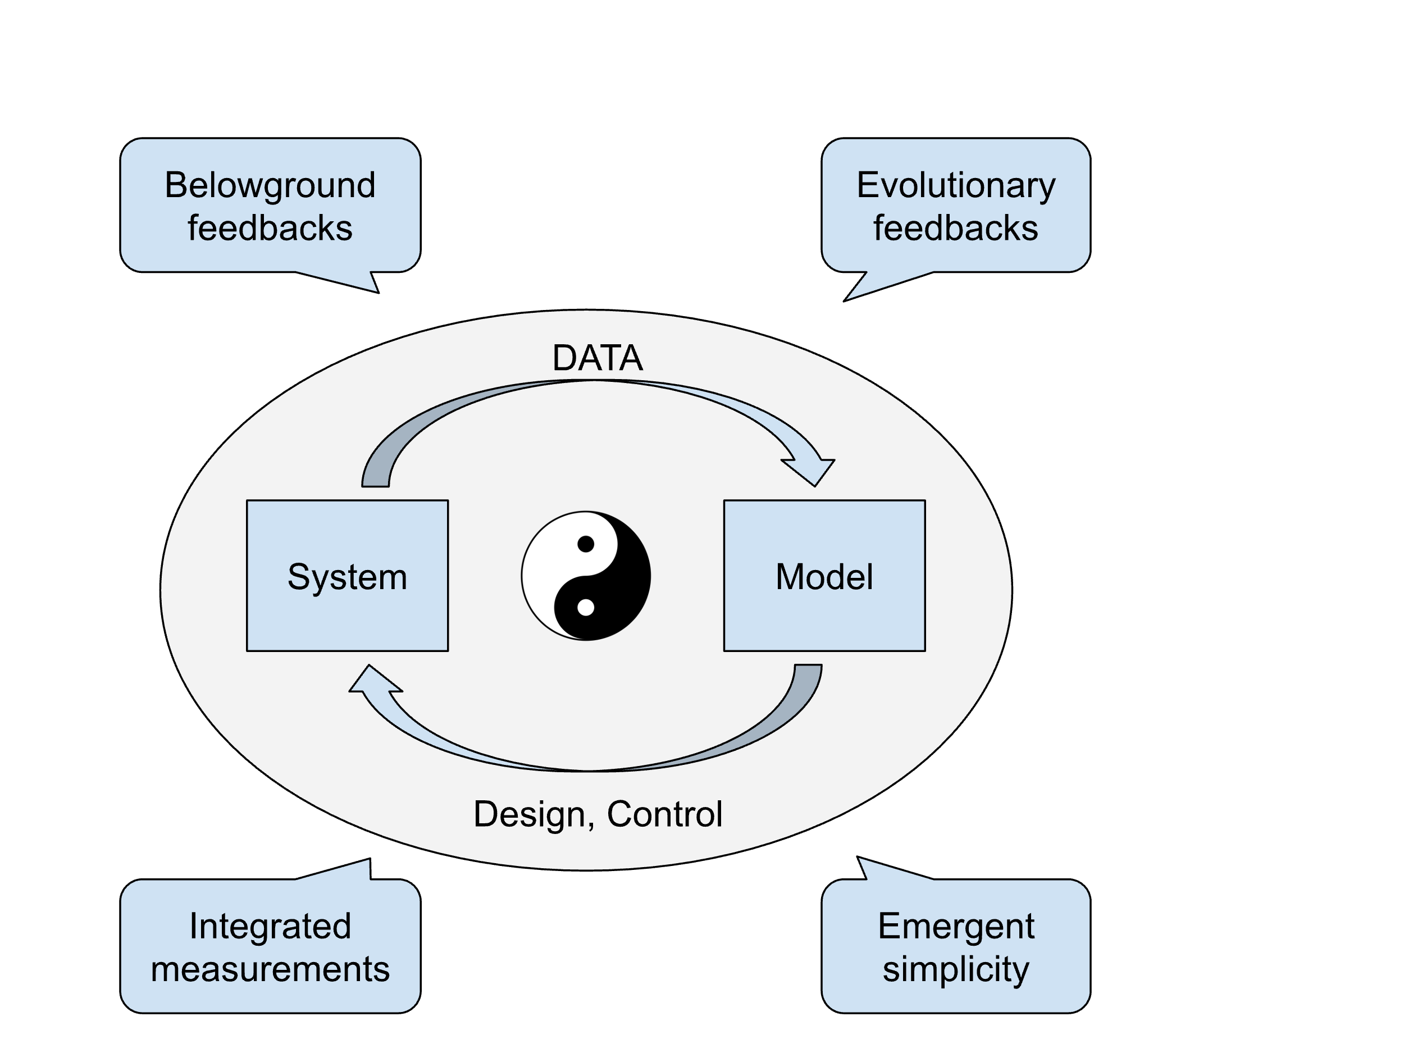

6. Implications for Earth System Science and Ecosystem Management
Simulating the ecosystems we try to manage with this integrative modelling framework is expected to play a big role in informing solutions (Fig.4). In the face of changing climate and disturbance regimes, ecosystem management needs to confront two complementary challenges: understanding ecosystem resilience and projecting ecosystem responses to environmental changes (Collings 1973; Scheffer et al. 2001; Novick et al. 2024), collectively a challenge of developing a science of predictive ecosystem resilience to build and enhance ecosystem resilience. The synergistic nature of this framework brings about all the excitement of an ever more integrative model closely interacting with the ecosystem of management concern through data acquisition (remote sensing and omics) and prediction of ecosystem dynamics, forming an ecosystem-digital twin system. The full potential of this digital twin system for understanding, prediction, and management is yet to be realized (National Academies of Sciences, Engineering, and Medicine, 2023). Nevertheless, if this modelling framework happens to be any impactful, it is because of its integrative nature, as there is no ‘super microbe’, ‘super plant’, or ‘super ecosystem’ to the pressure we have imposed on ecosystems and the entire biosphere. It is really a problem for all, just as how Alex Watt emphasized in the ending of his 1947 article (Watt 1947): ‘…to have the ultimate even if idealistic objective of fusing the shattered fragments into the original unity is of great scientific and practical importance; practical because so many problems in nature are problems of the ecosystem rather than of soil, animals or plants, and scientific because it is our primary business to understand.’

7. Conclusions
Motivated by a big question of predicting ecosystems confronted with changing disturbance regimes, we argue that integrative modelling falls short of our needs to contribute to addressing a daunting challenge of frequent and intense disturbances facing ecosystems and the biosphere. Reasoning fallacies of diverse angles make relevant efforts fall behind, although theories of ecosystems and the biosphere as complex adaptive systems have been in place for decades. Demography-based modelling of ecosystems and the biosphere, we believe, is on the right track to approach this grand challenge. To this end, we propose a trait-based PDP framework for demography-based modelling by synthesizing from an array of fields concepts, theories, and models for both vegetation and microbiome. We marshal arguments complemented with specific modelling examples of both forest and microbiome separately. With solid theories (for a not short history) and available data (if not readily), we argue against concerns of model complexity and predictability by discussing the yet included evolution and the outstanding role of this framework in marching together with empirical research. To understand and predict the urgent and daunting challenges facing the biosphere, we advocate for the role of this demography-based integrative modelling effort.

References
Albert, J. S., Carnaval, A. C., Flantua, S. G., Lohmann, L. G., Ribas, C. C., Riff, D., ... & Nobre, C. A. (2023). Human impacts outpace natural processes in the Amazon. Science, 379, eabo5003.

Albrich, K., Rammer, W., Turner, M. G., Ratajczak, Z., Braziunas, K. H., Hansen, W. D., & Seidl, R. (2020). Simulating forest resilience: A review. Global Ecology and Biogeography, 29, 2082-2096.

Allen, T. F., & Hoekstra, T. W. (1990). The confusion between scale‐defined levels and conventional levels of organization in ecology. Journal of Vegetation Science, 1, 5-12.

Allen, C. R., & Holling, C. S. (2008). Discontinuities in ecosystems and other complex systems. New York: Columbia University Press.

Allsup, C. M., George, I., & Lankau, R. A. (2023). Shifting microbial communities can enhance tree tolerance to changing climates. Science, 380, 835-840.

Arthur, W.B. (2021). Foundations of complexity economics. Nature Review Physics 3, 136–145.

Bauer, P., Stevens, B. & Hazeleger, W. A digital twin of Earth for the green transition. Nature Climate Change 11, 80–83 (2021). https://doi.org/10.1038/s41558-021-00986-y

Bardgett, R., van der Putten, W. (2014). Belowground biodiversity and ecosystem functioning. Nature 515, 505–511.

Barnosky, A., Hadly, E., Bascompte, J. et al. Approaching a state shift in Earth’s biosphere. Nature 486, 52–58 (2012).

Battiston, F., Amico, E., Barrat, A., Bianconi, G., Ferraz de Arruda, G., Franceschiello, B., ... & Petri, G. (2021). The physics of higher-order interactions in complex systems. Nature Physics, 17, 1093-1098.

Bever, J. D., Westover, K. M., & Antonovics, J. (1997). Incorporating the soil community into plant population dynamics: the utility of the feedback approach. Journal of Ecology, 561-573.

Blount, Z. D., Lenski, R. E., & Losos, J. B. (2018). Contingency and determinism in evolution: Replaying life’s tape. Science, 362, eaam5979.

Bowman, D. M., Perry, G. L., & Marston, J. B. (2015). Feedbacks and landscape-level vegetation dynamics. Trends in Ecology & Evolution, 30, 255-260.

Brook, Barry W., Erle C. Ellis, Michael P. Perring, Anson W. Mackay, and Linus Blomqvist. Does the terrestrial biosphere have planetary tipping points? Trends in Ecology & Evolution 28, no. 7 (2013): 396-401.

Callaway, R. M., & Meron, E. (2021). Belowground feedbacks as drivers of spatial self-organization and community assembly. Physics of Life Reviews, 38, 1-24.

Cavender-Bares, J., Schneider, F.D., Santos, M.J. et al. (2022). Integrating remote sensing with ecology and evolution to advance biodiversity conservation. Nature Ecology and Evolution 6, 506–519

Chapin III, F., Zavaleta, E., Eviner, V. et al. (2000). Consequences of changing biodiversity. Nature 405, 234–242.

Chapin, F. S., McGraw, J. B., & Shaver, G. R. (1989). Competition causes regular spacing of alder in Alaskan shrub tundra. Oecologia, 79, 412-416.

Chen, L., Lu, W., Wang, L. et al. (2021). Metabolite discovery through global annotation of untargeted metabolomics data. Nature Methods 18, 1377–1385

Chou, K. T., Dong-yeon, D. L., Chiou, J. G., Galera-Laporta, L., Ly, S., Garcia-Ojalvo, J., & Süel, G. M. (2022). A segmentation clock patterns cellular differentiation in a bacterial biofilm. Cell, 185, 145-157.

Coveney, P. V., Dougherty, E. R., & Highfield, R. R. (2016). Big data need big theory too. Philosophical Transactions of the Royal Society A: Mathematical, Physical and Engineering Sciences, 374(2080), 20160153.

Cox PM, RA Betts, CD Jones, SA Spall, IJ Totterdell Nature 408, 184–187 (2000).

Cramer, W., Bondeau, A., Woodward, F. I., Prentice, I. C., Betts, R. A., Brovkin, V., ... & Young‐Molling, C. (2001). Global response of terrestrial ecosystem structure and function to CO₂ and climate change: results from six dynamic global vegetation models. Global Change Biology, 7, 357-373.

Daily GC, ed. 1997. Nature’s Services: Societal Dependence on Natural Ecosystems.Washington (DC): Island Press.

Denef, V., Mueller, R. & Banfield, J. (2010). AMD biofilms: using model communities to study microbial evolution and ecological complexity in nature. ISME J 4, 599–610.

Eberwine, J., Kim, J., Anafi, R.C. et al. (2023). Subcellular omics: a new frontier pushing the limits of resolution, complexity and throughput. Nature Methods 20, 331–335.

Edmonds, B. (2000). Complexity and Scientific Modelling. Foundations of Science 5, 379–390.

Fei, S., Kivlin, S. N., Domke, G. M., Jo, I., LaRue, E. A., & Phillips, R. P. (2022). Coupling of plant and mycorrhizal fungal diversity: its occurrence, relevance, and possible implications under global change. New Phytologist, 234, 1960-1966.

Fierer, N., Barberán, A., & Laughlin, D. C. (2014). Seeing the forest for the genes: using metagenomics to infer the aggregated traits of microbial communities. Frontiers in Microbiology, 5, 614.

Flack JC. 2017. Coarse-graining as a downward causation mechanism. Phil. Trans. R. Soc. A 375: 20160338.

Foster, D. R., King, G. A., Glaser, P. H., & Wright Jr, H. E. (1983). Origin of string patterns in boreal peatlands. Nature, 306, 256-258.

Foster, A. C., Wang, J. A., Frost, G. V., Davidson, S. J., Hoy, E., Turner, K. W., ... & Goetz, S. (2022). Disturbances in North American boreal forest and Arctic tundra: impacts, interactions, and responses. Environmental Research Letters, 17, 113001.

Frost, G. V., & Epstein, H. E. (2014). Tall shrub and tree expansion in Siberian tundra ecotones since the 1960s. Global Change Biology 20, 1264-1277.

Fujita, H., Ushio, M., Suzuki, K. et al. (2023). Alternative stable states, nonlinear behavior, and predictability of microbiome dynamics. Microbiome 11, 63.

Fulton EA, Blanchard JL, Melbourne-Thomas J, Plagányi ÉE and Tulloch VJD (2019) Where the Ecological Gaps Remain, a Modelers’ Perspective. Frontiers in Ecology and Evolution 7, 424.

Getzin, S., Holch, S., Yizhaq, H., & Wiegand, K. (2022). Plant water stress, not termite herbivory, causes Namibia’s fairy circles. Perspectives in Plant Ecology, Evolution and Systematics, 57, 125698.

Golan, A., & Harte, J. (2022). Information theory: A foundation for complexity science. Proceedings of the National Academy of Sciences, 119, e2119089119.

Griffiths, H. M., Eggleton, P., Hemming‐Schroeder, N., Swinfield, T., Woon, J. S., Allison, S. D., ... & Parr, C. L. (2021). Carbon flux and forest dynamics: Increased deadwood decomposition in tropical rainforest tree‐fall canopy gaps. Global Change Biology, 27, 1601-1613.

Griffith, A. B., Salguero‐Gómez, R., Merow, C., & McMahon, S. (2016). Demography beyond the population. Journal of Ecology, 104, 271-280.

Grime JP (1977) Evidence for the existence of three primary strategies in plants and its relevance to ecological and evolutionary theory. Amer Nat 111:1169–1194. https:// doi. org/ 10. 1086/ 283244

Gunderson, L. H., & Holling, C. S. (Eds.). (2002). Panarchy: understanding transformations in human and natural systems. Island press.

Hastings, A., Abbott, K. C., Cuddington, K., Francis, T., Gellner, G., Lai, Y. C., ... & Zeeman, M. L. (2018). Transient phenomena in ecology. SCIENCE, 361, eaat6412.

Hatton, I. A., McCann, K. S., Fryxell, J. M., Davies, T. J., Smerlak, M., Sinclair, A. R., & Loreau, M. (2015). The predator-prey power law: Biomass scaling across terrestrial and aquatic biomes. Science, 349, aac6284.

Heijmans, M.M.P.D., Magnússon, R.Í., Lara, M.J. et al. (2022). Tundra vegetation change and impacts on permafrost. Nat Rev Earth Environ 3, 68–84.

Hellweger, F. L., Clegg, R. J., Clark, J. R., Plugge, C. M., & Kreft, J. U. (2016). Advancing microbial sciences by individual-based modelling. Nature Reviews Microbiology, 14(7), 461-471.

Hol, F. J., & Dekker, C. (2014). Zooming in to see the bigger picture: microfluidic and nanofabrication tools to study bacteria. Science, 346, 1251821.

Holling, C. S. (1992). Cross‐scale morphology, geometry, and dynamics of ecosystems. Ecological Monographs, 62, 447-502.

Huston, M., DeAngelis, D., & Post, W. (1988). New computer models unify ecological theory: computer simulations show that many ecological patterns can be explained by interactions among individual organisms. BioScience, 38, 682-691.

Inchausti, P., & Halley, J. (2001). Investigating long-term ecological variability using the global population dynamics database. Science, 293, 655-657.

Jaïbi, O. (2021). Geometry of vegetation patterns: understanding patterns in dryland ecosystems and beyond (Doctoral dissertation, Leiden University).

Jax, Kurt. (2005). Function and “functioning” in ecology: what does it mean? Oikos 111, 641-648.

Jones, O. R., Scheuerlein, A., Salguero-Gómez, R., Camarda, C. G., Schaible, R., Casper, B. B., ... & Vaupel, J. W. (2014). Diversity of ageing across the tree of life. Nature, 505, 169-173.

Kaisermann, A., de Vries, F. T., Griffiths, R. I., & Bardgett, R. D. (2017). Legacy effects of drought on plant–soil feedbacks and plant–plant interactions. New Phytologist, 215, 1413-1424.

Kaiser, C., Franklin, O., Dieckmann, U., & Richter, A. (2014). Microbial community dynamics alleviate stoichiometric constraints during litter decay. Ecology letters, 17(6), 680-690.

Keith, D.A., Ferrer-Paris, J.R., Nicholson, E. et al. (2022). A function-based typology for Earth’s ecosystems. Nature 610, 513–518.

Kohyama, T. 1993. Size structured tree populations in gap dynamic forest—the forest architecture hypothesis for the stable coexistence of species. Journal of Ecology 81,131–143.

Krishnamurthy R, P.K., Fisher, J.B., Choularton, R.J. et al. Anticipating drought-related food security changes. Nat Sustain 5, 956–964 (2022). https://doi.org/10.1038/s41893-022-00962-0

Lässig, M., Mustonen, V. & Walczak, A. (2017). Predicting evolution. Nature Ecology and Evolution 1, 0077.

Levin, S. A. (1998). Ecosystems and the biosphere as complex adaptive systems. Ecosystems, 1, 431-436.

Levin, S. (2003). Complex adaptive systems: exploring the known, the unknown and the unknowable. Bulletin of the American mathematical Society, 40, 3-19.

Levin, S. A., & Lo, A. W. (2021). Introduction to PNAS special issue on evolutionary models of financial markets. Proceedings of the National Academy of Sciences, 118, e2104800118.

Levin, S. A., and R. T. Paine. 1974. Disturbance, patch formation and community structure. Proceedings of the National Academy of Sciences 71, 2744-2747.

Levin, S. A., and R. T. Paine. 1975. The role of disturbance in models of community structure. Pages 56-67 in S. A. Levin, editor. Ecosystem analysis and prediction. Society for Industrial and Applied Mathematics, Philadelphia, Pennsylvania, USA.

Levin, S. A., Powell, T. M., Steele, J. H. (1993). Patch Dynamics. Germany: Springer Berlin Heidelberg
Levins, R. (1966). The strategy of model building in population biology. American Scientist, 54, 421-431.

Levins, R. (1969). Some demographic and genetic consequences of environmental heterogeneity for biological control. American Entomologist, 15, 237-240.

Loreau, M., & Holt, R. D. (2004). Spatial flows and the regulation of ecosystems. The American Naturalist, 163, 606-615.

Lorenz, E. N. (1970). Climatic change as a mathematical problem. Journal of Applied Meteorology and Climatology, 9, 325-329.

Mahecha, M. D., Bastos, A., Bohn, F. J., Eisenhauer, N., Feilhauer, H., Hartmann, H., ... & Wirth, C. (2022). Biodiversity loss and climate extremes—study the feedbacks. Nature, 612, 30-32.

Marquet, P. A., Quiñones, R. A., Abades, S., Labra, F., Tognelli, M., Arim, M., & Rivadeneira, M. (2005). Scaling and power-laws in ecological systems. Journal of Experimental Biology, 208, 1749-1769.

Mayfield, M., Stouffer, D. Higher-order interactions capture unexplained complexity in diverse communities. Nat Ecol Evol 1, 0062 (2017). https://doi.org/10.1038/s41559-016-0062

Mechenich, M.F., Žliobaitė, I. (2023). Eco-ISEA3H, a machine learning ready spatial database for ecometric and species distribution modeling. Scientific Data 10, 77.

Meron, E. (2016). Pattern formation–a missing link in the study of ecosystem response to environmental changes. Mathematical Biosciences, 271, 1-18.

Metcalf, C. J. E., & Pavard, S. (2007). Why evolutionary biologists should be demographers. Trends in Ecology & Evolution, 22, 205-212.

Momeni, B., Waite, A. J., & Shou, W. (2013). Spatial self-organization favors heterotypic cooperation over cheating. Elife, 2, e00960.

National Academies of Sciences, Engineering, and Medicine. 2023. Foundational Research Gaps and Future Directions for Digital Twins. Washington, DC: The National Academies Press. https://doi.org/10.17226/26894.

Nelson, A.R., Narrowe, A.B., Rhoades, C.C. et al. (2022). Wildfire-dependent changes in soil microbiome diversity and function. Nature Microbiology 7, 1419–1430

Odum, Eugene P. (1977). The Emergence of Ecology as a New Integrative Discipline: Ecology must combine holism with reductionism if applications are to benefit society. Science 195, 1289-1293.

Odum, H. T. (1988). Self-organization, transformity, and information. Science, 242, 1132-1139.

Ohse, B., Compagnoni, A., Farrior, C. E., McMahon, S. M., Salguero-Gómez, R., Rüger, N., & Knight, T. M. (2023). Demographic synthesis for global tree species conservation. Trends in Ecology & Evolution. https://doi.org/10.1016/j.tree.2023.01.013

Paine, R. T., & Levin, S. A. 1981. Intertidal landscapes: disturbance and the dynamics of pattern. Ecological Monographs, 51, 145-178.

Pascual M., & F. Guichard, (2005). Criticality and disturbance in spatial ecological systems. Trends in Ecology and Evolution 20, 88–95.

Peters, O. (2019). The ergodicity problem in economics. Nature Physics 15, 1216–1221.

Peterson, G. D. (2002). Contagious disturbance, ecological memory, and the emergence of landscape pattern. Ecosystems, 5, 329-338.

Peterson, G., Allen, C. R., & Holling, C. S. (1998). Ecological resilience, biodiversity, and scale. Ecosystems, 1, 6-18.

Pettorelli, N., Wegmann, M., Skidmore, A., Mücher, S., Dawson, T. P., Fernandez, M., ... & Geller, G. N. (2016). Framing the concept of satellite remote sensing essential biodiversity variables: challenges and future directions. Remote sensing in Ecology and Conservation, 2, 122-131.

Pitman, A. J. (2003). The evolution of, and revolution in, land surface schemes designed for climate models. International Journal of Climatology: A Journal of the Royal Meteorological Society, 23, 479-510.

Post, E., Forchhammer, M. C., Bret-Harte, M. S., Callaghan, T. V., Christensen, T. R., Elberling, B., ... & Aastrup, P. (2009). Ecological dynamics across the Arctic associated with recent climate change. SCIENCE, 325, 1355-1358.

Purves, D., Scharlemann, J. P., Harfoot, M., Newbold, T., Tittensor, D. P., Hutton, J., & Emmott, S. (2013). Time to model all life on Earth. Nature, 493, 295-297.

Purves, Drew, and Stephen Pacala. Predictive models of forest dynamics. Science 320.5882 (2008): 1452-1453.

Rantanen, M., Karpechko, A.Y., Lipponen, A. et al. (2022). The Arctic has warmed nearly four times faster than the globe since 1979. Commun Earth Environ 3, 168.

Ratzke, C., Gore, J. 2016. Self-organized patchiness facilitates survival in a cooperatively growing Bacillus subtilis population. Nature Microbiology 1, 16022

Reuter, H., Jopp, F., Blanco-Moreno, J. M., Damgaard, C., Matsinos, Y., & DeAngelis, D. L. (2010). Ecological hierarchies and self-organisation–Pattern analysis, modelling and process integration across scales. Basic and Applied Ecology, 11, 572-581.

Ricardo Martinez-Garcia, Corina E. Tarnita, Juan A. Bonachela. (2022). Spatial patterns in ecological systems: from microbial colonies to landscapes. Emerg Top Life Sci, 6, 245–258.

Rietkerk, M., Dekker, S. C., De Ruiter, P. C., & van de Koppel, J. (2004). Self-organized patchiness and catastrophic shifts in ecosystems. Science, 305, 1926-1929.

Rietkerk, M., Bastiaansen, R., Banerjee, S., van de Koppel, J., Baudena, M., & Doelman, A. (2021). Evasion of tipping in complex systems through spatial pattern formation. Science, 374, eabj0359.

Rocha, J. C., Peterson, G., Bodin, Ö., & Levin, S. (2018). Cascading regime shifts within and across scales. Science, 362, 1379-1383.

Rogers, T.L., Johnson, B.J. & Munch, S.B. (2022). Chaos is not rare in natural ecosystems. Nature Ecology and Evolution 6, 1105–1111.

Rohani, P., Lewis, T. J., Grünbaum, D., & Ruxton, G. D. (1997). Spatial self-organization in ecology: pretty patterns or robust reality? Trends in Ecology & Evolution, 12, 70-74.

Rossy, T., Nadell, C.D. & Persat, A. (2019). Cellular advective-diffusion drives the emergence of bacterial surface colonization patterns and heterogeneity. Nature Communications 10, 2471

Rudgers, J. A., Afkhami, M. E., Bell-Dereske, L., Chung, Y. A., Crawford, K. M., Kivlin, S. N., ... & Nuñez, M. A. (2020). Climate disruption of plant-microbe interactions. Annual review of ecology, evolution, and systematics, 51, 561-586.

Rüger, N., Condit, R., Dent, D. H., DeWalt, S. J., Hubbell, S. P., Lichstein, J. W., ... & Farrior, C. E. (2020). Demographic trade-offs predict tropical forest dynamics. Science, 368, 165-168.

Runge, J., Bathiany, S., Bollt, E. et al. Inferring causation from time series in Earth system sciences. Nat Commun 10, 2553 (2019). https://doi.org/10.1038/s41467-019-10105-3

Scheffer, M., Carpenter, S., Foley, J. et al. (2001). Catastrophic shifts in ecosystems. Nature 413, 591–596

Sheffer, E., von Hardenberg, J., Yizhaq, H., Shachak, M., & Meron, E. (2013). Emerged or imposed: a theory on the role of physical templates and self‐organisation for vegetation patchiness. Ecology letters, 16(2), 127-139.

Schimel, J., Balser, T. C., & Wallenstein, M. (2007). Microbial stress‐response physiology and its implications for ecosystem function. Ecology, 88, 1386-1394.

Schlüter, M., Brelsford, C., Ferraro, P. J., Orach, K., Qiu, M., & Smith, M. D. (2023). Unraveling complex causal processes that affect sustainability requires more integration between empirical and modeling approaches. Proceedings of the National Academy of Sciences, 120(41), e2215676120.

Shipley B, De Bello F, Cornelissen JHC, Lalibertè E, Laughlin DC, Reich PB (2016) Reinforcing loose foundation stones in traitbased pant ecology. Oecologia 180:923–931.

Scholten, R. C., Coumou, D., Luo, F., & Veraverbeke, S. (2022). Early snowmelt and polar jet dynamics co-influence recent extreme Siberian fire seasons. Science, 378, 1005-1009.

Seneviratne, S.I., X. Zhang, M. Adnan, W. Badi, C. Dereczynski, A. Di Luca, S. Ghosh, I. Iskandar, J. Kossin, S. Lewis, F. Otto, I. Pinto, M. Satoh, S.M. Vicente-Serrano, M. Wehner, and B. Zhou, 2021: Weather and Climate Extreme Events in a Changing Climate. In Climate Change 2021: The Physical Science Basis. Contribution of Working Group I to the Sixth Assessment Report of the Intergovernmental Panel on Climate Change [Masson-Delmotte, V., P. Zhai, A. Pirani, S.L. Connors, C. Péan, S. Berger, N. Caud, Y. Chen, L. Goldfarb, M.I. Gomis, M. Huang, K. Leitzell, E. Lonnoy, J.B.R. Matthews, T.K. Maycock, T. Waterfield, O. Yelekçi, R. Yu, and B. Zhou (eds.)]. Cambridge University Press, Cambridge, United Kingdom and New York, NY, USA, pp. 1513–1766, doi:10.1017/9781009157896.013.

Sellers, P. J., Mintz, Y. C. S. Y., Sud, Y. E. A., & Dalcher, A. (1986). A simple biosphere model (SiB) for use within general circulation models. Journal of the Atmospheric Sciences, 43, 505–531.

Sheffer, E., von Hardenberg, J., Yizhaq, H., Shachak, M., & Meron, E. (2013). Emerged or imposed: a theory on the role of physical templates and self‐organisation for vegetation patchiness. Ecology Letters, 16, 127-139.

Shu, WS., Huang, LN. (2022). Microbial diversity in extreme environments. Nature Review Microbiology 20, 219–235

Shugart, H. H., Asner, G. P., Fischer, R., Huth, A., Knapp, N., Le Toan, T., & Shuman, J. K. (2015). Computer and remote‐sensing infrastructure to enhance large‐scale testing of individual‐based forest models. Frontiers in Ecology and the Environment, 13, 503-511.

Smith, S.L., O’Neill, H.B., Isaksen, K. et al. (2022). The changing thermal state of permafrost. Nat Rev Earth Environ 3, 10–23.

Tarnita, C., Bonachela, J., Sheffer, E. et al. A theoretical foundation for multi-scale regular vegetation patterns. Nature 541, 398–401 (2017). https://doi.org/10.1038/nature20801

Torresani, M., Rocchini, D., Alberti, A., Moudrý, V., Heym, M., Thouverai, E., ... & Tomelleri, E. (2023). LiDAR GEDI derived tree canopy height heterogeneity reveals patterns of biodiversity in forest ecosystems. Ecological Informatics, 102082.

Traverse, Alfred (1988) Plant evolution dances to a different beat, Historical Biology, 1:4, 277-30

Transtrum, M. K., Machta, B. B., Brown, K. S., Daniels, B. C., Myers, C. R., & Sethna, J. P. (2015). Perspective: Sloppiness and emergent theories in physics, biology, and beyond. The Journal of Chemical Physics, 143, 07B201_1.

Tringe, S. G., & Rubin, E. M. (2005). Metagenomics: DNA sequencing of environmental samples. Nature reviews genetics, 6(11), 805-814.

Vahsen, M. L., Blum, M. J., Megonigal, J. P., Emrich, S. J., Holmquist, J. R., Stiller, B., ... & McLachlan, J. S. (2023). Rapid plant trait evolution can alter coastal wetland resilience to sea level rise. Science, 379, 393-398.

van de Koppel, J., Gascoigne, J. C., Theraulaz, G., Rietkerk, M., Mooij, W. M., & Herman, P. M. (2008). Experimental evidence for spatial self-organization and its emergent effects in mussel bed ecosystems. Science, 322, 739-742.

Vitousek, P. M., Mooney, H. A., Lubchenco, J., & Melillo, J. M. (1997). Human domination of Earth's ecosystems. Science, 277, 494-499.

Walker, Brian, Ann Kinzig, and Jenny Langridge. (1999). Plant attribute diversity, resilience, and ecosystem function: the nature and significance of dominant and minor species. Ecosystems 2, 95-113.

Walker, B., Crépin, AS., Nyström, M. et al. (2023). Response diversity as a sustainability strategy. Nature Sustainability. https://doi.org/10.1038/s41893-022-01048-7

Walker, T.W.N., Janssens, I.A., Weedon, J.T. et al. A systemic overreaction to years versus decades of warming in a subarctic grassland ecosystem. Nat Ecol Evol 4, 101–108 (2020). https://doi.org/10.1038/s41559-019-1055-3

Wang, B., Shugart, H. H., & Lerdau, M. T. (2017). An individual-based model of forest volatile organic compound emissions—UVAFME-VOC v1. 0. Ecological Modelling, 350, 69-78.

Wang, B., Lerdau, M., & He, Y. (2017). Widespread production of nonmicrobial greenhouse gases in soils. Global Change Biology, 23, 4472-4482.

Wang, B., Brewer, P. E., Shugart, H. H., Lerdau, M. T., & Allison, S. D. (2019). Soil aggregates as biogeochemical reactors and implications for soil–atmosphere exchange of greenhouse gases—A concept. Global Change Biology, 25, 373-385.

Wang, B., Brewer, P. E., Shugart, H. H., Lerdau, M. T., & Allison, S. D. (2019). Building bottom-up aggregate-based models (ABMs) in soil systems with a view of aggregates as biogeochemical reactors. Global Change Biology, 25, e6-e8.

Wang, B., McCormack, M. L., Ricciuto, D. M., Yang, X., & Iversen, C. M. (2023). Embracing fine‐root system complexity in terrestrial ecosystem modelling. Global Change Biology. https://doi.org/10.1111/gcb.16659

Walsh, F., Bidu, G.K., Bidu, N.K. et al. (2023). First Peoples’ knowledge leads scientists to reveal ‘fairy circles’ and termite linyji are linked in Australia. Nature Ecology and Evolution 7, 610–622.

Watt, A. S. (1947). Pattern and process in the plant community. Journal of Ecology, 35, 1-22.

Westoby, M., Gillings, M. R., Madin, J. S., Nielsen, D. A., Paulsen, I. T., and Tetu, S. G. (2021). Trait dimensions in bacteria and Archaea compared to vascular plants. Ecol. Lett. 24, 1487–1504.

Whittaker, R. H., & Levin, S. 1977. The role of mosaic phenomena in natural communities. Theoretical Population Biology, 12, 117-139.

Widder, S., Allen, R., Pfeiffer, T. et al. (2016). Challenges in microbial ecology: building predictive understanding of community function and dynamics. ISME J 10, 2557–2568.

Willis, K. J., & Bhagwat, S. A. (2009). Biodiversity and climate change. Science, 326, 806-807.

Wilson, E. O. (1999). Consilience: The unity of knowledge (Vol. 31). Vintage.

Wolf DM, Fontaine-Bodin L, Bischofs I, Price G, Keasling J, et al (2008). Memory in Microbes: Quantifying History-Dependent Behavior in a Bacterium. PLoS ONE 3, e1700.

Wolfe, B. E., & Klironomos, J. N. (2005). Breaking new ground: soil communities and exotic plant invasion. Bioscience, 55(6), 477-487.

Wood, Z. T., Palkovacs, E. P., Olsen, B. J., & Kinnison, M. T. (2021). The importance of eco-evolutionary potential in the Anthropocene. BioScience, 71, 805-819.

Woodward, F. I. (1987). Climate and plant distribution. Cambridge University Press.

Wright, I., Reich, P., Westoby, M. et al. The worldwide leaf economics spectrum. Nature 428, 821–827 (2004).

Wu, J., & Loucks, O. L. (1995). From balance of nature to hierarchical patch dynamics: a paradigm shift in ecology. The Quarterly Review of Biology, 70, 439-466.

Yang, X., Li, R., Jablonski, A., Stovall, A., Kim, J., Yi, K., ... & Lerdau, M. (2023). Leaf angle as a leaf and canopy trait: Rejuvenating its role in ecology with new technology. Ecology Letters.

Zobel, M., Moora, M., Pärtel, M., Semchenko, M., Tedersoo, L., Öpik, M., & Davison, J. (2022). The multiscale feedback theory of biodiversity. Trends in Ecology & Evolution. https://doi.org/10.1016/j.tree.2022.09.008

Appendix

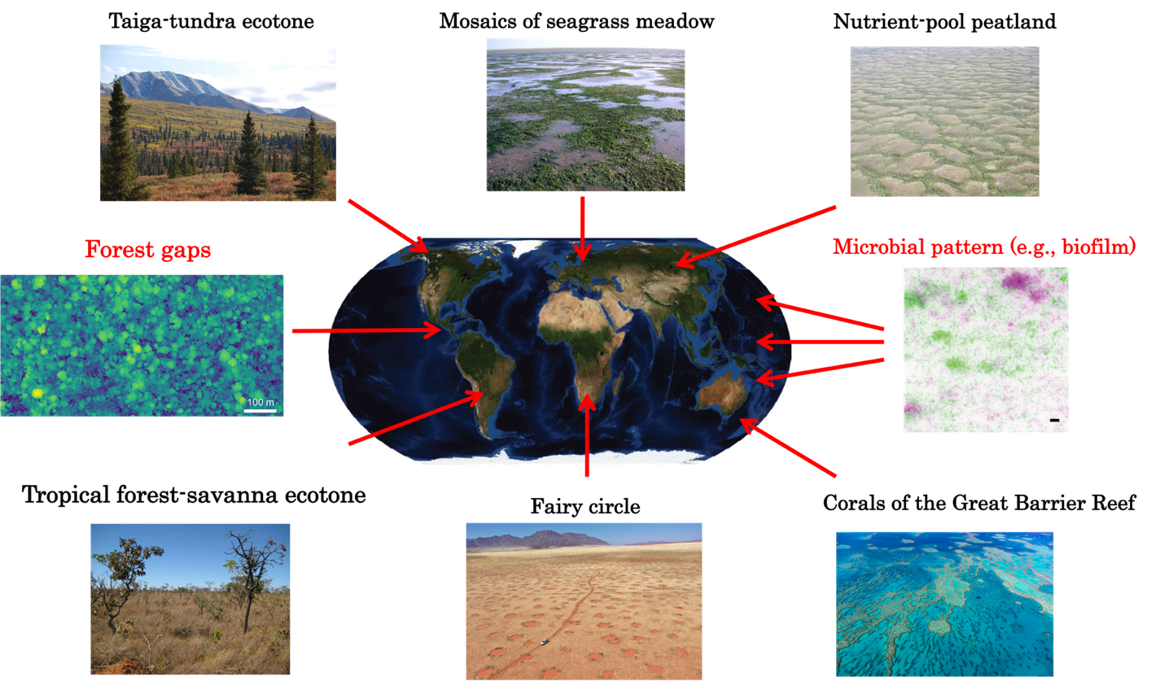

Fig.1 Spatial patterns of ecosystems across the biosphere. Forest gaps: a 1-m-resolution canopy heightmodel (CHM) derived from ALS data acquired over the 50 ha forest dynamics plot at Barro Colorado Island (BCI) in Panama (Jucker 2021). Taiga-tundra ecotone: Photo Credit: Bob Bolton. Mosaic of seagrass meadow: Uithuizerwad, The Netherlands (53°27′N, 6°41′E). Nutrient-poor peatland: in Siberia, Russia (56°16′N, 81°33′E). Corals of the Great Barrier Reef: Australia (18°17′S, 147°42′E). Image credit: imageBROKER / Alamy Stock Photo. Fairy circle: An April 2022 drone image in the NamibRand Nature Reserve (Credit: CNN). Tropical-savanna ecotone: Brazilian Cerrado with sparsely spaced trees (Credit: Simon Scheiter). All but the microbial pattern (fluorescence microscopy image of biofilm (scale bar: 10 μm; Rossy et al. 2019) is associated with an actual location, for which multiple arrows are used to indicate its ubiquity across the biosphere.

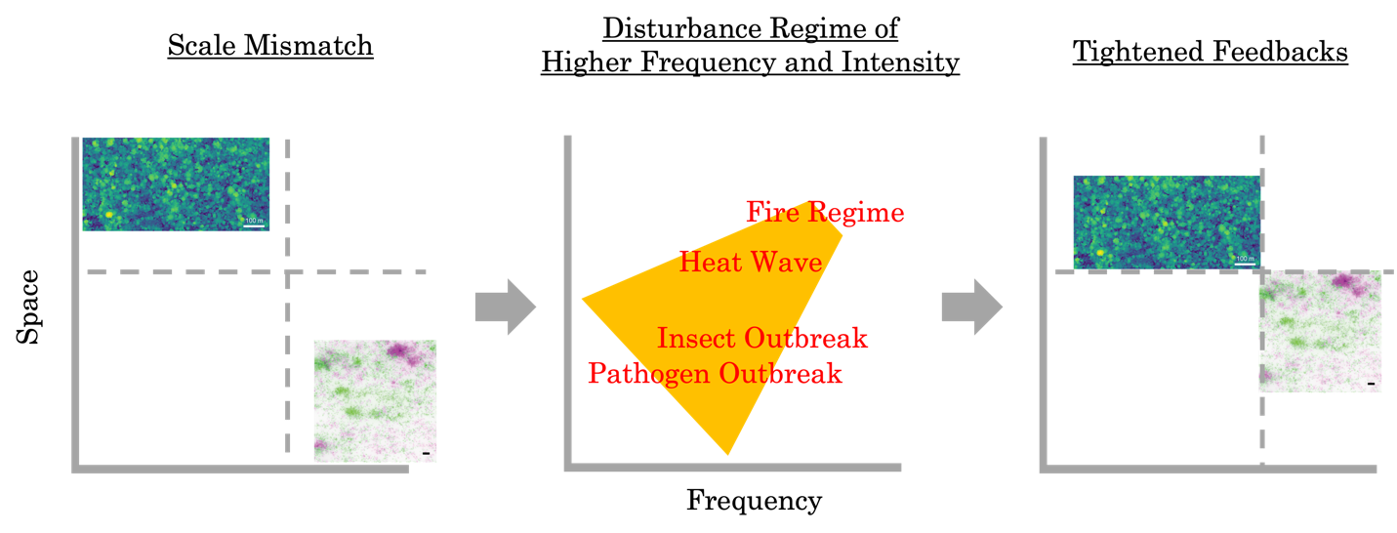
Fig.4 Relative operation scales of vegetation versus microbiome reduced by increasingly frequent and extensive disturbance events. Vegetation is represented by a mosaic of canopy gaps derived from LiDAR measurements of canopy height (scale bar: 100 m). Microbiome is represented by fluorescence microscopy image of biofilm (scale bar: 10 μm; Rossy et al. 2019). Among the many external disturbance agents (e.g., fire, heat wave, insect outbreak, and pathogen outbreak), their relative positions in the space-frequency plane are only loosely distinguished.

1. Going to the extreme—Integrative modelling of the Arctic
The arctic system, holding a uniquely extreme position, can be a highly rewarding candidate for developing such integrative modelling. These systems span from peatland to boreal forest to tundra, and the PDP framework proposed above applies to the arctic system as well (Fig.1). Indeed, Alex Watt (1947) briefly discussed applicability of the pattern concept to the arctic systems. We now have rich empirical evidence to support this notion (e.g., Foster et al. 1983; Chapin et al. 1989). Biological diversity is relatively much lower for both plants and microbes (Jansson and Taş 2014). This relative simplicity makes tackling the diversity component much easier, as has been argued for microbial ecology in extreme environments (e.g., Denef et al. 2010; Shu and Huang 2022). Although the artic involve unique physical and chemical processes (e.g., permafrost), we expect the application of this framework to the arctic to test and in turn inform the framework. More importantly, this integrative modelling is ever more urgently needed towards understanding and addressing challenges facing the arctic. The arctic is experiencing different disturbance regimes as the climate warms (e.g., Foster et al. 2022; Rantanen et al. 2022); for instance, wildfire is becoming bigger (e.g., Scholten et al. 2022), and permafrost is thawing (e.g., Smith et al. 2022). Changes in vegetation (e.g., shrub expansion; Frost and Epstein 2014) and microbiome (e.g., exit of dormancy; Jansson and Taş 2014; Heijmans et al. 2022; Nelson et al. 2022) entails and challenges the development of integrative models discussed here to understand and predict biogeophysical feedbacks and resilience of the arctic. However, the arctic is still understudied in general because of, e.g., low feasibility and accessibility (Griggs 1934), as reflected in the discussion above limited to forest and water-limited systems where relevant concepts were initially conceived, later developed, and mostly discussed. This is even more so with respect to modelling and model-data integration. Though demography-based boreal forest modelling does exist (e.g., Bonan et al. xxxx; Shuman et al. 2010), demography-based integrative modelling in general is largely missing, let alone the taiga-tundra ecotone. From theoretical constructs to applied challenges, the arctic approached with the PDP framework is expected to be a rewarding inquiry.

References

