**Drought Legacies in Soil Microbiome and Implications for Carbon Cycling**

# **Abstract**

**1 Introduction**

Drought of increasing severity and frequency both regionally and worldwide is one of the most pressing pressures to the biosphere in general and to microbiome in terrestrial ecosystems in particular (Borsa et al. 2014; Berdugo et al. 2020). Over a-half century of research has uncovered physical, physiological, and ecological mechanisms underpinning drought impacts on microbial systems functioning in soil environment (e.g., Birch 1958, Schimel 2007). These understandings, however, are all based on direct, immediate effects of contemporary drought. It has been extensively suggested that legacies of disturbances of various forms (including climate and specifically drought) prevail in socioecological systems (refs). Analogously, can drought form legacies in microbiome? If so, would these legacies be manifested in microbiome functioning in terms of organic matter decomposition? Answering these questions is essential for completely understanding microbial systems resilience and for eventually elucidating carbon and nutrients cycling they significantly contribute to in soil systems immediately and in the Earth system.

Responding to drought pressure microbial systems are expected to change accordingly, and these changes may all or partially persist. Changes in terms of community composition arising from individual level physiological adaptation and changes in community-level interactions in response to changing moisture would render the potential of microbial community functioning different. In detail, drought can induce allocation of more resources to combat drought (Schimel 2007; refs). Intra-cellular metabolic plasticity and inter-cellular variation in this metabolic capability in combination can result in more survival of drought-tolerant taxa that are prone to produce less enzymes, shaping communities of higher drought tolerance trade-offing against enzyme investment (Malik et al. 2019; refs). Therefore, when drought disappears and the condition returns to the normal, the functioning of the microbial community in terms of litter decomposition is expected to be different from the community of without undergoing the drought disturbance. In other words, the effects of drought disturbance can persist. We regard such changes (if happens) as a manifestation of drought legacy. More generally, this means that the functioning of a microbial community is contingent on both contemporary and past drought conditions.

To uncover whether drought legacies exist and possible influencing factors in microbiome driven by drought perturbation, it is methodologically intrinsic to incorporate component processes/mechanisms underpinning microbial systems functioning, especially microbial community diversity, and to be able to manipulate drought severity easily. These requirements entail a methodology transcending limitations embedded in lab and field investigations. Lab experiments could be one option, which, however, is significantly deterred because of its limitation to low diversity. Field experimentation is an popular alternative, which, though logistically challenging, has seen the most applications by microbial ecologists. Among these studies some suggested legacies (e.g., Meisner et al. 2015; Martiny et al. 2017; refs), whereas others drew contrary conclusions. For example, Rousk et al. (2013) did not find legacy effects. These field-based investigations, though inspiring overall, were still limited not only with respect to conclusion inconsistency but also conceptually. For example, dispersal of microbes, a pivotal process in microbial community assembly (Vila et al. 2019), may alter drought legacy, which, however, has not yet been touched at all by those previous efforts.

Accordingly, theory-driven models that are able to incorporate diversity to overcome these challenges can be a powerful alternative. Specifically, an individual-based microbial system model applying a trait-based approach, which can bridge across scales from individual cell through community to system by incorporating the tremendous diversity of microbial systems, offers a modelling framework that can simulate ecological dynamics of microbial communities driven by drought while examining microbial dispersal (Allison 2012). Moreover, conducting modelling investigations into legacy, which has not yet been performed but instead suggested trivial in affecting functioning by some studies (e.g., Rousk et al. 2013), holds a tremendous advantage with respect to moving forward microbial ecology toward a more predictive and prognostic direction specifically for legacy effects.

Can drought form legacies in soil microbial systems? This study addressed this overarching question using the spatially explicit trait- and individual-based soil microbial systems modelling framework—DEMENTpy. Specifically, these following questions were answered: can drought disturbance of varying severity all shape legacy effects in microbial systems? what are the underlying community mechanisms of legacy formation? And how would dispersal of microbes affect the formation of drought legacy? We tackled these questions by deploying DEMENTpy to the grassland ecosystem in Southern California. Answers to these questions together suggest the importance of legacy effects mediated by drought-driven community shift in tradeoff strength between drought tolerance and enzyme investment in regulating microbial systems stability and functioning. More broadly, this study opens up rich possibilities for future in-depth quantitative investigations into rules of soil microbial community assembly and implications for modelling microbial systems interacting with soil organic matter dynamics and vegetation productivity.

**2 Methods**

## **2.1 Model description**

DEMENTpy (DEcomposition Model of ENzymatic Traits in Python, v1.0) is a spatially explicit trait- and individual-based microbial systems modelling framework built upon its predecessor DEMENT (Allison 2012; Allison 2014; Allison and Goulden 2017; Wang and Allison 2019). This model initializes a microbial community on a spatial grid and simulates the dynamics of this community by modelling explicitly microbial cell metabolism, mortality, and reproduction driven by environmental factors of temperature and moisture at a daily time step. Processes simulated by DEMENTpy are described in detail below but with an emphasis on those components that are moisture-related and modified from Allison and Goulden (2017), aiming to be concise and informative. More details with respect to overall structure, parameters, and functions are listed in the Supporting information (Supporting Fig.1; GitHub Repo: <https://github.com/bioatmosphere/DEMENTpy>).

### **2.1.1 Initialization of microbial community**

With a trait-based approach, a microbial community comprised of a large number of proxy taxa in DEMENTpy is created by randomly drawing values from distributions of various microbial traits and assigning them to different taxa. These proxy taxa with differing combinations of traits’ values form a spatially-explicit microbial community. Trait distributions are all assumed to follow uniform distributions, except that for simplicity, some traits are assumed to be constants, and values of some traits are derived from correlations between traits. These distributions/assumptions largely arise from information scarcity (unlike the relatively more mature development of plant traits) (Allison 2012, 2014; Allison and Goulden 2017).

Traits included are listed in Table 1, among which traits that are directly moisture-related are rate of inducible osmolyte production. This rate of production of inducible osmolyte is then normalized to a value from 0 to 1, which is regarded as drought tolerance. This treatment of drought tolerance trait is in contrast to the drought tolerance trait adopted in a previous version which instead directly introduced a drought tolerance parameter and imposed a penalty on carbon use efficiency accordingly (Allison and Goulden 2017). This update in a bottom-up fashion of starting from osmolyte production and then determining drought tolerance is supposed to be more biologically realistic (Schimel 2007). Though with a differing production rate across taxon, osmolytes in the current version are still assumed to be same across taxon, holding a constant stoichiometry (refs).

### **2.1.2 Metabolic production of enzyme and osmolyte**

Different individuals comprising the microbial community finish their demographic processes of growth, mortality, and reproduction via degrading substrates and take up monomers while interacting with each other under the influences of temperature and moisture. Intra-cellular production of enzyme and osmolytes are described below in detail with respect to simulation methods and their underlying rationales.

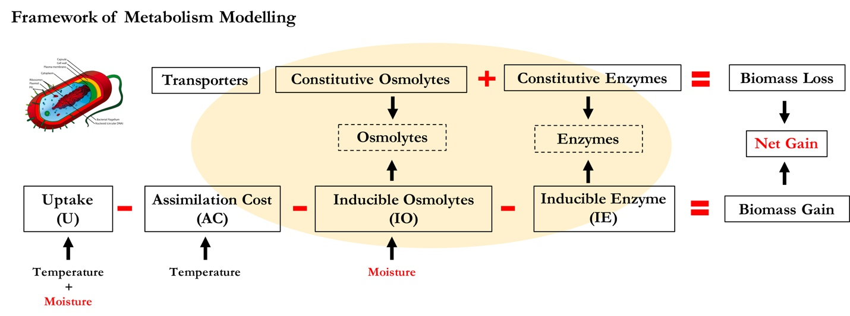

**Fig.1 Schematic of intra-cellular processes simulated in DEMENTpy.**

Metabolism explicitly deals with both the carbon upon uptake from degraded substrates and the carbon in biomass of microbial cells inducibly and constitutively (Fig.1). The metabolic processing of carbon assimilated after growth respiration is allocated to enzyme production (and respiration) and osmolyte production (and respiration; Csonka 1989; Witteveen and Visser 1995), which are treated horizontally in the model without prescribing an order. The C left after these processes accumulates toward biomass. We assume the constitutive osmolyte production rate varies across taxa without depending on water potential, accounting for bacterial/fungal cell’s allocation of biomass to keep a water potential balance across cell wall (**Csonka 1989**). By contrast, inducible production of osmolytes is subject to constraints from water potential and is calculated following:

Arising from metabolic production of enzyme and osmolyte, mortality of microbial cells is simulated both deterministically by accounting for mass balance and stochastically based on death probability constrained by drought tolerance and water potential. Microbes that are starving are designated as dead ones and then removed from the microbial community. These dead microbes are added into the substrates pools as dead microbes.

## **2.2 Modelling experiments**

We deployed DEMENTpy (v1.0) to the grassland system in Loma Ridge, Southern California, a system … and parameterized the model with grass litter (ten different substrates) (Supporting Table 1) on a 100*100 spatial grid with initial pools of substrates and monomers, as well as microbial biomass with 100 different proxy taxa of bacteria. DEMENTpy is benchmarked with the daily whether data of year 2012 and treated as the base scenario (Allison and Goulden 2017) (Supporting Fig.2).

On top of this base scenario we conducted a series of simulations examining the effects of drought disturbances of different severity (Supporting Fig. 2) on microbial communities in terms of responses spanning from physiology through community to the system level functions. For each drought scenario we imposed back the base scenario to examine drought legacies and implications for microbial communities degrading substrates. To further examine how dispersal affects drought legacy, we also included simulations that accounting for dispersal following the modelling strategy of Allison and Goulden (2017).

## **2.3 Simulation protocol and analysis**

With the model setup as described above, we conducted simulations following the protocol as follows: each simulation was run for 10 years, and in each new year substrates, monomers, and enzymes are reinitialized to have same configurations as the very first year in each new year except for the microbial community. In particular, microbial community on the spatial grid in each new year is randomly moved around with an initialization strategy based on frequency of each taxon on the grid in the last day of the previous year (Supporting Fig. 3A). However, in dispersal mode the frequency is based on cumulative biomass of each taxon across the previous whole year (Supporting Fig. 3B).

DEMENTpy is a stochastic model, and therefore, for each scenario we repeatedly run the model 40 times with 40 different seeds, and all results presented below, unless notified otherwise, were analyses of such an ensemble of 40 runs. Such a sample size is determined by a convergence analysis of a much larger sample size, which suggests that 40 is the least and robust sample size (Supporting Fig.4). Data including substrates and microbes, as well community-level drought tolerance were extracted and calculated from the outputs generated from these simulations, and 95% confidence intervals were presented in most of the cases except for microbial community composition and community carbon allocation, for which results of only one out of the 40 simulations were shown.

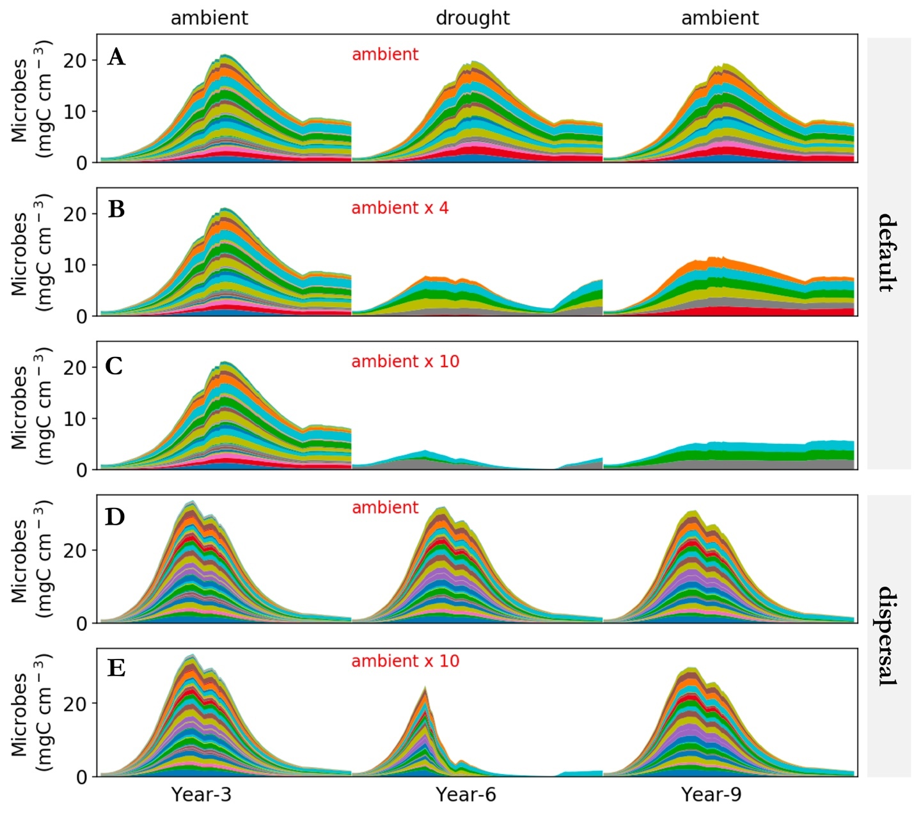

**Fig.2. Microbial community dynamics driven by drought of differing severity with and without dispersal. A-C**: dynamics without dispersal under ambient, ambient x 4, and ambient x 10, respectively. **D-E**: dynamics with dispersal under ambient and ambient x10, respectively. Different colors represent different proxy taxa in terms of biomass (mg C cm-3) averaged over the spatial grid.

# **3 Results**

## **3.1 Microbial community dynamics**

Seasonal dynamics with respect to community composition, biomass, and litter mass loss reflected a joint control of environment and microbial community. Starting from a wet season that was replete with substrates, microbial community consisting of different taxa established and flourished (**Fig.1A**). As substrates were degraded and depleted, microbial cells started to be starved and die. This was accompanied by increasing drought while entering the drought season (Supporting Fig. xx), which induced more death. These two processes in combination resulted in the decline of microbial biomass. This seasonal pattern repeated itself across years, and after 2 years the system became relatively stable with a relatively constant community composition over time. Similar seasonal and inter-annual dynamics were observed for a community with dispersal (**Fig.1D**).

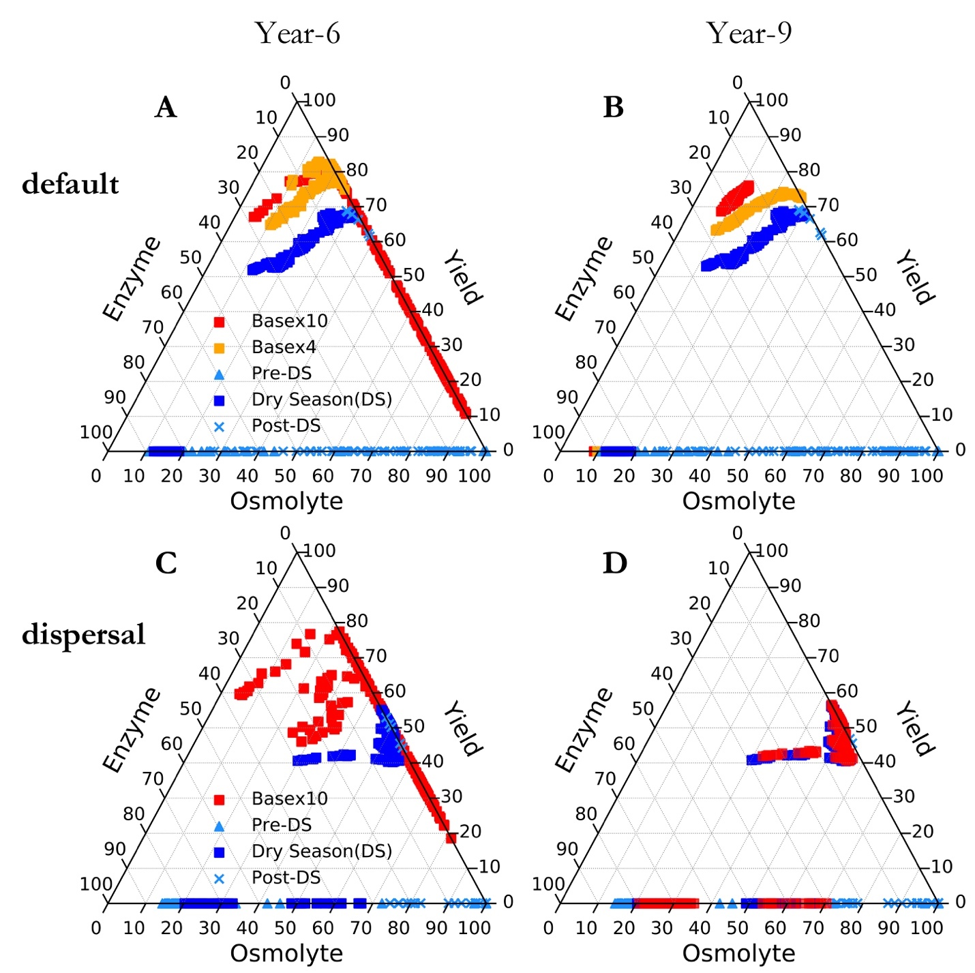

**Fig.3 Ternary plots of microbial community allocation among enzymes, osmolyte, and yield.** A and B show communities over year 6 and year 9, respectively, of the default mode (without dispersal); C and D of the dispersal mode. Besides the base (both default and dispersal mode), drought of varying scenarios were only shown with the drought season data.

## **3.2 Responses to and recoveries from drought disturbance of varying severity**

Microbial community was altered to varying extents by the exerted drought of differing severities. Biomass declined significantly with base x10 scenario displaying the most declines (**Fig.2B, C**). Composition of the stabilized communities changed dramatically in terms of taxonomic abundance as intuitively shown in **Fig. 2B, C**. These newly formed stable communities had differing drought tolerance and enzyme investment and reflected in community level enzyme investment and drought tolerance (**Fig.3A, B**). Eventually, these differences were reflected in the dampened degradation of substrates over the grid, with differing drought severity resulting in different levels of decomposition declines (**Fig.5A, B**).

When the base scenario was imposed back, new microbial communities stabilized persisted (**Fig2.B,C**). These communities apparently had higher allocation to osmolytes and lower to enzymes during the drought season (**Fig.3B**). These newly formed stable communities had differing drought tolerance and enzyme investment (**Fig.4A, B**). Although the magnitudes across the scenarios were dampened compared to the period of drought disturbance, the declines in degradation of substrates were significant except for the least severe scenario (**Fig.5A, B**).

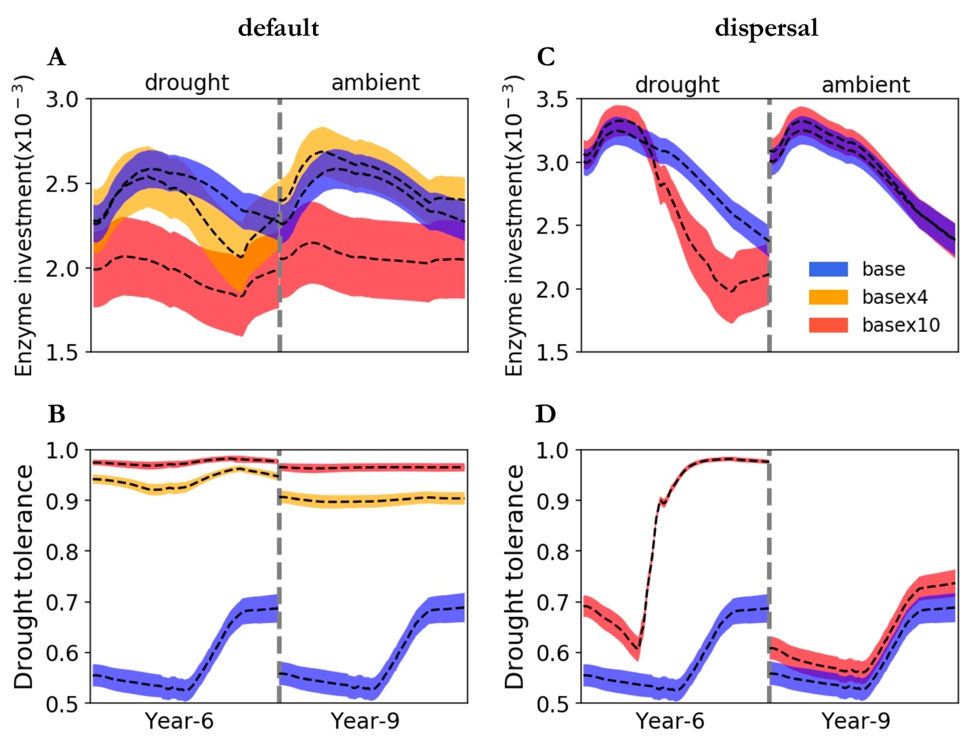

**Fig.4 Dynamics of community-level traits of enzyme investment and drought tolerance driven by drought without and with dispersal.** Dashed lines and bands of differing colors are means and confidence intervals (95%) based on 40 simulations.

## **3.3 Responses to and recoveries from drought disturbance with dispersal**

With dispersal the stable microbial community realized under drought scenario of 10 times ambient saw declined total biomass and declined taxonomic abundance, particularly obvious in the drought season. Clearly, this community allocated more carbon to produce osmolytes and less to enzymes, which even resulted in zero yield when drought was too severe (**Fig.3C**). These changes corresponded to declines in community enzyme investment and increases in drought tolerance (**Fig.4C,D**). All these pointed to significant declines in decomposition of substrates (**Fig.5C**). However, recovery from the drought was dramatically complete. These recoveries were illustrated very well by same community resource allocation (**Fig.3D**), same community-level traits (**Fig.4C,D**), and most importantly same substrates’ decomposition (**Fig.5D**).

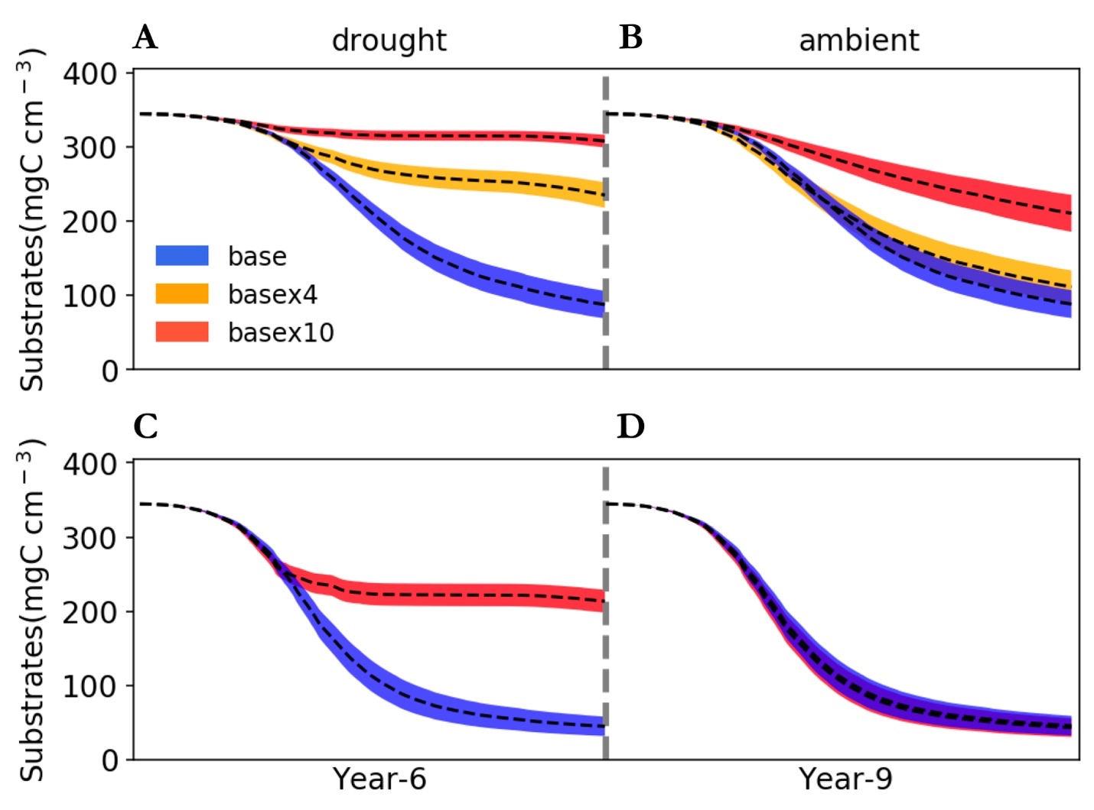

**Fig.5 Degradation of substrates subject to impacts of drought and its legacy with dispersal.** Bands of different colors are 95% confidence intervals based on 40 simulations of each of three scenarios including base, basex4, and basex10. The data shown are left-over of total substrates over the spatial grid.

# **4 Discussion**

Legacy phenomenon has been widely documented across various socio-ecological systems. A plethora of terms have been used in various disciplines denoting in essence the legacy effects, e.g., sticking points, memory, and delay, as well as historical contingency. No matter what terms are used, as Padisak (1992) defined, legacy, in essence, is the capacity of past states or experiences to influence present or future responses of the community. This study extended this notion to soil microbiome with respect to, specifically, drought disturbance by revealing that antecedent drought can form legacies, reinforcing the universality of legacy across natural and social systems . These drought legacies can be manifested at levels from individual through community, eventually propagating to the system level in terms of litter decomposition. Importantly, such legacies are contingent on drought severity and microbial dispersal.

## **4.1 Intensity-contingent drought legacies and alternative stable systems**

The declined litter decomposition during the normal drought scenarios clearly indicated that drought can form legacies. Obviously, the decomposition changes were rendered by underlying community differences. The declined decomposition corresponded to a community of declined enzyme investment and increased drought tolerance (**Fig.3,4**). These differences in community drought tolerance and enzyme investment between communities were exclusively traced back in time to the corresponding communities that, however, experienced a differing drought disturbance in terms of severity, where the drought legacy originated and which suggested that magnitude of legacy is dependent on drought intensity. Drought disturbance of a lower severity, though being able to result in declined decomposition immediately, induced a community that is functionally weaker in decomposing litters because of similar enzyme production capacity. It is noteworthy that the immediate drought impacts of dampened decomposition resulted from physical limitation of enzymatic degradation of substrates and the diffusion of monomers produced as well (Schimel et al.2007; Sardans and Peñuelas 2010).

It is particularly noteworthy that because of drought legacy, new alternative stable systems formed (Fig.2B,C). These new stable systems of microbiome hold differing capability of degrading litters, resulting from different levels of legacy that are ultimately caused by disturbance of drought disturbance of varying severities. Such legacy-shaped, current environmental condition-constrained assembly of new stable systems is also seen in vegetation. For example, the legacy of the last glacial is argued the bi-stability of boreal forest biome across Eurasia (deciduous dominated) and North America (evergreen-dominated) under similar climatic conditions (Herzschuh 2019). These new alternative stable states, though being able to last and carry the legacy effects into the future, are faced with disturbances and thereby subject to changes.

## **4.2 Dispersal plays an important role in shaping drought legacies**

Dispersal is a key process that can negate formation of alternative stable systems and drought legacies. Our quantitative exploration by constantly introducing taxa from the microbial pool into simulations across years demonstrated that dispersal can completely dampen the drought selection on a microbial community (**Fig.4C, D**). The scenario we explored in this study by no means is exhaustive, but it represents a plausible situation in field that dispersal might be one reason that over years mitigated drought legacy in terms of litter decomposition (Martiny et al. 2017).

Dispersal is a complicated process (Vila et al. 2019). We imagine different stable systems and varying magnitudes of changes in decomposition could exist depending on dispersal mode. For instance, timing of dispersal probably matters (Fukami 2015). A very recent study by Amor et al. (2020) demonstrates how dispersal, even unsuccessful cases with only transient interactions, would induce an alternative stable system. These lines of direct and indirect effects of dispersal have not been examined, which warrant dispersal as an essential process to consider while studying microbiome legacies in particular and microbial community assembly in general.

## **4.3 Mechanisms underpinning drought legacy**

From the contrast between cases of low vs high drought severity and cases with vs without dispersal, we can arguably deduce that drought legacy in microbiome is fundamentally generated by drought-driven community shift that prompts formation of alternative stable systems. Such new stable systems have differing community composition that holds differing strengths of tradeoff between drought tolerance and enzyme investment (Ferenci 2016). A community shift towards increasing drought tolerance because of increasing abundance of drought-tolerant taxa (which produce less enzymes) results in declined degradation of substrates. However, when drought stress is not strong enough or because of dispersal drought itself cannot exclusively shape community assembly, such tradeoffs and thereby drought legacy may not appear.

However, mechanisms and conditions favoring the formation of legacy are abundant in general. Legacy of a disturbance can be in various forms that occur along with each other simultaneously (Johnstone et al. 2016). There is no exception for drought in microbial systems, for which we may expect legacies of materials as well, e.g., dead microbes and inactivated enzymes. However, in this study these legacies were not all covered except for community changes. All these processes could contribute to the formation of legacies in microbiome with drought disturbance.

## **4.4 Implications for soil and ecosystem**

Drought legacies mediated by microbial community shift hold immediate implications for understanding soil microbiome and broad consequences for ecosystem in the context of ever increasing frequency of environmental changes. Legacy could contribute to shaping alternative stable systems in microbiome. A legacy of impaired decomposition can retard release of nutrients from and thus return to plants. Additionally, this reduced litter decomposition could allow fuels to accumulate for the next fire season, thereby increasing fire risk (Pellegrini et al. 2017). All these processes arising from legacy entail more complex feedbacks in ecosystems. All in all, taking into consideration microbial community memory of drought history would inform better understanding of microbial community assembly and hence more accurate quantification of microbes’ roles in cycling of various elements and above- and below-ground interactions and eventually biosphere-atmosphere interactions. Considering history as an essential component also means that to really establish a predictive science of carbon cycling in soil systems in the context of projected global climate change, legacies of historical and present disturbances should be incorporated.

**Conclusions**

# **References**

Birch, H. F. 1958. The effect of soil drying on humus decomposition and nitrogen availability. Plant and Soil 10, 9–31.

Borsa, A. A., Agnew, D. C., & Cayan, D. R. (2014). Ongoing drought-induced uplift in the western United States. *Science*, *345*, 1587-1590.

Csonka, L. N. (1989). Physiological and genetic responses of bacteria to osmotic stress. Microbiological reviews, 53, 121-147.

Ferenci, T. (2016). Trade-off mechanisms shaping the diversity of bacteria. Trends in microbiology, 24(3), 209-223.

Gommers, P. J. F., Van Schie, B. J., Van Dijken, J. P., & Kuenen, J. G. (1988). Biochemical limits to microbial growth yields: an analysis of mixed substrate utilization. *Biotechnology and bioengineering*, *32*, 86-94.

Hobbie, J. E., & Hobbie, E. A. (2013). Microbes in nature are limited by carbon and energy: the starving-survival lifestyle in soil and consequences for estimating microbial rates. *Frontiers in Microbiology*, *4*, 324.

Johnstone, J. F., Allen, C. D., Franklin, J. F., Frelich, L. E., Harvey, B. J., Higuera, P. E., ... & Schoennagel, T. (2016). Changing disturbance regimes, ecological memory, and forest resilience. Frontiers in Ecology and the Environment, 14(7), 369-378.

López-Urrutia, Á., & Morán, X. A. G. (2007). Resource limitation of bacterial production distorts the temperature dependence of oceanic carbon cycling. *Ecology*, *88*, 817-822.

Manzoni, S., Schimel, J. P., & Porporato, A. (2012b). Responses of soil microbial communities to water stress: results from a meta‐analysis. *Ecology*, *93*, 930-938.

Manzoni, S., Taylor, P., Richter, A., Porporato, A., & Ågren, G. I. (2012a). Environmental and stoichiometric controls on microbial carbon‐use efficiency in soils. New Phytologist, 196, 79-91.

Sardans, J., & Peñuelas, J. (2010). Soil enzyme activity in a Mediterranean forest after six years of drought. Soil Science Society of America Journal, 74, 838-851.

Scheiter, S., Langan, L., & Higgins, S. I. (2013). Next‐generation dynamic global vegetation models: learning from community ecology. New Phytologist, 198, 957-969.

Schimel, J., Balser, T. C., & Wallenstein, M. (2007). Microbial stress‐response physiology and its implications for ecosystem function. Ecology, 88, 1386-1394.

Schimel, J. P., & Weintraub, M. N. (2003). The implications of exoenzyme activity on microbial carbon and nitrogen limitation in soil: a theoretical model. Soil Biology and Biochemistry, 35, 549-563.

Sinsabaugh, R. L., Manzoni, S., Moorhead, D. L., & Richter, A. (2013). Carbon use efficiency of microbial communities: stoichiometry, methodology and modelling. Ecology Letters, 16, 930-939.

Tiemann, L. K., & Billings, S. A. (2011). Changes in variability of soil moisture alter microbial community C and N resource use. *Soil Biology and Biochemistry*, *43*, 1837-1847.

Wang, B., & Allison, S. D. (2019). Emergent properties of organic matter decomposition by soil enzymes. *Soil Biology and Biochemistry*, *136*, 107522.

Yao, Q., Li, Z., Song, Y., Wright, S. J., Guo, X., Tringe, S. G., ... & Mayes, M. A. (2018). Community proteogenomics reveals the systemic impact of phosphorus availability on microbial functions in tropical soil. Nature Ecology & Evolution, 1.

# **Acknowledgements**

…

# **Supporting Information**

**Model description**

Growth is simulated by explicitly dealing with intra-cellular metabolisms of enzymes, transporters, and osmolytes. Mortality is simulated both deterministically and stochastically. Microbial reproduction is simply calculated by splitting microbes into two halves, which disperse to surrounding grid boxes on the spatial grid. From these underlying processes emerges carbon use efficiency and respiration at both the microbial cell level and the whole system level.

The governing equation of substrates’ degradation follows the Michaelis-Menten equation. Degradation of substrates are calculated explicitly by using different enzymes with different kinetic properties. One principle during the simulation is that every substrate at least has one enzyme to degrade and vice versa. The central governing equation of monomers’ uptake follows the Michaelis-Menten equation. Different monomers are calculated explicitly by having differing transporters to target them. Transporters of different types and amounts are taxon-specific, which is described immediately below. Moisture influences these processes via affecting enzymatic kinetics and monomers’ uptake (Allison and Goulden 2017).

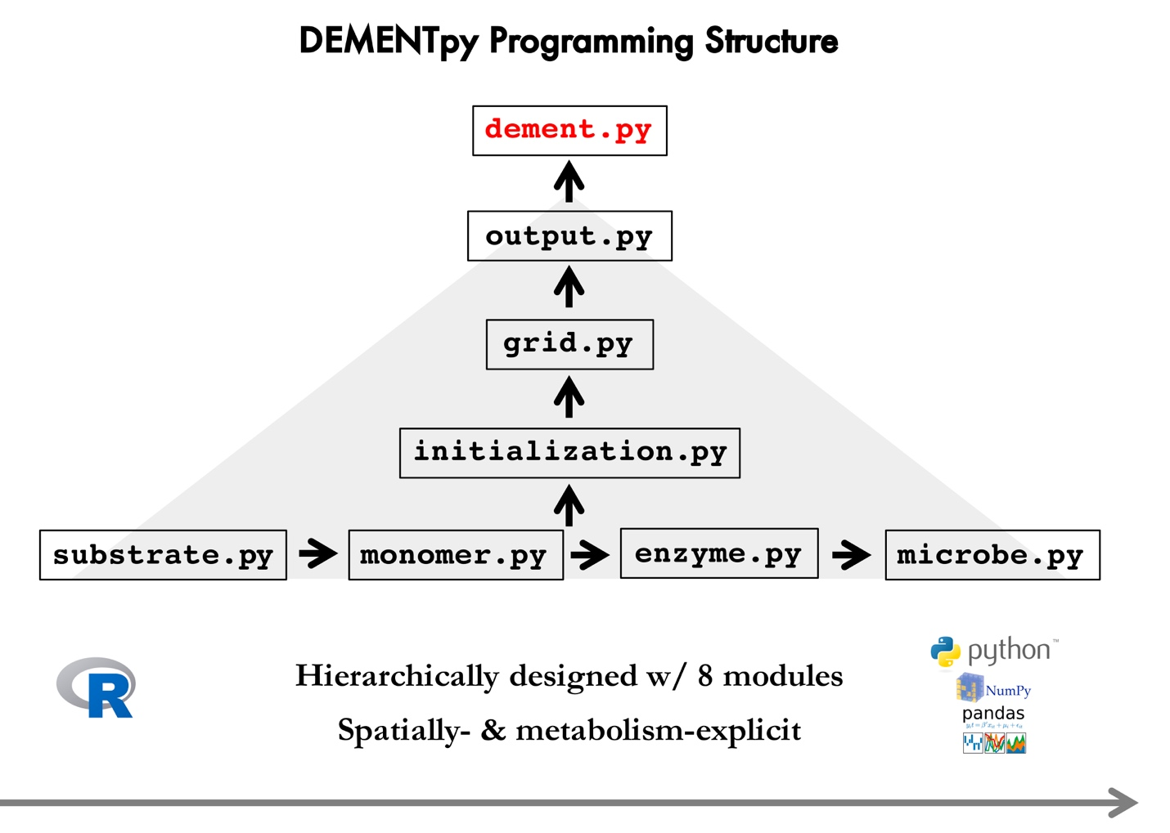

**Supporting Fig.1 DEMENTpy programming structure.**

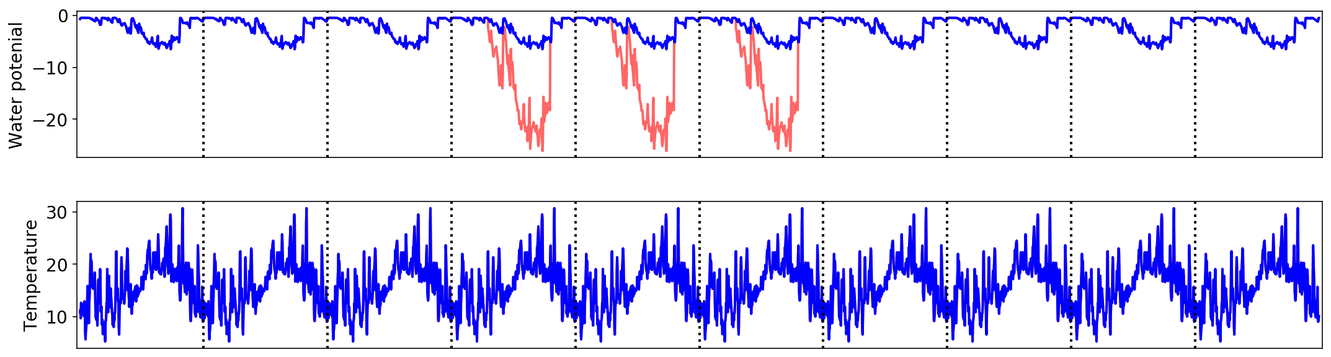

**Supporting Fig.2 Environmental forcing and drought scenarios applied and simulated in this study**. The red line (manipulated drought severity over the drought season from April through September and for illustration purpose only) denotes how the various drought scenarios (basex4, basex10, and basex15) were imposed.

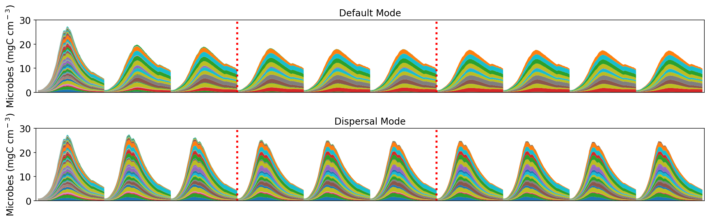

**Supporting Fig.3. Microbial community dynamics of the default vs dispersal model over 10 years under the ambient drought scenario.** The 3 years between the two dashed red lines were where drought scenarios of varying severities imposed. Results presented hereafter in the manuscript were only years of 3, 6, and 9. Different colors represent different proxy taxa.

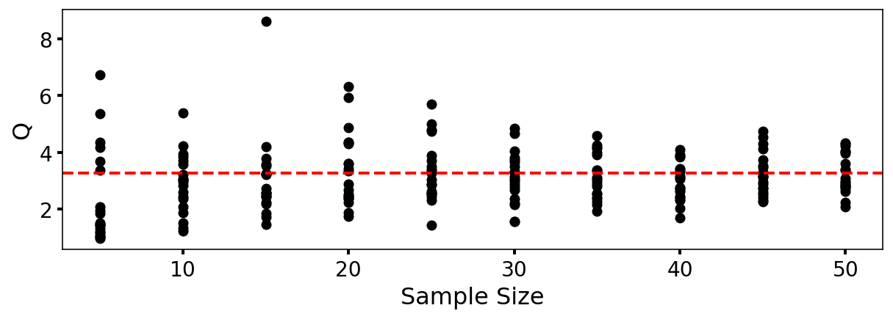

**Supporting Fig.4.** **DEMENTpy convergence analysis based on degradation of substrates**. Q (quotient) is calculated as (90% percentile -10% percentile)/median. Each sample size were 20 replicates that were randomly drawn from the sample pool of 120 runs.