**Drought Legacies in Soil Microbiome and Implications for Carbon Cycling**

# **Abstract**

The irreplaceable, fundamental role of soil microbiome in driving biogeochemical cycling in the Earth system makes its response to drought of increasing frequency and severity pivotal toward fully understanding and quantifying drought impacts on the biosphere. This study revealed drought legacies in soil microbial systems using a trait-based modelling framework. These legacies can manifest at levels from individual through community and eventually propagate to the system level in terms of decomposing plant organic matter. Rendered by the tradeoff between drought tolerance and enzyme investment in microbial communities, legacy is dependent on drought intensity and microbial dispersal that affect the tradeoff strength. These insights into soil microbiome functioning help to draw a more complete picture of microbiome responding to drought—history of drought instead of only contemporary conditions matters in quantifying microbiome functioning. Drought legacies in microbiome bear far-reaching implications for carbon and nutrients cycling in ecosystems. More generally, this study reinforces the universality of legacy across socioecological systems by extending the legacy notion to soil microbiome.

**1 Introduction**

Drought of increasing severity and frequency both regionally and worldwide is one of the most pressing problems to the biosphere in general and to, specifically, microbiome in terrestrial ecosystems (**Borsa et al. 2014; Berdugo et al. 2020**). Over a-half century of research has uncovered physio-chemical, physiological, and ecological mechanisms underpinning drought impacts on microbial systems functioning in soil environment (e.g., **Birch 1958, Schimel 2007; refs**). These understandings, however, are all based on direct, immediate effects of contemporary drought. It has been extensively suggested that legacies of disturbances of various forms (including climate change and specifically drought) prevail in socioecological systems (a review by **Cuddington 2011; Johnstone et al. 2016; refs**). Analogously, can drought form legacies in soil microbiome? If so, can these legacies be manifested in microbiome functioning in terms of organic matter decomposition? Answering these questions is essential for completely understanding microbial systems resilience and for eventually elucidating carbon and nutrients cycling they significantly contribute to in soil systems immediately and in the Earth system broadly (**Falkowski et al. 2008**).

Changes in microbial systems elicited by drought pressure may all or partially persist. Changes in terms of community composition arising from individual level physiological adaptation and changes in community-level interactions in response to changing moisture would render the potential of microbial community functioning different. In detail, drought can induce allocation of more resources to combat drought (**Schimel 2007; refs**). Intra-cellular metabolic plasticity and inter-cellular variation in this metabolic capability in combination can result in more survival of drought-tolerant taxa that are prone to produce less enzymes, shaping communities of higher drought tolerance trade-offing against enzyme investment (**Ferenci 2016; Malik et al. 2019**). Therefore, when drought disappears and the condition returns to the normal, the functioning of the microbial community in terms of litter decomposition is expected to be different from the community of without undergoing the drought disturbance. In other words, the effects of drought disturbance can persist. We regard such changes (if happens) as a manifestation of drought legacy. More generally, this means that the functioning of a microbial community is contingent on both contemporary and past drought conditions.

To uncover whether such drought legacies exist and possible influencing factors in microbiome driven by drought perturbation, it is methodologically intrinsic to incorporate component processes/mechanisms underpinning microbial systems functioning, especially microbial community diversity, and to be able to manipulate drought severity easily. These requirements entail a methodology transcending limitations embedded in lab and field investigations. Lab experiments could be one option, which, however, is significantly deterred by its confinement to low diversity (**Waltman and Smith 1995**). Field experimentation is an popular alternative, which, though logistically challenging, has seen the most endeavors by microbial ecologists. Among these studies some suggested legacies (e.g., **Meisner et al. 2015; Martiny et al. 2017; more**), whereas others drew contrary conclusions (**Rousk et al. 2013**). These field-based investigations, though inspiring overall, were still far from being conclusive not only with respect to results’ inconsistency but also conceptually. For example, dispersal of microbes, a pivotal process in microbial community assembly (**Vila et al. 2019**), may alter drought legacy, which, however, has not yet been touched at all by those previous efforts.

Instead, theory-driven models that are able to incorporate diversity to overcome these challenges can be a powerful alternative. Specifically, an individual-based microbial system model applying a trait-based approach, which can bridge across scales from individual cell through community to system by incorporating the tremendous diversity of microbial systems (**Allison 2012**), offers a modelling framework that can simulate ecological dynamics of microbial communities driven by drought while examining microbial dispersal. Moreover, conducting modelling investigations into legacy, which has not yet been performed but instead suggested trivial in simulating functioning (e.g., **Rousk et al. 2013)**, holds a tremendous promise to moving forward microbial ecology toward a more predictive and prognostic direction.

Can drought form legacies in soil microbial systems? This study addressed this overarching question using the spatially explicit trait- and individual-based soil microbial systems modelling framework—DEMENTpy. Specifically, these following questions were answered: can drought disturbance of varying severity all shape legacy effects in microbial systems? What are the underlying community mechanisms of legacy? Can the legacy be manifested in influencing organic matter decomposition? And how would dispersal of microbes affect the formation of drought legacy? We tackled these questions by deploying DEMENTpy to the grassland ecosystem in Southern California. Answers to these questions suggest the importance of legacy effects mediated by drought-driven community shift in tradeoff strength between drought tolerance and enzyme investment in regulating microbial systems stability and functioning. More broadly, this study opens up rich possibilities for future in-depth quantitative investigations into rules of soil microbial community assembly and implications for modelling microbial systems interacting with soil organic matter dynamics and vegetation productivity.

**2 Methods**

## **2.1 Model description**

DEMENTpy (DEcomposition Model of ENzymatic Traits in Python; GitHub Repository: <https://github.com/bioatmosphere/DEMENTpy>) is a spatially and mechanistically explicit trait- and individual-based microbial systems modelling framework built upon its predecessor DEMENT (**Allison 2012; Allison 2014; Allison and Goulden 2017; Wang and Allison 2019**). This model randomly initializes a microbial community on a spatial grid and simulates its dynamics by modelling explicitly demographic processes of each individual (including cell metabolism and growth, mortality, and reproduction) and their interactions under the influence of environmental factors of temperature and moisture at a daily time step, from which system-level functioning of decomposing substrates emerges (see **Supporting Fig.1** for model structure). More details with respect to overall structure, parameters, and functions are described in the Supporting information.

With a trait-based approach, DEMENTpy creates a microbial community comprised of a large number of proxy taxa by randomly drawing values from uniform distributions of various microbial traits and assigning them to different taxa (**Supporting Table 1;** see details in the **Supporting Text**). Among the traits closely metabolism-associated are rates of enzyme production (constitutive and inducible) and rates of osmolyte production (constitutive and inducible). Drought tolerance of each taxon is determined by normalizing the inducible osmolyte rate of production to a value from 0 to 1. This update in a bottom-up fashion of starting from metabolic production of osmolyte and then determining drought tolerance is more biologically realistic (Schimel 2007), which is against the drought tolerance trait adopted in a previous version which instead directly introduced a drought tolerance parameter and imposed a penalty on carbon use efficiency accordingly (Allison and Goulden 2017).

Intra-cellular metabolic processing of carbon taken up is highlighted (see the **Supporting Text** for substrate degradation and other demographic processes). The metabolic processing of carbon assimilated after growth respiration is directed to produce enzyme (and respiration) and osmolyte (and respiration; **Csonka 1989; Witteveen and Visser 1995**), which are treated horizontally in the model without prescribing an order (**Supporting Fig. 2**). The carbon left after these processes accumulates toward biomass. We assume the constitutive osmolyte production rate varies across taxa without depending on water potential, accounting for bacterial/fungal cell’s allocation of biomass to keep a water potential balance across cell wall (**Csonka 1989**). By contrast, inducible production of osmolytes is subject to constraints from water potential. Arising from metabolic production of enzyme and osmolyte, mortality of microbial cells is simulated both deterministically by accounting for mass balance and stochastically based on death probability constrained by drought tolerance and water potential.

## **2.2 Modelling experiments**

We deployed DEMENTpy (v1.0) to the grassland system at Loma Ridge, Southern California (**Allison et al. 2013**) and parameterized the model with 100 different proxy taxa of bacterium on a 100 by 100 spatial grid decomposing grass litter in terms of ten different substrates (see parameter values in **Supporting Table 1** and substrates in **Supporting Table 2**). DEMENTpy is benchmarked with the daily whether data of year 2012, which is treated as the base scenario (**Supporting Fig.3**; Allison and Goulden 2017).

On top of this base scenario we conducted reciprocal simulations with manipulated drought to examine drought legacies. Specifically, after drought disturbances of two different severities (**Supporting Fig. 3**) the base scenario was successively imposed back to examine changes in microbial communities degrading substrates. One set of such simulations without dispersal are referred to as the default mode. To further examine how dispersal affects drought legacy, we also conducted another set of simulations with dispersal by constantly introducing microbes from the microbial pool initialized at the onset of the simulations (hereafter referred to as dispersal mode).

## **2.3 Simulation protocol and data analysis**

With the model setup as above, we conducted simulations following the protocol as follows: each simulation was run for 10 years, and in each new year substrates, monomers, and enzymes were reinitialized to have the same configurations as the very first year except for the microbial community. For the default mode, microbial community on the spatial grid in each new year is randomly moved around with an initialization strategy based on frequency of each taxon on the grid in the last day of the previous year (**Supporting Fig. 4A**). By contrast, in the dispersal mode the frequency is based on cumulative biomass of each taxon across the previous whole year (**Supporting Fig. 4B**). Such a simulation were repeated for each scenario of each of the two modes (default and dispersal mode) for 40 times with 40 different seeds. This sample size is determined by a convergence analysis of DEMENTpy’s stochastic nature (**Supporting Fig.5**). All results presented in this work, unless notified otherwise, were analyses of such an ensemble of 40 runs.

From the outputs generated from these simulations data including microbes and substrates, as well as community-level traits (enzyme investment and drought tolerance) and community-level carbon allocation were extracted and calculated. See the **Supporting Text** for how calculations were done of community-level carbon allocation and traits of enzyme investment and drought tolerance. In addition, 95% confidence intervals were presented in most of the cases except for microbial community composition and community carbon allocation, for which results of only one out of the 40 simulations were shown.

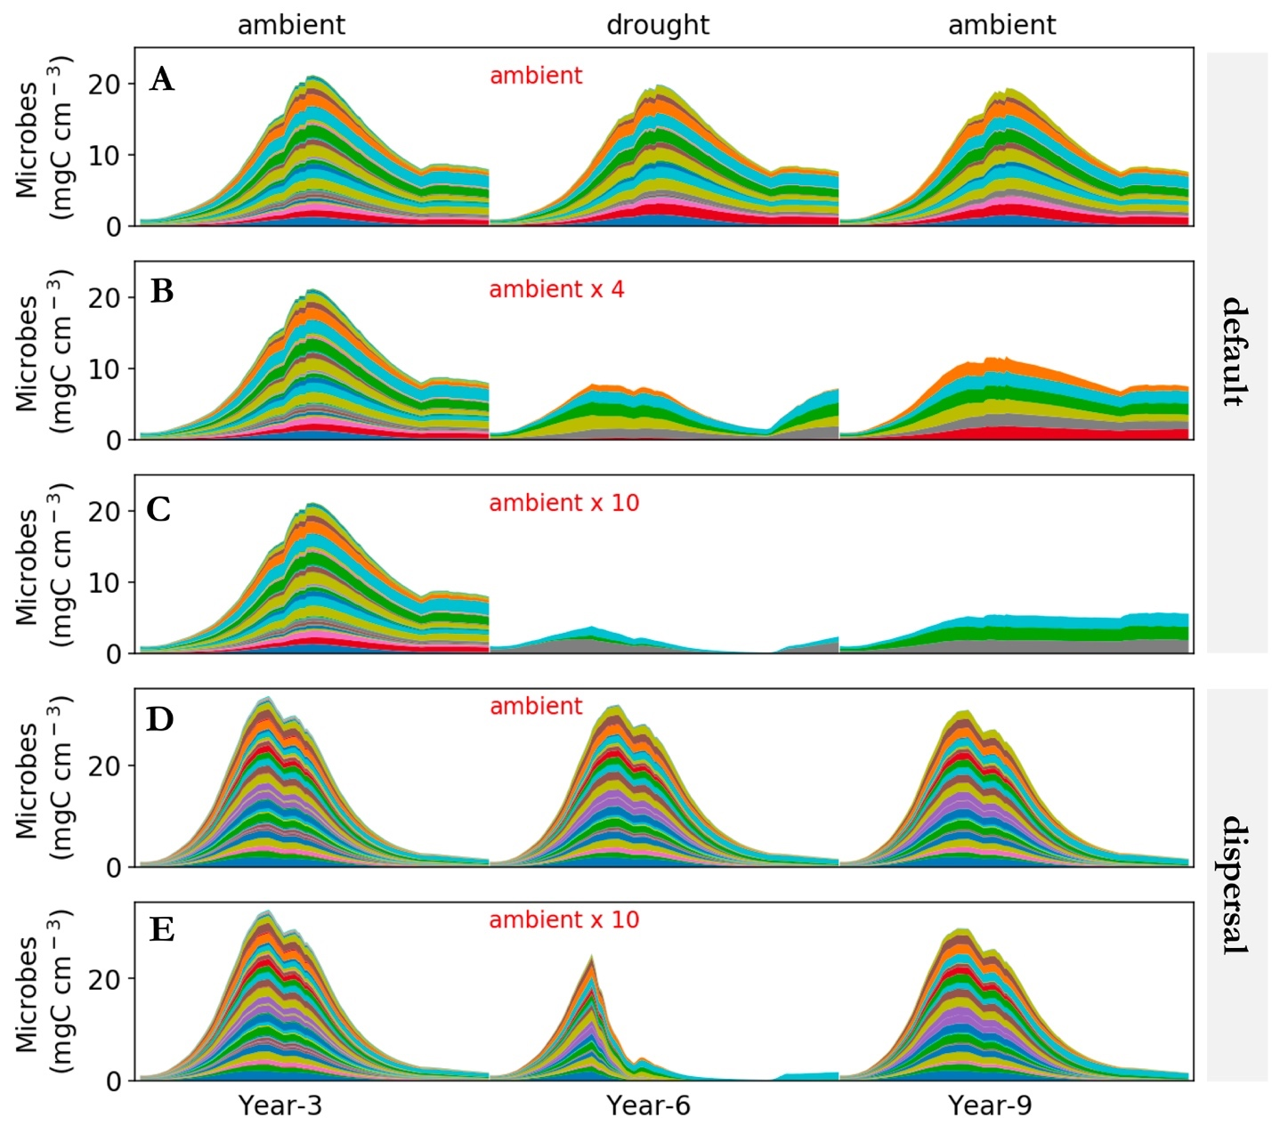

**Fig.1. Microbial community dynamics driven by drought of differing severity with and without dispersal.** (**A-C**) Dynamics without dispersal under ambient, ambient x 4, and ambient x 10, respectively. (**D-E**) Dynamics with dispersal under ambient and ambient x10, respectively. Different colors represent different proxy taxa in terms of biomass (mg C cm-3) averaged over the 100×100 spatial grid. Data shown are only years 3, 6, and 9.

# **3 Results**

## **3.1 Microbial community dynamics**

The system became relatively stable after 2 years, presenting a typical seasonal dynamics in microbial community that repeated itself across years. Seasonal dynamics with respect to community composition, biomass, and litter decomposition reflected a joint control of environment and microbial community. Starting from the wet season that was replete with substrates, microbial community consisting of different taxa established and flourished (**Fig.1A**). As substrates were degraded and depleted, microbial cells started to be starved and die. This was accompanied by increasing drought while entering the drought season (**Supporting Fig. 4**), which induced more death. These two processes in combination resulted in the decline of microbial biomass after a biomass peak around 20 mg C cm-3. Similar seasonal and inter-annual dynamics were observed for a community with dispersal but with much higher diversity and biomass (**Fig.1D**). A more quantitative depiction of community difference is presented in the Supporting Information.

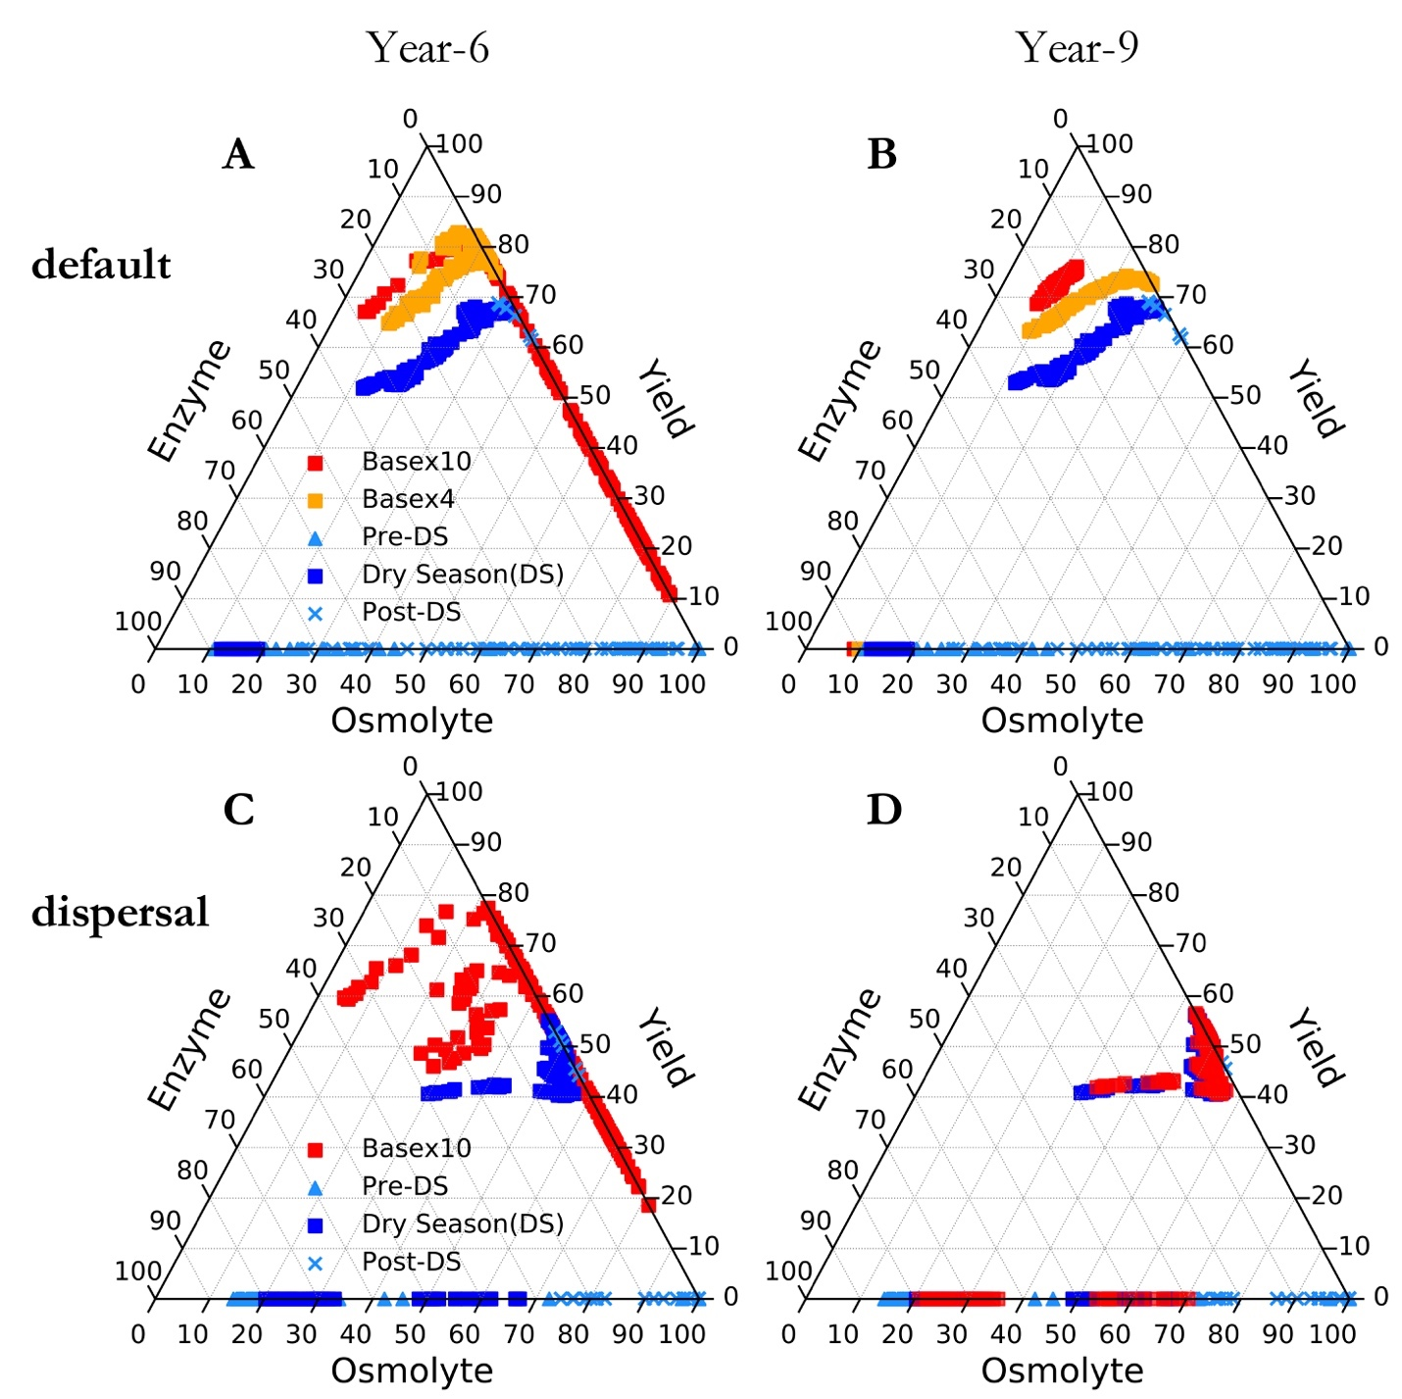

**Fig.2 Ternary plots of community-level allocation among enzyme, osmolyte, and yield over season and across drought scenario. (A, B**) Enzyme-Osmolyte-Yield tradeoff of communities over year 6 and year 9, respectively, of the default mode without dispersal. (**C, D**) The same for the dispersal mode. Besides the base bases (both default and dispersal mode) which illustrate whole season, drought of varying scenarios were only shown with the data of drought season.

## **3.2 Responses to and recoveries from drought disturbance of varying severity**

The exerted drought of differing severities altered microbial community to varying extents. Biomass declined significantly, with base x10 scenario displaying the most declines to less than 10 mg C cm-3 (**Fig.1B, C**). Composition of the stabilized communities changed dramatically in terms of taxonomic abundance as intuitively shown in **Fig. 1B,C**. These newly formed stable communities had differing drought tolerance and enzyme investment (**Fig.2A**), which were reflected in community level enzyme investment and drought tolerance (**Fig.3A,B**). Eventually, these differences manifested in the dampened degradation of substrates over the grid, with differing drought severity resulting in different levels of decomposition declines (**Fig.4A, B**).

When the base scenario was imposed back, new microbial communities stabilized persisted (year 9; **Fig1B,C**). These communities apparently had higher allocation to osmolytes and lower to enzymes during the drought season (**Fig.2B**). These newly formed stable communities had differing drought tolerance and enzyme investment (**Fig.3A, B**). Although the magnitudes of declines in degradation across the scenarios were dampened compared to the period of antecedent drought disturbance, the differences in degradation of substrates were significant except for the least severe scenario (**Fig.4A, B**).

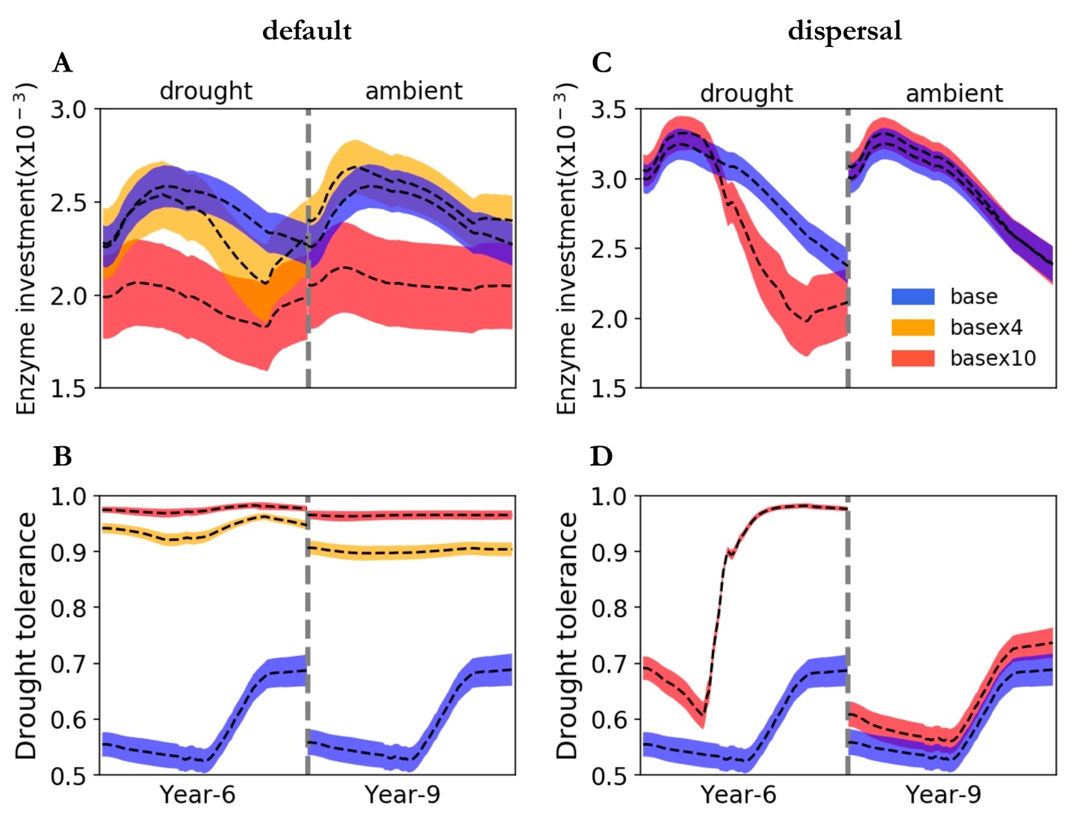

**Fig.4 Dynamics of community-level traits of enzyme investment and drought tolerance driven by drought.** (**A,B**) Enzyme investment and drought tolerance under three scenarios (base, basex4, and basex10), respectively, with dispersal. (**C,D**) The same for communities with dispersal under two scenarios (base and basex10).Dashed lines and bands of differing colors are means and confidence intervals (95%) based on 40 runs.

## **3.3 Responses to and recoveries from drought disturbance with dispersal**

With dispersal the stable microbial community realized under the drought scenario of 10 times ambient saw declined total biomass and declined taxonomic abundance, which were particularly obvious in the drought season (**Fig.1E**). Clearly, this community allocated more carbon to produce osmolytes and less to enzymes, which even resulted in zero yield when drought was too severe (**Fig.2C**). These changes corresponded to declines in community enzyme investment and increases in drought tolerance (**Fig.3C,D**). All these pointed to significant declines in decomposition of substrates (**Fig.4C**). However, recovery from the drought was dramatically complete. This recovery was illustrated axiomatically by the same community resource allocation (**Fig.2D**), the same community-level traits (**Fig.3C,D**), and most importantly the same substrates’ decomposition (about 50 mg C cm-3; **Fig.4D**).

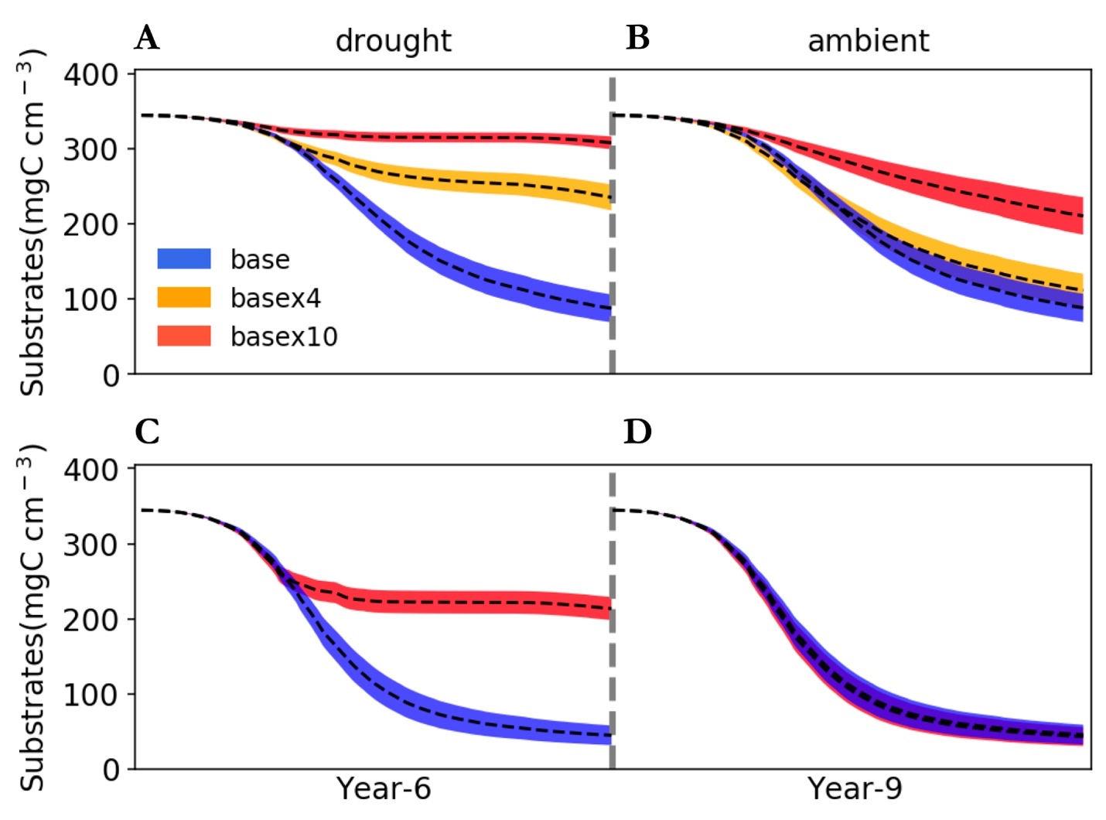

**Fig.5 Changes in substrates driven by drought.** (**A,B**)Total substrates on the spatial grid across year 6 and 9, respectively, under three different scenarios without dispersal. (**C,D**) The same for simulations with dispersal under only base and base x 10 scenarios. Dashed lines and bands of differing colors are means and confidence intervals (95%) based on 40 runs each of three scenarios.

# **4 Discussion**

The unparalleled role of soil microbiome in driving materials’ cycling in the Earth system ensures understanding its response to drought of increasing frequency and severity crucial toward completely evaluating drought impacts on the biosphere, which, however, is still largely missing in global assessments of drought-biosphere interactions (e.g., **Green et al. 2019**). This study revealed drought legacies in microbial community in the terrestrial ecosystem setting that can manifest at the system level in terms of litter decomposition. These insights into soil microbiome functioning build a more complete conceptual framework of microbiome responding to drought by extending the prevailing notion of immediate and direct effects of drought disturbance. Importantly, such legacies are contingent on drought severity and microbial dispersal, which bear significant implications for carbon and nutrients cycling in ecosystems.

## **4.1 Intensity-contingent drought legacies and alternative stable systems**

Drought can form legacies, as clearly suggested by the declined litter decomposition when experiencing the ambient drought after drought disturbance(**Fig.4B**). Obviously, the decomposition changes were rendered by differences in underlying communities. The reduced decomposition corresponded to a community of declined enzyme investment but with increased drought tolerance (**Fig.2,3**). These new stable systems of microbiome holding differing capability of degrading litters suggest that drought legacy can shape alternative stable systems (**Fig.1B,C**). Such legacy-shaped, current environmental condition-constrained assembly of new stable systems are also observed in vegetation. For instance, the legacy of the last glacial is argued the bi-stability of boreal forest biome across Eurasia (deciduous dominated) and North America (evergreen-dominated) under similar climatic conditions (**Herzschuh 2019**).

However, drought intensity matters in legacy formation. The differences in community drought tolerance and enzyme investment between communities after drought disturbances were exclusively traced back in time to the corresponding communities that, however, experienced differing drought disturbances in terms of severity, where the drought legacy originated and which suggested intensity-dependence of the magnitude of legacy. Drought disturbance of a lower severity, though being able to result in declined decomposition immediately, induced a community that is functionally weak in decomposing litters because of similar enzyme production capacity. It is noteworthy that the immediate drought effects of dampened decomposition include contributions from physical limitation of enzymatic degradation of substrates and the diffusion of monomers produced as well (**Schimel et al.2007; Sardans and Peñuelas 2010**).

## **4.2 Crucial role of dispersal in shaping drought legacies**

These new alternative stable states without dispersal, though being able to last and carry the legacy effects into the future, are faced with disturbances and thereby subject to changes. Dispersal is one such process that can negate the drought legacy. Dispersal is a complicated process (**Vila et al. 2019**). We imagine different stable systems and varying magnitudes of changes in decomposition could exist depending on dispersal mode. For instance, timing of dispersal probably matters (**Fukami 2015**). In addition, a very recent study by **Amor et al. (2020)** demonstrates how dispersal, even unsuccessful cases with only transient interactions, would induce an alternative stable system. In this setting, we explored a scenario in this study by randomly introducing taxa from the microbial pool into simulations across years. Results with even the worst scenario demonstrated that dispersal can completely dampen the drought selection on a microbial community (**Fig.3C, D**). dispersal can even overwhelm the drought effects. these are because of community-level similarities in drought tolerance and enzyme investment. Dispersal is a key process that can negate formation of alternative stable systems and drought legacies. It is worth noting that the scenario we explored in this study by no means is exhaustive, but it represents a plausible situation in field that dispersal might be one reason that over years mitigated drought legacy in terms of litter decomposition (**Martiny et al. 2017**).

## **4.3 Tradeoffs governing drought legacy**

From the contrasts of cases of low vs high drought severity and of cases with vs without dispersal, we can arguably deduce that drought legacy in microbiome functioning is fundamentally generated by drought-driven community shift towards higher drought tolerance by sacrificing capacity of enzyme investment. The strength of such a tradeoff eventually determines whether drought legacy will emerge. For instance, when drought stress is not strong enough or because of dispersal drought itself cannot exclusively shape community assembly, such tradeoffs and thereby drought legacy may not appear. When enough tradeoff strength is reached, a community shift towards increasing drought tolerance because of increasing abundance of drought-tolerant taxa (which produce less enzymes) results in impaired capability in degrading substrates.

Mechanisms and factors influencing strength of the specific tradeoff assumed in this study and tradeoffs in microbiome in general are complex and manifold (**Ferenci 2016**). The scenarios examined in this work with respect to drought disturbance and treatment of dispersal by no means exhaustive, particularly for dispersal. Dispersal, or more generally invasion, is a process of huge complexity (**Vila et al. 2019**). For instance, timing of dispersal probably matters (**Fukami 2015**). In addition, a very recent study by **Amor et al. (2020)** demonstrates how dispersal, even unsuccessful cases with only transient interactions, would induce an alternative stable system. These lines of direct and indirect effects of dispersal warrant considering dispersal as an essential process while studying microbiome legacies in particular and microbial community assembly in general. Therefore, broadening the scope of scenarios and relaxing assumptions in DEMENTpy offers natural directions in which our study could be extended for exploring more mechanisms underpinning drought legacy.

## **4.4 Implications for soil and ecosystem**

Drought legacies mediated by microbial community shift hold immediate implications for understanding soil microbiome and broad consequences for ecosystems in the context of increasing frequency and severity of environmental changes. Legacy can contribute to shaping alternative stable systems in microbiome. A legacy of impaired decomposition can retard release of nutrients from and thus return to plants, influencing plant-microbe interactions. Additionally, a more direct effect could be that the reduced litter decomposition amy allow fuels to accumulate for the next fire season, thereby increasing fire risk (**Pellegrini et al. 2017**). All these processes arising from microbiome legacy engender more complex feedbacks in ecosystems. All in all, taking into consideration microbial community memory of past drought would inform better understanding of microbial community assembly and hence more accurate quantification of microbes’ roles in cycling of various elements and above- and below-ground interactions and eventually biosphere-atmosphere interactions. This also means that considering history as an essential component also means that to really establish a predictive science of carbon cycling in soil systems in the context of projected global climate change, legacies of historical and present disturbances should be incorporated.

# **References**

Allison, S. D. (2012). A trait‐based approach for modelling microbial litter decomposition. Ecology letters, 15, 1058-1070.

Allison, S. D., Lu, Y., Weihe, C., Goulden, M. L., Martiny, A. C., Treseder, K. K., & Martiny, J. B. (2013). Microbial abundance and composition influence litter decomposition response to environmental change. Ecology, 94, 714-725.

Birch, H. F. 1958. The effect of soil drying on humus decomposition and nitrogen availability. Plant and Soil 10, 9–31.

Borsa, A. A., Agnew, D. C., & Cayan, D. R. (2014). Ongoing drought-induced uplift in the western United States. Science, 345, 1587-1590.

Csonka, L. N. (1989). Physiological and genetic responses of bacteria to osmotic stress. Microbiological Reviews, 53, 121-147.

Cuddington, K. (2011). Legacy Effects: The Persistent Impact of Ecological Interactions. Biological Theory 6, 203–210.

Falkowski, P. G., Fenchel, T., & Delong, E. F. (2008). The microbial engines that drive Earth's biogeochemical cycles. Science, 320, 1034-1039.

Ferenci, T. (2016). Trade-off mechanisms shaping the diversity of bacteria. Trends in Microbiology, 24, 209-223.

Gommers, P. J. F., Van Schie, B. J., Van Dijken, J. P., & Kuenen, J. G. (1988). Biochemical limits to microbial growth yields: an analysis of mixed substrate utilization. Biotechnology and Bioengineering, *32*, 86-94.

Green, J.K., Seneviratne, S.I., Berg, A.M. *et al.* (2019). Large influence of soil moisture on long-term terrestrial carbon uptake. Nature **565,**476–479.

Herzschuh, U. (2019). Legacy of the Last Glacial on the present‐day distribution of deciduous versus evergreen boreal forests. Global Ecology and Biogeography.

Hobbie, J. E., & Hobbie, E. A. (2013). Microbes in nature are limited by carbon and energy: the starving-survival lifestyle in soil and consequences for estimating microbial rates. Frontiers in Microbiology, *4*, 324.

Johnstone, J. F., Allen, C. D., Franklin, J. F., Frelich, L. E., Harvey, B. J., Higuera, P. E., ... & Schoennagel, T. (2016). Changing disturbance regimes, ecological memory, and forest resilience. Frontiers in Ecology and the Environment, 14, 369-378.

López-Urrutia, Á., & Morán, X. A. G. (2007). Resource limitation of bacterial production distorts the temperature dependence of oceanic carbon cycling. Ecology, 88, 817-822.

Manzoni, S., Schimel, J. P., & Porporato, A. (2012b). Responses of soil microbial communities to water stress: results from a meta‐analysis. Ecology, 93, 930-938.

Manzoni, S., Taylor, P., Richter, A., Porporato, A., & Ågren, G. I. (2012a). Environmental and stoichiometric controls on microbial carbon‐use efficiency in soils. New Phytologist, 196, 79-91.

Meisner, A., Rousk, J., & Bååth, E. (2015). Prolonged drought changes the bacterial growth response to rewetting. Soil Biology and Biochemistry, 88, 314-322.

Sardans, J., & Peñuelas, J. (2010). Soil enzyme activity in a Mediterranean forest after six years of drought. Soil Science Society of America Journal, 74, 838-851.

Schimel, J., Balser, T. C., & Wallenstein, M. (2007). Microbial stress‐response physiology and its implications for ecosystem function. Ecology, 88, 1386-1394.

Schimel, J. P., & Weintraub, M. N. (2003). The implications of exoenzyme activity on microbial carbon and nitrogen limitation in soil: a theoretical model. Soil Biology and Biochemistry, 35, 549-563.

Sinsabaugh, R. L., Manzoni, S., Moorhead, D. L., & Richter, A. (2013). Carbon use efficiency of microbial communities: stoichiometry, methodology and modelling. Ecology Letters, 16, 930-939.

Tiemann, L. K., & Billings, S. A. (2011). Changes in variability of soil moisture alter microbial community C and N resource use. Soil Biology and Biochemistry, *43*, 1837-1847.

Waltman, P., Smith, H. L. (1995). The Theory of the Chemostat: Dynamics of Microbial Competition. United Kingdom: Cambridge University Press.

Wang, B., & Allison, S. D. (2019). Emergent properties of organic matter decomposition by soil enzymes. Soil Biology and Biochemistry, 136, 107522.

# **Acknowledgements**

…

# **Supporting Information**

**Drought Legacies in Soil Microbiome and Implications for Carbon Cycling**

Bin Wang, Steven D. Allison

# **1 DEMENTpy**

DEMENTpy, an explicit microbial systems modelling framework both mechanistically and spatially, is an effort of restructuring and updating DEMENT (see **Supporting Fig.1** for conceptual structure and **Supporting Fig. 2** for the programming structure;GitHub Repository: <https://github.com/bioatmosphere/DEMENTpy>). Processes simulated in DEMENTpy are described briefly below.

### **1.1 Microbial community initialization**

With a trait-based approach, a microbial pool comprised of a large number of proxy taxa in DEMENTpy is created by randomly drawing values from distributions of various microbial and enzymatic traits (**Supporting Table 1**) and assigning them to different taxa. These proxy taxa with differing combinations of traits’ values are place on the spatial grid to form a spatially-explicit microbial community. Trait distributions are all assumed to follow uniform distributions, except that for simplicity, some traits are assumed to be constants, and values of some traits are derived from correlations between traits. These distributions and assumptions are largely informed by information scarcity (unlike the relatively more mature development of plant traits) (**Allison 2012; Allison and Goulden 2017**).

Four of the major traits determining intra-cellular metabolism of enzyme and osmolyte and thus mass balance are rates of enzyme production (constitutive and inducible) and rates of osmolyte production (constitutive and inducible). The rate of production of inducible osmolyte is then normalized to a value from 0 to 1, which is regarded as drought tolerance. Such a treatment of drought tolerance is in contrast to the drought tolerance trait adopted in a previous version which instead directly introduced a drought tolerance parameter and imposed a penalty on carbon use efficiency accordingly (**Allison and Goulden 2017**). This update in a bottom-up fashion of starting from osmolyte production and then determining drought tolerance is supposed to be more biologically realistic.

### **1.2 Metabolic production of enzyme and osmolyte**

Different individuals comprising the microbial community finish their demographic processes of growth, mortality, and reproduction while degrading substrates and taking up monomers under the influence of temperature and water potential. From these underlying processes emerges dynamics and functioning at both the microbial cell level and the whole system level.

Degradation of substrates are calculated explicitly by using different enzymes with different kinetic properties. One principle during the simulation is that every substrate at least has one enzyme to degrade and vice versa. Different monomers are calculated explicitly by having differing transporters to target them. Transporters of different types and amounts are taxon-specific, which is described immediately below. The governing equation of both substrates’ degradation and monomers’ uptake follows the Michaelis-Menten equation, which is further constrained by temperature (accounting for temperature impacts on enzymatic kinetics) and water potential (accounting for enzymatic kinetics and diffusion declines arising from drought; **Allison and Goulden 2017**):

where E and S represent enzyme and substrate concentration, respectively, Vmax represents the enzyme catalytic constant, Km denotes the concentration of S at which V is one half Vmax, 𝛆 is enzymatic activation energy, R is universal gas constant, and k is a coefficient controlling sensitivity to water potential which distinguishes between degradation and uptake.

Intra-cellular production of enzyme and osmolytes are described below in detail with respect to simulation methods and their underlying rationales. Metabolism explicitly deals with both the carbon upon uptake from degraded substrates and the carbon in biomass of microbial cells inducibly and constitutively (**Supporting Fig.3**). The metabolic processing of carbon assimilated after growth respiration is allocated to enzyme production (and respiration) and osmolyte production (and respiration; Csonka 1989; Witteveen and Visser 1995), which are treated horizontally in the model without prescribing an order. The C left after these processes accumulates toward biomass. We assume the constitutive osmolyte production rate (*Osmo_Con*) varies across taxa without depending on water potential, accounting for bacterial/fungal cell’s allocation of biomass to keep a water potential balance across cell wall (**Csonka 1989**). By contrast, taxon-specific inducible production of osmolytes (*Osmo_Ind*) is subject to constraints from water potential and is calculated following:

α

where *Osmo_Indi*, indexed by taxon i, is the *ith* taxon’s osmolyte production rate, *Psi* is the daily water potential, α is a rate constant, and is a system water potential constant, below which inducible osmolyte production is activated. Though with a differing production rate across taxa, osmolytes in the current version are assumed to hold a constant stoichiometry of C and N, which governs consumption of N in intracellular metabolism.

Arising from metabolic production of enzyme and osmolyte, mortality of microbial cells is simulated both deterministically by accounting for mass balance and stochastically based on death probability constrained by drought tolerance and water potential, of which taxon-specific mortality probability is calculated following:

where is Taxoni’s basal mortality probability, *Death_ratei* is a coefficient, and *Toli* is drought tolerance. Microbial cells that are either out of mass balance or randomly killed are designated as dead ones, removed from the microbial community, and added into the substrates pools as dead microbes. Microbial reproduction is simply calculated by splitting microbes into two halves, which disperse to surrounding grid boxes on the spatial grid.

# **References**

Allison, S. D. (2012). A trait‐based approach for modelling microbial litter decomposition. Ecology letters, 15, 1058-1070.

Allison, S. D., & Goulden, M. L. (2017). Consequences of drought tolerance traits for microbial decomposition in the DEMENT model. Soil Biology and Biochemistry, 107, 104-113.

Wang, B., & Allison, S. D. (2019). Emergent properties of organic matter decomposition by soil enzymes. Soil Biology and Biochemistry, 136, 107522.

|  |  |  |  |
| --- | --- | --- | --- |
| **Supporting Table 1** Major microbial and enzyme parameter | | | |
| **Parameter** | **Value** | **Unit** | **Note** |
| max_size_b | 2 | mg cm-3 | C quota threshold for bacterial cell division |
| Cfrac_b | 0.825 | mg mg-1 | Bacterial C fraction |
| Nfrac_b | 0.16 | mg mg-1 | Bacterial N fraction |
| Pfrac_b | 0.015 | mg mg-1 | Bacterial P fraction |
| Crange | 0.09 | mg mg-1 | Tolerance on C fraction |
| Nrange | 0.04 | mg mg-1 | Tolerance on N fraction |
| Prange | 0.005 | mg mg-1 | Tolerance on P fraction |
| C_min | 0.086 | mg cm-3 | threshold C concentration for cell death |
| N_min | 0.012 | mg cm-3 | threshold P concentration for cell death |
| P_min | 0.002 | mg cm-3 | threshold C concentration for cell death |
| Uptake_C_cost_min | 0.01 | transporter mg-1 biomass C | Minimun per enzyme C cost as a fraction of uptake |
| Uptake_C_cost_max | 0.1 | transporter mg-1 biomass C | Maximum per enzyme C cost as a fraction of uptake |
| Uptake_Maint_cost | 0.01 | mg C transporter-1 day-1 | Respiration cost of uptake transporters |
| Enz_per_taxon_min | 0 |  | Minimum number of enzymes a taxon can produce |
| Enz_per_taxon_max | 40 |  | Maximum number of enzymes a taxon can produce |
| Enz_Prod_min | 0.00001 | mg C mg-1 day-1 | Minimum per enzyme production cost as a fraction of C uptake rate |
| Enz_Prod_max | 0.0001 | mg C mg-1 day-1 | Maximum per enzyme producton cost as a fraction of C uptakte rate |
| Constit_Prod_min | 0.00001 | mg C mg-1 day-1 | Minimum per enzyme production cost as a fraction of biomass C |
| Constit_Prod_max | 0.0001 | mg C mg-1 day-1 | Maximum per enzyme production cost as a fraction of biomass C |
| Osmo_per_taxon_min | 1 |  | Minimum number of osmolyte a taxon can produce |
| Osmo_per_taxon_max | 1 |  | Maximum number of osmolyte a taxon can produce |
| Osmo_Consti_Prod_min | 0.0000001 | mg C mg-1 day-1 | Minimum per osmolyte production cost as a fraction of biomass C |
| Osmo_Consti_Prod_max | 0.000001 | mg C mg-1 day-1 | Maximum per osmolyte production cost as a fraction of biomass C |
| Osmo_Induci_Prod_min | 0.01 | mg C mg-1 day-1 | Minimum per osmolyte production cost as a fraction of C uptake rate |
| Osmo_Induci_Prod_max | 0.1 | mg C mg-1 day-1 | Maximum per osmolyte production cost as a fraction of C uptake rate |
| CUE_ref | 0.5 | mg mg-1 | Growth efficiency at the reference temperature |
| CUE_temp | -0.005 | mg mg-1 | Growth efficiency change with enzyme investment |
| death_rate_bac | 0.001 |  | Bacterial death rate |
| basal_bac | 10 |  | Bacterial basal death probability |
| wp_th | -2 |  | water potential threshold at which osmolyte is induced |
| alpha | 0.01 |  | Osmolyte production change with water potential |
| Vmax0_min | 5 | mg substrate mg-1 enzyme day-1 | Minimum Vmax for enzyme |
| Vmax0_max | 50 | mg substrate mg-1 enzyme day-1 | Maximum Vmax for enzyme |
| Uptake_Vmax0_min | 1 | mg substrate mg-1 substrate day-1 | Minimum uptake Vmax |
| Uptake_Vmax0_max | 10 | mg substrate mg-1 substrate day-1 | Maximum uptake Vmax |
| Uptake_Ea_min | 35 | kj mol-1 | Minimum activation energy for uptake |
| Uptake_Ea_max | 35 | kj mol-1 | Maximum activation energy for uptake |
| Km_min | 0.01 | mg cm-3 | Minimum Km |
| Uptake_Km_min | 0.001 | mg cm-3 | Minimum uptake Km |
| Vmax_Km | 1 | mg enzyme day cm-3 | Slope for Km-Vmax relationship |
| Vmax_Km_int | 0 | mg cm-3 | Intercept for Km-Vmax relationship |
| Uptake_Vmax_Km | 0.2 | mg biomass day cm-3 | Slope for uptake Km-Vmax relationship |
| Uptake_Vmax_Km_int | 0 | mg cm-3 | Intercept for uptake Km-Vmax relationship |
| Specif_factor | 1 |  | Efficiency-specificity |

|  |  |  |  |
| --- | --- | --- | --- |
| **Supporting Table 2** Substrate concentrations initialized in DEMENT simulations (mg cm-3). | | | |
| **Substrate** | **C** | **N** | **P** |
| DeadMic | 0 | 0 | 0 |
| DeadEnz | 0 | 0 | 0 |
| Cellulose | 146.89 | 0 | 0 |
| Hemicellulose | 85.855 | 0 | 0 |
| Starch | 12.21 | 0 | 0 |
| Chitin | 4.9952 | 0.83254 | 0 |
| Lignin | 48.51 | 0.40425 | 0 |
| Protein1 | 10.6 | 2.09704 | 0 |
| Protein2 | 10.6 | 2.09704 | 0 |
| Protein3 | 10.6 | 2.09704 | 0 |
| OrgP1 | 12.48 | 0 | 0.478469 |
| OrgP2 | 1.8182 | 0.79745 | 0.478469 |

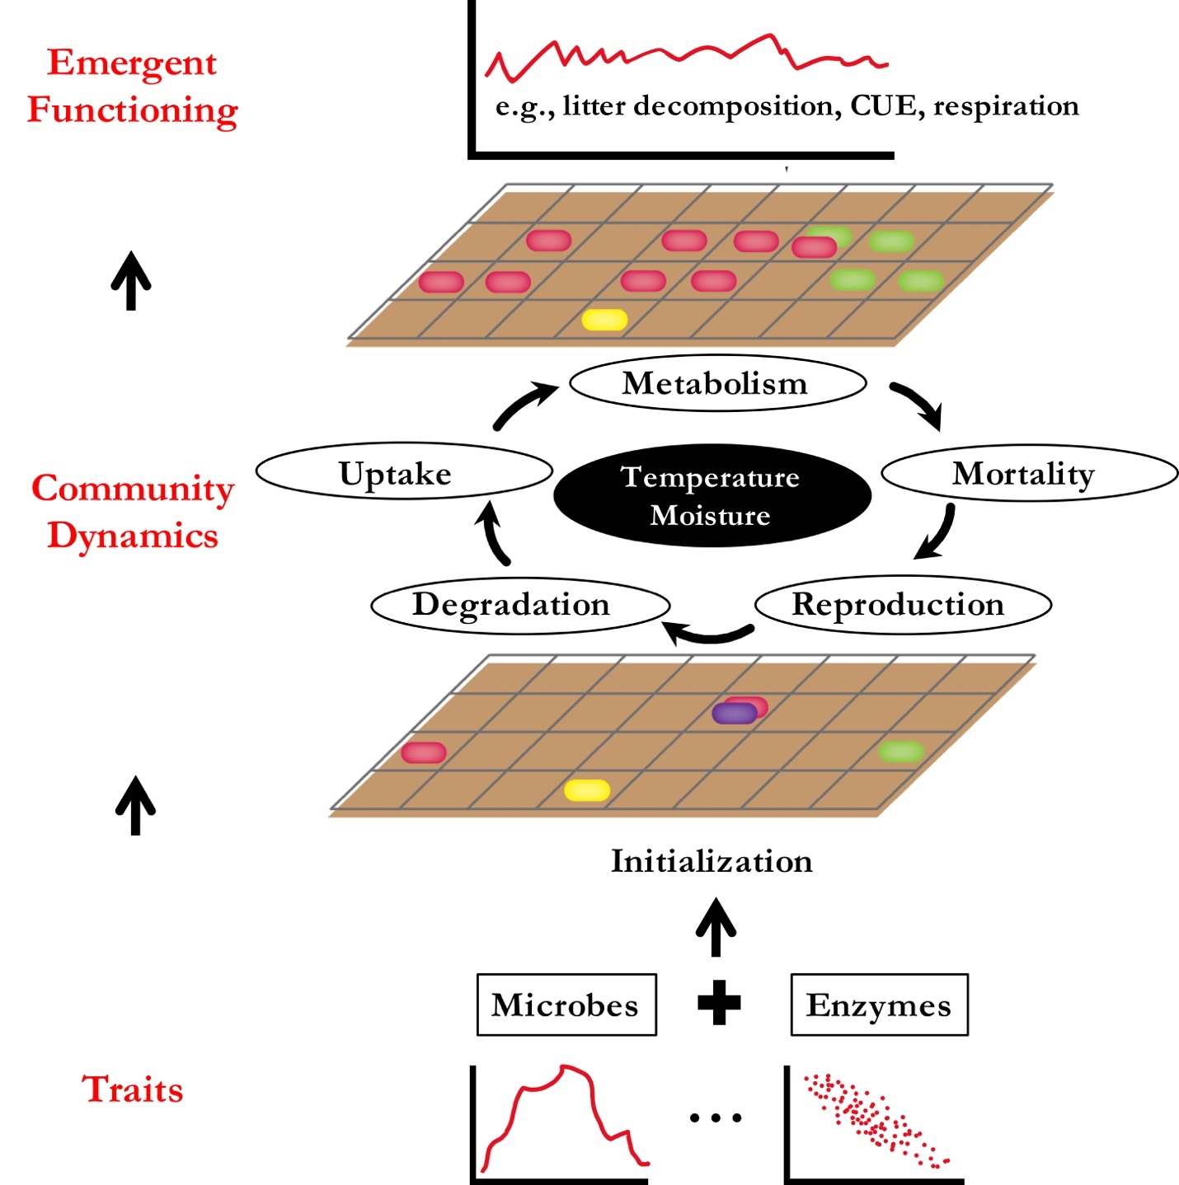

**Supporting Fig. 1 DEMENTpy structure.**

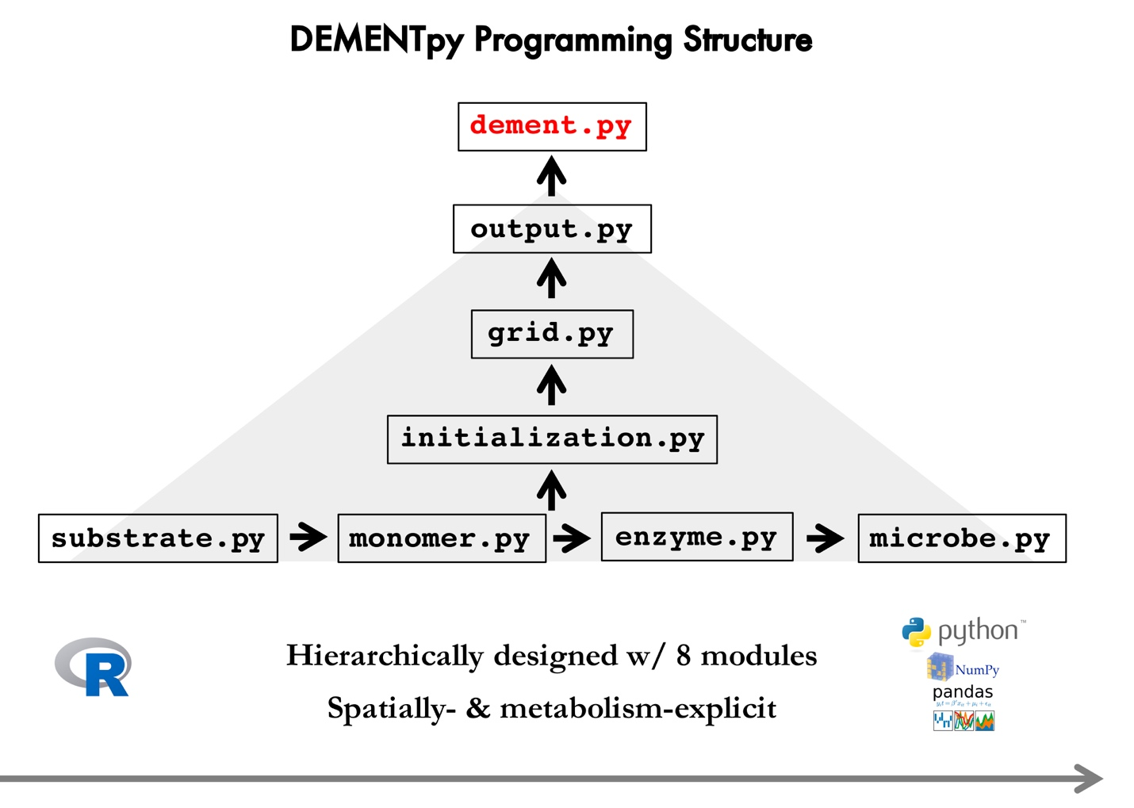

**Supporting Fig.2 DEMENTpy programming structure.** DEMENTpy emerges from restructuring and updating DEMENT programmed in R.

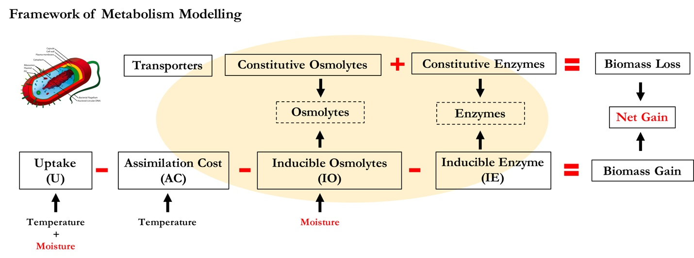

**Supporting Fig.3 Schematic of intra-cellular processes simulated in DEMENTpy.**

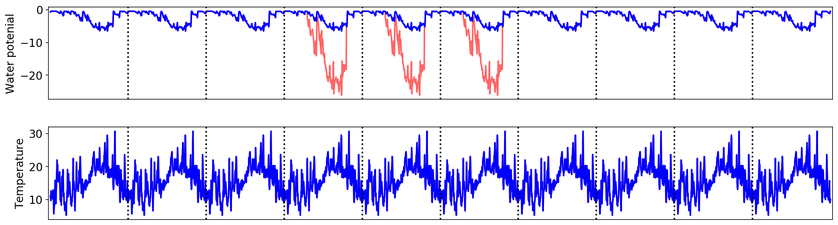

**Supporting Fig.3 Environmental forcing and drought scenarios applied**. (**Top**) The red line (manipulated drought severity over the drought season from April through September and for illustration purpose only) denotes how the various drought scenarios (basex4, basex10, and basex15) were imposed. (**Bottom**) The corresponding temperature.

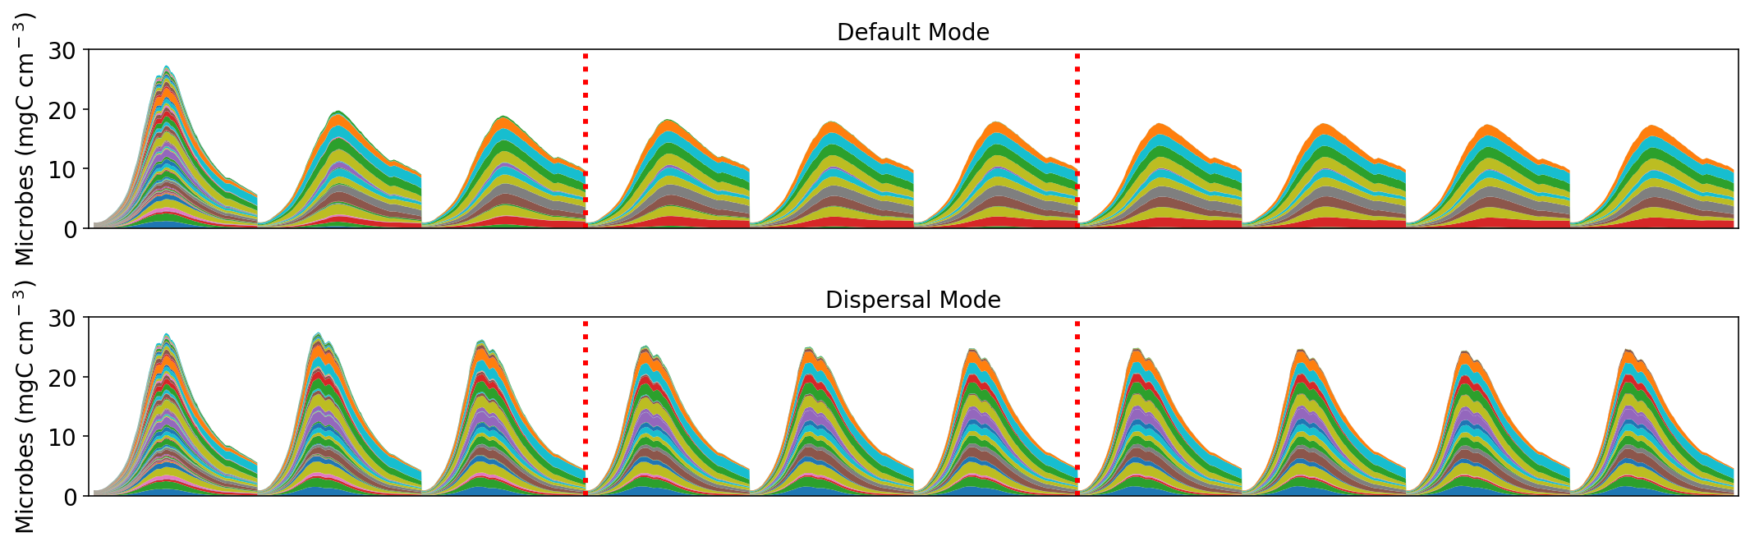

**Supporting Fig.4. Microbial community dynamics of the default vs dispersal model over 10 years under the ambient drought scenario.** The 3 years between the two red dashed lines were where drought scenarios of varying severities were imposed. Results presented throughout the manuscript were only years of 3, 6, and 9. Areas of different colors represent different proxy taxa.

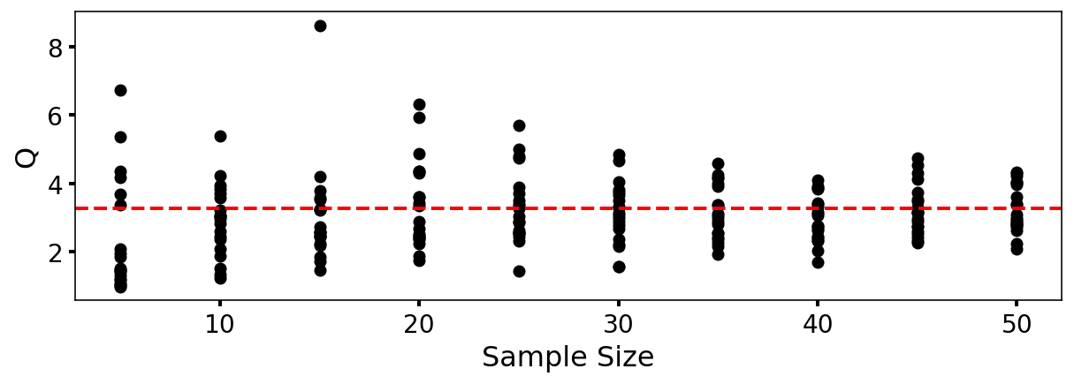

**Supporting Fig.4.** **DEMENTpy convergence analysis**. Q (quotient) is calculated as (90% percentile -10% percentile)/median. Each sample size has 20 replicates in terms ofdegradation of substrates that were randomly drawn from the sample pool of 120 runs. This analysis illustrates that a sample size of 40 may be an appropriate choice.