**Drought Legacies and Implications for Soil Microbiome Resilience**

**1 Introduction**

Understanding natural systems resilience is one of the central themes in Ecology. This is all the more so in the context of ever accelerating global environmental changes, a pressing challenge to confront for natural systems keeping stable in avoidance of collapse (refs). Otherwise, services they provide with respect to biogeochemical cycling/biosphere-atmosphere interactions and human sector needs would simply not be able to sustain. Natural systems are inherently complex, and understanding how systems complexity (in terms of diversity and their interactions) mediates ecological systems functioning is particularly essential for/integral to elucidating mechanisms underpinning systems’ resilience responding to environmental changes (refs). Across natural systems in the biosphere, we have gained knowledge relatively a lot from plant-based systems. However, for microbial systems it is even more challenging to address because of much higher diversity and methodological barriers. With a high diversity in natural microbial systems, how legacies of disturbances would form and thereby influence resilience of natural systems is yet unknown to a large extent. Increasing drought severity and frequency is one of the most pressing threats both regionally and worldwide (refs), and therefore how would drought legacy affects microbial systems responding to drought disturbances and thus affect their resilience?

How drought affects microbial communities has been an active research field since the pioneering work by Birch (1958), who reported that soil drying and rewetting can cause large pulses in nutrient mineralization and soil respiration, and raised the question of how changes in microbial activity affect decomposition under drought. Now with research of over half of a century, huge progress has been made in understanding how water conditions affect microbial systems across organizational levels. In general, underlying mechanisms involve physical, chemical, and biological, as well as ecological ones (refs). First, reduced water availability limits substrate diffusivity and accessibility, albeit increasing the oxygen transport rate, thus lowering microbial growth (Or et al. , 2007; Manzoni et al. , 2012). This is evidenced by the apparent lack of sensitivity of the respiration curves to climate and microbial community composition, suggesting thatat low water availability factors other than physiology (or community composition) may control respiration. Microorganisms protect themselves against large, negative soil matric and osmotic potentials through the acquisition of protective osmolytes (Csonka 1989; Harris 1981; Borken and Matzner, 2009; Schimel et al., 2007; Schimel 2018). Bacteria typically use amino compounds such as proline, glutamine, and glycine betaine (Csonka 1989), while fungi use polyols such as glycerol, erythritol, and mannitol (Witteveen and Visser 1995). In summary, these cellular-scale metabolic and physiological mechanisms could cause fewer resources to invest in enzymatic machinery (Sardans and Penuelas 2010) and reduces respiration (refs). Eventually, by altering the balance of growth and maintenance, changes in soil water might affect the microbial CUE. For instance, Tiemann & Billings (2011) hypothesized a shift from development to protection against water stress and reported a decline of CUE with an increasing drought. Given the amount of osmolyte production in culture-based studies, the ecosystem consequences of production and subsequent loss of osmolytes would be significant, potentially consuming 3 - 6% of net primary production and accounting for 10 - 40% of annual net N mineralization in grasslands (Schimel et al., 2007). However**,** though with a relatively better understanding of microbial physiology and metabolisms at the individual cell level, ecological processes at the community-level underpinning microbial systems responses to drought is **still in its infancy**. How would interactions between individuals within a microbial community change responding to changes in moisture conditions? Knowing these interactions between individuals comprising a system is essential to elucidating mechanisms underpinning microbial systems functioning. Though with these understandings across scales encompassing physical, biological, and ecological mechanisms, how drought disturbances cascade into legacies and thus affect microbial systems functioning and resilience are largely unknown.

To elucidate drought legacy formation and its relationship with resilience, it is essential to incorporate all these component processes/mechanisms underpinning microbial systems functioning into understanding how microbial systems form ‘memories’ of drought disturbances, among which microbial community diversity is especially important. This diversity-induced complexity results in a myriad of difficulties with respect to methodological incorporation of diversity and mechanistic details including both field and lab experiments and mechanistic models among others. This study aims to shed light on this grand issue by applying a spatially and mechanistically explicit microbial systems model to a natural microbial system focused on the disturbance of drought. To proceed, we need to confront the challenges arising from the tremendous diversity of microbial systems and rich processes. Either field manipulative studies or lab experiments have their own limitations. Instead, we seek help from theory-guided models that are able to incorporate diversity to overcome these challenges, at least partly and preliminarily. Specifically, an individual-based microbial system model applying a trait-based approach, which can bridge across scales from individual cell through community to system, fulfills the requirements.

Whether can a microbial system keep resilient in response to drought disturbance? This study addressed this overarching question using the spatially explicit trait- and individual-based soil microbial systems modelling framework—DEMENTpy(v1.0). Specifically, we tackled these following questions: can drought disturbance form legacy effects in microbial systems? Why can the legacy effects exist? how would dispersal affect drought legacy? In detail, we examined these questions regarding functions in terms of litter decomposition. Answers to these questions together indicate the unequivocal importance of microbial system complexity in mediating microbial systems functioning and systems stability, as well as the legacy effects (which results in delays in processes in a microbial system) it mediated via drought-driven compositional changes. More broadly, this study opens up a door to in-depth investigations into rules of microbial community assembly and structure and implications for modelling microbial systems interacting with soil organic matter dynamics.

**2 Methods**

## **2.1 Model description**

DEMENTpy (DEcomposition Model of ENzymatic Traits in Python, v1.0) is a spatially explicit trait- and individual-based microbial systems modelling framework built upon its predecessor DEMENT (Allison 2012; Allison 2014; Allison and Goulden 2017; Wang and Allison 2019). This model initializes a microbial community on a spatial grid and simulates the dynamics of this microbial community by modelling explicitly uptake of monomers and metabolism, mortality, and reproduction driven by degradation of substrates and environmental factors of temperature and moisture at a daily time step. DEMENTpy is programmed in Python in a hierarchical design with 8 modules (six core modules plus two supporting ones) (Supporting Fig.1; GitHub Repository: <https://github.com/bioatmosphere/DEMENTpy>). This redesign is expected to make the model more accessible to a wider community to modify and to improve in appropriate research. Specifically, these processes are described in detail below but with an emphasis on those components that are moisture-related and modified from Allison and Goulden (2017), aiming to be concise and informative. All other aspects of each module are only briefly described, and readers are referred to the earlier works using earlier versions of this model for more details (Allison 2012; Allison and Goulden 2017).

### **2.1.1 Initialization of microbial community**

With a trait-based approach, a microbial community comprised of a large number of proxy taxa in DEMENTpy is created by randomly drawing values from distributions of various microbial traits and assigning them to different taxa. These proxy taxa with differing combinations of traits’ values form a spatially-explicit microbial community. Trait distributions are all assumed to follow uniform distributions, except that for simplicity some traits are assumed to be constants (e.g., cell quota; reference CUE, etc.). It is noteworthy that values of some traits are derived from correlations between traits (elaborate more). These distributions/assumptions largely arise from information scarcity (unlike the relatively more mature development of plant traits) (Allison 2012, 2014; Allison and Goulden 2017).

Traits included are listed in Table 1, among which traits that are directly moisture-related are rate of inducible osmolyte production. [elaborate more on this osmolyte trait]. This rate of production of inducible osmolytes is then normalized to a value from 0 to 1, which is regarded as drought tolerance. This treatment of drought tolerance trait is in contrast to the drought tolerance trait adopted in a previous version which instead directly introduced a drought tolerance parameter and imposed a penalty on carbon use efficiency accordingly (Allison and Goulden 2017). This update with a bottom-up fashion of starting from osmolyte production and then determining drought tolerance is supposed to be more biologically realistic. Though with a differing production rate across taxon, osmolytes in the current version are still assumed to be same across taxon, holding a constant stoichiometry (refs). Once these proxy taxa are created, the model proceeds without any differences with traditional individual-based modelling approach to execute processes described immediately below.

### **2.1.2 Processes simulated**

Different individuals comprising the microbial community finish their demographic processes of growth, mortality, and reproduction via degrading substrates and take up monomers while interacting with each other under the influences of temperature and moisture. Growth is simulated by explicitly dealing with intra-cellular metabolisms of enzymes, transporters, and osmolytes. Mortality is simulated both deterministically and stochastically. Microbial reproduction is simply calculated by splitting microbes into two halves, which disperse to surrounding grid boxes on the spatial grid. From these underlying processes emerges carbon use efficiency and respiration at both the microbial cell level and the whole system level. Those processes that are directly affected by water potential are described below in detail with respect to simulation methods and their underlying rationales.

The governing equation of substrates’ degradation follows the Michaelis-Menten equation. Degradation of substrates are calculated explicitly by using different enzymes with different kinetic properties. One principle during the simulation is that every substrate at least has one enzyme to degrade and vice versa. The central governing equation of monomers’ uptake follows the Michaelis-Menten equation. Different monomers are calculated explicitly by having differing transporters to target them. Transporters of different types and amounts are taxon-specific, which is described immediately below. Moisture influences these processes via affecting enzymatic kinetics and monomers’ uptake (Allison and Goulden 2017).

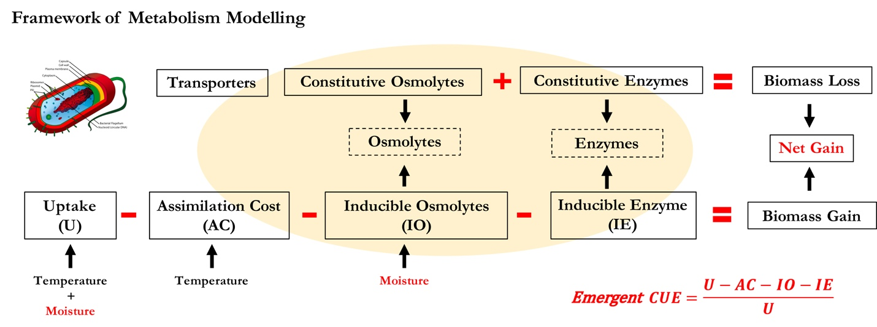

**Fig.1 Schematic of intra-cellular processes’ simulation in DEMENTpy.**

Metabolism explicitly deals with both the carbon upon uptake from degraded substrates and the carbon in biomass of microbial cells inducibly and constitutively (Fig.1). The metabolic processing of carbon assimilated after growth respiration is allocated to enzyme production (and respiration) and osmolyte production (and respiration), which are treated horizontally in the model without prescribing an order. The C left after these processes accumulates toward biomass. We assume the constitutive osmolyte production rate varies across taxa without depending on water potential, accounting for bacterial/fungal cell’s allocation of biomass to keep a water potential balance across cell wall (refs). By contrast, inducible production of osmolytes is subject to constraints from water potential and is calculated following:

Arising from metabolism of enzymes and osmolytes, mortality of microbial cells is simulated both deterministically by accounting for mass balance and stochastically based on death probability constrained by drought tolerance and water potential. Microbes that are starving are designated as dead ones and then removed from the microbial community. These dead microbes are added into the substrates pools as dead microbes.

## **2.2 Modelling experiments**

We deployed DEMENTpy (v1.0) to the grassland system in Loma Ridge, Southern California and parameterized the model with respect to plant litter (ten different substrates) (Supporting Table 1) with a setup of 100*100 spatial grid. We benchmarked DEMENTpy(v1.0) with the daily whether data of year 2012 and treated as the base scenario (Allison and Goulden 2017) (Supporting Fig.). We initialized our model by including initial pools of substrates and monomers, as well as microbial biomass with 100 different proxy taxa of bacteria. These substrates data are based on grass litters at Loma Ridge, Southern California. We setup the simulation on a lattice with a size of 100×100 grid.

On top of this base scenario we conducted a series of simulations examining the effects of drought disturbances of different severity (Supporting Fig. 2) on microbial communities in terms of responses spanning from physiology through community to the system level functions. Specifically, we did reciprocal simulations to examine the drought disturbances and implications for microbial communities degrading substrates. To further examine how dispersal affects drought legacy, we also included simulations that accounting for dispersal following the modelling strategy of Allison and Goulden (2017). Additionally, microbial community composition in terms of an introduction of functional group of fungi is also examined with respect to drought legacy.

## **2.3 Simulation protocol and analysis**

With the model setup as described above, we conducted simulations following the protocol as follows: each simulation was run for 10 years, and in each new year substrates, monomers, and enzymes are reinitialized to have same configurations as the very first year every year except for the microbial community. In particular, microbial community on the spatial grid in each new year is randomly moved around with an initialization strategy based on frequency of each taxon on the grid in the last day of the previous year (Supporting Fig. 3A). However, in dispersal mode the frequency is based on cumulative biomass of each taxon across the previous whole year (Supporting Fig. 3B).

DEMENTpy is a stochastic model, and therefore, for each scenario we repeatedly run the model 40 times with 40 different seeds, and all results presented below, unless notified otherwise, were analyses of such an ensemble of 40 runs. Such a sample size is determined by a convergence analysis of a much larger sample size, which suggests that 40 is the least and robust sample size (Supporting Fig.4). Data including substrates and microbes, as well community-level drought tolerance were extracted and calculated from the outputs generated from these simulations, and 95% confidence intervals were presented in most of the cases except for microbial community composition, for which results of only one out of the 40 simulations were shown.

# **3 Results**

## **3.1 Microbial system dynamics**

Seasonal and inter-annual dynamics in terms of drought tolerance and enzyme investment, as well as their relationship. Seasonal dynamics with respect to litter mass loss, biomass, and respiration reflect a joint control of environment and microbial community. Starting from a wet season that is relatively replete with substrates, microbial community consisting of different taxa established and flourished. However, as substrates depleted, microbial cells started to be starved and die. This is accompanied by increasing drought while entering the drought season, which induced more death. These two processes in combination resulted in the decline of microbial biomass. This seasonal pattern repeated itself across years, and after 2 years the system became stable with a relatively constant community composition over time.

## **3.2 Drought disturbance and microbial system responses (and recovery)**

When drought of different severity is imposed, degradation of substrates over the grid were significantly dampened.

When imposing back the base scenario, we can still clearly see the declines in degradation of substrates except for the least severe scenario. However, the magnitudes across the scenarios were dampened.

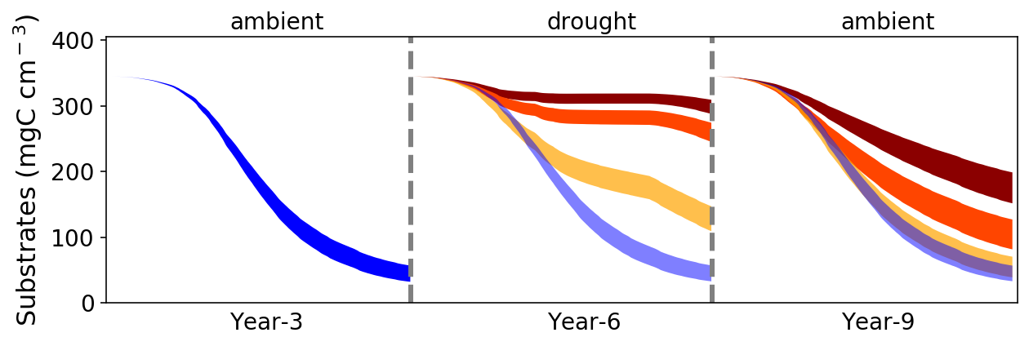

**Fig.2 Degradation of substrates subject to impacts of drought and its legacy.** Bands of different colors are 95% confidence intervals based on 40 simulations of each of four scenarios including base, basex4, basex10, and basex15.

Corresponding to the degradation changes, microbial community was altered to varying extents by the drought of differing severity as well (Fig.xx). Similarly, when changing the drought forcing back to the ambient, new microbial communities stabilized persisted.

These newly formed stable communities had differing drought tolerance and enzyme investment.

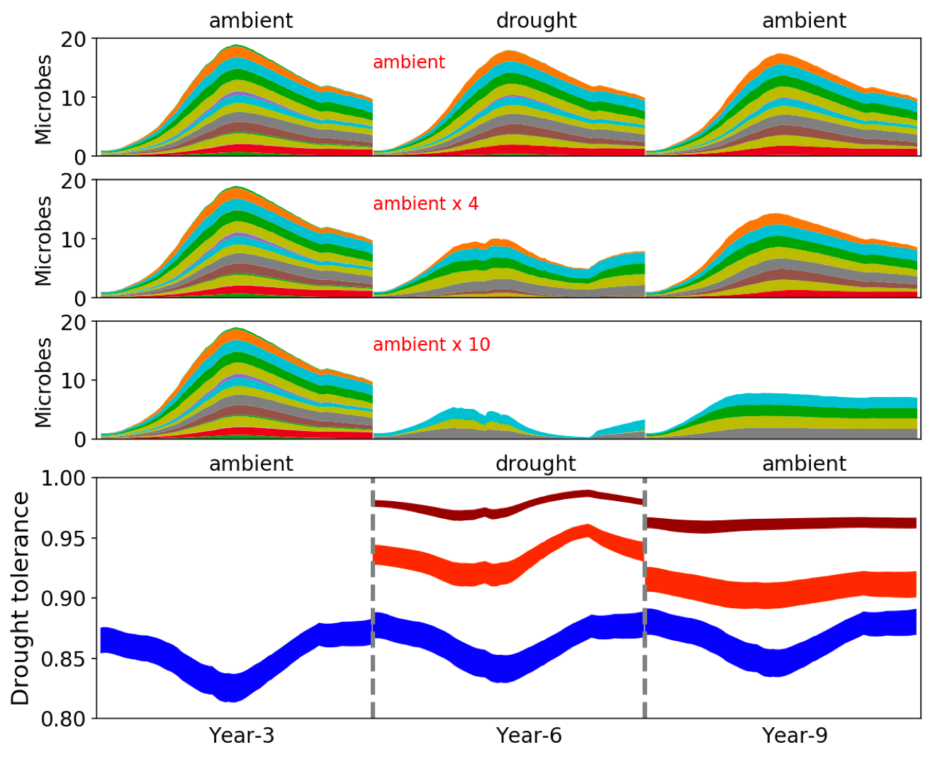

**Fig.3. Microbial community shift and drought tolerance changes driven by drought and its legacies.**

## **3.3 Drought legacy confounded by dispersal**

However, with dispersal the microbial community was hard to see significant legacy effects any more.

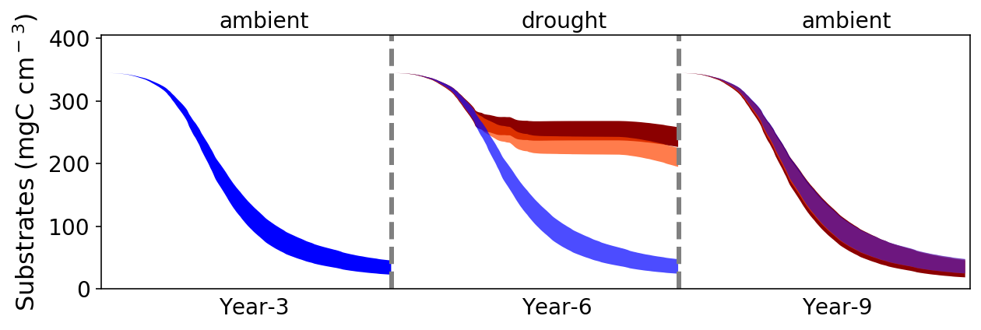

**Fig.4 Degradation of substrates subject to impacts of drought and its legacy with dispersal.** Bands of different colors are 95% confidence intervals based on 40 simulations of each of three scenarios including base, basex10, and basex15.

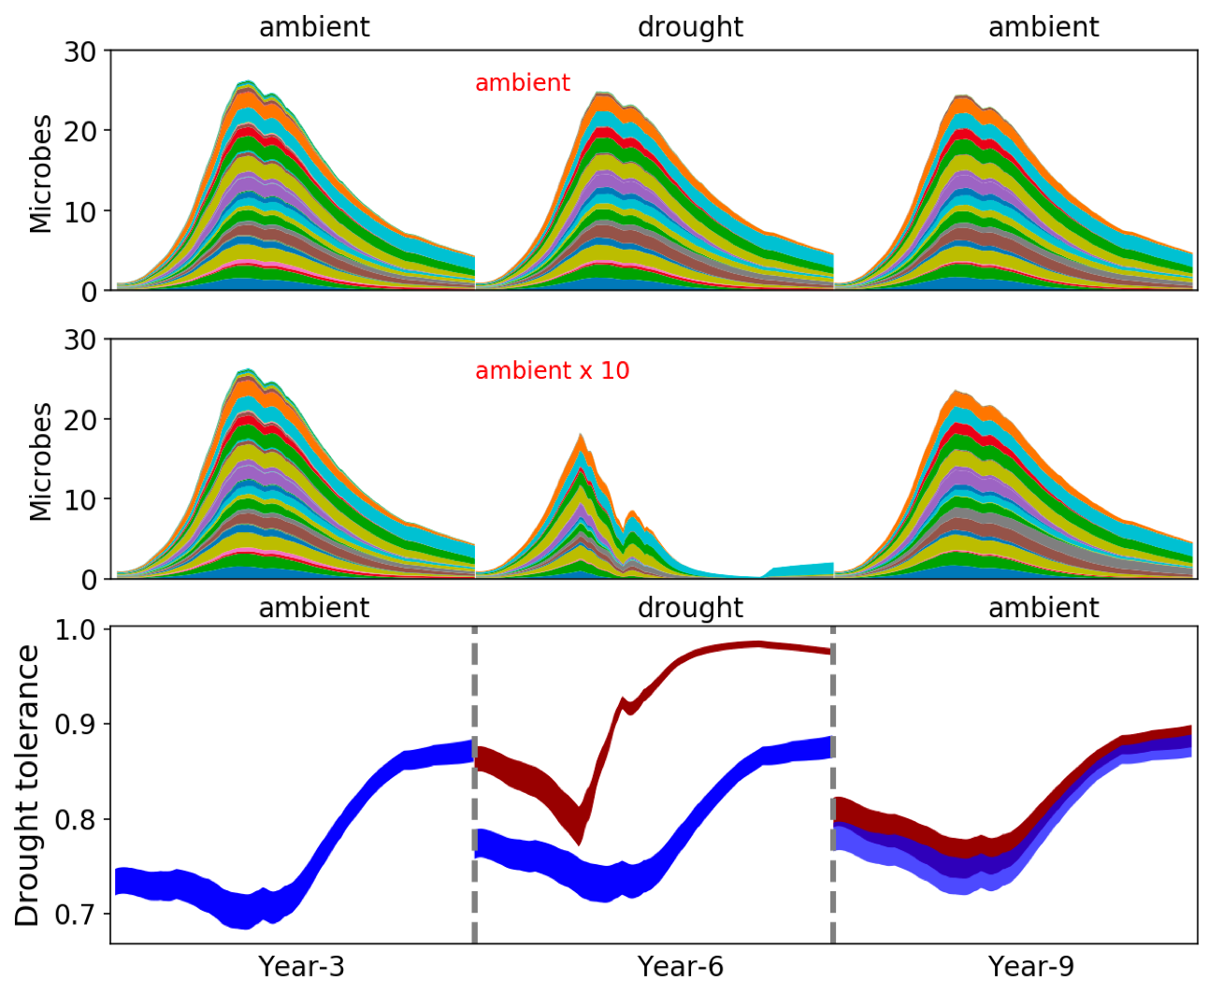

**Fig.5. Microbial community shift and drought tolerance changes driven by drought and its legacies with dispersal.**

# **4 Discussion**

## **4.1 Seasonal and inter-annual microbial system dynamics**

Seasonal dynamics with respect to litter mass loss and biomass reflect a joint control of environment and microbial community. Starting from a wet season that is relatively replete with substrates, microbial community consisting of different taxa established, and biomass increased. However, as substrates depleted, microbial cells started to be starved and die. This is accompanied by increasing drought while entering the drought season, which resulted in more death. These two processes in combination resulted in the decline of microbial biomass.

It is noteworthy that fungi are generally considered being more tolerant than bacteria to soil drying. This higher drought tolerance of fungi is due to their filamentous structure that enables the accumulation of osmoregulatory solutes without impairing metabolism via reaching and exploiting substrates even at very low soil moisture levels (Griffin 1980, 1981; Freckman 1986; Magan and Lynch 1986; Brown 1990; Manzoni et al. 2012b).

## **4.2 Drought impacts on and legacies in microbial systems**

Legacy of a disturbance in principle can be in various forms that occur along with each other simultaneously. There is no exception for drought, for which we may expect legacies of materials (dead microbes and inactivated enzymes) and community changes. However, in this study these legacies were not all covered fully except for community changes. The drought legacy is embedded in microbial community change, which is expressed in terms of the tradeoff between community-level drought tolerance and community-level resource acquisition. A community shift towards increasing drought tolerance because of increasing abundance of drought tolerance taxa results in declined degradation of substrates when even having the same environmental forcing. Drought-induced community shift results in a decline in capability degrading substrates in the system, and the magnitude of this effect positively correlated with drought severity (cite works in this regard).

Drought legacy forms a new stable microbial system (Fig. xx). Moreover, this new stable state can last and carry the legacy effects forever into the future. [find examples in the field of microbial systems].

Such legacy-driven/-shaped assembly of new stable systems is broadly true across natural systems comprised by different organisms with varying disturbances. For example, legacy effects of the last glacial shaped a bi-stable boreal biome of evergreen-dominated North America versus Deciduous dominated Eurasia (Moncrieff et al. 2015 GEB). In line with the bi-stability of boreal forest biome across Eurasia and North America because of the legacy of the last glacial (Herzschuh 2019 GEB). Additionally, tropospheric ozone pollution is a pressing problem for vegetation heath and productivity, and because of a compositional shift toward more ozone-tolerant species ozone pressure does not necessarily induce any productivity declines in the temperate deciduous forest of Southeast US (Wang et al. 2016).

However, such legacies and the new stable systems arising do not necessarily always stand. Dispersal is a key process that can negate the existence of this stable system (Fig. xx). We imagine different stable systems could exist depending on dispersal. In line with the bi-stability of boreal forest biome across Eurasia and North America because of the legacy of the last glacial (Herzschuh 2019 GEB). However, timing of dispersal probably matters, which, however, was not examined in this current study and warrants modelling studies next.

## **4.3 Deficiencies of processes simulated**

Deficiencies pertaining to this modelling study *per se* are manifold, which can be grouped into these categories: missing processes, structural biases, and parameter uncertainties. Reasons leading to these deficiencies are manifold as well, which, however, do not necessarily undermine the robustness of our conclusions.

First of all, although this model is explicit in terms of metabolism, it is still in its infancy in really capturing intracellular metabolisms which are fairly complex and entail both data accumulation and gap bridge from research communities of modelling and experiment within the microbial ecology domain. Metabolic network modelling advancements (Sauer and Teusink 2018) are accelerators in this regard, which could fuel a close coupling with DEMENTpy. One source of drought protection is the manufacture of a layer of polysaccharide-rich mucilage that prevents desiccation (Borken and Matzner, 2009). Second is to explicitly separate the total live biomass into active (BA) and dormant (BD) pools (e.g., Bäret al., 2002; Stolpovsky et al., 2011). These pathways have not yet been considered in the current version. Additionally, when the soil is re-wetted, microorganisms can release these osmolytes quickly to protect themselves against osmotic pressure and cell lysis; otherwise, they could burst due to excessive water movement into the cell (Csonka 1989).

Evolution is not simulated yet in the current version. This can be a fruitful avenue for future development. The trait-based modelling framework of vegetation by Scheiter el al. (2013) is inspirational in this regard. ‘Reproduction is a key element in next-generation DGVMs, as it transfers traits from one generation to the next (inheritance), allows transfer of traits between reproductive individuals (crossover) and allows novel trait values to enter through mutation (Scheiter *et al.* 2013)’.

Additionally, deficiencies regarding bounded rationality; that is, this whole study did not consider aboveground litter input determined by plant activities. If it were coupled with above-ground processes of litter input and plant-microbe nutrient competition, we would anticipate even more meaningful insights into whole ecosystem functioning. These, however, are beyond the scope of this investigation.

All these aspects could be avenues for explorations next as regards microbial responses to drought in particular and microbial systems composition, structure, functioning, and dynamics in general.

## **4.4 Broader implications for modelling microbiome, soil systems, and ecosystems**

The finding of legacy in this study holds broad implications for understanding microbiome and even the biosphere in the context of ever increasing frequency of environmental changes. This memory of past disturbance (or in other words, delay of a disturbance transmitting in a system) would enable more accurate quantification of soil biogeochemical cycling of various elements and above- and below-ground interactions at present. This legacy may explain the Birch Effects as for … In microbiome that is beyond natural systems, for example, human gut, legacy effect should also be taken into consideration (refs). In addition, this study focused only on drought-induced legacy, which, however, can be totally extrapolated to other perturbations that natural systems are widely experiencing, e.g, heatwave, microbial invasion, etc.

This legacy of past disturbance is broadly true across natural systems comprised by different organisms with varying disturbances. For example, legacy effects of the last glacial shaped a bi-stable boreal biome of evergreen-dominated North America versus Deciduous dominated Eurasia (Moncrieff et al. 2015 GEB). Additionally, ozone stress is an issue for vegetation heath and productivity, and because of compositional shift toward more ozone tolerance species ozone does not necessarily induce any productivity declines (Wang et al. 2016). Moreover, this study, plus all other studies on this topic, suggests that to really establish a predictive understanding of carbon cycling in soil systems in the context of projected global climate change, knowledge gained will eventually feed.

Methodologically, an incorporation of legacy effects or enable models capture microbial community memory of disturbances, and this study demonstrates that trait-based approach embedded in individual-based modelling is a feasible approach investigating microbial community ecology bridging physiology and systems functioning. This modelling system, DEMENTpy, can be used to address questions broadly related to the relative roles of environmental disturbance vs community in controlling microbial systems dynamics and functioning in terms of organic matter decomposition. Experimental investigations are possible but logistically harder to operate (Allison 2013; Martiny et al. 2017). Moreover, the deficiencies aforementioned can be directions next for improving DEMENTpy specifically and trait-based modelling of microbial systems in general. These endeavors should be carried out with incorporating rich -omics information (SCINECE & PNAS). More broadly, this applicability in microbial systems expands to other natural systems across the biosphere, especially vegetations (which are the most obvious one that has seen widespread applications). This advocation for including legacy poses huge challenges for developing and improving models, especially large scale ecosystem models. One of the challenges is scaling that resolves transcending of spatial and temporal boundaries. Finally, this study raises questions about how to scale up local scale explicit microbial community simulation to larger scale modelling by land surface models. To achieve regional and even global modelling, a prerequisite is global information on distribution of microbial traits’ distributions (like plants economic spectrum of microbial traits needs to be uncovered. Also multi-dimensional trait space is waiting to be unearthed). Then with a generic trait-based modelling framework, as illustrated by DEMENTpy, globally explicit simulation could be achieved. Of course, this requires companion datasets of soil moisture and temperature, which is already available (Green et al. Nature 2019).

# **References**

Birch, H. F. 1958. The effect of soil drying on humus decomposition and nitrogen availability. Plant and Soil 10, 9–31.

Csonka, L. N. (1989). Physiological and genetic responses of bacteria to osmotic stress. Microbiological reviews, 53, 121-147.

Gommers, P. J. F., Van Schie, B. J., Van Dijken, J. P., & Kuenen, J. G. (1988). Biochemical limits to microbial growth yields: an analysis of mixed substrate utilization. *Biotechnology and bioengineering*, *32*, 86-94.

Hobbie, J. E., & Hobbie, E. A. (2013). Microbes in nature are limited by carbon and energy: the starving-survival lifestyle in soil and consequences for estimating microbial rates. *Frontiers in Microbiology*, *4*, 324.

López-Urrutia, Á., & Morán, X. A. G. (2007). Resource limitation of bacterial production distorts the temperature dependence of oceanic carbon cycling. *Ecology*, *88*, 817-822.

Manzoni, S., Schimel, J. P., & Porporato, A. (2012b). Responses of soil microbial communities to water stress: results from a meta‐analysis. *Ecology*, *93*, 930-938.

Manzoni, S., Taylor, P., Richter, A., Porporato, A., & Ågren, G. I. (2012a). Environmental and stoichiometric controls on microbial carbon‐use efficiency in soils. New Phytologist, 196, 79-91.

Sardans, J., & Peñuelas, J. (2010). Soil enzyme activity in a Mediterranean forest after six years of drought. Soil Science Society of America Journal, 74, 838-851.

Scheiter, S., Langan, L., & Higgins, S. I. (2013). Next‐generation dynamic global vegetation models: learning from community ecology. New Phytologist, 198, 957-969.

Schimel, J., Balser, T. C., & Wallenstein, M. (2007). Microbial stress‐response physiology and its implications for ecosystem function. Ecology, 88, 1386-1394.

Schimel, J. P., & Weintraub, M. N. (2003). The implications of exoenzyme activity on microbial carbon and nitrogen limitation in soil: a theoretical model. Soil Biology and Biochemistry, 35, 549-563.

Sinsabaugh, R. L., Manzoni, S., Moorhead, D. L., & Richter, A. (2013). Carbon use efficiency of microbial communities: stoichiometry, methodology and modelling. Ecology Letters, 16, 930-939.

Tiemann, L. K., & Billings, S. A. (2011). Changes in variability of soil moisture alter microbial community C and N resource use. *Soil Biology and Biochemistry*, *43*, 1837-1847.

Wang, B., & Allison, S. D. (2019). Emergent properties of organic matter decomposition by soil enzymes. *Soil Biology and Biochemistry*, *136*, 107522.

Wang, B., Shugart, H. H., Shuman, J. K., & Lerdau, M. T. (2016). Forests and ozone: productivity, carbon storage, and feedbacks. *Scientific Reports*, *6*, 22133.

Yao, Q., Li, Z., Song, Y., Wright, S. J., Guo, X., Tringe, S. G., ... & Mayes, M. A. (2018). Community proteogenomics reveals the systemic impact of phosphorus availability on microbial functions in tropical soil. Nature Ecology & Evolution, 1.

# **Acknowledgements**

…

# **Supporting Information**

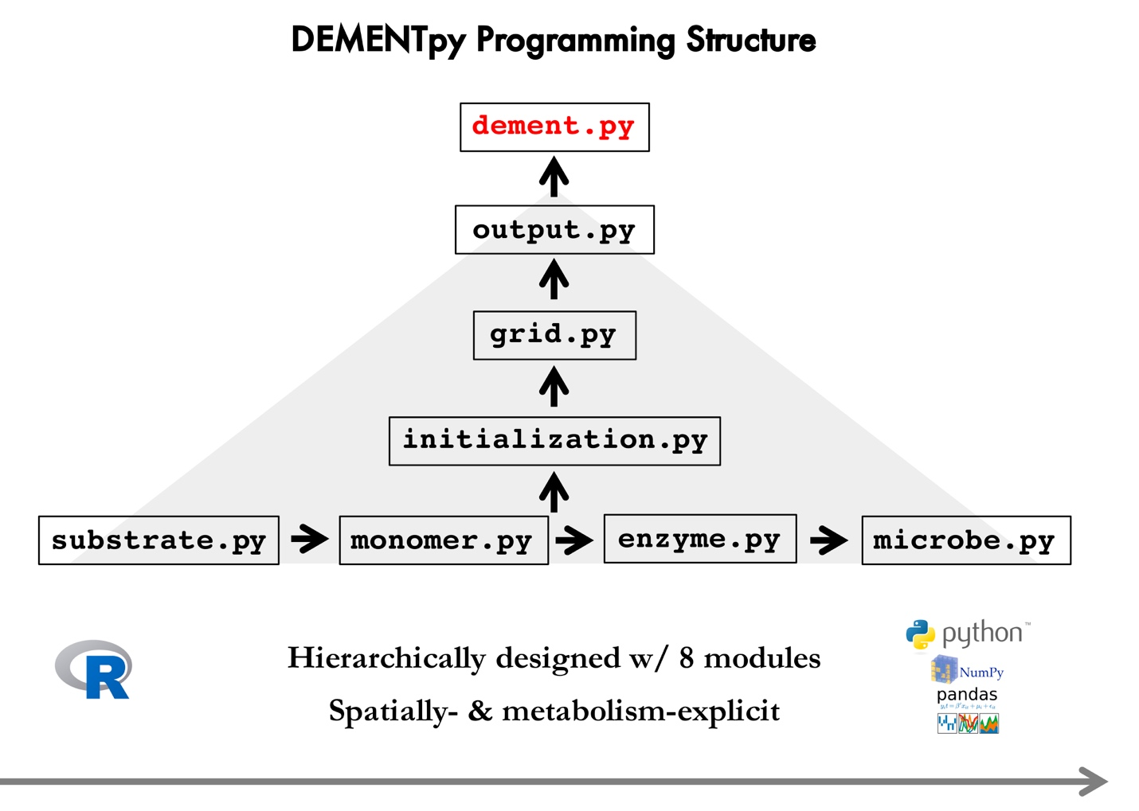

**Supporting Fig.1 DEMENTpy programming structure.**

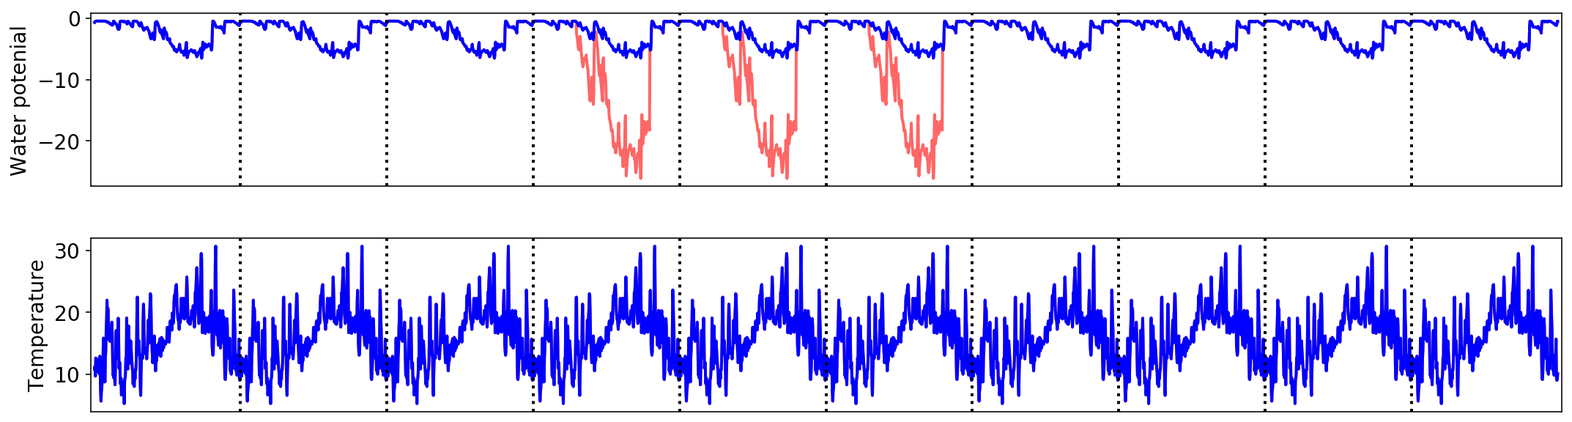

**Supporting Fig.2 Environmental forcing and drought scenarios applied and simulated in this study**. The red line (manipulated drought severity over the drought season from April through September and for illustration purpose only) denotes how the various drought scenarios (basex4, basex10, and basex15) were imposed.

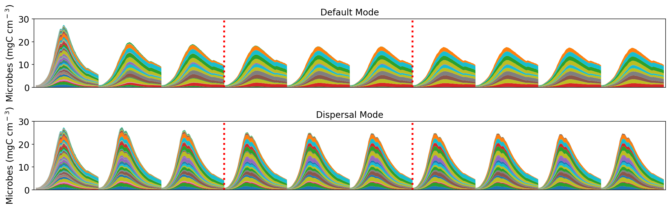

**Supporting Fig.3. Microbial community dynamics of the default vs dispersal model over 10 years under the ambient drought scenario.** The 3 years between the two dashed red lines were where drought scenarios of varying severities imposed. Results presented hereafter in the manuscript were only years of 3, 6, and 9. Different colors represent different proxy taxa.

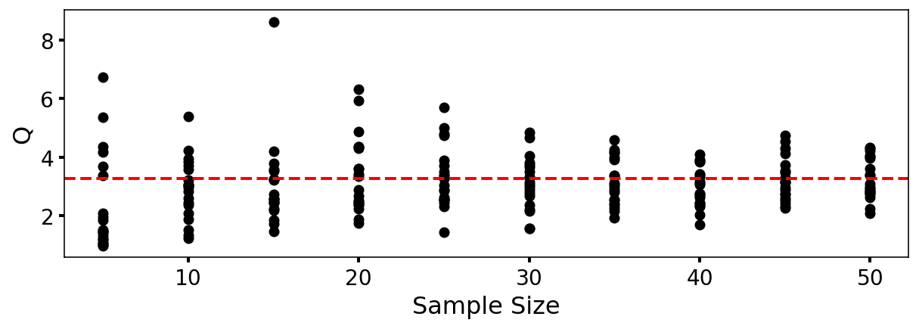

**Supporting Fig.4.** **DEMENTpy convergence analysis based on degradation of substrates**. Q (quotient) is calculated as (90% percentile -10% percentile)/median. With each sample size were 20 replicates that were randomly drawn from the sample pool of 107 runs.