methods to prepare answers for:
- binary logistic regression
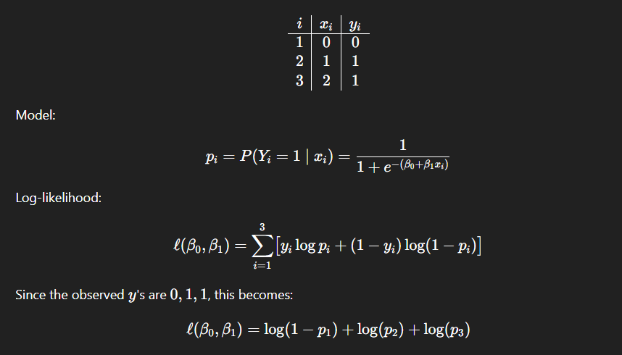
- multinomial logistic regression
- maximum likelihood estimation
The MLE is the coefficient vector that maximizes the log-likelihood function. In principle, we differentiate the log-likelihood, set the gradient equal to zero, and solve the first-order conditions. Since these equations are nonlinear in $β$, the solution is usually found numerically rather than in closed form.
- ridge regularisation
Variance goes down because the estimator becomes less sensitive to small changes in data
Bias goes up because you no longer pick the pure likelihood maximizer

  - how did we find a C?
cross validation over a grid of possible C values
- bias-variance trade-off
illustrated two ways
    - by model complexity. Increasing complexity (5 classes instead of 1) should increase variance, and model should predict better, but it cannot be directly compared with the binary model as they predict on different y dimensions
    - By ridge regularisation increasing bias and reducing variance making the model predict more generalized and predict better on unseen data
- 5-fold cross-validation
- log-loss
- leave-one-out jackknife
- 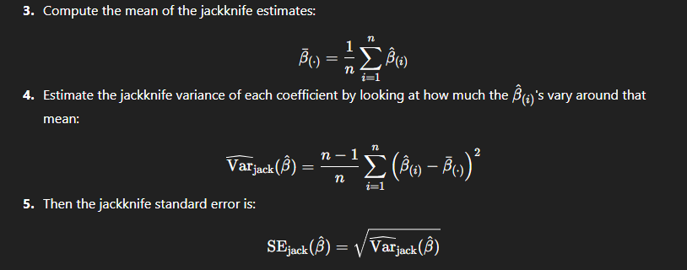
- coefficient instability / quasi-separation / finite-sample issues

- class imbalance and effective sample size
The strongest theoretical core is probably:
- why MLE can become unstable in finite samples
- why ridge helps
- why cross-validation and jackknife measure different things
- why multinomial logistic regression is harder here than binary logistic regression

