Class 6: R functions

Alberto Carreno

1/24/2020

## R Markdown

## this is a level 2 heading

x <- c(1:10)  
x

## [1] 1 2 3 4 5 6 7 8 9 10

here is my analyssis , the mean fof your data is 5.5

this is **regular** old *text*!

and a list of stuff

plot(1:5, col = "blue", type = "o")

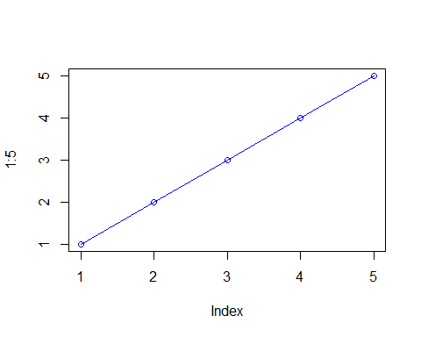

-a thing -another thing -and a third

### this is a level 3 heading

## more on reading input files

we will use the read.table() function again

This is an R Markdown document. Markdown is a simple formatting syntax for authoring HTML, PDF, and MS Word documents. For more details on using R Markdown see <http://rmarkdown.rstudio.com>.

When you click the **Knit** button a document will be generated that includes both content as well as the output of any embedded R code chunks within the document. You can embed an R code chunk like this:

summary(cars)

## speed dist   
## Min. : 4.0 Min. : 2.00   
## 1st Qu.:12.0 1st Qu.: 26.00   
## Median :15.0 Median : 36.00   
## Mean :15.4 Mean : 42.98   
## 3rd Qu.:19.0 3rd Qu.: 56.00   
## Max. :25.0 Max. :120.00

## Including Plots

You can also embed plots, for example:



Note that the echo = FALSE parameter was added to the code chunk to prevent printing of the R code that generated the plot.

x <- read.table("test1.txt" ,header = TRUE, sep = ",")  
x

## Col1 Col2 Col3  
## 1 1 2 3  
## 2 4 5 6  
## 3 7 8 9  
## 4 a b c

y <- read.table("test2.txt", sep = "$", header = T)  
y

## Col1 Col2 Col3  
## 1 1 2 3  
## 2 4 5 6  
## 3 7 8 9  
## 4 a b c

z <- read.table("test3.txt")  
z

## V1 V2 V3  
## 1 1 6 a  
## 2 2 7 b  
## 3 3 8 c  
## 4 4 9 d  
## 5 5 10 e

##Time to work on functions!

add <- function(x,y = 1){  
 x+y  
}

add(c(1,2,3),22)

## [1] 23 24 25

a <- range(c(1,2,3,4))  
a[2]

## [1] 4

rescale <- function(x){  
 rng <- range(x)  
 (x-rng[1])/(rng[2] -rng[1])  
}

rescale(c(1:10,30,100))

## [1] 0.00000000 0.01010101 0.02020202 0.03030303 0.04040404 0.05050505  
## [7] 0.06060606 0.07070707 0.08080808 0.09090909 0.29292929 1.00000000

x <- c(1:10)  
rng <- range(x,na.rm = T)  
rng

## [1] 1 10

rescale2 <- function(x){  
 rng <- range(x, na.rm = TRUE)  
 (x-rng[1])/(rng[2] -rng[1])  
}

rescale(c(1:10,NA))

## [1] NA NA NA NA NA NA NA NA NA NA NA

rescale2(c(1:10,NA))

## [1] 0.0000000 0.1111111 0.2222222 0.3333333 0.4444444 0.5555556 0.6666667  
## [8] 0.7777778 0.8888889 1.0000000 NA

rescale(c(1,10,NA))

## [1] NA NA NA

rescale2(c(1,10,NA))

## [1] 0 1 NA

rescale3 <- function(x, na.rm=TRUE, plot=FALSE) {  
 if(na.rm) {  
 rng <-range(x, na.rm=na.rm)  
 } else {  
 rng <-range(x)  
 }  
 print("Hello")  
 answer <- (x - rng[1]) / (rng[2] - rng[1])  
 print("is it me you are looking for?")  
 if(plot) {  
 plot(answer, typ="b", lwd=4)  
 }  
 print("I can see it in ...")  
 return(answer)  
}

rescale3(x)

## [1] "Hello"  
## [1] "is it me you are looking for?"  
## [1] "I can see it in ..."

## [1] 0.0000000 0.1111111 0.2222222 0.3333333 0.4444444 0.5555556 0.6666667  
## [8] 0.7777778 0.8888889 1.0000000

#install.packages("bio3d")

library(bio3d)

# Can you improve this analysis code?  
library(bio3d)  
s1 <- read.pdb("4AKE") # kinase with drug

## Note: Accessing on-line PDB file

s2 <- read.pdb("1AKE") # kinase no drug

## Note: Accessing on-line PDB file  
## PDB has ALT records, taking A only, rm.alt=TRUE

s3 <- read.pdb("1E4Y") # kinase with drug

## Note: Accessing on-line PDB file

s1.chainA <- trim.pdb(s1, chain="A", elety="CA")  
s2.chainA <- trim.pdb(s2, chain="A", elety="CA")  
s3.chainA <- trim.pdb(s3, chain="A", elety="CA")  
s1.b <- s1.chainA$atom$b  
s2.b <- s2.chainA$atom$b  
s3.b <- s3.chainA$atom$b  
plotb3(s1.b, sse=s1.chainA, typ="l", ylab="Bfactor")

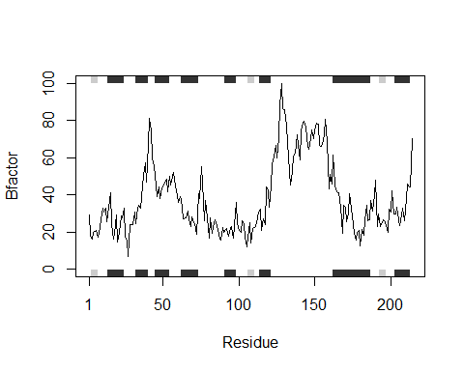

plotb3(s2.b, sse=s2.chainA, typ="l", ylab="Bfactor")

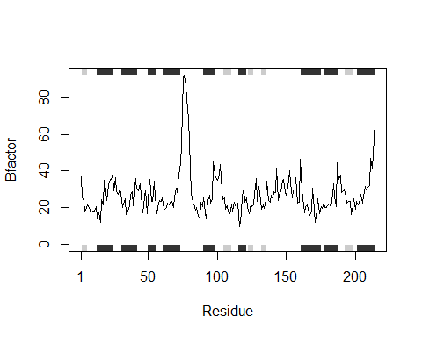

plotb3(s3.b, sse=s3.chainA, typ="l", ylab="Bfactor")

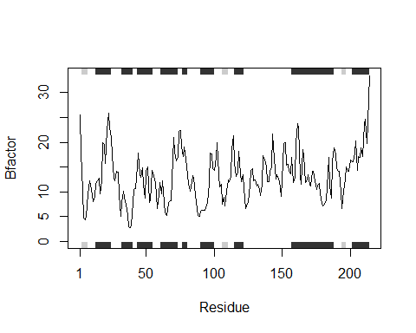

library(bio3d)  
s1 <- read.pdb("4AKE") # kinase with drug

## Note: Accessing on-line PDB file

## Warning in get.pdb(file, path = tempdir(), verbose = FALSE): C:  
## \Users\acarr\AppData\Local\Temp\RtmpEvtZpJ/4AKE.pdb exists. Skipping download

s2 <- read.pdb("1AKE") # kinase no drug

## Note: Accessing on-line PDB file

## Warning in get.pdb(file, path = tempdir(), verbose = FALSE): C:  
## \Users\acarr\AppData\Local\Temp\RtmpEvtZpJ/1AKE.pdb exists. Skipping download

## PDB has ALT records, taking A only, rm.alt=TRUE

s3 <- read.pdb("1E4Y") # kinase with drug

## Note: Accessing on-line PDB file

## Warning in get.pdb(file, path = tempdir(), verbose = FALSE): C:  
## \Users\acarr\AppData\Local\Temp\RtmpEvtZpJ/1E4Y.pdb exists. Skipping download

s4 <- read.pdb("1BG2") #test

## Note: Accessing on-line PDB file

s1.chainA <- trim.pdb(s1, chain="A", elety="CA")  
s2.chainA <- trim.pdb(s2, chain="A", elety="CA")  
s3.chainA <- trim.pdb(s3, chain="A", elety="CA")  
s1.b <- s1.chainA$atom$b  
s2.b <- s2.chainA$atom$b  
s3.b <- s3.chainA$atom$b  
plotb3(s1.b, sse=s1.chainA, typ="l", ylab="Bfactor")



plotb3(s2.b, sse=s2.chainA, typ="l", ylab="Bfactor")



plotb3(s3.b, sse=s3.chainA, typ="l", ylab="Bfactor")



#a,b, and c are values stores as read.pdb("protein")  
threeinone <- function(a,b,c) {  
 sa.chainA <- trim.pdb(a, chain = "A", elety = "CA")  
 sa.b <- sa.chainA$atom$b  
 plotb3(sa.b, sse=sa.chainA, typ = "l", ylab= "Bfactor")  
   
 sb.chainA <- trim.pdb(b, chain = "A", elety = "CA")  
 sb.b <- sb.chainA$atom$b  
 plotb3(sb.b, sse=sb.chainA, typ = "l", ylab= "Bfactor")  
   
 sc.chainA <- trim.pdb(c, chain = "A", elety = "CA")  
 sc.b <- sc.chainA$atom$b  
 plotb3(sc.b, sse=sc.chainA, typ = "l", ylab= "Bfactor")  
   
plotb3(sa.b, sse=s1.chainA, typ="l", ylab="Bfactor")  
points(sb.b, col="blue", typ="l")  
points(sc.b, col="red", typ="l", lwd=3)  
   
}  
threeinone(s1,s2,s3)

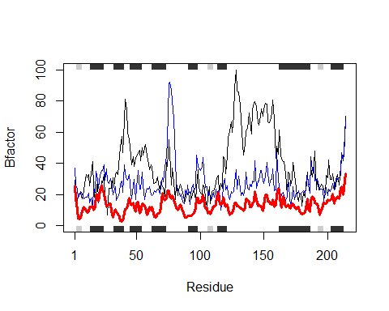

## BEGINNING OF MY FUNCTION

#a,b, and c are values stored as read.pdb("protein")  
library(bio3d)  
threeinone <- function(a,b,c) {  
 sa.chainA <- trim.pdb(a, chain = "A", elety = "CA") #take variable "a" (which is a read.pdb variable for a given protein) and filter out/trim structures from the original PDB input and select for Chain and atom type.  
 sa.b <- sa.chainA$atom$b #isolate the atoms in chain A from sa.chainA to get just the atom vector coordinates.  
 plotb3(sa.b, sse=sa.chainA, typ = "l", ylab= "Bfactor") #plot for variable as a line and setting the Bfactor values on the y axis  
   
 sb.chainA <- trim.pdb(b, chain = "A", elety = "CA")#repeat for second,b, variable   
 sb.b <- sb.chainA$atom$b  
 plotb3(sb.b, sse=sb.chainA, typ = "l", ylab= "Bfactor")#plot for second variable  
   
 sc.chainA <- trim.pdb(c, chain = "A", elety = "CA") #repeat for third,c, variable   
 sc.b <- sc.chainA$atom$b  
 plotb3(sc.b, sse=sc.chainA, typ = "l", ylab= "Bfactor") #plot for third variable  
#now overlay all three inputs into one graph  
plotb3(sa.b, sse=s1.chainA, typ="l", ylab="Bfactor")  
points(sb.b, col="blue", typ="l")  
points(sc.b, col="red", typ="l", lwd=3)  
   
}

#a,b, and c are values stores as read.pdb("protein")  
threeinone(s1,s2,s3)

