Class_10_markdown

fna.data <- “data/WisconsinCancer.csv”

fna.data <- "data/WisconsinCancer.csv"  
wisc.df <- read.csv("WisconsinCancer.csv")

wisc.data <- as.matrix(wisc.df[,3:32])  
head(wisc.data)

## radius_mean texture_mean perimeter_mean area_mean smoothness_mean  
## [1,] 17.99 10.38 122.80 1001.0 0.11840  
## [2,] 20.57 17.77 132.90 1326.0 0.08474  
## [3,] 19.69 21.25 130.00 1203.0 0.10960  
## [4,] 11.42 20.38 77.58 386.1 0.14250  
## [5,] 20.29 14.34 135.10 1297.0 0.10030  
## [6,] 12.45 15.70 82.57 477.1 0.12780  
## compactness_mean concavity_mean concave.points_mean symmetry_mean  
## [1,] 0.27760 0.3001 0.14710 0.2419  
## [2,] 0.07864 0.0869 0.07017 0.1812  
## [3,] 0.15990 0.1974 0.12790 0.2069  
## [4,] 0.28390 0.2414 0.10520 0.2597  
## [5,] 0.13280 0.1980 0.10430 0.1809  
## [6,] 0.17000 0.1578 0.08089 0.2087  
## fractal_dimension_mean radius_se texture_se perimeter_se area_se  
## [1,] 0.07871 1.0950 0.9053 8.589 153.40  
## [2,] 0.05667 0.5435 0.7339 3.398 74.08  
## [3,] 0.05999 0.7456 0.7869 4.585 94.03  
## [4,] 0.09744 0.4956 1.1560 3.445 27.23  
## [5,] 0.05883 0.7572 0.7813 5.438 94.44  
## [6,] 0.07613 0.3345 0.8902 2.217 27.19  
## smoothness_se compactness_se concavity_se concave.points_se symmetry_se  
## [1,] 0.006399 0.04904 0.05373 0.01587 0.03003  
## [2,] 0.005225 0.01308 0.01860 0.01340 0.01389  
## [3,] 0.006150 0.04006 0.03832 0.02058 0.02250  
## [4,] 0.009110 0.07458 0.05661 0.01867 0.05963  
## [5,] 0.011490 0.02461 0.05688 0.01885 0.01756  
## [6,] 0.007510 0.03345 0.03672 0.01137 0.02165  
## fractal_dimension_se radius_worst texture_worst perimeter_worst area_worst  
## [1,] 0.006193 25.38 17.33 184.60 2019.0  
## [2,] 0.003532 24.99 23.41 158.80 1956.0  
## [3,] 0.004571 23.57 25.53 152.50 1709.0  
## [4,] 0.009208 14.91 26.50 98.87 567.7  
## [5,] 0.005115 22.54 16.67 152.20 1575.0  
## [6,] 0.005082 15.47 23.75 103.40 741.6  
## smoothness_worst compactness_worst concavity_worst concave.points_worst  
## [1,] 0.1622 0.6656 0.7119 0.2654  
## [2,] 0.1238 0.1866 0.2416 0.1860  
## [3,] 0.1444 0.4245 0.4504 0.2430  
## [4,] 0.2098 0.8663 0.6869 0.2575  
## [5,] 0.1374 0.2050 0.4000 0.1625  
## [6,] 0.1791 0.5249 0.5355 0.1741  
## symmetry_worst fractal_dimension_worst  
## [1,] 0.4601 0.11890  
## [2,] 0.2750 0.08902  
## [3,] 0.3613 0.08758  
## [4,] 0.6638 0.17300  
## [5,] 0.2364 0.07678  
## [6,] 0.3985 0.12440

Q1.. What type of object is returned from the read.csv() function? data frame

Q2. How many observations (i.e. patients) are in this dataset? 569

Q3. How many of the observations have a malignant diagnosis? 212

Q4. How many variables/features in the data are suffixed with _mean? there are 10

nrow(wisc.data)

## [1] 569

table(wisc.df$diagnosis)

##   
## B M   
## 357 212

colnames(wisc.df)

## [1] "id" "diagnosis"   
## [3] "radius_mean" "texture_mean"   
## [5] "perimeter_mean" "area_mean"   
## [7] "smoothness_mean" "compactness_mean"   
## [9] "concavity_mean" "concave.points_mean"   
## [11] "symmetry_mean" "fractal_dimension_mean"   
## [13] "radius_se" "texture_se"   
## [15] "perimeter_se" "area_se"   
## [17] "smoothness_se" "compactness_se"   
## [19] "concavity_se" "concave.points_se"   
## [21] "symmetry_se" "fractal_dimension_se"   
## [23] "radius_worst" "texture_worst"   
## [25] "perimeter_worst" "area_worst"   
## [27] "smoothness_worst" "compactness_worst"   
## [29] "concavity_worst" "concave.points_worst"   
## [31] "symmetry_worst" "fractal_dimension_worst"  
## [33] "X"

grep("_mean",colnames(wisc.df),value = T)

## [1] "radius_mean" "texture_mean" "perimeter_mean"   
## [4] "area_mean" "smoothness_mean" "compactness_mean"   
## [7] "concavity_mean" "concave.points_mean" "symmetry_mean"   
## [10] "fractal_dimension_mean"

length(grep("_mean",colnames(wisc.df)))

## [1] 10

## Enter Principal Component Analysis

First we need ot check whether our input dara should be scaled or not…

first we need to look at the mean value and standard deviation of the columns, if they are close then we do not need to use scale. If they are not…we need to scale!

colMeans(wisc.data)

## radius_mean texture_mean perimeter_mean   
## 1.412729e+01 1.928965e+01 9.196903e+01   
## area_mean smoothness_mean compactness_mean   
## 6.548891e+02 9.636028e-02 1.043410e-01   
## concavity_mean concave.points_mean symmetry_mean   
## 8.879932e-02 4.891915e-02 1.811619e-01   
## fractal_dimension_mean radius_se texture_se   
## 6.279761e-02 4.051721e-01 1.216853e+00   
## perimeter_se area_se smoothness_se   
## 2.866059e+00 4.033708e+01 7.040979e-03   
## compactness_se concavity_se concave.points_se   
## 2.547814e-02 3.189372e-02 1.179614e-02   
## symmetry_se fractal_dimension_se radius_worst   
## 2.054230e-02 3.794904e-03 1.626919e+01   
## texture_worst perimeter_worst area_worst   
## 2.567722e+01 1.072612e+02 8.805831e+02   
## smoothness_worst compactness_worst concavity_worst   
## 1.323686e-01 2.542650e-01 2.721885e-01   
## concave.points_worst symmetry_worst fractal_dimension_worst   
## 1.146062e-01 2.900756e-01 8.394582e-02

round(apply(wisc.data,2,sd),2)

## radius_mean texture_mean perimeter_mean   
## 3.52 4.30 24.30   
## area_mean smoothness_mean compactness_mean   
## 351.91 0.01 0.05   
## concavity_mean concave.points_mean symmetry_mean   
## 0.08 0.04 0.03   
## fractal_dimension_mean radius_se texture_se   
## 0.01 0.28 0.55   
## perimeter_se area_se smoothness_se   
## 2.02 45.49 0.00   
## compactness_se concavity_se concave.points_se   
## 0.02 0.03 0.01   
## symmetry_se fractal_dimension_se radius_worst   
## 0.01 0.00 4.83   
## texture_worst perimeter_worst area_worst   
## 6.15 33.60 569.36   
## smoothness_worst compactness_worst concavity_worst   
## 0.02 0.16 0.21   
## concave.points_worst symmetry_worst fractal_dimension_worst   
## 0.07 0.06 0.02

wisc.pr <- prcomp(wisc.data,scale = T)

summary(wisc.pr)

## Importance of components:  
## PC1 PC2 PC3 PC4 PC5 PC6 PC7  
## Standard deviation 3.6444 2.3857 1.67867 1.40735 1.28403 1.09880 0.82172  
## Proportion of Variance 0.4427 0.1897 0.09393 0.06602 0.05496 0.04025 0.02251  
## Cumulative Proportion 0.4427 0.6324 0.72636 0.79239 0.84734 0.88759 0.91010  
## PC8 PC9 PC10 PC11 PC12 PC13 PC14  
## Standard deviation 0.69037 0.6457 0.59219 0.5421 0.51104 0.49128 0.39624  
## Proportion of Variance 0.01589 0.0139 0.01169 0.0098 0.00871 0.00805 0.00523  
## Cumulative Proportion 0.92598 0.9399 0.95157 0.9614 0.97007 0.97812 0.98335  
## PC15 PC16 PC17 PC18 PC19 PC20 PC21  
## Standard deviation 0.30681 0.28260 0.24372 0.22939 0.22244 0.17652 0.1731  
## Proportion of Variance 0.00314 0.00266 0.00198 0.00175 0.00165 0.00104 0.0010  
## Cumulative Proportion 0.98649 0.98915 0.99113 0.99288 0.99453 0.99557 0.9966  
## PC22 PC23 PC24 PC25 PC26 PC27 PC28  
## Standard deviation 0.16565 0.15602 0.1344 0.12442 0.09043 0.08307 0.03987  
## Proportion of Variance 0.00091 0.00081 0.0006 0.00052 0.00027 0.00023 0.00005  
## Cumulative Proportion 0.99749 0.99830 0.9989 0.99942 0.99969 0.99992 0.99997  
## PC29 PC30  
## Standard deviation 0.02736 0.01153  
## Proportion of Variance 0.00002 0.00000  
## Cumulative Proportion 1.00000 1.00000

biplot(wisc.pr)

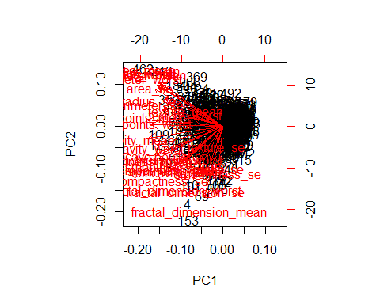

(wisc.pr)

## Standard deviations (1, .., p=30):  
## [1] 3.64439401 2.38565601 1.67867477 1.40735229 1.28402903 1.09879780  
## [7] 0.82171778 0.69037464 0.64567392 0.59219377 0.54213992 0.51103950  
## [13] 0.49128148 0.39624453 0.30681422 0.28260007 0.24371918 0.22938785  
## [19] 0.22243559 0.17652026 0.17312681 0.16564843 0.15601550 0.13436892  
## [25] 0.12442376 0.09043030 0.08306903 0.03986650 0.02736427 0.01153451  
##   
## Rotation (n x k) = (30 x 30):  
## PC1 PC2 PC3 PC4  
## radius_mean -0.21890244 0.233857132 -0.008531243 0.041408962  
## texture_mean -0.10372458 0.059706088 0.064549903 -0.603050001  
## perimeter_mean -0.22753729 0.215181361 -0.009314220 0.041983099  
## area_mean -0.22099499 0.231076711 0.028699526 0.053433795  
## smoothness_mean -0.14258969 -0.186113023 -0.104291904 0.159382765  
## compactness_mean -0.23928535 -0.151891610 -0.074091571 0.031794581  
## concavity_mean -0.25840048 -0.060165363 0.002733838 0.019122753  
## concave.points_mean -0.26085376 0.034767500 -0.025563541 0.065335944  
## symmetry_mean -0.13816696 -0.190348770 -0.040239936 0.067124984  
## fractal_dimension_mean -0.06436335 -0.366575471 -0.022574090 0.048586765  
## radius_se -0.20597878 0.105552152 0.268481387 0.097941242  
## texture_se -0.01742803 -0.089979682 0.374633665 -0.359855528  
## perimeter_se -0.21132592 0.089457234 0.266645367 0.088992415  
## area_se -0.20286964 0.152292628 0.216006528 0.108205039  
## smoothness_se -0.01453145 -0.204430453 0.308838979 0.044664180  
## compactness_se -0.17039345 -0.232715896 0.154779718 -0.027469363  
## concavity_se -0.15358979 -0.197207283 0.176463743 0.001316880  
## concave.points_se -0.18341740 -0.130321560 0.224657567 0.074067335  
## symmetry_se -0.04249842 -0.183848000 0.288584292 0.044073351  
## fractal_dimension_se -0.10256832 -0.280092027 0.211503764 0.015304750  
## radius_worst -0.22799663 0.219866379 -0.047506990 0.015417240  
## texture_worst -0.10446933 0.045467298 -0.042297823 -0.632807885  
## perimeter_worst -0.23663968 0.199878428 -0.048546508 0.013802794  
## area_worst -0.22487053 0.219351858 -0.011902318 0.025894749  
## smoothness_worst -0.12795256 -0.172304352 -0.259797613 0.017652216  
## compactness_worst -0.21009588 -0.143593173 -0.236075625 -0.091328415  
## concavity_worst -0.22876753 -0.097964114 -0.173057335 -0.073951180  
## concave.points_worst -0.25088597 0.008257235 -0.170344076 0.006006996  
## symmetry_worst -0.12290456 -0.141883349 -0.271312642 -0.036250695  
## fractal_dimension_worst -0.13178394 -0.275339469 -0.232791313 -0.077053470  
## PC5 PC6 PC7 PC8  
## radius_mean -0.037786354 0.0187407904 -0.1240883403 0.007452296  
## texture_mean 0.049468850 -0.0321788366 0.0113995382 -0.130674825  
## perimeter_mean -0.037374663 0.0173084449 -0.1144770573 0.018687258  
## area_mean -0.010331251 -0.0018877480 -0.0516534275 -0.034673604  
## smoothness_mean 0.365088528 -0.2863744966 -0.1406689928 0.288974575  
## compactness_mean -0.011703971 -0.0141309489 0.0309184960 0.151396350  
## concavity_mean -0.086375412 -0.0093441809 -0.1075204434 0.072827285  
## concave.points_mean 0.043861025 -0.0520499505 -0.1504822142 0.152322414  
## symmetry_mean 0.305941428 0.3564584607 -0.0938911345 0.231530989  
## fractal_dimension_mean 0.044424360 -0.1194306679 0.2957600240 0.177121441  
## radius_se 0.154456496 -0.0256032561 0.3124900373 -0.022539967  
## texture_se 0.191650506 -0.0287473145 -0.0907553556 0.475413139  
## perimeter_se 0.120990220 0.0018107150 0.3146403902 0.011896690  
## area_se 0.127574432 -0.0428639079 0.3466790028 -0.085805135  
## smoothness_se 0.232065676 -0.3429173935 -0.2440240556 -0.573410232  
## compactness_se -0.279968156 0.0691975186 0.0234635340 -0.117460157  
## concavity_se -0.353982091 0.0563432386 -0.2088237897 -0.060566501  
## concave.points_se -0.195548089 -0.0312244482 -0.3696459369 0.108319309  
## symmetry_se 0.252868765 0.4902456426 -0.0803822539 -0.220149279  
## fractal_dimension_se -0.263297438 -0.0531952674 0.1913949726 -0.011168188  
## radius_worst 0.004406592 -0.0002906849 -0.0097099360 -0.042619416  
## texture_worst 0.092883400 -0.0500080613 0.0098707439 -0.036251636  
## perimeter_worst -0.007454151 0.0085009872 -0.0004457267 -0.030558534  
## area_worst 0.027390903 -0.0251643821 0.0678316595 -0.079394246  
## smoothness_worst 0.324435445 -0.3692553703 -0.1088308865 -0.205852191  
## compactness_worst -0.121804107 0.0477057929 0.1404729381 -0.084019659  
## concavity_worst -0.188518727 0.0283792555 -0.0604880561 -0.072467871  
## concave.points_worst -0.043332069 -0.0308734498 -0.1679666187 0.036170795  
## symmetry_worst 0.244558663 0.4989267845 -0.0184906298 -0.228225053  
## fractal_dimension_worst -0.094423351 -0.0802235245 0.3746576261 -0.048360667  
## PC9 PC10 PC11 PC12  
## radius_mean -0.223109764 0.095486443 -0.04147149 0.051067457  
## texture_mean 0.112699390 0.240934066 0.30224340 0.254896423  
## perimeter_mean -0.223739213 0.086385615 -0.01678264 0.038926106  
## area_mean -0.195586014 0.074956489 -0.11016964 0.065437508  
## smoothness_mean 0.006424722 -0.069292681 0.13702184 0.316727211  
## compactness_mean -0.167841425 0.012936200 0.30800963 -0.104017044  
## concavity_mean 0.040591006 -0.135602298 -0.12419024 0.065653480  
## concave.points_mean -0.111971106 0.008054528 0.07244603 0.042589267  
## symmetry_mean 0.256040084 0.572069479 -0.16305408 -0.288865504  
## fractal_dimension_mean -0.123740789 0.081103207 0.03804827 0.236358988  
## radius_se 0.249985002 -0.049547594 0.02535702 -0.016687915  
## texture_se -0.246645397 -0.289142742 -0.34494446 -0.306160423  
## perimeter_se 0.227154024 -0.114508236 0.16731877 -0.101446828  
## area_se 0.229160015 -0.091927889 -0.05161946 -0.017679218  
## smoothness_se -0.141924890 0.160884609 -0.08420621 -0.294710053  
## compactness_se -0.145322810 0.043504866 0.20688568 -0.263456509  
## concavity_se 0.358107079 -0.141276243 -0.34951794 0.251146975  
## concave.points_se 0.272519886 0.086240847 0.34237591 -0.006458751  
## symmetry_se -0.304077200 -0.316529830 0.18784404 0.320571348  
## fractal_dimension_se -0.213722716 0.367541918 -0.25062479 0.276165974  
## radius_worst -0.112141463 0.077361643 -0.10506733 0.039679665  
## texture_worst 0.103341204 0.029550941 -0.01315727 0.079797450  
## perimeter_worst -0.109614364 0.050508334 -0.05107628 -0.008987738  
## area_worst -0.080732461 0.069921152 -0.18459894 0.048088657  
## smoothness_worst 0.112315904 -0.128304659 -0.14389035 0.056514866  
## compactness_worst -0.100677822 -0.172133632 0.19742047 -0.371662503  
## concavity_worst 0.161908621 -0.311638520 -0.18501676 -0.087034532  
## concave.points_worst 0.060488462 -0.076648291 0.11777205 -0.068125354  
## symmetry_worst 0.064637806 -0.029563075 -0.15756025 0.044033503  
## fractal_dimension_worst -0.134174175 0.012609579 -0.11828355 -0.034731693  
## PC13 PC14 PC15 PC16  
## radius_mean 0.01196721 0.059506135 -0.051118775 -0.15058388  
## texture_mean 0.20346133 -0.021560100 -0.107922421 -0.15784196  
## perimeter_mean 0.04410950 0.048513812 -0.039902936 -0.11445396  
## area_mean 0.06737574 0.010830829 0.013966907 -0.13244803  
## smoothness_mean 0.04557360 0.445064860 -0.118143364 -0.20461325  
## compactness_mean 0.22928130 0.008101057 0.230899962 0.17017837  
## concavity_mean 0.38709081 -0.189358699 -0.128283732 0.26947021  
## concave.points_mean 0.13213810 -0.244794768 -0.217099194 0.38046410  
## symmetry_mean 0.18993367 0.030738856 -0.073961707 -0.16466159  
## fractal_dimension_mean 0.10623908 -0.377078865 0.517975705 -0.04079279  
## radius_se -0.06819523 0.010347413 -0.110050711 0.05890572  
## texture_se -0.16822238 -0.010849347 0.032752721 -0.03450040  
## perimeter_se -0.03784399 -0.045523718 -0.008268089 0.02651665  
## area_se 0.05606493 0.083570718 -0.046024366 0.04115323  
## smoothness_se 0.15044143 -0.201152530 0.018559465 -0.05803906  
## compactness_se 0.01004017 0.491755932 0.168209315 0.18983090  
## concavity_se 0.15878319 0.134586924 0.250471408 -0.12542065  
## concave.points_se -0.49402674 -0.199666719 0.062079344 -0.19881035  
## symmetry_se 0.01033274 -0.046864383 -0.113383199 -0.15771150  
## fractal_dimension_se -0.24045832 0.145652466 -0.353232211 0.26855388  
## radius_worst -0.13789053 0.023101281 0.166567074 -0.08156057  
## texture_worst -0.08014543 0.053430792 0.101115399 0.18555785  
## perimeter_worst -0.09696571 0.012219382 0.182755198 -0.05485705  
## area_worst -0.10116061 -0.006685465 0.314993600 -0.09065339  
## smoothness_worst -0.20513034 0.162235443 0.046125866 0.14555166  
## compactness_worst 0.01227931 0.166470250 -0.049956014 -0.15373486  
## concavity_worst 0.21798433 -0.066798931 -0.204835886 -0.21502195  
## concave.points_worst -0.25438749 -0.276418891 -0.169499607 0.17814174  
## symmetry_worst -0.25653491 0.005355574 0.139888394 0.25789401  
## fractal_dimension_worst -0.17281424 -0.212104110 -0.256173195 -0.40555649  
## PC17 PC18 PC19 PC20  
## radius_mean 0.202924255 0.1467123385 0.22538466 -0.049698664  
## texture_mean -0.038706119 -0.0411029851 0.02978864 -0.244134993  
## perimeter_mean 0.194821310 0.1583174548 0.23959528 -0.017665012  
## area_mean 0.255705763 0.2661681046 -0.02732219 -0.090143762  
## smoothness_mean 0.167929914 -0.3522268017 -0.16456584 0.017100960  
## compactness_mean -0.020307708 0.0077941384 0.28422236 0.488686329  
## concavity_mean -0.001598353 -0.0269681105 0.00226636 -0.033387086  
## concave.points_mean 0.034509509 -0.0828277367 -0.15497236 -0.235407606  
## symmetry_mean -0.191737848 0.1733977905 -0.05881116 0.026069156  
## fractal_dimension_mean 0.050225246 0.0878673570 -0.05815705 -0.175637222  
## radius_se -0.139396866 -0.2362165319 0.17588331 -0.090800503  
## texture_se 0.043963016 -0.0098586620 0.03600985 -0.071659988  
## perimeter_se -0.024635639 -0.0259288003 0.36570154 -0.177250625  
## area_se 0.334418173 0.3049069032 -0.41657231 0.274201148  
## smoothness_se 0.139595006 -0.2312599432 -0.01326009 0.090061477  
## compactness_se -0.008246477 0.1004742346 -0.24244818 -0.461098220  
## concavity_se 0.084616716 -0.0001954852 0.12638102 0.066946174  
## concave.points_se 0.108132263 0.0460549116 -0.01216430 0.068868294  
## symmetry_se -0.274059129 0.1870147640 -0.08903929 0.107385289  
## fractal_dimension_se -0.122733398 -0.0598230982 0.08660084 0.222345297  
## radius_worst -0.240049982 -0.2161013526 0.01366130 -0.005626909  
## texture_worst 0.069365185 0.0583984505 -0.07586693 0.300599798  
## perimeter_worst -0.234164147 -0.1885435919 0.09081325 0.011003858  
## area_worst -0.273399584 -0.1420648558 -0.41004720 0.060047387  
## smoothness_worst -0.278030197 0.5015516751 0.23451384 -0.129723903  
## compactness_worst -0.004037123 -0.0735745143 0.02020070 0.229280589  
## concavity_worst -0.191313419 -0.1039079796 -0.04578612 -0.046482792  
## concave.points_worst -0.075485316 0.0758138963 -0.26022962 0.033022340  
## symmetry_worst 0.430658116 -0.2787138431 0.11725053 -0.116759236  
## fractal_dimension_worst 0.159394300 0.0235647497 -0.01149448 -0.104991974  
## PC21 PC22 PC23 PC24  
## radius_mean -0.0685700057 -0.07292890 -0.0985526942 -0.18257944  
## texture_mean 0.4483694667 -0.09480063 -0.0005549975 0.09878679  
## perimeter_mean -0.0697690429 -0.07516048 -0.0402447050 -0.11664888  
## area_mean -0.0184432785 -0.09756578 0.0077772734 0.06984834  
## smoothness_mean -0.1194917473 -0.06382295 -0.0206657211 0.06869742  
## compactness_mean 0.1926213963 0.09807756 0.0523603957 -0.10413552  
## concavity_mean 0.0055717533 0.18521200 0.3248703785 0.04474106  
## concave.points_mean -0.0094238187 0.31185243 -0.0514087968 0.08402770  
## symmetry_mean -0.0869384844 0.01840673 -0.0512005770 0.01933947  
## fractal_dimension_mean -0.0762718362 -0.28786888 -0.0846898562 -0.13326055  
## radius_se 0.0863867747 0.15027468 -0.2641253170 -0.55870157  
## texture_se 0.2170719674 -0.04845693 -0.0008738805 0.02426730  
## perimeter_se -0.3049501584 -0.15935280 0.0900742110 0.51675039  
## area_se 0.1925877857 -0.06423262 0.0982150746 -0.02246072  
## smoothness_se -0.0720987261 -0.05054490 -0.0598177179 0.01563119  
## compactness_se -0.1403865724 0.04528769 0.0091038710 -0.12177779  
## concavity_se 0.0630479298 0.20521269 -0.3875423290 0.18820504  
## concave.points_se 0.0343753236 0.07254538 0.3517550738 -0.10966898  
## symmetry_se -0.0976995265 0.08465443 -0.0423628949 0.00322620  
## fractal_dimension_se 0.0628432814 -0.24470508 0.0857810992 0.07519442  
## radius_worst 0.0072938995 0.09629821 -0.0556767923 -0.15683037  
## texture_worst -0.5944401434 0.11111202 -0.0089228997 -0.11848460  
## perimeter_worst -0.0920235990 -0.01722163 0.0633448296 0.23711317  
## area_worst 0.1467901315 0.09695982 0.1908896250 0.14406303  
## smoothness_worst 0.1648492374 0.06825409 0.0936901494 -0.01099014  
## compactness_worst 0.1813748671 -0.02967641 -0.1479209247 0.18674995  
## concavity_worst -0.1321005945 -0.46042619 0.2864331353 -0.28885257  
## concave.points_worst 0.0008860815 -0.29984056 -0.5675277966 0.10734024  
## symmetry_worst 0.1627085487 -0.09714484 0.1213434508 -0.01438181  
## fractal_dimension_worst -0.0923439434 0.46947115 0.0076253382 0.03782545  
## PC25 PC26 PC27 PC28  
## radius_mean -0.01922650 -0.129476396 -0.131526670 2.111940e-01  
## texture_mean 0.08474593 -0.024556664 -0.017357309 -6.581146e-05  
## perimeter_mean 0.02701541 -0.125255946 -0.115415423 8.433827e-02  
## area_mean -0.21004078 0.362727403 0.466612477 -2.725083e-01  
## smoothness_mean 0.02895489 -0.037003686 0.069689923 1.479269e-03  
## compactness_mean 0.39662323 0.262808474 0.097748705 -5.462767e-03  
## concavity_mean -0.09697732 -0.548876170 0.364808397 4.553864e-02  
## concave.points_mean -0.18645160 0.387643377 -0.454699351 -8.883097e-03  
## symmetry_mean -0.02458369 -0.016044038 -0.015164835 1.433026e-03  
## fractal_dimension_mean -0.20722186 -0.097404839 -0.101244946 -6.311687e-03  
## radius_se -0.17493043 0.049977080 0.212982901 -1.922239e-01  
## texture_se 0.05698648 -0.011237242 -0.010092889 -5.622611e-03  
## perimeter_se 0.07292764 0.103653282 0.041691553 2.631919e-01  
## area_se 0.13185041 -0.155304589 -0.313358657 -4.206811e-02  
## smoothness_se 0.03121070 -0.007717557 -0.009052154 9.792963e-03  
## compactness_se 0.17316455 -0.049727632 0.046536088 -1.539555e-02  
## concavity_se 0.01593998 0.091454968 -0.084224797 5.820978e-03  
## concave.points_se -0.12954655 -0.017941919 -0.011165509 -2.900930e-02  
## symmetry_se -0.01951493 -0.017267849 -0.019975983 -7.636526e-03  
## fractal_dimension_se -0.08417120 0.035488974 -0.012036564 1.975646e-02  
## radius_worst 0.07070972 -0.197054744 -0.178666740 4.126396e-01  
## texture_worst -0.11818972 0.036469433 0.021410694 -3.902509e-04  
## perimeter_worst 0.11803403 -0.244103670 -0.241031046 -7.286809e-01  
## area_worst -0.03828995 0.231359525 0.237162466 2.389603e-01  
## smoothness_worst -0.04796476 0.012602464 -0.040853568 -1.535248e-03  
## compactness_worst -0.62438494 -0.100463424 -0.070505414 4.869182e-02  
## concavity_worst 0.11577034 0.266853781 -0.142905801 -1.764090e-02  
## concave.points_worst 0.26319634 -0.133574507 0.230901389 2.247567e-02  
## symmetry_worst 0.04529962 0.028184296 0.022790444 4.920481e-03  
## fractal_dimension_worst 0.28013348 0.004520482 0.059985998 -2.356214e-02  
## PC29 PC30  
## radius_mean 2.114605e-01 0.7024140910  
## texture_mean -1.053393e-02 0.0002736610  
## perimeter_mean 3.838261e-01 -0.6898969685  
## area_mean -4.227949e-01 -0.0329473482  
## smoothness_mean -3.434667e-03 -0.0048474577  
## compactness_mean -4.101677e-02 0.0446741863  
## concavity_mean -1.001479e-02 0.0251386661  
## concave.points_mean -4.206949e-03 -0.0010772653  
## symmetry_mean -7.569862e-03 -0.0012803794  
## fractal_dimension_mean 7.301433e-03 -0.0047556848  
## radius_se 1.184421e-01 -0.0087110937  
## texture_se -8.776279e-03 -0.0010710392  
## perimeter_se -6.100219e-03 0.0137293906  
## area_se -8.592591e-02 0.0011053260  
## smoothness_se 1.776386e-03 -0.0016082109  
## compactness_se 3.158134e-03 0.0019156224  
## concavity_se 1.607852e-02 -0.0089265265  
## concave.points_se -2.393779e-02 -0.0021601973  
## symmetry_se -5.223292e-03 0.0003293898  
## fractal_dimension_se -8.341912e-03 0.0017989568  
## radius_worst -6.357249e-01 -0.1356430561  
## texture_worst 1.723549e-02 0.0010205360  
## perimeter_worst 2.292180e-02 0.0797438536  
## area_worst 4.449359e-01 0.0397422838  
## smoothness_worst 7.385492e-03 0.0045832773  
## compactness_worst 3.566904e-06 -0.0128415624  
## concavity_worst -1.267572e-02 0.0004021392  
## concave.points_worst 3.524045e-02 -0.0022884418  
## symmetry_worst 1.340423e-02 0.0003954435  
## fractal_dimension_worst 1.147766e-02 0.0018942925

“now that is one huge pile of crap”

attributes(wisc.pr)

## $names  
## [1] "sdev" "rotation" "center" "scale" "x"   
##   
## $class  
## [1] "prcomp"

we want the $x component to make our pca plot

plot(wisc.pr$x[,1:2],col=wisc.df$diagnosis)

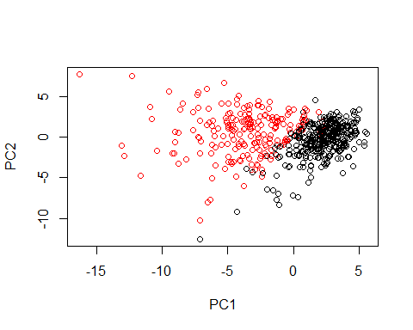

We want the $x component to make our PCA plot!

plot(wisc.pr$x[,1], wisc.pr$x[,2], col=wisc.df$diagnosis)

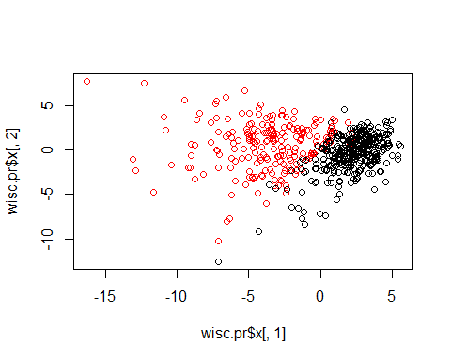

plot(wisc.pr$x[,1], wisc.pr$x[,3], col=wisc.df$diagnosis)

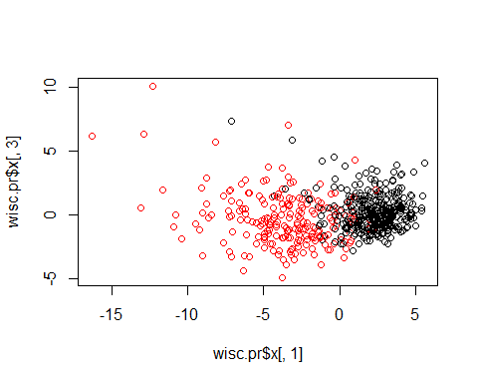

data.scaled <- scale(wisc.data)

data.dist <- dist(data.scaled)

wisc.clust <- hclust((data.dist))

wisc.pr.hc <- hclust(dist(wisc.pr$x[,1:3]),method = "ward.D2")  
plot(wisc.pr.hc)

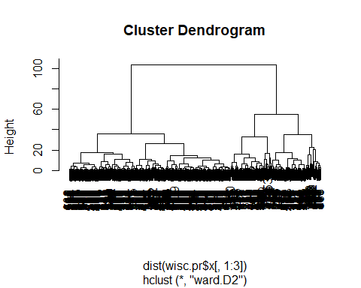

grps <- cutree(wisc.pr.hc,k=2)  
table(grps)

## grps  
## 1 2   
## 203 366

table(grps,wisc.df$diagnosis)

##   
## grps B M  
## 1 24 179  
## 2 333 33

plot(wisc.pr$x[,1],wisc.pr$x[,2],col = grps)

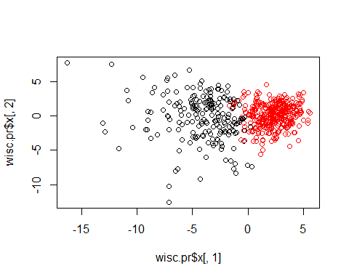

plot(wisc.clust)  
abline(h=19,col = "red" ,lty=2)

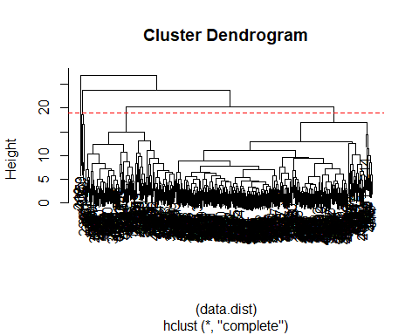

wisc.hclust.clusters

wisc.hclust.clusters <- cutree((wisc.clust),k=4)

##Section 7

new <- read.csv("new_samples.csv")  
npc <- predict(wisc.pr, newdata=new)  
npc

## PC1 PC2 PC3 PC4 PC5 PC6 PC7  
## [1,] 2.576616 -3.135913 1.3990492 -0.7631950 2.781648 -0.8150185 -0.3959098  
## [2,] -4.754928 -3.009033 -0.1660946 -0.6052952 -1.140698 -1.2189945 0.8193031  
## PC8 PC9 PC10 PC11 PC12 PC13 PC14  
## [1,] -0.2307350 0.1029569 -0.9272861 0.3411457 0.375921 0.1610764 1.187882  
## [2,] -0.3307423 0.5281896 -0.4855301 0.7173233 -1.185917 0.5893856 0.303029  
## PC15 PC16 PC17 PC18 PC19 PC20  
## [1,] 0.3216974 -0.1743616 -0.07875393 -0.11207028 -0.08802955 -0.2495216  
## [2,] 0.1299153 0.1448061 -0.40509706 0.06565549 0.25591230 -0.4289500  
## PC21 PC22 PC23 PC24 PC25 PC26  
## [1,] 0.1228233 0.09358453 0.08347651 0.1223396 0.02124121 0.078884581  
## [2,] -0.1224776 0.01732146 0.06316631 -0.2338618 -0.20755948 -0.009833238  
## PC27 PC28 PC29 PC30  
## [1,] 0.220199544 -0.02946023 -0.015620933 0.005269029  
## [2,] -0.001134152 0.09638361 0.002795349 -0.019015820

plot(wisc.pr$x[,1],wisc.pr$x[,2], col=wisc.df$diagnosis)  
points(npc[,1], npc[,2], col="blue", pch=16, cex=3)  
text(npc[,1], npc[,2], c(1,2), col="white")

