Crop Analysis Q3 2013

John Smith

May 3rd, 2014

Class 05 Graphics and plots with R This is some narative text that I can style **bold** and *italic* and add links to [webpages](https://rmarkdown.rstudio.com/articles_report_from_r_script.html)

# Section 2A: line plot  
  
weight <- read.table("bimm143_05_rstats/weight_chart.txt", header=TRUE)  
  
plot(weight[,1], weight[,2])

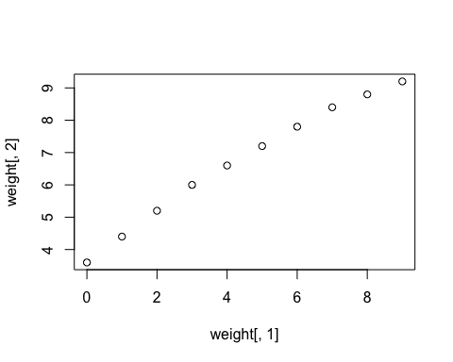

plot(weight$Age, weight$Weight, pch=15, type="o" )

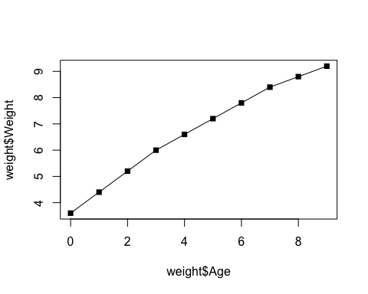

# 2B Barplot  
  
feat <- read.table("bimm143_05_rstats/feature_counts.txt", header=TRUE, sep="\t")  
  
barplot(feat$Count, names.arg = feat$Feature, las=2, horiz=TRUE)  
  
old.mar <- par()$mar  
  
par(mar=c(5, 11, 4, 2))  
barplot(feat$Count, names.arg = feat$Feature, las=2, horiz=TRUE)

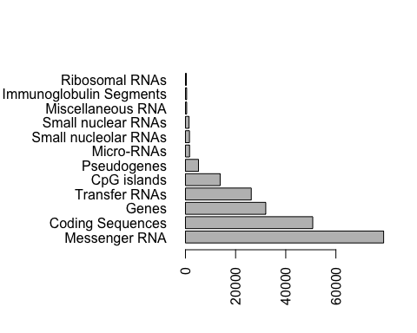

# More custom arguments  
par(mar=c(3.1, 11.1, 4.1, 2))  
barplot(feat$Count, names.arg=feat$Feature,   
 horiz=TRUE, ylab="",   
 main="Number of features in the mouse GRCm38 genome",   
 las=1, xlim=c(0,80000))

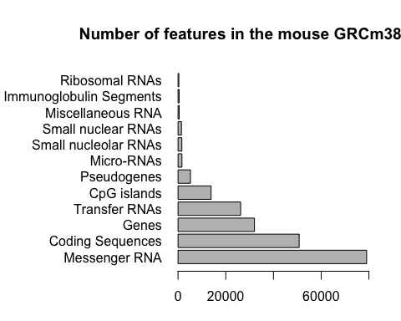

par(mar=old.mar)  
  
# Section 3  
  
mf <- read.table("bimm143_05_rstats/male_female_counts.txt", header=TRUE, sep="\t")  
  
barplot(mf$Count, names.arg = mf$Sample, las=2, col=rainbow( nrow(mf) ))

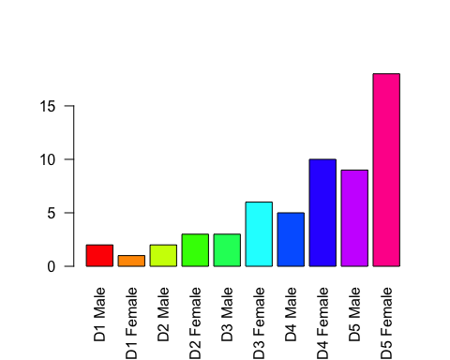

barplot(mf$Count, names.arg = mf$Sample, las=2, col=cm.colors( nrow(mf) ))

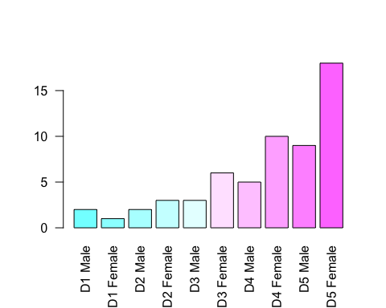

barplot(mf$Count, names.arg = mf$Sample, las=2, col=topo.colors( nrow(mf) ))

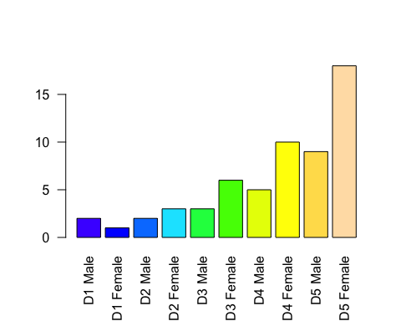

# Section 3B RNA-Seq data  
  
exp <- read.delim("bimm143_05_rstats/up_down_expression.txt")  
  
# how many genes  
nrow(exp)

## [1] 5196

table(exp$State)

##   
## down unchanging up   
## 72 4997 127

plot(exp$Condition1, exp$Condition2, col=exp$State,   
 xlab="Expression condition 1", ylab="Expression condition 2")

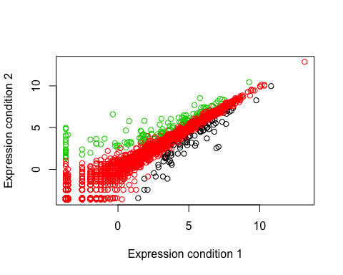

old.pal <- palette()  
palette(c("blue","gray","red"))  
plot(exp$Condition1, exp$Condition2,   
 col=exp$State, xlab="Expression condition 1", ylab="Expression condition 2")

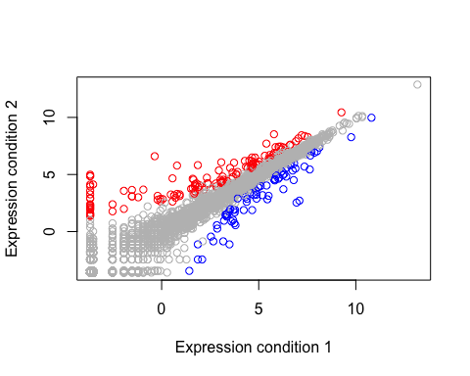

palette(old.pal)  
  
  
View(exp)