class04.R
barry
2024-10-11
# My first Rscript
x <- 1:50
plot(x)
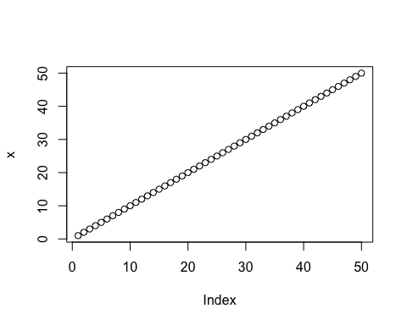
plot(x, sin(x), typ="l", col="blue")
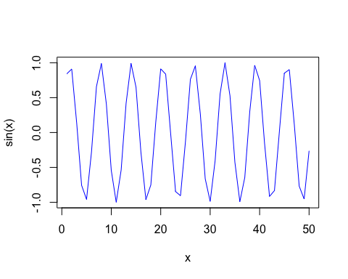
plot(x=x, y=sin(x), col="red", typ="l", lwd=3)
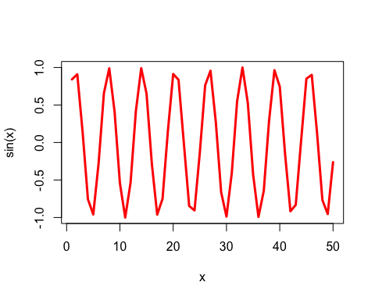
log(10, base=2)
## [1] 3.321928

