class04.R

barry

2025-01-16

x <- 1:50  
plot(x, sin(x))

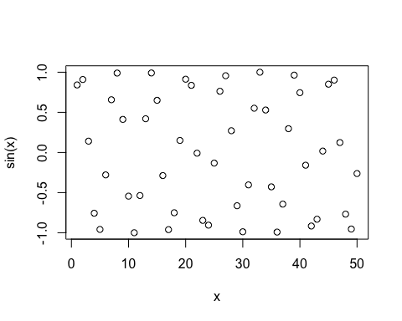

# Make this nicer  
plot(x, sin(x), col="blue", type="l", lwd=3)

