Assignment #3
BIOINF 525: Module 2

Use the data set from the TROPHY study to answer the following questions. Return the R code, the output, and a brief description of the results.

- One-sample test: Testing whether the proportion of subjects who developed hypertension (HT=1) is equal to a fixed value p₀ or not. H₀: p = p₀ vs. H_{A}: p ≠ p₀.

- Visually display the number and the proportion of subjects with HT using barplot.

- What are the number and the proportion of subjects with hypertension (HT=1)? What are the odds of hypertension (HT=1)?

- Test if the proportion of subjects with hypertension (HT=1) is different from 40%: H₀: p = .4 vs. H_{A}: p ≠ .4 using the chi-square test.

- Repeat d), but test H₀: p = .4 vs. H_{A}: p ≠ .4 separately for Candesartan group (Trt==1) and Placebo group (Trt==2). Are the results the same? Write a couple of sentences to summarize the results for Q1.

- Two-sample test: Testing whether the proportions of subjects who developed hypertension (HT=1) are equal between Candesartan and Placebo groups. H₀: p₁ = p₂ vs. H_{A}: p₁ ≠ p₂.

- Calculate the number and the % of subjects from Candesartan/Placebo group with HT=0 and HT=1.
 | Candesartan | Placebo | Total
Hypertension (No: (HT=0)
Hypertension (Yes: HT=1)
Total |  |  | 255

- Use the barplot to visually display the number and the proportion of subjects with hypertension for Candesartan and Placebo groups. Is there any visual evidence of a difference by Treatment?

- Test whether treatment with Candesartan reduces the incidence HT compared. H₀: p₁ = p₂ vs. H_{A}: p₁ ≠ p₂

- Calculate and report the Absolute Risk Reduction (ARR), Relative Risk (RR), and the OR for dveloping hypertension between subjects in the Placebo group and Candesartan group? Write a couple of sentences explaining the results in Q2.

- Use the Fisher’s exact test to replicate the main results in theTROPHY study article, using the aggregated data shown in Table 2. Note, the results in Table 2 are based on the full sample (n=772).

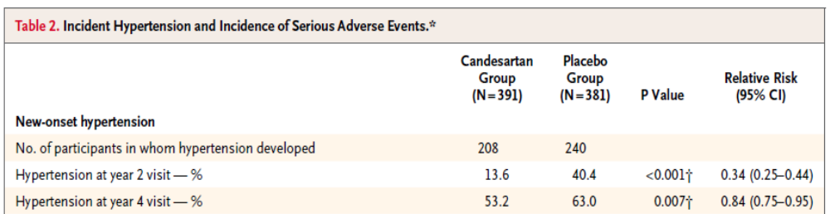
 | Candesartan | Placebo | Total
Hypertension (No: (HT=0)
Hypertension (Yes: HT=1) |  |  | 448
Total | 391 | 381 | 772

What is the p-value based on your Fisher’s Exact test? What is the OR and its 95%CI?

- Extra Credit: Logistic Regression for predicting hypertension

  - Use the logistic regression to identify what baseline covariate predicts the development of hypertension in untreated subjects (use the placebo group, Trt==2). Fit one logistic regression, by including in the model all the predictors (from the table). Populate the Table.
Table: Placebo Group
Coefficients | Estimate | p-value | OR=exp(Estimate)
Age | xx
SBP0
BMI
Cholesterol

  - Repeat the same analysis as in a), but for subjects in the candesartan group (Trt==1) Are the findings from a) and b) the same? Does it seem that the candesartan changes the effect of any of the above risks factors on predicting Hypertension? Write a couple of sentences to summarize the results for Q4.
Table: Candesartan Group
Coefficients | Estimate | p-value | OR=exp(Estimate)
Age | xx
SBP0
BMI
Cholesterol

