FINDABLE
1. Are you aware that a data(set) should be assigned a globally unique persistent and resolvable identifier when deposited with a data repository?
- The dataset has to be findable for both humans and machines and must have a persistent and resolvable identifier (PID). This data set has PMID: 39417215 which is unique in Pubmed database.
2. Are you aware that when you deposit a data(set) in a data repository, you will need to provide discovery metadata in order to make the data(set) findable, understandable and reusable to others?
- Metadata describe the information about the dataset. In GSE276609 we can see the name of the creators: Harrell JC, Olex AL, Dozmorov M, Altman J, Boyd D, Zboril E
Title: Evaluation of breast cancer PDX tumor heterogeneity at single cell resolution II
Publisher, creation and publication date: Clin Transl Med 2024 Oct;14(10):e70044. Nov 22, 2024
summary: Breast cancer is the most commonly diagnosed cancer among women. PDXs (patient-derived xenografts) are similar to cancer cell lines but differ in that they are maintained in a physiological setting as soon as they are isolated from the patient and for subsequent passages. These models are valuable for preclinical trials because PDX models have been shown to closely match their patient counterparts, both in genomic profile and response to treatment. One challenge to treatment development is tumor heterogeneity. In this study, we profiled ER+ and triple negative breast cancer PDX models using single-cell RNA-sequencing. This data may help identify populations of cells which are susceptible to certain treatments in order to improve clinical outcomes for breast cancer patients.
The unique, persistent, and resolvable identifier (PID) for the data(set): PMID: 39417215. The article also has ID numbers: PMID: 39417215, PMCID: PMC11483560, DOI: 10.1002/ctm2.70044.
Other meta data are as follow:
Assay Type: RNA-Seq, Bases, Name of the BioProject and BioSample: PRJNA1158224, SAMN43532737. Bases and bytes, cell type if they are Carboplatin Resistant, PDX or Cell Line. Center Name: VIRGINIA COMMONWEALTH UNIVERSITY, Consent is public. DATASTORE filetype: gs,ncbi,s3, DATASTORE provider: fastq,run.zq,sra, DATASTORE region: gs.us-east1,ncbi.public,s3.us-east-1, Experiment: SRX26012154, Instrument: Illumina HiSeq 4000, Library Name: GSM8503006, LibraryLayout: PAIRED, Organism, ReleaseDate, create_date, version, Library Name, LibraryLayout, Organism.
relevant organizations: Virginia Commonwealth University
variable(s) measured or observed, method, data format and size:
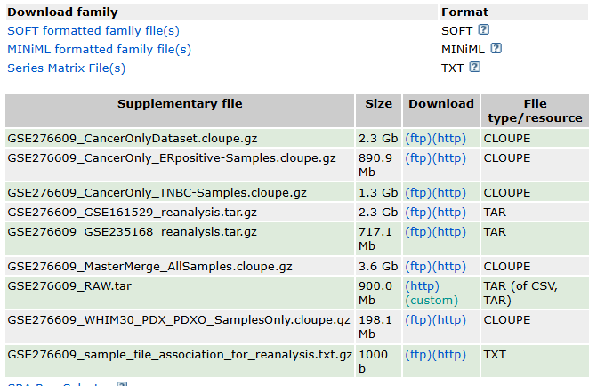
3- Are you aware that the data repository providing access to your data(set) should make the metadata describing your data(set) available in a format readable by machines as well as humans?
- This data follows the readability by machine and it is HTTP-based Representational State Transfer.
ACCESSIBLE
4. Are you aware that access to your data(set) may need to be controlled and that metadata should include license information under which the data(set) can be reused?
- Ideally, data(sets) should be public domain and openly accessible without restrictions. This dataset is available openly through GEO website. Raw data of this data set are available in SRA. And in metadata table they mentioned all data are publicly available.
5. Are you aware that metadata should remain available over time, even if the data(set) is no longer accessible?
- We have to check whether data(set) has the policy to maintain metadata when data are removed. Therefore, including the PID in remaining metadata and providing a reason for unavailability of the data(set) will be useful to keep our data set accessible.
INTEROPERABLE
6. Are you aware that the metadata describing your data(set) should use controlled vocabularies?
- Controlled vocabulary in metadata is a unique way to describe the information in our dataset. this can prevent vagueness and increase findability, interoperability, and machine-readability. For example: FASTQ Sequence and Sequence Quality Format(fastq), or Patient Derived Xenograft (PDX), or NCBI Reference Sequence Database Identifier (RefSeq ID)
REUSABLE
7. Are you aware that provenance information about the collection and/or generation of data should be included in the metadata?
Data provenance in metadata shows the history of dataset, information about the people, entities, and processes involved in the data creation. In GSE276609 series’ metadata it is mentioned how they got the cell lines (The American Type Culture Collection (ATCC) or the PDX (Washington University in St. Louis, Huntsman Cancer Institute, Baylor College of Medicine, University of Colorado Anschutz Medical Campus). Instrument and methodology also mentioned (illumina hiseq, nextseq 2000 and ILLUMINA).
8. Are you aware that metadata describing your data(set) should follow the specifications of a community-endorsed standard?
- Community-endorsed standard. is any structured unit and format that is used in a specific community. It is used to make a clear language. It is easier to interpret and reuse data that aligns with same language (format). In GSE276609 series, for example SOFT format is a plain text format that can be easily accessed programmatically and used in data analysis tools or spreadsheets. MiniML is an XML-based data format for gene expression data in GEO. All files are in . GZ format(Gzip) to compress a single file, reducing its size for efficient storage and transfer. Repository is BioSample. Data is in BioProject dataset and raw sequencing data are stored in Sequence Read Archive (SRA).
9. Are you aware that your data(set) should be deposited preferably in a file format that is open and supported by the data repository for long-term preservation?
File formats is methods for encoding digital information and is recognizable by the extension. A file can either be open or proprietary in its format. Repositories’ file formats generally have a couple of different options per data type which are available in their website. In GSE276609, metadata are available in CSV format which is accessible. In addition, the whole data is in both http and txt form.
10. Are you aware that keeping your data(set) FAIR over time requires professional data curation and digital preservation?
To ensure that the dataset is well preserved and accessible, we have to deposit it in a Trusted Digital Repository (TDR) such as Github or BioSample which provide long-term access and preservation of data. GSE276609 is stored in BioSample. In addition, this data is processed and made FAIR by a professional bioinformaticien in Wright Center for Clinical and Translational Research Bioinformatics Core (Dr Amy Olex).

