# GeOMe Help Document

GeOMe Help Document 1

Introduction 1

Generate Template 1

Validate and Load Data 2

Photo Upload 3

Photo upload option 1: Upload metadata that references images that are already online. 3

Photo upload option 2: Upload photos from your hard-drive. 3

Deleting Photos 3

FASTA Upload 4

FASTQ Upload 5

Project Overview 6

Query 7

Accession Numbers and Sample Identifiers 7

Physical Sample Identifiers 7

Expedition Identifiers 7

Sequence Identifiers 7

Instructions for loading your data to the NCBI Short Read Archive (SRA) 8

# Introduction

The Genomic Observatories Meta-Database (GeOMe) is a web-based database which captures metadata on biological samples, used for biodiversity inventories, population studies, and environmental metagenomics. GeOMe assigns persistent identifiers for collecting events, samples, and tissues and specifies the set of metadata attributes which satisfy the requirements of the [genomic observatories model](https://gigascience.biomedcentral.com/articles/10.1186/2047-217X-3-2), including capturing the who, what, where, and when associated with all samples. GeOMe provides instant feedback to users on the quality of their data and packages data for further analysis for use in a laboratory information system (LIMS) using the [Biocode LIMS plugin](http://software.mooreabiocode.org/). GeOMe also packages submissions for easy delivery to the Sequence Read Archive (SRA) and Genbank's Nucleotide database.

# Create a Project

GEOME lets users creates projects from scratch (letting the user define their own rules) or creating project as part of a “Team”. If you choose to create a project as part of a team, you accept a pre-set list of attributes and controlled vocabularies that are controlled by the Team. If you create a project from scratch, you select your own attributes and can set your own vocabularies. The Create Project wizard is available under the user icon in the upper right corner of the screen. Note that various GEOME options are only accessible to you if you choose the associated module during project creation. If you create a project from scratch you can edit project configuration options after you create your project, under “Project Configuration”. If you are part of a team, only the team administrator has this option.

# Generate Template

Generate a template (see Workbench -> "Generate Template") to create spreadsheet templates for your metadata. Fields in the template generator that are checked and greyed out are mandatory fields. Fields that are checked and in blue are recommended fields. Check all fields that you wish to include in your sheets that you download. Spreadsheets can be downloaded as a workbook (containing all available sheets), or as individual sheets.

The following options are available for downloading metadata template sheets:

* **Workbook**: Selecting this option will create a single workbook containing all available sheets (described below) for project. See descriptions of the following sheets for more information about each sheet.
* **Events**: eventID, principalInvestigator, and yearCollected are required fields. Also, either decimalLatitude and decimalLongitude or Locality is required.
* **Samples**: specimenID eventID are required fields. In many cases, multiple samples are collected at the same location. You will create an event in the Events sheet with a unique identifier (e.g. "Event1") and then insert the eventID into the Samples sheet.
* **Tissues**: tissueID and specimenID are required fields. If you do not have distinct tissues for each sample, you can just name the tissueID field the same as the specimenID field. If there is more than one tissue per sample, you will need to name each tissue with a unique identifier. For example, specimenID = "sample1" with two tissues could have tissueIDs of "sample1.1" and "sample1.2".
* **sample_photos\***: This is a worksheet that relates samples to photos of samples
* **event_photos\***: This is a worksheet that relates events to photos of events

* sample_photos and event_photos do not appear in all projects.

# Validate and Load Data

You can load data into the system using the Loading interface (see Workbench -> "Load Data") . If you do not have an account and a project is public, you may validate your data to make sure it passes all required checks. If you have an account you will be able to load your data for each project, assuming that it passes all validation checks. For information about acquring an account, please send an email with you name, title and affiliation to [geome.database@gmail.com](mailto:geome.database@gmail.com)

In addition to loading the metadata sheets described in the "Create Template" section above, you may also upload FASTA sequences and FASTQ metadata for projects that are configured to accept sequence data (Note: we are currently not accepting microsatellite datasets).

## Photo Upload

There are two primary methods for uploading photos to GEOME:

### Photo upload option 1: Upload metadata that references images that are already online.

This option is used when your photos are already accessible online. You simply need to load a CSV file telling GEOME where these photos are located along with relevant metadata. Goto *Workbench->Load Data* and select the *sample_photos_csv* or the *event_photos_csv* option.

1. You can upload photos on a project by project basis
2. If your photos span multiple expeditions, select “multiple expeditions” in the expedition code option and specify the expeditionCode in the upload file.
3. Fields to include in the CSV file:
   * photoID (May be required. A good idea to specify this so you can update photos using the ID later.).
   * originalUrl (required. URL location of photo that GEOME will obtain)
   * expeditionCode (required if photos span multiple expeditions)
   * other fields (see photo fields under *"Generate Template"*)

### Photo upload option 2: Upload photos from your hard-drive.

The GEOME bulk image loader accepts a directory of images zipped into a single file. The max file size is 2GB. If you need to upload more than that, split the upload into multiple uploads. When uploading images, you have the following options:

1. **File name option**: Name each file according to the following template. Each file will then be parsed and attached to the appropriate record:
   * {parentIdentifier}+{imgIdentifier}.{ext}
2. **Metadata option**: Include a *metadata.csv* with the following fields:
   * materialSampleID OR eventID (required - the identifier of the record to attach the photo to. Use either materialSampleID or eventID to denote the parentIdentifier)
   * fileName (required -the name of the file in the directory)
   * expeditionCode (required if photos span multiple expeditions)
   * other fields (see photo fields under *"Generate Template"*)

Once you upload it may take several minutes to an hour or more for all photos to appear.

### Deleting Photos

If you want to remove or “scrub” photos from an expedition you will need to follow this method:

1. Download excel workbook with all expedition data
2. Goto the sample_photos tab
3. Remove the lines of all photos you want to remove. IMPORTANT NOTE!: If you intend to remove every photo leave one line (note down this photo name so it can be removed later)
4. Re-load this workbook, making sure that “replace expedition data” is checked
5. Upload new photos
6. If you are attempting to remove all photos, repeat steps 1-4, this time only removing the single row that was left in step 3

## FASTA Upload

You must create, or select a pre-existing expedition name for your dataset before continuing. Select your FIMS Metadata file, along with a FASTA filename and a Marker name. After selecting the FIMS Metadata file, you must check a box stating that you have visually verified the sample locations on the map at the bottom of the page. The name of your FASTA sequences must match the sample identifiers in the metadata file. Each FASTA file should only include data from a single marker type. If you have multiple markers for the same taxa you must upload multiple FASTA files for a single metadata file, which can be added by clicking on the “+” button.

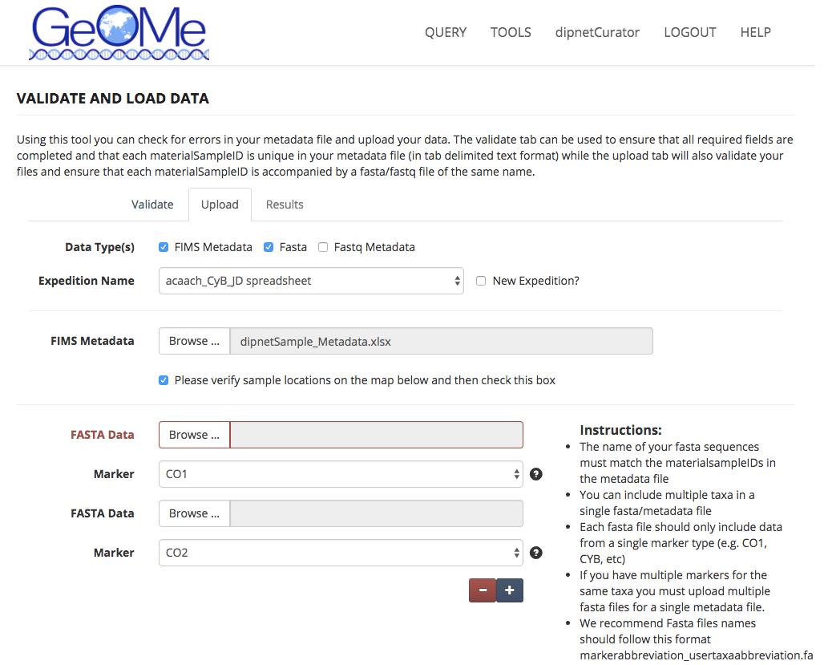

## FASTQ Upload

***NOTE About Tissues and FASTQ Metadata****: GEOME connects FASTQ metadata to Tissues and not directly to Samples. For this reason, you must have tissue metadata present in order to connect to FASTQ files. The presence of any tissue metadata field will automatically generate a Tissue Identifier and if the Tissue Identifier is not explicitly set it will add a .1, .2, etc… after the material sample to create a Tissue Identifier. If you do not store tissue information with your sample metadata and wish to still upload FASTQ metadata, goto the “Project Configuration” option on the left-side menu, click on the Edit Symbol for Tissues and check the box that says “Generate Empty Tissues?”. This will generate an empty tissue on upload that will enable you to link your Samples to FASTQ metadata.*

***NOTE About FASTQ Filename Format:*** *The with FASTQ filenames needs to be in ASCII text format… the system will throw an error if it is Unicode. This is a current bug that needs to be fixed. If you get an error when uploading your FASTQ filenames, then see* [*https://github.com/biocodellc/geome-db/issues/41*](https://github.com/biocodellc/geome-db/issues/41) *for tips on seeing your file format and converting to ASCII.*

The FASTQ Upload example follows the same protocols as the FASTA upload example. The following points should be followed when uploading FASTQ data:

* FIMS will accept single and paired end read data
* Each FASTQ file should contain reads from a single individual
* Names of fastq files must match the tissueIDs in the metadata file up to the first dash (e.g., sample1-anythingelse.fq.gz)
* Paired-end files must have a either 1||2 OR F||R immediately preceeding the *.fastq.gz or *.fq.gz (e.g. sample1-F.fastq.gz, sample1-R.fastq.gz)
* The actual fastq sequence files will not be uploaded here and stored on the FIMS system. Instead the metadata file will be uploaded and stored here.
* For validation purposes a text file of the fastq file names (one name per line and including the file extension) will be uploaded here. If you are uploading PE data there should be two file names per sample. This process ensures that required fields are complete, that each materialsampleID is unique, and that the materialsampleIDs match the fastq file names.
* Once uploading is complete the FIMS system will produce two files (SRA metadata and BioSample attributes files) that will ease the upload process to NCBI’s Short Read Archive (SRA). When these files are downloaded a set of simple instructions are included that will speed your SRA submission.

Once you have validated and uploaded FASTQ file, a screen is presented that shows you two buttons and your validation results. One button enables you to download pre-generated Genbank submission files. The second button is available which opens a browser window taking you to Genbank’s SRA Portal.

GeOMe accepts FASTQ submissions because we want to archive unmanipulated sequence data that are free of filtering biases. By doing this we are reducing ascertainment bias (a site that is not a SNP in your dataset may be a SNP when combined with data from a different population). We are also avoiding the subjective choices that go into calling SNPs, such as thresholds for trimming, filtering, coverage and likelihood. Our objective is for future users of your data to be able to make these choices in the context of their own question and dataset.

# Project Overview

The “Project Overview” option shows all available uploaded expeditions that are part of GeOMe. This pages shows you the number of samples, FASTA sequences, and FASTQ metadata provided for each sample. Here you have the option of downloading CSV, FASTA, or FASTQ formatted metadata.

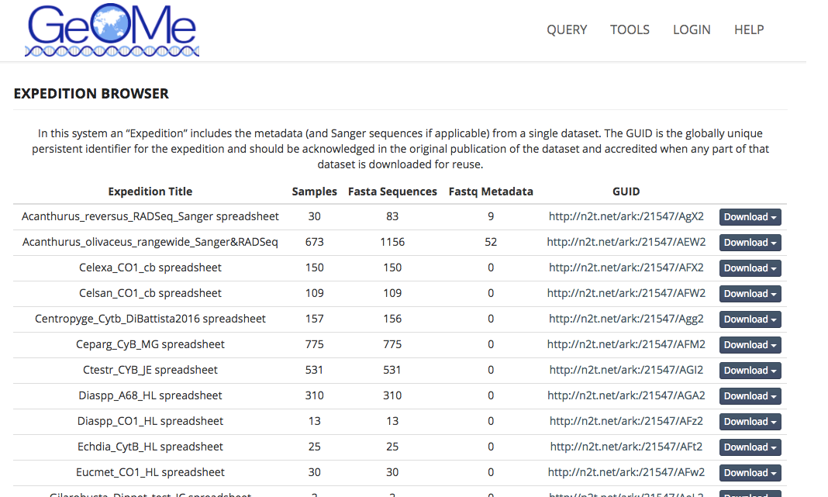

# Query

The GeOMe query interface enables users to filter on geographic information, any word string as part of the metadata (e.g. “Moorea”), Darwin core terms, expedition names, or any other column that is part of the GeOMe specification. The Query interface returns results either in map form or table form, selectable by clicking on the “Map” or “Table” buttons on the upper right corner of the interface. The “Download” link enables metadata download of the queried results.

# Accession Numbers and Sample Identifiers

When you submit your work for publication you may be asked for Genbank accession numbers, dataset identifiers, or even sample identifiers. GeOMe creates identifiers for both individual physical samples and expeditions, as well as automatically syncing sequence read archive SRA numbers. The following information describes how to handle these identifiers.

## Physical Sample Identifiers

You can obtain the globally unique form of the materialSampleID in the "GUID" column at the when viewing metadata which has been successfully validated and loaded. When viewing the GUID, it will appear like this:

|  |
| --- |
| ark:/21547/Apj2Acaoli_262 |

If you want the GUID to be resolvable, then prepend name-to-thing resolution target:

<https://n2t.net/ark:/21547/Apj2Acaoli_262>

## Expedition Identifiers

You can find expedition identifiers (sometimes referred to as “dataset” identifiers) by going to "Project Overview" in the workbench and you'll see a column called "GUID" that if you click on will bring you to information about your expedition. An example of an expedition Identifier looks like:

<https://n2t.net/ark:/21547/Apc2>

## Sequence Identifiers

For nextgen sequences that have followed the GeOMe path described in this document you can enter the resolvable GUID for the materialSample and find links to the BioProject and BioSample identifier, e.g. check out the following record:

<http://n2t.net/ark:/21547/le2Acaoli_CAS44>

GeOMe currently doesn’t link Genbank Accession identifiers for FASTA data submissions, so these will need to be researched independently.

# Instructions for load your data to the NCBI Short Read Archive (SRA)

After submitting your metadata to DIPnet two files will be produced the bioSample-attributes.tsv and the sra- metadata.tsv files and you will be directed to SRA to upload your data. There are several steps but the creation of those two files will streamline the process significantly!

If you don’t already have a NCBI account you will need to create one. If you do have an account then sign in using the tab at the top right corner of page.

After you sign in start a new submission

**Step 1**: Submitter

Enter your personal information

**Step 2**: General Info

You will be asked two important questions here:

1. Did you already register a BioProject for this data set?
2. Did you already register BioSamples for this data set?

In the majority of cases the answer to both questions will be NO

The following instructions are based on the user answering “NO” to both of the above questions.

**Step 3**: Project Info

Fill in project information. For example:

Project Title: Acanthurus_reversus_RADSeq_data

Project Description: RADSeq data for the reef fish Acanthurus reversus Relevance: Evolution

Is your project part of a larger initiative that is already registered with NCBI?

Most likely No

External links: Add if relevant

Select your grants: If relevant

**Step 4**: Biosample type

Here you choose your sample type. Most DIPnet members will check either “Invertebrates” OR “Model organism or animal sample” for vertebrates.

**Step 5**: Biosample attributes

Upload the bioSample-attributes file (.tsv) produced by GeOMe. You may see additional warnings or error messages produced by the SRA validator. You must fix error messages. In some cases, you may safely ignore warnings. For example, we have seen cases for users working in marine system where locality is often based on nearby terrestrial locations, and the SRA responds with a warning that the locality is invalid since it is located in the warning. This particular message may be ignored for marine users where this is intentional.

**Step 6**: SRA metadata

Check the Upload a file option and ppload the sra-metadata file (.tsv) produced by GeOMe

**Step 7**: Files

Follow the directions on SRA and upload your files. You will be asked to download the latest version of Aspera Connect. This will speed upload tremendously. Once Aspera is installed go directly to the Choose Files option, choose your zipped folder, and Aspera will automatically open.

**Step 8**: Submit!