# GeOMe Help Document

GeOMe Help Document 1

Introduction 1

Generate Template 1

Validate and Load Data 2

FASTA Upload Example 3

FASTQ Upload Example 3

GeOMe R Package 5

Browse Expeditions 5

Query 5

## Introduction

The Genomic Observatories Meta-Database (GeOMe) is a web-based database which captures metadata on biological samples, used for biodiversity inventories, population studies, and environmental metagenomics. GeOMe assigns persistent identifiers for all samples and sampling events and specifies the set of metadata attributes which satisfy the requirements of the [genomic observatories model](https://gigascience.biomedcentral.com/articles/10.1186/2047-217X-3-2), including capturing the who, what, where, and when associated with all samples. GeOMe provides instant feedback to users on the quality of their data and packages data for further analysis for use in a laboratory information system (LIMS) using the [Biocode LIMS plugin](http://software.mooreabiocode.org/). GeOMe also packages submissions for easy delivery to the Sequence Read Archive (SRA) and Genbank's Nucleotide database.

## Generate Template

Sample metadata is recorded on an Excel Spreadsheet and you can create and customize your own templates under “Tools -> Generate Template”

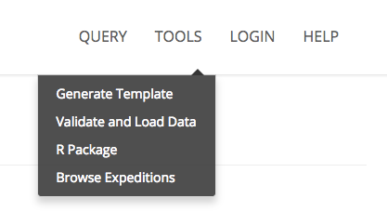

On the Generate Template page, you can select columns that you want to include on your spreadsheet. Click on the “DEF” link beside each column name to view the definition of the column name. Columns that are pre-checked and shown in grey, indicate that they are mandatory fields and not able to be un-checked. Columns that are pre-checked and shown in blue indicate they are suggested and can be un-checked. Once you have checked the columns you wish to include in your spreadsheet, press the “Export Excel” button to download an Excel Spreadsheet which you can then use to fill in Sample Metadata.

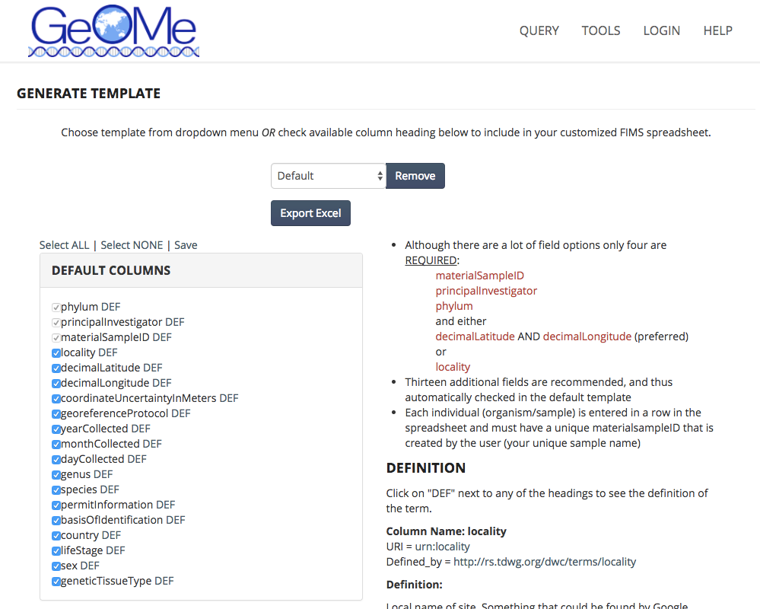

## Validate and Load Data

The Validate and Load Data option can be found under “Tools -> Validate and Load Data”. The first step is validating your sample metadata. Use the Browse button to browse for your file and select the “Validate” button. After data validation, you can Upload your dataset and include just the metadata or include FASTA or FASTQ metadata.

### FASTA Upload Example

You must create, or select a pre-existing expedition name for your dataset before continuing. Select your FIMS Metadata file, along with a FASTA filename and a Marker name. After selecting the FIMS Metadata file, you must check a box stating that you have visually verified the sample locations on the map at the bottom of the page. The name of your FASTA sequences must match the sample identifiers in the metadata file. Each FASTA file should only include data from a single marker type. If you have multiple markers for the same taxa you must upload multiple FASTA files for a single metadata file, which can be added by clicking on the “+” button.

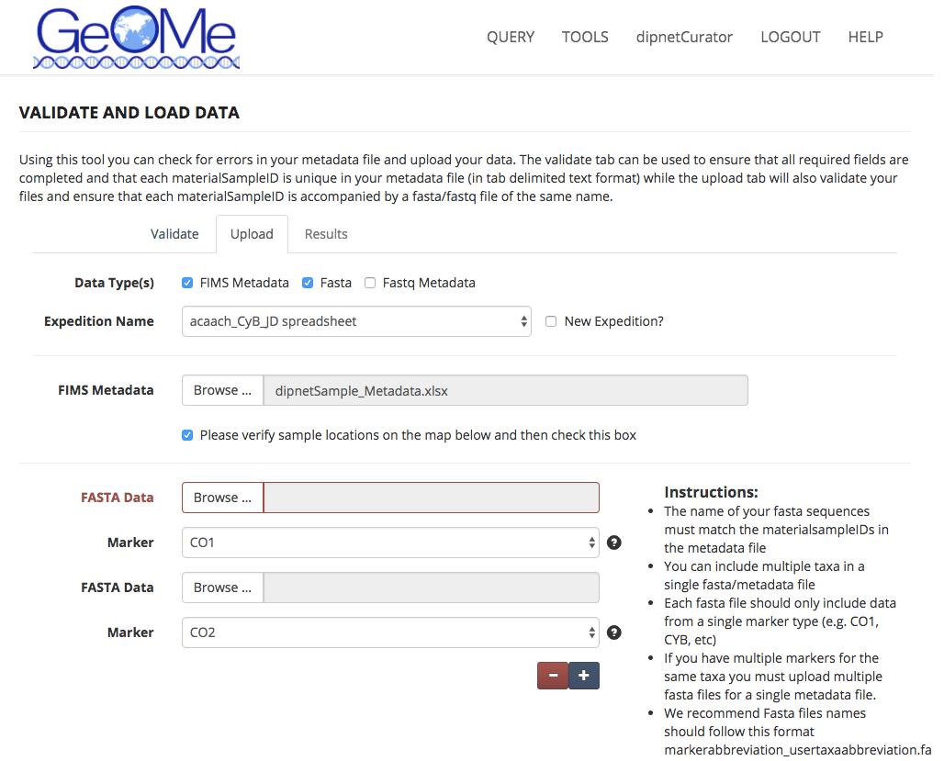

### FASTQ Upload Example

The FASTQ Upload example follows the same protocols as the FASTA upload example. The following points should be followed when uploading FASTQ data:

* FIMS will accept single and paired end read data
* Each FASTQ file should contain reads from a single individual
* Names of fastq files must match the materialsampleIDs in the metadata file up to the file extension (e.g., R1.fq.gz, .1.fq, etc)
* The actual fastq sequence files will not be uploaded here and stored on the FIMS system. Instead the metadata file will be uploaded and stored here.
* For validation purposes a text file of the fastq file names (one name per line and including the file extension) will be uploaded here. If you are uploading PE data there should be two file names per sample. This process ensures that required fields are complete, that each materialsampleID is unique, and that the materialsampleIDs match the fastq file names.
* Once uploading is complete the FIMS system will produce two files (SRA metadata and BioSample attributes files) that will ease the upload process to NCBI’s Short Read Archive (SRA). When these files are downloaded a set of simple instructions are included that will speed your SRA submission.

Once you have validated and uploaded FASTQ file, a screen is presented that shows you two buttons and your validation results. One button enables you to download pre-generated Genbank submission files. The second button is available which opens a browser window taking you to Genbank’s SRA Portal.

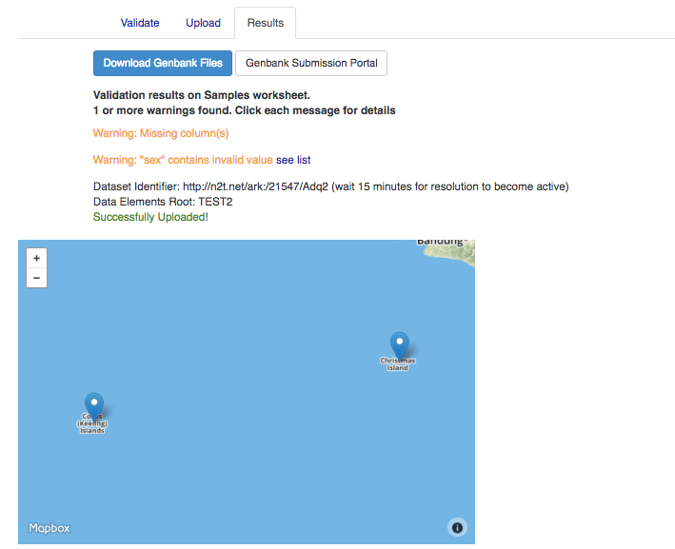

## GeOMe R Package

A link is available under the tools menu which takes you to the GeOMe R package github page, located at <https://github.com/DIPnet/fimsR-access>. More instructions are available at that link.

## Browse Expeditions

The “Browse Expeditions” option shows all available uploaded expeditions that are part of GeOMe. This pages shows you the number of samples, FASTA sequences, and FASTQ metadata provided for each sample. Here you have the option of downloading CSV, FASTA, or FASTQ formatted metadata.

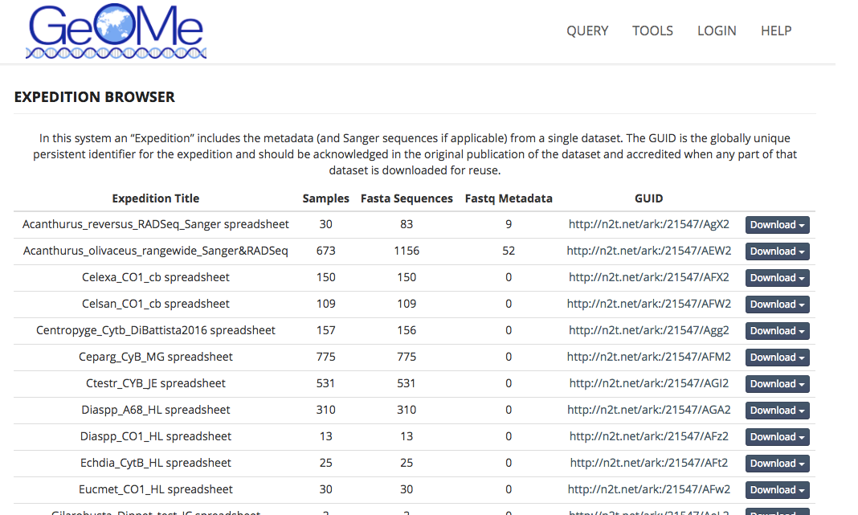

## Query

The GeOMe query interface enables users to filter on geographic information, any word string as part of the metadata (e.g. “Moorea”), Darwin core terms, expedition names, or any other column that is part of the GeOMe specification. The Query interface returns results either in map form or table form, selectable by clicking on the “Map” or “Table” buttons on the upper right corner of the interface. The “Download” link enables metadata download of the queried results.