Model fit results 2018/12/11

 | Period 1 |  |  | Period 2 |  |  | Period 3 |  |  | Units
 | R² | RMSE | RMSE/SD | R² | RMSE | RMSE/SD | R² | RMSE | RMSE/SD
Ice Break | 0.92 | 1.35 | 0.21 | 0.81 | 3.21 | 0.41 | 0.68 | 5.92 | 0.55 | d
Ice Freeze | 0.76 | 1.05 | 0.40 | 0.14 | 4.93 | 0.86 | 0.49 | 5.65 | 0.69 | d
Temp 1 m | 0.94 | 1.75 | 0.24 | 0.94 | 1.37 | 0.25 | 0.88 | 2.03 | 0.34 | °C
Temp 4 m | 0.78 | 1.28 | 0.46 | 0.44 | 1.78 | 0.74 | 0.57 | 1.62 | 0.65 | °C
Temp 9 m | 0.39 | 0.31 | 0.77 | 0.23 | 0.33 | 0.87 | 0.21 | 0.58 | 0.89 | °C
PP | 0.00 | 20.63 | 0.99 | 0.01 | 21.76 | 0.99 | 0.00 | 10.49 | 1.00 | μg L⁻¹
TDP | 0.00 | 4.91 | 0.99 | 0.00 | 3.62 | 0.99 | 0.00 | 3.69 | 1.00 | μg L⁻¹
O2 4 m | 0.02 | 3.56 | 0.97 | 0.00 | 4.59 | 0.99 | 0.00 | 4.67 | 0.99 | mg L⁻¹
DOC | 0.00 | 2.88 | 0.99 | 0.00 | 5.11 | 1.00 | 0.16 | 1.62 | 0.91 | mg L⁻¹

Cumulative PP  Modeled/Observed | Mean | Median | SD | Minimum | Maximum
Period 1 | 0.91 | 1.07 | 0.28 | 0.60 | 1.20
Period 2 | 0.76 | 0.80 | 0.28 | 0.35 | 1.16
Period 3 | 1.12 | 1.15 | 0.21 | 0.69 | 1.53

PP residuals (mean +- SD)
Period 1 1.87 +- 21.61
Period 2 11.06 +- 22.05
Period 3 -3.31 +- 12.49

Parameter | Period 1 | Period 2 | Period 3
PAR_sat | 2.38e-4 | 2.84e-4 | 2.46 e-4
w_chl | 0.0978 | 0.0934 | 0.0785
m_twty | 0.0104 | 0.01 | 0.01
g_twty | 0.614 | 0.612 | 0.656
P_half | 3.42 | 0.233 | 0.483

Under no fertilization scenario, the maximum instantaneous PP concentration is modeled to be 2.54 +- 2.23 ug/L. Under the fertilization scenario, the maximum instantaneous PP concentration is modeled to be 39.78 +- 6.90 ug/L.
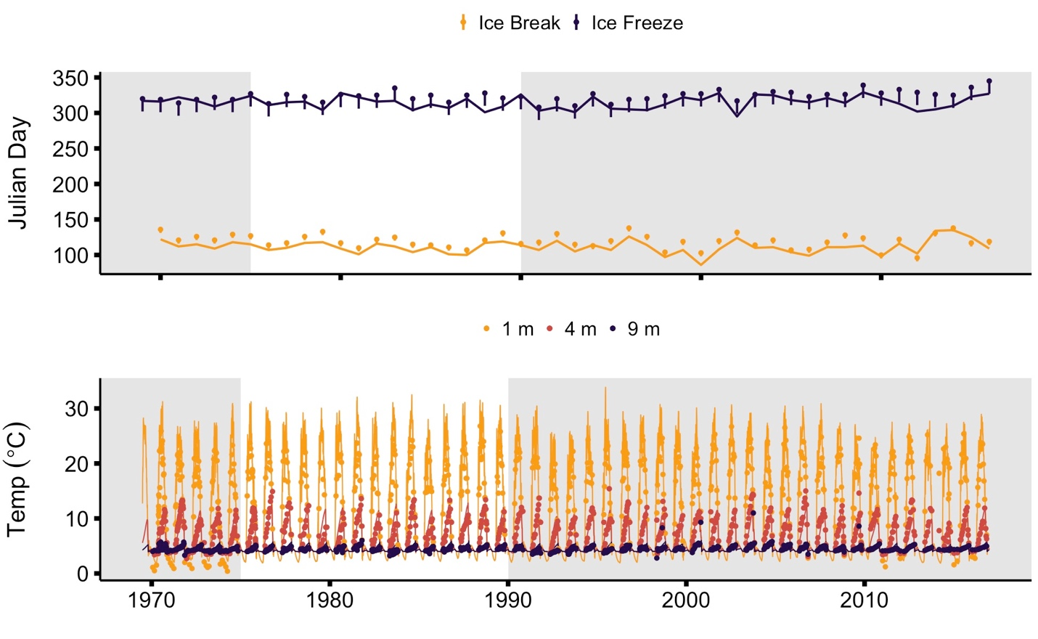
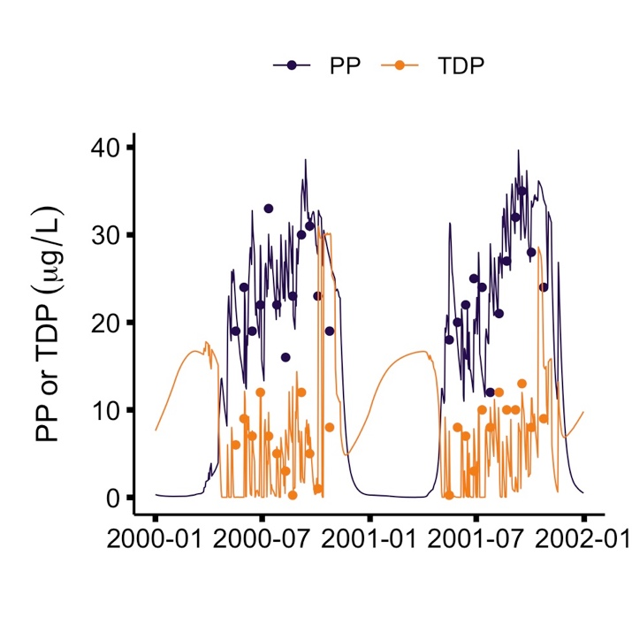
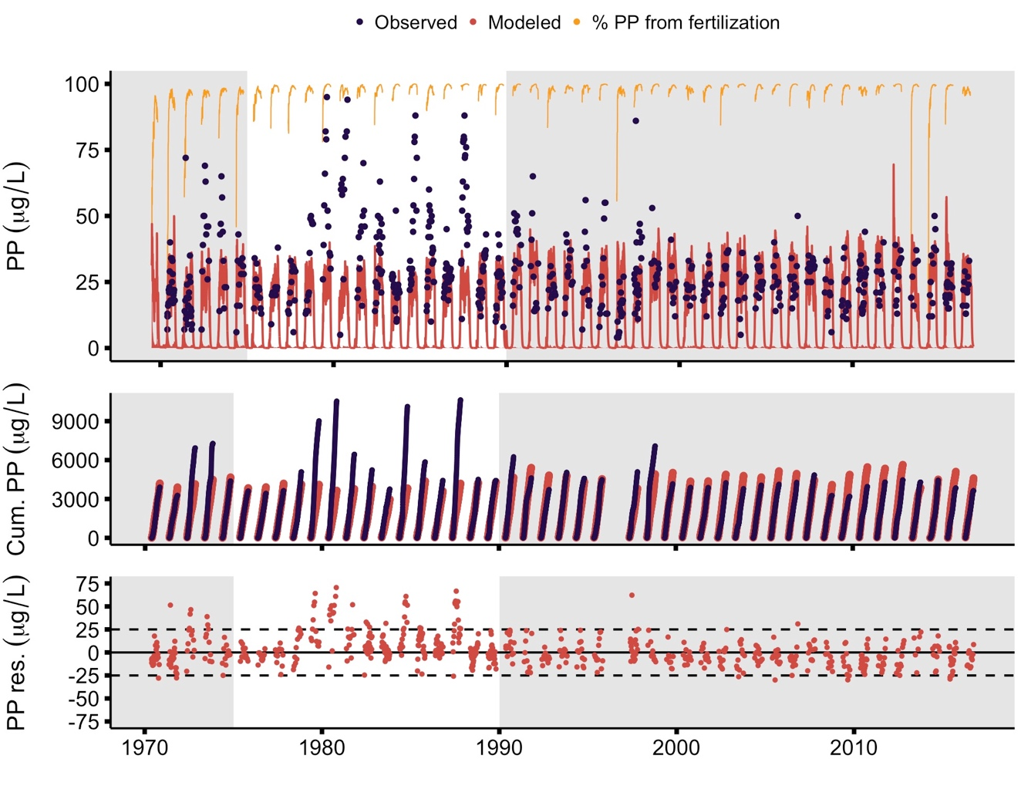
Temp 1m | High N:P | 0.396 | 0.301
Temp 1m | Low N:P | 0.510 | 0.676
Temp 1m | P only | 0.319 | 0.577
Temp 4m | High N:P | -0.011 | -0.150
Temp 4m | Low N:P | 0.044 | -0.152
Temp 4m | P only | -0.186 | -0.244
Temp 9m | High N:P | 0.200 | 0.114
Temp 9m | Low N:P | 0.817 | 0.171
Temp 9m | P only | 0.138 | -0.150
DO 4m | High N:P | -0.406 | -0.654
DO 4m | Low N:P | 0.239 | -2.160
DO 4m | P only | -0.036 | -1.887
TDP | High N:P | 0.344 | 22.116
TDP | Low N:P | -0.969 | 8.692
TDP | P only | -0.355 | 6.464
PP | High N:P | -0.090 | -15.376
PP | Low N:P | -0.502 | -15.891
PP | P only | 0.369 | -3.570

