ISoLDE: a data-driven statistical method for the inference of allelic imbalance in datasets with reciprocal crosses
Christelle Reynès^{1,2,∗}, Guilhem Kister², Marine Rohmer³, Tristan Bouschet¹, Annie Varrault¹, Emeric Dubois³, Stéphanie Rialle³, Laurent Journot^{1,3}, and Robert Sabatier^{1,2,∗}
¹ Institut de Génomique Fonctionnelle, IGF, Univ Montpellier, CNRS, INSERM, Montpellier, France.
² Faculté de Pharmacie, Univ Montpellier, Montpellier, France.
³ Montpellier GenomiX, MGX, Univ Montpellier, CNRS, INSERM, Montpellier, France.

- Supplementary methods

In this section, we provide further details with respect to the ISoLDE method, the generation of simulated data, the sequence mapping methods, and the method to identify the set of searchable, mouse strain-specific genes for AI studies.

  - Details on the resampling-based ISoLDE method

The definition of the S_{g} statistic is given in the manuscript. Two different statistical tests, Q1 and Q2, were performed; Q1 was testing whether a given gene was allelically imbalanced, and Q2 was testing whether it was bi-allelically expressed. A randomization approach was used to infer S_{g} exact distribution for each test Q1 and Q2.
For the sake of simplicity, let us consider an experiment with four replicates in each reciprocal cross, i.e. 8 samples and 16 measurements (2 crosses × 4 replicates × 2 parental origins). Then, the data for a typical gene looked like:
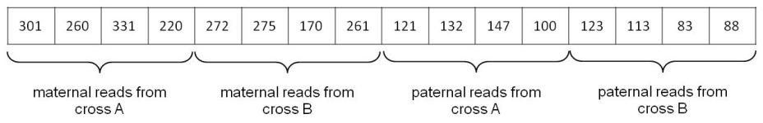
To perform resampling, reads from the same biological replicate were summed before a new label, maternal or paternal, was given to each read. The summed reads from our typical gene are as follows:
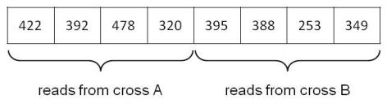

    - Resampling for the Q1 test

For Q1, ISoLDE generated the distribution of S_{g} under the null hypothesis, i.e. bi-allelic expression. In a classical parametric approach, the reads of each biological replicate would be assigned a parental origin according to a Binomial distribution with probability parameter equal to 0.5. Due to both biological and technical biases, experimental data are far from the Binomial distribution. In ISoLDE, the true distribution is directly learned on the dataset working on observed differences between biological replicates within each reciprocal cross. Then, each read of each biological replicate is independently relabeled paternal or maternal according to this distribution. As relabeling is independently performed on each biological replicate, with different proportions of reads from maternal origin, the global distribution of reads between paternal and maternal cannot be considered as a binomial one.
By applying this method to our example, one possible result is:
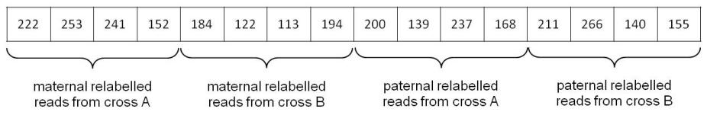

Once a resampled vector of reads is obtained, the S_{g} statistic is computed. In the previous example, the total number of maternal relabeled reads from cross A is 868 and the total number of reads in cross A (unchanged through resampling) is 1612, hence according to the main manuscript definition, π_{M,1} = 868/1612 = 0.5385. In the same way, π_{P,2} = 772/1385 = 0.5574. The median of maternal reads over both crosses is computed. The vector of maternal reads is {222, 253, 241, 152, 184, 122, 113, 194}, its median is 189, and its MAD is 44.5. The median of paternal reads is 184 and the corresponding MAD is 36.5. By applying the S_{g} statistic formula, we obtain:
$$S_{g}=\frac{0.5385-0.5574}{\sqrt{\frac{44.5}{189}+\frac{36.5}{184}}}$$
This process is repeated 10,000 times in order to obtain an empirical distribution of S_{g} for this gene under the bi-allelic assumption.
Finally, empirical p-values are estimated by combining the true value of the statistic for this gene and its estimated distribution under bi-allelic assumption. This is performed by following the method described in Dudoit & van der Laan (Dudoit and van der Laan, 2008) to obtain the null distribution of null shift and scale-transformed test statistics. The obtained p-value allows to call a gene parentally biased or not. A gene not called parentally biased should be called bi-allelically expressed or undetermined. To make a decision between these 2 calls a symmetrical test Q2 is performed.

    - Resampling for the Q2 test

For Q2, ISoLDE generated the distribution of S_{g} under the null hypothesis, i.e. parentally biased. The only difference in this situation with regards to the previous one is the choice of the bias target value for reads relabeling. As explained in the manuscript, a global bias proportion is uniformly chosen between 0.6 and 1. The minimum bias value of 0.6 has been chosen as it is the lowest threshold considered a significant bias so far. As a bias value has been chosen for all biological replicates, a bias noise is independently added to each biological replicated using the same distribution as the one used in the bi-allelic situation. Indeed, the distribution learned in this previous situation can be viewed as the distribution of the deviation to the target value of 0.5, hence it can be applied to any target value chosen between 0.6 and 1. Once the final bias value is chosen for each biological replicate, relabeling can be performed and the process continues in the same way as previously described until an empirical p-value is obtained.

    - Final call for a given gene

Pooling calls from Q1 and Q2
The calculation of the two p-values resulted in 3 possible options:

- the first p-value was significant (the gene was considered as significantly parentally biased) and the second one was not (the gene is not considered as significantly bi-allelically expressed), then the gene was called allelically imbalanced ‘AI’;
- the first p-value was not significant and the second one was then the gene was called bi-allelically expressed ‘BA’;
- all other situations, the gene is called undetermined ‘UN’.

Improving the robustness of the calls
As resampling is a stochastic process, some genes with in-between behaviors may be called differently during different runs of the method. Hence, we recommend to run the full process three times in order to identify genes with discrepancies between runs and call them ‘UN’. In our experience, the number of such genes was very limited.

Flagging ‘UN’ genes
To further inform the investigator, two types of genes called ‘UN’ were flagged:

- genes with consistency in the bias direction, i.e. genes with a number of paternal (resp. maternal) reads systematically higher than the number of maternal (resp. paternal) reads in all biological replicates of both crosses;
- genes with significance warning, i.e. genes with a Q1 significant p-value (‘AI’) but with at least one discrepancy in the parental bias direction.

  - Simulation details

In this section, we provide further details with respect to the generation of the simulated datasets. Two datasets were generated with three or five replicates in each cross. We generated datasets stepwise by 1- generating reads numbers for each gene and 2- allocating the reads to each parent.

    - Generating read numbers

We selected the Bioconductor package compcodeR (Soneson, 2014) that performed simulations of count data based on Negative Binomial distribution for comparison purpose (Soneson and Delorenzi, 2013). We used the generateSyntheticData function with the following parameters; n.vars = 15,500, n.diﬀexp= 0, filter.threshold.total = −1, seqdepth = 5.10⁶. Finally, the samples.per.cond was alternatively set to 3 and 5 to generate both datasets. We obtained two count tables for 15,500 genes with 6 and 10 columns corresponding to the required number of replicates for each of two conditions. In our application context, those conditions correspond to the two reciprocal crosses.

    - Allocating reads to each parent

To the best of our knowledge, there is no reported method for simulating the observed distribution of reads between paternal and maternal origins, whether genes are bi-allelically expressed or parentally biased. We then decided to simulate an experimental dataset and selected the P0 cortex dataset described in the main manuscript.

Learning the distribution from an experimental dataset
We started by estimating the distribution of the difference of proportions between paternal and maternal reads under the bi-allelic assumption. This was performed in the same way as in section 1.1 of this document; within each cross the difference between the proportion of maternal and paternal reads over all biological replicates of each gene was computed. All the values corresponding to a global parental bias in the range [0.4; 0.6] were concatenated to estimate the bi-allelic bias distribution referred to as dGBB.
Then, we had to learn the variability within biological replicates. The volcano plots displayed in the main manuscript and in the Supplementary File showed that the variability range (in ordinates) depended on the allelic bias (in abscissa). The variability of genes with no or few bias ranged from very low to very high values; in contrast, genes with higher bias tend to have more intermediate range variabilities and no extreme values. To mimic this behavior, the global biases values were divided into bins of 0.02 and the distribution of the bias differences between biological replicates was recorded for all genes and all pairs of biological replicates within the different bins. Hence, a bias difference distribution, called dBD_{b} was learned in each bin b.

Application to simulated count datasets for bi-allelically expressed genes
Let us consider a gene whose reads were assigned equally paternal and maternal origins. First, a global allelic bias (common for all biological replicates of this gene) was randomly chosen from the distribution dGBB previously described. Then, the corresponding global bias bin b was identified and the corresponding bias difference distribution dBD_{b} was used to generate individual bias values for each biological replicate. Finally, reads of each biological replicate were assigned paternal and maternal origin according to those individual ratios.

Application to simulated count datasets for parentally biased genes
The process was exactly the same as above except that the global allelic bias was drawn from a uniform distribution between 0.6 and 1 as previously mentioned.

    - Final dataset generation

Finally, we had to decide which genes were going to be parentally biased. We selected 80 genes whose average expression distribution was representative of the global average expression distribution. The filter described in the main manuscript was applied to the 3- and 5-replicate datasets and resulted in 10,882 genes including 59 imprinted and 11,889 genes including 68 imprinted, respectively.

  - Mapping methods

Mapping was performed using standard aligner software. Alignment bias was taken into account using the following procedures.

    - Bouschet P0 and E13.5 cortex datasets (Bouschet et al., 2017)

We generated a hybrid genome consisting of the C57BL/6J genome in which nucleotides at the known JF1 SNPs were replaced with the IUPAC ambiguous codes for C57BL/6J and JF1 nucleotides. 12,508,968 SNPs between JF1 and C57BL/6J strains were downloaded from ftp://molossinus.lab.nig.ac.jp/pub/msmdb/For_Seq_Analysis/ (Takada et al., 2013) and merged with the C57BL/6J (MGSCv37-mm9) reference genome using Novoutil IUPAC (Novocraft). Note that indels were not taken into account. The alignment of the reads was then performed with Novoalign (Novocraft, http://www.novocraft.com/main/index.php), which allowed IUPAC ambiguous codes in the reference genome. The alignment bias was reduced from 8% to less than 2% using the C57BL/6JxJF1 hybrid genome compared to the C57BL/6J genome (not shown) indicating that this strategy improved the accuracy of reads alignment.
For the other datasets, the authors used the following procedures.

    - Perez dataset (Perez et al., 2015)

Perez et al. generated Cast/EiJ and C57Bl/6J diploid genomes and transcriptomes by introducing Cast/EiJ and C57Bl/6J single nucleotide and indel polymorphisms into the Mus musculus GRCm38-mm10 reference genome sequence using the AlleleSeq package. When MMSeq was used, mapping was performed on a hybrid reference genome including two copies for each heterozygous transcript.

    - Babak dataset (Babak et al., 2008)

Before alignment, Babak et al. masked 19.6 million C57BL/6 and CAST/EiJ SNPs, representing the union of the 2 collections, to minimize alignment biases. Reads were aligned with Novoalign (Novocraft) against gene models, all possible splice junctions representing up to two exon-skipping events, and the MGSCv37-mm9 mouse genome.

    - DeVeale dataset (DeVeale et al., 2012)

Same as Babak dataset.

    - Lorenc dataset (Lorenc et al., 2014) (mappming tools?)

To minimize alignment bias, Lorenc et al. constructed 2 strain-specific genomes in silico by introducing all identified PWD or WSB SNPs into the reference genome. All raw reads from F1s were remapped to both reference genomes, and a maximum of one mismatch was allowed. If a read was mapping to different coordinates in the PWD and WSB genomes, the better quality mapping was kept. Uniquely mapping de-duplicated reads were used for quantification of allelic expression.

    - Hasin-Brumshtein dataset (Hasin-Brumshtein et al., 2014)

To help address alignment bias, all known D variants were masked to N in the reference genome. This procedure reduced the bias by 2.3 fold, mostly affecting the B specific counts.

    - Bonthuis dataset (Bonthuis et al., 2015)

To reduce alignment bias, Bonthuis et al. used Novoalign, which allows for the incorporation of IUPAC base codes at polymorphic sites in the reference genome sequence. This alignment strategy improved the sensitivity to detect imprinting effects by 11% compared to aligning to the MGSCv37-mm9 reference genome sequence.

  - Finding the set of searchable, mouse strain-specific genes in AI studies (where is the pl. script)

This section describes the method we used to determine the number of genes whose AI is testable in 18 mouse strains.
The SNPs of 17 mouse strains (129P2, 129S1, 129S5, AKR, A_J, BALB, C3H, C57BL, CAST, CBA, DBA, LP_J, NOD, NZO, PWK, SPRET, and WSB) were retrieved from the Mouse Genomes Project (www.sanger.ac.uk/science/data/mouse-genomes-project). These SNPs were called from alignment to MGSCv37-mm9 (ftp://ftp-mouse.sanger.ac.uk/REL-1111-SNPs/) (Keane et al., 2011; Yalcin et al., 2011). SNPs between the JF1 and C57BL/6J strains were identified as described in section 1.3.1. SNPs from X and M chromosomes were discarded because they were not present in the files retrieved from the Sanger Institute. The SNPs of the 17 mouse strains from Mouse Genomes Project and the SNPs between JF1 and C57BL/6 were merged using an in-house Perl script. All SNPs were annotated using the annotate variation.pl script from Annovar (Wang et al., 2010), after the conversion of the UCSC refFlat file (refFlat.txt.gz downloaded on 2012-01-15) to a refGene file. GeneIDs were from the NCBI (gene2refseq.gz file downloaded on 2012-01-19).
We retrieved exonic SNPs using a grep command. We used an in-house Perl script to survey these SNPs among each possible pair of the 18 mouse strains, plus the MGSCv37-mm9 reference genome. We recorded disparate SNPs for each pair of strains and determined the number of disparate SNPs per gene using an in-house Perl script. SNPs belonging to 2 different genes on the same strand were summed across a new feature created by concatenating the names of the 2 genes. The result of this study is summarized in Figure S1.

- Published statistical methods to infer AI from RNAseq data.
In this section, we surveyed 36 published studies reporting statistical methods to infer AI. In Supplementary Table S1, we annotated each method with various features; analysis level, statistical law used for data modeling, statistical test, post hoc filtering, multiple test correction method, and availability. We discuss these features in the following paragraphs.

  - Modeling RNA-seq data
Pandey et al. modeled the data with a normal distribution through an ANOVA test (Pandey et al., 2013). However, because raw RNA-seq data are discrete, normal modeling is not appropriate. The binomial distribution is more natural for modeling proportions such as those involved in AI inference. In several methods (Gregg et al., 2010; Babak et al., 2015; DeVeale et al., 2012; Gådin et al., 2015; Heap et al., 2010; Liu et al., 2014; Lorenc et al., 2014; Zou et al., 2014), classical chi-square tests have been used, implying a normal distribution to approximate the binomial distribution. The mono-allelic expression of genes results in very few reads or no read from the repressed allele, which makes chi-square test difficult to apply. Simple binomial modeling has also frequently been used (Babak et al., 2008; Andergassen et al., 2015; Babak, 2012; Lagarrigue et al., 2013; Mayba et al., 2014; Metsalu et al., 2014; Nothnagel et al., 2011; Pinter et al., 2015; Romanel et al., 2015; Rozowsky et al., 2011; Soderlund et al., 2014; Tran et al., 2014). The binomial distribution underlies the Storer-Kim exact test (Storer and Kim, 1990) used by Wang et al. (Wang and Clark, 2014; Wang et al., 2008). A recent method proposed by Romanel et al. (Romanel et al., 2015) uses binomial distributions through binomial or Fisher exact tests. However, the binomial distribution, which implies a variance smaller than the mean, does not faithfully approximate RNA-seq data as the average number of reads for a gene is often smaller than its variance (Wang and Clark, 2014).
The MMSEQ package (Turro et al., 2014, 2011), which is used by Perez et al. (Perez et al., 2015), used the Poisson distribution; Lu and co-workers used Poisson mixtures (Lu et al., 2015). In the Poisson distribution, the mean equals the variance, which again does not faithfully approximate RNA-seq data.
Over-dispersion has been introduced in the binomial context through beta-binomial distribution, negative binomial distribution, which has become a standard in RNA-seq analyses (Love et al., 2014; Robinson et al., 2010), or Poisson-gamma distribution. Such approaches have been chosen for AI inference by several groups (Bonthuis et al., 2015; Zou et al., 2014; Goncalves et al., 2012; Harvey et al., 2015; Hasin-Brumshtein et al., 2014; León-Novelo et al., 2014; Pirinen et al., 2015; Skelly et al., 2011). Introducing over-dispersion parameters requires their estimation, either globally on the dataset or individually at the gene/transcript level. Global dispersion estimation is inaccurate because variability strongly depends on genes and individual dispersion estimation is prone to over-fitting, especially when few replicates are available.

  - Statistical testing
It is interesting to note that, apart from classical testing such as chi-square, likelihood ratio, exact tests..., and regardless of the data modeling, several of the previously cited authors have chosen to use a Bayesian framework to infer statistical significance (Perez et al., 2015; Turro et al., 2014, 2011; Pirinen et al., 2015; Skelly et al., 2011). We benchmarked two of those methods (Perez et al., 2015; Pirinen et al., 2015) in the manuscript. All these methods will succeed in ranking genes from the least to the most reliably mono-allelically expressed. However, the threshold issue remains. As modeling is approximate, p-value significance is questionable.

  - Multiple test correction
Classical ways of correcting p-values have been used; Bonferroni (Nothnagel et al., 2011), Benjamini-Hochberg (Mayba et al., 2014; Goncalves et al., 2012), Storey (Wang and Clark, 2014; Wang et al., 2008; Harvey et al., 2015), and/or a low p-value threshold set using reference datasets or simulations (DeVeale et al., 2012; Romanel et al., 2015). Those methods account for multiple tests but do not intend to correct for inappropriate data modeling. Some studies tried to fix this issue using mock reciprocal crosses (Babak et al., 2015; DeVeale et al., 2012; Bonthuis et al., 2015; Lorenc et al., 2014; Zou et al., 2014; Andergassen et al., 2015; Babak, 2012; Rozowsky et al., 2011; Goncalves et al., 2012).

  - Filtering
Alternatively, additional filters have been applied. Setting minimal bias amplitude transcript (Gregg et al., 2010; Babak et al., 2015; DeVeale et al., 2012; Lorenc et al., 2014; Andergassen et al., 2015; Lagarrigue et al., 2013; Mayba et al., 2014; Pinter et al., 2015; Soderlund et al., 2014; Wang and Clark, 2014) is a questionable way of eliminating true positives. Some groups preferred to rely on consistency between SNPs of the same gene or between replicates (Babak et al., 2008, 2015; DeVeale et al., 2012; Lorenc et al., 2014; Andergassen et al., 2015; Babak, 2012; Mayba et al., 2014; Romanel et al., 2015).

  - Replicates
A related issue is the use of biological replicates, which is crucial when inferring AI from RNA-seq data (DeVeale et al., 2012; Perez et al., 2015; Bonthuis et al., 2015; Zou et al., 2014). Some methods rely on only one (Gregg et al., 2010; Mayba et al., 2014; Wang et al., 2008) or two (Andergassen et al., 2015) replicate(s) in each cross. Replicates were sometimes summed (Lorenc et al., 2014) or modeled independently (Babak et al., 2008; DeVeale et al., 2012; Babak, 2012; Romanel et al., 2015). Given the technical and biological biases, only multiple replicates will lead to confidence in the results.

  - Analysis level
Finally, the question of the analysis level, SNP, transcript or gene, is important. Inference of AI at the SNP level is likely to introduce biases (DeVeale et al., 2012; Bonthuis et al., 2015; Hasin-Brumshtein et al., 2014). Combining different SNPs smooths the signal and allows a global decision that avoids arbitrary choices (Turro et al., 2011). Several groups (Wang et al., 2008; Turro et al., 2014; Hasin-Brumshtein et al., 2014; Bonthuis et al., 2015) suggested that, given the variability of read counts, it may be more accurate to sum the read numbers over the different transcripts to estimate gene expression. All in all, the inference of AI at the SNP level does not perform robustly; the choice of the transcript or gene levels depends on the data characteristics (sequencing depth and number of replicates) and on the question under study.

References
Andergassen,D. et al. (2015) Allelome.PRO, a pipeline to define allele-specific genomic features from high-throughput sequencing data. Nucleic Acids Res., 43, e146.
Babak,T. et al. (2015) Genetic conflict reflected in tissue-specific maps of genomic imprinting in human and mouse. Nat. Genet., 47, 544–549.
Babak,T. et al. (2008) Global survey of genomic imprinting by transcriptome sequencing. Curr. Biol., 18, 1735–1741.
Babak,T. (2012) Identification of imprinted loci by transcriptome sequencing. Methods Mol. Biol., 925, 79–88.
Bonthuis,P.J. et al. (2015) Noncanonical Genomic Imprinting Effects in Offspring. Cell Rep, 12, 979–991.
Bouschet,T. et al. (2017) In Vitro Corticogenesis from Embryonic Stem Cells Recapitulates the In Vivo Epigenetic Control of Imprinted Gene Expression. Cereb. Cortex, 27, 2418–2433.
DeVeale,B. et al. (2012) Critical evaluation of imprinted gene expression by RNA-Seq: a new perspective. PLoS Genet., 8, e1002600.
Dudoit,S. and van der Laan,M.J. (2008) Multiple Testing Procedures with Applications to Genomics Springer-Verlag New York.
Gådin,J.R. et al. (2015) AllelicImbalance: an R/bioconductor package for detecting, managing, and visualizing allele expression imbalance data from RNA sequencing. BMC Bioinformatics, 16, 194.
Goncalves,A. et al. (2012) Extensive compensatory cis-trans regulation in the evolution of mouse gene expression. Genome Res., 22, 2376–2384.
Gregg,C. et al. (2010) High-resolution analysis of parent-of-origin allelic expression in the mouse brain. Science, 329, 643–648.
Harvey,C.T. et al. (2015) QuASAR: quantitative allele-specific analysis of reads. Bioinformatics, 31, 1235–1242.
Hasin-Brumshtein,Y. et al. (2014) Allele-specific expression and eQTL analysis in mouse adipose tissue. BMC Genomics, 15, 471.
Heap,G.A. et al. (2010) Genome-wide analysis of allelic expression imbalance in human primary cells by high-throughput transcriptome resequencing. Hum. Mol. Genet., 19, 122–134.
Keane,T.M. et al. (2011) Mouse genomic variation and its effect on phenotypes and gene regulation. Nature, 477, 289–294.
Lagarrigue,S. et al. (2013) Analysis of allele-specific expression in mouse liver by RNA-Seq: a comparison with Cis-eQTL identified using genetic linkage. Genetics, 195, 1157–1166.
León-Novelo,L.G. et al. (2014) A flexible Bayesian method for detecting allelic imbalance in RNA-seq data. BMC Genomics, 15, 920.
Liu,Z. et al. (2014) Comparing computational methods for identification of allele-specific expression based on next generation sequencing data. Genet. Epidemiol., 38, 591–598.
Lorenc,A. et al. (2014) Genetic differentiation of hypothalamus parentally biased transcripts in populations of the house mouse implicate the Prader-Willi syndrome imprinted region as a possible source of behavioral divergence. Mol. Biol. Evol., 31, 3240–3249.
Love,M.I. et al. (2014) Moderated estimation of fold change and dispersion for RNA-seq data with DESeq2. Genome Biol., 15, 550.
Lu,R. et al. (2015) Analyzing allele specific RNA expression using mixture models. BMC Genomics, 16, 566.
Mayba,O. et al. (2014) MBASED: allele-specific expression detection in cancer tissues and cell lines. Genome Biol., 15, 405.
Metsalu,T. et al. (2014) Using RNA sequencing for identifying gene imprinting and random monoallelic expression in human placenta. Epigenetics, 9, 1397–1409.
Nothnagel,M. et al. (2011) Statistical inference of allelic imbalance from transcriptome data. Hum. Mutat., 32, 98–106.
Pandey,R.V. et al. (2013) Allelic imbalance metre (Allim), a new tool for measuring allele-specific gene expression with RNA-seq data. Mol Ecol Resour, 13, 740–745.
Perez,J.D. et al. (2015) Quantitative and functional interrogation of parent-of-origin allelic expression biases in the brain. Elife, 4, e07860.
Pinter,S.F. et al. (2015) Allelic Imbalance Is a Prevalent and Tissue-Specific Feature of the Mouse Transcriptome. Genetics, 200, 537–549.
Pirinen,M. et al. (2015) Assessing allele-specific expression across multiple tissues from RNA-seq read data. Bioinformatics, 31, 2497–2504.
Robinson,M.D. et al. (2010) edgeR: a Bioconductor package for differential expression analysis of digital gene expression data. Bioinformatics, 26, 139–140.
Romanel,A. et al. (2015) ASEQ: fast allele-specific studies from next-generation sequencing data. BMC Med Genomics, 8, 9.
Rozowsky,J. et al. (2011) AlleleSeq: analysis of allele-specific expression and binding in a network framework. Mol. Syst. Biol., 7, 522.
Skelly,D.A. et al. (2011) A powerful and flexible statistical framework for testing hypotheses of allele-specific gene expression from RNA-seq data. Genome Res., 21, 1728–1737.
Soderlund,C.A. et al. (2014) Allele Workbench: transcriptome pipeline and interactive graphics for allele-specific expression. PLoS ONE, 9, e115740.
Soneson,C. (2014) compcodeR--an R package for benchmarking differential expression methods for RNA-seq data. Bioinformatics, 30, 2517–2518.
Soneson,C. and Delorenzi,M. (2013) A comparison of methods for differential expression analysis of RNA-seq data. BMC Bioinformatics, 14, 91.
Storer,B.E. and Kim,C. (1990) Exact Properties of Some Exact Test Statistics for Comparing Two Binomial Proportions. Journal of the American Statistical Association, 85, 146–155.
Takada,T. et al. (2013) The ancestor of extant Japanese fancy mice contributed to the mosaic genomes of classical inbred strains. Genome Res., 23, 1329–1338.
Tran,D.A. et al. (2014) Characterization of the imprinting signature of mouse embryo fibroblasts by RNA deep sequencing. Nucleic Acids Res., 42, 1772–1783.
Turro,E. et al. (2014) Flexible analysis of RNA-seq data using mixed effects models. Bioinformatics, 30, 180–188.
Turro,E. et al. (2011) Haplotype and isoform specific expression estimation using multi-mapping RNA-seq reads. Genome Biol., 12, R13.
Wang,K. et al. (2010) ANNOVAR: functional annotation of genetic variants from high-throughput sequencing data. Nucleic Acids Res., 38, e164.
Wang,X. et al. (2008) Transcriptome-wide identification of novel imprinted genes in neonatal mouse brain. PLoS ONE, 3, e3839.
Wang,X. and Clark,A.G. (2014) Using next-generation RNA sequencing to identify imprinted genes. Heredity (Edinb), 113, 156–166.
Yalcin,B. et al. (2011) Sequence-based characterization of structural variation in the mouse genome. Nature, 477, 326–329.
Zou,F. et al. (2014) A novel statistical approach for jointly analyzing RNA-Seq data from F1 reciprocal crosses and inbred lines. Genetics, 197, 389–399.

Supplementary figures

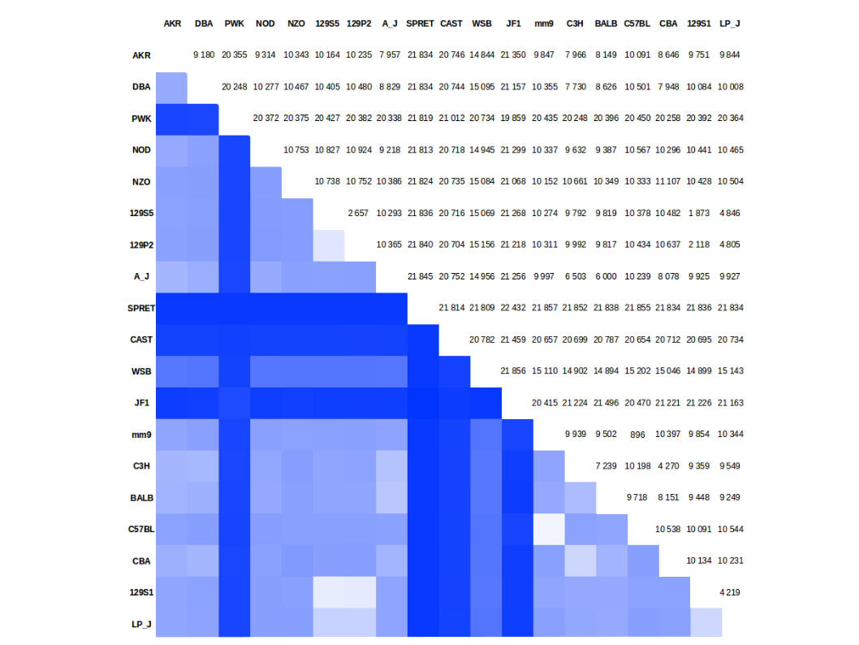

Supplementary Figure S1 — Number of searchable genes in F1 progeny of 18 mouse strains.
The table shows the expected number of genes with exonic SNPs in the F1 progeny of each cross of 18 mouse strains and the mm9 mouse reference genome. The numbers are color-coded in the lower part of the table with dark blue representing the highest number of searchable geness, i.e. 21,857, and white representing no searchable gene. We excluded from the analysis the X chromosome and the mitochondrial genome, which were not included in the files retrieved from the Mouse Genomes Project. (Y chromosome included?)

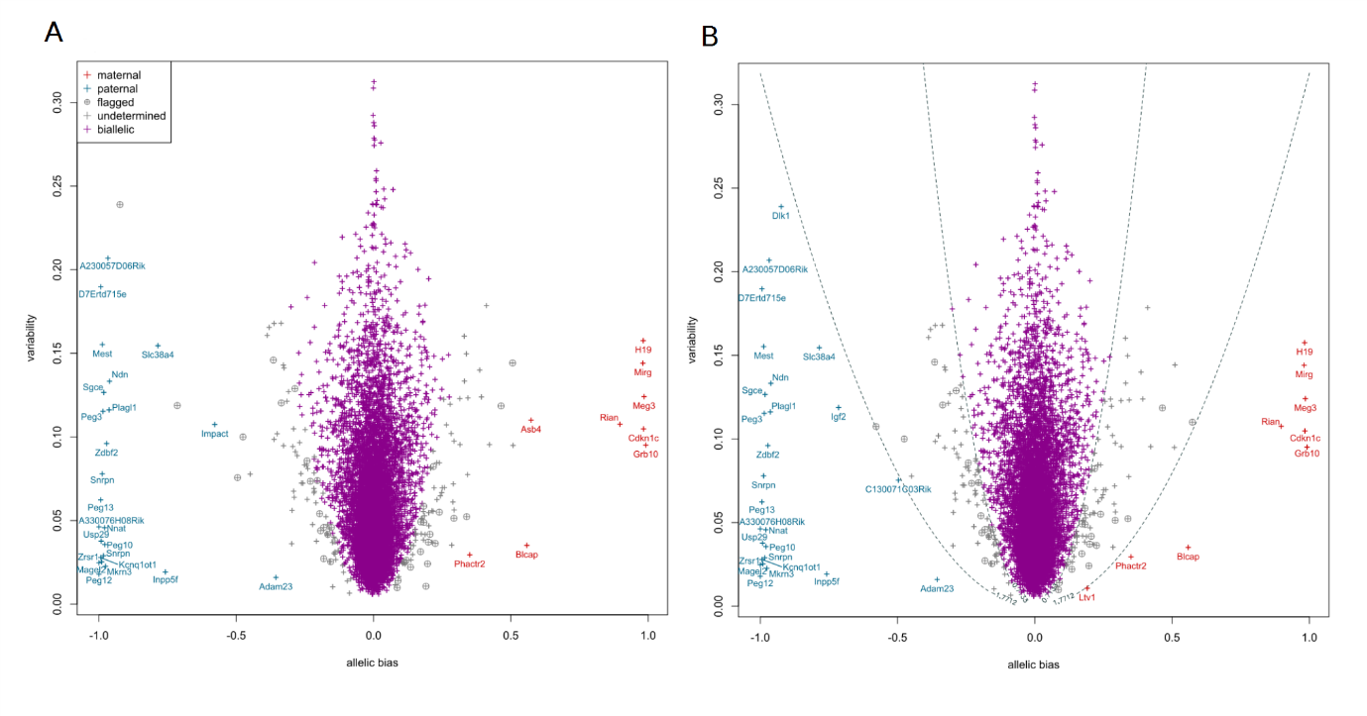
Supplementary Figure S2 — ISoLDE calls on the E13.5 cortex dataset.
The legends are the same as in Figure 1A (A) Output of the resampling-based version of ISoLDE. (B) Output of the ISoLDE version using predefined thresholds. Dashed lines represent the empirical threshold values.

---------------------------------------------- (font in plots is hard to read)
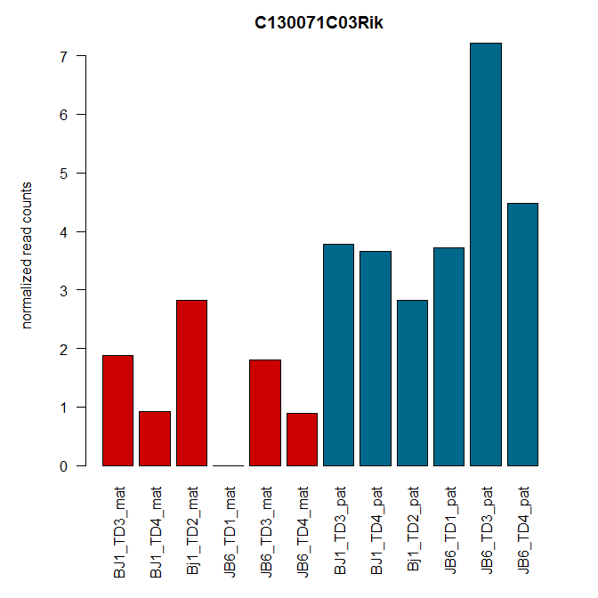
Supplementary Figure S3 — Read counts for C130071C03Rik called AI by the predefined thresholds version of ISoLDE and flagged by the resampling version on E13.5 dataset.
Normalized maternal (red) and paternal (blue) read counts are displayed for three replicates of the BJ1 (mother C57BL/6 x father JF1) cross and the 3 replicates of the JB6 cross (mother JF1 x father C57BL/6).

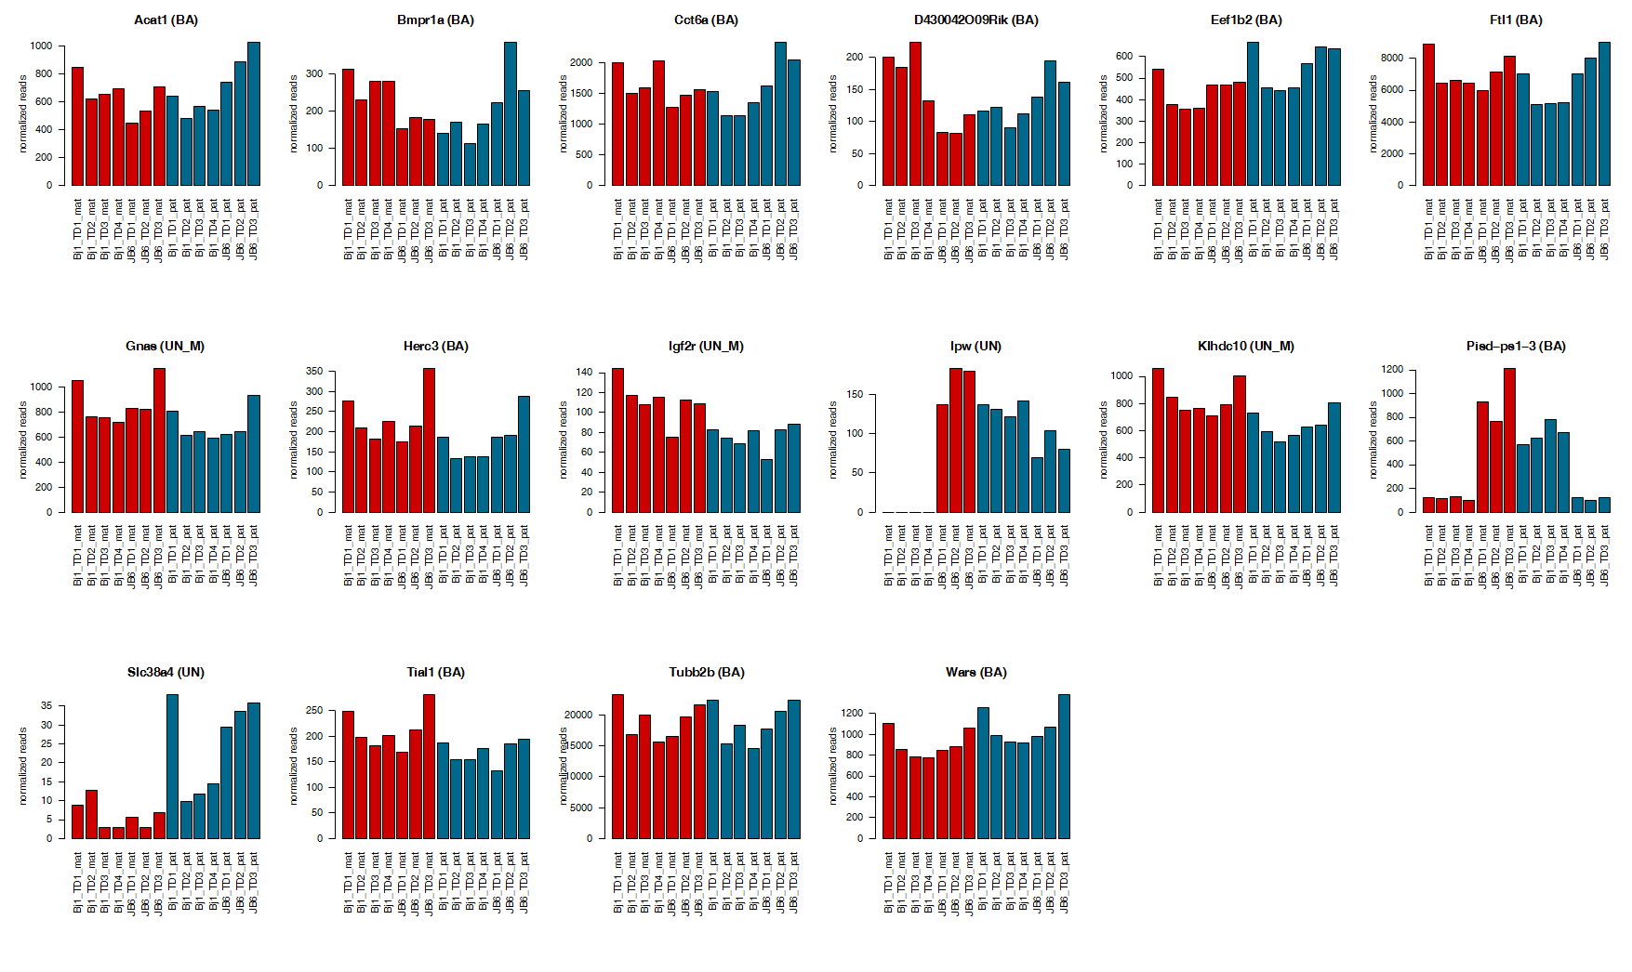
Supplementary Figure S4 — Read counts for genes called AI by DeVeale (7) and not by ISoLDE on P0 dataset.
Normalized maternal (red) and paternal (blue) read counts are displayed for four replicates of the BJ1 (mother C57BL/6 x father JF1) cross and the 3 replicates of the JB6 cross (mother JF1 x father C57BL/6). The titles over the graphs indicate the genes and, in brackets, the ISoLDE call vs. the DeVeale call. UN M and UN P denote consistency flags.

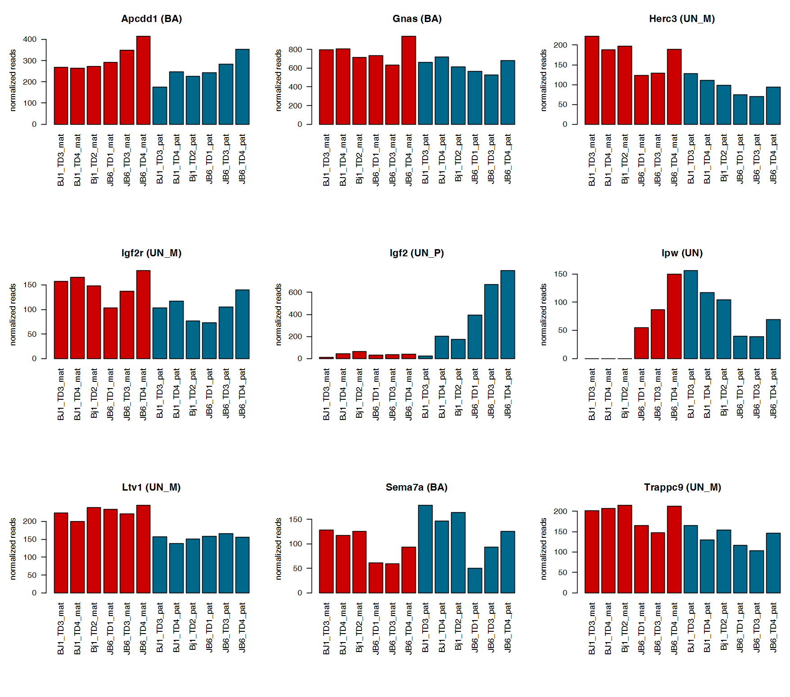
Supplementary Figure S5 — Read counts for genes called AI by DeVeale (7) and not by ISoLDE on the E13.5 dataset.
Normalized maternal (red) and paternal (blue) read counts are displayed for the 3 replicates of each reciprocal cross BJ1 (mother C57BL/6 x father JF1) and JB6 (mother JF1 x father C57BL/6). The titles over the graphs indicate the genes and in brackets, ISoLDE call vs. DeVeale call. UN M and UN P denote a consistency flag.

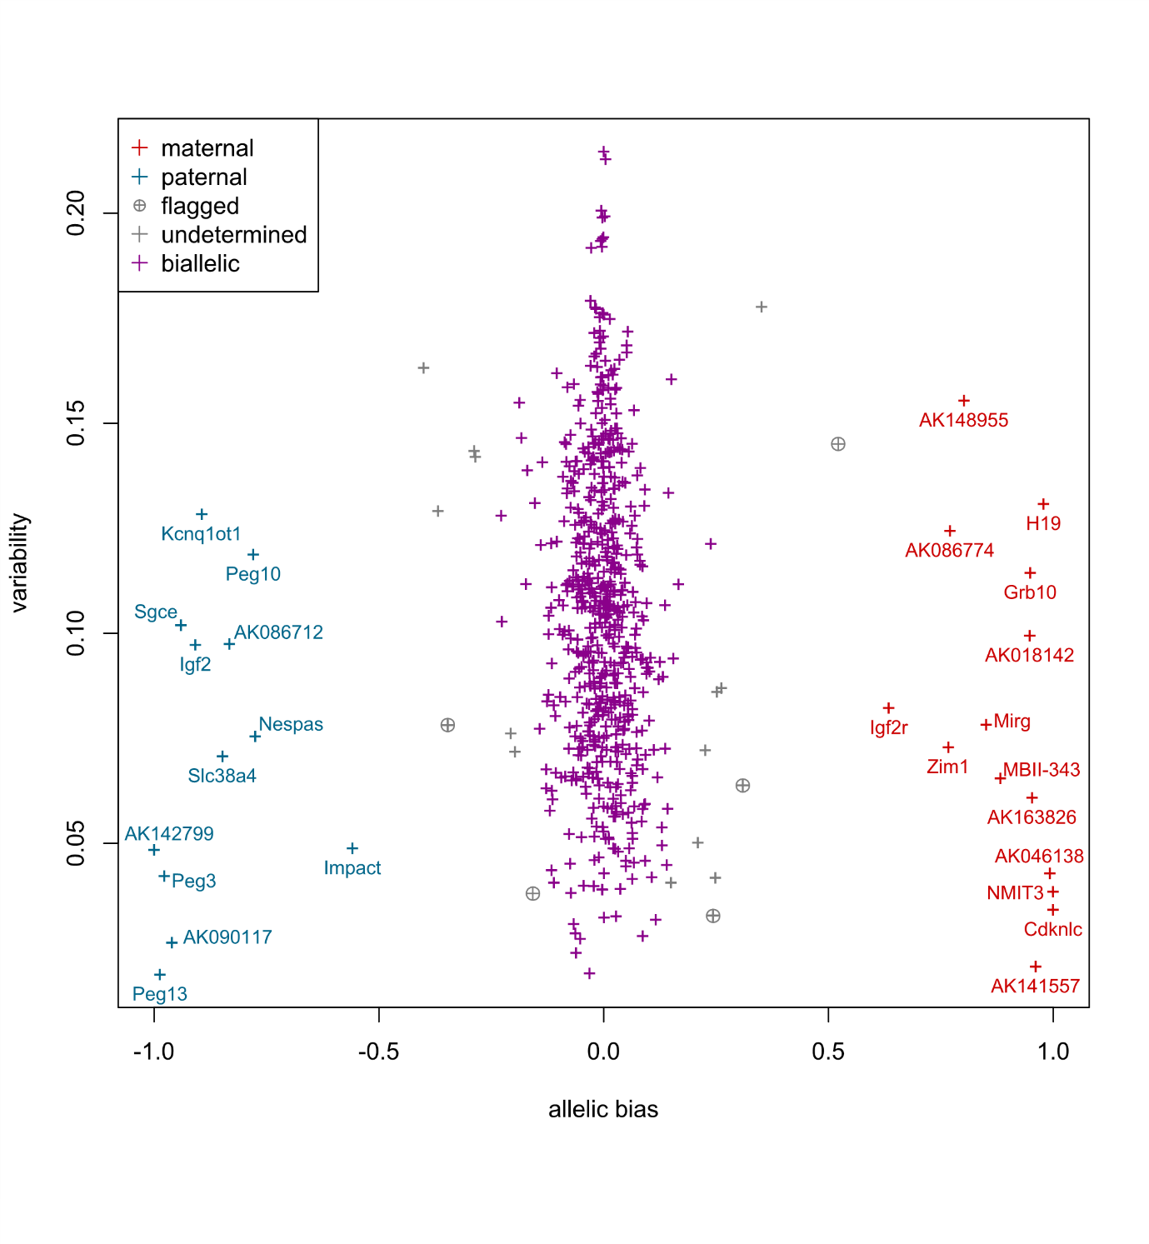
Supplementary Figure S6 — ISoLDE resampling version calls on Babak dataset (1).
Same legends as in Figure 1A.

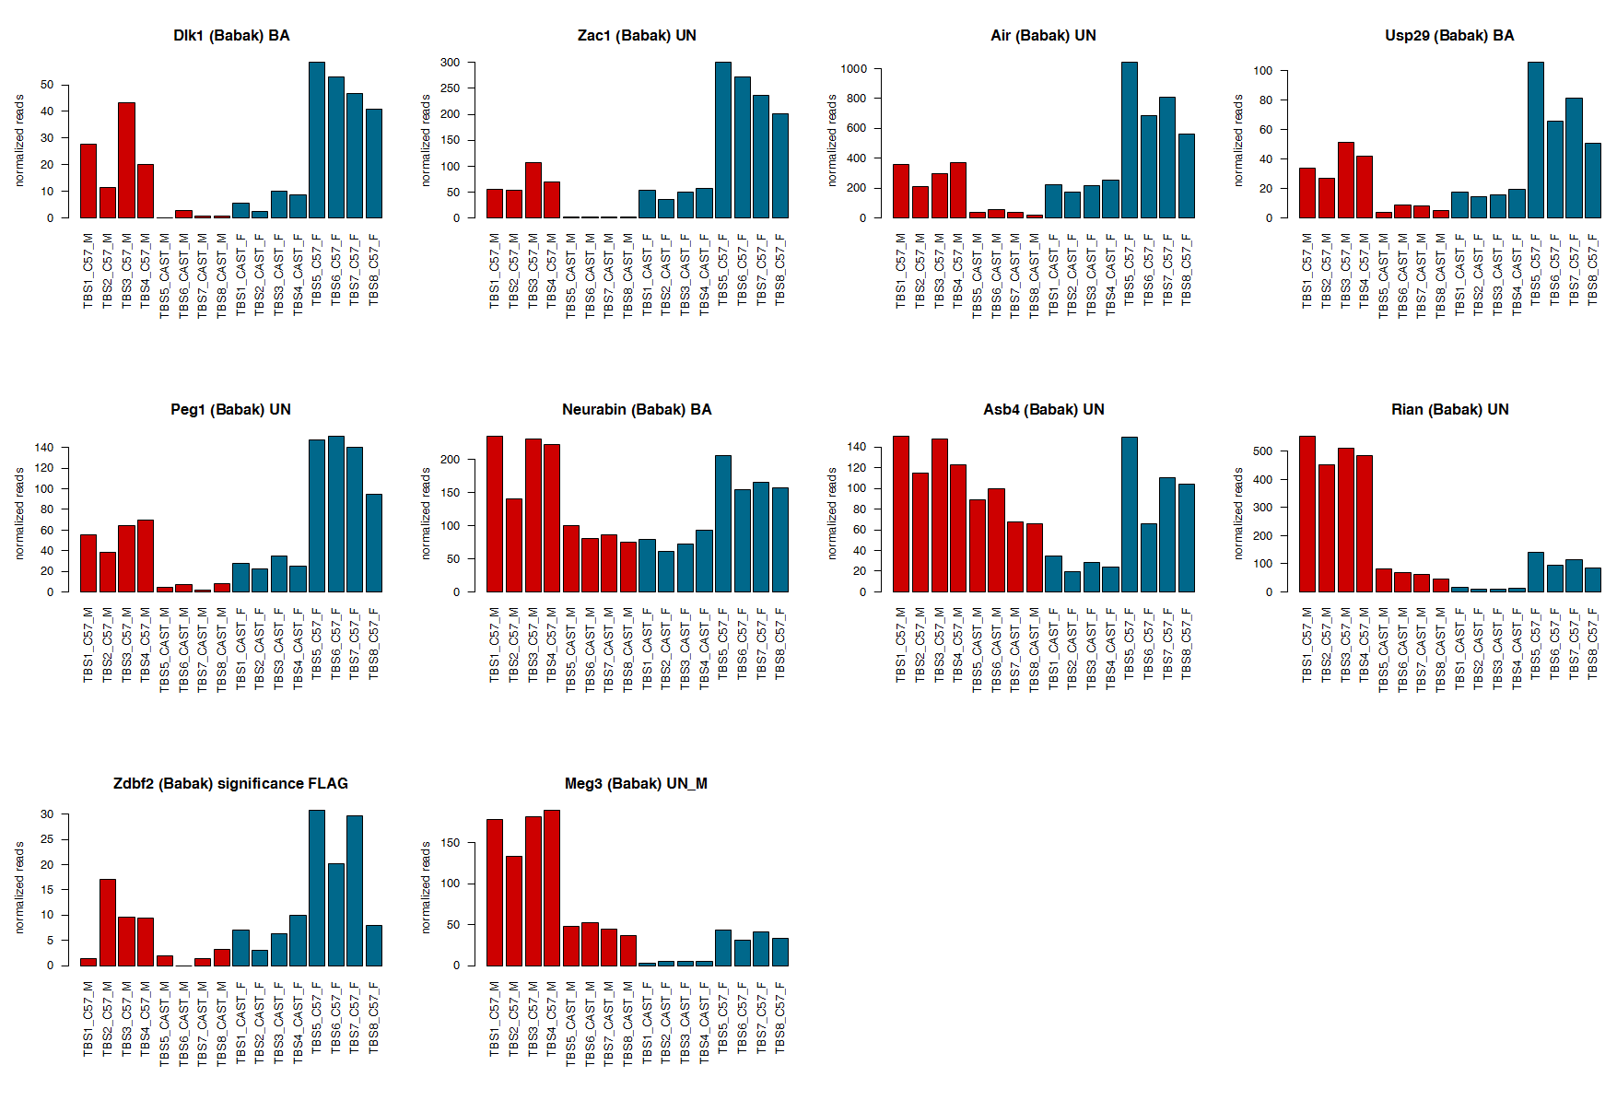

Supplementary Figure S7 — Read counts for genes called AI by Babak (1) and not by ISoLDE on Babak dataset.
Normalized maternal (M, red) and paternal (F, blue) read counts are displayed for the 4 replicates of each reciprocal cross between the C57BL/6 and CAST strains. The titles over the graphs indicate the genes and, in brackets, the ISoLDE call vs. the Babak call. UN M denotes a consistency flag.

----------------------------------------------

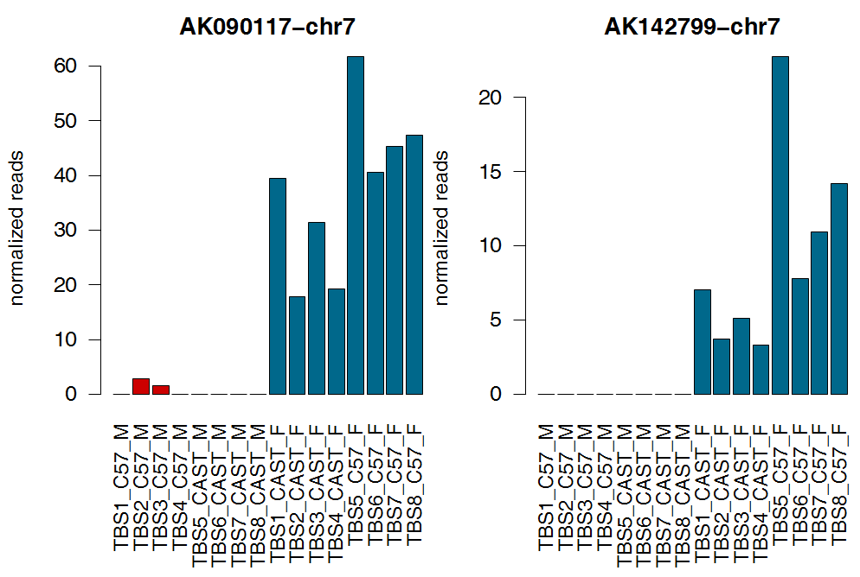
Supplementary Figure S8 — Read counts for genes called AI by ISoLDE and not by Babak (1) on the Babak dataset.
Same legend as in Figure S6.
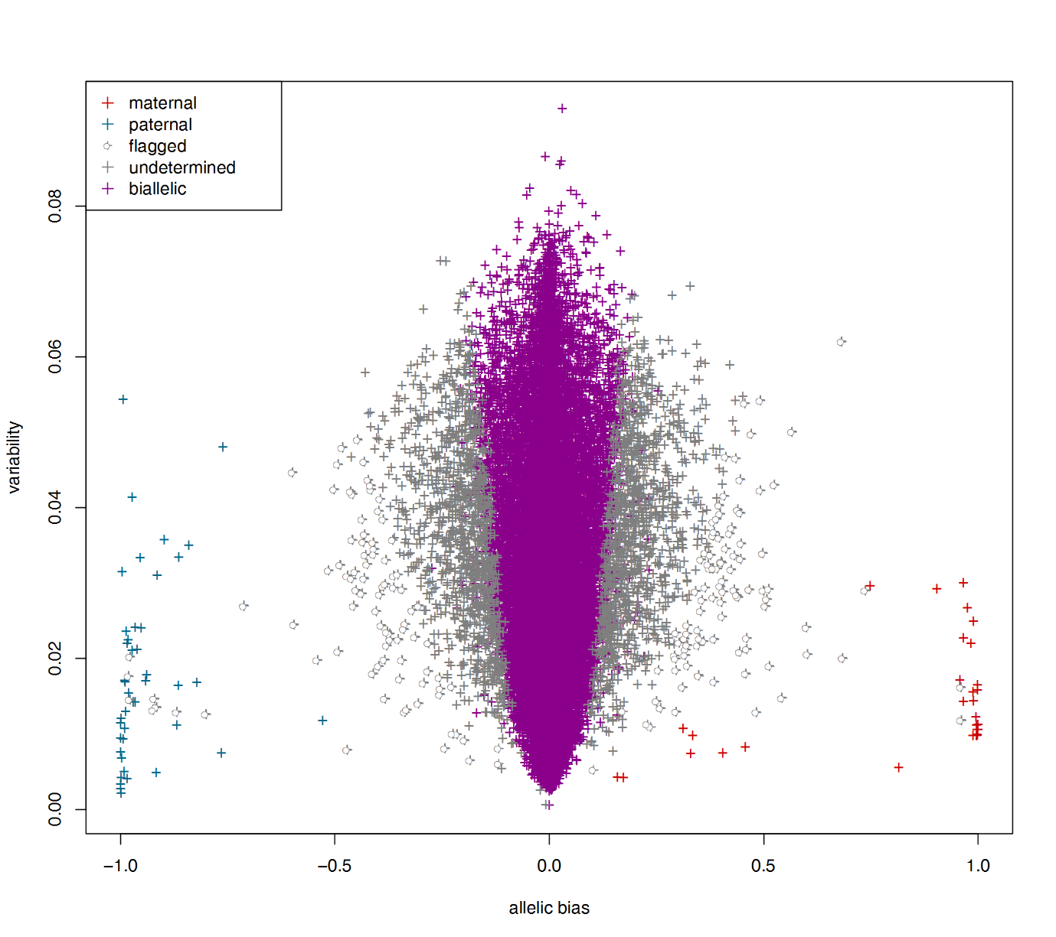
Supplementary Figure S9 — ISoLDE resampling version calls on the Perez dataset (9).
Same legends as in Figure 1A.

----------------------------------------------

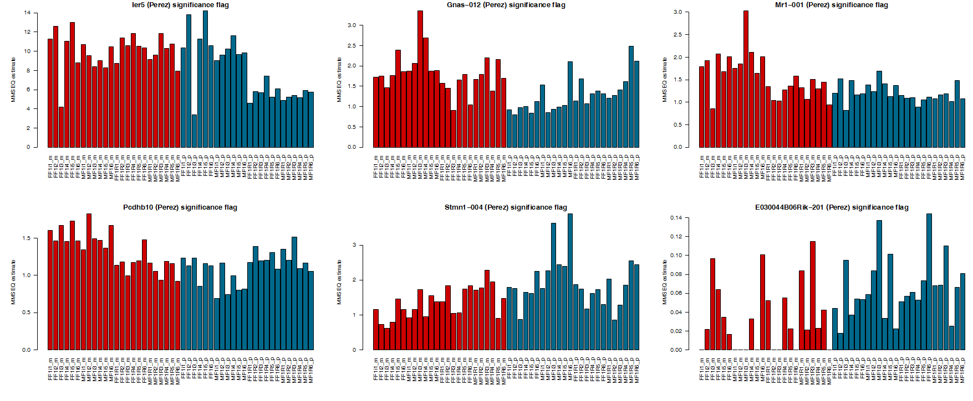
Supplementary Figure S10 — MMSEQ estimates for genes called AI by Perez (9) and flagged by ISoLDE on the Perez dataset.
MMSEQ estimates are displayed for the maternal (m, red) and paternal (p, blue) allele of the indicated genes. In the brackets, the ISoLDE call is given first. F1R and F1i in the replicate
names refer to the reciprocal crosses.
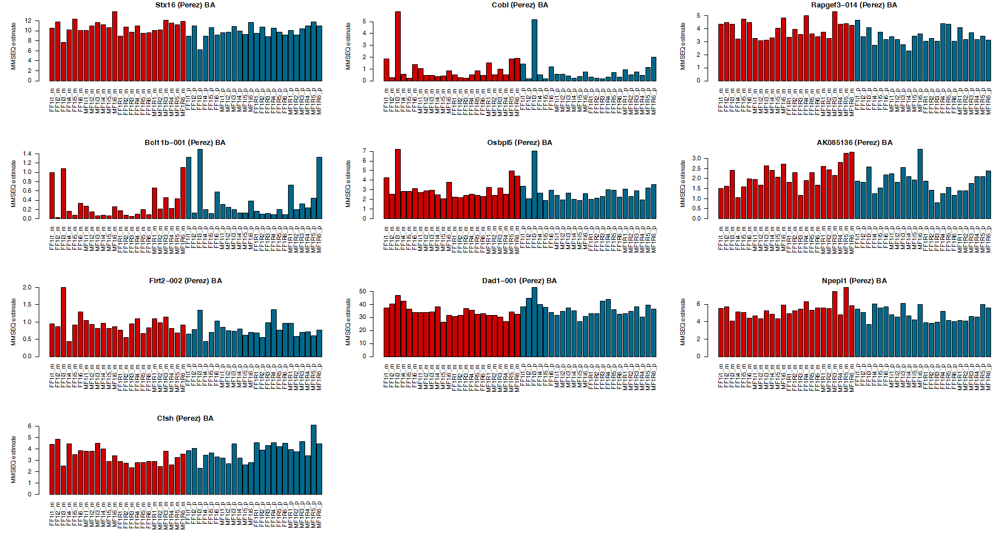
Supplementary Figure S11 — MMSEQ estimates for genes called AI by Perez (9) and bi-allelically expressed by ISoLDE on the Perez dataset.
Same legend as in Figure S9.
----------------------------------------------

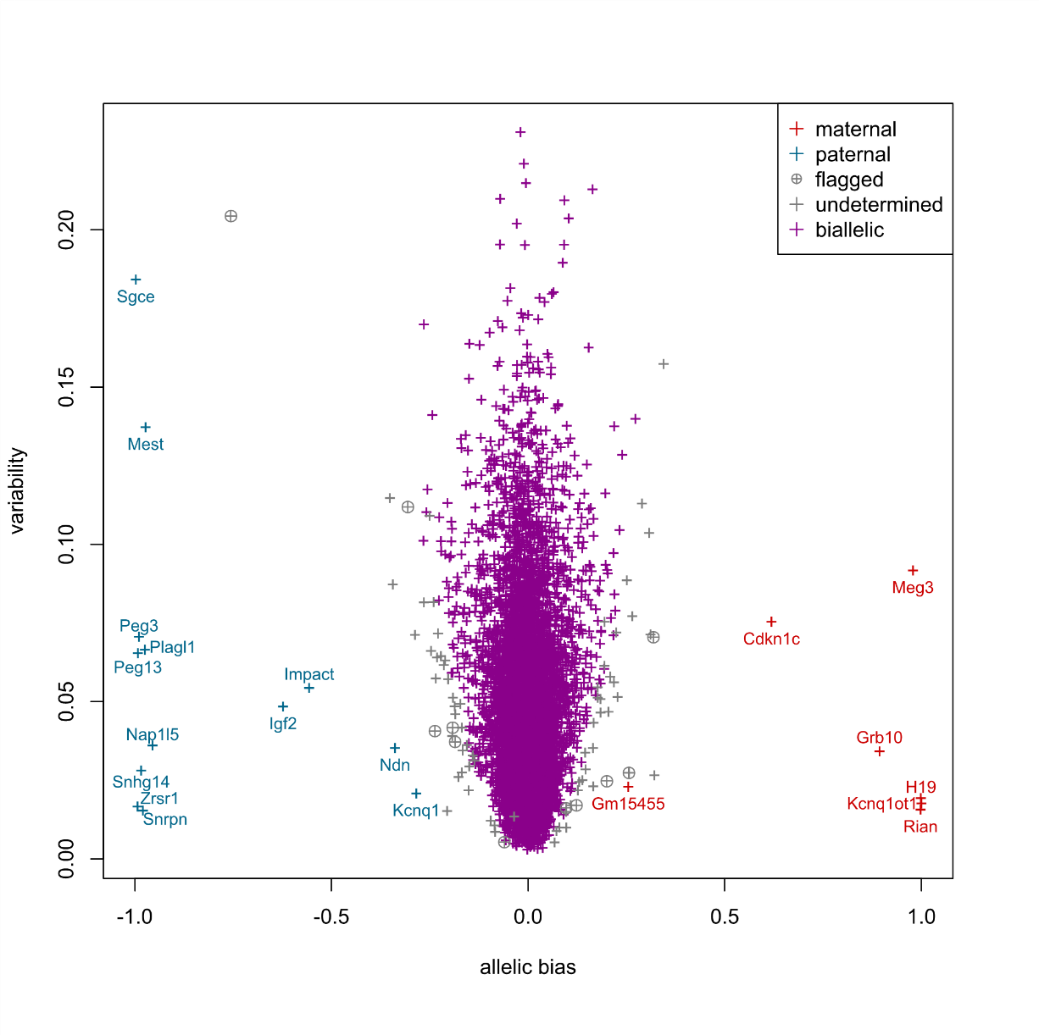

Supplementary Figure S12 — ISoLDE resampling version calls on the Lorenc VNO dataset (15).
Same legends as in Figure 1A.
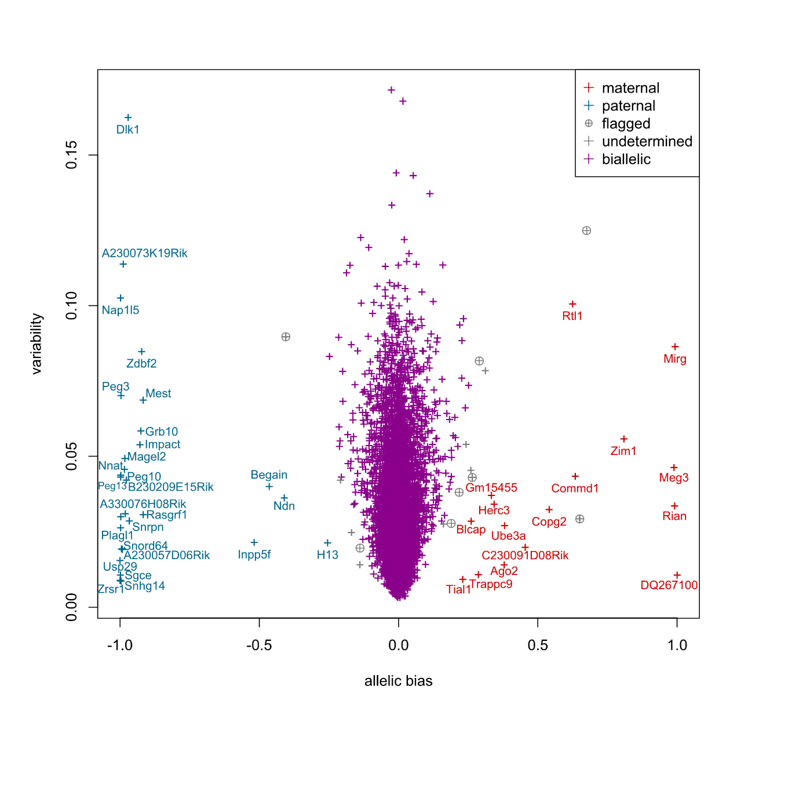
Supplementary Figure S13 — ISoLDE resampling version calls on the Lorenc HYP dataset (15).
Same legends as in Figure 1A.
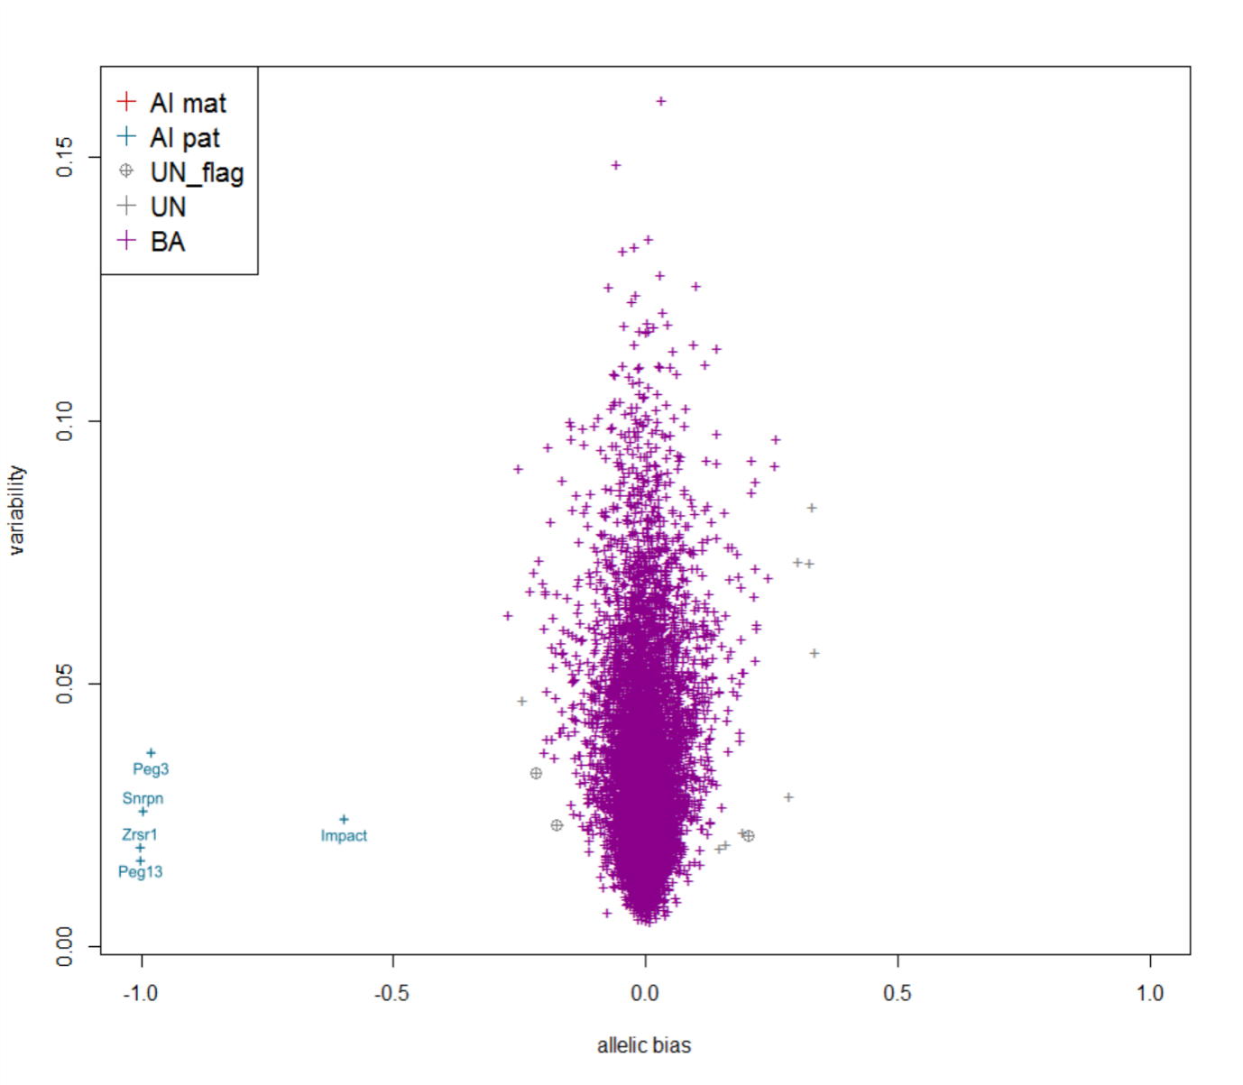
Supplementary Figure S14 — ISoLDE resampling version calls on the Lorenc LIV dataset (15).
Same legends as in Figure 1A.

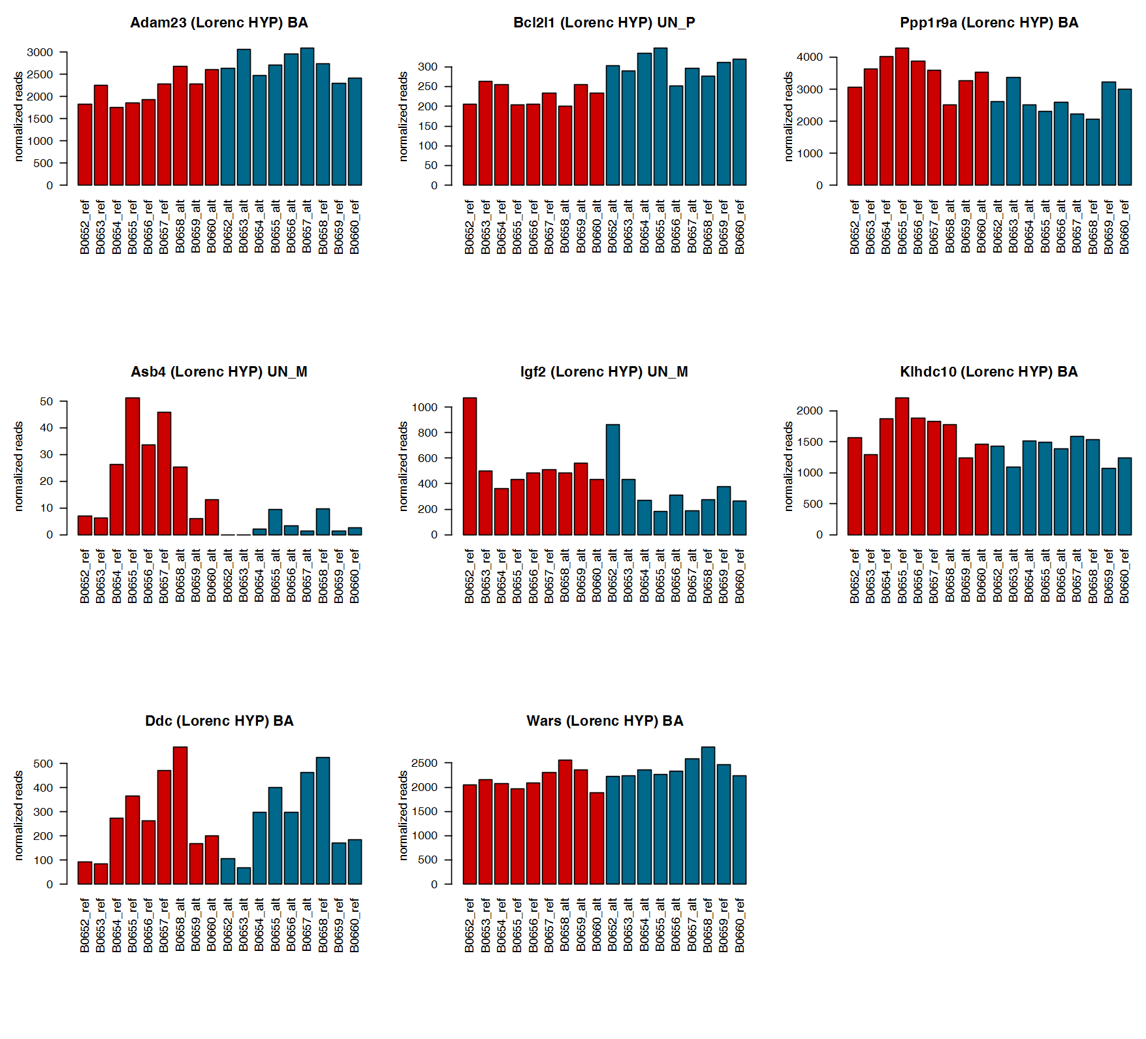
Supplementary Figure S15 — Read counts for genes called AI by Lorenc (15) and not by ISoLDE on the Lorenc HYP dataset.
Normalized maternal (red) and paternal (blue) read counts are displayed for the 6 and 3 replicates of each reciprocal cross. The titles over the graphs indicate the genes and, in brackets, the ISoLDE call vs. the Lorenc call. UN M and UN P denote consistency flags.
----------------------------------------------

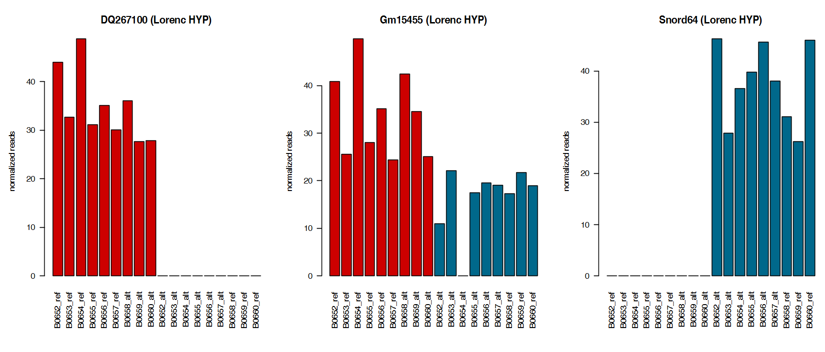
Supplementary Figure S16 — Read counts for genes called AI by ISoLDE and not by Lorenc (15) on the Lorenc HYP dataset.
Normalized maternal (red) and paternal (blue) read counts are displayed for the 6 and 3 replicates of each reciprocal cross. The titles over the graphs indicate the genes and, in brackets, the ISoLDE call vs. the Lorenc call.
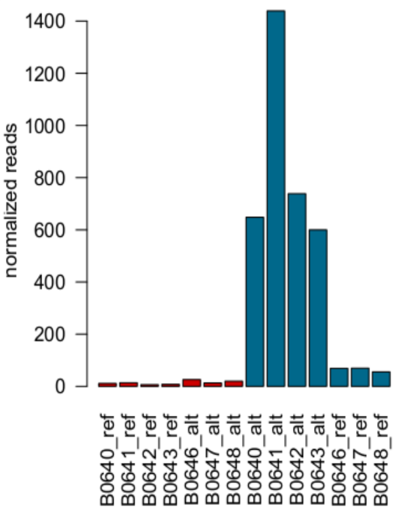
Supplementary Figure S17 — Read counts for Nnat called AI by Lorenc (15) and flagged by ISoLDE on the Lorenc VNO dataset.
Normalized maternal (red) and paternal (blue) read counts are displayed for the 4 and 3 replicates of each reciprocal cross. The title over the graph indicates the gene and, in brackets, the ISoLDE call vs. the Lorenc call. UN P denotes a consistency flag.

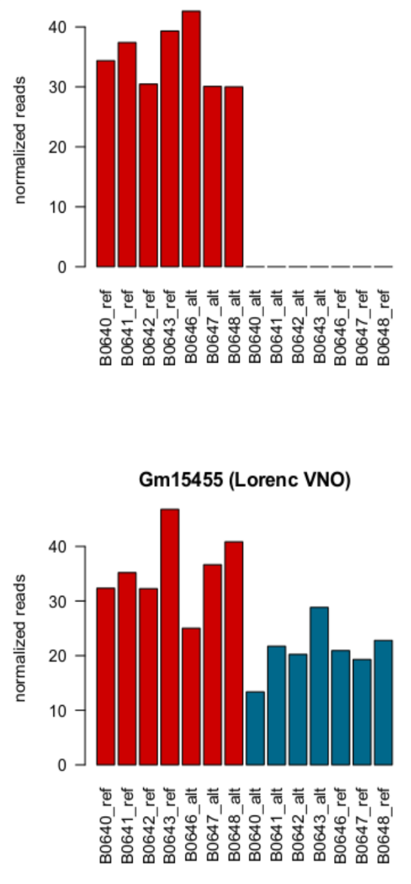
Supplementary Figure S18 — Read counts for genes called AI by ISoLDE and not by Lorenc (15) on the Lorenc VNO dataset.
Normalized maternal (red) and paternal (blue) read counts are displayed for the 4 and 3 replicates of each reciprocal cross. The titles over the graphs indicate the genes and, in brackets, the ISoLDE call vs. the Lorenc call.

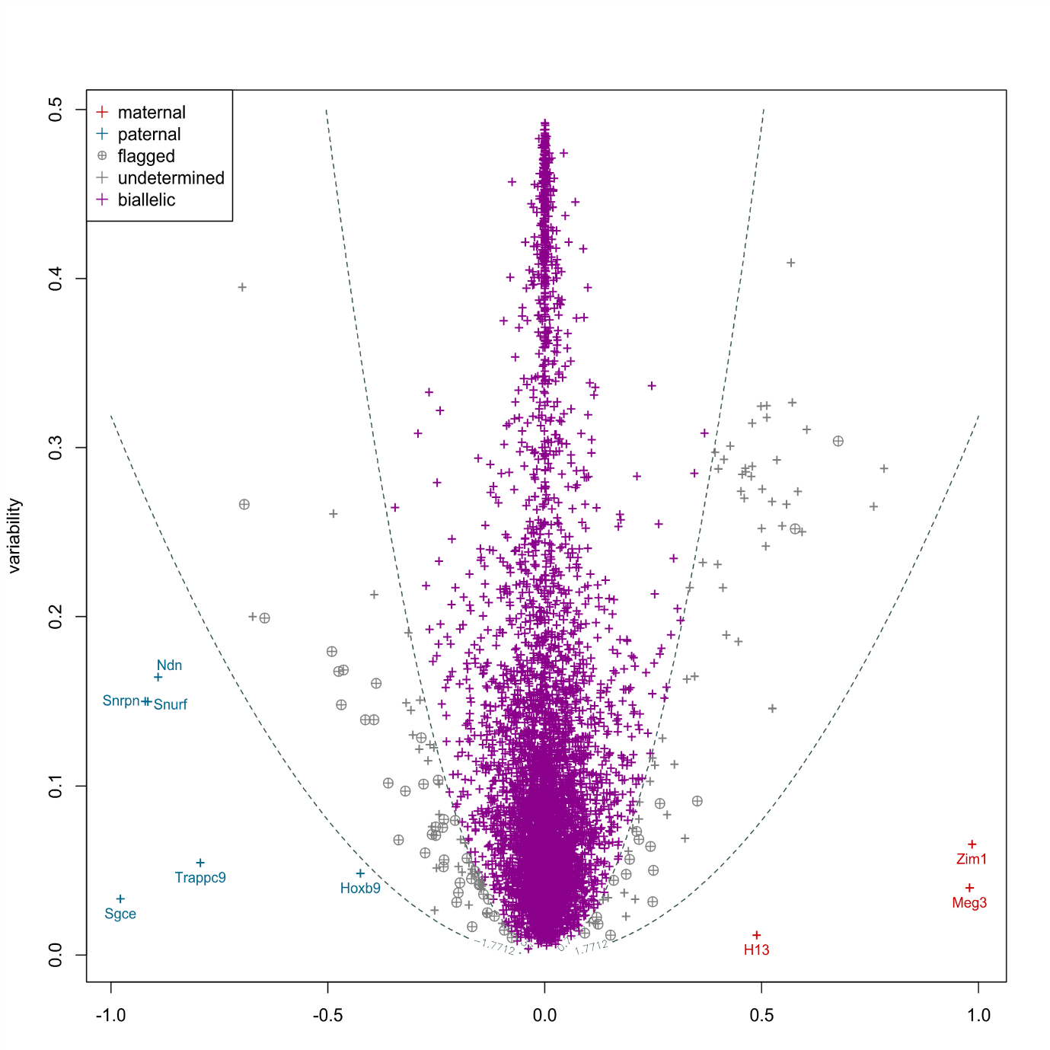
Supplementary Figure S19 — ISoLDE predefined thresholds version calls on the Hasin-Brumshtein dataset (38).
Violet crosses correspond to bi-allelically expressed genes. Red and blue crosses correspond to genes called maternally and paternally biased, respectively. Grey crosses are undetermined genes. Grey circled crosses correspond to flagged genes. Dashed lines represent the empirical threshold values. The predefined thresholds version of ISoLDE was used because only two replicates of each cross were available.

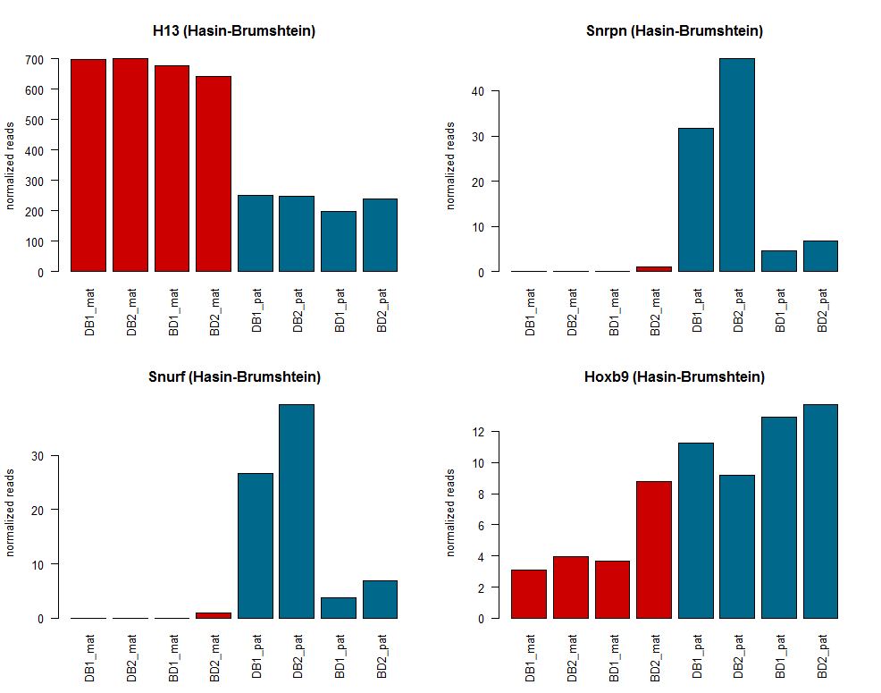
Supplementary Figure S20 — Read counts for genes called AI by ISoLDE and not by Hasin-Brumshtein (38) on the Hasin-Brumshtein dataset.
Normalized maternal (red) and paternal (blue) read counts are displayed for the 2 replicates of each reciprocal cross.

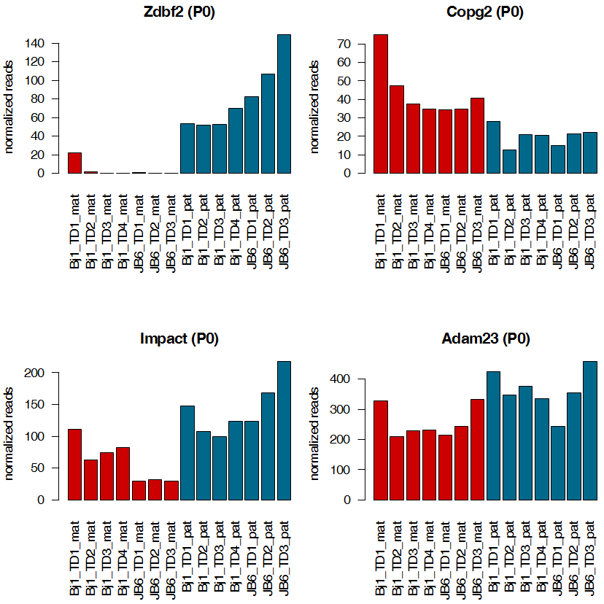
Supplementary Figure S21 — Read counts for genes called AI by ISoLDE and not by Bonthuis (10) on the P0 dataset.
Normalized maternal (red) and paternal (blue) read counts are displayed for the 4 replicates of the BJ1 (mother C57BL/6 x father JF1) cross and the 3 replicates of the JB6 cross (mother JF1 x father C57BL/6). The titles over the graphs indicate the genes and in brackets, ISoLDE call vs. Bonthuis call.

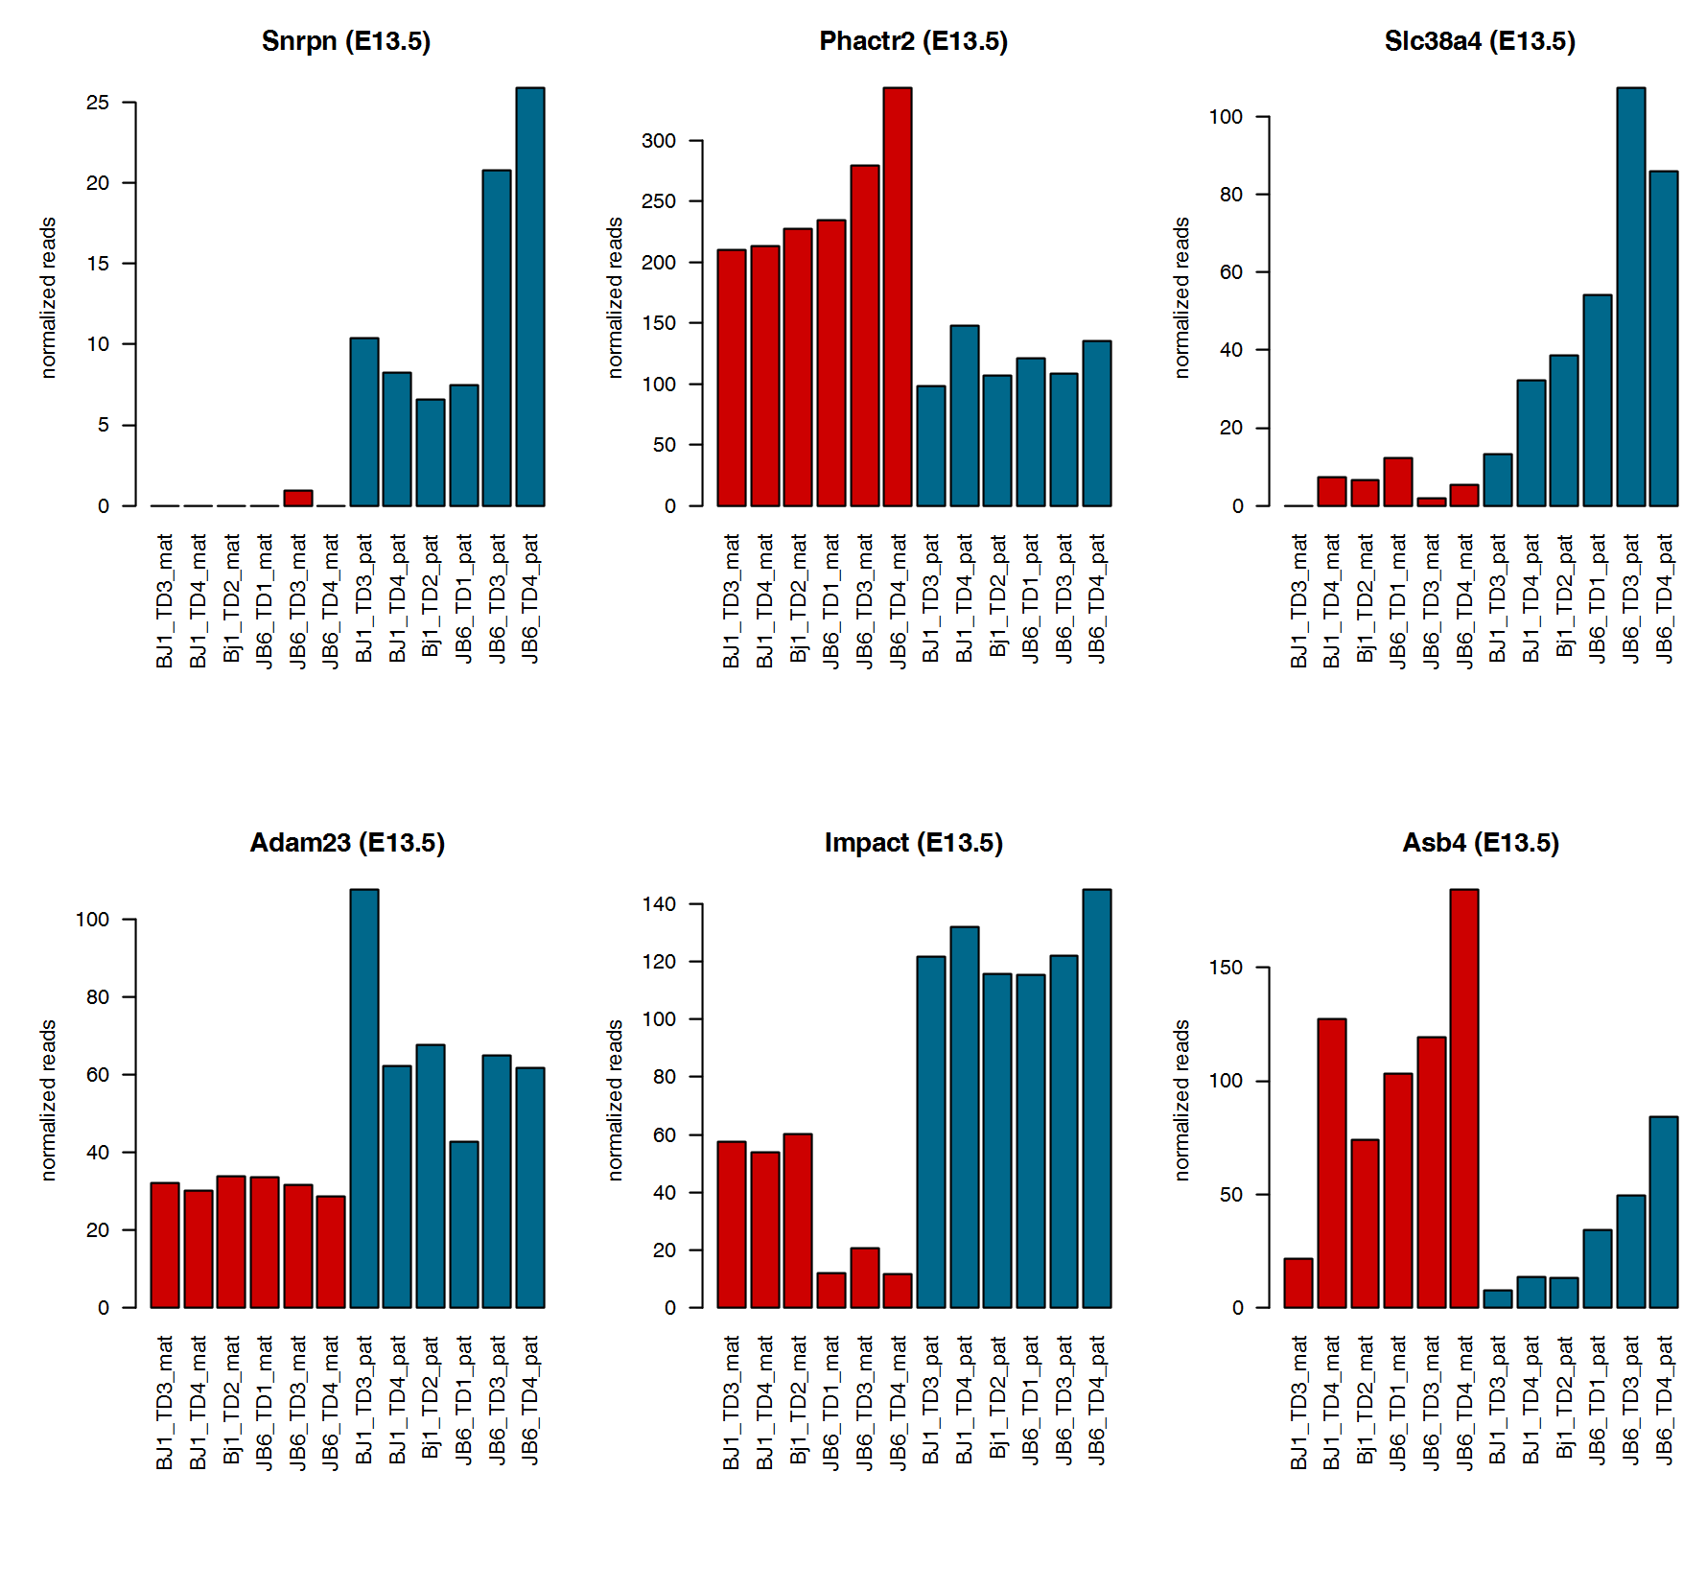
Supplementary Figure S22 — Read counts for genes called AI by ISoLDE and not by Bonthuis (10) on the E13.5 dataset.
Normalized maternal (red) and paternal (blue) read counts are displayed for the 3 replicates of each reciprocal cross BJ1 (mother C57BL/6 x father JF1) and JB6 (mother JF1 x father
C57BL/6). TD is for dorsal telencephalon, the presumptive cortex at E13.5. The titles over the graphs indicate the genes and in brackets, ISoLDE call vs. Bonthuis call.

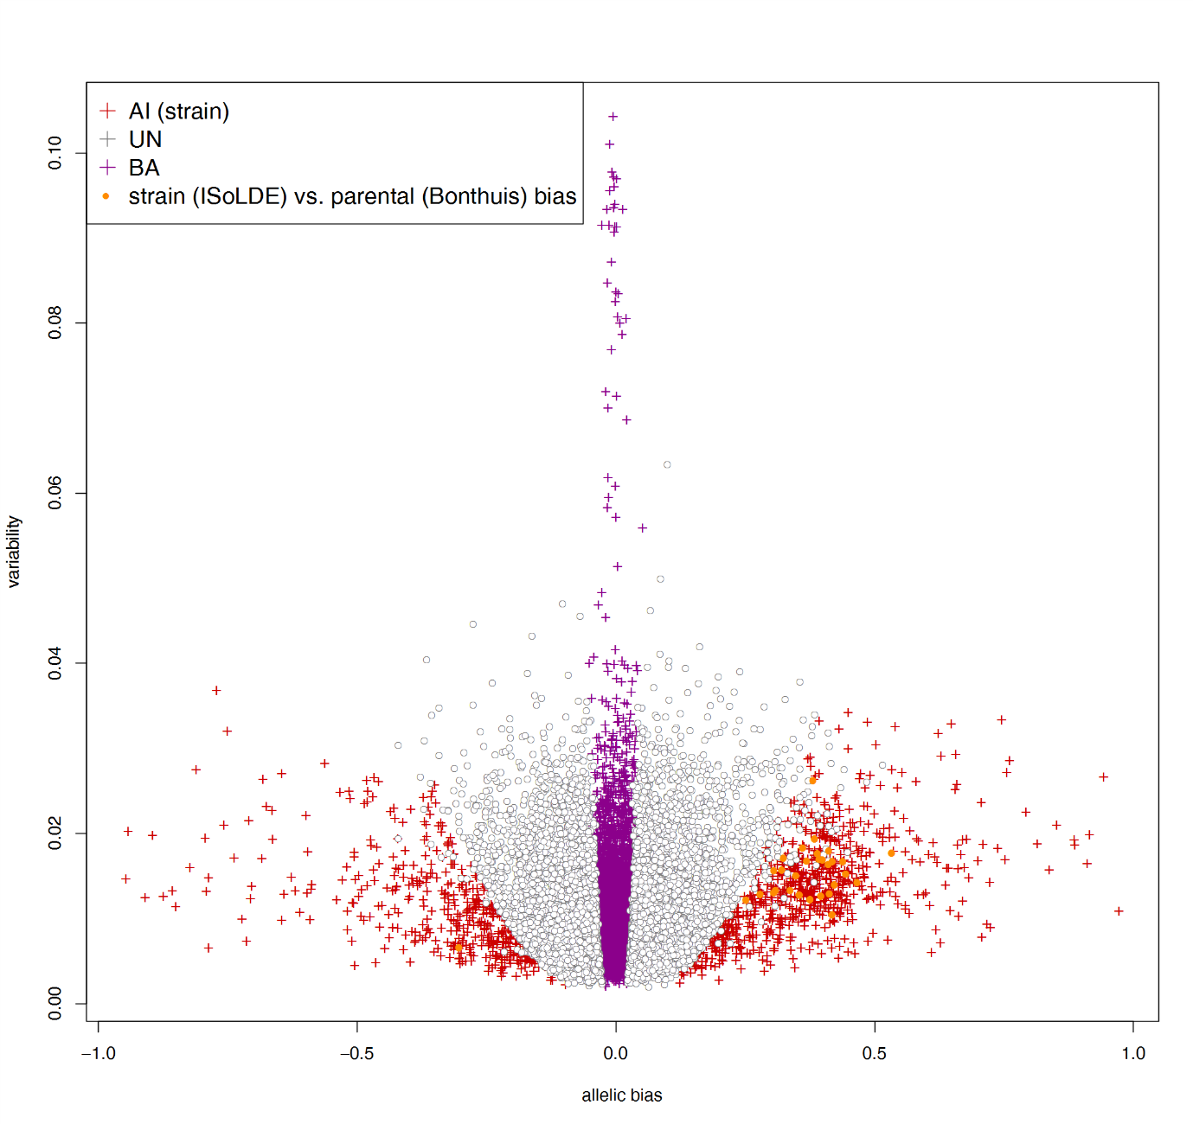
Supplementary Figure S23 — ISoLDE resampling version calls for strain bias on the Bonthuis (10) DRN dataset.
Output of resampling version of ISoLDE for strain bias. Orange dots identify genes called parentally biased by Bonthuis and strain biased by ISoLDE.

