

GIPSy: Genomic Island

Prediction Software

Version 1.1.2

Summary
I. What is GIPSy? 3
II. Importance of genomic islands 3
III. Method summary 3
IV. GIPSy input formats 3
IV.1 EMBL format (.embl) 3
IV.2 Genbank format (.genbank, .gb, .gbk) 4
1. Installation process: 5
2. Running GIPSy 7
2.1 Step 1 7
2.2 Going further from one Step to another. 9
2.3 Step 2 3
2.4 Step 3 4
2.5 Step 4 5
2.6 Step 5 6
2.6.1 Visualizing the amino acid composition and blast result for each gene (Step 5) 7
2.7 Step 6 7
2.8 Step 7 8
2.9 Step 8 9
3. Saving results and exporting additional analyses 10
4. TroubleShooting 11
4.1 GIPSy breaks at step 5 on Linux 11
4.2 GIPSy breaks at steps 4 and 7 on Linux 11
4.3 GIPSy breaks at steps 3 to 7 on Linux 11
5. Acknowledgments 12

What is GIPSy?
GIPSy is a software for accurate prediction of genomic islands into the classes:
pathogenicity islands (PAIs), resistance Islands (RIs), metabolic Islands (MIs) and symbiotic
Islands (SIs).

Importance of genomic islands
Bacteria are highly diverse organisms that are able to adapt to a broad range of environments and hosts due to their high genomic plasticity. Horizontal gene transfer plays a pivotal role in this genome plasticity and evolution by leaps through the incorporation of large blocks of genome sequences, ordinarily known as genomic islands (GEIs). GEIs may harbor genes encoding virulence, metabolism, antibiotic resistance and symbiosis-related functions, namely
pathogenicity islands (PAIs), metabolic islands (MIs), resistance islands (RIs) and symbiotic islands (SIs).

Method summary
GIPSy predicts GEIs based on commonly shared features: genomic signature deviation (G+C content and codon usage); presence of tranposase genes; virulence, metabolism, antibiotic resistance, or symbiosis factors; flanking tRNA genes; and absence in other organisms of the same genus or closely related species. Eight steps are necessary to evaluate the presence of
these genomic features in GIPSy.

GIPSy input formats
GIPSy accepts complete genomes only of bacteria in embl or genbank formats.

IV.1 EMBL format (.embl)
The embl format has the following structure, where the regions highlighted with red boxes are important for GIPSy analyses.

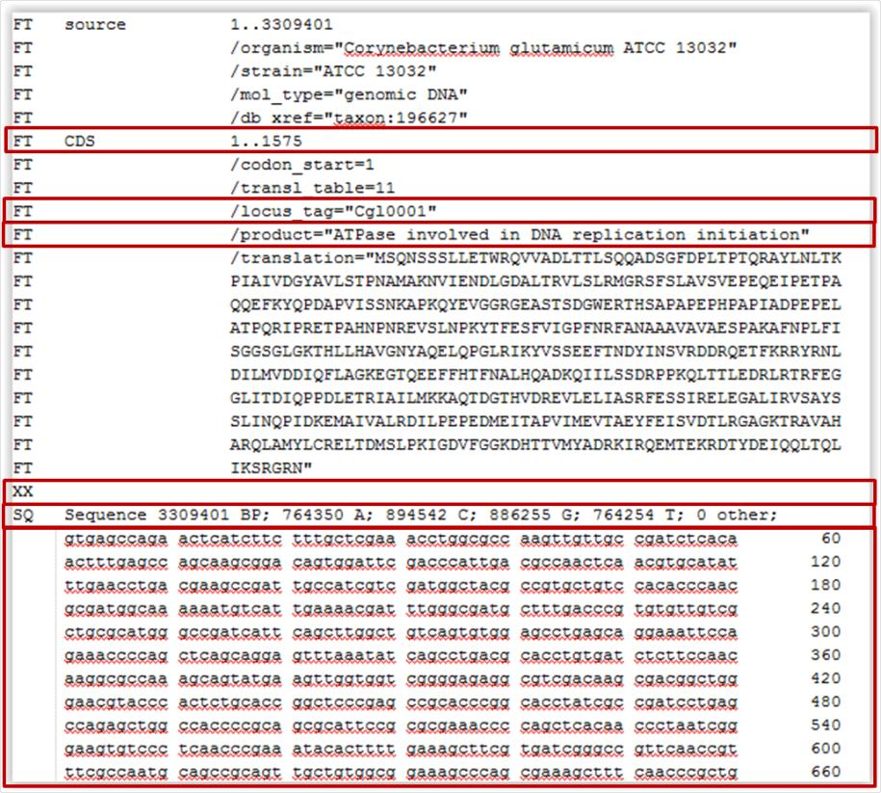

IV.2 Genbank format (.genbank, .gb, .gbk)
Although presenting similar information, the genbank file presents a different structure, as
shown below. Likewise the embl format example, the important features are highlighted by red boxes in the figure.

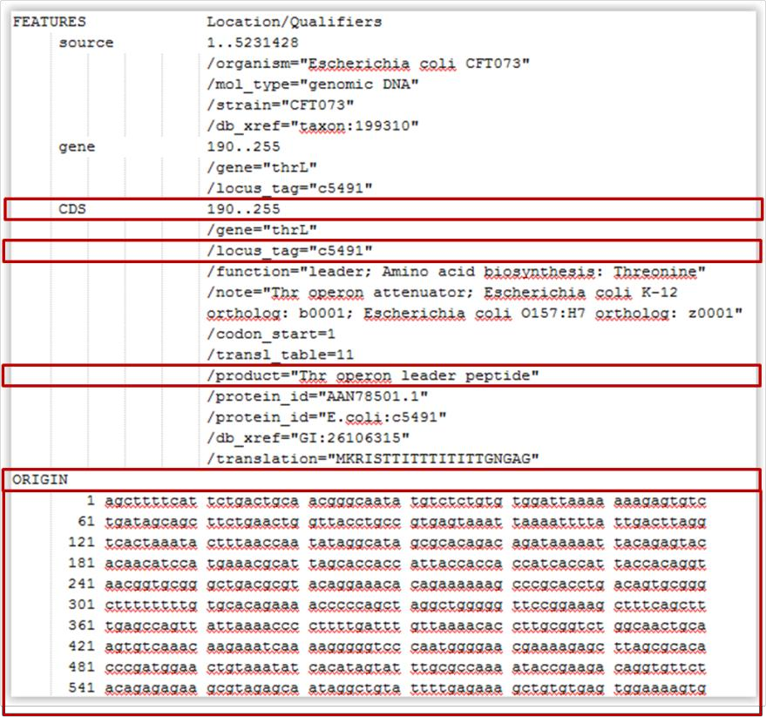

1. Installation process:
GIPSy may be used both in Windows- and Linux-based platforms. It only requires a Java
Virtual Machine 1.7.0_51-b13 or higher to work. However, we strongly advise the use of openjdk instead of the Oracle version of java virtual machine when working in linux-based machines as the Oracle version may result in some exceptions during the analyses. The download of all databases and dependencies as well as the environment setup are performed by GIPSy.Installer.jar.

GIPSy.Installer.jar may be run in Windows by simply double clicking, whereas in Linux it only requires a simple command line, as follow:

java –jar GIPSy.Installer.jar

a) choose the appropriate folder for installation:

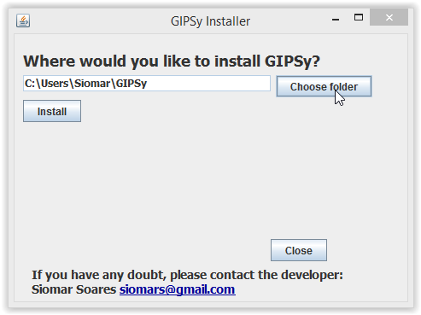

b) click install:

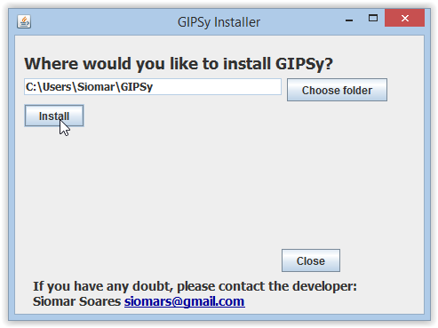
c) the installer will automatically download the databases, dependencies, GIPSy.jar and set up all the environment:

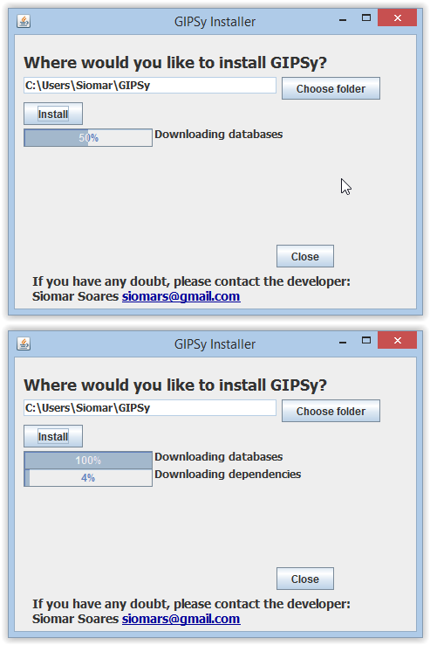

d) one shortcut will be created on Desktop.

OBS.: If it is not created, a prompt will appear warning that the Desktop folder was not found. In this case, simply go to the installation folder defined on the beginning of the installation process and execute GIPSy.jar from within this folder or create a Desktop shortcut.

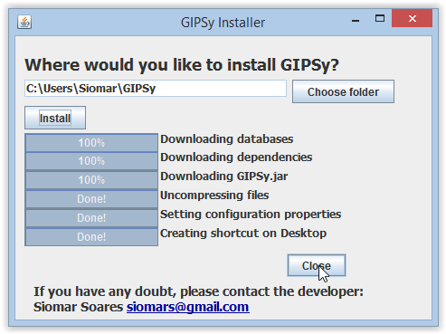

2. Running GIPSy
Similarly to the GIPSy.Installer.jar, GIPSy.jar may be run in Windows by simply double clicking,
whereas in Linux-based environments, it requires a simple command line, as follow:

java –jar GIPSy.jar

2.1 Step 1
After the software is open, click the button “Open Query” and choose the file for the
pathogenic organism “Escherichia_coli_CFT073.gbk” (downloadable as part of the dataset.zip example files at http://www.bioinformatics.org/downloads/index.php?file_id=587) and click the buttom “Create files”.

A) Creating files for the query genome.

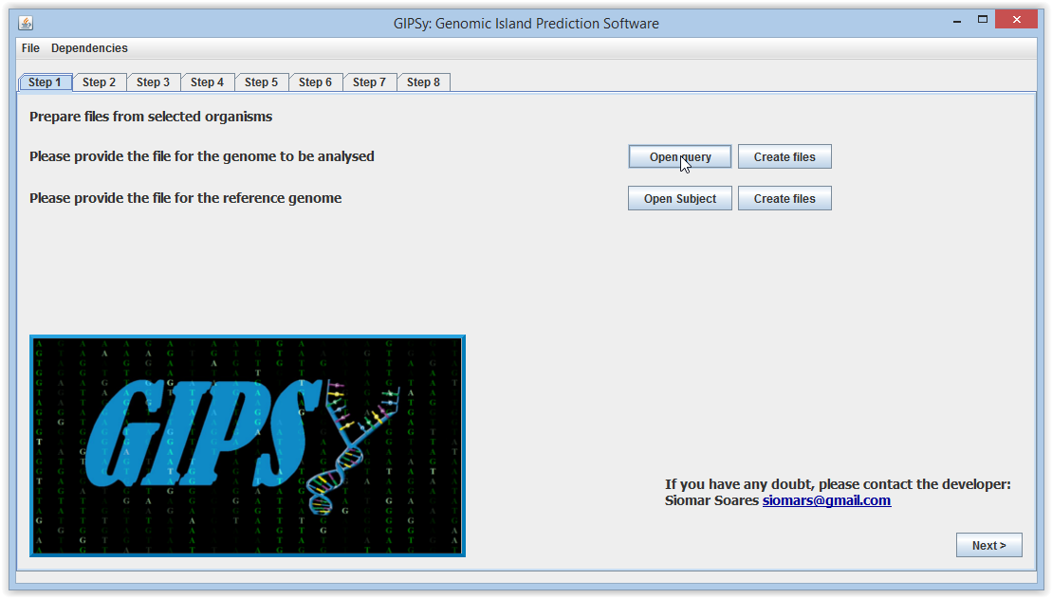

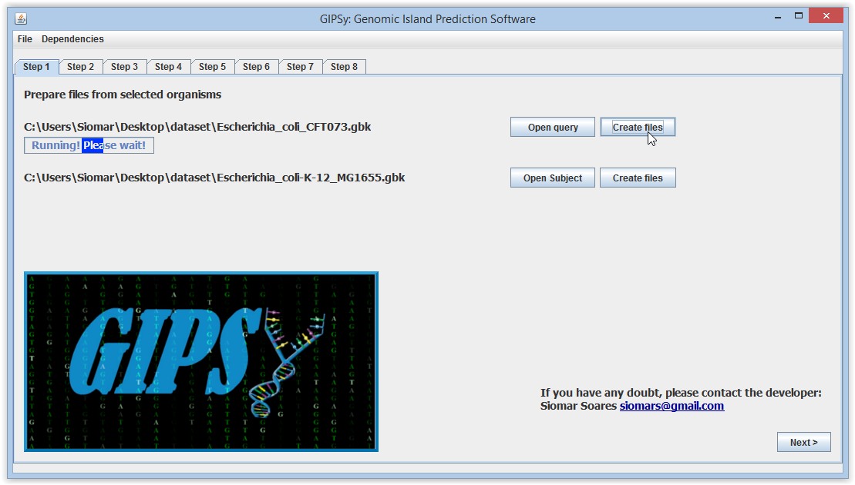
b) Creating files for the subject genome

Click the button “Open Subject” and choose the file for the non-pathogenic closely-related organism “Escherichia_coli-K-12_MG1655.gbk” (downloadable as part of the dataset.zip example files at http://www.bioinformatics.org/downloads/index.php?file_id=587) and click the buttom “Create files”.

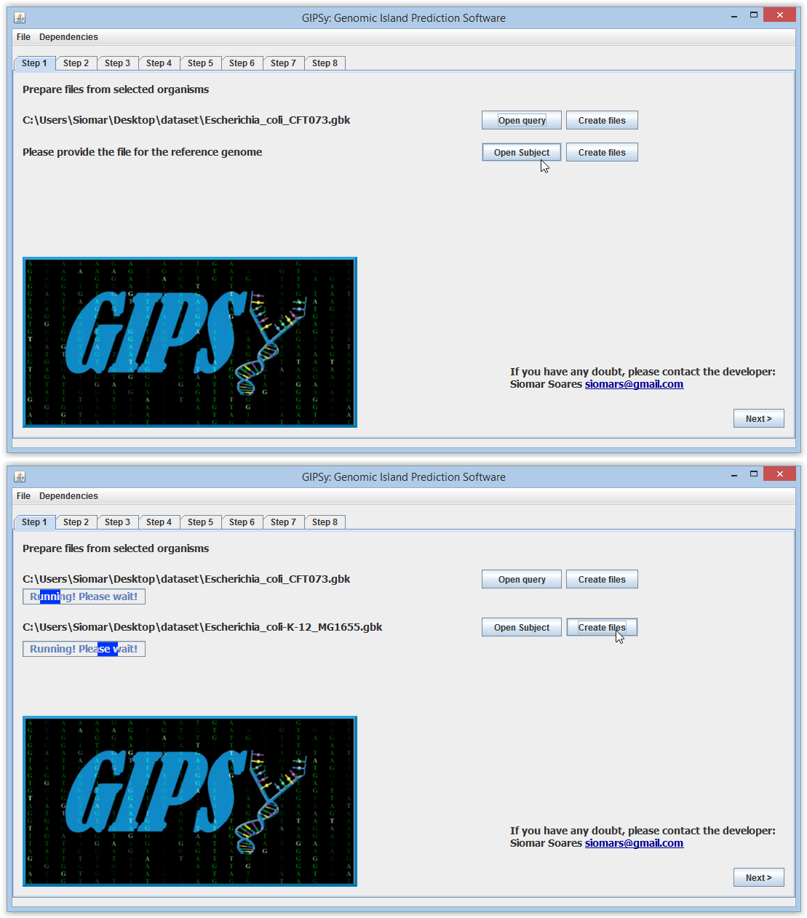

2.2 Going further from one Step to another.
After finishing Step 1, you may click Step 2 or next in order to go further.

Obs.: All steps are dependent on Step 1. After step 1 is finished, you may run Steps 2-7 concomitantly. Step 8 is dependent on all previous Steps. Be sure to finish all of them before going to Step 8.

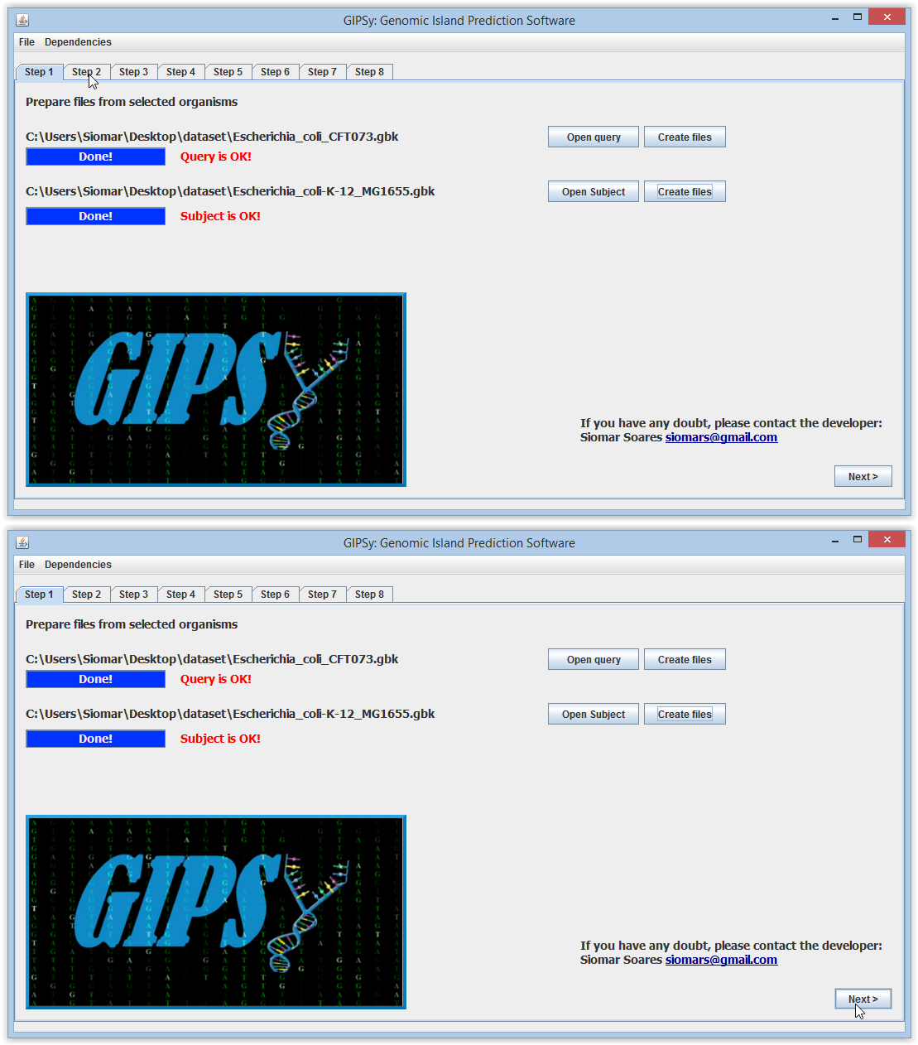

2.3 Step 2
On Step 2, you may choose the cutoff value, in standard deviations (SD), for anomalous G+C analyses. The standard value is 1.5 SDs from the mean. After choosing the cutoff for both query and subject, run the analyses and click visualize in order to see the results.

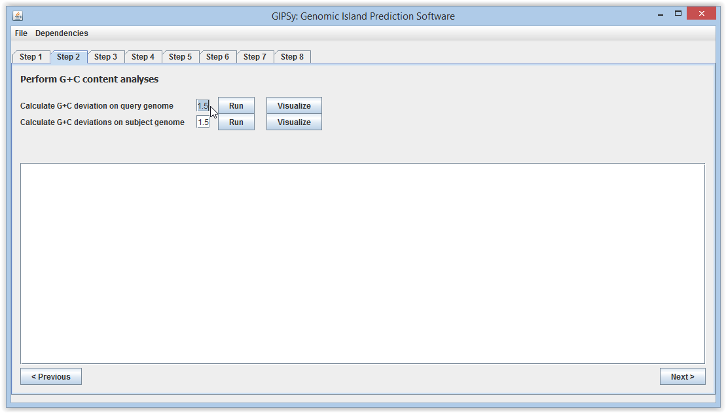

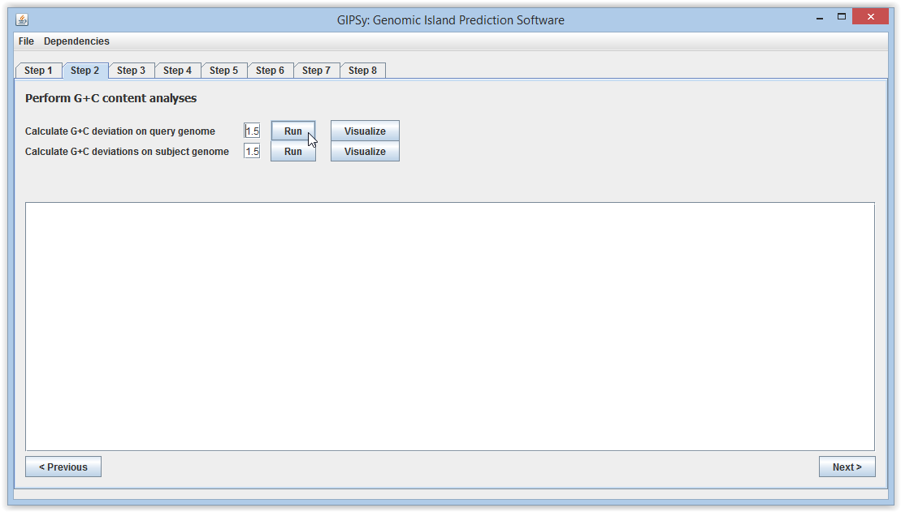

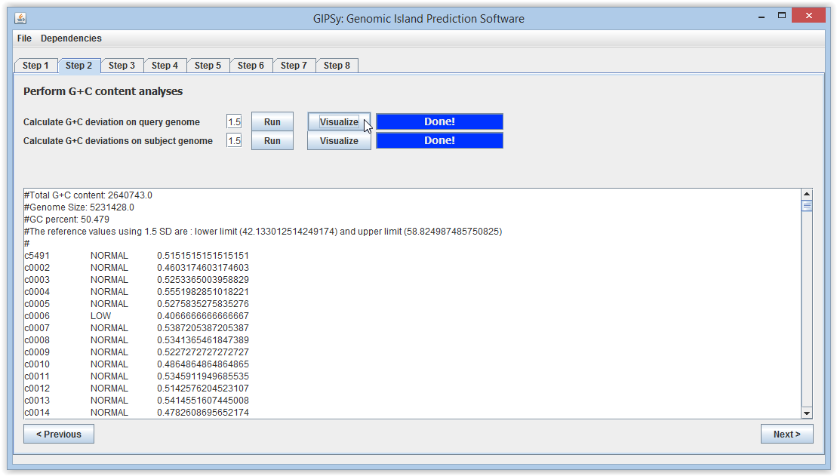

2.4 Step 3
On Step 3, you may choose the sensitivity, from 0.5 to 0.95, for codon usage deviation analyses in Colombo/SigiHMM. The standard value is 0.95. After choosing the cutoff for both query and subject, run the analyses and click visualize in order to see the results.

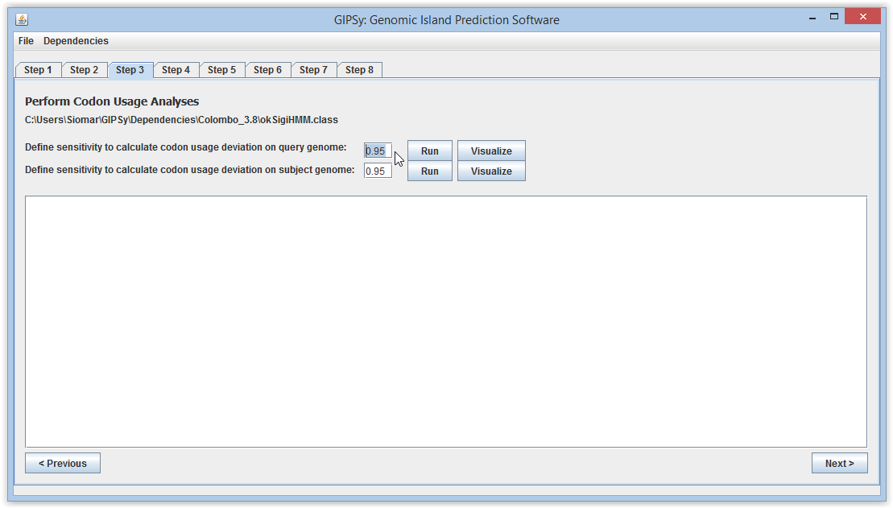

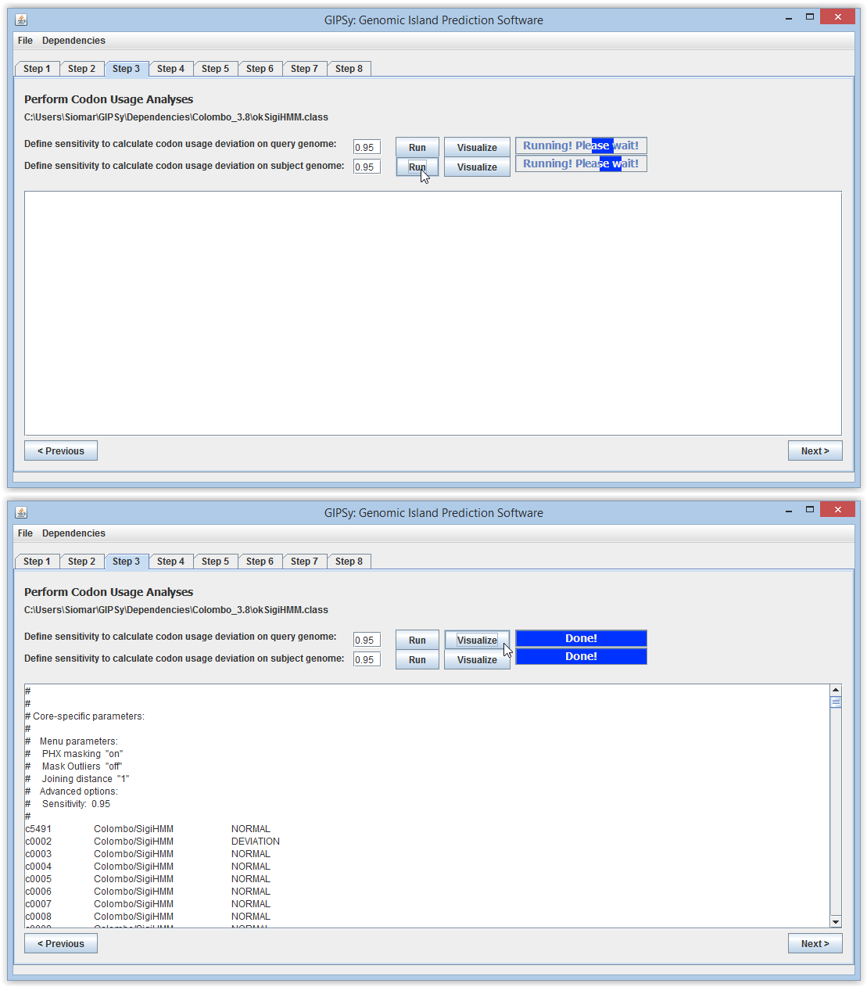

2.5 Step 4
On Step 4, you may choose the e-value for transposase prediction using HMMer. The standard value is 0.0001. After choosing the e-value, run the analyses and click visualize in order to see the results.

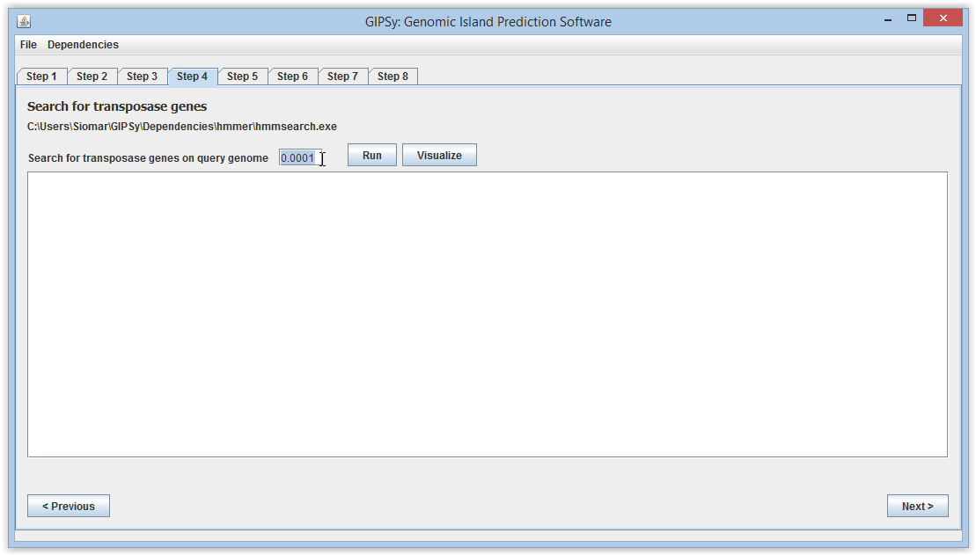

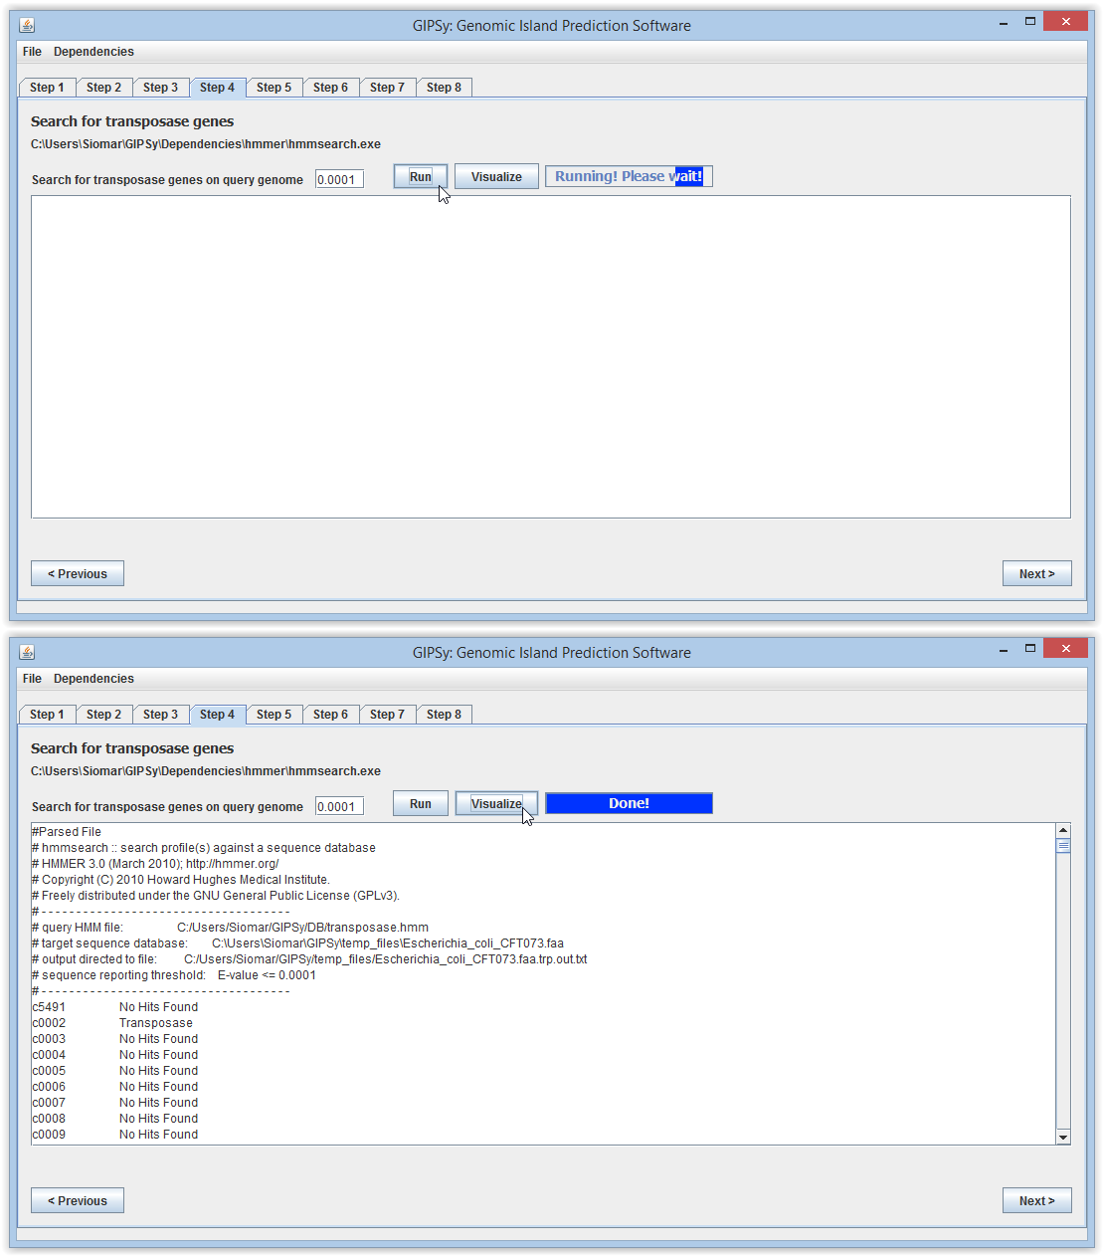

2.6 Step 5
On Step 5, you may choose the e-value for the prediction of specific factors using blastp. The standard value is 0.000001. Moreover, if you are striving to predict Pathogenicity Islands, run the prediction for virulence factors. If you are searching for Resistance Islands, run the analyses for antibiotic resistance genes, and so on. After choosing the e-value, run the analyses for “Virulence Factors” and click visualize in order to see the results.

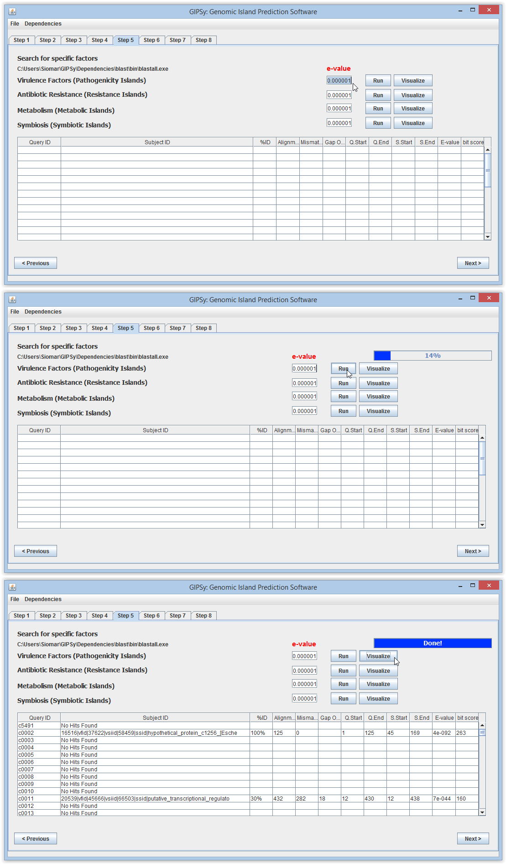
2.6.1 Visualizing the amino acid composition and blast result for each gene (Step 5)
The first and second columns of the table in Step 5 are clickable. Choose some gene and click in the first column in order to see its amino acid composition.

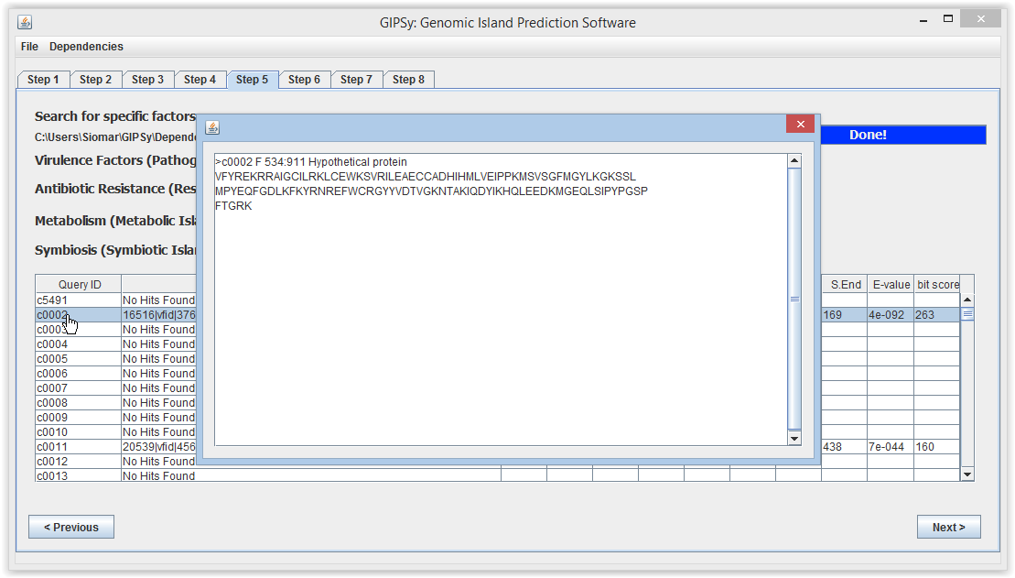

If you want to see the blast result of the given gene against the specific factor database, cli ck the second column and the alignment will appear.

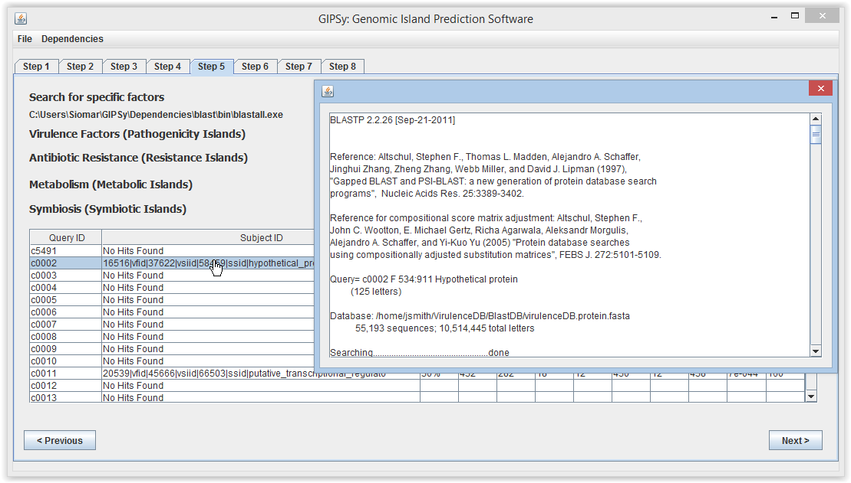

2.7 Step 6
On Step 6, you may choose the e-value for reciprocal blast analyses between the query and subject genomes. The standard value is 0.000001. After choosing the e-value, run the analyses and click visualize in order to see the results.

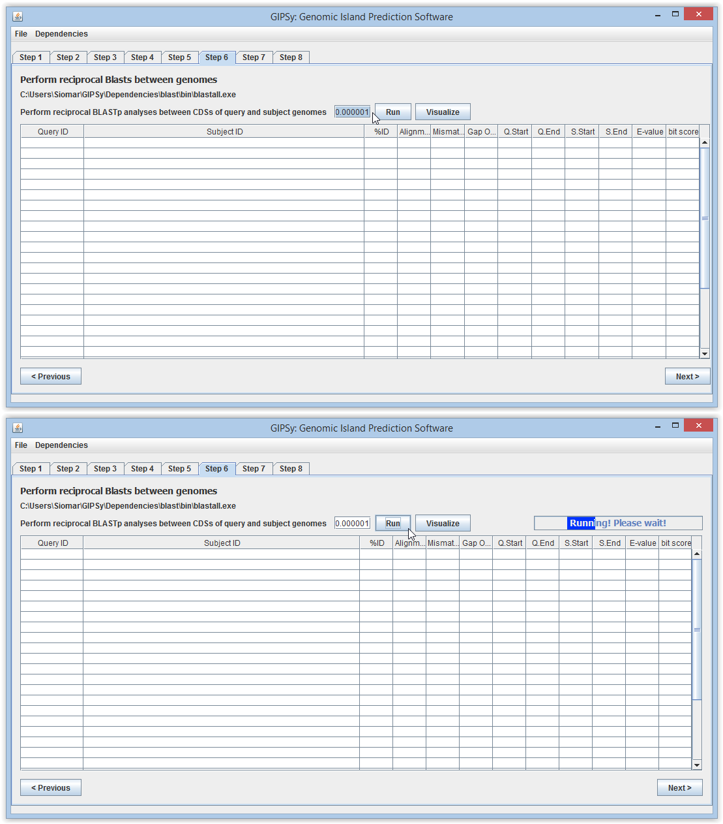

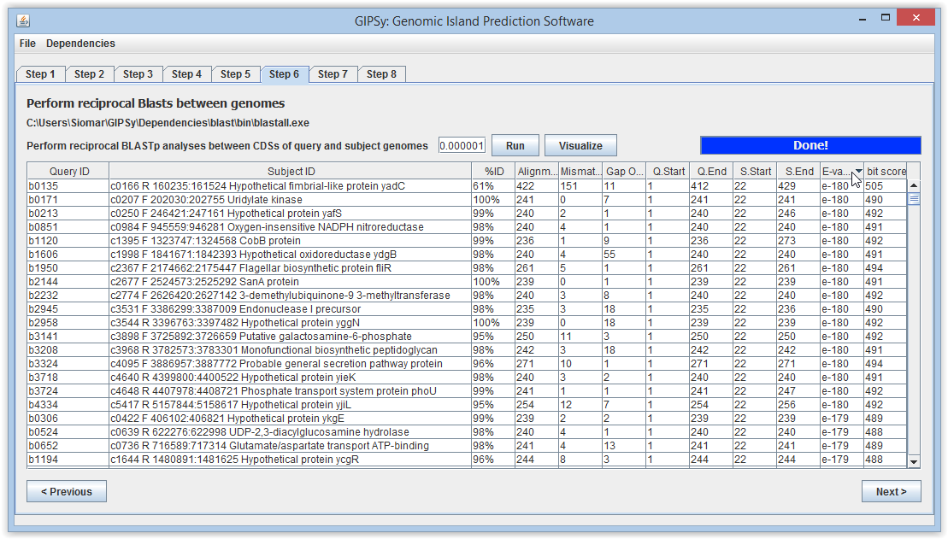

2.8 Step 7
On Step 7, you may choose the e-value for tRNA prediction using HMMer. The standard value is 0.0001. After choosing the e-value, run the analyses and click visualize in order to see the results.

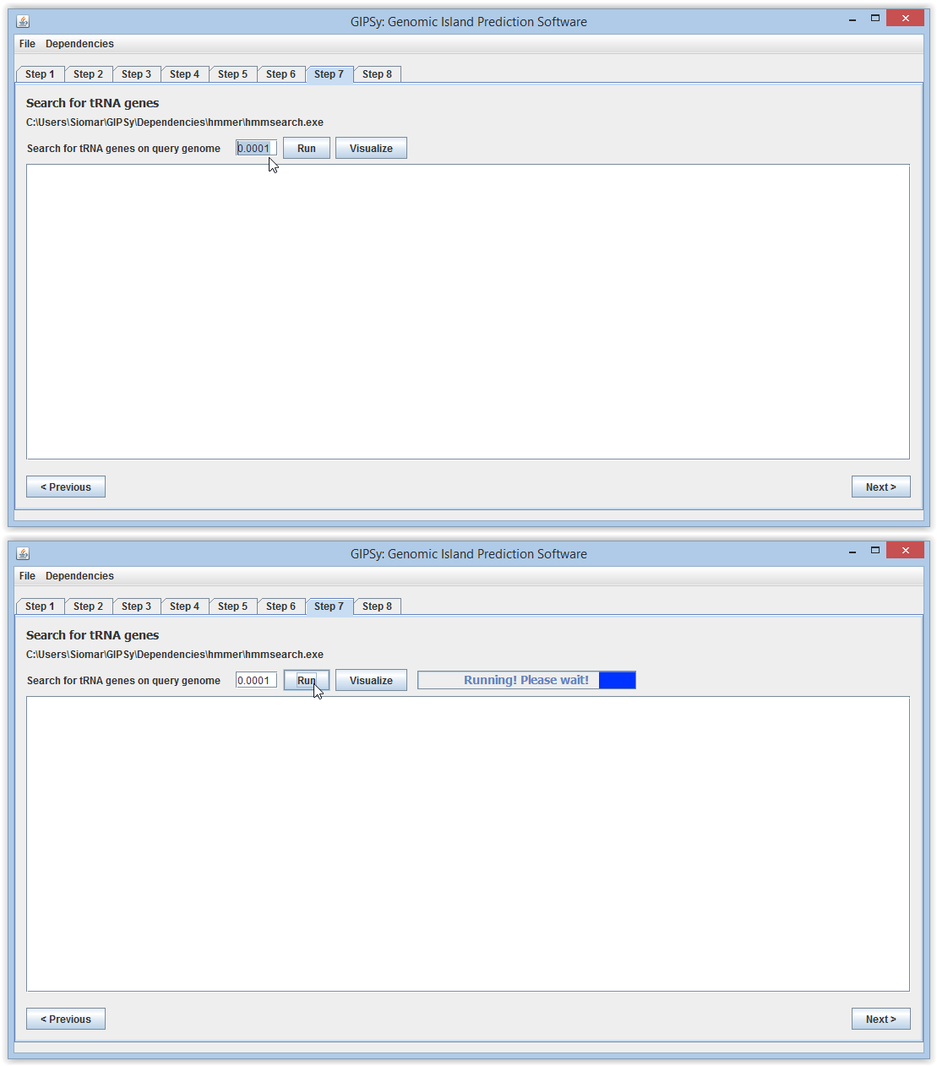

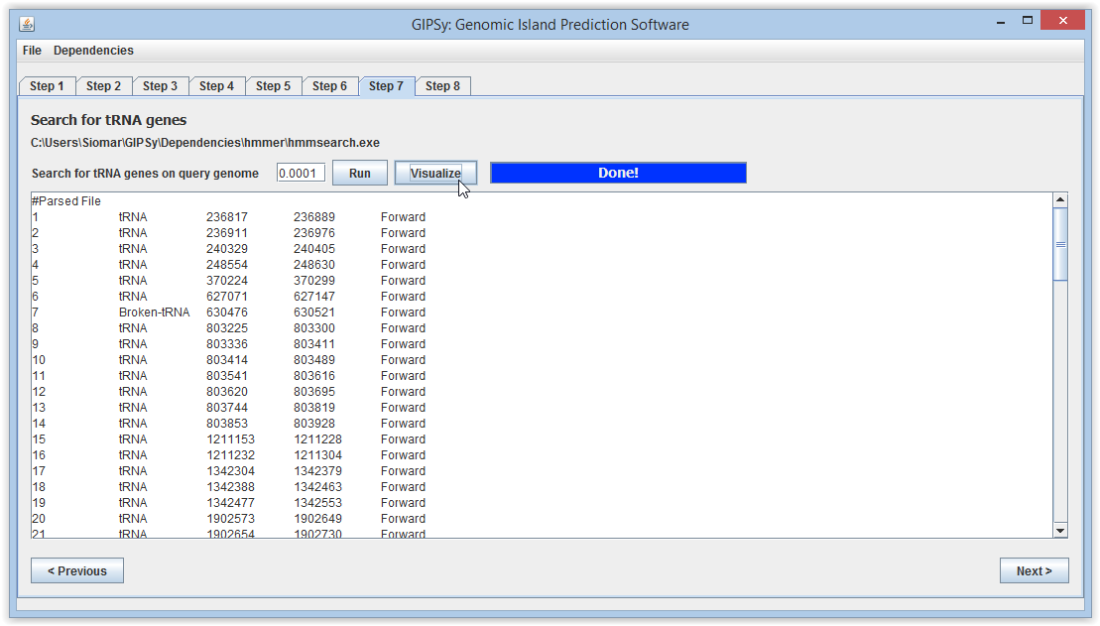

2.9 Step 8
Finally, on Step 8, all the data from the previous steps are used to predict the chosen genomic islands of the given organism. Run the analyses for “Pathogenicity Islands” and click visualize in order to see the results.

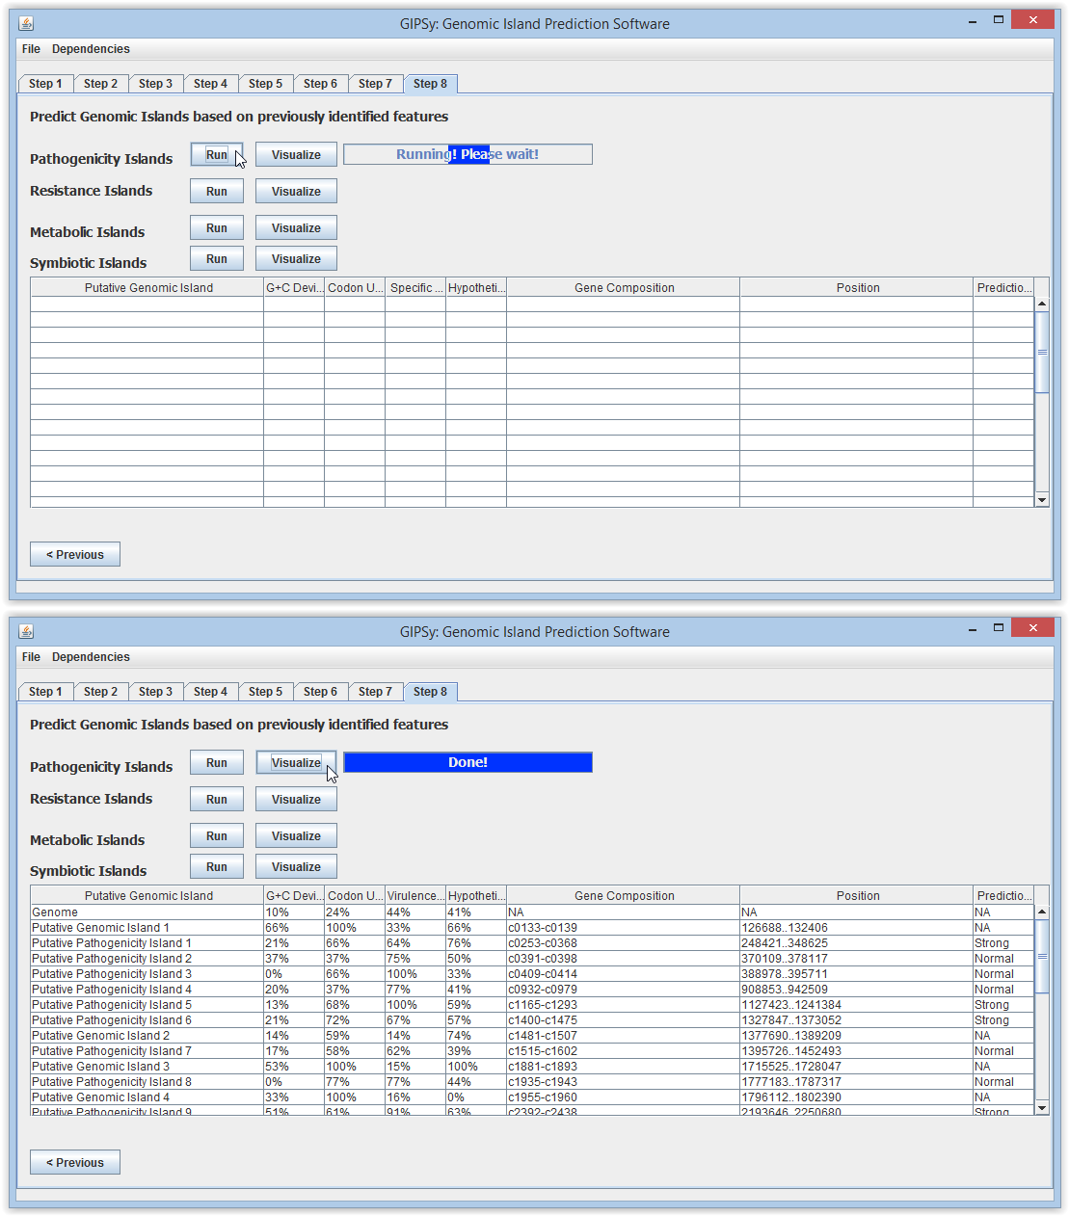

3. Saving results and exporting additional analyses
After all the analyses have been performed, the results may be saved by clicking “File → Save
Results → PAI Results”.

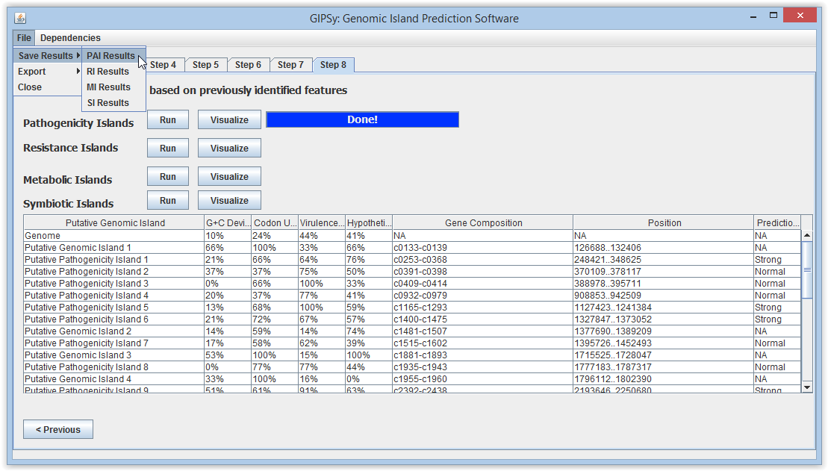

Also, the results for each intermediary step may also be exported in “File → Export”.

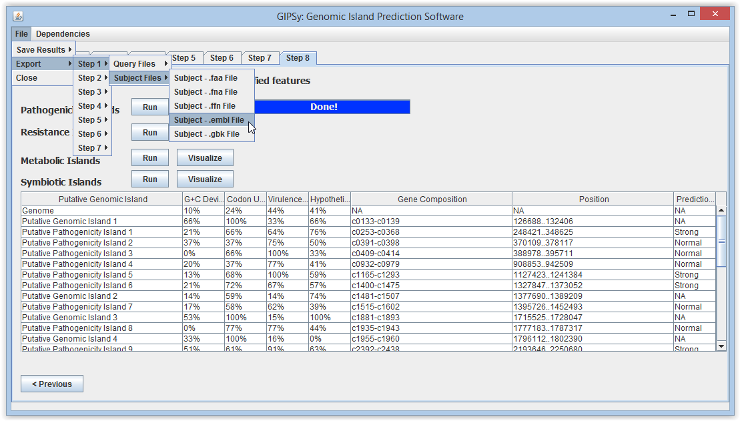

4. TroubleShooting

4.1 GIPSy breaks at step 5 on Linux
If GIPSy returns an error message at step 5 on Linux, there is probably a limitation on the number of files submitted to blastp. In order to circumvent this problem, please try increasing the ulimit. In Ubuntu, you must modify /etc/security/limits.conf. In a terminal, type:
sudo gedit /etc/security/limits.conf
Then, before the end of file, add the following lines:

* soft nofile 40000
* hard nofile 40000
# End of file
Also, you need to modify the following just before the end of file:
sudo gedit /etc/pam.d/common-session*
session required pam_limits.so
# end of pam-auth-update config
Finally, restart your machine and test your new ulimit typing on the terminal:
ulimit -n

4.2 GIPSy breaks at steps 4 and 7 on Linux
In this version of GIPSy, we used a 32 bits version of hmmer, which prevents it from working properly on some Linux distributions. We are currently working to update the dependencies package; however, this problem may also be circumvented by installing some 32 bits libraries. On Ubuntu, open a terminal and type:
sudo apt-get install libgtk2.0-0:i386 libnss3-1d:i386 libnspr4-0d:i386 lib32nss-mdns libxml2:i386 libxslt1.1:i386 libstdc++6:i386

4.3 GIPSy breaks at steps 3 to 7 on Linux
Finally, when the files or their paths have spaces in their names, the third-party software may not work properly. We tried to circumvent this the most as possible. However, the command formatdb from blast is still not working fine. So, in order to circumvent this problem, avoid any space in the names of files.
Wrong: Corynebacterium pseudotuberculosis 1002.gbk
Right: Corynebacterium_pseudotuberculosis_1002.gbk
Also, be sure that the complete path does not have any spaces in names.
Wrong: /home/siomar/gipsy folder/Corynebacterium.gbk
Right: /home/siomar/gipsy_folder/Corynebacterium.gbk

5. Acknowledgments
We would like to kindly thank Taryn Takebayashi for sharing her experience with the software and also for providing a valuable feedback on the problems from sections 4.1 and 4.2.

