**See powerpoint PDF for background information**



**Place to get code for activity - run R in jupyter notebook:**

[https://mybinder.org/v2/gh/bioinfo-ucsd/outreachWorkshop_SIRinR/HEAD](https://mybinder.org/v2/gh/jennifer-bio/SIR_workshop/HEAD)

**If you do not want to code but explore parameters:**

<https://alhill.shinyapps.io/COVID19seir/>

Combination of makes ***Set transmission rates...***​ ​ makes up beta

Combination of ***Set clinical parameters…*** ​ ​makes gamma

**Download code for future:** your current work, ​

[https://github.com/bioinfo-ucsd/outreachWorkshop_SIRinR](https://github.com/jennifer-bio/SIR_workshop)

**Interesting things to learn and some places to go after conference to continue learning:**

**Background knowledge related to this activity**

* SIR model

■ Adding compartments

[https://towardsdatascience.com/infectious-disease-modelling-beyond-thebasic-sir-model-216369c584c4](https://towardsdatascience.com/infectious-disease-modelling-beyond-the-basic-sir-model-216369c584c4)

■ Pre made R starting code <https://cran.r-project.org/web/packages/shinySIR/vignettes/Vignette.html>

* 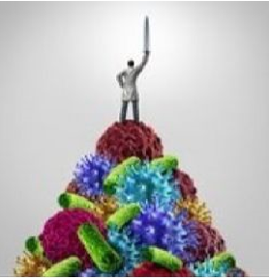Cell biology
* Viruses in people
  1. Short article <https://www.thepartnershipineducation.com/resources/immune-system>

○ Full course [https://www.edx.org/course/viruses-how-to-beat-them-cells-immunity-vacc ines](https://www.edx.org/course/viruses-how-to-beat-them-cells-immunity-vaccines)

**Technical skills - shares skills with data science**

* Computer ideas/introductory algorithms practice - drag and drop scratch

<https://scratch.mit.edu/>

* Computer coding - python and R
  1. <https://www.codecademy.com/>

○ <https://www.dataquest.io>

○ Edx - a few course examples I have not looked into

- https://www.edx.org/course/programming-for-everybody-getting- st[arted-with-pyt](https://www.edx.org/course/programming-for-everybody-getting-started-with-pyt)

-[https://www.edx.org/course/python-basics-for-data-scienc](https://www.edx.org/course/python-basics-for-data-science)​[e](https://www.edx.org/course/python-basics-for-data-science)

○ Partial course available online for introduction to python:

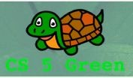<https://www.cs.hmc.edu/twiki/bin/view/CS5>​ and

with biology motivated problems: <https://www.cs.hmc.edu/twiki/bin/view/CS5Gree>​[n](https://www.cs.hmc.edu/twiki/bin/view/CS5Green)

(textbook completes the information)

* Statistics