Supplementary Material
Bandwise Stability and Redundancy Selection for Near-Infrared Prediction of Total C21 Steroidal Glycoside Equivalents in Baishouwu
Cheng Guo ¹, Chen Qiu ¹, Yang Qian ¹, Hongle An ^{2,*}, Mingguang Zhang ¹, Baolin Zhu ^{3,4,*} and Cuiyan Han ^{1,*}
¹ School of Pharmacy, Jiangsu Medical College, Jiangsu 224005, PR China
² Key Laboratory of Magnetic Molecules and Magnetic Information Materials (Ministry of Education), College of Chemistry and Chemical Engineering, Shanxi Normal University, Taiyuan 030006, PR China
³ College of Chemistry, Nankai University, Tianjin 300071, China
⁴ National Demonstration Center for Experimental Chemistry Education, Nankai University, Tianjin 300071, China
* Correspondence: honglean@sxnu.edu.cn (H.A.); zhubaolin@nankai.edu.cn (B.Z.);
hancuiyan@jsmc.edu.cn (C.H.)

Supplementary figures and tables
The analysis uses 84 samples, each measured at 141 near-infrared spectral variables. SPXY partitions the samples into 63 calibration and 21 prediction samples using normalized Euclidean distances in the full raw spectral matrix and the reference response. The main manuscript defines the preprocessing, variable-selection methods and calibration procedure.
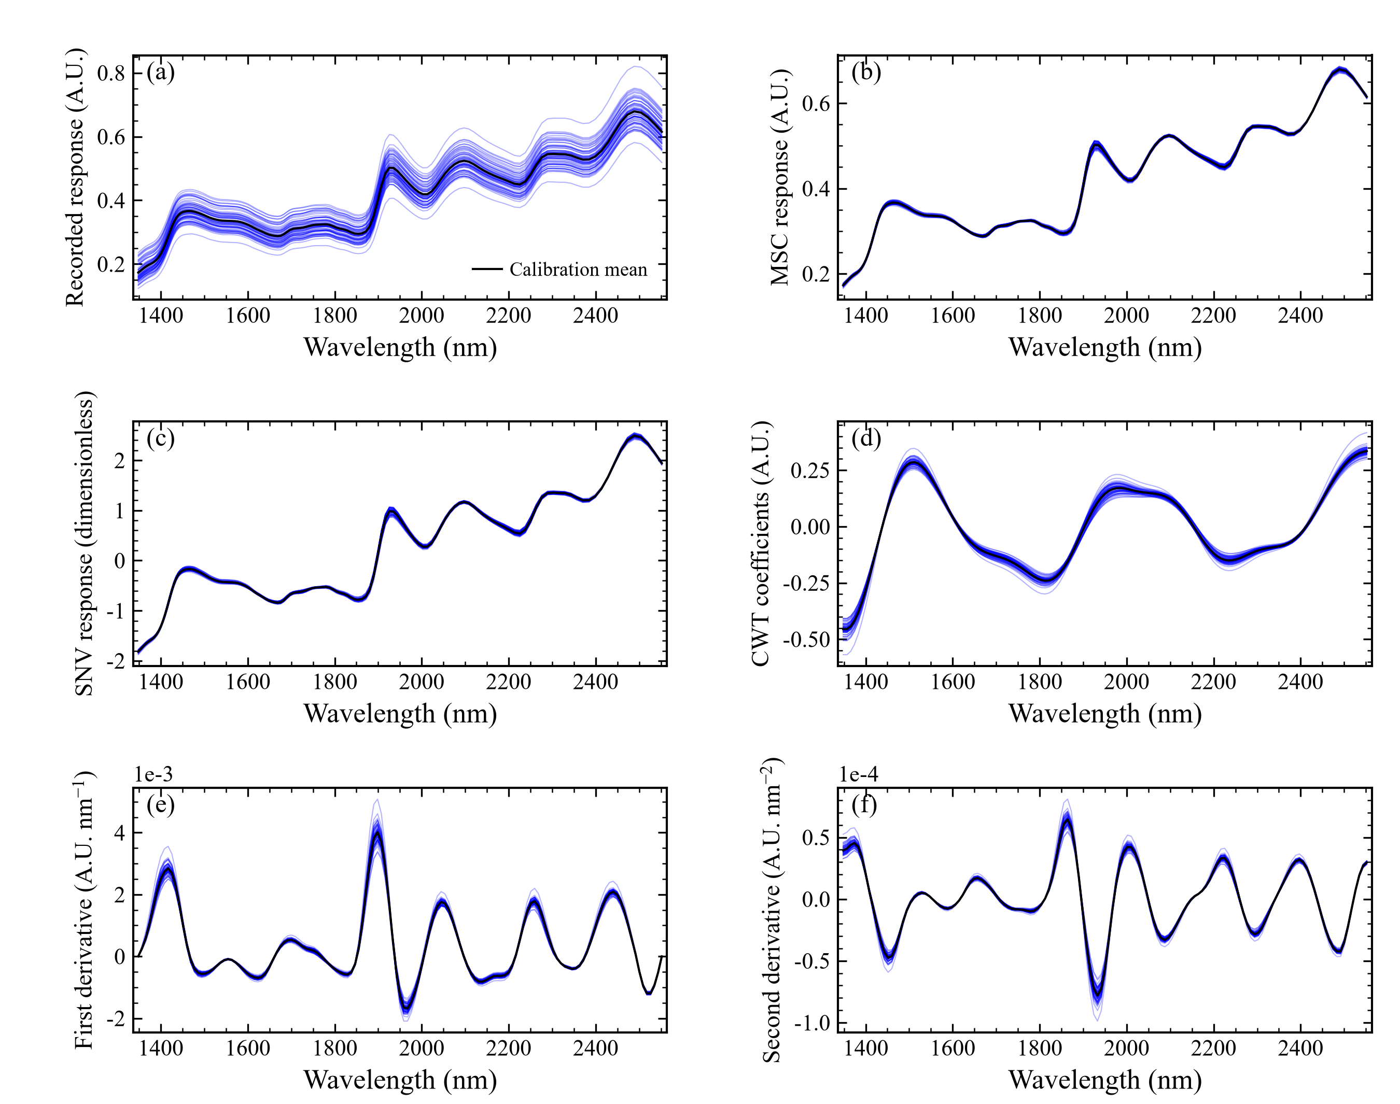
Figure S1. Calibration spectra under (a) raw, (b) MSC, (c) SNV, (d) CWT, (e) first-derivative and (f) second-derivative preprocessing. Thin blue curves represent individual samples and black curves their means. MSC references use calibration samples; derivatives and CWT use uniform wavelength grids. Vertical scales retain the units of each transformation.
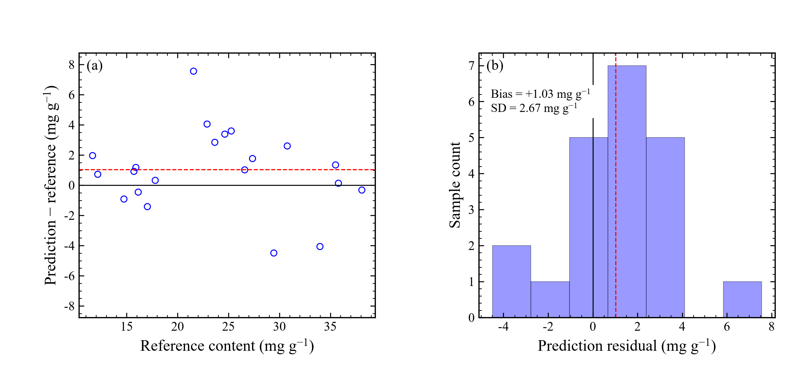
Figure S2. Prediction residuals for the calibration-selected BSRS model: (a) residuals versus reference content and (b) residual distribution for the 21 prediction samples. Black lines indicate zero error and red dashed lines indicate mean bias.
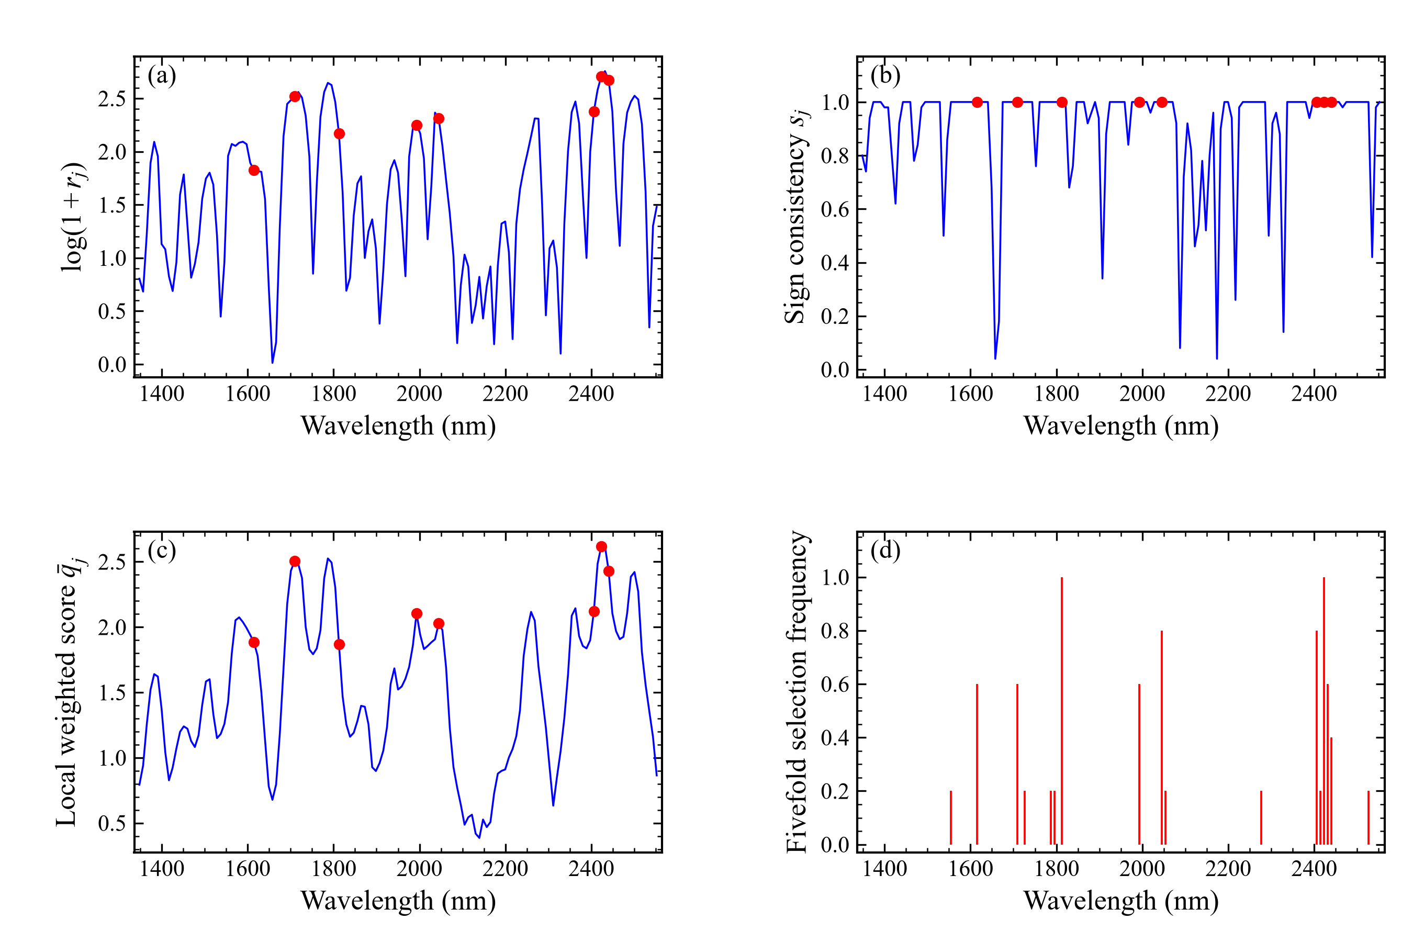
Figure S3. BSRS diagnostics: (a) log coefficient reliability, (b) sign consistency, (c) the five-variable local mean of sign-weighted log reliability and (d) fivefold selection frequency. Red points mark selected variables. Reliability uses 100 subsamples containing 80% of calibration samples without replacement; selection frequency describes consistency across calibration folds.
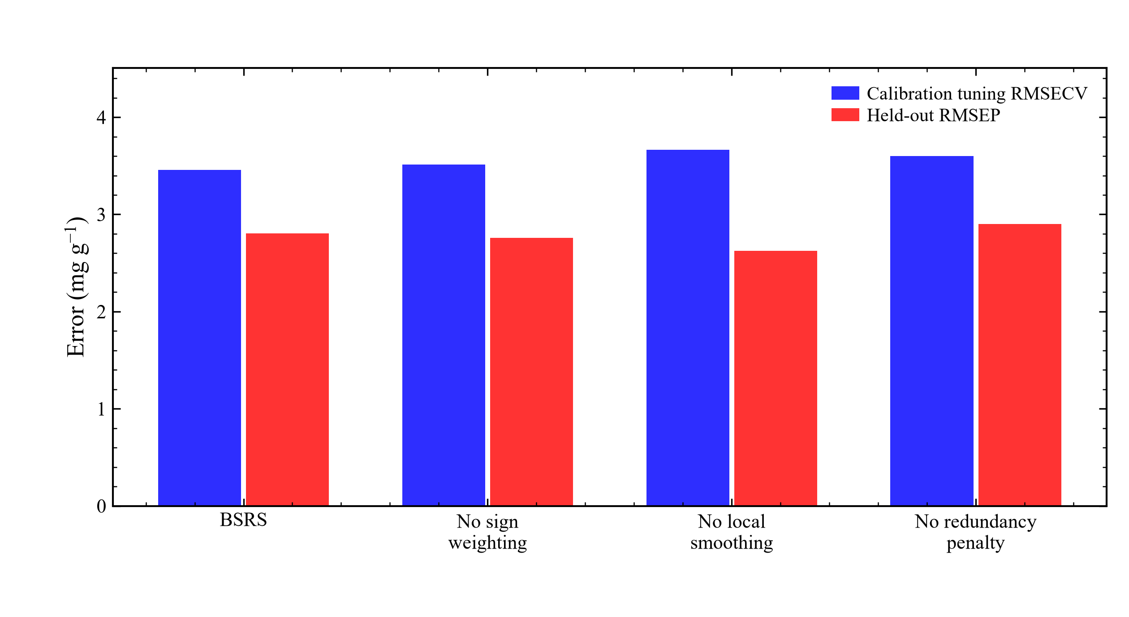
Figure S4. BSRS component ablations with separately optimized variable budgets and latent-variable counts. Blue bars show fivefold calibration RMSECV and red bars show prediction RMSEP. Each ablation omits sign weighting, local smoothing or redundancy penalization.
Table S1. Complete sample assignment for the SPXY 75:25 partition.
Sample row | Source ID | Reference  (mg g⁻¹) | Set
1 | A01 | 15.51 | Calibration
2 | A02 | 12.24 | Calibration
3 | A03 | 17.81 | Calibration
4 | A04 | 18.93 | Calibration
5 | A05 | 19.34 | Calibration
6 | A06 | 12.72 | Calibration
7 | A07 | 15.16 | Calibration
8 | A08 | 13.28 | Calibration
9 | A09 | 16.14 | Prediction
10 | A10 | 16.42 | Calibration
11 | A11 | 13.98 | Calibration
12 | A12 | 16.42 | Calibration
13 | A13 | 17.04 | Prediction
14 | A14 | 17.81 | Prediction
15 | A15 | 14.74 | Prediction
16 | A16 | 18.86 | Calibration
17 | A17 | 16.97 | Calibration
18 | A18 | 19.34 | Calibration
19 | A20 | 19.97 | Calibration
20 | B01 | 15.72 | Prediction
21 | B02 | 16.35 | Calibration
22 | B03 | 14.19 | Calibration
23 | B04 | 17.60 | Calibration
24 | B05 | 16.28 | Calibration
25 | C01 | 23.66 | Prediction
26 | C02 | 24.57 | Calibration
27 | C03 | 26.59 | Prediction
28 | C04 | 28.61 | Calibration
29 | C05 | 28.54 | Calibration
30 | C06 | 29.45 | Prediction
31 | C07 | 21.99 | Calibration
32 | C08 | 24.15 | Calibration
33 | C09 | 22.13 | Calibration
34 | C10 | 25.20 | Calibration
35 | C11 | 27.22 | Calibration
36 | C12 | 25.96 | Calibration
37 | C13 | 27.85 | Calibration
38 | C14 | 26.17 | Calibration
39 | C15 | 22.90 | Prediction
40 | C16 | 23.94 | Calibration
41 | C17 | 27.64 | Calibration
42 | C18 | 25.27 | Prediction
43 | C19 | 23.39 | Calibration
44 | C20 | 24.64 | Prediction
45 | C21 | 23.53 | Calibration
46 | C22 | 27.78 | Calibration
47 | C23 | 27.36 | Prediction
48 | C24 | 21.57 | Prediction
49 | C25 | 21.37 | Calibration
50 | C26 | 22.62 | Calibration
51 | D01 | 31.19 | Calibration
52 | D02 | 35.79 | Prediction
53 | D03 | 37.95 | Calibration
54 | D04 | 35.51 | Prediction
55 | D05 | 36.07 | Calibration
56 | D06 | 30.22 | Calibration
57 | D07 | 32.38 | Calibration
58 | D08 | 30.91 | Calibration
59 | D09 | 37.05 | Calibration
60 | D10 | 39.55 | Calibration
61 | D11 | 42.69 | Calibration
62 | D12 | 34.47 | Calibration
63 | D13 | 38.02 | Calibration
64 | D14 | 38.09 | Prediction
65 | D15 | 32.45 | Calibration
66 | D16 | 33.70 | Calibration
67 | D17 | 36.91 | Calibration
68 | D18 | 36.21 | Calibration
69 | D19 | 33.98 | Prediction
70 | D20 | 35.30 | Calibration
71 | D21 | 31.12 | Calibration
72 | D22 | 35.16 | Calibration
73 | D23 | 30.77 | Prediction
74 | D25 | 45.13 | Calibration
75 | E01 | 15.35 | Calibration
76 | E02 | 21.64 | Calibration
77 | E03 | 21.95 | Calibration
78 | E04 | 15.91 | Prediction
79 | E05 | 11.31 | Calibration
80 | E06 | 12.42 | Calibration
81 | E07 | 11.66 | Prediction
82 | E08 | 11.49 | Calibration
83 | E09 | 11.14 | Calibration
84 | E10 | 12.17 | Prediction
Source identifiers link the numerical data to the companion reference-content records. No sample exclusion was applied.
Table S2. Additional prediction performance for the SPXY prediction set.
Method | MAE | Bias | RPD | RPIQ
Full-spectrum PLS | 2.125 | 0.857 | 2.815 | 4.594
UVE rank-PLS | 2.552 | 0.948 | 2.483 | 4.053
MC-UVE rank-PLS | 2.294 | 1.119 | 2.942 | 4.801
RT-PLS | 2.190 | 1.145 | 2.971 | 4.848
C-value-PLS | 2.476 | 0.635 | 2.566 | 4.188
BSRS-PLS | 2.146 | 1.035 | 2.907 | 4.744
MAE and bias are in mg g⁻¹. RPD and RPIQ are dimensionless.
Table S3. Descriptive selection consistency across calibration CV folds.
Method | Final variables | Mean fold Jaccard
Full-spectrum PLS | 141 | 1.000
UVE rank-PLS | 8 | 0.560
MC-UVE rank-PLS | 8 | 0.515
RT-PLS | 8 | 0.707
C-value-PLS | 32 | 0.295
BSRS-PLS | 8 | 0.410
Pairwise Jaccard similarity is averaged across ten pairs of five calibration CV training folds. The subsets may have different sizes.
Table S4. Final BSRS wavelength positions.
Grid | Count | Selected wavelength positions (nm)
Uniform grid | 8 | 1614.8, 1709.4, 1812.6, 1993.1, 2044.7, 2405.8, 2423.0, 2440.2
These positions are predictive features rather than molecular assignments. selected_wavelengths.csv records the selections of every comparator at full precision.
Table S5. Settings required to reproduce the comparisons.
Setting | Value
Input | 84 samples; 141 near-infrared spectral variables
Partition | SPXY; 63 calibration and 21 prediction samples
SPXY distance | Full raw spectral Euclidean distance divided by its maximum plus response Euclidean distance divided by its maximum
Random seed | 20261006; deterministic offsets for selector and fold draws
Preprocessing selection | Minimum five-fold full-spectrum calibration tuning RMSECV
PLS | Mean centering; no autoscaling; 1–10 requested LVs
Derivative | Uniform grid; cubic Savitzky–Golay; 15 points; mirror edges
CWT | Uniform grid; Mexican hat; scale 10; integration precision 10; 40-point reflected boundary extension
Stability sampling | 100 subsamples; 80% without replacement
UVE | Leave-one-out reliability; appended Gaussian noise; CV-tuned rank prefix
MC-UVE | 100-subsample reliability; appended Gaussian noise; CV-tuned rank prefix
RT | 199 response permutations; finite-sample correction
C-value adapted | 2p binary subset rows; 70% inclusion; three-fold internal CV
BSRS | Sign-weighted log reliability; five-point smoothing; redundancy weight 2
Subset budgets | 4, 8, 16, 32, 64, 71 and 128

Computational reproducibility
The complete program includes data_io.py, analysis.py, plot_figures.py, verify_results.py, predict_new.py and build_manuscript.py. run_all.py executes the pipeline. The input MAT file contains the 141-variable spectral matrix, its wavelength vector and the reference response; its SHA-256 hash, SPXY assignments, model coefficients and numerical outputs are included. Requirements and tested package versions are documented. Figures are generated directly from result tables.

