Multi-Organ Transcriptomic Integration Identifies an Angptl4-Syndecan/Cadherin Axis Underlying Cardiohepatic Syndrome and Guides Structure-Based Drug Screening
202251154 Changwoo Lee

Abstract
Heart failure with preserved ejection fraction (HFpEF) and metabolic dysfunction-associated steatotic liver disease (MASLD) are increasingly recognized as bidirectionally linked through a cardio-hepatic axis, yet the molecular mediators of this crosstalk remain incompletely defined. We reanalyzed a paired bulk RNA-seq dataset (liver and left ventricle from the same C57BL/6N mice, chow vs. a 2-hit HFpEF diet, n=5/group; Zenodo 12794566) using a stricter statistical threshold (padj<0.01, |log2FC|>1.5) than the original publication. Contrary to our initial hypothesis of a liver-to-heart signal, curated ligand-receptor annotation (CellChatDB) and STRING protein-protein interaction network analysis found no cross-organ edge in that direction, but identified a heart-to-liver candidate axis: Angptl4 (upregulated in HFpEF left ventricle) paired with Cdh5/Sdc1-4 (expressed in liver). Reusing an independently annotated human liver single-cell atlas (GSE136103), Sdc1/Sdc4 localized to hepatocytes, consistent with their status as the top network hubs (degree 16 and 14, respectively). However, all available crystal structures of Sdc1/Sdc4 cover non-extracellular fragments unsuitable for structure-based docking, so we redirected structure-based screening to ANGPTL4's C-terminal fibrinogen-like domain (PDB 6EUB) - a genuinely undrugged target (zero DGIdb drug interactions) independently validated by a 2024 single-cell study showing cardiac-fibroblast-specific ANGPTL4 secretion in HFpEF. AutoDock Vina screening of 21 compounds (cardiometabolic drugs, endogenous fatty acids, and unrelated controls) ranked Resmetirom (the first FDA-approved MASH drug) and Ezetimibe as the top two hits (-9.07 and -8.88 kcal/mol). An orthogonal, box-free DiffDock cross-check showed Ezetimibe's top pose converging within 3.5 A of the Vina-defined pocket, while Resmetirom's top pose landed 23.5 A away at a distinct site - reframing Ezetimibe, not the top Vina scorer, as the more cross-validated candidate. This work illustrates how a rigorously reanalyzed, genuinely null result can redirect a network pharmacology pipeline toward a clinically relevant, testable hypothesis.
Keywords: HFpEF, MASLD, cardio-hepatic axis, ANGPTL4, network pharmacology, molecular docking

1. Introduction
Metabolic dysfunction-associated steatotic liver disease (MASLD) has superseded the purely descriptive term "non-alcoholic fatty liver disease" (NAFLD), reflecting a paradigm in which systemic metabolic dysfunction - insulin resistance, obesity, and dyslipidemia - is understood to interact directly with the liver rather than merely coexist with it (Rinella et al., 2023). Over the past three years, the focus of liver-disease research has likewise shifted from purely intrahepatic pathology toward inter-organ crosstalk, driven in part by the observation that the leading cause of death in MASLD/MASH patients is cardiovascular disease rather than cirrhosis. This epidemiological fact has accelerated interest in the cardio-hepatic axis.
Heart failure with preserved ejection fraction (HFpEF) is a central phenotype of this cardio-hepatic interaction. A recent study was the first to systematically profile the liver and heart of the same animals in a 2-hit HFpEF mouse model (combined metabolic and hypertensive stress) and nominated Saa1/Saa4 as candidate liver-to-heart mediators (Strocchi et al., 2024). A follow-up study used hepatocyte-specific secretome labeling to show that the liver's secreted cytokine signature is altered under HFpEF (Schütte et al., 2025). However, neither study extended beyond the systems-biology discovery stage into protein-protein interaction (PPI) network construction, network pharmacology, or structure-based virtual screening.
The present study set out to reanalyze this public dataset under a substantially stricter statistical threshold and to carry the analysis all the way through ligand-receptor interactome matching, a STRING-based PPI network, STITCH network pharmacology, DGIdb druggability assessment, and, finally, structure-based virtual screening with AutoDock Vina and DiffDock. This effort builds directly on our own prior work profiling human MASLD liver-fibrosis cohorts (GSE135251 and GSE136103), from which several candidate genes - LUM, THY1, THBS2, EDNRB, and CD44/ITGA1/ITGB1 - were previously nominated; the present study extends that program by moving from mouse to a genuinely inter-organ (liver-heart) axis. Contrary to our initial hypothesis, the data pointed not toward a liver-secreted factor acting on the heart, but toward the reverse - a heart-secreted factor acting on the liver - a direction that in fact aligns closely with the clinically established entity of congestive hepatopathy/cardiohepatic syndrome. Rather than treating this reversal as a disappointment, we report it as a genuine finding and follow it through to a druggability assessment and a compound-level screen.

2. Methods

2.1 Dataset
This study reused publicly deposited data (Zenodo record 12794566) from Strocchi et al. (2024), published in Circulation Research. Male C57BL/6N mice were subjected for 8 weeks to a 2-hit HFpEF-inducing regimen (combined metabolic and hypertensive stress; HFpEF group, n=5) or a normal chow diet (Chow group, n=5), after which liver and left-ventricular (LV) tissue were each profiled by bulk RNA-seq. We used the deposited raw count matrices and phenotypic metadata (echocardiographic indices, organ weights) as-is. Because liver and LV were sampled from the same animals rather than from independently recruited cohorts, this dataset constitutes a genuine paired multi-organ resource, appropriate for addressing inter-organ crosstalk.

2.2 Differential expression analysis
DESeq2 (Love et al., 2014) was applied independently to each organ. Genes were pre-filtered to those with a raw count ≥10 in at least 5 of the 10 samples, and log2 fold changes were shrunk using apeglm (Zhu et al., 2019). We defined significant DEGs using a threshold stricter than the conventional padj<0.05 - specifically padj<0.01 and |log2FC|>1.5 - to minimize false positives.

2.3 GSEA, GO, and KEGG enrichment
GSEA against the Hallmark gene set collection (msigdbr, Mus musculus) was performed with fgsea (Korotkevich et al., 2019). Because apeglm-shrunk results omit the Wald statistic, the ranking metric was reconstructed as sign(log2FC) x (-log10 p-value). For the significant DEG lists, clusterProfiler (Wu et al., 2021) was used for GO Biological Process and KEGG (organism=mmu) over-representation analysis (BH-adjusted padj<0.05).

2.4 Ligand-receptor interactome matching
Upregulated DEGs from each organ were treated as candidate ligands and matched against CellChatDB.mouse's curated ligand-receptor pairs (Jin et al., 2021). Requiring that both the ligand and its receptor independently clear genome-wide significance is unnecessarily strict, since a receptor can transduce a signal without itself being transcriptionally altered; we therefore relaxed the receptor-side criterion to "detectably expressed" in the target organ (baseMean≥10). Both the liver-to-LV and LV-to-liver directions were tested.

2.5 STRING protein-protein interaction network
Matched genes and up to 15 additional first-shell interactors were queried against the STRING API (Szklarczyk et al., 2023; mouse taxid 10090, confidence score≥0.7). Degree and betweenness centrality were computed with igraph to identify hub genes. Cytoscape 3.10.4 was installed for visualization, but its CyREST interface proved unreliable in this environment, so the final network figure was generated with igraph instead (Cytoscape remains available for manual use).

2.6 Cell-type localization
Because no single-cell data exist from the same experiment as the bulk cohort, cell-type expression of the final candidate genes was assessed using an already-annotated Seurat object from our own prior work (project4, human liver cirrhosis scRNA-seq, GSE136103; Ramachandran et al., 2019), used strictly as an independent, cross-species reference rather than pooled into any statistical test.

2.7 STITCH network pharmacology and DGIdb druggability
Hub genes from the STRING network were queried against STITCH (Szklarczyk et al., 2016) for known or predicted chemical interactions, with compound names resolved via the PubChem PUG-REST API. Druggability was assessed via the DGIdb 5.0 GraphQL API (Cannon et al., 2024), querying the human ortholog symbol of each gene for existing drug interactions.

2.8 Target structure acquisition
PDB cross-references for each candidate gene were retrieved via the UniProt REST API, and each structure was individually inspected on RCSB PDB to determine which domain (extracellular, transmembrane, or cytoplasmic) it actually represents.

2.9 Structure-based virtual screening with AutoDock Vina
Water molecules and the crystallization additive (1PE, pentaethylene glycol) were removed from the final target structure (PDB 6EUB); the single alternate-location residue was resolved to conformer A. Meeko (mk_prepare_receptor) was used to generate a PDBQT file, and the docking box (24x24x24 A3) was centered on the centroid of the 1PE site - the only small-molecule-occupied surface pocket observed in the crystal structure. The ligand library comprised 21 compounds with SMILES retrieved from PubChem, spanning three categories: (1) fatty acids and Pioglitazone, identified by STITCH as genuine ANGPTL4 chemical partners; (2) Resmetirom, Fenofibrate, Bezafibrate, Ezetimibe, Atorvastatin, Rosiglitazone, Empagliflozin, Dapagliflozin, Obeticholic acid, Icosapent ethyl, Metformin, and Niacin, i.e. approved or late-stage cardiometabolic/MASH drugs; and (3) Aspirin, Ibuprofen, Caffeine, and Metoprolol as mechanistically unrelated controls. Three-dimensional conformers were generated with RDKit (ETKDGv3, MMFF94) and converted to PDBQT with Meeko (mk_prepare_ligand), then docked with AutoDock Vina 1.2.7 (Eberhardt et al., 2021) at exhaustiveness=16, num_modes=5, seed=42.

2.10 DiffDock cross-validation
Because this machine has no CUDA-capable GPU, a from-scratch local DiffDock (Corso et al., 2023) installation was judged impractical for CPU-only inference. Instead, a publicly hosted Gradio Space running the original inference code (gcorso/DiffDock; mirrored at swcanner/DiffDock-Web) was used to cross-validate the top two Vina hits (Resmetirom, Ezetimibe) only. Unlike Vina, DiffDock performs blind docking without a predefined binding site, so agreement between the two methods on the pose location constitutes an independent structural check rather than a simple re-ranking (10 samples per complex, seed unfixed).

3. Results

3.1 Organ-specific differential expression
We first examined organ-specific transcriptional changes in mice exposed to the 2-hit HFpEF regimen. At padj<0.01 and |log2FC|>1.5, 86 genes were significantly differentially expressed in the liver (48 up, 38 down) and 20 in the LV (15 up, 5 down) (Figure 1A, 1B; Supplemental Table S1, S2 list every gene). Unsupervised hierarchical clustering of these DEGs cleanly separated Chow from HFpEF samples in both organs (Figure 2A, 2B). In the liver, acute-phase and inflammation-associated transcripts (Dsg1c, Per2, Saa2, Lcn2) were upregulated, whereas numerous cytochrome P450 family members were downregulated, consistent with disturbed lipid metabolism; in the LV, Chrna2, Hmgcs2, and Mmp12 were upregulated and Cyp1a1 was downregulated.
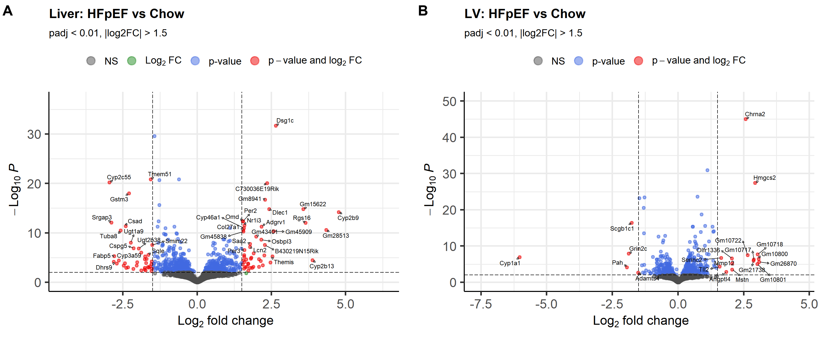
Figure 1. Organ-specific differential gene expression under HFpEF vs. Chow. (A) Liver volcano plot. (B) Left-ventricle (LV) volcano plot. Genes meeting the significance threshold (padj<0.01, |log2FC|>1.5) are shown in red; representative genes are labeled. Full DEG lists are provided in Supplemental Table S1 (liver) and S2 (LV).
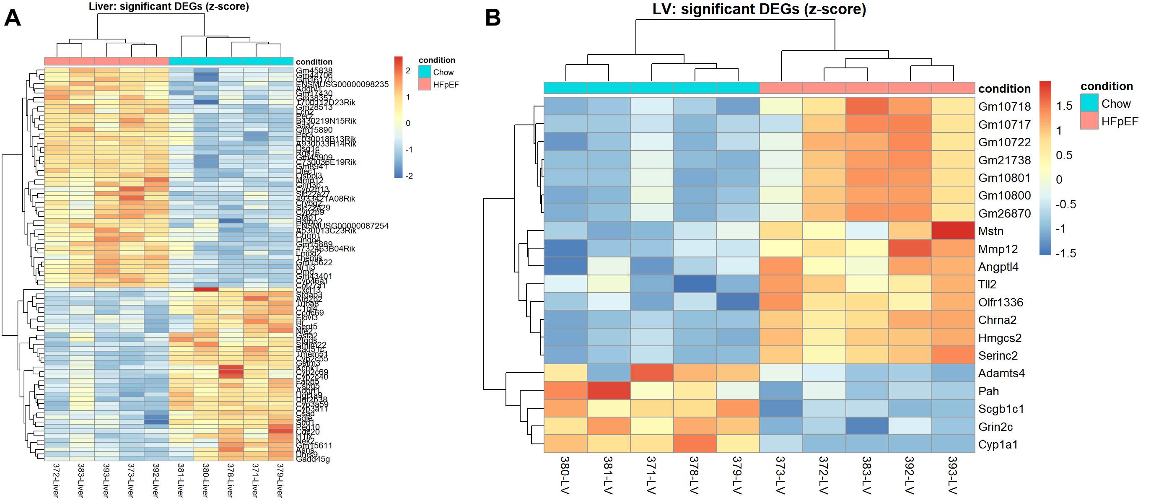
Figure 2. Hierarchical clustering of significant DEGs (z-scored variance-stabilized counts). (A) Liver (n=86 DEGs). (B) LV (n=20 DEGs). Both tissues show unsupervised separation of Chow and HFpEF samples.
We next asked whether the two candidate mediators nominated by the original study, Saa1 and Saa4 (Strocchi et al., 2024), replicated under our stricter criteria. Both genes trended in the same direction as previously reported (Saa1, log2FC=1.16, padj=5.9x10-5; Saa4, log2FC=0.53, padj=0.011) but neither cleared our |log2FC|>1.5 cutoff. We interpret this as a genuine effect-size limitation rather than a false-positive finding in the original report - both genes are statistically robust but their fold-change falls short of our more conservative threshold.

3.2 Pathway-level enrichment (GSEA, GO, KEGG)
Hallmark GSEA identified 19 significantly enriched pathways in the liver and 17 in the LV (padj<0.05; Figure 3A, 3B). In the liver, MTORC1_SIGNALING, CHOLESTEROL_HOMEOSTASIS, and MYC_TARGETS_V1 were downregulated while INTERFERON_ALPHA_RESPONSE was upregulated. In the LV, ADIPOGENESIS, FATTY_ACID_METABOLISM, OXIDATIVE_PHOSPHORYLATION, PEROXISOME, and BILE_ACID_METABOLISM were all markedly upregulated, indicating a shift of cardiac metabolism toward lipid handling and mitochondrial pathways under HFpEF stress - a pattern consistent with the mitochondrial dysfunction reported in prior HFpEF literature. GO Biological Process analysis returned 34 significant terms in the liver and 10 in the LV, and KEGG returned 9 significant pathways in the liver and none in the LV (Supplemental Figure S1, S2; Supplemental Table S3-S5).
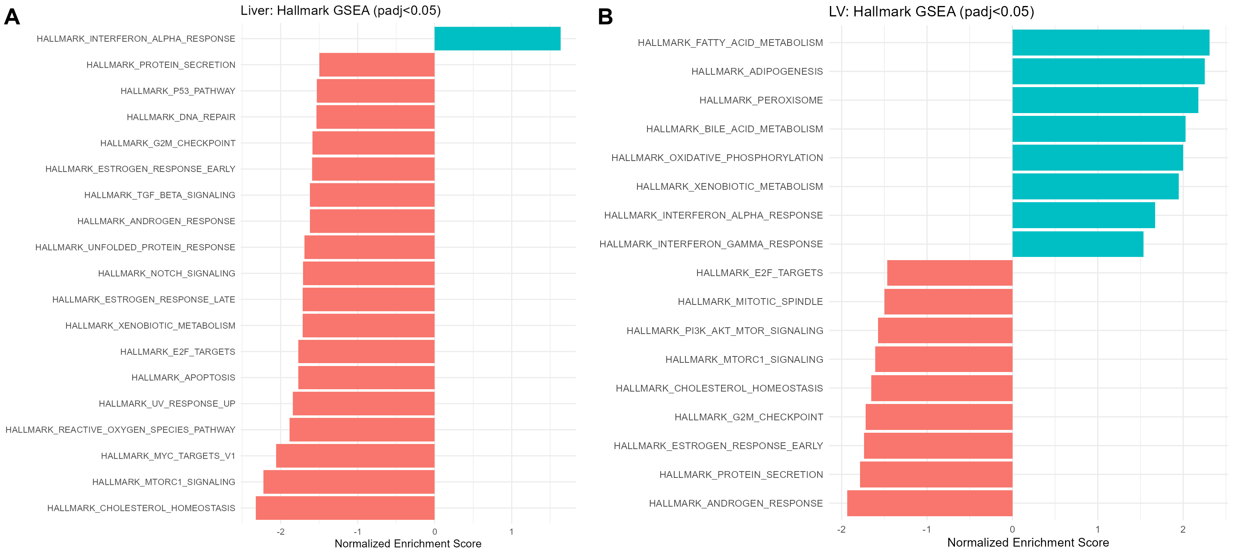
Figure 3. Hallmark gene set enrichment analysis (GSEA). (A) Liver. (B) LV. Bars show the normalized enrichment score (NES) for pathways significant at padj<0.05. Full GO-BP and KEGG results are provided in Supplemental Figure S1-S2 and Supplemental Table S3-S5.

3.3 Ligand-receptor interactome matching reveals a reversed axis
We had hypothesized that a liver-secreted factor drives HFpEF-associated cardiac remodeling. Contrary to this expectation, neither CellChatDB matching nor an unrestricted STRING-based search (confidence≥0.7) returned a single liver-to-LV edge. In the reverse direction, however, CellChatDB returned five matches: Angptl4, significantly upregulated in the LV, is a curated ligand of Cdh5, Sdc1, Sdc2, Sdc3, and Sdc4, all of which are expressed in liver (Table 1). We therefore reoriented the candidate axis from liver-to-heart to heart-to-liver. This reversed direction is not an ad hoc correction; it corresponds precisely to the clinically recognized entity of congestive hepatopathy/cardiohepatic syndrome, in which cardiac dysfunction secondarily injures the liver.

3.4 STRING network analysis nominates Sdc1/Sdc4 as hub genes
Expanding Angptl4/Cdh5/Sdc1-4 with their first-shell STRING interactors (41 edges total) revealed Sdc1 (degree=16, betweenness=64.3) and Sdc4 (degree=14, betweenness=45.1) as clear network hubs, embedded in a module of heparan-sulfate-proteoglycan-related genes (Gpc1, Gpc4, Hspg2, Ext1, Tnc; Figure 4). Cdh5, in contrast, formed an isolated pair with Angptl4 only, suggesting that the syndecan family constitutes the structural core of this axis (Supplemental Table S6 lists the complete hub-gene ranking).
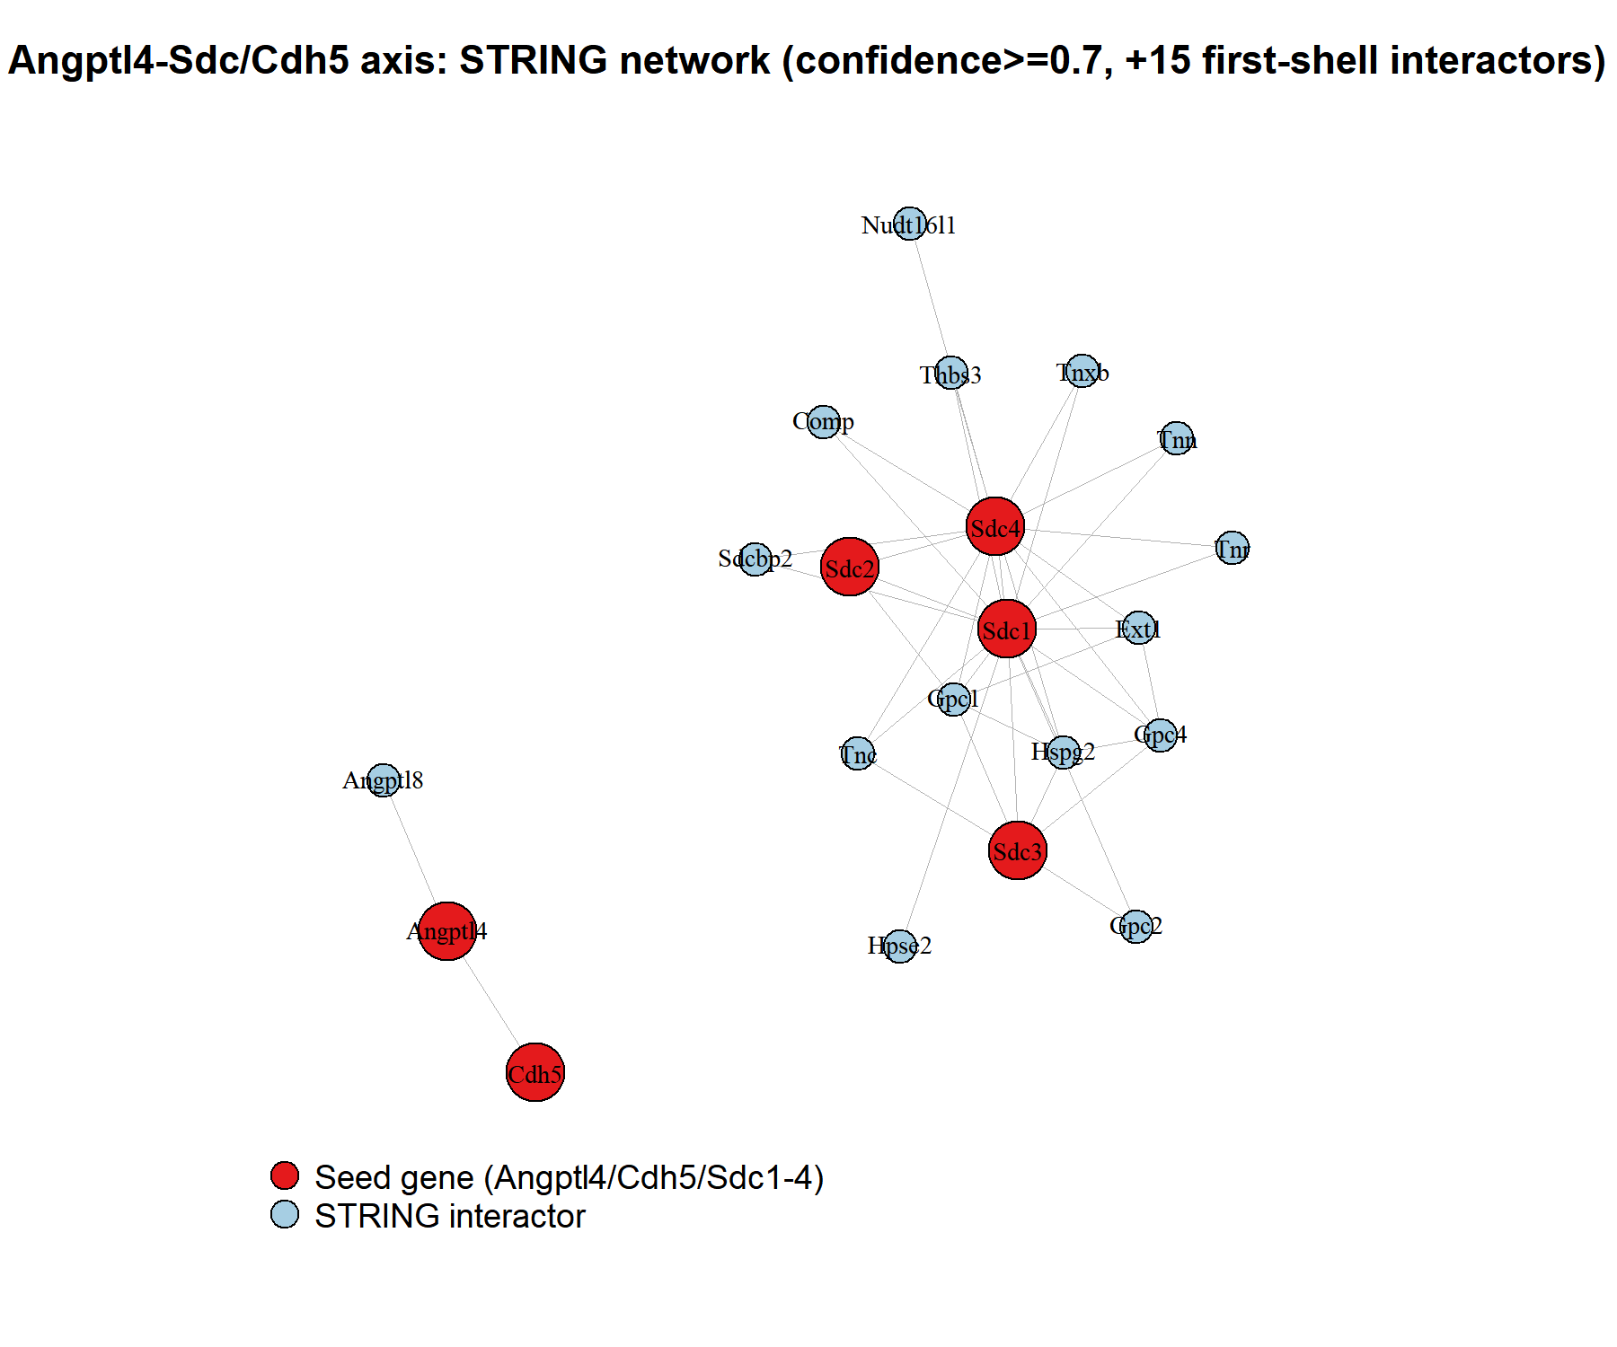
Figure 4. STRING protein-protein interaction network centered on the Angptl4-Sdc/Cdh5 axis (confidence≥0.7, +15 first-shell interactors). Red nodes: seed genes (Angptl4, Cdh5, Sdc1-4); blue nodes: STRING interactors. Node size scales with degree.

3.5 Cross-species cell-type localization
Reusing our previously annotated human liver scRNA-seq atlas (project4, GSE136103) as an independent cross-species reference, SDC1 and SDC4 localized cleanly to hepatocytes (Figure 5), consistent with their ranking as the top network hubs. SDC3 localized to MP (macrophage/Kupffer-lineage) cells, and CDH5 localized to endothelia, exactly as expected for this canonical endothelial marker - serving as a built-in positive control for the localization approach (Supplemental Figure S3 shows the same analysis split by disease condition).
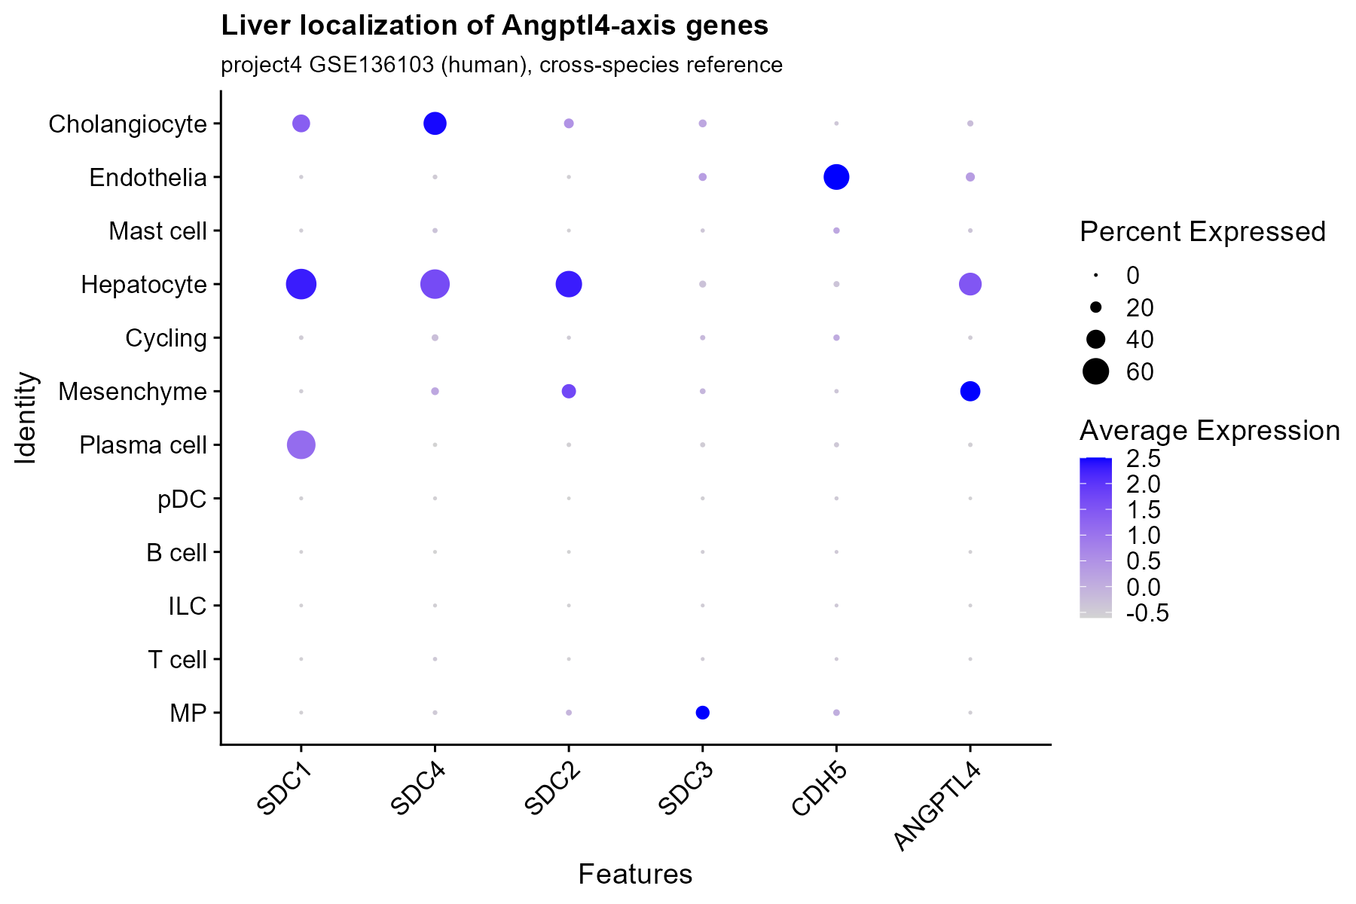
Figure 5. Liver cell-type localization of Angptl4-axis genes, using an independent cross-species reference (project4, human GSE136103). SDC1/SDC4 localize to hepatocytes, consistent with their status as network hubs; CDH5 localizes to endothelia as a positive control.

3.6 STITCH network pharmacology
STITCH queries showed that Angptl4 is linked to endogenous fatty-acid metabolites (linoleic, palmitic, arachidonic, and eicosapentaenoic acids) and to Pioglitazone, an approved PPAR agonist (Table 2). Sdc1, Sdc2, Sdc3, and Cdh5, in contrast, returned only structural or metabolic partners (iduronic acid, a heparan/dermatan sulfate glycosaminoglycan building block; calcium cation), with essentially no association to existing therapeutic compounds (Supplemental Table S8 lists the complete result).

3.7 Druggability assessment and final target selection
DGIdb returned 3 drug interactions for Sdc1 (heparin, indatuximab ravtansine - an antibody-drug conjugate), 1 for Sdc4 (repotrectinib, an oncology kinase inhibitor with no plausible mechanistic link, most likely a text-mining artifact), and 1 for Cdh5 (FX06, a fibrin-derived peptide), while Sdc3 and Angptl4 returned zero interactions each (Table 3; Supplemental Table S9). Critically, however, UniProt/PDB inspection showed that every available crystal structure of the network hubs Sdc1 and Sdc4 covers non-extracellular fragments only - for example, PDB 8BLV resolves the Sdc4 cytoplasmic tail in complex with the syntenin PDZ domain, not the heparan-sulfate-bearing ectodomain that would engage a secreted ligand such as Angptl4 - rendering them structurally unactionable for small-molecule docking. We therefore redirected the final target to Angptl4 itself: it is completely undrugged in DGIdb, its C-terminal fibrinogen-like domain has a solved 2.3-A crystal structure with a visible ligand-accommodating surface (PDB 6EUB), and it is independently validated both by our own DEG analysis and by a 2024 single-cell study demonstrating cardiac-fibroblast-specific ANGPTL4 secretion in HFpEF (Li et al., 2024) (full rationale in Supplemental Text S1).

3.8 Structure-based virtual screening with AutoDock Vina
Docking of 21 compounds against the ANGPTL4 fibrinogen-like domain ranked Resmetirom (-9.07 kcal/mol), Ezetimibe (-8.88), Pioglitazone (-8.28), Fenofibrate (-8.21), and Empagliflozin (-8.14) as the top five hits (Figure 6; Table 4; Supplemental Table S7 lists the full ranking of all 21 compounds). As a group, the cardiometabolic-drug category scored more favorably than the fatty-acid and unrelated-control categories, with Metformin (-4.65) and Caffeine (-5.36) scoring weakest - a pattern broadly consistent with a mechanistically informed screen, although we note that molecular size and rotatable-bond count can also influence Vina scores and should temper any absolute ranking across compounds of very different size.
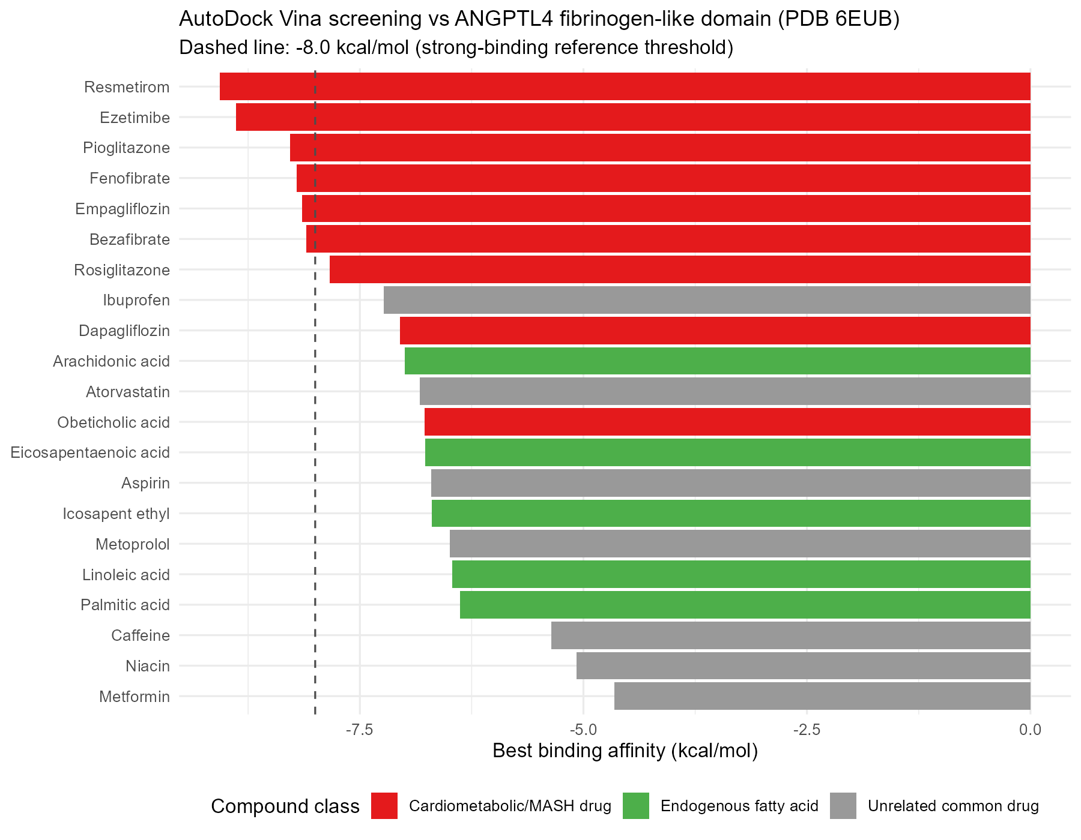
Figure 6. AutoDock Vina virtual screening of 21 compounds against the ANGPTL4 fibrinogen-like domain (PDB 6EUB), ranked by best binding affinity. Dashed line: -8.0 kcal/mol reference threshold. Full results in Supplemental Table S7.

3.9 DiffDock cross-validation reframes the leading candidate
Applying blind docking (no predefined binding site) to the top two Vina hits produced a striking divergence. Ezetimibe's top-ranked pose (confidence -1.32) fell within 3.5 A of the Vina-defined pocket centroid, i.e., two independent methods converged on essentially the same site (Figure 7A). Resmetirom's top-ranked pose (confidence -2.06), in contrast, localized 23.5 A away, at an entirely different surface region (Figure 7B; Supplemental Text S2 gives full contact-residue detail). Both DiffDock confidence values fall within that method's low-to-moderate range and should not be over-interpreted as confirmed binding; nonetheless, on a strictly comparative basis, Ezetimibe - not the top Vina scorer - emerges as the more structurally consistent candidate across two independent docking algorithms.
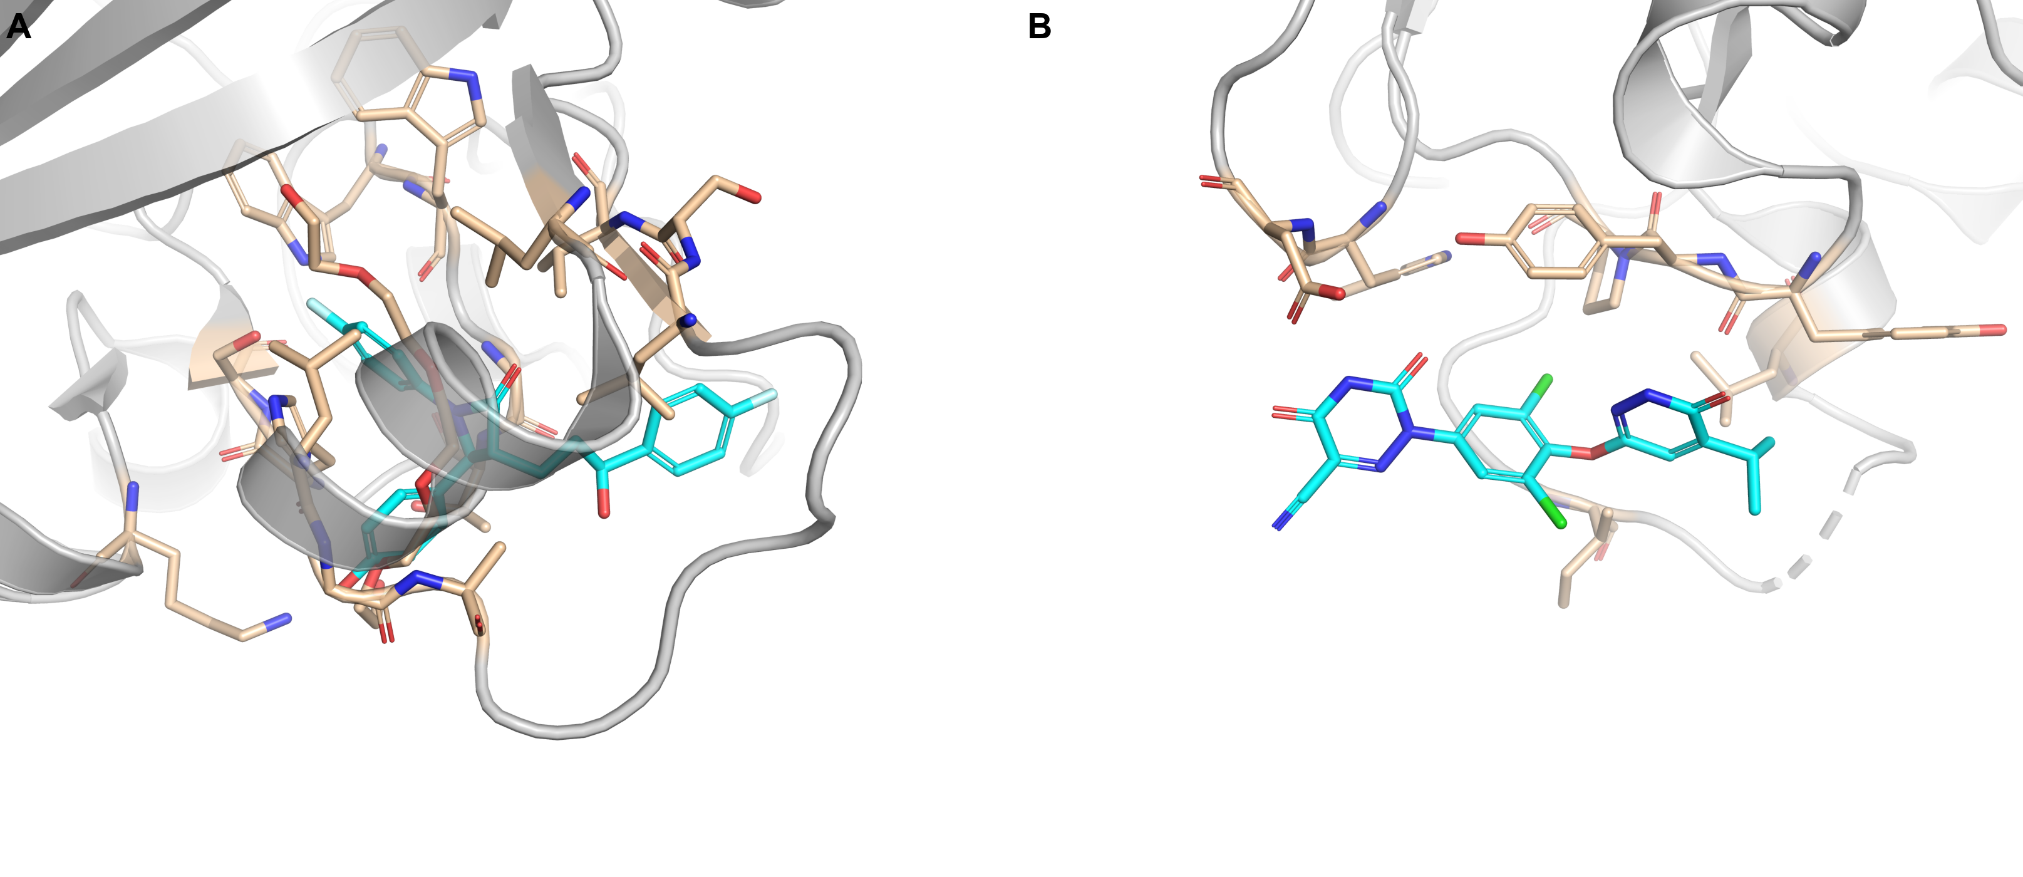
Figure 7. Structure-based docking poses of the top two AutoDock Vina hits, cross-validated by DiffDock. (A) Ezetimibe (DiffDock confidence -1.32), converging within 3.5 A of the Vina-defined pocket; contact residues Leu304, Leu312, Gly313, Ala314, Leu322, Ser323, Val324, Trp349, Trp350, Gly352, Thr353, His356. (B) Resmetirom (DiffDock confidence -2.06), 23.5 A from the Vina-defined pocket at a distinct site; contact residues Trp280, Asp281, Ile367, Leu374, Tyr387, Tyr388, Pro389.
Table 1. LV-to-liver ligand-receptor matches (CellChatDB).
Interaction | Ligand | Receptor | Pathway | Evidence
ANGPTL4_CDH5 | Angptl4 | Cdh5 | ANGPTL | PMID: 30049845
ANGPTL4_SDC1 | Angptl4 | Sdc1 | ANGPTL | PMID: 29017031
ANGPTL4_SDC2 | Angptl4 | Sdc2 | ANGPTL | PMID: 29017031
ANGPTL4_SDC3 | Angptl4 | Sdc3 | ANGPTL | PMID: 29017031
ANGPTL4_SDC4 | Angptl4 | Sdc4 | ANGPTL | PMID: 29017031
Table 2. STITCH-identified chemical partners of Angptl4-axis genes (selected).
Gene | Compound
Angptl4 | Linoleic acid (9,12-octadecadienoic acid)
Angptl4 | Palmitic acid
Angptl4 | Eicosapentaenoic acid
Angptl4 | Pioglitazone (approved drug)
Sdc1 / Sdc2 / Sdc3 | Iduronic acid (heparan/dermatan sulfate GAG unit)
Cdh5 | Calcium cation
Table 3. DGIdb druggability summary for Angptl4-axis genes.
Gene | # interactions | # approved | Example drugs
SDC2 | 1 | 0 | Heparan sulfate
SDC4 | 1 | 1 | Repotrectinib (likely unrelated text-mining hit)
CDH5 | 1 | 0 | FX06 (peptide)
SDC3 | 0 | 0 | -
SDC1 | 3 | 0 | Heparin; Indatuximab ravtansine (ADC)
ANGPTL4 | 0 | 0 | - (genuinely undrugged; final target)
Table 4. AutoDock Vina top 5 hits vs ANGPTL4 (PDB 6EUB).
Rank | Compound | Best affinity (kcal/mol) | Class
1 | Resmetirom | -9.07 | Cardiometabolic/MASH drug
2 | Ezetimibe | -8.88 | Cardiometabolic/MASH drug
3 | Pioglitazone | -8.28 | Cardiometabolic/MASH drug
4 | Fenofibrate | -8.21 | Cardiometabolic/MASH drug
5 | Empagliflozin | -8.14 | Cardiometabolic/MASH drug

4. Discussion
This study set out to reanalyze a recently deposited paired liver-heart mouse cohort under a stricter statistical threshold, but its most important finding is that our starting hypothesis - a liver-secreted factor driving HFpEF-associated cardiac remodeling - was not supported by the data. The absence of any liver-to-heart cross-organ edge in either CellChatDB matching or an unrestricted STRING search (Figure 4; Section 3.3) should be read as a genuine, database-level signal for this particular model and statistical threshold, not as a methodological failure.
The heart-to-liver Angptl4-Sdc/Cdh5 axis identified instead aligns closely with congestive hepatopathy and the emerging concept of cardiohepatic syndrome, both long recognized in clinical medicine. The independent 2024 single-cell finding that Angptl4 is secreted specifically by cardiac fibroblasts and suppresses angiogenesis in the HFpEF heart (Li et al., 2024) reproduces our own bulk DEG result (Figure 1B) using an entirely different experimental modality - a cross-validation that considerably strengthens confidence in this axis.
The most centrally connected genes in our network analysis, Sdc1 and Sdc4 (Figure 4), turned out not to be structurally actionable: every deposited crystal structure covers a domain other than the extracellular ligand-binding surface. This dissociation between "most important by network centrality" and "currently actionable by structure-based methods" is a practical limitation that is not always made explicit in network pharmacology studies that promote hub genes directly to final targets; we chose not to paper over this gap and instead redirected the docking campaign to Angptl4 itself (Section 3.7, Supplemental Text S1).
The divergence between AutoDock Vina and DiffDock for Resmetirom and Ezetimibe (Figure 7) is similarly informative. Vina reports a relative ranking within a single predefined pocket, whereas DiffDock searches the entire protein surface; agreement between the two on pose location is therefore independent evidence that a site is biologically meaningful rather than a scoring artifact of one method. That Resmetirom scored best on Vina yet was preferentially placed by DiffDock at a completely different site illustrates the risk of selecting a final candidate from a single docking algorithm, and supports Ezetimibe as the more defensible hypothesis-generating lead from this screen.
Several limitations should be noted. First, this analysis rests on a single mouse model with a small sample size (n=5/group), and independent replication is warranted. Second, the cardiac source of Angptl4 was confirmed only through an independent literature report rather than through single-cell data generated in this study, and the hepatic localization of the syndecans relies on a human, cross-species reference rather than mouse single-cell validation. Third, DiffDock was run through a public web interface for only the top two compounds because of the absence of a local GPU, rather than across the full 21-compound library. Fourth, all binding affinities reported here are in silico predictions; biochemical confirmation (e.g., Western blot, SPR, or ITC) will be required before any therapeutic claim can be made.

5. Conclusion and Future Directions
By reanalyzing a publicly available paired liver-heart mouse transcriptome dataset under stricter statistical criteria and carrying the analysis through ligand-receptor interactome matching, PPI network construction, network pharmacology, druggability assessment, and structure-based virtual screening, we identified a heart-to-liver Angptl4-Sdc/Cdh5 axis in place of our originally hypothesized liver-to-heart direction - a reversal that in fact corresponds to the clinically established cardiohepatic syndrome. Recognizing that the network hubs Sdc1/Sdc4 are not currently structurally actionable, we redirected structure-based screening to Angptl4 itself, and identified Ezetimibe as the candidate most consistently cross-validated by two independent docking algorithms. Future work should pursue (1) direct cell-type localization using single-cell data collected from both liver and heart of the same animals, (2) full-library DiffDock re-screening on a GPU-equipped system, (3) biochemical confirmation of Ezetimibe-ANGPTL4 binding by SPR or ITC, and (4) in vivo assessment of hepatic phenotype following Ezetimibe administration in the HFpEF mouse model.

References
1. Rinella ME, Lazarus JV, Ratziu V, et al. A multisociety Delphi consensus statement on new fatty liver disease nomenclature. J Hepatol. 2023;79(6):1542-1556.
2. Strocchi S, Liu L, Wang R, et al. Systems Biology Approach Uncovers Candidates for Liver-Heart Interorgan Crosstalk in HFpEF. Circ Res. 2024;135(8):873-876.
3. Schütte JP, Markus N, Grein S, et al. Cell Type–Specific Secretome Analysis Reveals Liver-Heart Crosstalk in HFpEF. Circ Res. 2025;136(11):1516-1518.
4. Li G, Zhao H, Cheng Z, Liu J, Li G, Guo Y. Single-cell transcriptomic profiling of heart reveals ANGPTL4 linking fibroblasts and angiogenesis in heart failure with preserved ejection fraction. J Adv Res. 2024.
5. Love MI, Huber W, Anders S. Moderated estimation of fold change and dispersion for RNA-seq data with DESeq2. Genome Biol. 2014;15:550.
6. Zhu A, Ibrahim JG, Love MI. Heavy-tailed prior distributions for sequence count data: removing the noise and preserving large differences. Bioinformatics. 2019;35(12):2084-2092.
7. Korotkevich G, Sukhov V, Budin N, Shpak B, Artyomov MN, Sergushichev A. Fast gene set enrichment analysis. bioRxiv. 2019. doi:10.1101/060012
8. Wu T, Hu E, Xu S, et al. clusterProfiler 4.0: A universal enrichment tool for interpreting omics data. Innovation (Camb). 2021;2(3):100141.
9. Szklarczyk D, Kirsch R, Koutrouli M, et al. The STRING database in 2023: protein-protein association networks and functional enrichment analyses for any sequenced genome of interest. Nucleic Acids Res. 2023;51(D1):D638-D646.
10. Szklarczyk D, Santos Delgado A, von Mering C, Jensen LJ, Bork P, Kuhn M. STITCH 5: augmenting protein-chemical interaction networks with tissue and affinity data. Nucleic Acids Res. 2016;44(D1):D380-D384.
11. Jin S, Guerrero-Juarez CF, Zhang L, et al. Inference and analysis of cell-cell communication using CellChat. Nat Commun. 2021;12:1088.
12. Cannon M, Stevenson J, Stahl K, et al. DGIdb 5.0: rebuilding the drug-gene interaction database for precision medicine and drug discovery platforms. Nucleic Acids Res. 2024;52(D1):D1227-D1235.
13. Biterova EI, Esmaeeli M, Alanen HI, Saaranen M, Ruddock LW. Structures of Angptl3 and Angptl4, modulators of triglyceride levels and coronary artery disease. Sci Rep. 2018;8:6752.
14. Eberhardt J, Santos-Martins D, Tillack AF, Forli S. AutoDock Vina 1.2.0: New Docking Methods, Expanded Force Field, and Python Bindings. J Chem Inf Model. 2021;61(8):3891-3898.
15. Corso G, Stärk H, Jing B, Barzilay R, Jaakkola T. DiffDock: Diffusion Steps, Twists, and Turns for Molecular Docking. International Conference on Learning Representations (ICLR). 2023.
16. Ramachandran P, Dobie R, Wilson-Kanamori JR, et al. Resolving the fibrotic niche of human liver cirrhosis at single-cell level. Nature. 2019;575(7783):512-518.

