Supplemental Data
Multi-Organ Transcriptomic Integration Identifies an Angptl4-Syndecan/Cadherin Axis Underlying Cardiohepatic Syndrome and Guides Structure-Based Drug Screening — Supplemental Figures, Tables, and Text

Code and Analysis Workflow
All code, intermediate results, and figures for this study are version-controlled at github.com/bioinform25/essay. The repository is organized into scripts/ (analysis code, run in the numeric order below), results/ (CSV outputs and text summaries), figures/ (all PNG figures, with composite multi-panel images under figures/composite/), docking/ (receptor/ligand PDBQT files and Vina/DiffDock outputs), and manuscript/ (this document's build scripts and content). The list below walks through every script in execution order so that the analysis can be fully reproduced or audited step by step.
Script | Description
00_check_packages.R / 00b-00d | Verify/install required R packages (DESeq2, clusterProfiler, fgsea, msigdbr, EnhancedVolcano, pheatmap, igraph, CellChat, RCy3) before running the pipeline.
01_deseq2_analysis.R | Load the Zenodo raw count matrices and metadata, run DESeq2 independently for Liver and LV, apply apeglm shrinkage, export full and significant (padj<0.01, |log2FC|>1.5) DEG tables, volcano plots, and heatmaps.
02_gsea_go_kegg.R | Hallmark GSEA (fgsea) ranked by sign(log2FC)*-log10(p), plus GO-BP and KEGG over-representation analysis (clusterProfiler) on the significant DEG lists, for each organ.
03_ligand_receptor_matching.R | Match upregulated DEGs (ligand candidates) against CellChatDB.mouse ligand-receptor pairs, receptor side relaxed to baseMean>=10 expression, tested in both liver-to-LV and LV-to-liver directions.
04_string_ppi_network.R | Query the STRING API for the combined significant gene set to search directly for cross-organ edges (result: zero in the hypothesized direction).
05_angptl4_axis_network.R / 05b | Expand the Angptl4/Cdh5/Sdc1-4 seed set with STRING first-shell interactors, compute degree/betweenness centrality with igraph, and render the network figure.
06_liver_localization_project4.R | Reload the previously annotated project4 (GSE136103) Seurat object and generate DotPlots of Angptl4-axis genes across annotated liver cell types.
07_stitch_network_pharmacology.R | Query the STITCH API for chemical partners of each hub gene and resolve PubChem CIDs to compound names.
08_druggability_dgidb.R | Query the DGIdb 5.0 GraphQL API for existing drug interactions of each hub gene (human ortholog symbols).
09_build_ligand_library.py | Resolve canonical SMILES for the 21-compound docking library from PubChem PUG-REST.
10_prepare_receptor.py | Strip waters/crystallization additives from PDB 6EUB, compute the 1PE-site centroid as the docking box center, and generate a receptor PDBQT with Meeko.
11_prepare_ligands.py | Generate 3D conformers (RDKit ETKDGv3/MMFF94) for all 21 ligands and convert to PDBQT with Meeko.
12_run_vina_screening.py | Run AutoDock Vina for every ligand against the prepared receptor and collate best binding affinities.
13_vina_results_plot.R | Render the ranked Vina results as a categorized bar chart.
14_visualize_poses.py / 15_static_pose_figure.py | Early-stage pose visualization attempts (py3Dmol web-rendering, then a matplotlib-based static fallback) before the PyMOL pipeline below was added.
16_pymol_pose_render.py | Headless PyMOL (installed via a dedicated Miniconda environment) rendering of the final publication-quality binding-pose figures, run via `pymol -cq`.
17_stitch_panels.py | Combine paired single-panel figures (volcano, heatmap, GSEA, docking pose, GO) into single composite Figure images with panel letters (A)/(B), matching standard journal figure layout.

Software versions: R 4.5.2 (DESeq2, apeglm, clusterProfiler, fgsea, msigdbr, CellChat, igraph, httr/jsonlite, EnhancedVolcano, pheatmap); Python 3.14 (RDKit, Meeko, PyMuPDF, matplotlib, py3Dmol); AutoDock Vina 1.2.7; PyMOL (open-source build, installed via a dedicated Miniconda environment); Cytoscape 3.10.4 (installed, available for manual use). DiffDock was not installed locally (no CUDA-capable GPU on this machine) and was instead run through a publicly hosted Gradio Space mirroring the original gcorso/DiffDock inference code, for the top two Vina candidates only. The full commit history of the repository constitutes a complete, chronological log of the analysis as it was actually performed, including the initial (liver-to-heart) hypothesis, the point at which it was found unsupported, and the subsequent re-direction of the target and screening strategy.

Supplemental Figures
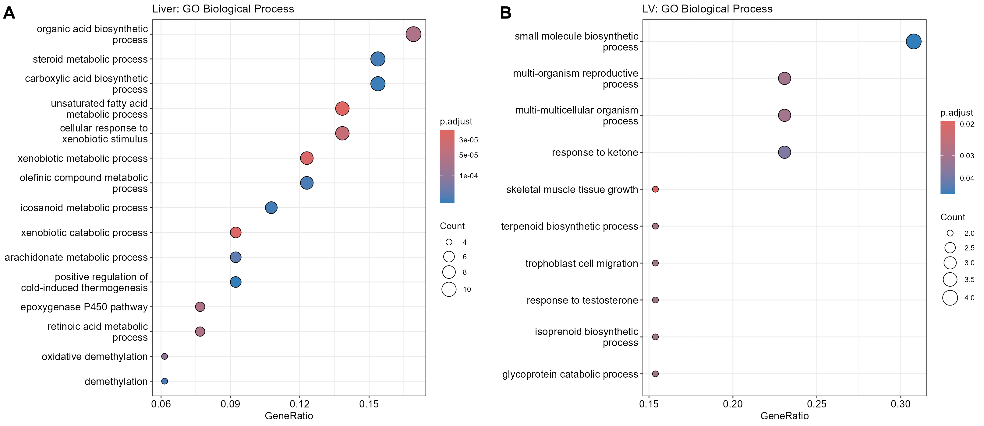
Figure S1. GO Biological Process enrichment. (A) Liver (34 significant terms, padj<0.05). (B) LV (10 significant terms, padj<0.05). Complements the Hallmark GSEA in Figure 3 with a complementary, non-overlapping ontology.
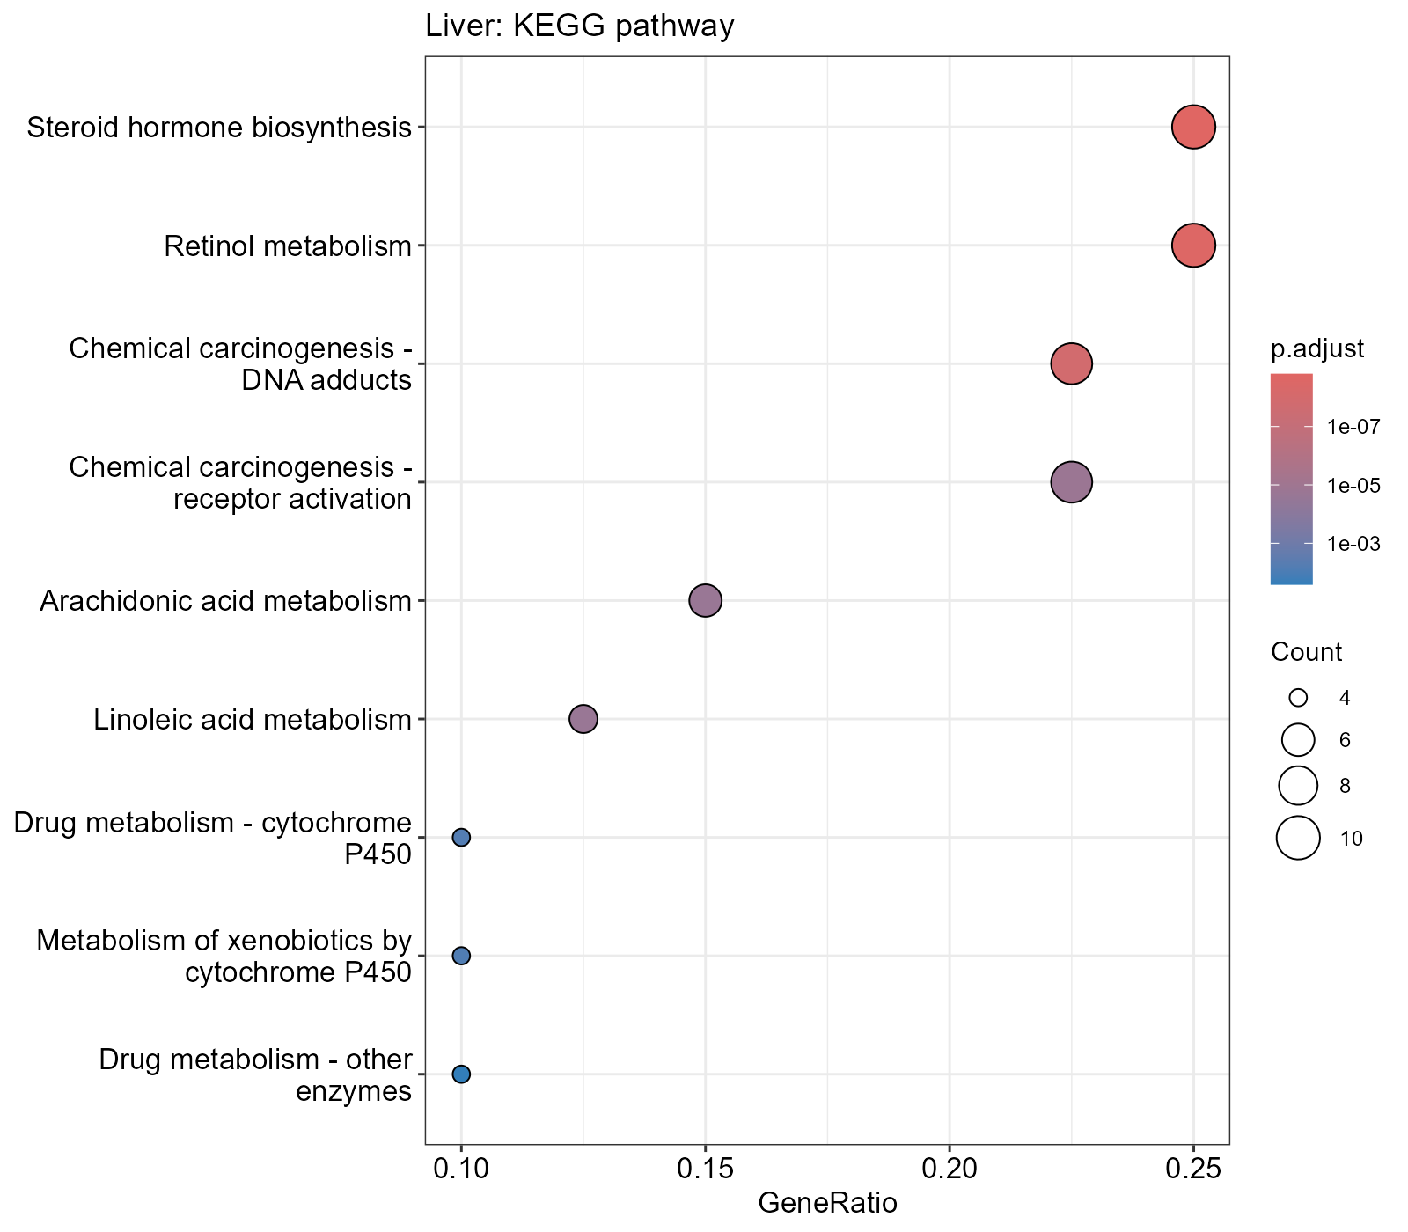
Figure S2. Liver KEGG pathway enrichment (9 significant pathways, padj<0.05). No KEGG pathway reached significance in LV under the same threshold, which is reported here rather than omitted.
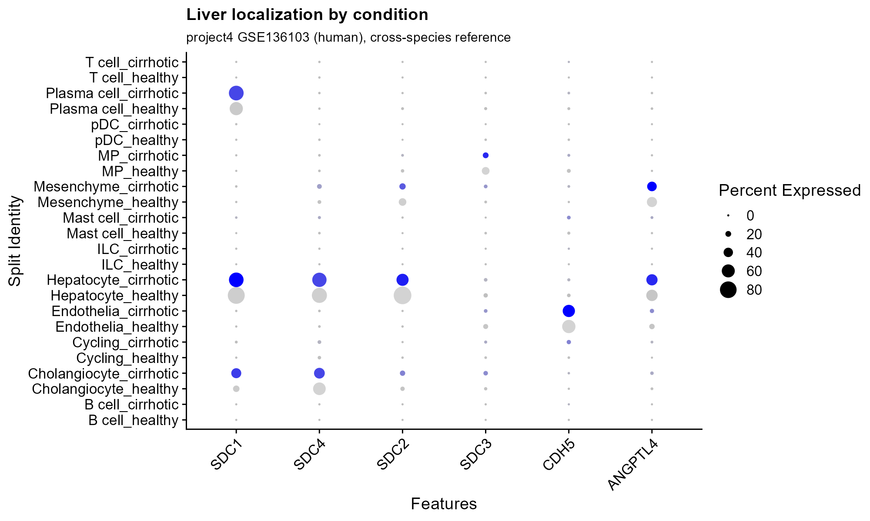
Figure S3. Liver cell-type localization of Angptl4-axis genes, split by disease condition (healthy vs. cirrhotic; project4 GSE136103 cross-species reference). Provided in addition to Figure 5 to show whether localization itself, rather than only expression level, shifts with disease state.

Supplemental Tables

Table S1. Full significant DEG list, Liver (n=86, padj<0.01, |log2FC|>1.5)
Complete Liver DEG table underlying Figure 1A and the 86-gene count reported in Section 3.1 (all columns from the DESeq2/apeglm output: baseMean, log2FoldChange, lfcSE, pvalue, padj, gene_name).
ensembl_id | baseMean | log2FoldChange | lfcSE | pvalue | padj | gene_name
ENSMUSG00000034774 | 503.475388306876 | 2.64429327634708 | 0.212996384936588 | 1.39537690151581e-36 | 2.02469188409944e-32 | Dsg1c
ENSMUSG00000040616 | 233.084960747301 | -1.57213782341264 | 0.155920994817588 | 3.88811679866027e-25 | 1.41041436871401e-21 | Tmem51
ENSMUSG00000025002 | 184.776235730195 | -2.95549606645123 | 0.298917764494612 | 2.45979852017676e-24 | 5.94861275462746e-21 | Cyp2c55
ENSMUSG00000102095 | 1213.4461453138 | 2.34989330530966 | 0.238929661089155 | 4.28063697314542e-24 | 8.87314892576287e-21 | C730036E19Rik
ENSMUSG00000004038 | 1671.89161257983 | -2.30069790272563 | 0.246866137221666 | 5.60733540057556e-22 | 1.01703045827939e-18 | Gstm3
ENSMUSG00000097426 | 757.931557207992 | 2.28745881411989 | 0.254033251749858 | 1.17539446263632e-20 | 1.89499707253922e-17 | Gm8941
ENSMUSG00000038060 | 62.4375612302593 | 2.41883223232349 | 0.285631383979538 | 1.20429163712742e-18 | 1.52184952092415e-15 | Dlec1
ENSMUSG00000085834 | 232.693670444981 | 3.57622385332592 | 0.424846999216286 | 1.25859367684974e-18 | 1.52184952092415e-15 | Gm15622
ENSMUSG00000040660 | 461.654325493277 | 4.76612271546659 | 0.576013184410581 | 5.53051412404958e-18 | 6.17290461076611e-15 | Cyp2b9
ENSMUSG00000048368 | 86.633193258359 | 1.53140854822275 | 0.197566523167157 | 4.63189442300078e-16 | 4.65051132709902e-13 | Omd
ENSMUSG00000055866 | 1283.92773618528 | 1.54300995671552 | 0.199506431618138 | 5.25542389511422e-16 | 4.76601254488171e-13 | Per2
ENSMUSG00000030257 | 165.45506970847 | -2.8895867942592 | 0.377010856772018 | 9.15700661810583e-16 | 7.81577447227738e-13 | Srgap3
ENSMUSG00000026475 | 2092.78574519369 | 3.64609583478058 | 0.47804254562425 | 1.14747928863316e-15 | 9.24995804337065e-13 | Rgs16
ENSMUSG00000005677 | 3000.74783767299 | 1.58700471125647 | 0.212480251653979 | 4.12265691679091e-15 | 3.14840799277032e-12 | Nr1i3
ENSMUSG00000023044 | 6673.59478721416 | -2.41062007521851 | 0.325742646236205 | 6.25723758426475e-15 | 4.53962586738408e-12 | Csad
ENSMUSG00000069170 | 251.592851664664 | 2.16651042225976 | 0.293105763859143 | 8.06590679703661e-15 | 5.4017476922126e-12 | Adgrv1
ENSMUSG00000021259 | 98.7214766767695 | 1.57370677646021 | 0.217545271349545 | 1.94822058822189e-14 | 1.09348856000731e-11 | Cyp46a1
ENSMUSG00000099568 | 19.1449077349142 | 4.34751291066598 | 0.58927805915887 | 4.84230967169531e-14 | 2.50935404772496e-11 | Gm28513
ENSMUSG00000045672 | 2462.59697503316 | 1.54499356864996 | 0.216470787518036 | 4.84099137795888e-14 | 2.50935404772496e-11 | Col27a1
ENSMUSG00000030137 | 43.2872368975039 | -2.58353717790484 | 0.36523637624022 | 6.48414079516269e-14 | 3.24430630820037e-11 | Tuba8
ENSMUSG00000110496 | 146.126556323611 | 2.57568270325534 | 0.366567136943467 | 9.75018475899839e-14 | 4.71583936176889e-11 | Gm45909
ENSMUSG00000108825 | 195.710461902802 | 1.55720788262107 | 0.221565285877381 | 1.15524818052276e-13 | 5.40730680625329e-11 | Gm45838
ENSMUSG00000105391 | 49.3606698062927 | 1.98512987136949 | 0.299921203596909 | 1.44201892492306e-12 | 5.65505259476582e-10 | Gm43401
ENSMUSG00000029822 | 237.08162061726 | 2.15505014321603 | 0.335962066861222 | 6.46341694714879e-12 | 2.28741902202753e-09 | Osbpl3
ENSMUSG00000090175 | 516.646697485 | -2.23470003682453 | 0.361619080246087 | 2.87808381998234e-11 | 9.07847744085733e-09 | Ugt1a9
ENSMUSG00000057465 | 690.886491056676 | 1.78114533656839 | 0.29329685555328 | 5.61399049943249e-11 | 1.62918004293531e-08 | Saa2
ENSMUSG00000085211 | 83.5853289326452 | 2.27299239156911 | 0.381437351389097 | 1.01331119158786e-10 | 2.74957833813579e-08 | B430219N15Rik
ENSMUSG00000096215 | 81.7240445139723 | -1.51458742919241 | 0.25397202093263 | 1.02327519131174e-10 | 2.74957833813579e-08 | Smim22
ENSMUSG00000026822 | 143.919404952623 | 1.7747824470032 | 0.305858713103111 | 2.96510237092158e-10 | 7.17060590034535e-08 | Lcn2
ENSMUSG00000032482 | 105.343357814561 | -2.14370854029406 | 0.374939490019592 | 5.29145372862328e-10 | 1.21871418416387e-07 | Cspg5
ENSMUSG00000061906 | 407.471077450847 | -1.96973865869983 | 0.348547255980042 | 6.99493400180646e-10 | 1.51487302039122e-07 | Ugt2b38
ENSMUSG00000028957 | 1220.41286940673 | 1.59277260353284 | 0.287416193049593 | 1.39738912020119e-09 | 2.8161272408499e-07 | Per3
ENSMUSG00000061292 | 1015.4361831682 | -1.88983330776215 | 0.356498362621404 | 4.997147882676e-09 | 9.17830579463655e-07 | Cyp3a59
ENSMUSG00000029254 | 51.497023631564 | 1.897757223332 | 0.364838568194038 | 8.4090970410215e-09 | 1.40248273638186e-06 | Stap1
ENSMUSG00000022351 | 1927.2188631814 | -1.64467428029207 | 0.324712848462326 | 1.81916911200905e-08 | 2.66121461743334e-06 | Sqle
ENSMUSG00000108425 | 79.8323823453028 | 1.57831612368138 | 0.312015737650785 | 2.27885225064761e-08 | 3.14915677684731e-06 | Gm44706
ENSMUSG00000032773 | 17.487534249692 | 2.25711338050943 | 0.453268229847169 | 2.58531317852317e-08 | 3.50587796452068e-06 | Chrm1
ENSMUSG00000027533 | 1000.06428063829 | -2.79306755072058 | 0.570708158333458 | 3.88111120324011e-08 | 5.1195385053649e-06 | Fabp5
ENSMUSG00000030302 | 47.1906926893873 | -1.75980397182386 | 0.358818599568666 | 4.18218637123124e-08 | 5.41817180772905e-06 | Atp2b2
ENSMUSG00000049109 | 63.0119494150958 | 2.53186062101198 | 0.518540976460581 | 4.1553296293353e-08 | 5.41817180772905e-06 | Themis
ENSMUSG00000086245 | 108.32248138857 | 1.58443107419618 | 0.324445748864558 | 5.35431450050601e-08 | 6.64026524806344e-06 | Gm16170
ENSMUSG00000097762 | 81.651463977587 | 1.81925116292515 | 0.384014851633741 | 9.0015745869005e-08 | 1.07944501864402e-05 | 4732463B04Rik
ENSMUSG00000089712 | 100.580184766758 | 1.80356149676301 | 0.38842663020433 | 1.40830651123545e-07 | 1.59644745922081e-05 | Gm15889
ENSMUSG00000001076 | 17.02603990295 | -1.70405875993617 | 0.365141246779795 | 1.69231016012441e-07 | 1.86025912298524e-05 | C1ql4
ENSMUSG00000049723 | 20.0381554698832 | 2.07998968568883 | 0.447192498406029 | 1.85165569632691e-07 | 2.00503911594802e-05 | Mmp12
ENSMUSG00000057933 | 576.196153284774 | -1.76891069316312 | 0.385887177021199 | 1.89327750344454e-07 | 2.03492270925779e-05 | Gsta2
ENSMUSG00000012123 | 35.4531322336344 | 1.65101650446626 | 0.362947647808665 | 2.39274357106565e-07 | 2.47990780115447e-05 | Crybg2
ENSMUSG00000040583 | 17.2718000888921 | 3.88076851176883 | 0.869928156891006 | 3.74043305763701e-07 | 3.54729958603353e-05 | Cyp2b13
ENSMUSG00000090105 | 23.2866504862879 | 1.54441267413779 | 0.346895517391425 | 4.06125678891998e-07 | 3.77748948764288e-05 | Gm15890
ENSMUSG00000092008 | 46.6255327924104 | -2.64333323561804 | 0.599234862145356 | 4.46404324338968e-07 | 4.02318431438411e-05 | Cyp2c69
ENSMUSG00000075044 | 21.1374986591566 | 2.13622927040766 | 0.490388947072474 | 5.6067350284095e-07 | 4.89463689651337e-05 | Slc22a29
ENSMUSG00000026622 | 62.252521168354 | -1.53132834673788 | 0.354434296556186 | 7.09378466082344e-07 | 5.93321979152194e-05 | Nek2
ENSMUSG00000027068 | 82.6238537349016 | -2.814860625705 | 0.665050568618433 | 8.51820731959965e-07 | 6.64511764555866e-05 | Dhrs9
ENSMUSG00000056978 | 487.384642782162 | 1.58898036242832 | 0.374757650569082 | 9.75852495665254e-07 | 7.37480193338689e-05 | Hamp2
ENSMUSG00000037071 | 175490.135891387 | -2.02412764651439 | 0.487542574417716 | 1.26180457426227e-06 | 9.16514088912715e-05 | Scd1
ENSMUSG00000067656 | 26.2965331234244 | 2.46144330277243 | 0.590769149946265 | 1.33466790904984e-06 | 9.4009860972394e-05 | Slc22a27
ENSMUSG00000092035 | 22.3035997476215 | -1.71998464310816 | 0.416284049827858 | 1.77080224543639e-06 | 0.00011786394762056 | Peg10
ENSMUSG00000006398 | 24.3137100703418 | -2.43262130844438 | 0.599393330092832 | 2.10459567280823e-06 | 0.000132772535706293 | Cdc20
ENSMUSG00000095061 | 68.3373006070974 | 1.71155768038216 | 0.427769779770463 | 2.45326589560022e-06 | 0.000150197840274933 | E030018B13Rik
ENSMUSG00000056035 | 65946.37167539 | -2.70741979301712 | 0.688205414363059 | 2.86541008749761e-06 | 0.000166976306705182 | Cyp3a11
ENSMUSG00000044505 | 74.0480845187485 | 1.71797789626701 | 0.439744974240386 | 3.43750635218637e-06 | 0.000193326423140404 | Lingo4
ENSMUSG00000007646 | 14.5434640260684 | -1.54688192713275 | 0.391678403098943 | 3.6192781387486e-06 | 0.000201209677368744 | Rad51c
ENSMUSG00000035745 | 16.5068263207717 | 1.52920944340881 | 0.394934486430846 | 5.06798269744679e-06 | 0.00025815824275548 | Grin3b
ENSMUSG00000103313 | 40.8231287897529 | 2.21018692770093 | 0.586870220040183 | 7.37628169895806e-06 | 0.000352071866618031 | Gm38357
ENSMUSG00000023078 | 36.4033126608795 | -2.47721835141111 | 0.672748158828972 | 8.39354656501186e-06 | 0.000387867390631599 | Cxcl13
ENSMUSG00000041293 | 342.851910878944 | -2.03996031393003 | 0.553788962719193 | 8.39021053015753e-06 | 0.000387867390631599 | Adgrf1
ENSMUSG00000049588 | 15.7664311672807 | -1.59648912607105 | 0.445196468458205 | 1.47524492907155e-05 | 0.000614347689265848 | Ccdc69
ENSMUSG00000090622 | 186.968621810295 | 2.07931874974341 | 0.596992867515225 | 1.76136912768898e-05 | 0.000711907132110504 | A930033H14Rik
ENSMUSG00000091285 | 12.5426764629515 | 1.66480927533007 | 0.460608968350895 | 1.7926272086661e-05 | 0.000722528355492918 | Gm17430
ENSMUSG00000098235 | 9.0423526380464 | 1.89263875018585 | 0.529982563592486 | 1.91858276480984e-05 | 0.000764797690038209 | NA
ENSMUSG00000044927 | 18.6701815274399 | -1.66092011588795 | 0.473372285624801 | 2.10637769487617e-05 | 0.000830257841100728 | H1fx
ENSMUSG00000091329 | 14.9238965550706 | 1.6170186674955 | 0.455899291508546 | 2.24152480716831e-05 | 0.000871971178338127 | 1700112D23Rik
ENSMUSG00000025004 | 135.326894605277 | -2.33292120167468 | 0.693578718681911 | 2.58684703726434e-05 | 0.000982595563107475 | Cyp2c40
ENSMUSG00000072214 | 18.0952564086128 | -1.63249852676583 | 0.478718351284391 | 2.93136512727684e-05 | 0.0010713881107503 | Sept5
ENSMUSG00000084923 | 23.8451045529001 | -1.76332092933545 | 0.525454064875518 | 3.13448285331093e-05 | 0.00112023020200841 | Gm15611
ENSMUSG00000021453 | 540.427360807802 | -2.39570363720549 | 0.729984863931386 | 3.28647651581548e-05 | 0.0011602621470677 | Gadd45g
ENSMUSG00000029683 | 26.9885474287585 | 1.77962755758898 | 0.541412453953807 | 3.34303765700773e-05 | 0.00117451516714727 | Lmod2
ENSMUSG00000086443 | 12.0909751392291 | 1.85071654481559 | 0.549115921662533 | 3.37671935891849e-05 | 0.00118348304101225 | 4933421A08Rik
ENSMUSG00000015090 | 95.3717341781163 | -1.52962101948474 | 0.479170558604883 | 4.97657883354906e-05 | 0.00160919470135149 | Ptgds
ENSMUSG00000006462 | 13.4890520143902 | 1.58108973392906 | 0.49717225944575 | 5.54023259477142e-05 | 0.00172879085914265 | A530013C23Rik
ENSMUSG00000038754 | 6084.34344550565 | -2.15476809845514 | 0.701577767390768 | 6.6537436402692e-05 | 0.00199063546845992 | Elovl3
ENSMUSG00000022096 | 22.2632109520546 | -1.77540049077713 | 0.582188876729559 | 7.91064368348631e-05 | 0.00227744920332116 | Hr
ENSMUSG00000029752 | 212.574567726209 | -1.88285840191387 | 0.669351737134485 | 0.000152233894218673 | 0.00380682251413293 | Asns
ENSMUSG00000033998 | 15.7718075458625 | -1.74070476260931 | 0.606968526647088 | 0.000152459270445777 | 0.00380682251413293 | Kcnk1
ENSMUSG00000087254 | 8.09623464906621 | 1.71663945665183 | 0.602968728803784 | 0.000191675630750793 | 0.00454446634345425 | NA
ENSMUSG00000058794 | 26.4527269794215 | -1.54676842649068 | 0.572930281769438 | 0.000240890502064942 | 0.00541071390861038 | Nfe2

Table S2. Full significant DEG list, LV (n=20, padj<0.01, |log2FC|>1.5)
Complete LV DEG table underlying Figure 1B and the 20-gene count reported in Section 3.1.
ensembl_id | baseMean | log2FoldChange | lfcSE | pvalue | padj | gene_name
ENSMUSG00000022041 | 145.660582378684 | 2.57638439138763 | 0.175843685950858 | 6.1318175414205e-50 | 9.18300995003134e-46 | Chrna2
ENSMUSG00000027875 | 1200.94711694295 | 2.93313922478898 | 0.255403028018164 | 7.28163702360386e-32 | 3.63499320218305e-28 | Hmgcs2
ENSMUSG00000038801 | 120.14262231586 | -1.76007778391204 | 0.197567104717418 | 2.21194253633446e-20 | 3.68067238046055e-17 | Scgb1c1
ENSMUSG00000020734 | 29.5517812480675 | -1.87895225500635 | 0.302122564522168 | 2.83651105537677e-11 | 1.21370255900921e-08 | Grin2c
ENSMUSG00000095186 | 19.8826870421646 | 3.03089625163073 | 0.502555274565173 | 5.29227988373781e-11 | 1.98142958847144e-08 | Gm10718
ENSMUSG00000091028 | 31.1354029618796 | 2.64570833732513 | 0.439222559838314 | 8.39734026689665e-11 | 3.04987400456305e-08 | Gm10722
ENSMUSG00000032315 | 10.8139329400401 | -6.02992297872652 | 1.30126997553086 | 4.4898497679556e-10 | 1.20071410937327e-07 | Cyp1a1
ENSMUSG00000023232 | 24.0675346558095 | 1.64299469724139 | 0.289940313243567 | 7.4787126441852e-10 | 1.89832543320877e-07 | Serinc2
ENSMUSG00000048620 | 22.3566691030969 | 2.0496171970267 | 0.370097871919196 | 1.05750764999413e-09 | 2.62398780297812e-07 | Olfr1336
ENSMUSG00000075014 | 2251.45787365954 | 3.06552801252231 | 0.557506255662567 | 1.59928976755004e-09 | 3.74233805606709e-07 | Gm10800
ENSMUSG00000095891 | 21.063915790526 | 2.88083802519752 | 0.526001024305662 | 2.38810538624774e-09 | 5.03722060062621e-07 | Gm10717
ENSMUSG00000095280 | 217.188661699615 | 2.8743840603429 | 0.548218694671638 | 6.31642994321212e-09 | 1.15832159708323e-06 | Gm21738
ENSMUSG00000097312 | 239.456629550122 | 3.08767833419825 | 0.604875992305882 | 1.31846837492715e-08 | 2.2959746956871e-06 | Gm26870
ENSMUSG00000049723 | 21.4361424790104 | 2.06072610110078 | 0.420170005494377 | 4.79570759286431e-08 | 7.04122714811136e-06 | Mmp12
ENSMUSG00000075015 | 207.91191270844 | 3.01379288346187 | 0.62766517825187 | 6.03228232122677e-08 | 8.4429401909058e-06 | Gm10801
ENSMUSG00000025013 | 27.9371153821631 | 1.58150802858036 | 0.358002237498504 | 4.13730908907278e-07 | 4.2731269598589e-05 | Tll2
ENSMUSG00000020051 | 25.730795060773 | -1.95357435059826 | 0.458852987463658 | 7.5656679899915e-07 | 7.12600275585615e-05 | Pah
ENSMUSG00000026100 | 19.0938326318089 | 2.05910611163272 | 0.520708593907008 | 4.04892180786927e-06 | 0.000295788551193416 | Mstn
ENSMUSG00000002289 | 313.214505276466 | 1.83669349577153 | 0.543242960858156 | 2.50597877149388e-05 | 0.0012778693073941 | Angptl4
ENSMUSG00000006403 | 28.2065760557275 | -1.51948001831172 | 0.469992790167038 | 4.52982011755165e-05 | 0.00202503242031204 | Adamts4

Table S3. Liver GO-BP enrichment (full, padj<0.05)
Complete Liver GO-BP enrichment table underlying Figure S1A.
ID | Description | GeneRatio | BgRatio | RichFactor | FoldEnrichment
GO:0033559 | unsaturated fatty acid metabolic process | 9/65 | 127/12443 | 0.0708661417322835 | 13.5659600242277
GO:0042178 | xenobiotic catabolic process | 6/65 | 38/12443 | 0.157894736842105 | 30.2259109311741
GO:0006805 | xenobiotic metabolic process | 8/65 | 104/12443 | 0.0769230769230769 | 14.7254437869822
GO:0071466 | cellular response to xenobiotic stimulus | 9/65 | 159/12443 | 0.0566037735849057 | 10.8357039187228
GO:0019373 | epoxygenase P450 pathway | 5/65 | 27/12443 | 0.185185185185185 | 35.4501424501425
GO:0042573 | retinoic acid metabolic process | 5/65 | 28/12443 | 0.178571428571429 | 34.1840659340659
GO:0016053 | organic acid biosynthetic process | 11/65 | 298/12443 | 0.0369127516778524 | 7.06623644811564
GO:0070989 | oxidative demethylation | 4/65 | 14/12443 | 0.285714285714286 | 54.6945054945055
GO:0019369 | arachidonate metabolic process | 6/65 | 68/12443 | 0.0882352941176471 | 16.8909502262443
GO:0120254 | olefinic compound metabolic process | 8/65 | 163/12443 | 0.049079754601227 | 9.39537517697027
GO:0070988 | demethylation | 4/65 | 18/12443 | 0.222222222222222 | 42.5401709401709
GO:0008202 | steroid metabolic process | 10/65 | 288/12443 | 0.0347222222222222 | 6.64690170940171
GO:0006690 | icosanoid metabolic process | 7/65 | 117/12443 | 0.0598290598290598 | 11.4531229454306
GO:0046394 | carboxylic acid biosynthetic process | 10/65 | 295/12443 | 0.0338983050847458 | 6.48917861799218
GO:0120162 | positive regulation of cold-induced thermogenesis | 6/65 | 78/12443 | 0.0769230769230769 | 14.7254437869822
GO:0009410 | response to xenobiotic stimulus | 10/65 | 348/12443 | 0.028735632183908 | 5.50088417329797
GO:0001523 | retinoid metabolic process | 5/65 | 68/12443 | 0.0735294117647059 | 14.0757918552036
GO:0016101 | diterpenoid metabolic process | 5/65 | 71/12443 | 0.0704225352112676 | 13.4810400866739
GO:0120161 | regulation of cold-induced thermogenesis | 6/65 | 121/12443 | 0.0495867768595041 | 9.49243483788938
GO:0006631 | fatty acid metabolic process | 10/65 | 406/12443 | 0.0246305418719212 | 4.71504357711254
GO:0001676 | long-chain fatty acid metabolic process | 6/65 | 126/12443 | 0.0476190476190476 | 9.11575091575092
GO:0106106 | cold-induced thermogenesis | 6/65 | 126/12443 | 0.0476190476190476 | 9.11575091575092
GO:0046456 | icosanoid biosynthetic process | 4/65 | 43/12443 | 0.0930232558139535 | 17.8075134168157
GO:0006721 | terpenoid metabolic process | 5/65 | 84/12443 | 0.0595238095238095 | 11.3946886446886
GO:0072330 | monocarboxylic acid biosynthetic process | 7/65 | 199/12443 | 0.0351758793969849 | 6.73374565133359
GO:1990845 | adaptive thermogenesis | 6/65 | 138/12443 | 0.0434782608695652 | 8.32307692307692
GO:0006636 | unsaturated fatty acid biosynthetic process | 4/65 | 48/12443 | 0.0833333333333333 | 15.9525641025641
GO:0001659 | temperature homeostasis | 6/65 | 152/12443 | 0.0394736842105263 | 7.55647773279352
GO:0006720 | isoprenoid metabolic process | 5/65 | 99/12443 | 0.0505050505050505 | 9.66822066822067
GO:0035634 | response to stilbenoid | 3/65 | 24/12443 | 0.125 | 23.9288461538462
GO:0042445 | hormone metabolic process | 6/65 | 187/12443 | 0.0320855614973262 | 6.14216371863431
GO:0008210 | estrogen metabolic process | 3/65 | 29/12443 | 0.103448275862069 | 19.8031830238727
GO:0034756 | regulation of iron ion transport | 2/65 | 10/12443 | 0.2 | 38.2861538461539
GO:0050910 | detection of mechanical stimulus involved in sensory perception of sound | 2/65 | 10/12443 | 0.2 | 38.2861538461539

Table S4. LV GO-BP enrichment (full, padj<0.05)
Complete LV GO-BP enrichment table underlying Figure S1B.
ID | Description | GeneRatio | BgRatio | RichFactor | FoldEnrichment
GO:0048630 | skeletal muscle tissue growth | 2/13 | 10/13056 | 0.2 | 200.861538461538
GO:0016114 | terpenoid biosynthetic process | 2/13 | 17/13056 | 0.117647058823529 | 118.153846153846
GO:0061450 | trophoblast cell migration | 2/13 | 21/13056 | 0.0952380952380952 | 95.6483516483516
GO:0033574 | response to testosterone | 2/13 | 28/13056 | 0.0714285714285714 | 71.7362637362637
GO:0008299 | isoprenoid biosynthetic process | 2/13 | 29/13056 | 0.0689655172413793 | 69.262599469496
GO:0006516 | glycoprotein catabolic process | 2/13 | 30/13056 | 0.0666666666666667 | 66.9538461538462
GO:0044703 | multi-organism reproductive process | 3/13 | 163/13056 | 0.0184049079754601 | 18.4841906559698
GO:0044706 | multi-multicellular organism process | 3/13 | 165/13056 | 0.0181818181818182 | 18.2601398601399
GO:1901654 | response to ketone | 3/13 | 185/13056 | 0.0162162162162162 | 16.2860706860707
GO:0044283 | small molecule biosynthetic process | 4/13 | 487/13056 | 0.0082135523613963 | 8.24893381772232

Table S5. Liver KEGG pathway enrichment (full, padj<0.05)
Complete Liver KEGG enrichment table underlying Figure S2.
category | subcategory | ID | Description | GeneRatio | BgRatio
Metabolism | Lipid metabolism | mmu00140 | Steroid hormone biosynthesis | 10/40 | 69/5954
Metabolism | Metabolism of cofactors and vitamins | mmu00830 | Retinol metabolism | 10/40 | 77/5954
Human Diseases | Cancer: overview | mmu05204 | Chemical carcinogenesis - DNA adducts | 9/40 | 67/5954
Human Diseases | Cancer: overview | mmu05207 | Chemical carcinogenesis - receptor activation | 9/40 | 155/5954
Metabolism | Lipid metabolism | mmu00591 | Linoleic acid metabolism | 5/40 | 28/5954
Metabolism | Lipid metabolism | mmu00590 | Arachidonic acid metabolism | 6/40 | 53/5954
Metabolism | Xenobiotics biodegradation and metabolism | mmu00982 | Drug metabolism - cytochrome P450 | 4/40 | 53/5954
Metabolism | Xenobiotics biodegradation and metabolism | mmu00980 | Metabolism of xenobiotics by cytochrome P450 | 4/40 | 57/5954
Metabolism | Xenobiotics biodegradation and metabolism | mmu00983 | Drug metabolism - other enzymes | 4/40 | 82/5954

Table S6. STRING network hub genes (Angptl4-Sdc/Cdh5 axis + first-shell interactors)
Complete STRING network hub-gene ranking (degree, betweenness) underlying the discussion of Sdc1/Sdc4 centrality in Section 3.4.
gene | degree | betweenness | is_seed
Sdc1 | 16 | 64.3 | TRUE
Sdc4 | 14 | 45.1 | TRUE
Sdc3 | 6 | 3.2 | TRUE
Gpc1 | 6 | 2.1 | FALSE
Gpc4 | 5 | 1 | FALSE
Hspg2 | 5 | 0.6 | FALSE
Ext1 | 4 | 0.2 | FALSE
Tnc | 3 | 0.4 | FALSE
Sdc2 | 3 | 0 | TRUE
Angptl4 | 2 | 1 | TRUE
Comp | 2 | 0 | FALSE
Sdcbp2 | 2 | 0 | FALSE
Tnr | 2 | 0 | FALSE
Thbs3 | 2 | 0 | FALSE
Tnxb | 2 | 0 | FALSE
Tnn | 2 | 0 | FALSE
Gpc2 | 2 | 0 | FALSE
Cdh5 | 1 | 0 | TRUE
Angptl8 | 1 | 0 | FALSE
Nudt16l1 | 1 | 0 | FALSE
Hpse2 | 1 | 0 | FALSE

Table S7. Full AutoDock Vina ranking (all 21 compounds)
Complete AutoDock Vina ranking for all 21 screened compounds (Section 3.8), including the fatty-acid and unrelated-control categories omitted from the main-text Table 4 top-5 summary.
label | best_affinity_kcal_mol | status
Resmetirom | -9.068 | OK
Ezetimibe | -8.883 | OK
Pioglitazone | -8.279 | OK
Fenofibrate | -8.206 | OK
Empagliflozin | -8.144 | OK
Bezafibrate | -8.101 | OK
Rosiglitazone | -7.841 | OK
Ibuprofen | -7.233 | OK
Dapagliflozin | -7.05 | OK
Arachidonic_acid | -6.995 | OK
Atorvastatin | -6.831 | OK
Obeticholic_acid | -6.775 | OK
Eicosapentaenoic_acid | -6.772 | OK
Aspirin | -6.703 | OK
Icosapent_ethyl | -6.693 | OK
Metoprolol | -6.493 | OK
Linoleic_acid | -6.467 | OK
Palmitic_acid | -6.38 | OK
Caffeine | -5.358 | OK
Niacin | -5.078 | OK
Metformin | -4.654 | OK

Table S8. STITCH chemical partners of Angptl4-axis genes (full)
Complete STITCH chemical-partner query results for all Angptl4-axis genes (Section 3.6), including compound identity resolved via PubChem.
gene | cid | raw_id | compound_name
Angptl4 | 3931 | -10.CID100003931 | 9,12-Octadecadienoic Acid
Angptl4 | 77998 | -10.CID100077998 | C22H23N3O7S
Angptl4 | 985 | -10.CID100000985 | Palmitic Acid
Angptl4 | 231 | -10.CID100000231 | 5,8,11,14-Eicosatetraenoic acid, (5Z,8Z,11Z,14Z)-
Angptl4 | 860 | -10.CID100000860 | Linseed Acid
Angptl4 | 1424 | -10.CID100001424 | 13-Hydroxyoctadeca-9,11-dienoic acid
Angptl4 | 1927 | -10.CID100001927 | 9-Hydroxy-10,12-Octadecadienoic Acid
Angptl4 | 3209 | -10.CID100003209 | 5,8,11,14,17-Eicosapentaenoic Acid
Angptl4 | 4829 | -10.CID100004829 | Pioglitazone
Sdc1 | 18845 | -10.CID100018845 | Iduronic Acid
Sdc1 | 150835 | -10.CID100150835 | [3,7-Dimethyl-9-(2,6,6-trimethylcyclohexen-1-yl)nona-2,4,6,8-tetraenyl] octadeca-9,12-dienoate
Sdc1 | 122008 | -10.CID100122008 | 9-cis-RetinylStearate-d5
Sdc1 | 961 | -10.CID100000961 | Hydroxide
Sdc1 | 175 | -10.CID100000175 | Acetate
Sdc1 | 1172 | -10.CID100001172 | (5-(2,4-Dioxopyrimidin-1-yl)-3,4-dihydroxyoxolan-2-yl)methyl dihydrogen phosphate
Sdc3 | 18845 | -10.CID100018845 | Iduronic Acid
Sdc3 | 175 | -10.CID100000175 | Acetate
Sdc2 | 18845 | -10.CID100018845 | Iduronic Acid
Cdh5 | 271 | -10.CID100000271 | Calcium Cation

Table S9. DGIdb druggability summary
Complete DGIdb druggability query results underlying Table 3 and the target-selection rationale in Section 3.7.
gene | n_interactions | n_approved | example_drugs
SDC2 | 1 | 0 | HEPARAN SULFATE
SDC4 | 1 | 1 | REPOTRECTINIB
CDH5 | 1 | 0 | FX06
SDC3 | 0 | 0
SDC1 | 3 | 0 | HEPARIN; INDATUXIMAB RAVTANSINE
ANGPTL4 | 0 | 0

Supplemental Text

Text S1. Final target selection rationale
Five candidates arising from the Angptl4-Sdc/Cdh5 axis were evaluated as the final structure-based screening target: Angptl4 itself, and its four curated receptors Sdc1, Sdc2, Sdc3, and Cdh5.
Sdc1 is the top network hub (degree 16) and localizes to hepatocytes, but DGIdb lists 3 existing interactions (heparin, and the antibody-drug conjugate indatuximab ravtansine) and, more importantly, its only solved structures (e.g., PDB 4GVC/4GVD/6EJE) cover small ectodomain fragments rather than a druggable ligand-binding pocket.
Sdc4 is the second network hub (degree 14) and also localizes to hepatocytes, but its only solved structures (e.g., PDB 8BLV) resolve the cytoplasmic tail in complex with the syntenin PDZ domain - the opposite side of the membrane from where a secreted ligand such as Angptl4 would engage - and DGIdb's single hit (repotrectinib, an oncology kinase inhibitor) has no plausible mechanistic connection to Sdc4 and is most likely a text-mining artifact.
Sdc3 has no solved structure at all and zero DGIdb interactions; while genuinely undrugged, it is simply not structurally actionable.
Cdh5 is an isolated node in the network (linked to Angptl4 only) and localizes to endothelia (the expected, canonical result for this marker, serving as a positive control for the localization method rather than a disease-specific finding). Its one DGIdb hit, FX06, is a fibrin-derived peptide, not a small molecule.
Angptl4 itself was therefore selected: it has zero DGIdb drug interactions (genuinely undrugged); its C-terminal fibrinogen-like domain has a solved 2.3-A crystal structure (PDB 6EUB) with a visible, ligand-accommodating surface (a pentaethylene glycol molecule from the crystallization buffer occupies this site in the deposited structure, marking a real surface pocket rather than a computationally predicted one); and it is validated by two independent lines of evidence - our own stricter DEG reanalysis (LV upregulated, Section 3.1) and an independent 2024 single-cell study demonstrating cardiac-fibroblast-specific Angptl4 secretion in HFpEF (Li et al., 2024).
We explicitly note the resulting limitation: this choice reframes the docking target from the network-centrality hub genes (Sdc1/Sdc4) to the ligand itself, purely because of a structural-biology constraint (no usable receptor ectodomain structure), not because the network analysis itself pointed away from the syndecans. Sdc1/Sdc4 remain the top computational hubs of this axis and should be revisited once a structure of their heparan-sulfate-bearing ectodomain becomes available.

Text S2. DiffDock cross-check summary
Ezetimibe emerged as the more cross-validated candidate: an orthogonal, box-free method (DiffDock) independently converged on essentially the same surface pocket that Vina was constrained to search, and did so with a better confidence score than Resmetirom. The contact residues at this site (Leu304, Leu312, Gly313, Ala314, Leu322, Ser323, Val324, Trp349, Trp350, Gly352, Thr353, His356) form a real hydrophobic groove consistent with a genuine small-molecule pocket rather than a surface artifact.
Resmetirom scored best on Vina, which only searched the predefined pocket, but DiffDock's unconstrained search preferred a completely different surface region (contact residues Trp280, Asp281, Ile367, Leu374, Tyr387, Tyr388, Pro389). We report this as a genuine discrepancy rather than smoothing it over: Resmetirom's top Vina score should be read as "the best-fitting pose within the pocket we searched," not as strong independent evidence that this is its preferred binding site on ANGPTL4.
Both DiffDock confidence scores (-2.06 for Resmetirom, -1.32 for Ezetimibe) fall within that method's own low-to-moderate confidence range (published benchmarks treat a confidence score above 0 as high-confidence), so neither result should be oversold as a confirmed binder - both remain hypothesis-generating leads from this screen, not validated hits.
DiffDock was not run locally: this machine has no CUDA-capable GPU, and a local from-scratch install (PyTorch, PyTorch Geometric, e3nn, and the ESM protein language model) would have made CPU-only inference impractically slow for even a single complex. Instead, a publicly running DiffDock Gradio Space (swcanner/DiffDock-Web, mirroring the original gcorso/DiffDock inference code) was used via its web interface for the two approved top-hit compounds only, consistent with the earlier CPU-budget decision to restrict DiffDock to the final 1-2 candidates rather than the full 21-compound library.

