Supplemental Data
다중장기 전사체 통합분석을 통한 Angptl4-Syndecan/Cadherin 축 매개 심장-간 증후군 신규 표적 발굴 및 구조 기반 약물 스크리닝 — Supplemental Figures and Tables

Supplemental Figures
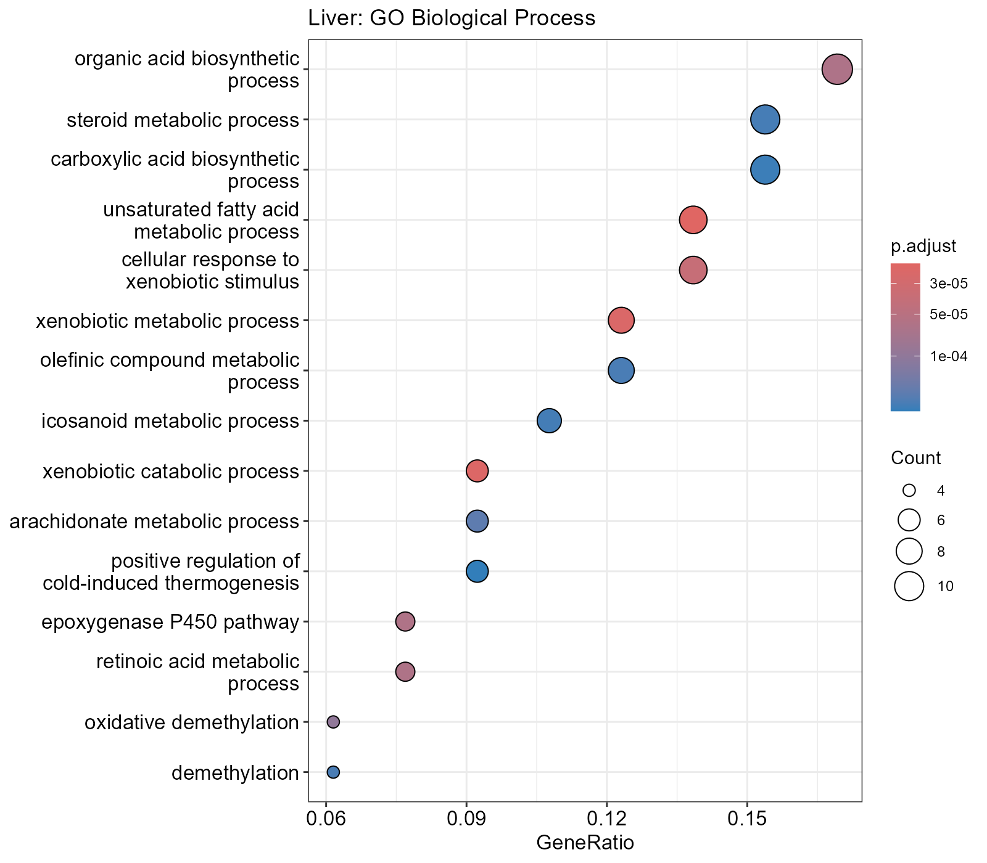
Figure S1. Liver GO Biological Process enrichment (34 significant terms, padj<0.05).
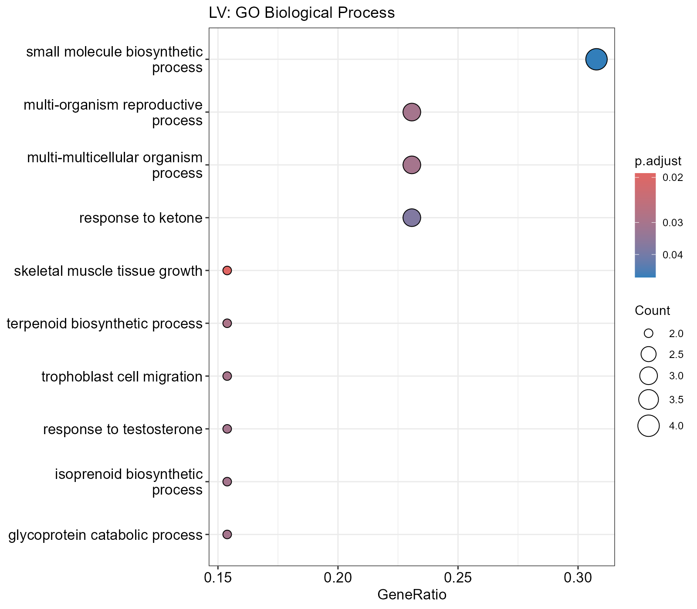
Figure S2. LV GO Biological Process enrichment (10 significant terms, padj<0.05).
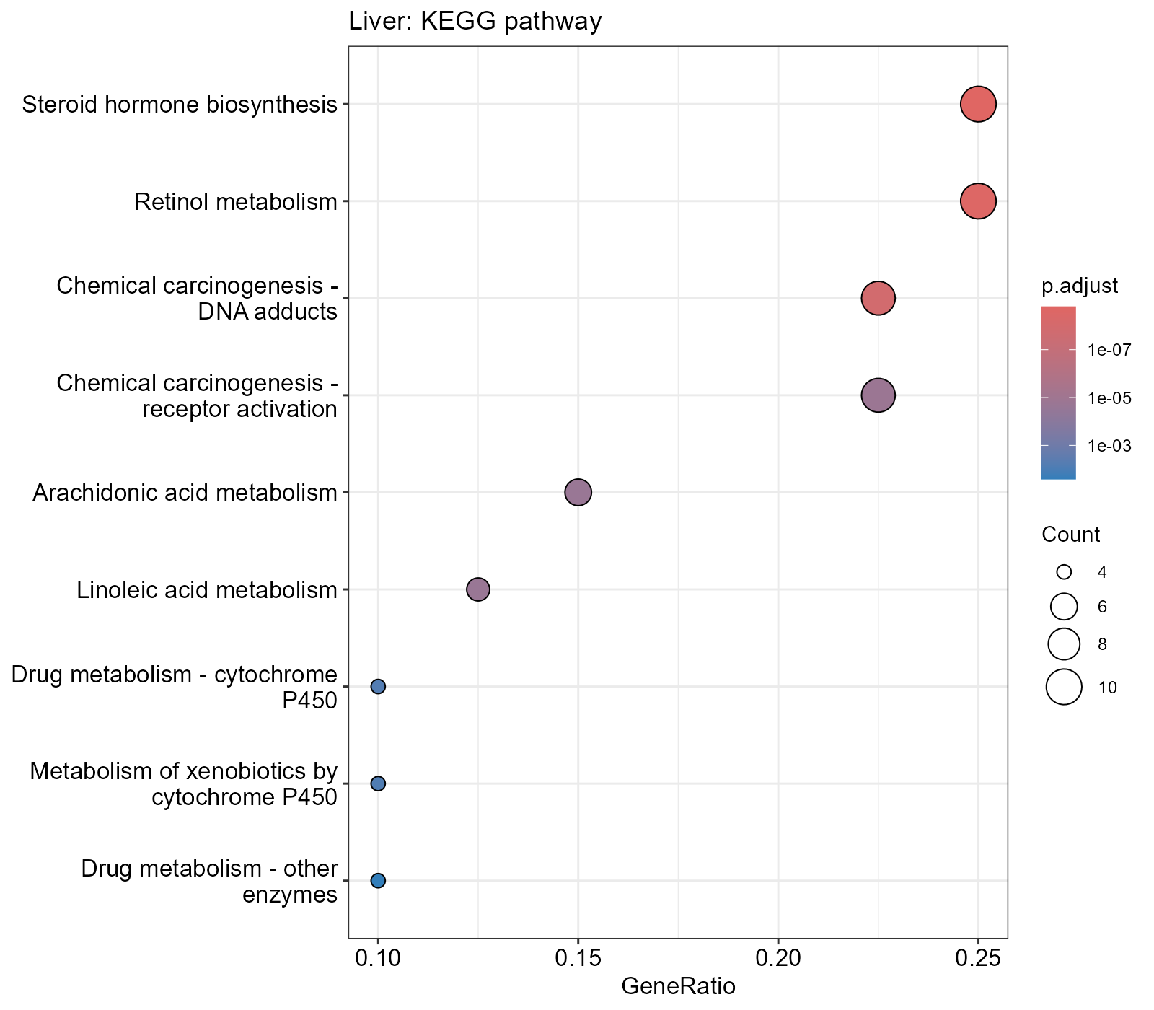
Figure S3. Liver KEGG pathway enrichment (9 significant pathways, padj<0.05). No KEGG pathway reached significance in LV.
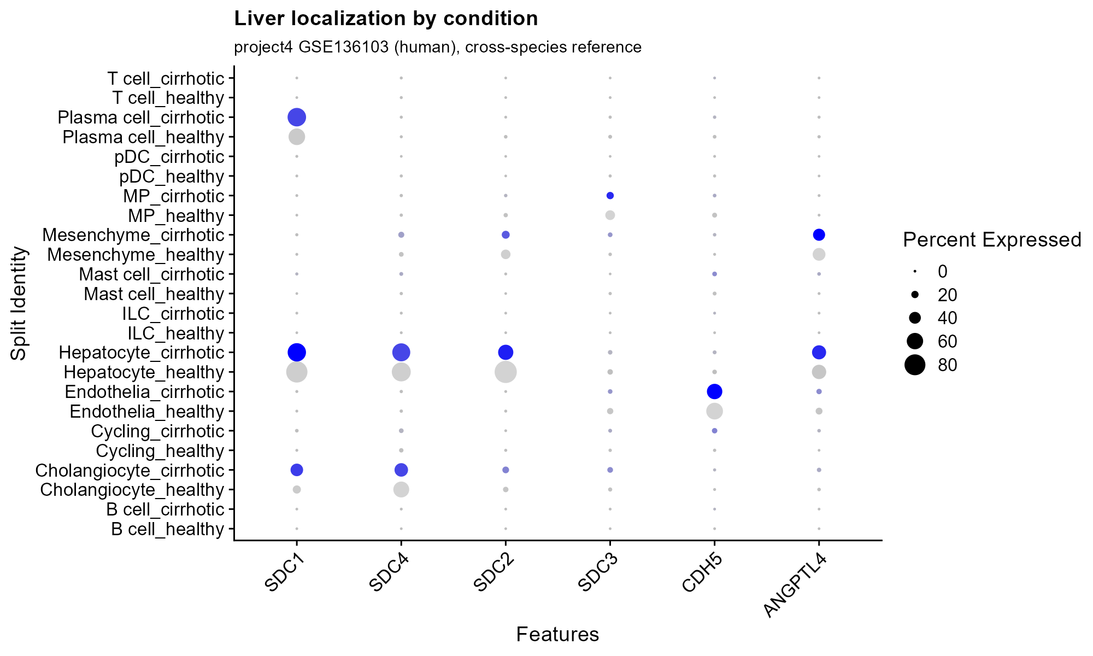
Figure S4. Liver localization of Angptl4-axis genes split by condition (healthy vs. cirrhotic; project4 GSE136103 cross-species reference).

Supplemental Tables

Table S1. Full significant DEG list, Liver (n=86, padj<0.01, |log2FC|>1.5)
ensembl_id | baseMean | log2FoldChange | lfcSE | pvalue | padj | gene_name
ENSMUSG00000034774 | 503.475388306876 | 2.64429327634708 | 0.212996384936588 | 1.39537690151581e-36 | 2.02469188409944e-32 | Dsg1c
ENSMUSG00000040616 | 233.084960747301 | -1.57213782341264 | 0.155920994817588 | 3.88811679866027e-25 | 1.41041436871401e-21 | Tmem51
ENSMUSG00000025002 | 184.776235730195 | -2.95549606645123 | 0.298917764494612 | 2.45979852017676e-24 | 5.94861275462746e-21 | Cyp2c55
ENSMUSG00000102095 | 1213.4461453138 | 2.34989330530966 | 0.238929661089155 | 4.28063697314542e-24 | 8.87314892576287e-21 | C730036E19Rik
ENSMUSG00000004038 | 1671.89161257983 | -2.30069790272563 | 0.246866137221666 | 5.60733540057556e-22 | 1.01703045827939e-18 | Gstm3
ENSMUSG00000097426 | 757.931557207992 | 2.28745881411989 | 0.254033251749858 | 1.17539446263632e-20 | 1.89499707253922e-17 | Gm8941
ENSMUSG00000038060 | 62.4375612302593 | 2.41883223232349 | 0.285631383979538 | 1.20429163712742e-18 | 1.52184952092415e-15 | Dlec1
ENSMUSG00000085834 | 232.693670444981 | 3.57622385332592 | 0.424846999216286 | 1.25859367684974e-18 | 1.52184952092415e-15 | Gm15622
ENSMUSG00000040660 | 461.654325493277 | 4.76612271546659 | 0.576013184410581 | 5.53051412404958e-18 | 6.17290461076611e-15 | Cyp2b9
ENSMUSG00000048368 | 86.633193258359 | 1.53140854822275 | 0.197566523167157 | 4.63189442300078e-16 | 4.65051132709902e-13 | Omd
ENSMUSG00000055866 | 1283.92773618528 | 1.54300995671552 | 0.199506431618138 | 5.25542389511422e-16 | 4.76601254488171e-13 | Per2
ENSMUSG00000030257 | 165.45506970847 | -2.8895867942592 | 0.377010856772018 | 9.15700661810583e-16 | 7.81577447227738e-13 | Srgap3
ENSMUSG00000026475 | 2092.78574519369 | 3.64609583478058 | 0.47804254562425 | 1.14747928863316e-15 | 9.24995804337065e-13 | Rgs16
ENSMUSG00000005677 | 3000.74783767299 | 1.58700471125647 | 0.212480251653979 | 4.12265691679091e-15 | 3.14840799277032e-12 | Nr1i3
ENSMUSG00000023044 | 6673.59478721416 | -2.41062007521851 | 0.325742646236205 | 6.25723758426475e-15 | 4.53962586738408e-12 | Csad
ENSMUSG00000069170 | 251.592851664664 | 2.16651042225976 | 0.293105763859143 | 8.06590679703661e-15 | 5.4017476922126e-12 | Adgrv1
ENSMUSG00000021259 | 98.7214766767695 | 1.57370677646021 | 0.217545271349545 | 1.94822058822189e-14 | 1.09348856000731e-11 | Cyp46a1
ENSMUSG00000099568 | 19.1449077349142 | 4.34751291066598 | 0.58927805915887 | 4.84230967169531e-14 | 2.50935404772496e-11 | Gm28513
ENSMUSG00000045672 | 2462.59697503316 | 1.54499356864996 | 0.216470787518036 | 4.84099137795888e-14 | 2.50935404772496e-11 | Col27a1
ENSMUSG00000030137 | 43.2872368975039 | -2.58353717790484 | 0.36523637624022 | 6.48414079516269e-14 | 3.24430630820037e-11 | Tuba8
ENSMUSG00000110496 | 146.126556323611 | 2.57568270325534 | 0.366567136943467 | 9.75018475899839e-14 | 4.71583936176889e-11 | Gm45909
ENSMUSG00000108825 | 195.710461902802 | 1.55720788262107 | 0.221565285877381 | 1.15524818052276e-13 | 5.40730680625329e-11 | Gm45838
ENSMUSG00000105391 | 49.3606698062927 | 1.98512987136949 | 0.299921203596909 | 1.44201892492306e-12 | 5.65505259476582e-10 | Gm43401
ENSMUSG00000029822 | 237.08162061726 | 2.15505014321603 | 0.335962066861222 | 6.46341694714879e-12 | 2.28741902202753e-09 | Osbpl3
ENSMUSG00000090175 | 516.646697485 | -2.23470003682453 | 0.361619080246087 | 2.87808381998234e-11 | 9.07847744085733e-09 | Ugt1a9
ENSMUSG00000057465 | 690.886491056676 | 1.78114533656839 | 0.29329685555328 | 5.61399049943249e-11 | 1.62918004293531e-08 | Saa2
ENSMUSG00000085211 | 83.5853289326452 | 2.27299239156911 | 0.381437351389097 | 1.01331119158786e-10 | 2.74957833813579e-08 | B430219N15Rik
ENSMUSG00000096215 | 81.7240445139723 | -1.51458742919241 | 0.25397202093263 | 1.02327519131174e-10 | 2.74957833813579e-08 | Smim22
ENSMUSG00000026822 | 143.919404952623 | 1.7747824470032 | 0.305858713103111 | 2.96510237092158e-10 | 7.17060590034535e-08 | Lcn2
ENSMUSG00000032482 | 105.343357814561 | -2.14370854029406 | 0.374939490019592 | 5.29145372862328e-10 | 1.21871418416387e-07 | Cspg5
ENSMUSG00000061906 | 407.471077450847 | -1.96973865869983 | 0.348547255980042 | 6.99493400180646e-10 | 1.51487302039122e-07 | Ugt2b38
ENSMUSG00000028957 | 1220.41286940673 | 1.59277260353284 | 0.287416193049593 | 1.39738912020119e-09 | 2.8161272408499e-07 | Per3
ENSMUSG00000061292 | 1015.4361831682 | -1.88983330776215 | 0.356498362621404 | 4.997147882676e-09 | 9.17830579463655e-07 | Cyp3a59
ENSMUSG00000029254 | 51.497023631564 | 1.897757223332 | 0.364838568194038 | 8.4090970410215e-09 | 1.40248273638186e-06 | Stap1
ENSMUSG00000022351 | 1927.2188631814 | -1.64467428029207 | 0.324712848462326 | 1.81916911200905e-08 | 2.66121461743334e-06 | Sqle
ENSMUSG00000108425 | 79.8323823453028 | 1.57831612368138 | 0.312015737650785 | 2.27885225064761e-08 | 3.14915677684731e-06 | Gm44706
ENSMUSG00000032773 | 17.487534249692 | 2.25711338050943 | 0.453268229847169 | 2.58531317852317e-08 | 3.50587796452068e-06 | Chrm1
ENSMUSG00000027533 | 1000.06428063829 | -2.79306755072058 | 0.570708158333458 | 3.88111120324011e-08 | 5.1195385053649e-06 | Fabp5
ENSMUSG00000030302 | 47.1906926893873 | -1.75980397182386 | 0.358818599568666 | 4.18218637123124e-08 | 5.41817180772905e-06 | Atp2b2
ENSMUSG00000049109 | 63.0119494150958 | 2.53186062101198 | 0.518540976460581 | 4.1553296293353e-08 | 5.41817180772905e-06 | Themis
ENSMUSG00000086245 | 108.32248138857 | 1.58443107419618 | 0.324445748864558 | 5.35431450050601e-08 | 6.64026524806344e-06 | Gm16170
ENSMUSG00000097762 | 81.651463977587 | 1.81925116292515 | 0.384014851633741 | 9.0015745869005e-08 | 1.07944501864402e-05 | 4732463B04Rik
ENSMUSG00000089712 | 100.580184766758 | 1.80356149676301 | 0.38842663020433 | 1.40830651123545e-07 | 1.59644745922081e-05 | Gm15889
ENSMUSG00000001076 | 17.02603990295 | -1.70405875993617 | 0.365141246779795 | 1.69231016012441e-07 | 1.86025912298524e-05 | C1ql4
ENSMUSG00000049723 | 20.0381554698832 | 2.07998968568883 | 0.447192498406029 | 1.85165569632691e-07 | 2.00503911594802e-05 | Mmp12
ENSMUSG00000057933 | 576.196153284774 | -1.76891069316312 | 0.385887177021199 | 1.89327750344454e-07 | 2.03492270925779e-05 | Gsta2
ENSMUSG00000012123 | 35.4531322336344 | 1.65101650446626 | 0.362947647808665 | 2.39274357106565e-07 | 2.47990780115447e-05 | Crybg2
ENSMUSG00000040583 | 17.2718000888921 | 3.88076851176883 | 0.869928156891006 | 3.74043305763701e-07 | 3.54729958603353e-05 | Cyp2b13
ENSMUSG00000090105 | 23.2866504862879 | 1.54441267413779 | 0.346895517391425 | 4.06125678891998e-07 | 3.77748948764288e-05 | Gm15890
ENSMUSG00000092008 | 46.6255327924104 | -2.64333323561804 | 0.599234862145356 | 4.46404324338968e-07 | 4.02318431438411e-05 | Cyp2c69
ENSMUSG00000075044 | 21.1374986591566 | 2.13622927040766 | 0.490388947072474 | 5.6067350284095e-07 | 4.89463689651337e-05 | Slc22a29
ENSMUSG00000026622 | 62.252521168354 | -1.53132834673788 | 0.354434296556186 | 7.09378466082344e-07 | 5.93321979152194e-05 | Nek2
ENSMUSG00000027068 | 82.6238537349016 | -2.814860625705 | 0.665050568618433 | 8.51820731959965e-07 | 6.64511764555866e-05 | Dhrs9
ENSMUSG00000056978 | 487.384642782162 | 1.58898036242832 | 0.374757650569082 | 9.75852495665254e-07 | 7.37480193338689e-05 | Hamp2
ENSMUSG00000037071 | 175490.135891387 | -2.02412764651439 | 0.487542574417716 | 1.26180457426227e-06 | 9.16514088912715e-05 | Scd1
ENSMUSG00000067656 | 26.2965331234244 | 2.46144330277243 | 0.590769149946265 | 1.33466790904984e-06 | 9.4009860972394e-05 | Slc22a27
ENSMUSG00000092035 | 22.3035997476215 | -1.71998464310816 | 0.416284049827858 | 1.77080224543639e-06 | 0.00011786394762056 | Peg10
ENSMUSG00000006398 | 24.3137100703418 | -2.43262130844438 | 0.599393330092832 | 2.10459567280823e-06 | 0.000132772535706293 | Cdc20
ENSMUSG00000095061 | 68.3373006070974 | 1.71155768038216 | 0.427769779770463 | 2.45326589560022e-06 | 0.000150197840274933 | E030018B13Rik
ENSMUSG00000056035 | 65946.37167539 | -2.70741979301712 | 0.688205414363059 | 2.86541008749761e-06 | 0.000166976306705182 | Cyp3a11
ENSMUSG00000044505 | 74.0480845187485 | 1.71797789626701 | 0.439744974240386 | 3.43750635218637e-06 | 0.000193326423140404 | Lingo4
ENSMUSG00000007646 | 14.5434640260684 | -1.54688192713275 | 0.391678403098943 | 3.6192781387486e-06 | 0.000201209677368744 | Rad51c
ENSMUSG00000035745 | 16.5068263207717 | 1.52920944340881 | 0.394934486430846 | 5.06798269744679e-06 | 0.00025815824275548 | Grin3b
ENSMUSG00000103313 | 40.8231287897529 | 2.21018692770093 | 0.586870220040183 | 7.37628169895806e-06 | 0.000352071866618031 | Gm38357
ENSMUSG00000023078 | 36.4033126608795 | -2.47721835141111 | 0.672748158828972 | 8.39354656501186e-06 | 0.000387867390631599 | Cxcl13
ENSMUSG00000041293 | 342.851910878944 | -2.03996031393003 | 0.553788962719193 | 8.39021053015753e-06 | 0.000387867390631599 | Adgrf1
ENSMUSG00000049588 | 15.7664311672807 | -1.59648912607105 | 0.445196468458205 | 1.47524492907155e-05 | 0.000614347689265848 | Ccdc69
ENSMUSG00000090622 | 186.968621810295 | 2.07931874974341 | 0.596992867515225 | 1.76136912768898e-05 | 0.000711907132110504 | A930033H14Rik
ENSMUSG00000091285 | 12.5426764629515 | 1.66480927533007 | 0.460608968350895 | 1.7926272086661e-05 | 0.000722528355492918 | Gm17430
ENSMUSG00000098235 | 9.0423526380464 | 1.89263875018585 | 0.529982563592486 | 1.91858276480984e-05 | 0.000764797690038209 | NA
ENSMUSG00000044927 | 18.6701815274399 | -1.66092011588795 | 0.473372285624801 | 2.10637769487617e-05 | 0.000830257841100728 | H1fx
ENSMUSG00000091329 | 14.9238965550706 | 1.6170186674955 | 0.455899291508546 | 2.24152480716831e-05 | 0.000871971178338127 | 1700112D23Rik
ENSMUSG00000025004 | 135.326894605277 | -2.33292120167468 | 0.693578718681911 | 2.58684703726434e-05 | 0.000982595563107475 | Cyp2c40
ENSMUSG00000072214 | 18.0952564086128 | -1.63249852676583 | 0.478718351284391 | 2.93136512727684e-05 | 0.0010713881107503 | Sept5
ENSMUSG00000084923 | 23.8451045529001 | -1.76332092933545 | 0.525454064875518 | 3.13448285331093e-05 | 0.00112023020200841 | Gm15611
ENSMUSG00000021453 | 540.427360807802 | -2.39570363720549 | 0.729984863931386 | 3.28647651581548e-05 | 0.0011602621470677 | Gadd45g
ENSMUSG00000029683 | 26.9885474287585 | 1.77962755758898 | 0.541412453953807 | 3.34303765700773e-05 | 0.00117451516714727 | Lmod2
ENSMUSG00000086443 | 12.0909751392291 | 1.85071654481559 | 0.549115921662533 | 3.37671935891849e-05 | 0.00118348304101225 | 4933421A08Rik
ENSMUSG00000015090 | 95.3717341781163 | -1.52962101948474 | 0.479170558604883 | 4.97657883354906e-05 | 0.00160919470135149 | Ptgds
ENSMUSG00000006462 | 13.4890520143902 | 1.58108973392906 | 0.49717225944575 | 5.54023259477142e-05 | 0.00172879085914265 | A530013C23Rik
ENSMUSG00000038754 | 6084.34344550565 | -2.15476809845514 | 0.701577767390768 | 6.6537436402692e-05 | 0.00199063546845992 | Elovl3
ENSMUSG00000022096 | 22.2632109520546 | -1.77540049077713 | 0.582188876729559 | 7.91064368348631e-05 | 0.00227744920332116 | Hr
ENSMUSG00000029752 | 212.574567726209 | -1.88285840191387 | 0.669351737134485 | 0.000152233894218673 | 0.00380682251413293 | Asns
ENSMUSG00000033998 | 15.7718075458625 | -1.74070476260931 | 0.606968526647088 | 0.000152459270445777 | 0.00380682251413293 | Kcnk1
ENSMUSG00000087254 | 8.09623464906621 | 1.71663945665183 | 0.602968728803784 | 0.000191675630750793 | 0.00454446634345425 | NA
ENSMUSG00000058794 | 26.4527269794215 | -1.54676842649068 | 0.572930281769438 | 0.000240890502064942 | 0.00541071390861038 | Nfe2

Table S2. Full significant DEG list, LV (n=20, padj<0.01, |log2FC|>1.5)
ensembl_id | baseMean | log2FoldChange | lfcSE | pvalue | padj | gene_name
ENSMUSG00000022041 | 145.660582378684 | 2.57638439138763 | 0.175843685950858 | 6.1318175414205e-50 | 9.18300995003134e-46 | Chrna2
ENSMUSG00000027875 | 1200.94711694295 | 2.93313922478898 | 0.255403028018164 | 7.28163702360386e-32 | 3.63499320218305e-28 | Hmgcs2
ENSMUSG00000038801 | 120.14262231586 | -1.76007778391204 | 0.197567104717418 | 2.21194253633446e-20 | 3.68067238046055e-17 | Scgb1c1
ENSMUSG00000020734 | 29.5517812480675 | -1.87895225500635 | 0.302122564522168 | 2.83651105537677e-11 | 1.21370255900921e-08 | Grin2c
ENSMUSG00000095186 | 19.8826870421646 | 3.03089625163073 | 0.502555274565173 | 5.29227988373781e-11 | 1.98142958847144e-08 | Gm10718
ENSMUSG00000091028 | 31.1354029618796 | 2.64570833732513 | 0.439222559838314 | 8.39734026689665e-11 | 3.04987400456305e-08 | Gm10722
ENSMUSG00000032315 | 10.8139329400401 | -6.02992297872652 | 1.30126997553086 | 4.4898497679556e-10 | 1.20071410937327e-07 | Cyp1a1
ENSMUSG00000023232 | 24.0675346558095 | 1.64299469724139 | 0.289940313243567 | 7.4787126441852e-10 | 1.89832543320877e-07 | Serinc2
ENSMUSG00000048620 | 22.3566691030969 | 2.0496171970267 | 0.370097871919196 | 1.05750764999413e-09 | 2.62398780297812e-07 | Olfr1336
ENSMUSG00000075014 | 2251.45787365954 | 3.06552801252231 | 0.557506255662567 | 1.59928976755004e-09 | 3.74233805606709e-07 | Gm10800
ENSMUSG00000095891 | 21.063915790526 | 2.88083802519752 | 0.526001024305662 | 2.38810538624774e-09 | 5.03722060062621e-07 | Gm10717
ENSMUSG00000095280 | 217.188661699615 | 2.8743840603429 | 0.548218694671638 | 6.31642994321212e-09 | 1.15832159708323e-06 | Gm21738
ENSMUSG00000097312 | 239.456629550122 | 3.08767833419825 | 0.604875992305882 | 1.31846837492715e-08 | 2.2959746956871e-06 | Gm26870
ENSMUSG00000049723 | 21.4361424790104 | 2.06072610110078 | 0.420170005494377 | 4.79570759286431e-08 | 7.04122714811136e-06 | Mmp12
ENSMUSG00000075015 | 207.91191270844 | 3.01379288346187 | 0.62766517825187 | 6.03228232122677e-08 | 8.4429401909058e-06 | Gm10801
ENSMUSG00000025013 | 27.9371153821631 | 1.58150802858036 | 0.358002237498504 | 4.13730908907278e-07 | 4.2731269598589e-05 | Tll2
ENSMUSG00000020051 | 25.730795060773 | -1.95357435059826 | 0.458852987463658 | 7.5656679899915e-07 | 7.12600275585615e-05 | Pah
ENSMUSG00000026100 | 19.0938326318089 | 2.05910611163272 | 0.520708593907008 | 4.04892180786927e-06 | 0.000295788551193416 | Mstn
ENSMUSG00000002289 | 313.214505276466 | 1.83669349577153 | 0.543242960858156 | 2.50597877149388e-05 | 0.0012778693073941 | Angptl4
ENSMUSG00000006403 | 28.2065760557275 | -1.51948001831172 | 0.469992790167038 | 4.52982011755165e-05 | 0.00202503242031204 | Adamts4

Table S3. Liver GO-BP enrichment (full, padj<0.05)
ID | Description | GeneRatio | BgRatio | RichFactor | FoldEnrichment
GO:0033559 | unsaturated fatty acid metabolic process | 9/65 | 127/12443 | 0.0708661417322835 | 13.5659600242277
GO:0042178 | xenobiotic catabolic process | 6/65 | 38/12443 | 0.157894736842105 | 30.2259109311741
GO:0006805 | xenobiotic metabolic process | 8/65 | 104/12443 | 0.0769230769230769 | 14.7254437869822
GO:0071466 | cellular response to xenobiotic stimulus | 9/65 | 159/12443 | 0.0566037735849057 | 10.8357039187228
GO:0019373 | epoxygenase P450 pathway | 5/65 | 27/12443 | 0.185185185185185 | 35.4501424501425
GO:0042573 | retinoic acid metabolic process | 5/65 | 28/12443 | 0.178571428571429 | 34.1840659340659
GO:0016053 | organic acid biosynthetic process | 11/65 | 298/12443 | 0.0369127516778524 | 7.06623644811564
GO:0070989 | oxidative demethylation | 4/65 | 14/12443 | 0.285714285714286 | 54.6945054945055
GO:0019369 | arachidonate metabolic process | 6/65 | 68/12443 | 0.0882352941176471 | 16.8909502262443
GO:0120254 | olefinic compound metabolic process | 8/65 | 163/12443 | 0.049079754601227 | 9.39537517697027
GO:0070988 | demethylation | 4/65 | 18/12443 | 0.222222222222222 | 42.5401709401709
GO:0008202 | steroid metabolic process | 10/65 | 288/12443 | 0.0347222222222222 | 6.64690170940171
GO:0006690 | icosanoid metabolic process | 7/65 | 117/12443 | 0.0598290598290598 | 11.4531229454306
GO:0046394 | carboxylic acid biosynthetic process | 10/65 | 295/12443 | 0.0338983050847458 | 6.48917861799218
GO:0120162 | positive regulation of cold-induced thermogenesis | 6/65 | 78/12443 | 0.0769230769230769 | 14.7254437869822
GO:0009410 | response to xenobiotic stimulus | 10/65 | 348/12443 | 0.028735632183908 | 5.50088417329797
GO:0001523 | retinoid metabolic process | 5/65 | 68/12443 | 0.0735294117647059 | 14.0757918552036
GO:0016101 | diterpenoid metabolic process | 5/65 | 71/12443 | 0.0704225352112676 | 13.4810400866739
GO:0120161 | regulation of cold-induced thermogenesis | 6/65 | 121/12443 | 0.0495867768595041 | 9.49243483788938
GO:0006631 | fatty acid metabolic process | 10/65 | 406/12443 | 0.0246305418719212 | 4.71504357711254
GO:0001676 | long-chain fatty acid metabolic process | 6/65 | 126/12443 | 0.0476190476190476 | 9.11575091575092
GO:0106106 | cold-induced thermogenesis | 6/65 | 126/12443 | 0.0476190476190476 | 9.11575091575092
GO:0046456 | icosanoid biosynthetic process | 4/65 | 43/12443 | 0.0930232558139535 | 17.8075134168157
GO:0006721 | terpenoid metabolic process | 5/65 | 84/12443 | 0.0595238095238095 | 11.3946886446886
GO:0072330 | monocarboxylic acid biosynthetic process | 7/65 | 199/12443 | 0.0351758793969849 | 6.73374565133359
GO:1990845 | adaptive thermogenesis | 6/65 | 138/12443 | 0.0434782608695652 | 8.32307692307692
GO:0006636 | unsaturated fatty acid biosynthetic process | 4/65 | 48/12443 | 0.0833333333333333 | 15.9525641025641
GO:0001659 | temperature homeostasis | 6/65 | 152/12443 | 0.0394736842105263 | 7.55647773279352
GO:0006720 | isoprenoid metabolic process | 5/65 | 99/12443 | 0.0505050505050505 | 9.66822066822067
GO:0035634 | response to stilbenoid | 3/65 | 24/12443 | 0.125 | 23.9288461538462
GO:0042445 | hormone metabolic process | 6/65 | 187/12443 | 0.0320855614973262 | 6.14216371863431
GO:0008210 | estrogen metabolic process | 3/65 | 29/12443 | 0.103448275862069 | 19.8031830238727
GO:0034756 | regulation of iron ion transport | 2/65 | 10/12443 | 0.2 | 38.2861538461539
GO:0050910 | detection of mechanical stimulus involved in sensory perception of sound | 2/65 | 10/12443 | 0.2 | 38.2861538461539

Table S4. LV GO-BP enrichment (full, padj<0.05)
ID | Description | GeneRatio | BgRatio | RichFactor | FoldEnrichment
GO:0048630 | skeletal muscle tissue growth | 2/13 | 10/13056 | 0.2 | 200.861538461538
GO:0016114 | terpenoid biosynthetic process | 2/13 | 17/13056 | 0.117647058823529 | 118.153846153846
GO:0061450 | trophoblast cell migration | 2/13 | 21/13056 | 0.0952380952380952 | 95.6483516483516
GO:0033574 | response to testosterone | 2/13 | 28/13056 | 0.0714285714285714 | 71.7362637362637
GO:0008299 | isoprenoid biosynthetic process | 2/13 | 29/13056 | 0.0689655172413793 | 69.262599469496
GO:0006516 | glycoprotein catabolic process | 2/13 | 30/13056 | 0.0666666666666667 | 66.9538461538462
GO:0044703 | multi-organism reproductive process | 3/13 | 163/13056 | 0.0184049079754601 | 18.4841906559698
GO:0044706 | multi-multicellular organism process | 3/13 | 165/13056 | 0.0181818181818182 | 18.2601398601399
GO:1901654 | response to ketone | 3/13 | 185/13056 | 0.0162162162162162 | 16.2860706860707
GO:0044283 | small molecule biosynthetic process | 4/13 | 487/13056 | 0.0082135523613963 | 8.24893381772232

Table S5. Liver KEGG pathway enrichment (full, padj<0.05)
category | subcategory | ID | Description | GeneRatio | BgRatio
Metabolism | Lipid metabolism | mmu00140 | Steroid hormone biosynthesis | 10/40 | 69/5954
Metabolism | Metabolism of cofactors and vitamins | mmu00830 | Retinol metabolism | 10/40 | 77/5954
Human Diseases | Cancer: overview | mmu05204 | Chemical carcinogenesis - DNA adducts | 9/40 | 67/5954
Human Diseases | Cancer: overview | mmu05207 | Chemical carcinogenesis - receptor activation | 9/40 | 155/5954
Metabolism | Lipid metabolism | mmu00591 | Linoleic acid metabolism | 5/40 | 28/5954
Metabolism | Lipid metabolism | mmu00590 | Arachidonic acid metabolism | 6/40 | 53/5954
Metabolism | Xenobiotics biodegradation and metabolism | mmu00982 | Drug metabolism - cytochrome P450 | 4/40 | 53/5954
Metabolism | Xenobiotics biodegradation and metabolism | mmu00980 | Metabolism of xenobiotics by cytochrome P450 | 4/40 | 57/5954
Metabolism | Xenobiotics biodegradation and metabolism | mmu00983 | Drug metabolism - other enzymes | 4/40 | 82/5954

Table S6. STRING network hub genes (Angptl4-Sdc/Cdh5 axis + first-shell interactors)
gene | degree | betweenness | is_seed
Sdc1 | 16 | 64.3 | TRUE
Sdc4 | 14 | 45.1 | TRUE
Sdc3 | 6 | 3.2 | TRUE
Gpc1 | 6 | 2.1 | FALSE
Gpc4 | 5 | 1 | FALSE
Hspg2 | 5 | 0.6 | FALSE
Ext1 | 4 | 0.2 | FALSE
Tnc | 3 | 0.4 | FALSE
Sdc2 | 3 | 0 | TRUE
Angptl4 | 2 | 1 | TRUE
Comp | 2 | 0 | FALSE
Sdcbp2 | 2 | 0 | FALSE
Tnr | 2 | 0 | FALSE
Thbs3 | 2 | 0 | FALSE
Tnxb | 2 | 0 | FALSE
Tnn | 2 | 0 | FALSE
Gpc2 | 2 | 0 | FALSE
Cdh5 | 1 | 0 | TRUE
Angptl8 | 1 | 0 | FALSE
Nudt16l1 | 1 | 0 | FALSE
Hpse2 | 1 | 0 | FALSE

Table S7. Full AutoDock Vina ranking (all 21 compounds)
label | best_affinity_kcal_mol | status
Resmetirom | -9.068 | OK
Ezetimibe | -8.883 | OK
Pioglitazone | -8.279 | OK
Fenofibrate | -8.206 | OK
Empagliflozin | -8.144 | OK
Bezafibrate | -8.101 | OK
Rosiglitazone | -7.841 | OK
Ibuprofen | -7.233 | OK
Dapagliflozin | -7.05 | OK
Arachidonic_acid | -6.995 | OK
Atorvastatin | -6.831 | OK
Obeticholic_acid | -6.775 | OK
Eicosapentaenoic_acid | -6.772 | OK
Aspirin | -6.703 | OK
Icosapent_ethyl | -6.693 | OK
Metoprolol | -6.493 | OK
Linoleic_acid | -6.467 | OK
Palmitic_acid | -6.38 | OK
Caffeine | -5.358 | OK
Niacin | -5.078 | OK
Metformin | -4.654 | OK

Table S8. STITCH chemical partners of Angptl4-axis genes (full)
gene | cid | raw_id | compound_name
Angptl4 | 3931 | -10.CID100003931 | 9,12-Octadecadienoic Acid
Angptl4 | 77998 | -10.CID100077998 | C22H23N3O7S
Angptl4 | 985 | -10.CID100000985 | Palmitic Acid
Angptl4 | 231 | -10.CID100000231 | 5,8,11,14-Eicosatetraenoic acid, (5Z,8Z,11Z,14Z)-
Angptl4 | 860 | -10.CID100000860 | Linseed Acid
Angptl4 | 1424 | -10.CID100001424 | 13-Hydroxyoctadeca-9,11-dienoic acid
Angptl4 | 1927 | -10.CID100001927 | 9-Hydroxy-10,12-Octadecadienoic Acid
Angptl4 | 3209 | -10.CID100003209 | 5,8,11,14,17-Eicosapentaenoic Acid
Angptl4 | 4829 | -10.CID100004829 | Pioglitazone
Sdc1 | 18845 | -10.CID100018845 | Iduronic Acid
Sdc1 | 150835 | -10.CID100150835 | [3,7-Dimethyl-9-(2,6,6-trimethylcyclohexen-1-yl)nona-2,4,6,8-tetraenyl] octadeca-9,12-dienoate
Sdc1 | 122008 | -10.CID100122008 | 9-cis-RetinylStearate-d5
Sdc1 | 961 | -10.CID100000961 | Hydroxide
Sdc1 | 175 | -10.CID100000175 | Acetate
Sdc1 | 1172 | -10.CID100001172 | (5-(2,4-Dioxopyrimidin-1-yl)-3,4-dihydroxyoxolan-2-yl)methyl dihydrogen phosphate
Sdc3 | 18845 | -10.CID100018845 | Iduronic Acid
Sdc3 | 175 | -10.CID100000175 | Acetate
Sdc2 | 18845 | -10.CID100018845 | Iduronic Acid
Cdh5 | 271 | -10.CID100000271 | Calcium Cation

Table S9. DGIdb druggability summary
gene | n_interactions | n_approved | example_drugs
SDC2 | 1 | 0 | HEPARAN SULFATE
SDC4 | 1 | 1 | REPOTRECTINIB
CDH5 | 1 | 0 | FX06
SDC3 | 0 | 0
SDC1 | 3 | 0 | HEPARIN; INDATUXIMAB RAVTANSINE
ANGPTL4 | 0 | 0

Supplemental Text

Text S1. Final target selection rationale
Why not the syndecans (the actual network hubs): all available PDB structures for
SDC1/SDC4 cover fragments other than the extracellular heparan-sulfate-bearing
ectodomain that would physically engage a secreted ligand like Angptl4 (e.g. 8BLV is
the SDC4 cytoplasmic tail bound to syntenin PDZ domains, not an extracellular pocket).
Docking a small molecule against a cytoplasmic PDZ-binding motif would not address the
actual Angptl4-syndecan extracellular interaction, so despite their strong network
centrality, they are not structurally actionable for this step.
Why ANGPTL4: (1) zero existing DGIdb drug interactions -- genuinely undrugged;
(2) a real, solved, 2.3-angstrom crystal structure of its C-terminal fibrinogen-like
domain exists (6EUB) with a visible ligand-accommodating surface (PEG fragment bound
in the deposited structure); (3) it is the molecule directly validated twice over --
by our own stricter DEG reanalysis (LV upregulated, padj/lfc-significant) and by an
independent 2024 single-cell paper confirming cardiac-fibroblast secretion in HFpEF;
(4) blocking this domain would act at the source of the axis (the secreted signal
itself) rather than downstream, which is defensible as the more tractable
intervention point given the receptor-side structures are unusable.
Limitation to state plainly in the paper: this reframes the intervention target
from the network-centrality hub (Sdc1/Sdc4) to the ligand itself, because of a
structural-biology constraint, not a change in the network analysis's conclusions --
Sdc1/Sdc4 remain the top computational hubs, but are not currently actionable for
small-molecule structure-based screening with public structural data.

Text S2. DiffDock cross-check summary
Vina docking (Section above) used a fixed search box centered on the only
observed small-molecule-occupied surface site in the ANGPTL4 crystal structure
(the 1PE/PEG cryoprotectant site). DiffDock, by contrast, performs blind
docking across the entire protein surface with no box constraint — so
agreement between the two methods on *where* a ligand binds is an independent
structural check, not just a re-ranking of the same fixed site.
- Ezetimibe is the more cross-validated candidate: an orthogonal,
box-free method (DiffDock) independently converged on essentially the same
surface pocket that Vina was constrained to search, and did so with a
*better* confidence score than Resmetirom. Contact residues at this site
(Leu304, Leu312, Gly313, Ala314, Leu322, Ser323, Val324, Trp349, Trp350,
Gly352, Thr353, His356) form a real hydrophobic groove consistent with a
genuine small-molecule pocket, not a surface artifact.
- Resmetirom scored best on Vina (which only searched the predefined
pocket), but DiffDock's unconstrained search preferred a completely
different surface region (contact residues Trp280, Asp281, Ile367, Leu374,
Tyr387, Tyr388, Pro389). This is reported as a genuine discrepancy rather
than smoothed over: Resmetirom's top Vina score should be read as
"the best-fitting pose *within the pocket we searched*," not as strong
independent evidence that this is its preferred binding site on ANGPTL4.
- Both DiffDock confidence scores (-2.06, -1.32) fall in DiffDock's own
low-to-moderate confidence range (published benchmarks treat c > 0 as
high-confidence), so neither result should be oversold as a confirmed
binder -- both are hypothesis-generating leads for this 학술제 pipeline,
not validated hits.
DiffDock was not run locally: this machine has no CUDA-capable GPU, and a
local from-scratch install (PyTorch + PyTorch Geometric + e3nn + ESM) would
have made CPU inference impractically slow for even one complex. Instead, a
publicly running DiffDock Gradio Space (swcanner/DiffDock-Web, mirroring
the original gcorso/DiffDock inference code) was used via its web UI for
the two approved top-hit compounds only, consistent with the earlier
CPU-budget decision to limit DiffDock to the final 1-2 candidates rather than
the full 21-compound library.

