Single-Cell-Informed Deconvolution Reveals That General Macrophage Infiltration, Not the S100A8-Hi Subset Specifically, Tracks Lipogenic Gene Expression in a Mouse Model of Steatotic Liver Disease
[Author Name]¹, [Corresponding Author Name]¹*
¹[Department/Institution]
*Corresponding author: [email address]
This manuscript reports a secondary, hypothesis-generating computational reanalysis of a public dataset; it has not been peer reviewed.

Abstract
Background: Adipocyte death promotes hepatic accumulation of S100A8⁺ macrophages, which suppress CCN3 and increase hepatocyte CD36 expression, driving metabolic dysfunction-associated steatotic liver disease (MASLD).¹ The public dataset underlying this mechanism (GEO GSE285614/GSE285615) comprises 34 bulk RNA-seq samples across two independent genotype axes and only two single-cell RNA-seq (scRNA-seq) samples (one wild-type [WT], one Bcl2-transgenic [TG]), leaving the second axis — a macrophage-specific S100a8 knockout (MKO) — without any matched single-cell reference.
Methods: We reprocessed the public scRNA-seq reference, identified 12 hepatic cell populations including an S100A8-hi macrophage/monocyte population explicitly distinguished from neutrophils, and built a marker-gene signature. Because the reference contains only one biological replicate per genotype, subject-variance-based deconvolution methods were not applicable; we instead used marker-based deconvolution (BisqueRNA::MarkerBasedDecomposition) to estimate relative cell-type abundance in all 34 bulk samples. We validated the deconvolution against the direction of the original, fully replicated (n=5 vs n=5) bulk DESeq2 result, then applied it to the MKO axis and tested correlation with hepatic lipogenic gene expression. Group comparisons used Wilcoxon rank-sum tests (primary), Welch's t-test and Cohen's d (sensitivity/effect size), Benjamini-Hochberg (BH) correction within each comparison family, and post hoc power analysis.
Results: Deconvolution direction matched the replicated bulk DESeq2 result for every cell type checked. General macrophage/Kupffer abundance was significantly higher in WT than TG (Cohen's d = -2.86, BH q = 0.024) and correlated with Cd36, Pparg, Scd1 and Plin2 expression (all q < 0.05); the S100A8-hi subset trended in the same direction (d = -0.92) but did not reach significance and did not correlate with Cd36 (q = 0.76). In the MKO axis, no composition shift survived correction (this design is powered only for d ≳ 2.0-2.4); nominal, uncorrected effects were observed in neutrophils and mast cells.
Conclusions: Bulk-level compositional correlates of this pathway are driven predominantly by the general hepatic macrophage/Kupffer compartment rather than the S100A8-hi subset specifically, and macrophage-specific S100a8 deletion does not produce a statistically resolvable shift in broader immune composition at the sample sizes available — a pattern consistent with a gene-regulatory rather than a compositional/recruitment mechanism, though it requires confirmation in an adequately powered cohort.
Keywords: MASLD; S100A8; hepatic macrophage; cell-type deconvolution; single-cell RNA sequencing; BisqueRNA

1. Introduction
Metabolic dysfunction-associated steatotic liver disease (MASLD, formerly nonalcoholic fatty liver disease)² affects a large proportion of the global population and can progress to steatohepatitis, fibrosis and cirrhosis. A recent study using genetically modified mice and paired bulk and single-cell RNA sequencing (scRNA-seq) demonstrated that death of visceral adipocytes under high-fat diet (HFD) feeding drives hepatic infiltration of S100A8⁺ macrophages, which suppress the CD36-negative regulator CCN3 and thereby increase hepatocyte CD36 expression and lipid storage. Blocking adipocyte death (adipocyte-specific Bcl2 overexpression, "Bcl2TG", which inhibits the mitochondrial apoptosis pathway) or deleting S100a8 specifically in macrophages (S100a8^{fl/fl};Cx3cr1-Cre, "MKO") both reduced hepatic steatosis, establishing this as a mechanistic axis in MASLD progression¹.
The public data supporting this study (GEO accessions GSE285614 and GSE285615) include 34 bulk liver RNA-seq samples spanning two independent genotype axes — an adipocyte-death axis (WT vs Bcl2TG) and a macrophage-specific knockout axis (WT vs MKO) — but only two scRNA-seq samples, one WT and one Bcl2TG, both under HFD. The original analysis of these data relied on single-gene bulk differential expression; it did not use the scRNA-seq reference to ask whether the two genotype manipulations change the composition of the hepatic immune infiltrate, as opposed to the expression level of individual genes within it — a distinction that matters because a shrinking S100A8⁺ macrophage population and a stable population that has simply down-regulated S100a8 would look identical in a single-gene analysis but imply different biology. This question is structurally unanswerable for the MKO axis using the original study's own data, because that axis has no scRNA-seq reference of its own.
Here we reprocess the public scRNA-seq reference, build a marker-gene signature that explicitly separates an S100A8-hi macrophage/monocyte population from mature neutrophils (both S100a8/S100a9-positive, but otherwise transcriptionally distinct), and use marker-based deconvolution to estimate relative cell-type abundance across all 34 bulk samples. Because the scRNA-seq reference contains only one biological replicate per genotype, we first establish, and then apply throughout, a validation strategy suited to this constraint: rather than trusting the single scRNA-seq sample pair as ground truth (which we show can be directionally misleading), we validate the deconvolution against the original, fully replicated (n=5 vs n=5) bulk differential expression result for the same genotype comparison. We then apply the validated signature to the MKO axis — which has no scRNA-seq reference of its own — to test whether macrophage-specific S100a8 deletion detectably remodels the broader hepatic immune landscape, and we test whether cell-type abundance correlates with hepatic lipogenic gene expression across the full cohort.

2. Methods

2.1 Data sources
Raw and processed data were downloaded from the NCBI Gene Expression Omnibus⁸ (GSE285614, bulk liver RNA-seq; GSE285615, liver scRNA-seq), originally deposited alongside¹. GSE285614 was deposited as two separate DESeq2 analyses, each with per-sample raw counts embedded alongside summary statistics: "HFD_TG_vs_WT" (16 samples: WT and Bcl2TG, chow and HFD; the "adipocyte-death axis") and "MKO_HFD_vs_WT_HFD" (18 samples: S100a8^{fl/fl} and S100a8^{fl/fl};Cx3cr1-Cre, chow and HFD; the "macrophage-knockout axis"). GSE285615 contains two 10x Genomics filtered feature-barcode matrices (one WT, one Bcl2TG, both HFD, both male, 8 weeks of age at study start). Study design and sample sizes are summarized in Table 1.
Table 1. Study design: bulk RNA-seq sample sizes and single-cell reference availability by genotype axis and diet.
Axis | Genotype comparison | Diet | n (bulk) | scRNA-seq reference
1 — Adipocyte death | WT vs Bcl2TG | Chow | 3 vs 3 | No
1 — Adipocyte death | WT vs Bcl2TG | HFD | 5 vs 5 | Yes (1 vs 1)
2 — Macrophage S100a8 KO | WT(fl/fl) vs MKO | Chow | 4 vs 5 | No
2 — Macrophage S100a8 KO | WT(fl/fl) vs MKO | HFD | 5 vs 4 | No

2.2 Single-cell RNA-seq processing and cell-type annotation
Filtered feature-barcode matrices were loaded with Seurat v5.4.0³ (CreateSeuratObject, min.cells = 3, min.features = 200). Cells were retained if 200 < nFeature_RNA < 6,000, nCount_RNA < 30,000 and percent.mt < 25% (mitochondrial fraction threshold set liberally because hepatocytes are naturally mitochondria-rich); this removed 320/11,579 WT cells and 277/8,158 TG cells (retained: WT = 11,259, TG = 7,881; total = 19,140). The two samples were merged without cross-sample batch correction (e.g., Harmony or CCA-based integration): because sample identity is completely confounded with genotype in this n=1-per-group design, batch correction would risk removing exactly the biological signal under study. Data were log-normalized, 2,000 highly variable genes were selected, and principal component analysis was run on scaled data (30 components). Cells were clustered with a shared nearest-neighbor graph and the Louvain algorithm (resolution = 0.8, 28 clusters) and visualized with UMAP⁹.
Cluster identities were assigned from canonical marker genes (e.g., Alb/Apoa1/Cyp2e1, hepatocyte; Clec4f/Csf1r/Adgre1/Cd68, macrophage/Kupffer; Pecam1/Stab2/Clec4g, endothelial; Dcn/Pdgfrb, stellate/fibroblast; Cd3e/Cd3d, T cell; Cd79a/Ms4a1, B cell; Ncr1, NK cell; Krt19/Epcam, cholangiocyte) together with FindAllMarkers (Wilcoxon rank-sum test, only.pos = TRUE, min.pct = 0.25, logFC threshold = 0.5). Twenty-eight clusters were collapsed into 12 cell types. Two low-confidence clusters (973/19,140 cells, 5.1%) were excluded before downstream analysis: one dominated by ambient-RNA/mitochondrial genes and one defined only by cell-cycle genes with no clear lineage identity. Critically, S100a8/S100a9-positive myeloid cells resolved into two transcriptionally distinct clusters: an "S100A8hi_macrophage" population (S100a8/S100a9-positive, Ly6g-negative, partially Csf1r/Cd68/Adgre1-positive — monocyte/macrophage lineage) and a "Neutrophil" population (S100a8/S100a9-positive together with Ly6g, Camp, Ltf, Ngp and Mpo — mature granulocyte lineage; Figure 1B). These were kept as separate cell types throughout, since collapsing them would confound the population of biological interest with an unrelated granulocyte lineage that also expresses S100a8/S100a9.

2.3 Bulk RNA-seq data integration
Per-sample raw counts were extracted from both GSE285614 supplementary tables, duplicate gene symbols were collapsed by summation, and the two gene sets were intersected (12,505 shared genes) before merging into a single 34-sample raw count matrix. The two genotype axes were kept labeled separately throughout all downstream analyses — although both contain a group labeled "WT", they were sequenced as independent DESeq2 runs/batches and were never pooled or treated as the same biological samples. Counts were converted to counts-per-million (CPM) per sample and log₂(CPM + 1)-transformed for variance stabilization prior to principal-component-based deconvolution.

2.4 Cell-type deconvolution
Because the scRNA-seq reference contains only one biological replicate per genotype, subject-variance-aware deconvolution methods (e.g., MuSiC, or BisqueRNA's own reference-based decomposition), which require multiple donors per cell type to estimate cross-subject variance, were not statistically appropriate. We therefore used BisqueRNA::MarkerBasedDecomposition⁴, which requires only a stable per-cell-type marker-gene signature and returns, for each cell type, the first principal component (PC1) of that cell type's marker-gene sub-matrix in the bulk expression data as a relative abundance score. This score is not an absolute proportion and does not sum to 1 across cell types; it is only valid for comparing the same cell type across samples or groups, not for comparing magnitude between different cell types.
Marker genes were obtained by running FindAllMarkers on the final annotated scRNA-seq object (Wilcoxon rank-sum test, only.pos = TRUE, min.pct = 0.25, logFC threshold = 0.5), restricting to genes unique to a single cell type and present in the bulk gene set, and ranking by adjusted p-value. Decomposition was run with weighted = TRUE using average log₂ fold-change as the marker weight (min_gene = 5, max_gene = 100, unique_markers = TRUE). The number of marker genes actually used per cell type (5-25) is not a fixed or arbitrary cutoff: BisqueRNA's internal GetNumGenesWeighted() routine selects, within the allowed range, the panel size that maximizes the ratio of the first to second eigenvalue of the marker sub-matrix — a scree-like criterion that favors a single dominant compositional signal over simply maximizing gene count. We report, for transparency, both the number of markers used and the percentage of marker-panel variance explained by PC1 for each cell type (Table S1); this exceeded 70% for Macrophage_Kupffer (72.4%), S100A8hi_macrophage (76.9%) and NK_cell (78.1%), indicating a coherent single-factor signal for the cell types most relevant to this study, and fell to 33-39% for Cholangiocyte, Mast_cell, Neutrophil and T_cell, which should be interpreted more cautiously.

2.5 Validation strategy
We initially validated the axis-1 (WT vs Bcl2TG, HFD) deconvolution against cell-type proportions counted directly from the single WT/TG scRNA-seq sample pair. This showed the S100A8hi_macrophage proportion as higher in TG than WT (3.55% vs 2.43%, a 1.46-fold difference), whereas the deconvolution estimated the opposite direction (WT > TG). Because a single biological replicate per group cannot establish a population-level direction, we treated this apparent discrepancy as inconclusive rather than as validation failure, and instead checked the direction of the original, fully replicated (n=5 WT vs n=5 TG) bulk DESeq2 result for the same marker genes in the identical comparison, obtained from the same publicly deposited supplementary table used for count extraction (Section 2.3). S100a8 (log₂ fold-change = -0.80, p = 0.039), Cd68 (log₂ fold-change = -0.74, p = 0.004, BH-adjusted p = 0.050) and other macrophage markers (Adgre1, Csf1r, Clec4f, Ptprc) were all higher in WT than TG, matching the deconvolution direction rather than the single-pair scRNA-seq comparison (Figure 2C). This is also the direction predicted mechanistically: Bcl2 overexpression blocks adipocyte apoptosis and is therefore protective, so Bcl2TG mice are expected to show less HFD-induced hepatic immune infiltration than WT, not more. We adopted this replicated-bulk benchmark as the validation standard for all subsequent analyses.

2.6 Statistical analysis
All pairwise group comparisons of deconvolution scores used the two-sided Wilcoxon rank-sum test as the primary statistic, given the small group sizes (n = 4-5) and the inability to verify normality; Welch's two-sample t-test and Cohen's d (pooled-SD) are reported alongside as sensitivity and effect-size measures. Benjamini-Hochberg (BH) false discovery rate correction⁷ was applied within each pre-specified comparison family (12 cell types, separately within axis 1's HFD validation cohort and within each diet of axis 2's MKO screen; 30 cell-type-by-gene-by-sample-subset combinations for the lipogenic-gene correlation analysis), and q < 0.05 was used as the significance threshold for corrected results. Correlations between deconvolution scores and log₂(CPM + 1) gene expression used Spearman's rank correlation, appropriate given the arbitrary, non-linear scale of PC1-based deconvolution scores. Post hoc statistical power was assessed with a two-sample t-test power calculation (alpha = 0.05, 80% power) for n = 4 and n = 5 per group to contextualize non-significant results. All analyses were performed in R 4.5.2; the complete, version-controlled analysis code (scripts 00-12) is available at the repository in Section 2.7.

2.7 Data and code availability
Raw data: NCBI GEO GSE285614 (bulk RNA-seq) and GSE285615 (scRNA-seq). Analysis code, intermediate result tables and all figures: https://github.com/bioinform25/project1.

3. Results

3.1 A distinct S100A8-hi macrophage/monocyte population is separable from neutrophils in the scRNA-seq reference
After quality control, 19,140 cells (WT = 11,259; TG = 7,881) were clustered into 28 groups and, after excluding two low-confidence clusters, annotated into 12 hepatic cell types comprising 18,167 cells (Figure 1A). As anticipated from the source study, S100a8/S100a9 expression was not confined to a single cluster: it appeared both in a monocyte/macrophage-lineage population (S100A8hi_macrophage: partial Csf1r/Cd68/Adgre1 positivity, Ly6g-negative) and, independently, in a mature neutrophil population (Ly6g/Camp/Ltf/Ngp/Mpo-positive; Figure 1B). Treating S100a8/S100a9 positivity alone as sufficient to define "the" S100A8⁺ macrophage population would have conflated these two unrelated myeloid lineages; they were therefore modeled as separate cell types throughout.
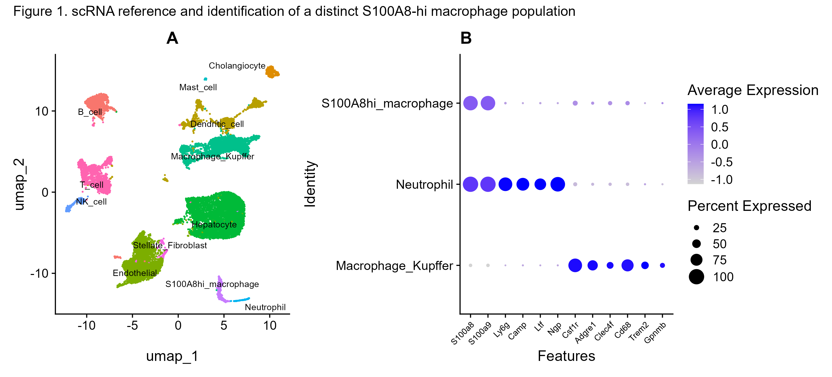
Figure 1. scRNA-seq reference and identification of a distinct S100A8-hi macrophage population. (A) UMAP projection of 18,167 quality-controlled hepatic cells (WT + Bcl2TG, HFD), colored by annotated cell type. (B) Marker-gene dot plot distinguishing S100A8hi_macrophage from Neutrophil and from other Macrophage_Kupffer populations: only Neutrophil is positive for Ly6g, Camp, Ltf and Ngp, despite both S100A8hi_macrophage and Neutrophil expressing S100a8/S100a9.

3.2 Marker-based deconvolution recovers the direction of the original, fully replicated bulk analysis
In the axis-1 (WT vs Bcl2TG, HFD) validation cohort (n = 5 per group), the Macrophage_Kupffer deconvolution score was significantly higher in WT than TG (Wilcoxon p = 0.012, BH q = 0.024, Cohen's d = -2.86; Figure 2A), matching the direction of every individual macrophage marker gene (Adgre1, Csf1r, Clec4f, Cd68) in the original, fully replicated bulk DESeq2 analysis (Figure 2C). The S100A8hi_macrophage score trended in the same direction (Cohen's d = -0.92) but did not reach significance at this sample size (Wilcoxon p = 0.30, BH q = 0.36; Figure 2B) — consistent with the corresponding single-gene result (S100a8 nominal p = 0.039 but BH-adjusted p = 0.22 in the original n=5-vs-5 DESeq2 analysis). Four additional cell types reached BH q = 0.024 in the same direction as expected for a protective genotype (reduced HFD-associated immune infiltration in Bcl2TG): Dendritic_cell, NK_cell, Stellate_Fibroblast and T_cell; Hepatocyte scored higher in TG than WT (q = 0.024), consistent with proportionally less immune infiltrate diluting the hepatocyte signal in WT.
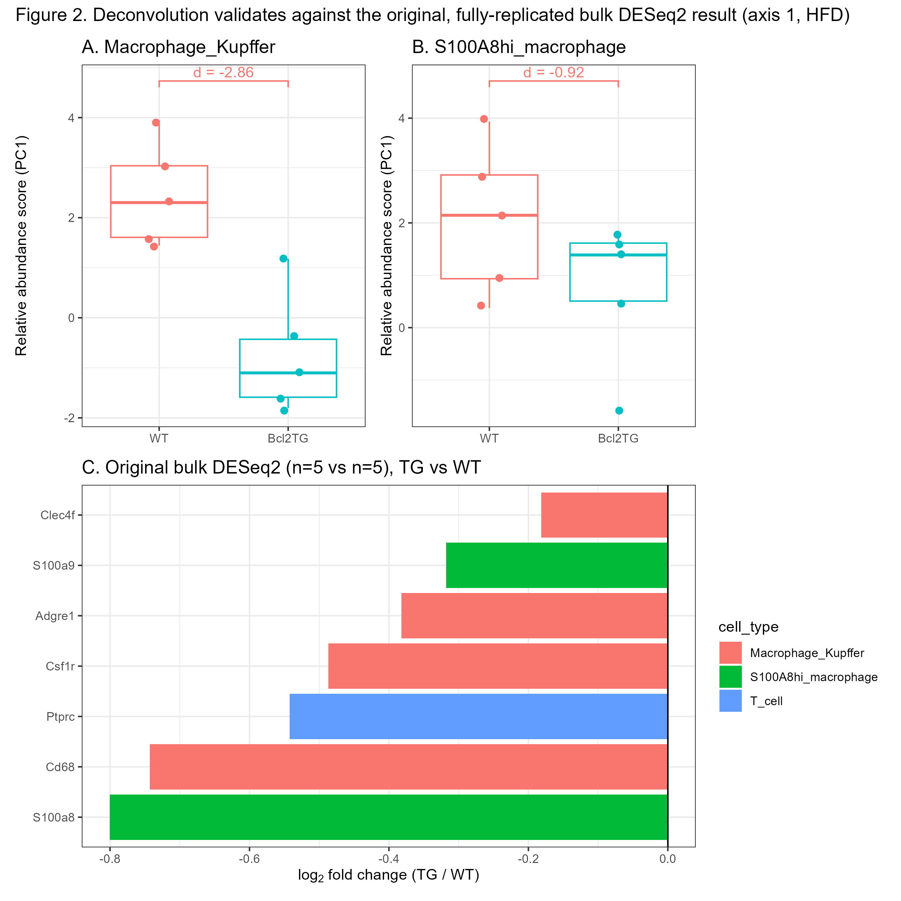
Figure 2. Deconvolution validates against the original, fully replicated bulk DESeq2 result (axis 1, HFD). (A) Macrophage_Kupffer and (B) S100A8hi_macrophage deconvolution scores, WT vs Bcl2TG (n = 5 per group; boxplots with individual samples; Wilcoxon p and Cohen's d shown). (C) log₂ fold-change (Bcl2TG / WT) for the corresponding marker genes in the original authors' bulk DESeq2 analysis of the same 16-sample cohort (n = 5 vs 5, HFD subset shown).

3.3 Macrophage-specific S100a8 deletion does not produce a statistically resolvable shift in hepatic cell composition
Applying the validated signature to the MKO axis (which has no scRNA-seq reference of its own), no cell type reached BH q < 0.05 in either diet (12 cell types x 2 diets; all q ≥ 0.22). Neither S100A8hi_macrophage (HFD: d = -0.91, p = 0.39, q = 0.43; Figure 3B) nor Macrophage_Kupffer (HFD: d = 0.49, p = 0.27, q = 0.43; Figure 3D) differed between WT and MKO. Post hoc power analysis showed this cohort (n = 4-5 per group) is powered (80%, alpha = 0.05) to detect only Cohen's d ≳ 2.0-2.4 — larger than the effect sizes observed for either macrophage population, meaning the null result reflects limited power for moderate effects rather than a confirmed absence of any composition change. Two cell types showed nominal, BH-uncorrected effects at exactly the magnitude this design can detect: Neutrophil was lower in MKO (d = -2.42, p = 0.037) and Mast_cell was higher in MKO (d = 2.36, p = 0.037) under HFD (Figure 3E-F); neither survived correction across the 12-cell-type family (q = 0.22) and both require confirmation in an adequately powered cohort before mechanistic interpretation.
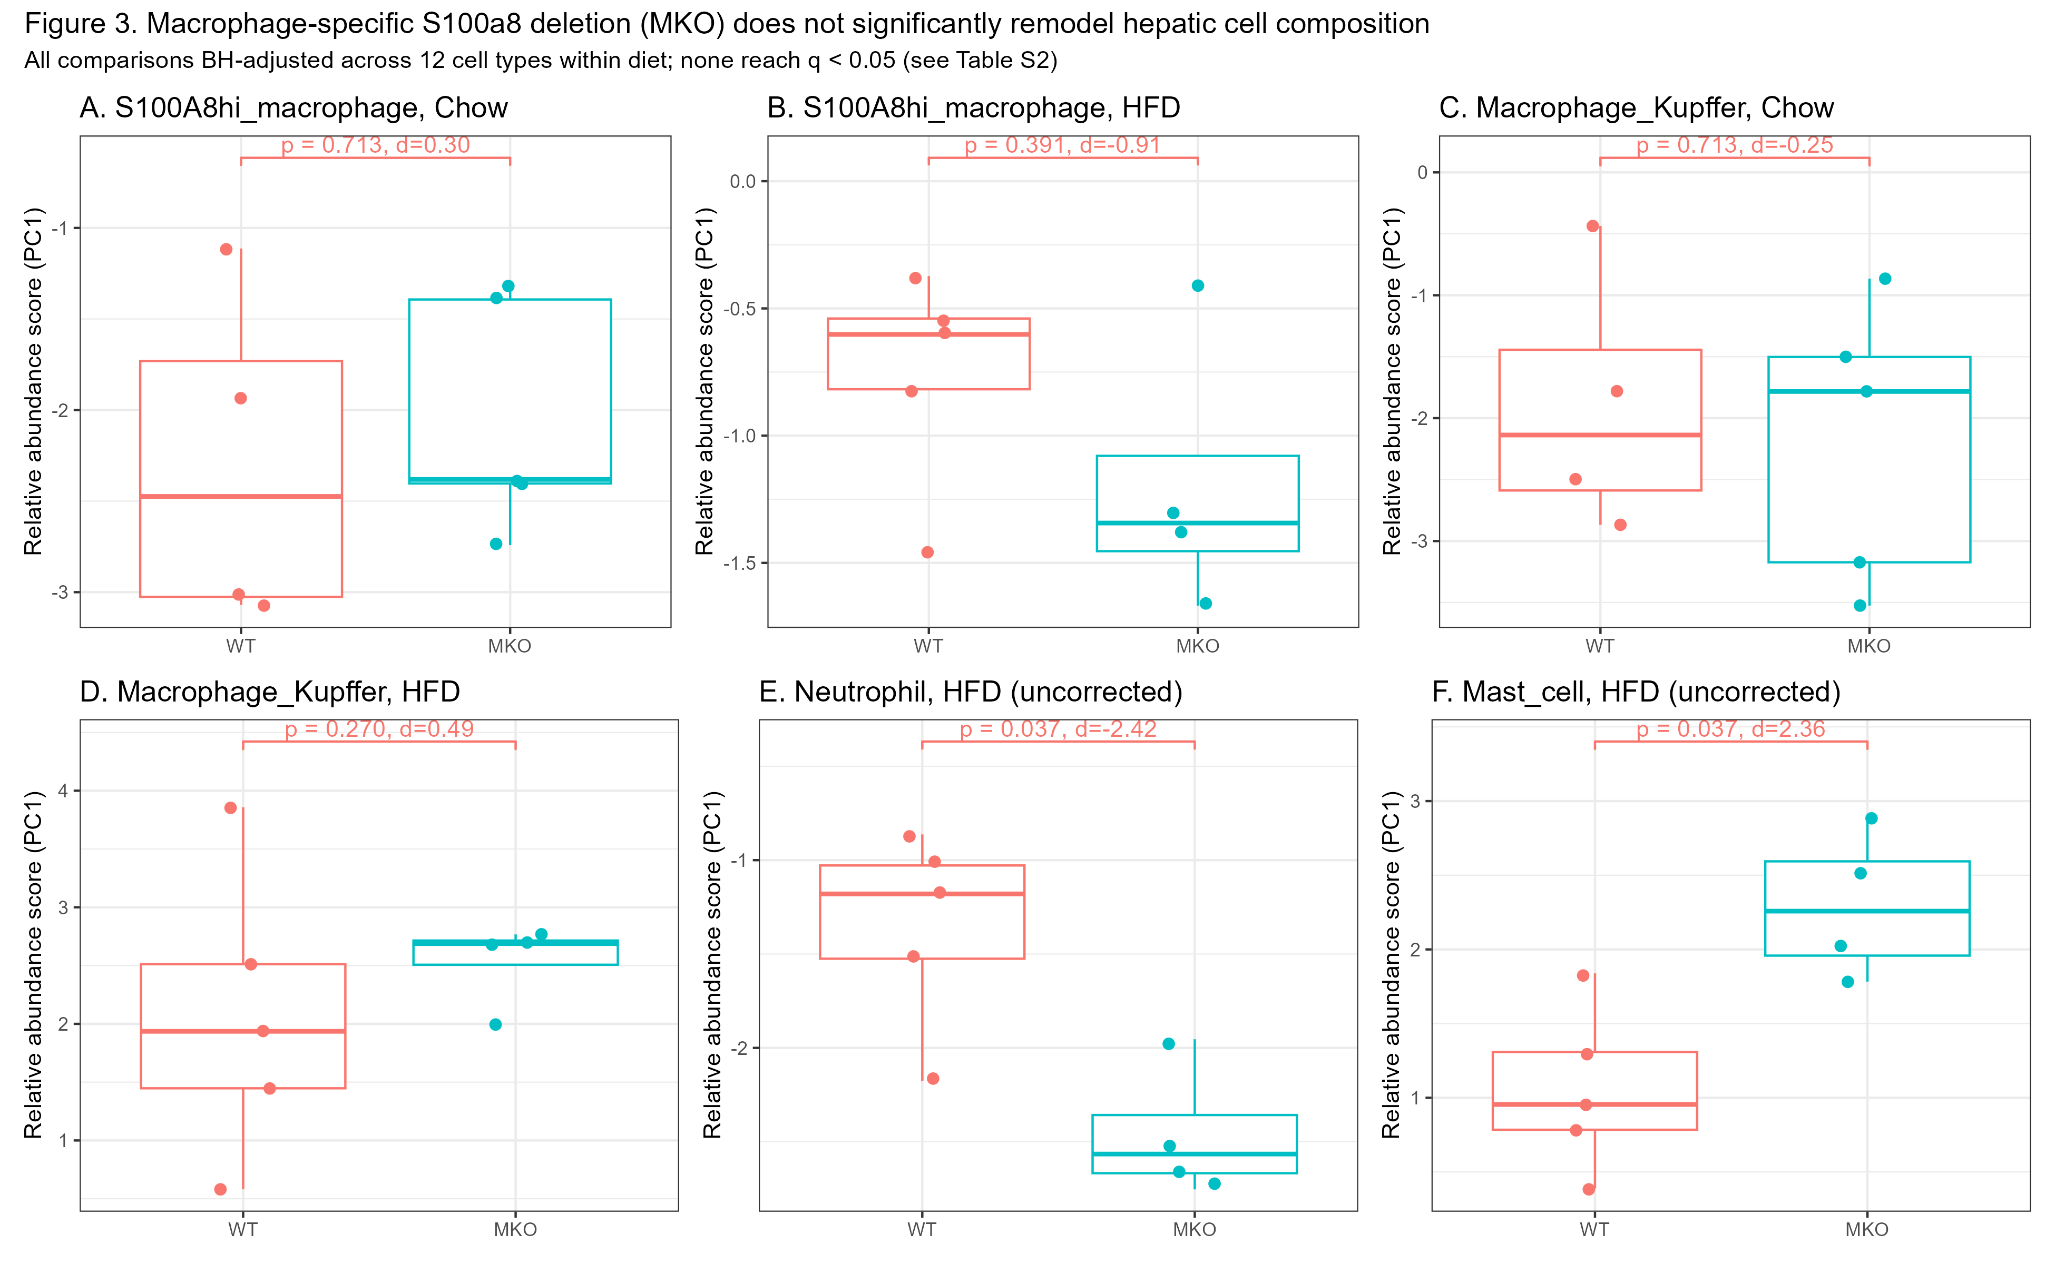
Figure 3. Macrophage-specific S100a8 deletion (MKO) does not significantly remodel hepatic cell composition. Deconvolution scores for WT vs MKO, by diet, for (A-B) S100A8hi_macrophage, (C-D) Macrophage_Kupffer, and (E-F) the two cell types with the largest nominal (BH-uncorrected) effect sizes, Neutrophil and Mast_cell (HFD only). p-values are two-sided Wilcoxon rank-sum; d is Cohen's d. All comparisons were BH-adjusted across the 12 cell types tested within each diet; none reached q < 0.05 (Table 2; results/11_MKO_stats_full.csv).

3.4 General macrophage abundance, not the S100A8-hi subset, correlates with hepatic lipogenic gene expression
Across all 19 HFD bulk samples (both axes pooled), the Macrophage_Kupffer deconvolution score correlated with Cd36 (Spearman r = 0.74, BH q = 0.006), Pparg (r = 0.75, q = 0.006), Scd1 (r = 0.73, q = 0.006) and Plin2 (r = 0.65, q = 0.021) after correcting for the 30 tests performed (Figure 4A, 4C). The S100A8hi_macrophage score showed no correlation with any of the five lipogenic genes tested in any sample subset (all q ≥ 0.42; Cd36: r = 0.11, q = 0.76; Figure 4B-C) — a consistent, reproducible null across the full cohort, within axis 1 alone, and within axis 2 alone.
Table 2. Selected statistical comparisons (full results: results/11_axis1_stats_full.csv, results/11_MKO_stats_full.csv, results/11_lipid_correlation_BH.csv). p-values are two-sided Wilcoxon rank-sum (group comparisons) or Spearman correlation test (correlations); BH q = Benjamini-Hochberg-adjusted p-value within the relevant comparison family.
Comparison | Cell type / gene pair | Effect size | p-value | BH q
Axis 1, WT vs TG (HFD) | Macrophage_Kupffer | d = -2.86 | 0.012 | 0.024
Axis 1, WT vs TG (HFD) | S100A8hi_macrophage | d = -0.92 | 0.30 | 0.36
Axis 2, WT vs MKO (HFD) | S100A8hi_macrophage | d = -0.91 | 0.39 | 0.43
Axis 2, WT vs MKO (HFD) | Macrophage_Kupffer | d = 0.49 | 0.27 | 0.43
Axis 2, WT vs MKO (HFD) | Neutrophil | d = -2.42 | 0.037 | 0.22
Axis 2, WT vs MKO (HFD) | Mast_cell | d = 2.36 | 0.037 | 0.22
Correlation, all HFD (n=19) | Macrophage_Kupffer vs Cd36 | r = 0.74 | 0.0005 | 0.006
Correlation, all HFD (n=19) | S100A8hi_macrophage vs Cd36 | r = 0.11 | 0.66 | 0.76

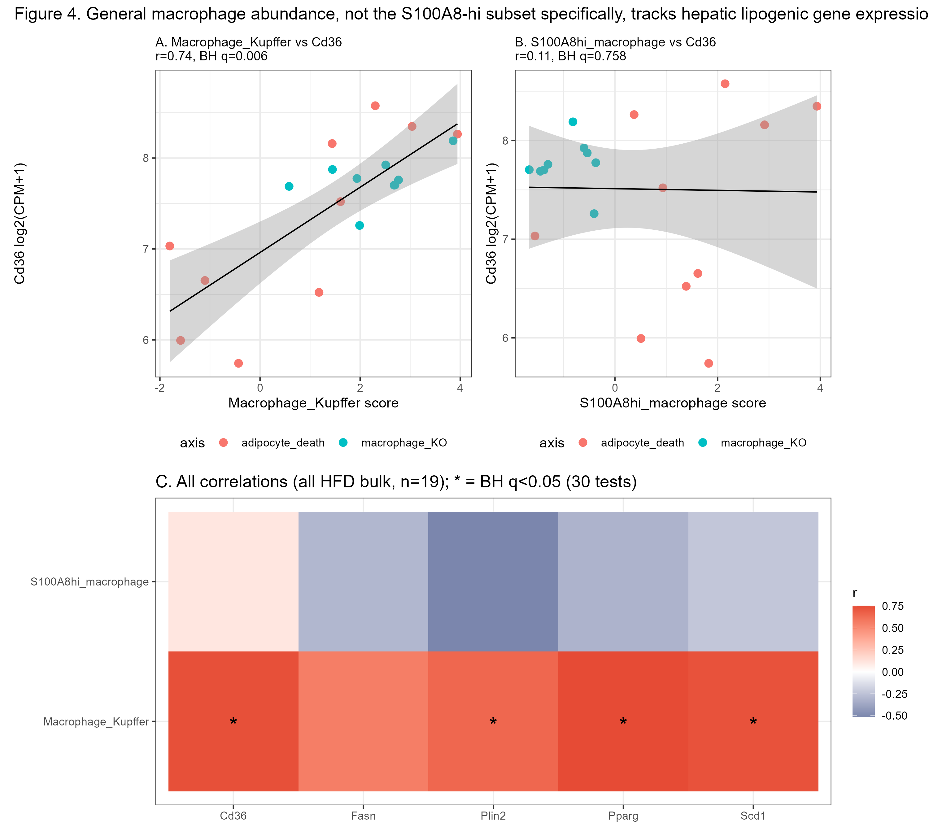
Figure 4. General macrophage abundance tracks lipogenic gene expression; the S100A8-hi subset does not. (A) Macrophage_Kupffer and (B) S100A8hi_macrophage deconvolution scores vs Cd36 expression across all 19 HFD bulk samples (both axes; linear fit shown for visualization). (C) Spearman correlation (r) between each macrophage-lineage cell type's deconvolution score and five lipogenic genes; asterisks mark BH q < 0.05 across all 30 tests performed.

4. Discussion
This study reprocesses a public bulk-and-single-cell RNA-seq dataset to ask a question the original analysis could not: whether the two genetic manipulations that block this adipocyte death-CD36 axis change the composition of the hepatic immune infiltrate, not just the expression of individual marker genes within it. Three results converge on a consistent interpretation. First, general hepatic macrophage/Kupffer abundance — not the S100A8-hi subset specifically — is the compositional signal that is both statistically robust in the validation cohort and correlated with hepatic lipogenic gene expression across the full 19-sample HFD cohort. Second, the S100A8-hi subset shows a directionally concordant trend at every checkpoint in this study (matching the replicated bulk marker-gene direction in axis 1, and trending lower in MKO as would be expected if the mechanism were partly compositional) but never reaches statistical significance on its own — a pattern our power analysis indicates is expected given the observed effect size (d ≈ 0.9) relative to what a 4-5-sample-per-group design can resolve (d ≳ 2.0-2.4 at 80% power), not evidence against a real effect. Third, macrophage-specific S100a8 deletion (MKO) does not produce a statistically resolvable shift in broader immune composition in either diet. Taken together with the original study's finding that MKO is protective at the phenotypic and CD36-expression level¹, the most parsimonious interpretation is that S100A8 acts primarily through a gene-regulatory mechanism within the existing macrophage compartment (i.e., loss of S100A8 protein function suppresses CCN3 regardless of macrophage abundance) rather than by changing which or how many immune cells infiltrate the liver — though, given the power limitations discussed below, this should be read as a hypothesis refined rather than a mechanism confirmed.
This work also illustrates a general methodological point relevant to any study pairing a small pilot scRNA-seq cohort with a larger, properly replicated bulk cohort: an n=1-per-group single-cell comparison should not be used as an unqualified validation benchmark for a downstream computational method. In this dataset, the single WT/TG scRNA-seq pair suggested the opposite direction from the properly replicated bulk result for the same comparison; had we accepted the scRNA-seq pair at face value, we would have incorrectly concluded that the deconvolution method had failed. Cross-checking against an independent, adequately powered statistical result — here, the original authors' own bulk differential expression analysis — was necessary to correctly adjudicate which comparison was unreliable.

4.1 Limitations
- Single-donor scRNA-seq reference. The scRNA-seq reference contains one biological replicate per genotype. As demonstrated directly in this study (Section 2.5), a single pair cannot establish population-level direction, and individual-mouse variability likely adds noise to the marker-gene signature itself that cannot be quantified without additional biological replicates.
- Relative, not absolute, abundance scores. MarkerBasedDecomposition returns a per-cell-type relative abundance score (marker-panel PC1), not an absolute cell proportion; scores are only interpretable for comparing the same cell type across samples, not for comparing magnitude between different cell types.
- Small bulk sample sizes. Group sizes of 4-5 per condition limit this study to detecting Cohen's d ≳ 2.0-2.4 at conventional power; moderate true effects, including the S100A8-hi subset's own directionally consistent signal (d ≈ 0.9 in both axes), cannot be excluded and require a larger cohort to resolve.
- Bulk deconvolution cannot resolve cell state or spatial context. A change in per-cell S100A8 activity, paracrine signaling range, or spatial proximity to hepatocytes would not necessarily register as a change in our composition estimate, and whole-liver bulk correlation cannot distinguish these from true compositional shifts.
- Ccn3 (Nov) was not testable. This transcript was absent from the bulk gene annotation used in this dataset and could not be included in the lipogenic-gene correlation analysis.
- Two genotype axes were processed as separate sequencing batches. Although "WT" samples from the two axes were never pooled or treated as interchangeable, subtler batch effects on library composition or normalization between the two independently deposited DESeq2 analyses cannot be fully excluded.
- Correlational design. Associations between cell-type abundance scores and lipogenic gene expression are correlational; this study cannot establish causal direction and does not substitute for the interventional experiments in the original report.

5. Conclusions
Reprocessing a public bulk-and-single-cell dataset with a validated, marker-based deconvolution approach shows that the compositional correlate of hepatic lipogenic gene expression in this model is the general macrophage/Kupffer compartment rather than the S100A8-hi subset specifically, and that macrophage-specific S100a8 deletion does not produce a statistically resolvable shift in broader hepatic immune composition at the sample sizes available. These results refine, rather than contradict, the original mechanistic model, and highlight specific, adequately powered follow-up experiments — larger MKO cohorts, and dedicated attention to neutrophil and mast cell populations — that could distinguish a purely gene-regulatory mechanism from one with a compositional component.

Supplementary Materials
Full result tables underlying all figures and in-text statistics are available in the code repository (Section 2.7): results/11_axis1_stats_full.csv (axis 1 validation), results/11_MKO_stats_full.csv (axis 2 application), results/11_lipid_correlation_BH.csv (lipogenic-gene correlations), and results/11_marker_panel_QC.csv (Table S1 source data, below).
Table S1. Marker-panel size and signal coherence per cell type. Panel size is algorithmically selected by BisqueRNA::GetNumGenesWeighted() (Section 2.4), not a fixed cutoff. % variance explained by PC1 indicates how coherently the marker panel behaves as a single factor; values below ~50% (Cholangiocyte, Mast_cell, Neutrophil, T_cell) indicate a noisier, less unidimensional signal and should be interpreted with additional caution.
Cell type | Marker genes used | % variance explained by PC1
B_cell | 5 | 70.4
Cholangiocyte | 14 | 33.5
Dendritic_cell | 5 | 54.6
Endothelial | 5 | 64.3
Hepatocyte | 6 | 50.6
Macrophage_Kupffer | 7 | 72.4
Mast_cell | 9 | 35.9
Neutrophil | 25 | 38.7
NK_cell | 5 | 78.1
S100A8hi_macrophage | 7 | 76.9
Stellate_Fibroblast | 10 | 69.1
T_cell | 7 | 34.8

References
1. Guan Y, Kim Y, Wang Y, Cho YE, Xiang X, Kim SJ, Yao T, Feng D, Hwang S, Gao B. Adipocyte death promotes hepatic infiltration of S100A8+ macrophages and steatotic liver disease progression in mice. J Clin Invest. 2025;135(21):e190635. doi:10.1172/JCI190635
2. Rinella ME, Lazarus JV, Ratziu V, et al. A multisociety Delphi consensus statement on new fatty liver disease nomenclature. Hepatology. 2023;78(6):1966-1986. doi:10.1097/HEP.0000000000000520
3. Hao Y, Stuart T, Kowalski MH, Choudhary S, Hoffman P, Hartman A, Srivastava A, Molla G, Madad S, Fernandez-Granda C, Satija R. Dictionary learning for integrative, multimodal and scalable single-cell analysis. Nat Biotechnol. 2024;42(2):293-304. doi:10.1038/s41587-023-01767-y
4. Jew B, Alvarez M, Rahmani E, Miao Z, Ko A, Garske KM, Sul JH, Pietiläinen KH, Pajukanta P, Halperin E. Accurate estimation of cell composition in bulk expression through robust integration of single-cell information. Nat Commun. 2020;11:1971. doi:10.1038/s41467-020-15816-6
5. Love MI, Huber W, Anders S. Moderated estimation of fold change and dispersion for RNA-seq data with DESeq2. Genome Biol. 2014;15:550. doi:10.1186/s13059-014-0550-8
6. Ritchie ME, Phipson B, Wu D, Hu Y, Law CW, Shi W, Smyth GK. limma powers differential expression analyses for RNA-sequencing and microarray studies. Nucleic Acids Res. 2015;43(7):e47. doi:10.1093/nar/gkv007
7. Benjamini Y, Hochberg Y. Controlling the false discovery rate: a practical and powerful approach to multiple testing. J R Stat Soc Series B. 1995;57(1):289-300.
8. Barrett T, Wilhite SE, Ledoux P, et al. NCBI GEO: archive for functional genomics data sets--update. Nucleic Acids Res. 2013;41(D1):D991-D995. doi:10.1093/nar/gks1193
9. McInnes L, Healy J, Melville J. UMAP: Uniform Manifold Approximation and Projection for Dimension Reduction. arXiv:1802.03426 [stat.ML]. 2018.

